**SCTR’s Pune Institute of Computer Technology Dhankawadi, Pune**

**A.Y. 2023-24**

**WADL MINI PROJECT REPORT ON**

**“CAMPUSNOTES”**

**Submitted By**

33164

33171

33177

33181

**Under the guidance of**

Mrs. Amruta Patil



**DEPARTMENT OF INFORMATION TECHNOLOGY**

**ACADEMIC YEAR 2023-24**

**ABSTRACT**

CampusNotes is a dynamic web application developed on the MERN (MongoDB, Express.js, React.js, Node.js) stack, tailored to meet the academic needs of engineering students. With a primary focus on providing an extensive repository of study materials and resources, CampusNotes serves as a centralized hub for students seeking lecture notes, textbooks, and supplementary materials relevant to their coursework. Through its user-friendly interface, users can efficiently navigate through the platform, utilizing robust search functionalities to locate specific resources with ease.

Moreover, CampusNotes integrates advanced features such as note uploading capabilities, enabling users to contribute and share their own study materials with peers. Additionally, the inclusion of a chatbot feature enhances user interaction, providing instant assistance and guidance on academic queries. By fostering collaboration through interactive tools and facilitating real-time communication via the chatbot, CampusNotes aims to revolutionize the accessibility and engagement of educational resources, ultimately enhancing the academic journey for engineering students in the digital age

**INTRODUCTION**

In today's digital world, learning is becoming more interactive and accessible thanks to technology. CampusNotes is a new web platform designed specifically for engineering students. It's like a digital library where students can find all kinds of study materials, like notes and textbooks, for their courses. Using CampusNotes is easy; you just search for what you need, and you can even upload your own notes to share with others.

Through a user-friendly interface and intuitive search functionalities, students can effortlessly navigate the platform to locate and download relevant materials pertinent to their coursework. Additionally, CampusNotes empowers students to actively engage in the learning process by facilitating the sharing of knowledge through note uploading capabilities. By enabling users to contribute their own study materials, CampusNotes fosters a culture of peer-to-peer learning and collaboration, transcending the limitations of traditional learning environments.

Furthermore, CampusNotes integrates cutting-edge features such as a chatbot, providing students with instant assistance and guidance on academic queries. This interactive feature not only enhances user experience but also encourages continuous learning and engagement. As such, CampusNotes represents more than just a repository of resources; it symbolizes a dynamic ecosystem wherein students can connect, collaborate, and thrive in their academic endeavors.

**CampusNotes provides following functionalities:**

* **Resource Repository:** CampusNotes serves as a centralized repository of study materials, including lecture notes, textbooks, and reference materials, organized by course and subject.
* **Search and Filter:** Users can efficiently search and filter through the collection of resources to find materials relevant to their specific needs, streamlining the process of resource discovery.
* **Notes Upload:** Students have the ability to contribute their own study materials, lecture notes, and other resources to the platform, fostering a culture of knowledge sharing and collaboration among peers.
* **Chatbot Assistance:** The integrated chatbot feature provides instant assistance and guidance to users, answering queries related to academic topics, resource navigation, and platform functionalities.
* **User Authentication:** CampusNotes incorporates user authentication mechanisms, allowing registered users to personalize their experience and access additional features.
* **Responsive Design:** CampusNotes is designed with a responsive layout, ensuring compatibility across various devices, including desktops, laptops, tablets, and smartphones, for seamless accessibility anytime, anywhere.

**LITERATURE SURVEY**

The development of CampusNotes draws inspiration from existing research and literature in several key areas related to educational technology, online learning platforms, and collaborative learning environments. The literature survey conducted for this project encompasses a variety of studies and publications that have informed the design and implementation of CampusNotes.

Educational Technology and Online Learning Platforms: Numerous studies have explored the impact of educational technology on student learning outcomes and engagement. Research by Means et al. (2013) and Picciano (2017) highlights the potential of online learning platforms to enhance student performance and facilitate flexible learning experiences. By leveraging insights from these studies, CampusNotes aims to harness the power of technology to create a user-friendly and accessible platform for engineering students.

Collaborative Learning Environments: Collaborative learning has been identified as a valuable pedagogical approach that fosters active engagement and knowledge sharing among students. Studies by Dillenbourg (1999) and Stahl (2002) emphasize the benefits of collaborative learning environments in promoting deeper understanding and critical thinking skills. CampusNotes integrates features such as discussion forums and note sharing capabilities to facilitate peer-to-peer interactions and collaborative learning experiences.

User Experience Design: User experience (UX) design principles play a crucial role in the development of effective online platforms. Research by Norman (2013) and Nielsen (2012) provides valuable insights into designing intuitive and user-friendly interfaces that enhance user satisfaction and engagement. CampusNotes prioritizes UX design considerations to ensure seamless navigation, efficient resource discovery, and personalized user experiences.

Chatbot Technology in Education: The integration of chatbot technology in educational settings has gained traction in recent years. Studies by He et al. (2019) and Altrabsheh et al. (2020) explore the potential of chatbots to provide personalized learning support and assistance to students. CampusNotes incorporates a chatbot feature to offer instant help and guidance, drawing from the findings of these studies to enhance user interaction and support.

**IMPLEMENTATION DETAILS**

Web technologies used:

1.MongoDB

2.React

3.Talwind CSS and material Tailwind

4.JavaScript

5.Express.js

6.Node.js

7.Google API(drive)

Frontend development :

Frontend development in CampusNotes focuses on creating an intuitive and engaging user interface (UI) using modern web technologies.

1. UI Design:

Wireframes and mockups guide the layout and structure of the application.

Emphasis on usability, accessibility, and aesthetics for engineering students' needs.

1. Component Architecture:

Utilizes React.js to create modular and reusable frontend components.

Components organized hierarchically for maintainability and scalability.

1. Styling:

Tailwind CSS and Material Tailwind used for rapid prototyping and customization.

Ensures consistency and responsiveness across different screen sizes and devices.

1. State Management:

React's state management handles dynamic behavior and component state.

Manages data such as user preferences, search queries, and bookmarked resources.

1. User Interaction:

JavaScript event handling manages user interactions like clicks and inputs.

Event listeners trigger specific actions in response to user input.

1. Responsive Design:

Media queries and CSS flexbox/grid layouts ensure optimal viewing across devices.

Adapts UI dynamically based on viewport dimensions for seamless accessibility.

Backend development:

Backend development in CampusNotes focuses on building the server-side logic and infrastructure necessary to support the frontend interface and handle data processing tasks.

1. Server Setup:

Utilizes Node.js and Express.js for server-side logic and routing.

1. Database Management:

MongoDB is used for efficient data storage and retrieval.

1. API Endpoints:

Defines RESTful API endpoints for CRUD operations.

1. Authentication and Authorization:

Implements user authentication with JWT and Bcrypt password hashing for secure access control.

1. Middleware Integration:

Applies middleware for logging, error handling, and request processing.

1. File Handling:

Implements file upload/download functionalities using Multer and google drive API.

1. External Service Integration:

Integrates external services like Google Drive API for accessing study materials.

**OUTPUT**

Home page:

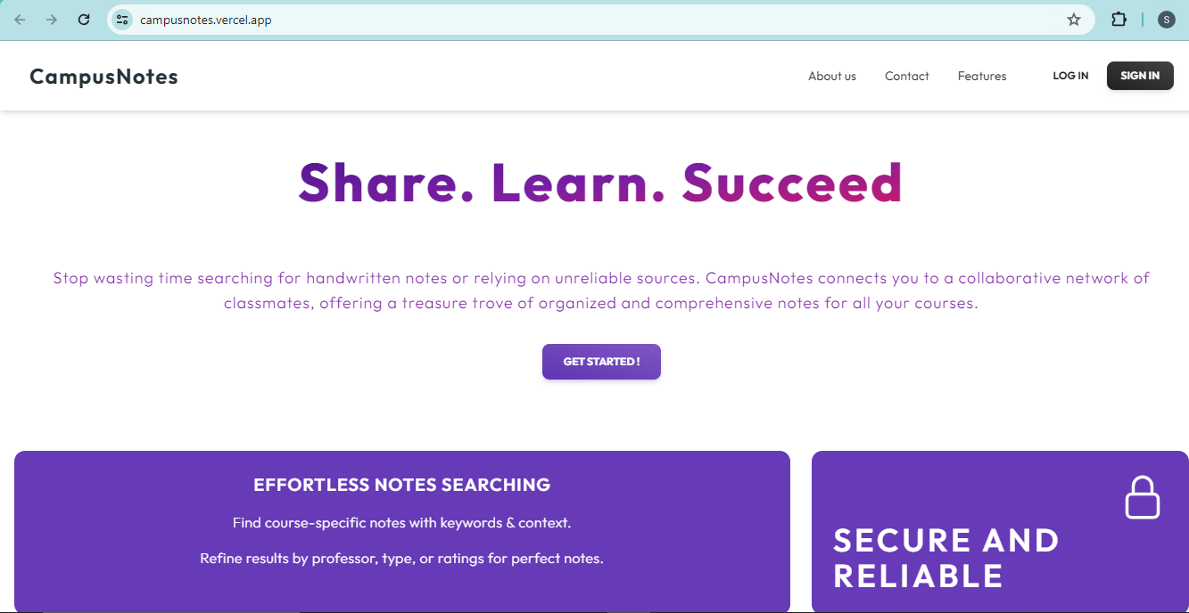

Sign up Page:

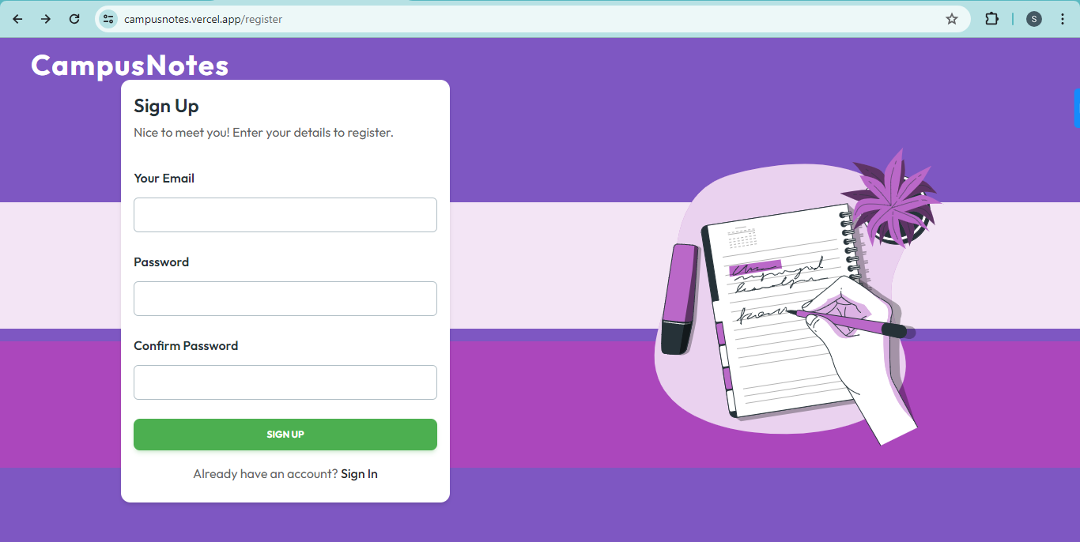

SignIn page:

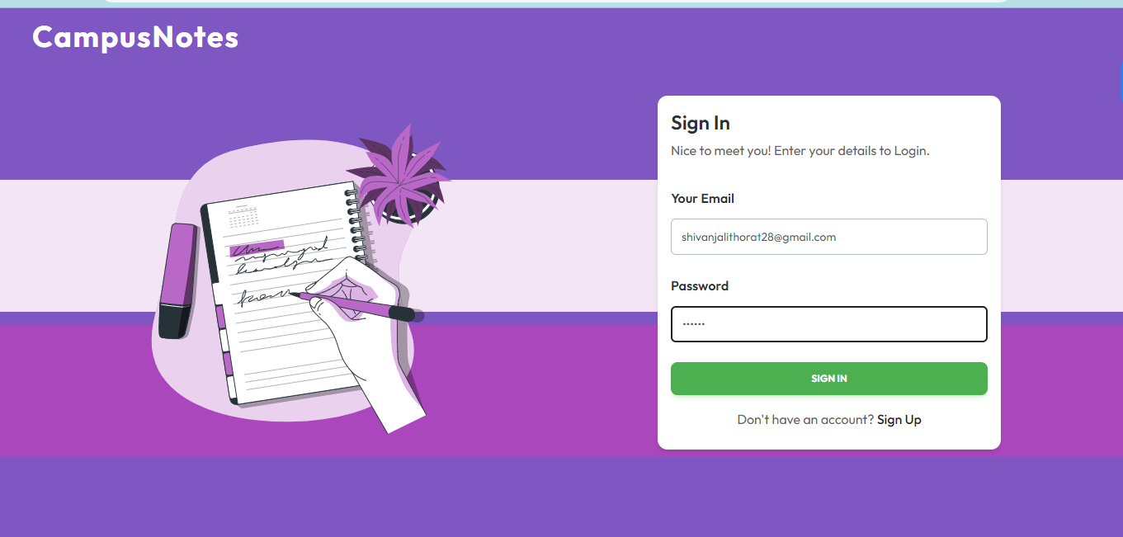

Profile Page:

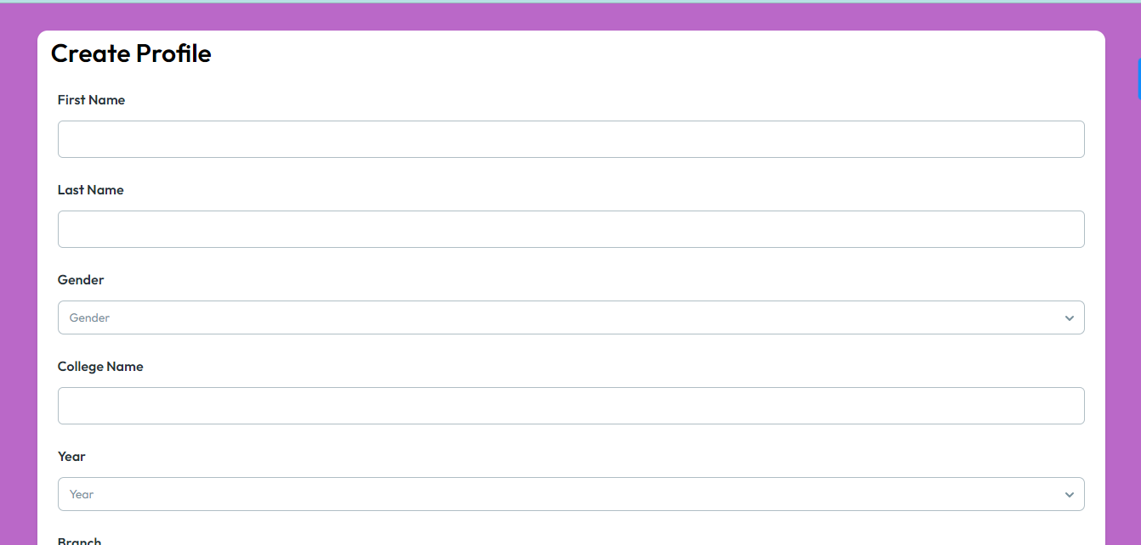

Notes Upload Page:

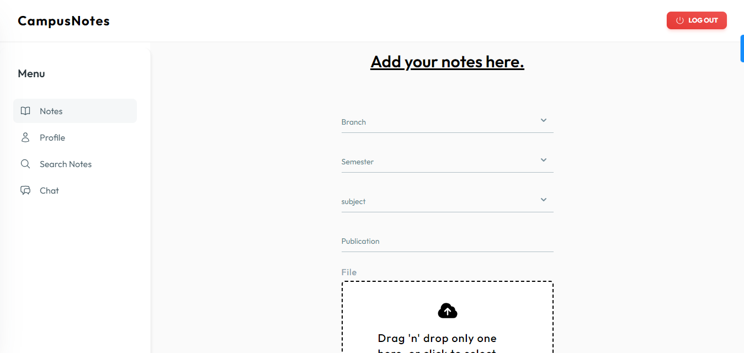

Search Notes Page:

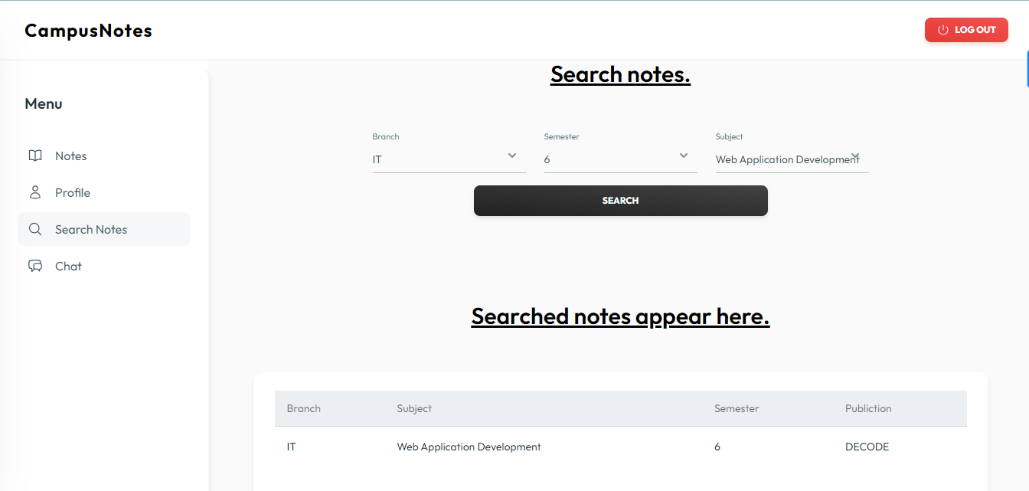

Chat Page:

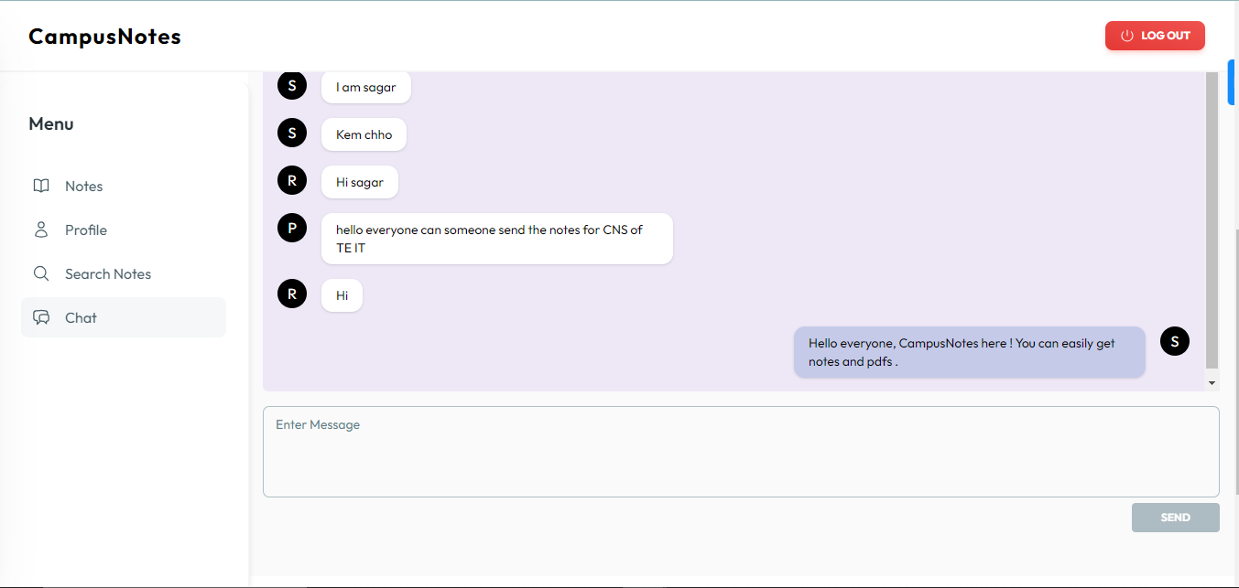

**CONCLUSION**

CampusNotes is a helpful tool designed especially for engineering students. It combines modern web technology with easy-to-use interfaces to provide a platform where students can find study materials, collaborate with peers, and improve their learning experience. By focusing on simplicity, security, and accessibility, CampusNotes aims to make studying easier and more effective for engineering students everywhere. With CampusNotes, students can access resources, connect with classmates, and succeed in their academic journey with confidence.

CampusNotes represents a pivotal shift towards digital solutions in education, bridging the gap between traditional learning methods and contemporary technological advancements. As engineering students embrace this innovative platform, they gain access to a wealth of resources and tools to support their academic growth and success. With CampusNotes, the future of engineering education is redefined, offering a dynamic and inclusive environment where students can thrive and excel in their pursuit of knowledge and excellence.

**REFERENCES**

1. "The Effect of Educational Technology on Student Learning Outcomes: A Meta-Analysis" by Robert B. Kozma: https://www.researchgate.net/publication/222276467_The_Effect_of_Educational_Technology_on_Student_Learning_Outcomes_A_Meta-Analysis
2. "Collaborative Learning: Cognitive and Computational Approaches" by Gerry Stahl: https://www.springer.com/gp/book/9789401060425
3. React.js Official Documentation: https://reactjs.org/docs/getting-started.html
4. Node.js Official Documentation: https://nodejs.org/en/docs/
5. Express.js Official Documentation: https://expressjs.com/en/4x/api.html
6. MongoDB Official Documentation: https://docs.mongodb.com/
7. Tailwind CSS Official Documentation: https://tailwindcss.com/docs
8. Material Tailwind Official Documentation: <https://material-tailwind.com/docs>