**ATOC 4770: Wind Energy Meteorology**

**HW5 (25 points)**

In this homework assignment, you will review the issues with using lidar and sodar data for wind resource assessment.

**Please type your answers to the following questions in a concise report. Please save it as a pdf named “YOURLASTNAME_ATOC4770_HW5.pdf before uploading to Canvas, and use a different font for your answers. You may find it more convenient to do this project in software other than Excel; please use whatever software you prefer to create the plots requested below.**

1. (1 pts) Describe the basic operating principle of lidar in a few sentences.
2. (1 pts) Describe the basic operating principle of sodar in a few sentences.
3. (2 pts) Summarize the advantages and disadvantages of lidar and sodar as compared to a 60m tower; give at least two advantages and two disadvantages.
4. (1 pts) Both sodar and lidar measure a “volume” of air. (For the purposes of this question, we will focus on vertically-profiling lidars.) How is this different from an anemometer? (It may be helpful to draw a figure to help you provide the dimensions of this measurement volume.)
5. (1 pts) What is “SNR” and how does it apply to ground-based remote sensing devices?
6. (1 pts) You are conducting a wind resource assessment campaign and want to determine how wind shear will affect your choice of turbine hub height. You decide to supplement your current assessment campaign, which uses two 60m masts, with a ground-based remote sensing device. The available monitoring location is near woods with 30m tall trees, and a road with frequent traffic. Your budget allows for either a lidar or a sodar, and both are available from a supplier who can meet your schedule (this does not always happen!). Which type of device would you choose? Why is the chosen device appropriate for the site? What siting considerations should be addressed during deployment?
7. (1 pts) You are assessing a wind project site that faces up a steep slope in the prevailing wind direction. What adjustments might be considered when comparing the wind data collected on a monitoring tower using cup anemometers with that collected by either lidar or sodar? Explain the item or parameter to be considered or adjusted for, and if it applies to all remote sensing systems or just a particular type.

The Wind Forecast Improvement Project is an experiment in the Columbia River Gorge between Washington and Oregon, funded by the Dept. of Energy, to improve forecasts of wind energy generation in the complex terrain of the Pacific Northwest. You can read about this experiment at <https://www.esrl.noaa.gov/gsd/renewable/wfip2.html>. At one of the measurement sites near Wasco, Oregon, several instruments were deployed including CU’s wind profiling lidar and a sodar from NOAA’s Air Resources Laboratory, and a scanning lidar from NOAA’s Earth Sciences Research Laboratory.

1. (1 pt) You can learn about this experiment at <https://www.esrl.noaa.gov/gsd/renewable/wfip2.html>. What are some of the research questions this project addresses?

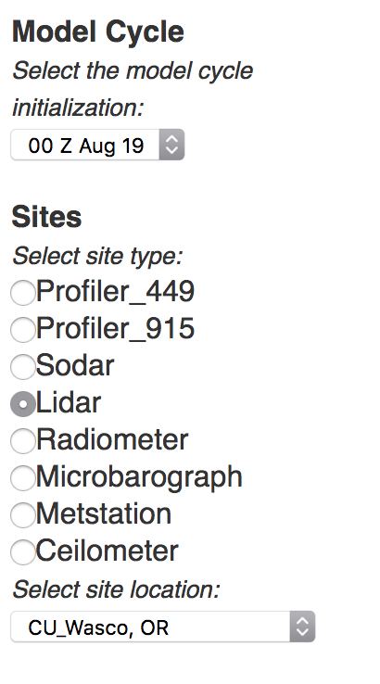At the website <https://wfip.esrl.noaa.gov/psd/programs/wfip2/> you can look at plots of sodar and lidar data from a site in the Columbia River Gorge, at the Wasco airport. Below, I have included three plots from different instruments located at the Wasco airport.

1. (3 pts) Fill in the table below describing the height ranges of data, the maximum and minimum wind speeds, general wind direction (northerly, easterly, westerly, or southerly) and the maximum altitude where all data are present throughout the entire day:

|  |  |  |  |  |  |
| --- | --- | --- | --- | --- | --- |
|  | Height Range | Min to Max Wind Speeds | Highest altitude with all data reporting | General wind direction | Time and height of maximum wind speed |
| CU_Wasco |  |  |  |  |  |
| NOAA_Wasco |  |  |  |  |  |
| ARL_Wasco |  |  |  |  |  |

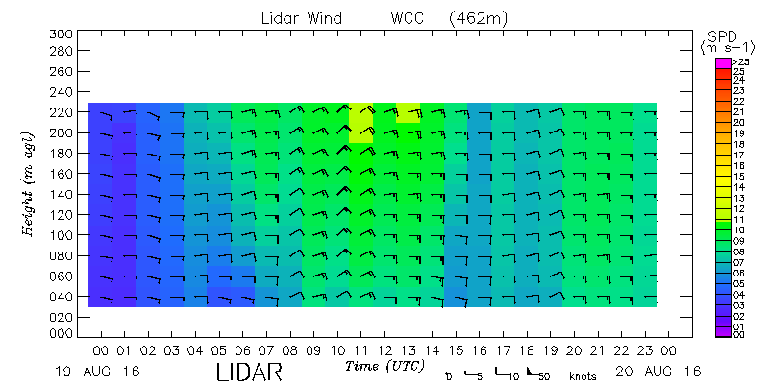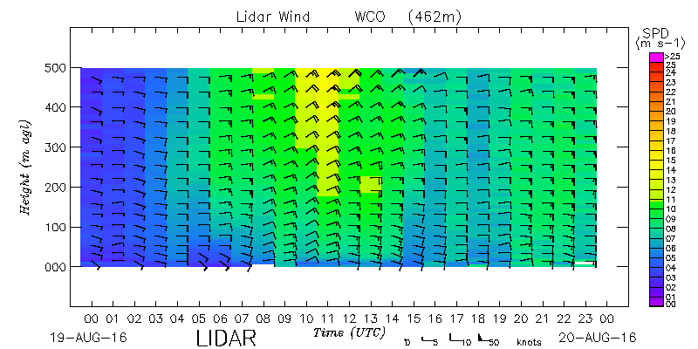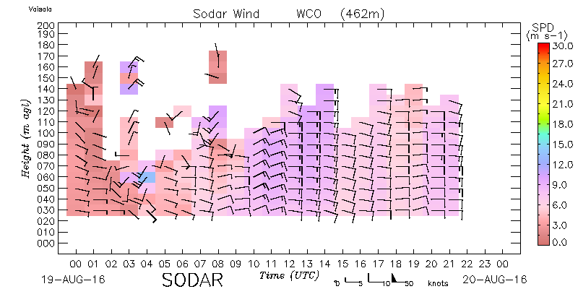

1. (3 pts)
   1. (1pt) At what time of day (UTC) does the sodar provide the worst data quality (i.e. the fewest data points), ignoring the power outage from 2130 UTC on?
   2. (1 pt)Given that this lidar is located in Oregon, in the Pacific time zone, and these measurements were collected in August, at what point in the diurnal cycle does this “worst” period occur?
   3. (1 pt)Why might sodar data quality be poor during this time?
2. 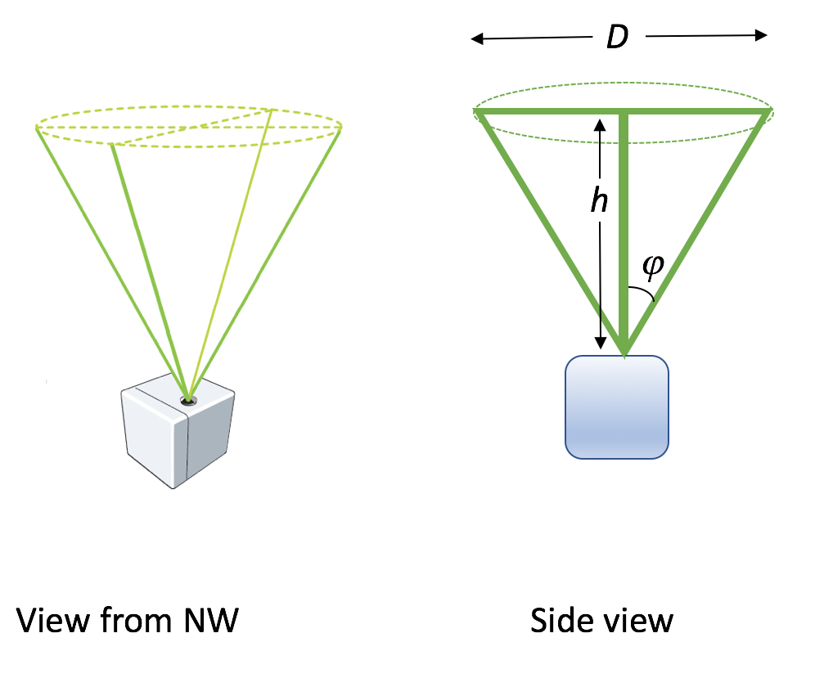(1 pt) These systems estimate the wind profile with DBS scanning, in which three or four beams probe the atmosphere at an angle from vertical, as in the image at right. The CU lidar uses four beams directed to the N, E, S, and W at an elevation angle  = 28 deg. The line-of-sight (or radial) velocities measured by each of these beams will be labelled $V_{rN}, V_{rE}, V_{rS}, V_{rW}$. If we assume that the actual horizontal flow with components $u, v$ and the vertical flow $w$ is homogeneous across the measurement volume at a given altitude, then we can solve for the components of the wind:

$$u= \frac{V_{rE}-V_{rW}}{2\sin{φ}},$$

$$v= \frac{V_{rN}-V_{rS}}{2\sin{φ}},$$

$$w= \frac{V_{rN}+V_{rS}+V_{rE}+V_{rW}}{4\cos{φ}}$$

And we can also solve for the total wind speed

$U= \sqrt{u^{2}+v^{2}}$ and wind direction. At an altitude *h* of 200 m, how wide is the diameter *D* of the measurement volume across which the flow must be homogeneous? How large is this volume compared to the measurement volume of a sonic anemometer or a cup anemometer?

1. (1 pt) Download the WLS7-0068_2016_08_19__00_00_00 data file from Canvas. Wind speed, wind direction, and CNR (carrier-to-noise ratio, another name for signal-to-noise ratio) for 10 heights from 40 m to 220 m are given. These data should match the plot downloaded for CU_Wasco, above, although this datafile provides data more frequently than shown in the plot. Using the maximum and minimum functions, what is the maximum wind speed found in this time series, and at what altitude does it occur, and when does it occur (UTC and PDT)?
2. (1 pt) Given the time of day of this maximum, suggest a meteorological explanation for this wind speed maximum.
3. (2 pt) One advantage of remote sensing instrumentation is the ability to measure winds throughout the altitudes of a turbine rotor disk rather than one measurement at hub-height or at the top of a meteorological tower. An assessment of the winds throughout the rotor disk would be called a “rotor equivalent wind speed,” (REWS) which would be an average of wind speeds at several levels within the rotor disk. For a typical 80-m hub-height and 80-m rotor diameter wind turbine, the REWS can be calculated as

$REWS= \frac{\sum_{1}^{N}{U_{N}}}{N}$, or for this case $REWS= \frac{U_{40m}+U_{60m}+U_{80m}+U_{100m}+U_{120m}}{5}$. (Note that this calculation should be weighted by the area of the rotor disk, but we will not do that here.) Given the variability that you see in the plot of these lidar data and the data you see in the spreadsheet, pose a hypothesis comparing the REWS and the hub-height wind speed. (For example, which value will be larger?) Pose a second hypothesis comparing the REWS and the 60-m wind speed, which is the highest height that can be typically measured with a meteorological tower.

1. (4 pts) Using your spreadsheet (or other software), create a scatter plot comparing the REWS to the hub-height wind speed, including axes labels (and units), a trendline, and an R^2 value for that trendline. Include your plot below. How different is the REWS from the hub-height wind speed? Repeat for a comparison of the REWS to the 60-m wind speed.
2. (1 pt) Evaluate your hypothesis from number 16 above in light of your analysis. Do you think this conclusion is robust for all circumstances?