**PRD**

**Cameron Kozinski**

**Codeigniter**

**Project/App Title:**

AYSI News (As you see it news)

**Project/App Summary:**

AYSI News is a news site written entirely by everyday people. Anyone can submit a story and whether it fails or becomes a headline is determined by user feedback. In many ways it is like a blog but as user friendly as YouTube.

**Twist:**

The twist is really the layout of the webpage. It will look much like any of your favorite news site and have the same search capabilities. In the world full of easy to use video blogs and podcast AYSI News will bring that same atmosphere to those of us that prefer to read and/or write.

**Week 1 Schedule:**

Monday-Tuesday: Researching websites that fall under the umbrella of AYSI News. Including Hacker News, Youtube, NBC News, Aljazeera, Fox News, and Buzz Feed. Creating style tiles and design comps. Making the database, and setting up base files.

Wednesday-Thursday: Coding and debugging.

Friday: Delivery and Testing

**Week 1 features:**

By the end of the first week the user will be able to sign in or sign up (including Facebook) to the website and have a profile page.

The user will be able to submit stories, add images to stories, and edit stories written by them.

The user will be able to read stories written by other users.

**Wire Diagrams:**

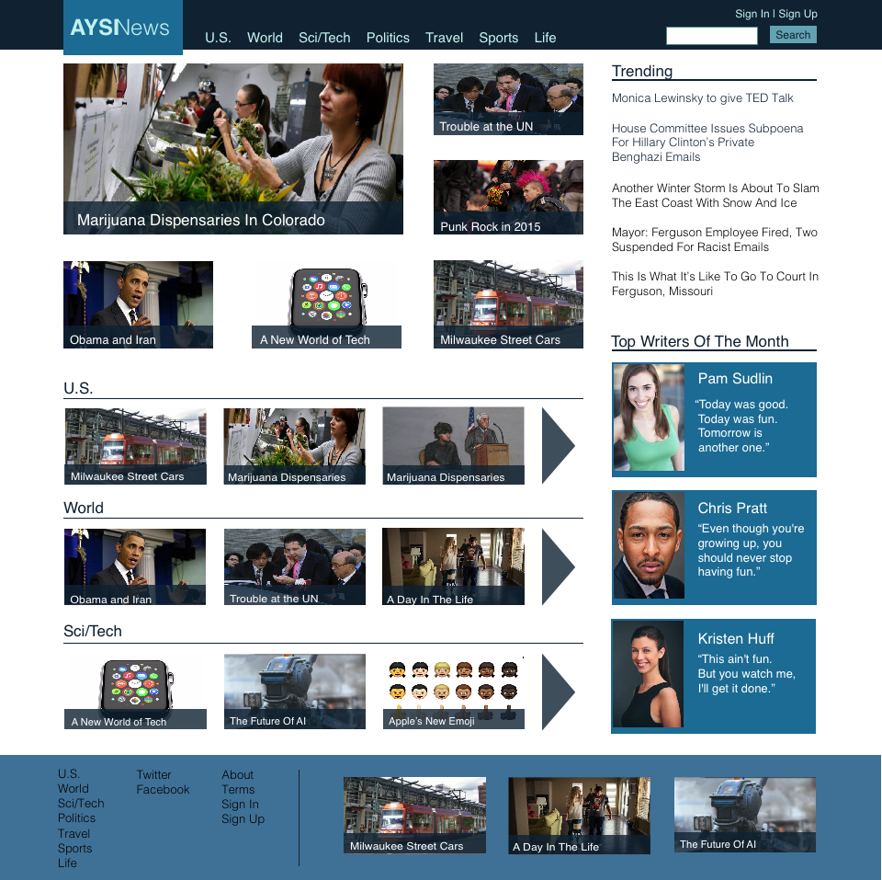

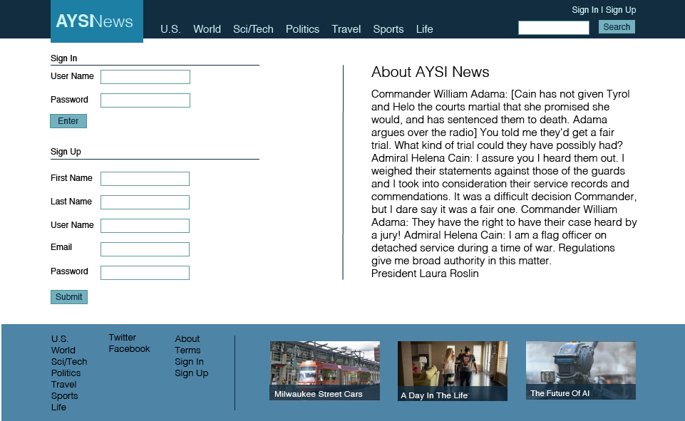

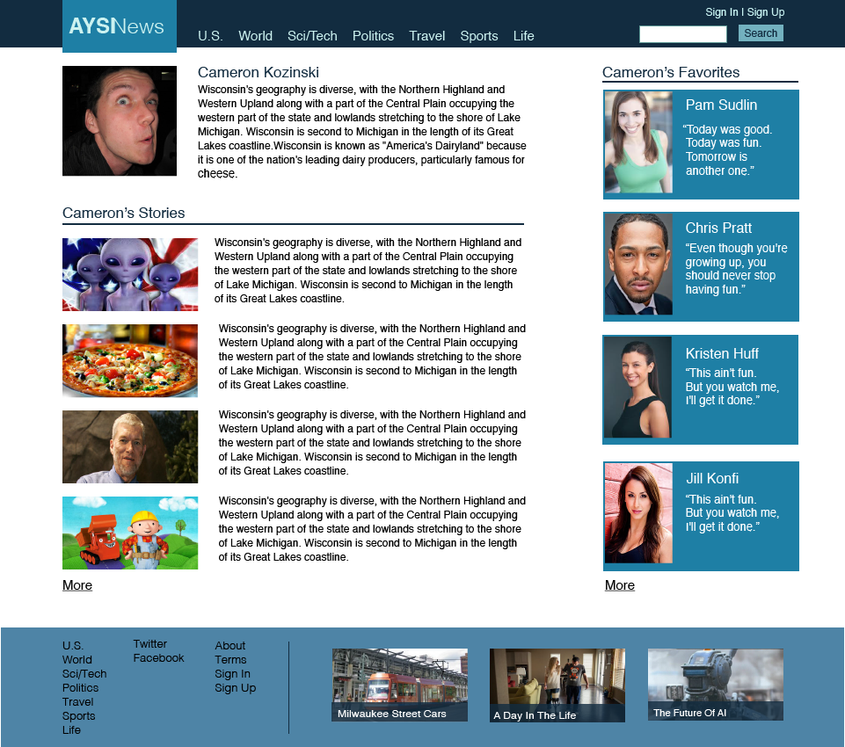

**Design Templates:**

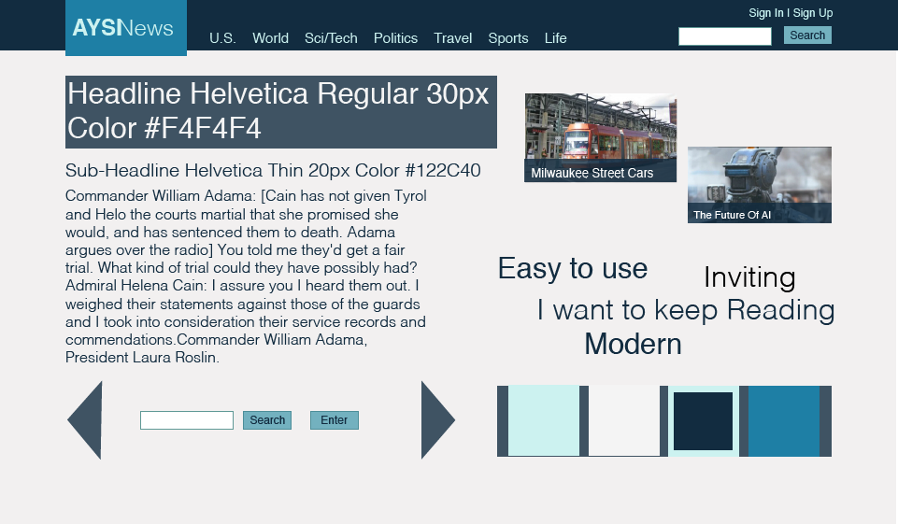

**Database Diagram:**

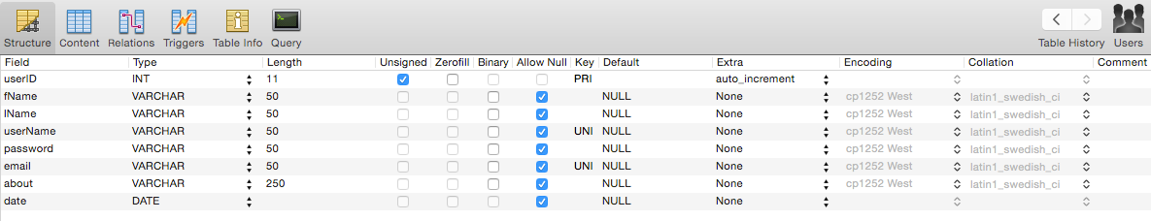

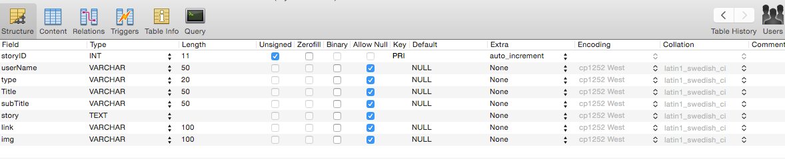

**Language and framework:**

I will be using Codeigniter and PHP for this website. I decided to continue working with PHP mostly as a result of it being the Sever Side language that I have had the most experience with. I decided to use Codeigniter for its lightweight seemingly easy use set up, and the massive amount of documentation and videos I have been able to find.

**Version one:**

At the end of four weeks this should be a fully functional site with…

Create a profile

Create, edit, and delete stories

Comment on and like stories

Search for stories by type, author, or headline

Favorite other users

and

Edit Profile info

**Version two:**

In the future I would like to add better a better search system, the ability to send other users messages, and add more customization to stories.