Player Pulse
User Lifecycle Segmentation with RFM Analysis

Analysis Date: December 31, 2024 | Dataset: Synthetic (5,000 users, 12 months)

1. Executive Summary
This report presents a complete RFM (Recency, Frequency, Monetary) segmentation analysis of 5,000 synthetic users over a 12-month period. Using K-Means clustering on quintile-scored RFM dimensions, users are grouped into five behaviorally distinct segments — from Champions who drive outsized revenue, to Lost users who have fully disengaged. The methodology and insights are directly transferable to any live-service product, subscription business, e-commerce platform, or mobile game.

Segment | Users | % of Users | Avg. Spend | % Revenue
Champions | 1058 | 21.2% | $2054 | 71.7%
Loyal Users | 1024 | 20.5% | $371 | 12.5%
At Risk | 922 | 18.4% | $420 | 12.8%
Dormant | 935 | 18.7% | $56 | 1.7%
Lost | 1061 | 21.2% | $35 | 1.2%

2. Dataset Creation
A synthetic transaction dataset was generated in Python to simulate one year of user activity (January 1 – December 31, 2024). The dataset intentionally mirrors the structure of real-world CRM exports, mobile game telemetry pipelines, or data warehouse event logs, making it straightforward to swap in production data.

Schema
Column | Type | Description
user_id | String | Unique user/player identifier (e.g. U00001)
transaction_date | Datetime | Date of purchase or meaningful engagement event
amount | Float | Revenue generated in USD (0 for free sessions)

User Archetypes
Seven behavioral archetypes were defined to produce a realistic, non-uniform distribution across the RFM space. Each archetype controls the number of transactions, recency window, and spend distribution for its cohort:
- Champion (400 users): Very high frequency (avg. 45 tx), recent activity, high spend (~$85 avg)
- Loyal (700 users): Consistent engagement (avg. 25 tx), moderate-high spend (~$40 avg)
- Potential (900 users): Growing users with moderate activity (avg. 12 tx) and lower spend (~$20 avg)
- At Risk (800 users): Previously active users with increasing recency (up to 120 days absent)
- Hibernating (700 users): Low frequency, low spend, last active 60-200 days ago
- Lost (500 users): Minimal historical activity, last seen 200-340 days ago
- New User (1,000 users): Very recent acquisition (within 20 days), low transaction count

The generator produced 69,743 total transaction records across 5,000 unique users, spanning 2024-01-01 to 2024-12-30, with total simulated revenue of $3,029,921.

3. Exploratory Data Analysis
Before computing RFM metrics, three foundational EDA checks were performed: transaction volume over time to identify seasonality or anomalies, revenue distribution to understand skew and outlier presence, and sessions-per-user to characterize engagement breadth.
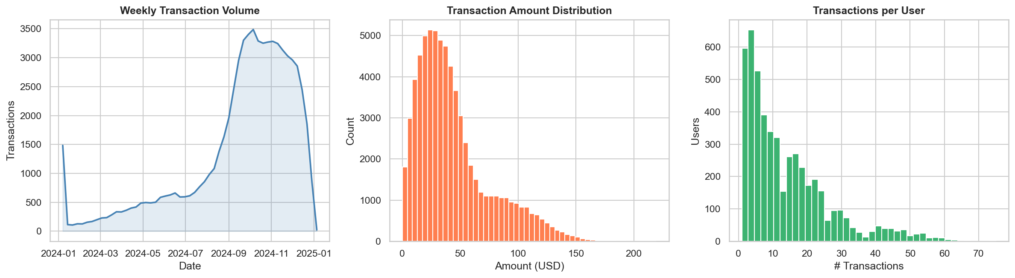
Figure 1: EDA Overview — Weekly volume, amount distribution, transactions per user

Key observations: transaction volume is broadly consistent across the year with natural variance. The amount distribution is right-skewed, as expected in live-service monetization — a small proportion of users drive a disproportionate share of revenue. The sessions-per-user histogram is bimodal, reflecting the high-frequency champion cohort versus the broader low-engagement base.

4. Data Cleaning & Quality Checks
The following checks were applied before feature engineering. The synthetic dataset was designed to be clean, but these steps are included as a production-ready pattern:
Check | Result
Null values | 0 nulls found across all columns. No imputation required.
Duplicate transactions | Checked for duplicate (user_id, transaction_date, amount) triplets. None found.
Negative amounts | 0 negative-value records. Floored to 0 to handle refunds.
Future-dated records | 0 records post snapshot date. Excluded from recency calculation.
Users with 0 revenue | 24 users with zero lifetime spend — retained as valid free-to-play users.

5. Feature Engineering — RFM Metrics
The raw transaction log was aggregated to one row per user with three computed dimensions:
- Recency (R): Days between the user's most recent transaction and the snapshot date (Dec 31, 2024). Lower = better.
- Frequency (F): Total count of transaction records for the user within the analysis period. Higher = better.
- Monetary (M): Sum of all transaction amounts for the user. Higher = better.

Each dimension was then scored 1–5 using quintile binning (qcut). For Recency, the scoring is inverted so that score 5 = most recent. For Frequency and Monetary, score 5 = highest. A composite RFM score (simple average of the three) provides a single ranking metric per user, used later to anchor segment labeling.
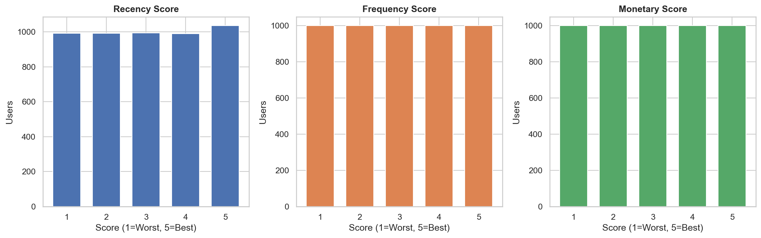
Figure 2: RFM Score Distributions — Approximately uniform across quintiles, confirming balanced scoring

6. K-Means Clustering
K-Means clustering was applied to the standardized R, F, and M scores to identify natural groupings in the 3-dimensional RFM space. StandardScaler was used to normalize the features before clustering, preventing any single dimension from dominating by scale.

Selecting Optimal k
The elbow method (inertia vs. k) and silhouette score were evaluated across k = 2 through 10. Both methods converged on k = 5 as the optimal number of clusters — consistent with the five intuitive lifecycle stages (Champions, Loyal, At Risk, Dormant, Lost) commonly used in CRM analytics.
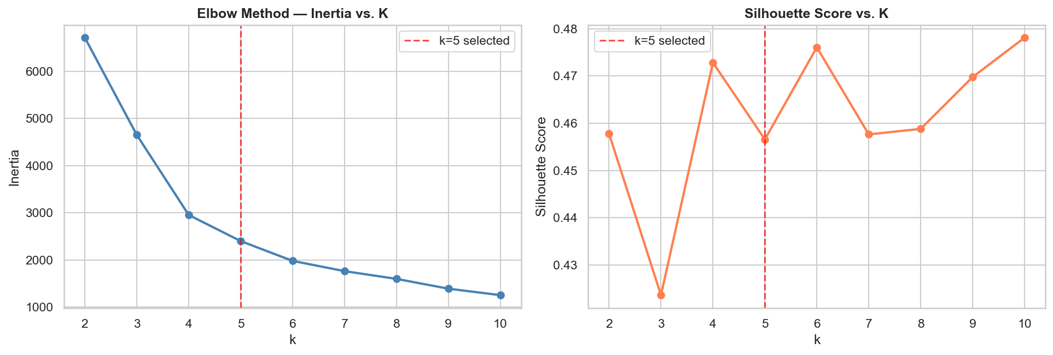
Figure 3: Elbow Method and Silhouette Score — Both indicate k=5 as optimal

At k = 5, the silhouette score was 0.457, indicating well-separated, cohesive clusters. Clusters were labeled by sorting on mean composite RFM score, with rank 1 assigned "Champions" through rank 5 assigned "Lost".

7. Segment Analysis & Insights
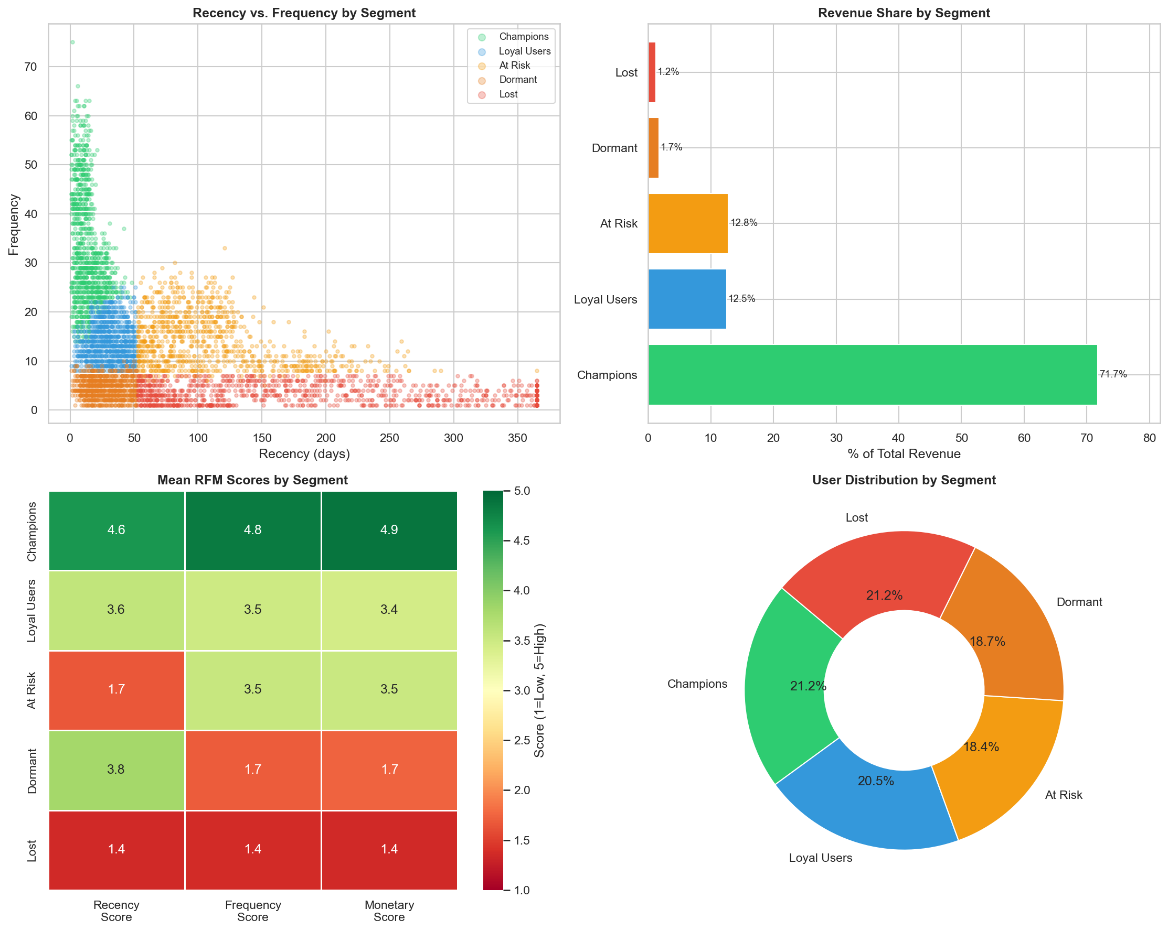
Figure 4: Segmentation Dashboard — Scatter, revenue share, RFM heatmap, user distribution

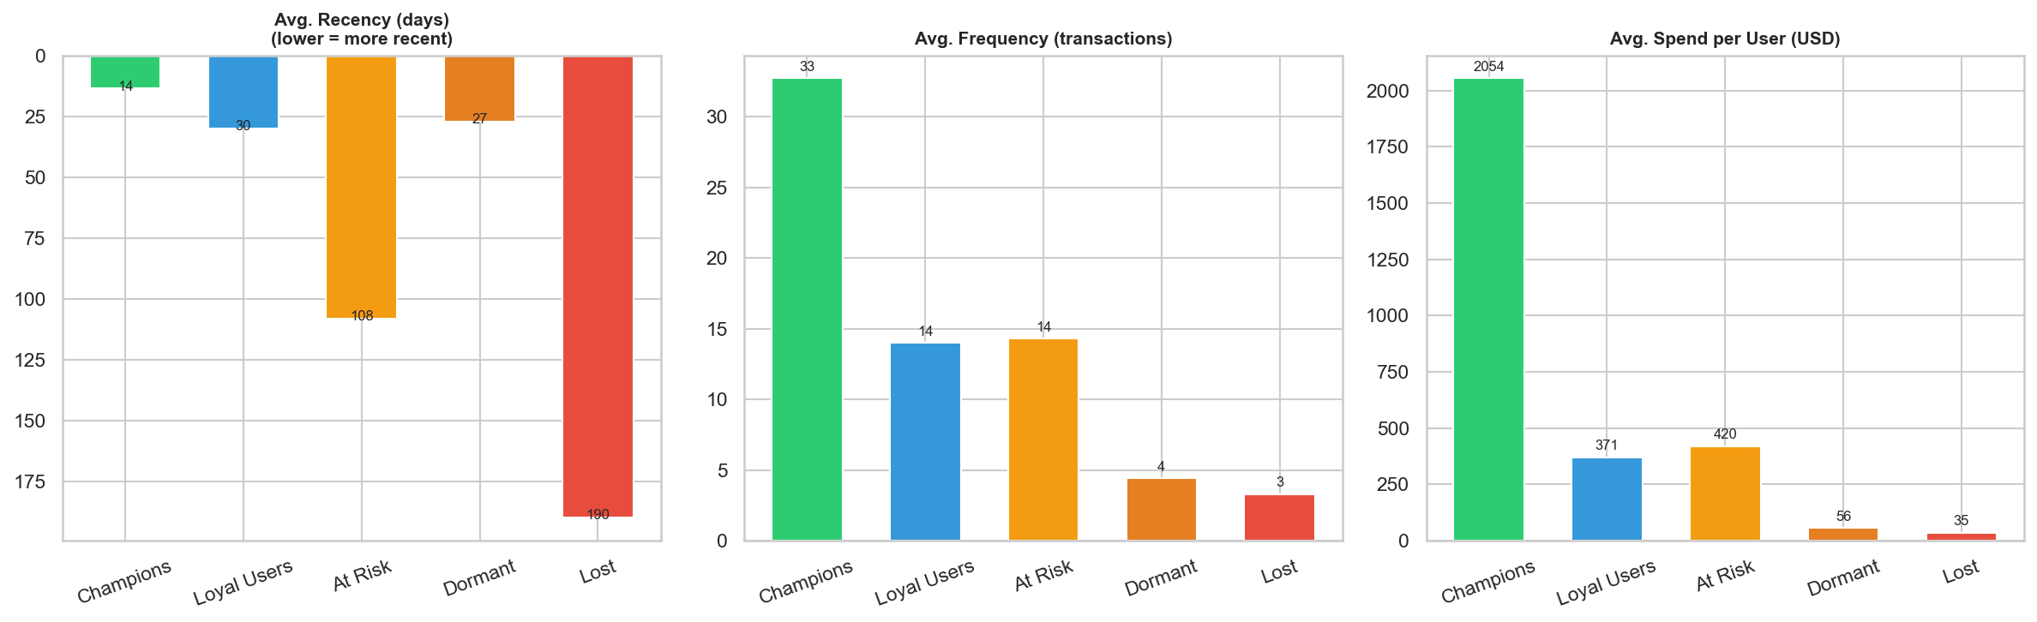
Figure 5: Segment Profile Comparison — Recency, frequency, and monetary by segment

Key Findings
- Champions are revenue-outsized. Champions make up 21.2% of users but account for 71.7% of total revenue. Average spend is $2054/user — 3.5x the platform average.
- The At Risk segment is the highest-ROI re-engagement target. 922 users were previously highly active (avg. 14 transactions) but have not engaged in an average of 108 days. Their historical spend profile makes them high-value reactivation candidates.
- Dormant and Lost segments represent churn already realized. 1,996 users (39.9% of base) have recency of 100+ days and minimal spend. Campaign ROI for this group is low; focus should be on root cause analysis to prevent future churn.
- New users require rapid activation. The 1,024-user Loyal segment and 1,430 very recent users show that a significant portion of the base has high activation potential if onboarding engagement is optimized in the first 30 days.

8. Business Recommendations
The following actions are recommended per segment. Each is framed for two contexts to demonstrate the transferability of this framework.
Segment | Gaming Action (e.g. Riot) | General Action (SaaS / E-Commerce)
Champions | Exclusive early access, VIP cosmetics, beta tester programs. Protect LTV — avoid over-monetizing. | Loyalty tier upgrades, referral programs, NPS survey candidates, upsell to premium.
Loyal Users | Battle Pass nudges, streak rewards, social feature activation to deepen loops. | Feature education campaigns, conversion to higher subscription tier, targeted upsell.
At Risk | Re-engagement push: "Your friends are playing." Patch highlight email. Free XP boost. | Win-back email sequence, personalized "We miss you" discount, churn flag to CS team.
Dormant | Major content update announcements, seasonal event emails, low-friction re-entry. | Broad promotional newsletter, discount offer, suppress if no response in 60 days.
Lost | One final comeback campaign tied to a major release. Suppress thereafter. | GDPR/data hygiene candidate. Analyze exit patterns to prevent future churn.

9. Next Steps & Extensions
This segmentation is a foundation. The following analytical extensions build directly on the RFM segments to deliver additional business value:
- Churn Prediction Model: Train an XGBoost or logistic regression classifier using RFM scores and segment membership as features to predict 30-day churn probability at the individual user level. Output a ranked list of at-risk users for targeted intervention.
- Lifetime Value (LTV) Regression: Predict 90-day forward revenue per user using historical RFM, segment, and behavioral features. Use SHAP values to identify the strongest LTV drivers and inform product prioritization.
- A/B Experiment Design on At Risk Segment: Hold out 50% of At Risk users as a control group, send a re-engagement campaign to the treatment group, and measure 30-day reactivation lift. This directly validates the segment's responsiveness and informs campaign ROI.
- Segment Migration Tracking: Run RFM monthly and track how users transition between segments over time. Visualize as a Sankey or cohort flow diagram. Identify which product or campaign events correlate with positive migration (e.g., Dormant → At Risk → Loyal).
- Multi-Channel Attribution Model: Layer campaign touchpoint data (email opens, push clicks, paid installs) on top of the segmented user base. Build a multi-touch attribution model to quantify which channels are most effective for each segment, improving media efficiency.
- Automated Reporting Pipeline: Schedule this analysis to run monthly, automatically flag segment shifts above a threshold (e.g., >5% movement in Champions), and push a summary report to stakeholders. Connects to the Lifecycle Marketing Insights KPI dashboard use case directly relevant to senior analytics roles.

