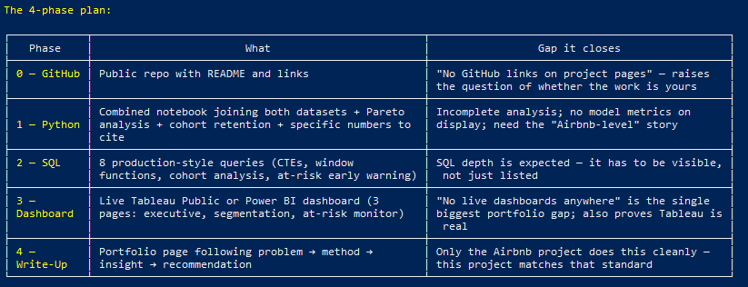

1. Data Collection
The transaction dataset contains synthetic data for 5,000 users across 2025, designed to reflect realistic spending distribution patterns — from low-frequency casual buyers to high-LTV power users — mirroring the spending skew typically seen in free-to-play game economies
1. EDA
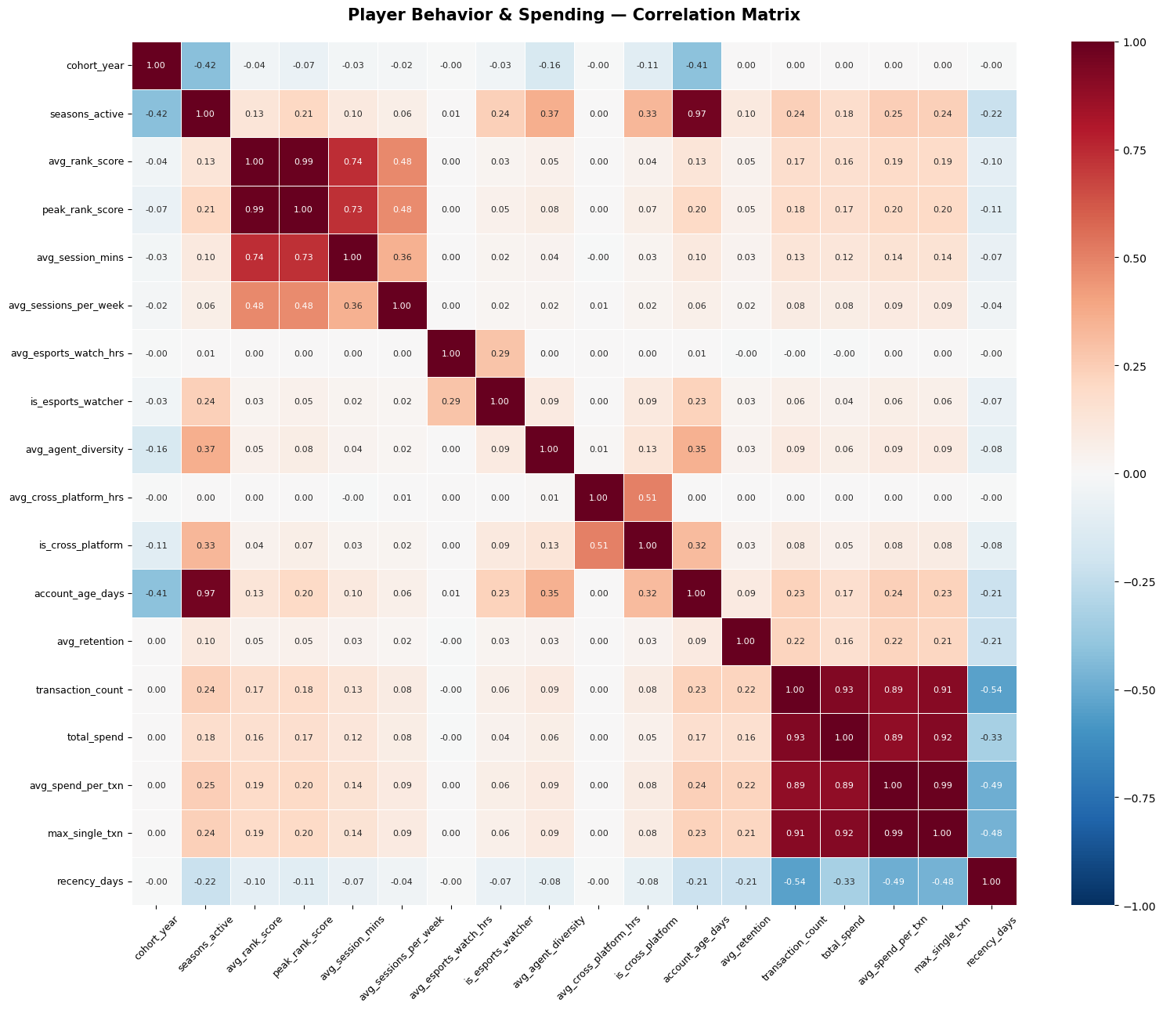
A heat map was run to see the correlation between all factors in the data set.

Initial Impression:
Positive
- the transaction variables are correlated with retention and account age
- Agent diversity is correlated with seasons active
- Esports watcher is correlated with seasons active,average sessions per week, age of account
- Cross platform correlated to season active and account age
Negative
- Cohort and seasons active
- Cohort and account age
- Transaction and recency

On your positive findings
The transaction variables correlating with retention and account age makes intuitive sense — players who spend money have more skin in the game and stick around longer. The SQL question worth asking is which came first: do they spend because they're already retained, or does spending cause retention? You can get at this by looking at whether first transaction date predicts retention in the seasons that follow.
The esports watcher correlation with sessions per week is expected and not that interesting — people who watch esports probably play more. The more interesting angle is whether esports watchers have higher spend despite similar session times, which would suggest marketing through esports content has ROI.
Agent diversity correlating with seasons active is genuinely interesting and non-obvious. It suggests players who experiment with more agents are more engaged long-term — possibly because they're still discovering the game rather than having hit their ceiling. That's a real business insight worth quantifying in SQL.
On your negative findings
The cohort/seasons active and cohort/account age negatives are both expected by construction — players who joined in 2021 have had more time to accumulate seasons and account age than players who joined in 2024. Be careful not to present these as real insights, a hiring manager would flag that immediately.
The transaction/recency negative is the most valuable one on the board. High spenders have lower recency days, meaning they purchased more recently. That's your churn risk signal — players with high recency days (haven't bought in a long time) who previously had high spend are your at-risk revenue.
The one correlation you didn't mention that I'd look at
avg_rank_score and avg_session_mins at 0.74 — higher ranked players play significantly longer sessions. Combined with the moderate spend correlation, this suggests rank progression and session depth together are stronger spend predictors than either alone. A SQL query bucketing players by both rank tier and session length could surface a high-value segment that isn't obvious from spend data alone.

-- Q1: Does early spending predict future retention?
-- Heatmap signal: transaction variables correlated with retention & account age
-- Business question: Do players who spend in their first season retain better
-- in the seasons that follow?

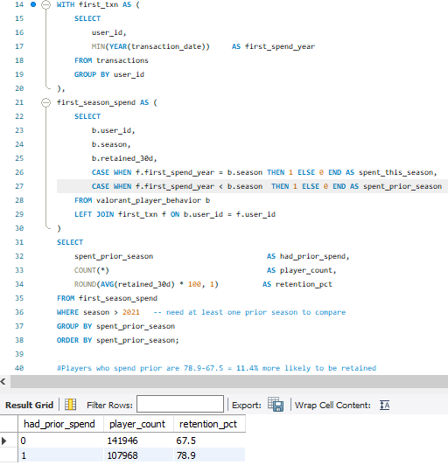
If you spend, you are more likely to be retained as a customer. A retained customer is defined as a player who was active in more than one season.

-- Q2: Do esports watchers spend more despite similar session times?
-- Heatmap signal: is_esports_watcher correlated with seasons_active but
-- esports_watch_hrs shows near-zero spend correlation
-- Business question: Is watching esports a spend signal, or just an
-- engagement signal?

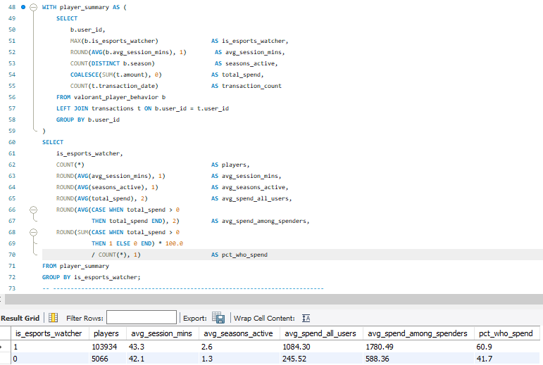
This shows that if you are an esports viewer, you are about twice as active and are about 19.2% more likely to spend(60.9-41.7=19.2). The increase in spend could also be attributed to the increased amount of season activity.

Q2b: Esports watchers — spend per season (controls for longevity)
-- Business question: Do watchers spend more per season, or just because
-- they stick around longer?
-- This version divides spend by seasons_active so both groups are compared
-- on a level playing field regardless of how long they've been active.
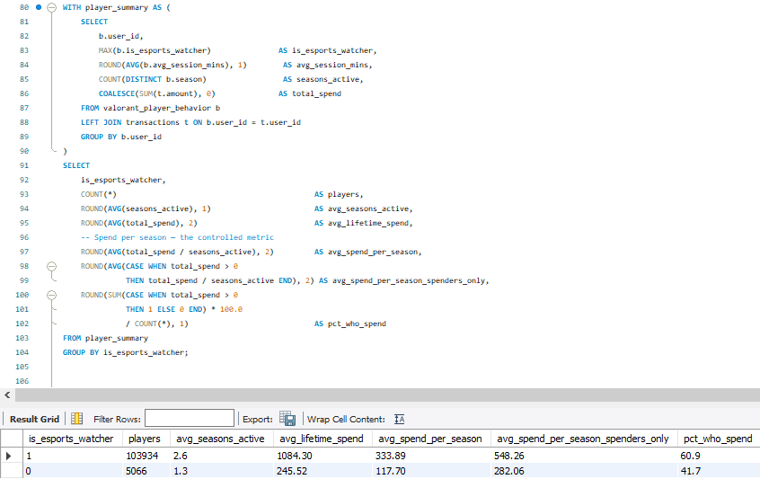
Upon further inspection, there is a significant difference in the average life time spent too, meaning it doesn’t necessarily have anything to do with the lifespan of the user. However, something to take into account for model development later is the class imbalance.

-- Q3: Does agent diversity predict long-term engagement?
-- Heatmap signal: avg_agent_diversity correlated with seasons_active (0.37)
-- Business question: Do players who experiment with more agents stay longer,
-- and does this hold across rank tiers?

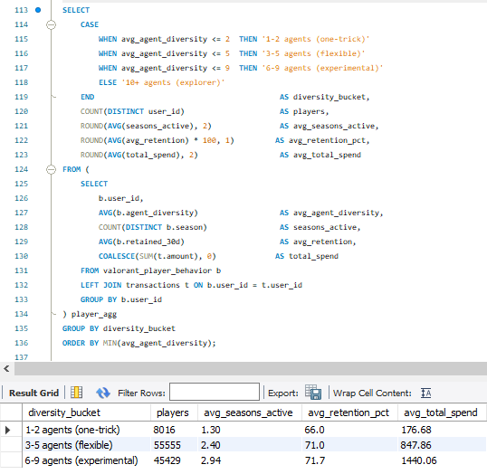
The “one trick” type of players tend to burn out more quickly and also tend to spend a lot less. Most players play 3 or more agents, but for those who don’t this could be a segment to target to keep engaged. Could look at why they only play 1-2 agents and see if they can mimic their other game League of Legends where there are bans, forcing people to play other agents than the ones they are used to.

Q4: Who are the at-risk high-value players?
-- Heatmap signal: recency_days negatively correlated with all spend metrics
-- Business question: Which previously high-spending players haven't purchased
-- recently — and how much revenue is at risk?

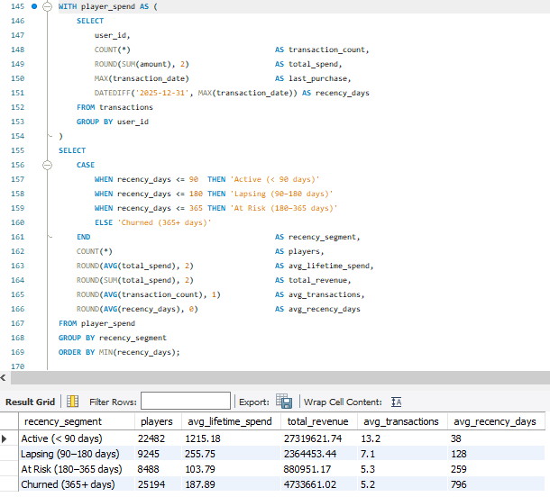
Of the players that spend, active players spend much more on average. So the goal should be to turn Churned players into Active players. That being said, the average number of transactions for Churned players is about 5. This number isn’t necessarily small, but what it could relate to are the number of weapons in the game that are mainly used(Phantom/Vandal, Operator, judge/bucky, ghost/sheriff/classic). So, by adding more weapons that are part of the main strategic meta(strongest guns in the game), we could potentially convert those players from churned to active or lapsing. Another avenue worth looking at is art styles of the cosmetics getting purchased. However, since art is subjective, Riot would need to introduce a new type of animation style or interactive feature.

-- Q5: Does rank + session depth together predict spend better than either alone?
-- Heatmap signal: avg_rank_score ↔ avg_session_mins (0.74), both moderately
-- correlated with spend
-- Business question: Is there a high-value segment defined by BOTH high rank
-- AND long sessions that outspends all other combinations?
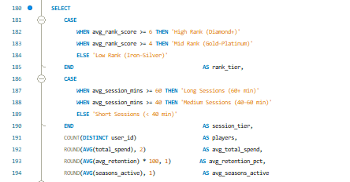
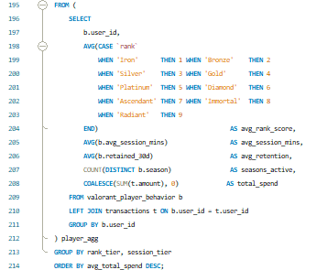
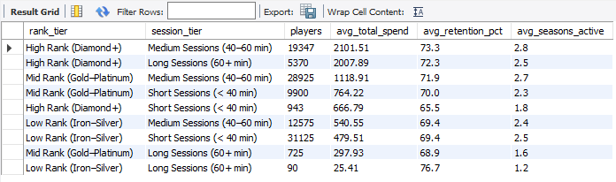
In terms of retention, the only slightly noticeable dip is for High rank and short sessions, these are probably players that came over from another FPS(First person shooter) who like valorant but for their main competitive fix, they play something else like Overwatch or Counter Strike Global Offensive.

For average spend, for the most part, players who are higher ranked will spend more. Additionally, something to look at further is that “high rank” players that have medium or long sessions(the players that have invested most time/effort in the game) are the biggest spenders.

Also those with higher active seasons have higher spend besides the “low rank” players whose lower spend can be attributed to caring less about cosmetics and learning the game more before they spend more money.

