1. PASSIVE ACOUSTIC SURVEILLANCE

Passive acoustic surveillance system that we are working on is a TÜBİTAK-2209A project. As its name suggest, we aim to design a acoustic surveillance with 8 MEMS microphone. The microphones are put into circular uniform area and each microphone is responsible for listening a specific direction. The PCB board also includes IMU sensor for navigation, GPS module for marking the board movements onto the map, SD card for backup, LoRa module for wireless comm and other tools for various purposes. I’m responsible for end-to-end software development so that I’m gonna give the software-specific details of this system.

1.1. Libraries

I’ve used many type of library in this project. Also I have designed two custom libraries. I will explain these in separately.

Libraries for embedded firmware:
- CMSIS (Common Microcontroller Software Interface Standard)
- HAL (Hardware Abstraction Layer)
- FreeRTOS Kernel

Libraries for ground station:
- GNU C (for standard POSIX-compatible API)
- SQLite3 (for database integration)
- Shumate (for mapping)
- Cairo (for 2D plotting)
- GTK 4 and Adwaita (for UI and main application)
- GNU GSL (for numeric computations)
- Custom DSP toolkit (will be explain below)
- Custom linear algebra toolkit (will be explain below)

1.1.1. DSP (Digital Signal Processing) Library

I’ve designed a custom DSP library for this project. The main reason of this choice is that passive acoustic surveillance requires some kind of special algorithms like beamforming, direction of arrival or specific filter designs. So this custom library was designed with these considerations.

This library includes the following modules:
- core (for the main time and frequency domain operations)
- filter (for FIR and IIR – based filter designs)
- signal (for common signal generations)
- transform (for time-frequency domain transformations)
- plot (for 2D signal plotting)
- window (for windowing operations)
- beamform (for beamforming operations)
- arrival (for direction/angle of arrival operations)

Each module is grouped with associated prefix like dsp_transform_dft(), dsp_filter_fir_low_pass() or so on. Also each data in any kind of signal is being represented as double and dynamic allocation memory is not being used at all. So that each signal is defined in stack. This is required for deterministic behavior. Figure 1.1. and Figure 1.2. shows the example usage.
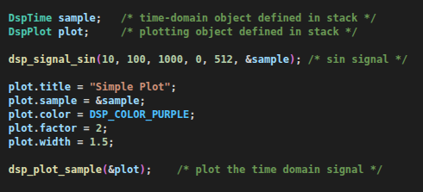

Figure 1.1. Code snippet for plotting sine

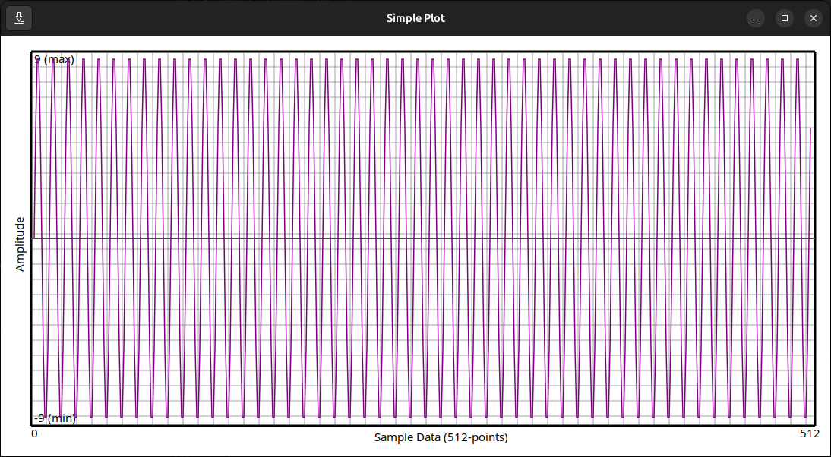
Figure 1.2. Result of the code snippet

This custom library was directly embedded into the ground station codebase. After the microphone outputs are captured from the serial port, the ground station makes required analysis using this custom library.

The project link: https://github.com/CanGulmez/Digital-Signal-Processing

1.1.2. ALAT (Advanced Linear Algebra Toolkit) Library

I’ve wrote this custom linear algebra library independently from passive acoustic surveillance project. But I noticed that this project also requires the numeric computations. After that I’ve included this library into the this project.

As being custom DSP library, each data was defined as double and the library object is being defined in stack. So that this behavior provides determinism also.
This custom library includes the following modules:
- matrices (for matrix operations)
- vectors (for vector operations)
- complexes (for complex-number operations)
- crypts (for encoding/decoding messages)
- apps (for some real-world applications)

This library also includes the GUI script to use the library easily. Figure 1.3 shows an example usage.

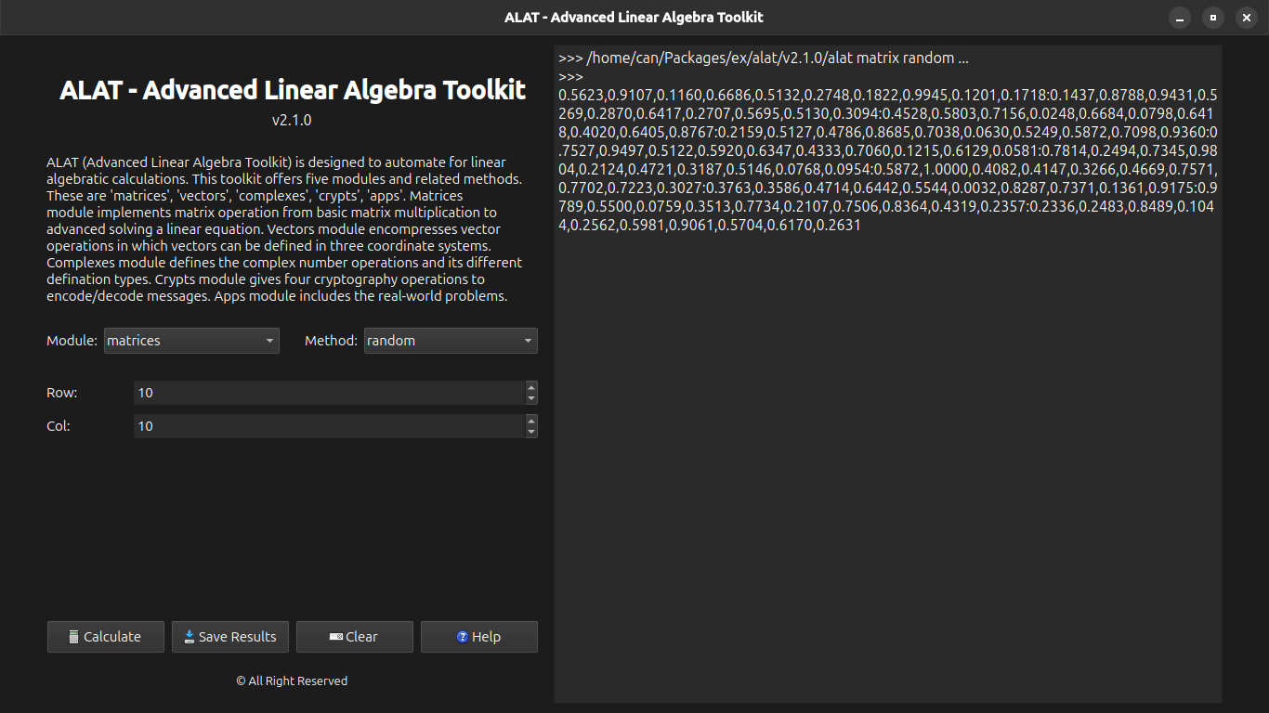
Figure 1.3. Creating a random matrix

This library is not being directly embedded into the ground station. Because it has separate CLI and GUI tools. So it can be thought the complementary program to the main ground station.

The project link: https://github.com/CanGulmez/ALAT

1.2. Embedded Firmware

1.3. Ground Station

1.3.1. Microphone Module

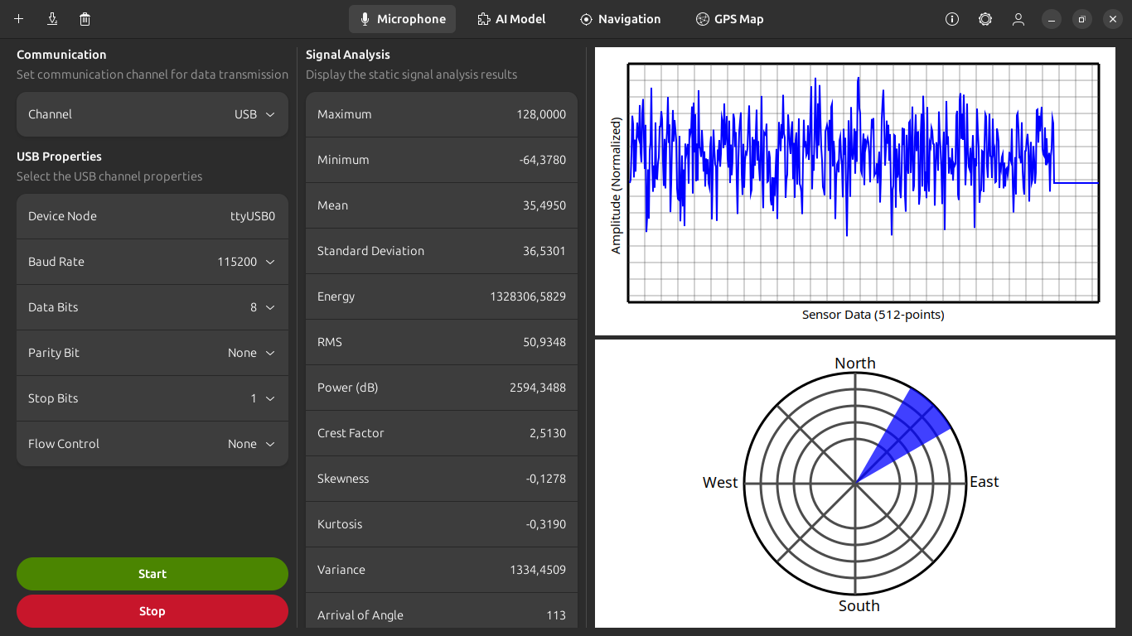

1.3.2. AI Model Module

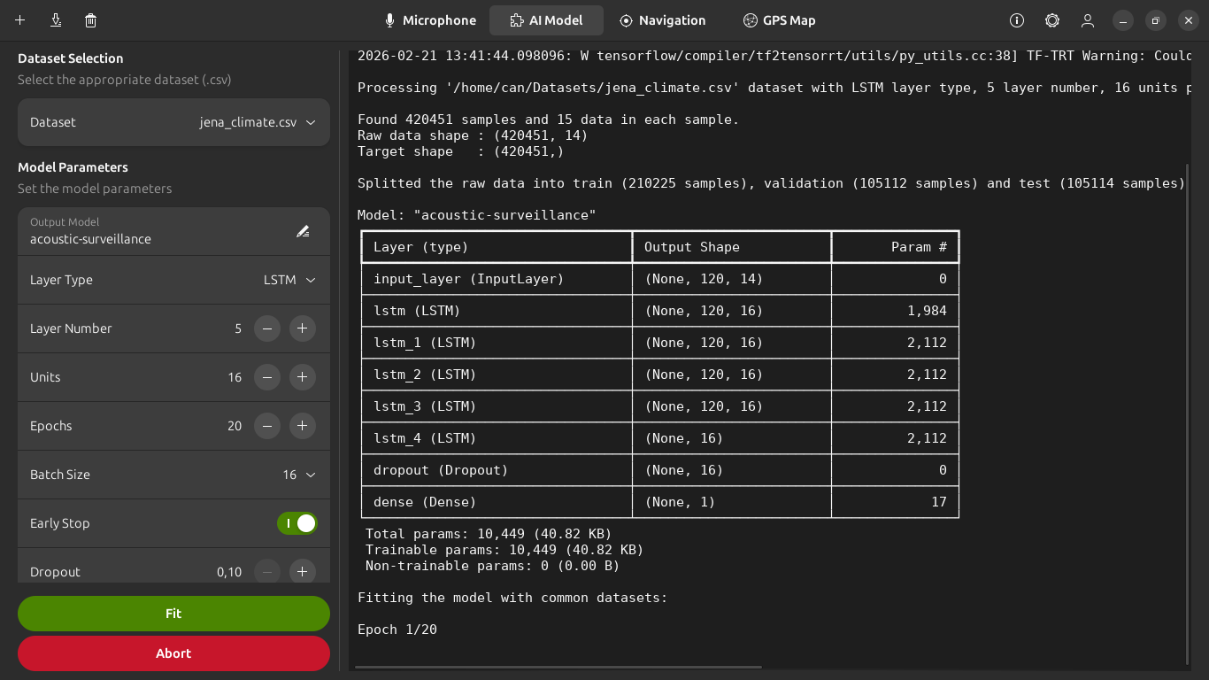

1.3.3. Navigation Module

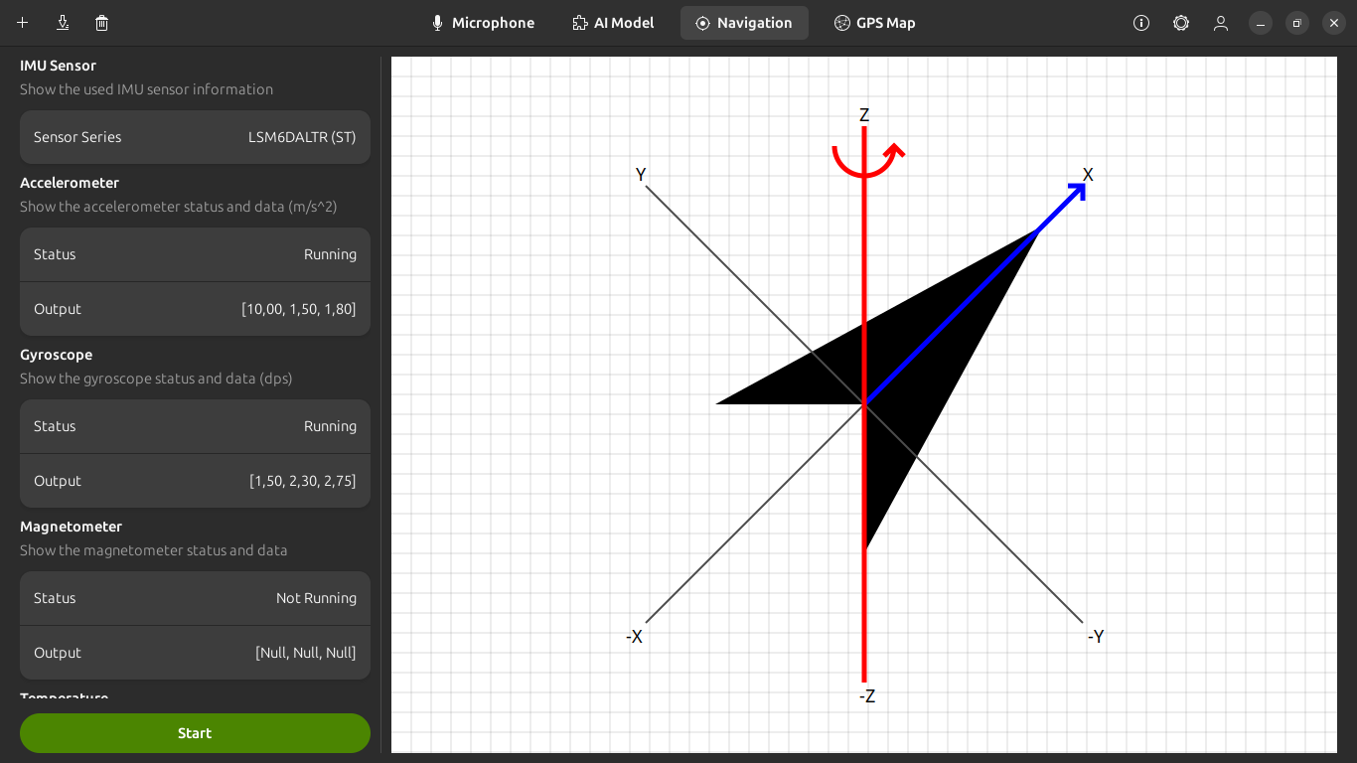

1.3.4. GPS Map Module

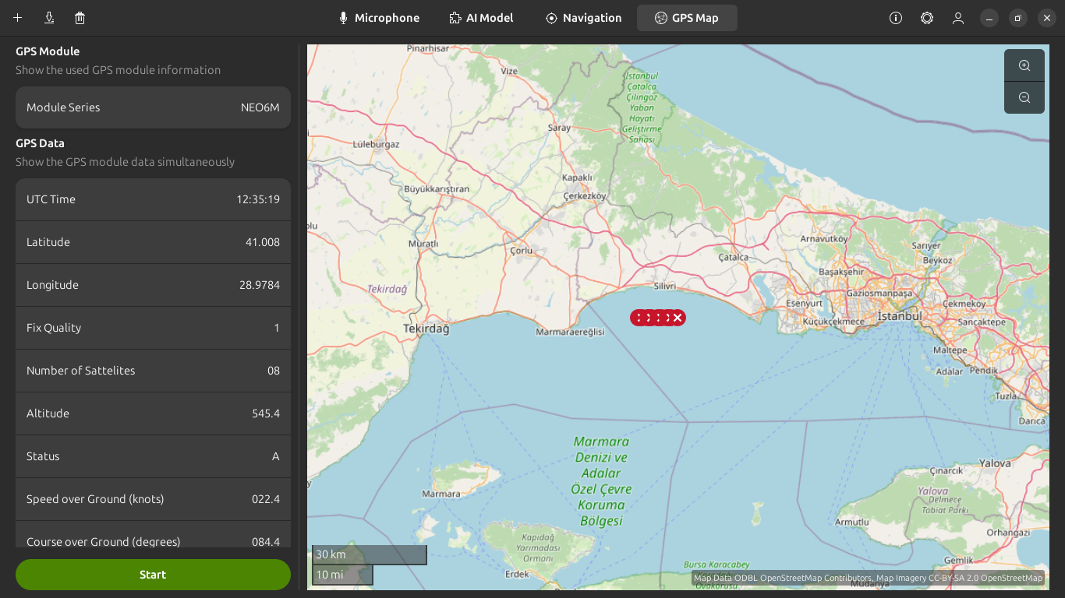

The project link: https://github.com/CanGulmez/Passive-Acoustic-Surveillance

