**TOC EX1**

**EX1B:**

%option noyywrap

%{

#include<stdio.h>

%}

%%

[a-z]*a{3}[a-z]* {

printf("Valid-Accepted");

}

.* {

printf("InValid-Rejected");

}

%%

int main()

{

yylex();

return 0;

}

**OUTPUT:**

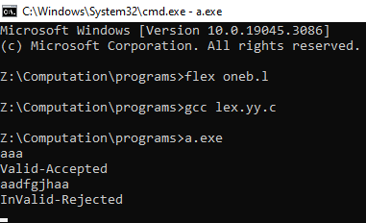

**EX1C:**

%option noyywrap

%{

#include<stdio.h>

int w=0,c=0,l=0;

%}

%%

"" {

w++;

}

\n {

l++;

w++;

}

. {

c++;

}

%%

int main()

{

yyin=fopen("bio.txt","r");

yylex();

printf("word:%d\tlines:%d\tcharacter:%d\t",w,l,c);

return 0;

}

**BIO.TXT:**

This is my first lex program

5

4

3

2

1

lets check the output

**OUTPUT:**

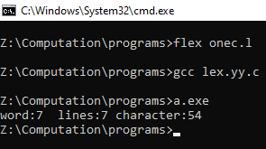

**EX1D:**

%option noyywrap

%{

#include<stdio.h>

%}

%%

[A-Z][a-z]+ {

printf("Valid-Name");

}

[0-9]{10} {

printf("Valid-Mobile Number");

}

[a-z]+@[a-z]+\.[a-z]+ {

printf("Valid-EmailAddress");

}

.* {

printf("InValid-Data");

}

%%

int main()

{

yyin=fopen("input1.txt","r");

yylex();

return 0;

}

**INPUT1.TXT:**

Vishnu

9600311540

[vis@gamil.com](mailto:vis@gamil.com)

**OUTPUT:**

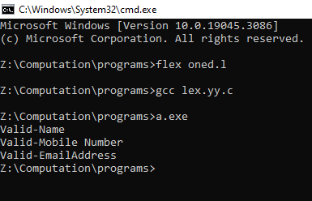

**EX1E:**

%option noyywrap

%{

#include<stdio.h>

%}

%%

"int"|"float"|"return" {

printf("%s-Keyword",yytext);

}

";" {

printf("%s-Special Symbol",yytext);

}

"+"|"=" {

printf("%s-operator",yytext);

}

"("|")"|"{"|"}" {

printf("%s-Bracket",yytext);

}

[a-z]+[0-9]*_* {

printf("%s-Identifier",yytext);

}

[0-9]+ {

printf("%s-constant",yytext);

}

%%

int main()

{

yyin=fopen("input.txt","r");

yylex();

return 0;

}

**INPUT.TXT:**

int add ( )

{

int a = 20 ;

int b = 30 ;

int c = a + b ;

return c ;

}

**OUTPUT:**

