**EX1A:**

#include <stdio.h>

#include <ctype.h>

#include <string.h>

// Function to check if a string is a keyword

int isKeyword(const char *str) {

const char *keywords[] = {"int", "return"};

for (int i = 0; i < sizeof(keywords) / sizeof(keywords[0]); ++i) {

if (strcmp(str, keywords[i]) == 0) {

return 1;

}

}

return 0;

}

// Function to check if a string is an identifier

int isIdentifier(const char *str) {

return isalpha(str[0]) || str[0] == '_';

}

// Function to check if a string is a number

int isNumber(const char *str) {

for (int i = 0; str[i] != '\0'; ++i) {

if (!isdigit(str[i]) && !(i == 0 && str[i] == '-')) {

return 0;

}

}

return 1;

}

// Function to check if a character is an operator

int isOperator(char c) {

const char operators[] = {'=', '+', '-'};

for (int i = 0; i < sizeof(operators) / sizeof(operators[0]); ++i) {

if (c == operators[i]) {

return 1;

}

}

return 0;

}

// Function to check if a character is a delimiter

int isDelimiter(char c) {

const char delimiters[] = {'(', ')', '{', '}', ';'};

for (int i = 0; i < sizeof(delimiters) / sizeof(delimiters[0]); ++i) {

if (c == delimiters[i]) {

return 1;

}

}

return 0;

}

int main() {

FILE *file;

char filename[100];

char token[100];

file = fopen("test.txt", "r");

if (file == NULL) {

printf("Error opening file.\n");

return 1;

}

printf("Tokens in the file:\n");

while (fscanf(file, "%s", token) == 1) {

if (isKeyword(token)) {

printf("%s - Keyword\n", token);

} else if (isIdentifier(token)) {

printf("%s - Identifier\n", token);

} else if (isNumber(token)) {

printf("%s - Constant\n", token);

} else {

// Check each character in the token

for (int i = 0; token[i] != '\0'; ++i) {

if (isOperator(token[i])) {

printf("%c - Operators\n", token[i]);

} else if (isDelimiter(token[i])) {

if (token[i] == ';') {

printf("%c - Delimiter\n", token[i]);  **OUTPUT:**

} else {

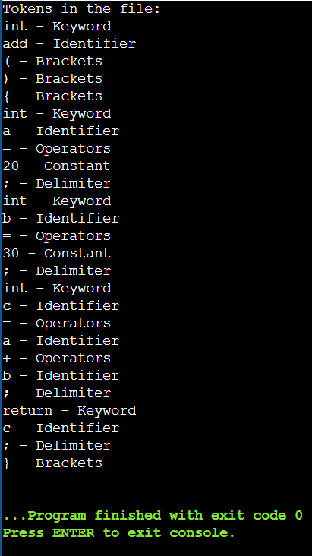 printf("%c - Brackets\n", token[i]);

}

}

}

}

}

fclose(file);

return 0;

}

**TEST.TXT**

int add ( )

{

int a = 20 ;

int b = 30 ;

int c = a + b ;

return c ;

}