Lab1:Understand the SEU campus network
1. Targets：
1.Figure out the meaning of key components of the campus network (2021.7)
2.Have a basic idea about how to construct a real computer network
3.Describe the evolution of campus networks from 2007 to 2021.
2. Campus networks from 2007 to 2021：
SEU campus network topology 2007.10：
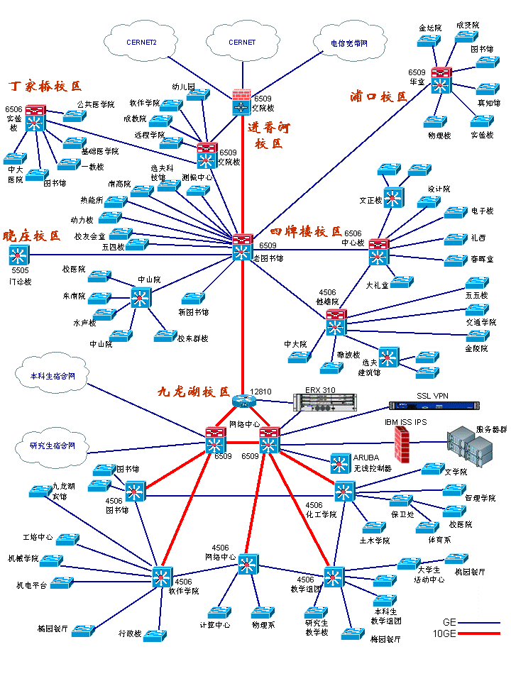

SEU campus network topology 2017.05：
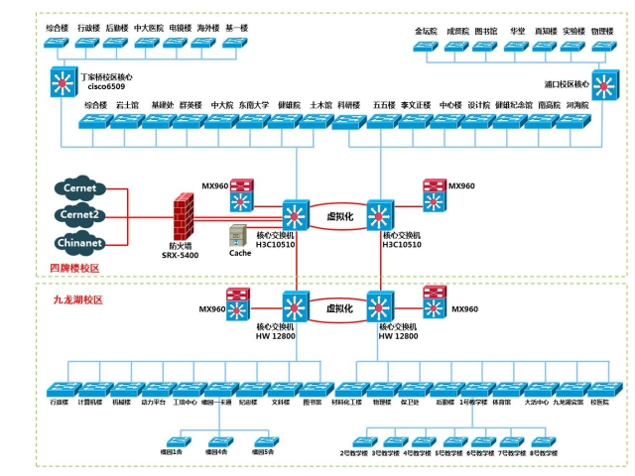
SEU campus network topology 2019.03：
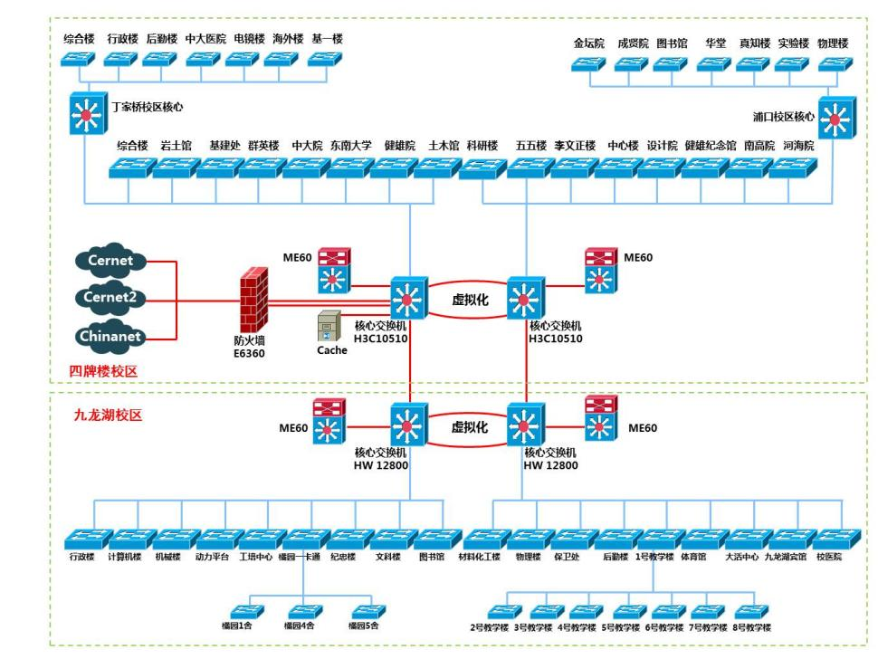

SEU campus network topology 2021.07：
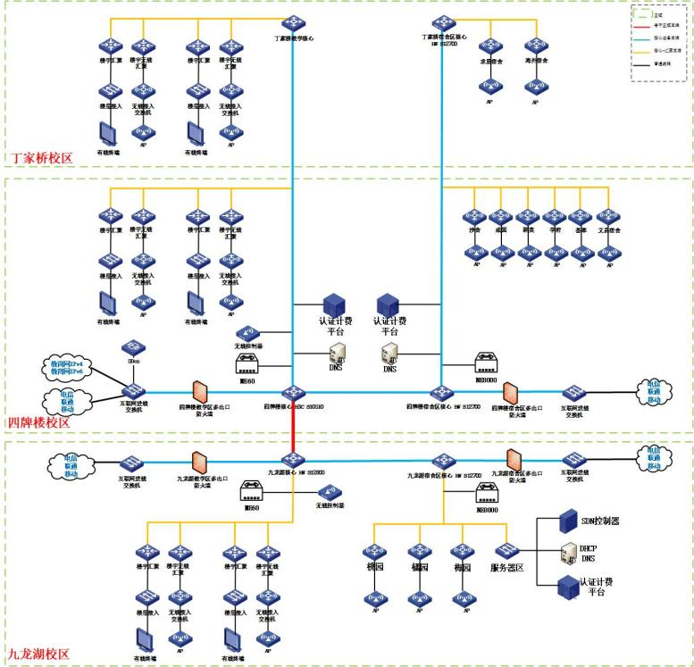
- Key components of the campus network (2021.7)：
The campus network is divided into three parts: Dingjiaqiao Campus, Sipailou Campus, and Jiulonghu Campus. Each campus has its own network structure and is interconnected through core network devices. Here are the key components of the network structure:
Each campus has a similar network structure for its own teaching areas and residence halls. The teaching area uses a dual setup of wired and wireless connections, converging at the building convergence point and entering the teaching core, managed by the H3C S10510 switches. The dormitories are equipped with wireless access aps and are managed by high-capacity Huawei S12700 switches.
Feature | H3C S10510 | Huawei S12700
Manufacturer | H3C (a brand of New H3C Group) | Huawei
Product Position | Core Switch | Core Switch
Network Layer | Layer 3 | Layer 3
Throughput | Up to 1.2Tbps | Up to 1.28Tbps
Performance | High performance with advanced features | High performance with advanced features
Application Scenario | Large enterprises, campus networks, data centers | Large enterprises, campus networks, data centers
For the Sipai Lou teaching area, it also includes the education network IPV4 and IPV6, as well as the Internet access of China Telecom, mobile and Unicom. The network traffic first enters the switch through the Internet, and then is protected by the multi-exit firewall of the Sipai Lou Teaching area. Wireless controllers and ME60 devices manage wireless network access points (aps) and multiple network services. The authentication and accounting platform and DNS server provide user authentication, accounting, and domain name resolution services. Sipai Lou dormitory area is a similar structure.The network structure of the Jiulonghu Lake Campus and Sipai Lou Campus is similar as well.
- The evolution of campus networks from 2007 to 2021：
Compared with the network in 2017, the network in 2007 adopts a layered network structure, including the core layer, convergence layer and access layer. But in 2017, a two-tier structure was adopted. A three-tier network architecture provides greater flexibility, scalability and performance, while a two-tier network architecture is simpler and less costly, and both have benefits. In addition, the network in 2017 mainly uses Huawei equipment and introduces network virtualization technology, which improves device performance, network management and security.
The 2017 network is almost the same as the 2019 network, with only some firewall and routing product changes.
Compared to the 2019 network, the 2021 network has enhanced security measures such as firewalls, as well as added authentication and billing platforms to optimize network management and service billing.

Lab 2: Simulation based network configuration
- Targets：
1.Familiar with Cisco Packet Tracer
2.Familiar with the basic network configuration scenarios
Network design/construction
Router configuration
IP/network configuration
Test network connectivity
Show network configuration/status
Routing (static / RIP)
- Experiments：
2.1 Routing (static)：
2.1.1 Overall result：
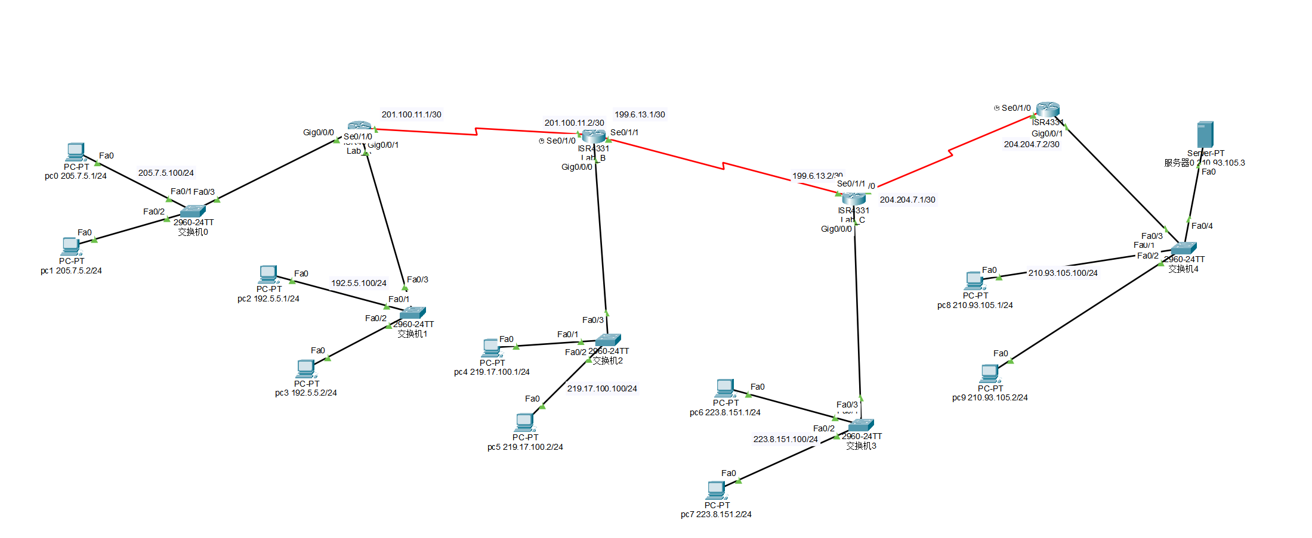
2.1.2 Computer configuration
For easy memorization, each switch is connected to two computers with host numbers set to 1 and 2, the server is set to 3, and the gateway is set to 100, with other hosts similarly configured.
P0,P1:205.7.5.1/24, 205.7.5.2/24 gateway ：205.7.5.100
P2,P3:192.5.5.1/24, 192.5.5.2/24 gateway ：192.5.5.100
P4,P5:219.17.100.1/24, 219.17.100.2/24 gateway ：219.17.100.100
P6,P7:223.8.151.1/24, 223.8.151.2/24 gateway ：223.8.151.100
P8,P9,server0:210.93.105.1/24, 210.93.105.2/24, 210.93.105.3/24 gateway ：210.93.105.100
The following two diagrams are the Settings of P0 and P1:
P0：
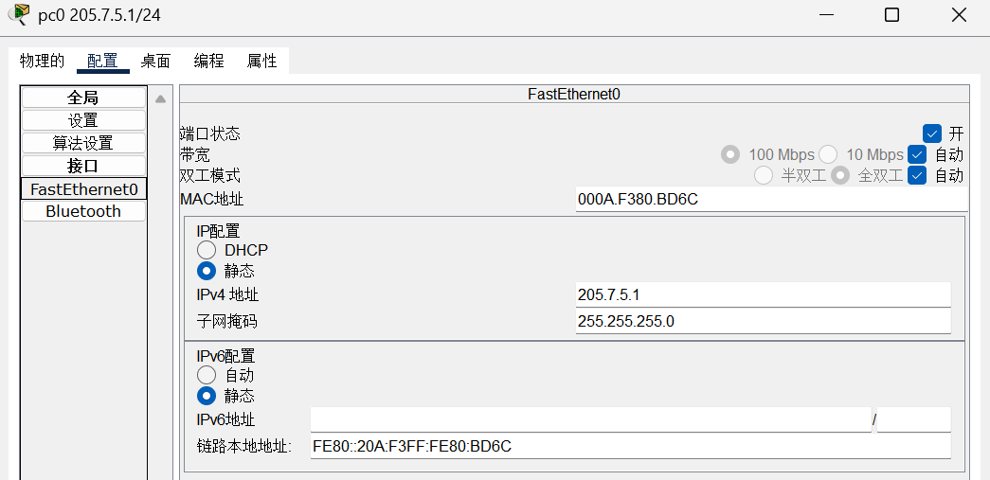
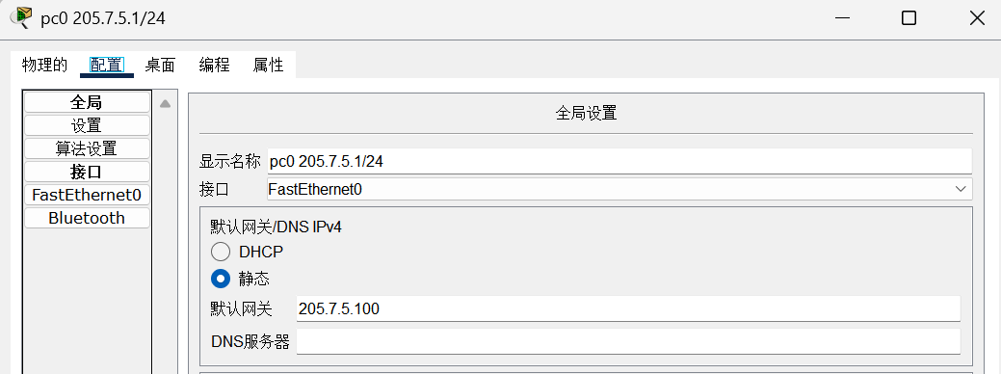
P1：
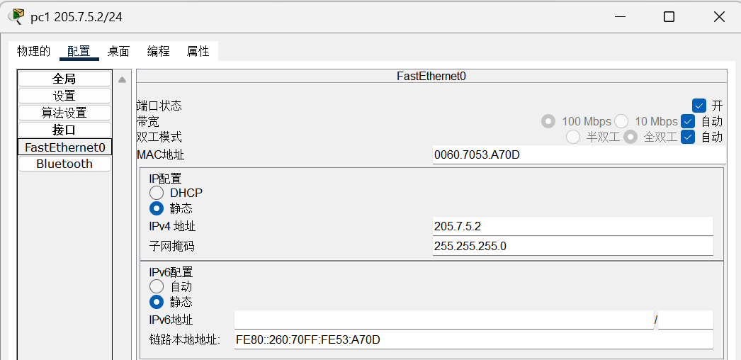
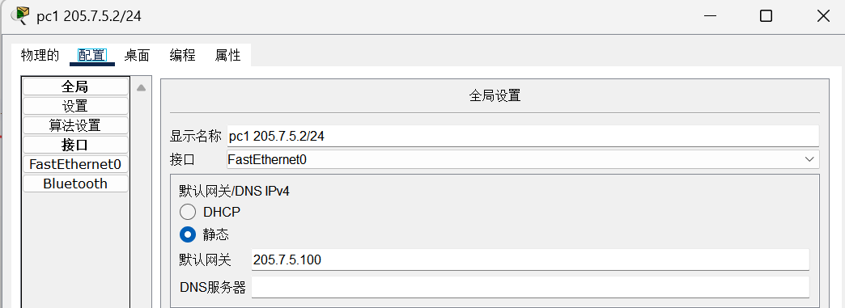
2.1.3 Router configuration
The IP address of the router's end connected to the switch needs to be set to the gateway number of the hosts under the switch. Taking Lab-A as an example, since Lab_1 router has three ports in use, which are connected to Switch 0 and Switch 1, as well as the router in Lab_B: therefore, the three ports are set up as the gateway for Switch 0, the gateway for Switch 1, and the subnet between Lab_A and Lab_B, respectively.
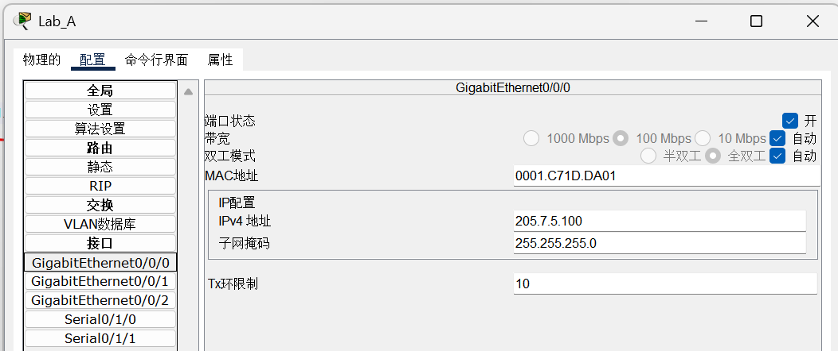
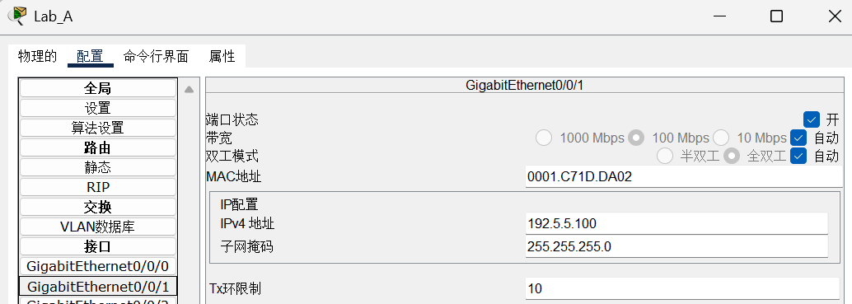
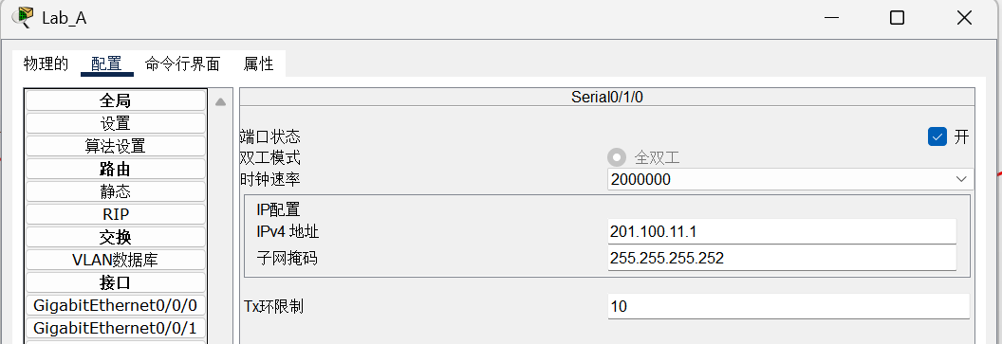
The IP addresses that Lab_A needs to configure for its three ports are:
205.7.5.100/24，192.5.5.100/24，201.100.11.1/32
The IP addresses that Lab_B needs to configure for its three ports are:
219.17.100.100/24，201.100.11.2/32，199.6.13.1/32
The IP addresses that Lab_C needs to configure for its three ports are:
223.8.151.100/24，199.6.13.2/32，204.204.7.1/32
The IP addresses that Lab_D needs to configure for its three ports are:
210.93.105.100/24，204.204.7.2/32
The configurations of the four routers are as follows：
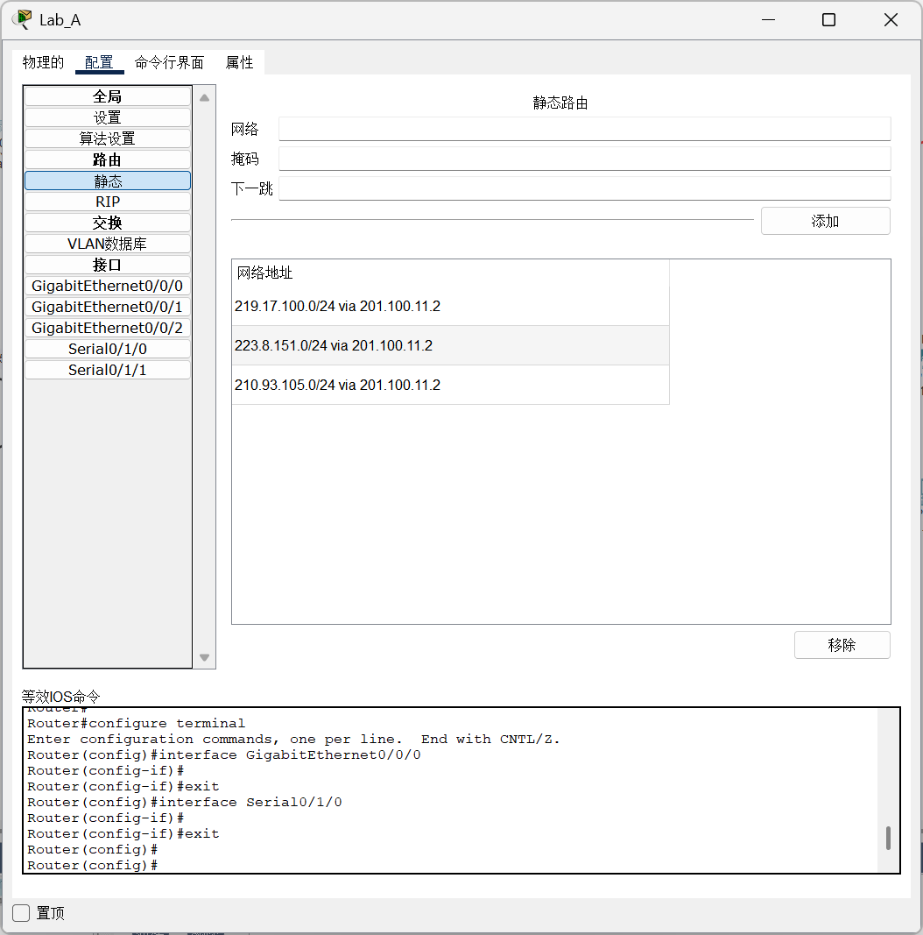
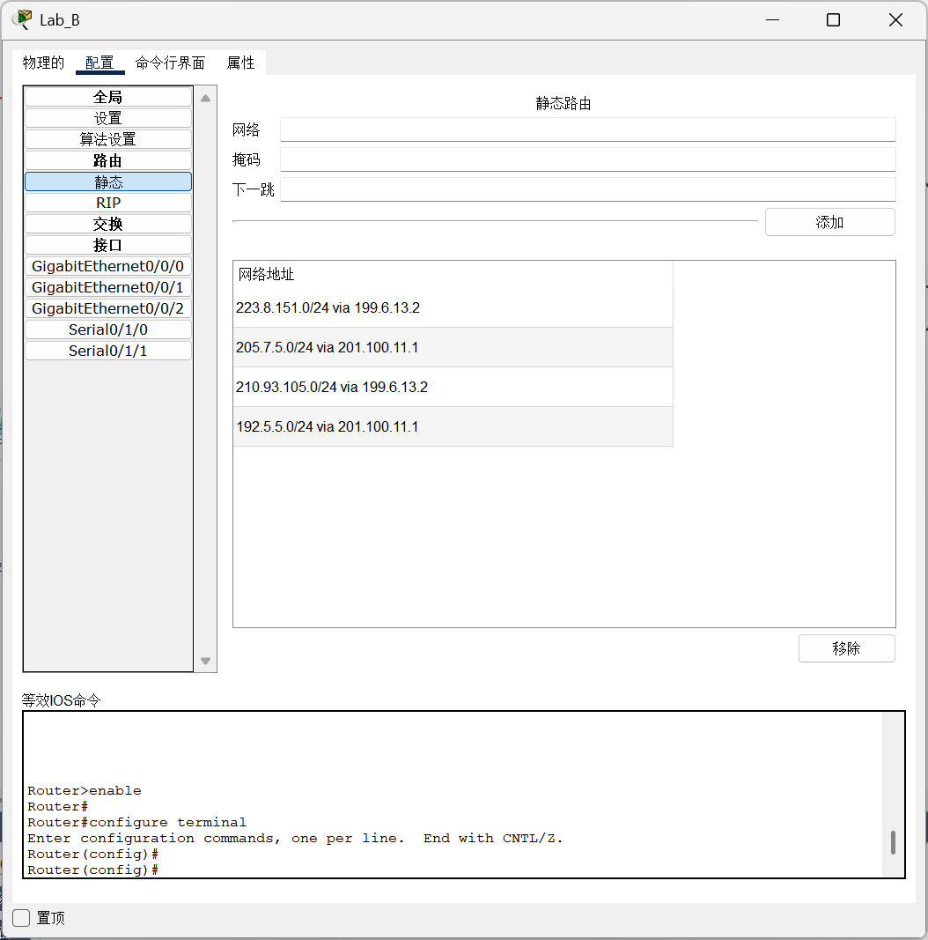
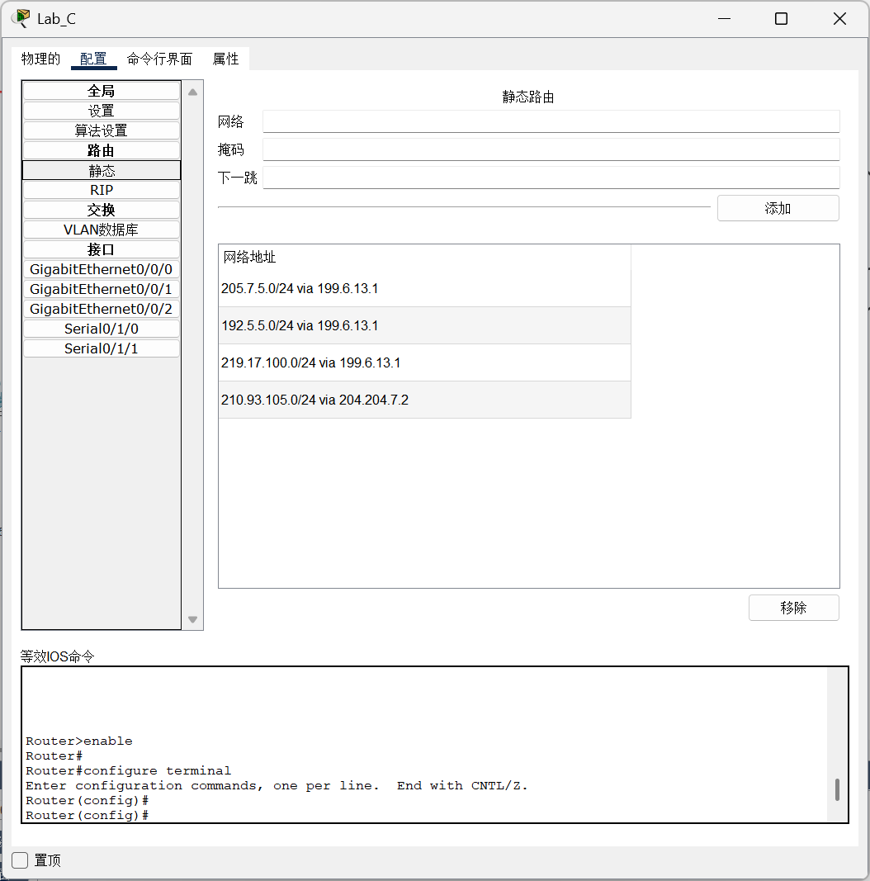
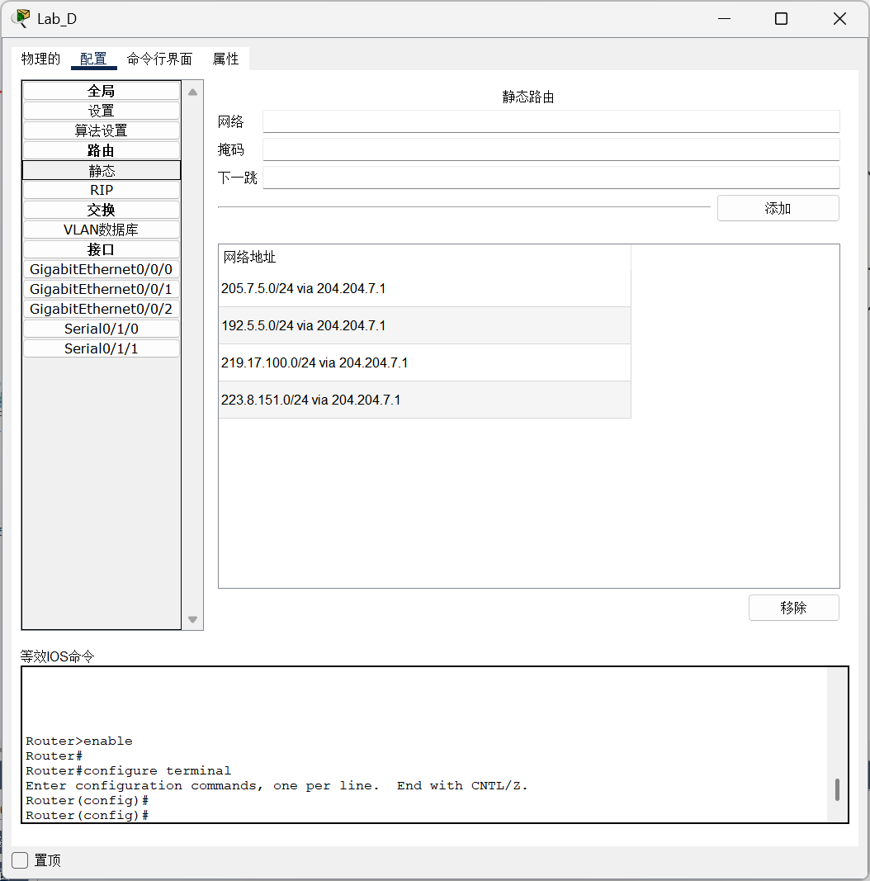
What needs to be recorded are the destination network address, subnet mask, and the IP address of the next hop router.

2.1.4 result：
Use P0 to ping the first host under each switch, which are P2, P4, P6, and P8:
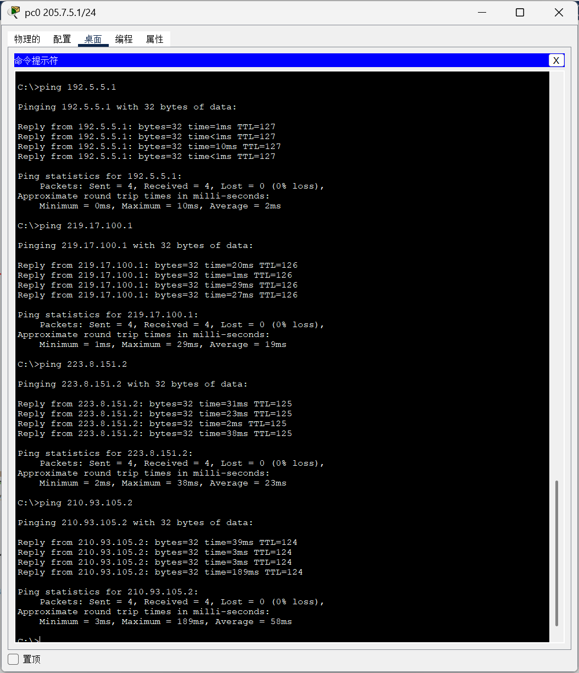

2.2 Routing (RIP)：
When configuring RIP, the process is similar to configuring static routes. I need to delete the static route configurations and then set up RIP route configurations. Since RIP only needs to focus on adjacent networks, the configuration is as follows:
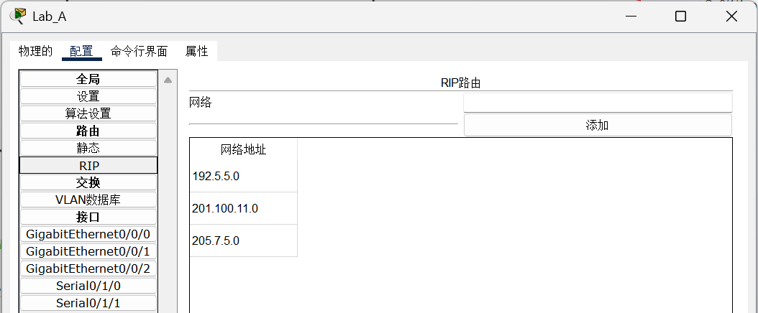
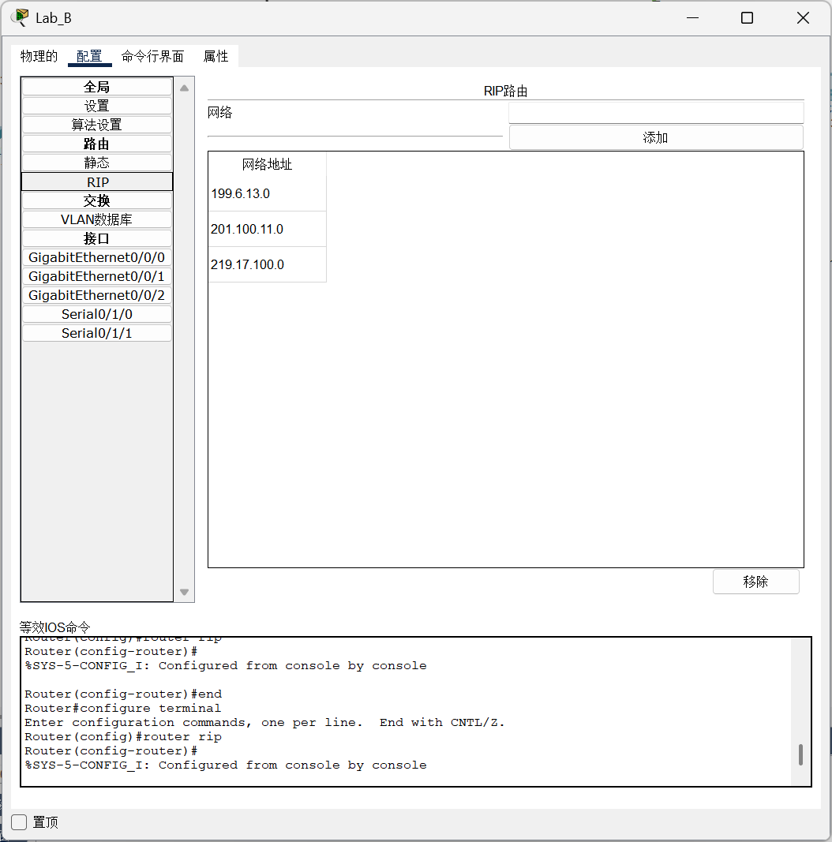
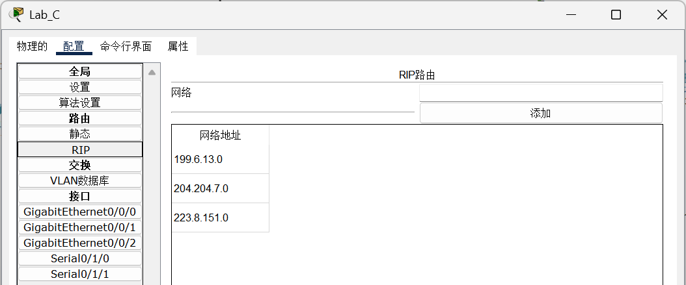
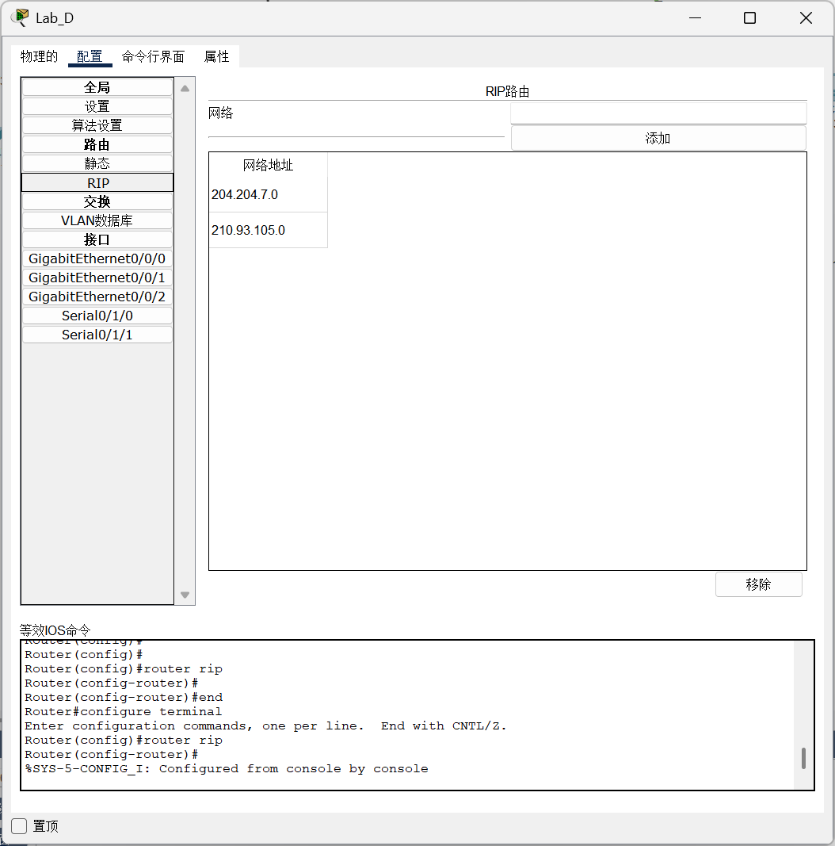
2.2.1 result：
Use P1 to ping the first host under each switch, which are P3, P5, P7, and P9：
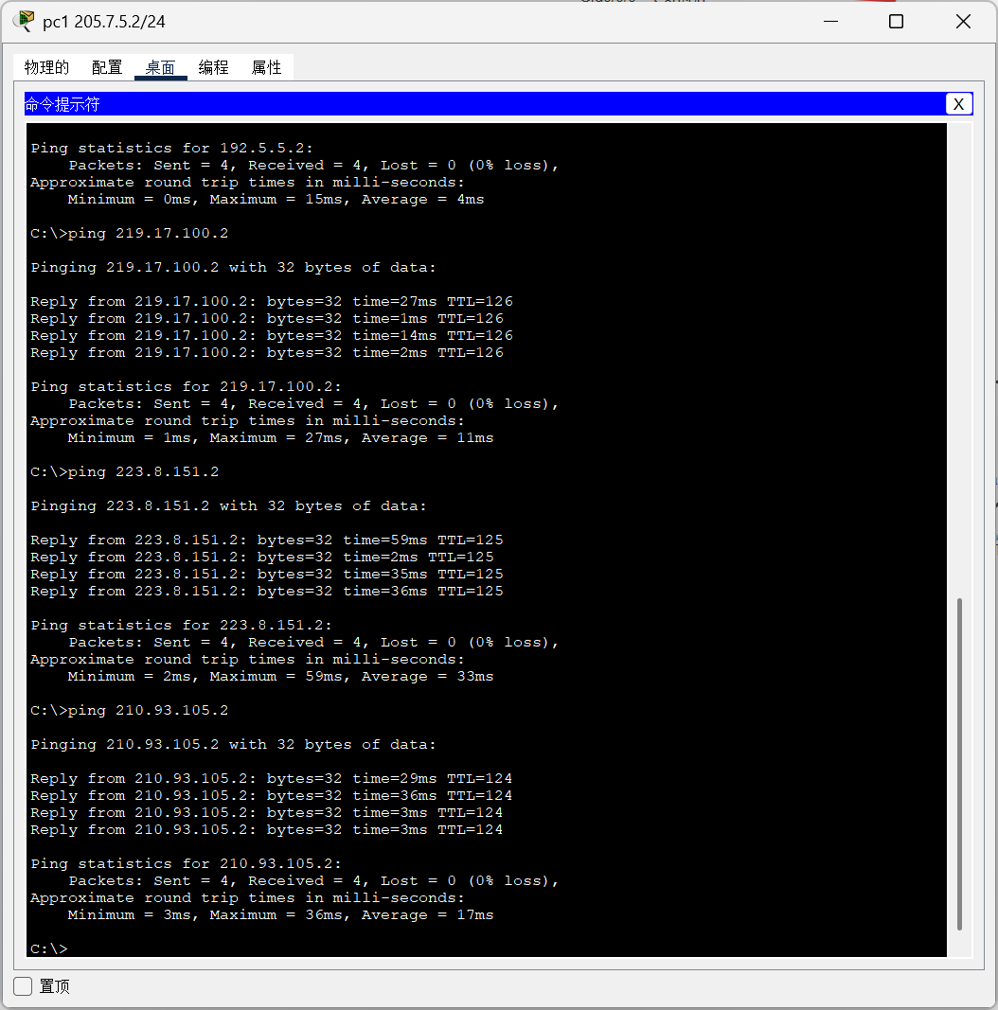

- Problems:
When connecting the router, it was found that using a serial DTE could not connect to the router, and a serial cable was needed for connection, but the router did not have such an interface. Eventually, it was discovered that the NIM-2T module needed to be enabled, as it provides serial ports.
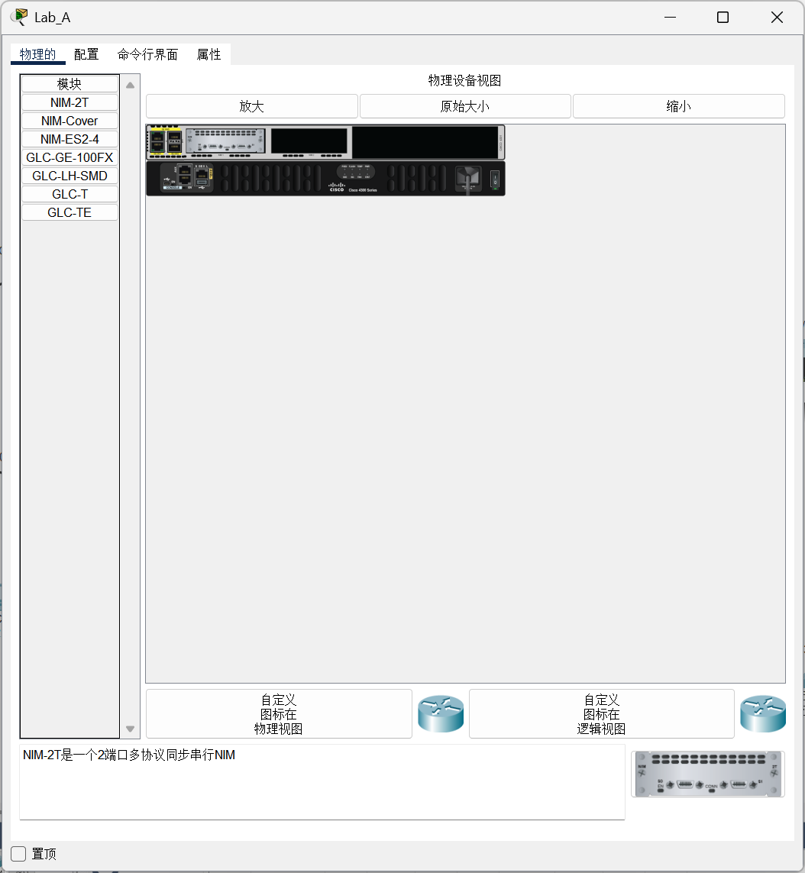
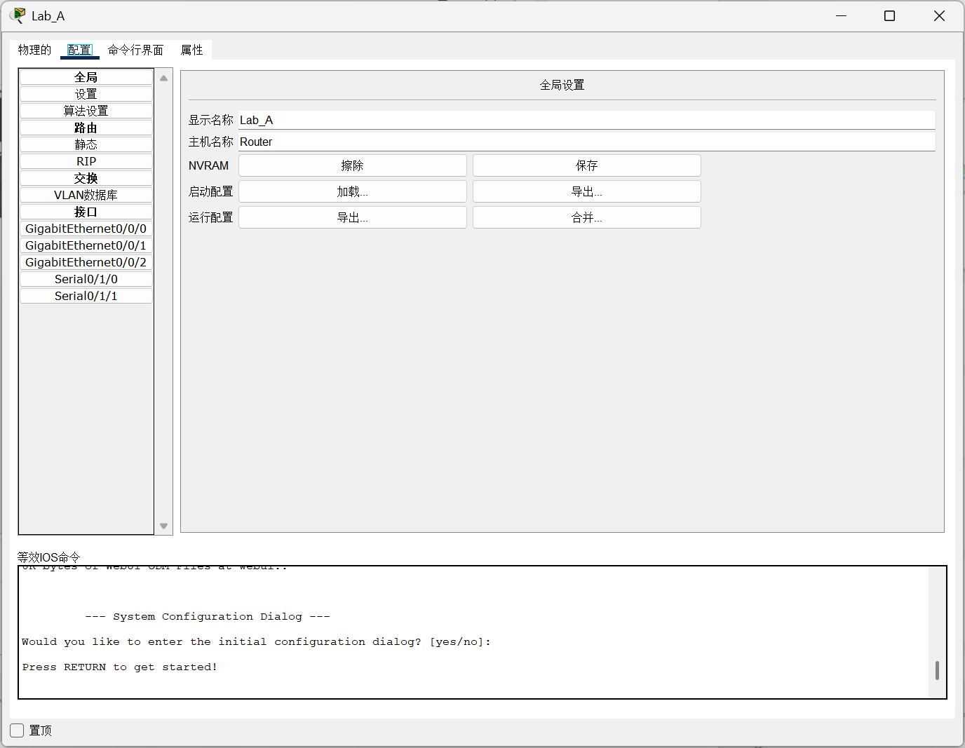
When pinging each other, I noticed that sometimes the ping would fail. Eventually, I found out that the issue was due to mismatched port numbers and IP addresses, so one must be more careful. In the configuration of static IP, I initially only configured the static network address for one router, which resulted in a long time without a successful ping. Later, I realized that this configuration works both ways and then it worked.

