Criterion B: Design

Flowcharts
Fig. 1: Flowchart of the main game process
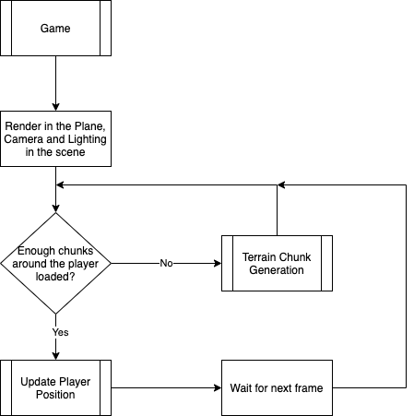

Fig. 2: Flowchart of Player Position Updating (Flight Simulation)

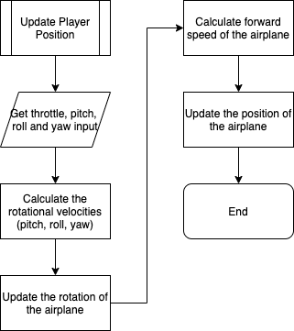

Fig. 3: Flowchart of the Terrain Chunk Generation

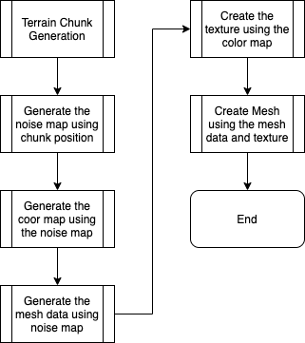
The terrain will be loaded using “chunks”, which are small segments of the terrain. Using them allows not having to load an unmanageable amount of terrain. Setting up a render distance and individual management is very easy.

Fig. 4: Flowchart for the Noise Map Generation

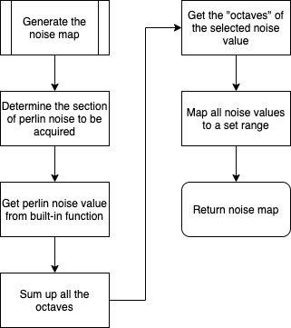

Fig. 5: Flowchart for the Color Map Generation

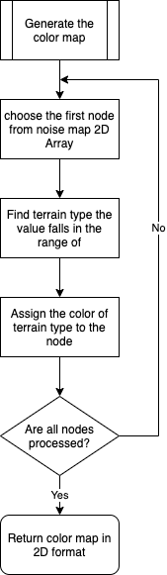
Creating a 2D color map and applying it directly instead of calculating each pixel on each iteration of color assignment results in a more efficient code.
There will be different types of terrain covering a range of noise height value, all of them assigned to a color in the inspector panel in Unity

Fig. 6: Flowchart for Mesh Data Generation

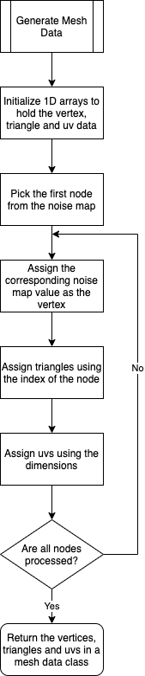
Having the vertices, triangles and uvs as 1D arrays is needed to be able to use the built-in mesh creation method Unity has.

Diagram of Birdseye View from above the Player
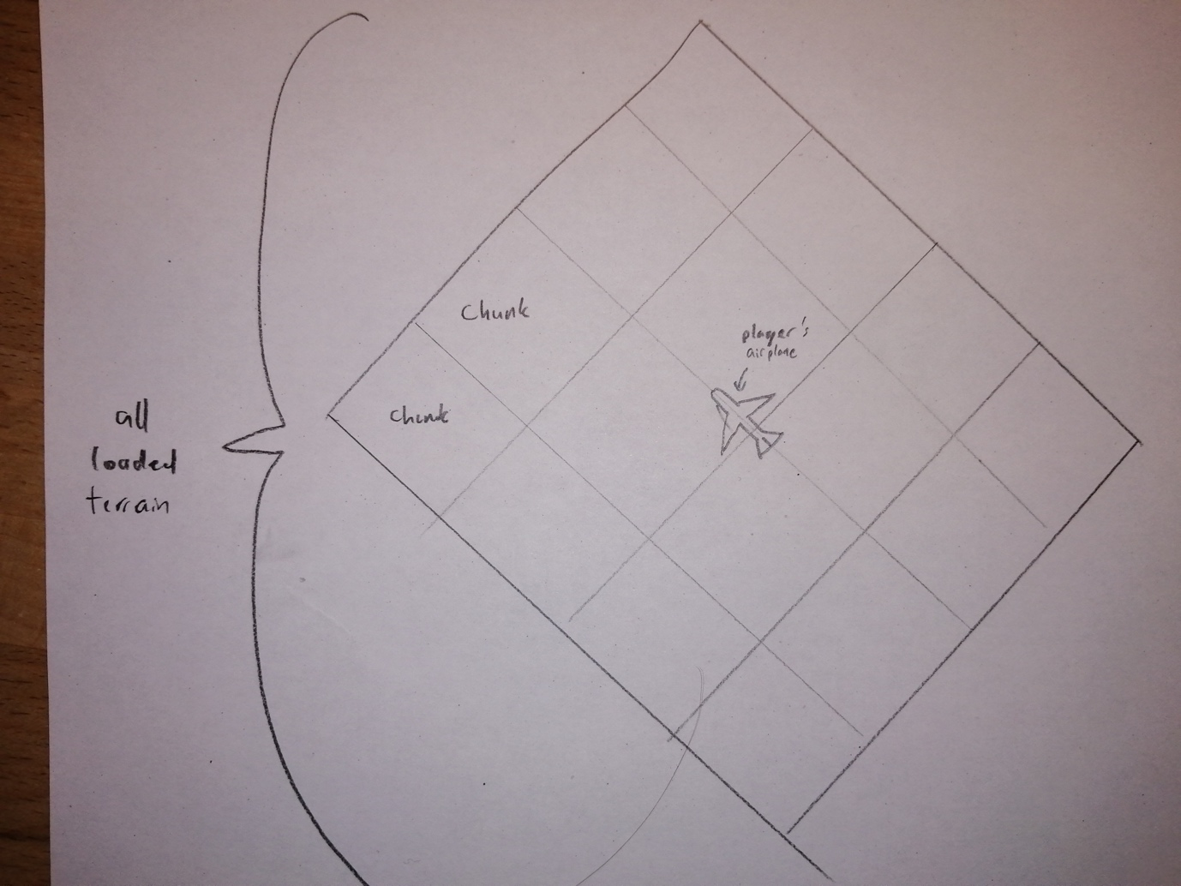

UML Diagrams
Independent Classes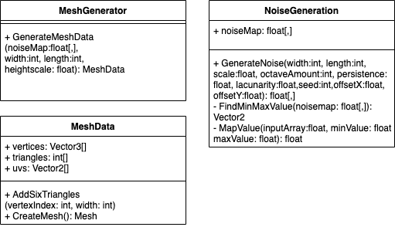

Parts of Built-in Classes that will be used
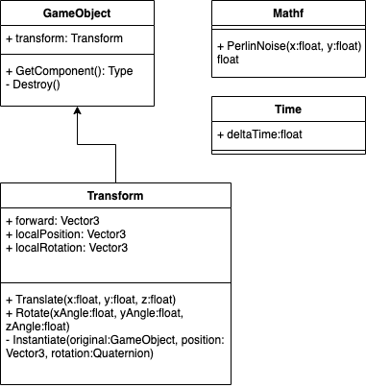

Classes that inherit from Monobehaviour:
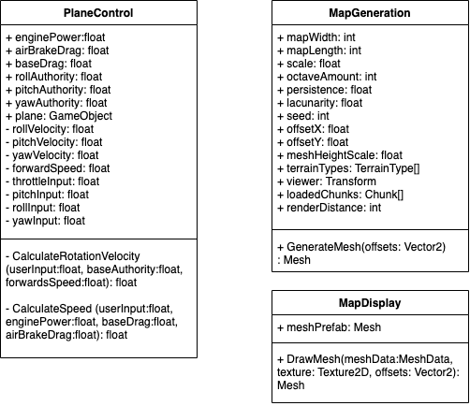

Structs
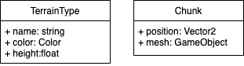

Test Plan
Relevant Success Criterion | Test | Expected Outcome
The plane will be able to be flown with the characteristics of a usual plane; its plane’s pitch, roll, yaw axes and its throttle will be able to be controlled by the player using keyboard buttons | Press each of the assigned buttons | Changes to the airplane speed and rotation will be seen:  W – speed increase  S – significant speed decrease  A – yaw left  D – yaw right  I – pitch down  K – pitch up  J – roll left  L – roll right
Some characteristics of the plane (the scale of control over throttle and rotational axes) will be able to be changed by the player without altering code | Observe and change the public variables on the “inspector” panel of Unity | Change in each six variable (scales of angular velocity of each 3 axis, engine power, static drag, airbrake drag) will result in observable change in the handling of the aircraft
The player will be able to restart if the plane crashes | Fly the airplane into the terrain as a player | The plane will go uninterrupted through the terrain
The player will be able to load previously generated terrain they flew over before | Change the seed for the random generation and then change it back to what it was | The same seed will result in the exact same terrain, while the other seed will result in a different terrain
The terrain of the planet will be able to be randomly generated for them to be replayable | Examine the features of the terrain while flying over it with the airplane as a player | The terrain will not repeat the same pattern as distance is travelled
The procedural terrain will be generated over infinitely large spaces | Observe the terrain chunk generation while flying towards the edge of the loaded chunks with the airplane as a player | More chunks of the terrain will be loaded when it is traveled outwards instead of stopping to load
The colors of the terrain will be able to be changed without altering the code by the client | Change the public variables regarding the characteristics of the terrain | Map width & length: changes in the size of each chunk  scale: if scale is higher, the terrain will seem more spread out  persistence: as it gets higher towards 1, the effect of later octaves will become more apparent (less smooth surface)  lacunarity: as it gets higher, the frequency of the later octaves will increase, decreasing the wideness of effect they have
The characteristics of the terrain (size, amount, shape of specific features like mountains) will be able to be changed without altering the code by the client | Change the color settings of the terrain types in the inspector | The changes in the color pattern will result in observable change
The client should be able to fully observe the terrain below from the view of the plane above | Fly over the terrain | Any obstruction by the plane will be limited
Some parameters of code will be able to be manipulated by the client to conform to the specifications of their computer | Change the vision distance of the player | The amount of chunks loaded around the player will change
A limited version of the game without needing to install Unity will be able to be played on computers using either Windows or Mac OS | Run the exported game on a computer with Mac OS and a computer with Windows OS | The game will run on both OS successfully

