Appendix 2
Detailed comparison of model observers
We evaluated the performance of three model observers with the optimal criteria for various levels of prior probability of the target being present that ranging from 0.05 to 0.95. The amplitude range is scaled down with a single scalar value to evaluate models for a particular amplitude range scalar level. The range of scalars (amplitude range scalars) was between 0.005 to 0.5. We assumed that prior probability distributions of target amplitude and background contrast levels are uniform. The overall performance is measured by two metrics: simple percent correct difference between the ideal observer and sub-optimal observer models (TM and NTM) and the percentage of the maximum increase (the maximum increase depends on the optimal performance and the target prior). To calculate the percent correct difference, the sub-optimal observer’s percentage correct is subtracted from the percentage correct of the ideal observer in any condition (Figure A2.1).
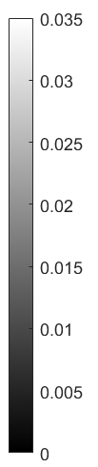
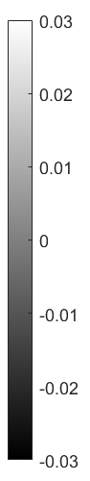
Figure A2.1 Percent correct difference from the optimal performance. The percentage correct difference of two sub-optimal observer models from the ideal observer is shown in the first two panels as a function of the target prior and amplitude range scalar. The third panel shows the difference between the first two panels. Positive numbers correspond to conditions that the NTM observer is closer to the ideal observer than the TM observer. Note that the different grayscale is provided for the third panel.
TM
NTM
NTM-TM
Amplitude Range Scalar
Amplitude Range Scalar
Amplitude Range Scalar

The highest difference between the TM observer and the ideal observer is in the low amplitude range scalars when the target prior is low. On the contrary, the highest difference for the NTM observer is in relatively higher amplitude range scalars when the target prior is high. The total percent correct difference for the NTM observer (3.06) is slightly higher than the TM observer (2.78). Even though the TM observer is not substantially better than the NTM observer in any condition, for most of the high-amplitude range scalars, the TM observer is slightly better than the NTM observer. In contrast, when the target prior is low, and the amplitude range scalar is low, the NTM observer is substantially better than the TM observer (up to 3 percent difference). However, these percent differences are not enough to fully capture the difference between NTM observer and TM observer because a ten percent correct difference might be a small or a large portion of the difference between chance and optimal performance. Therefore, the fraction of the percent correct difference to the difference between chance and optimal performance might play a key role in task performance. We calculated a second metric (relative performance measure) that represents the fraction of the maximum performance increase from the chance that the model observer captures. To calculate the percentage of maximum increase ($I$), we first scale percentage corrects for all target prior conditions between 0 and 1 (subtract the performance expected by prior, $PP$, divide by one minus performance expected by the prior). Then, the scaled percent corrects ($S_{s}$) of sub-optimal observers is subtracted from the scaled percent corrects of the ideal observer ($S_{i}$) and divided by it. Any value that is smaller than 10^-9 is fixed to be zero. Zero divided by zero, shown as zero (Figure A2.2).

Both observer models capture most of the maximum performance increase when the amplitude range scalar is high. However, the TM observer fails to capture a substantial amount of maximum performance increase when the target prior is low, and the overall percentage correct is around 75 percent. On the other hand, the NTM observer only fails to capture a significant degree of the maximum performance increase if the target prior is high. On average, the TM observer fails to capture 17 percent of the maximum performance increase, whereas the NTM observer only fails to capture 12 percent. This suggests that for most higher amplitude range scalars, which the TM observer does better in terms of percent correct, the difference in percent correct only constitutes a small amount of the maximum performance increase for these conditions. However, for almost all the conditions that NTM does perform better in terms of percent correct, the difference between models constitutes a large portion of maximum performance increase. At the threshold efficiencies (when the overall percentage correct is around 75 percent) and when the target prior is low, the three percent correct difference constitutes more than seventy percent of the maximum performance increase, so the NTM observer does capture 70 percent more of the maximum performance increase compared to TM observer.
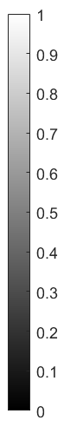
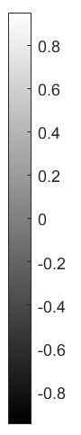
Figure A2.2 The relative performance measure for sub-optimal observers. The percentage of a maximum performance increase for sub-optimal observer models is shown in the first two panels as a function of the target prior and amplitude range scalar. The third panel shows the difference between the first two panels. Positive numbers correspond to conditions in which the NTM is performing better than the TM observer. Note that the different grayscale is provided for the third panel.
NTM
TM
NTM-TM
Amplitude Range Scalar
Amplitude Range Scalar
Amplitude Range Scalar

In sum, we found that the NTM observer performs better than the TM observer for low target priors. Also, it well-approximates the ideal observer (on average, TM fails to capture 18 percent of the maximum increase, whereas NTM only does this misses 6 percent). On the other hand, when the target prior is high and models are operating with high amplitudes (high amplitude range scalars), we found that TM observer is only slightly better than NTM (maximum better by 1.5 percent correct that is 7 percent of the maximum increase, at maximum captures 15 percent more of the maximum increase where the percent correct difference is less than 1 percent correct).

The effect of background contrast uncertainty in isolation
Both measures revealed very similar trends when there is only background contrast uncertainty. However, the difference between the NTM and TM observers shrinks in general favor of the TM observer. The total percentage correct difference (3.95) for the NTM observer is bigger than the total percent correct difference for the TM observer (2.22, Figure A2.3A). On average, the TM observer fails to capture 15 percent of the maximum performance increase, whereas the NTM observer only fails to capture 12 percent (Figure A2.3B).
Figure A2.3 Performance under only background contrast uncertainty. A The simple percentage correct difference between two sub-optimal model observers is shown in the first two panels as a function of the target prior and amplitude range scalar. The third panel shows the difference between the first two panels. B The percentage of the maximum performance increase for sub-optimal observer models is shown in the first two panels as a function of the target prior and amplitude range scalar. The third panel shows the difference between the first two panels.
TM
NTM
NTM
TM
A
NTM-TM
B
NTM-TM
Amplitude Range Scalar
Amplitude Range Scalar
Amplitude Range Scalar
Amplitude Range Scalar
Amplitude Range Scalar
Amplitude Range Scalar

The effect of target amplitude uncertainty in isolation
To quantify the effect of amplitude uncertainty, we calculated both metrics for the ideal observer under low uncertainty, and for the ideal observer under amplitude uncertainty. The overall effect of amplitude uncertainty is small (less than 1 percent correct difference and less than ten percent of the maximum performance increase in general). However, the effect strikingly depends on the target prior for both metrics, and it is negligible when the target prior is low, whereas when the target prior is high, it goes up to a loss of 35 percent of the maximum performance increase (Figure A2.4).
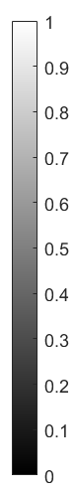
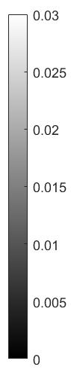
Figure A2.4 The effect of amplitude uncertainty. Two measures of performance are calculated to compare the ideal observer when there is no uncertainty to the ideal observer when there is only amplitude uncertainty. A The simple percentage correct difference for each target prior and amplitude range scalar is shown in the image matrix. The plot shows the percent correct difference averaged over efficiencies as a function of the target prior. B The percentage of maximum increase for each target prior and amplitude range scalar. The plot shows the percentage of maximum increase over efficiencies as a function of the target prior.
Percentage Difference
Percentage of Maximum Increase
A
B
Amplitude Range Scalar
Amplitude Range Scalar

