Adapt Learning: Adapt Framework Concept and Vision

# Document control

|  |  |  |  |
| --- | --- | --- | --- |
| **Abstract:** | Describes the concept of the Adapt Framework | | |
| **Author:** | Sven Laux | Version: 0.1 | Date: 12 / 11 / 2013 |

| **Summary of Changes:** | **Versions** | **Date** | **Description** |
| --- | --- | --- | --- |
| 0.1 | 12 / 10 / 2013 | Initial draft for review. |
|  |  |  |

Document control 1

Purpose of document 3

Concept overview diagram 4

Explanation 5

# Purpose of document

The purpose of this document is to outline the vision and concept of the Adapt Learning Framework. It contains a concept diagram, similar of a mind map of the key functionality, components and elements of the underlying code framework, which make up the programming logic of the e-learning course.

This document is not a specification document. It is intended to help the project team and wider community understand the full product we are aiming for. As such, the document will therefore set the context in discussions about requirements, system architecture, specification etc.

The document is also intended to help newcomers to the project to get an overview.

# What is the Adapt Framework?

What is it?

How does it relate to the authoring tool?

Who uses it?

How can / should it be used?

# Concept overview diagram

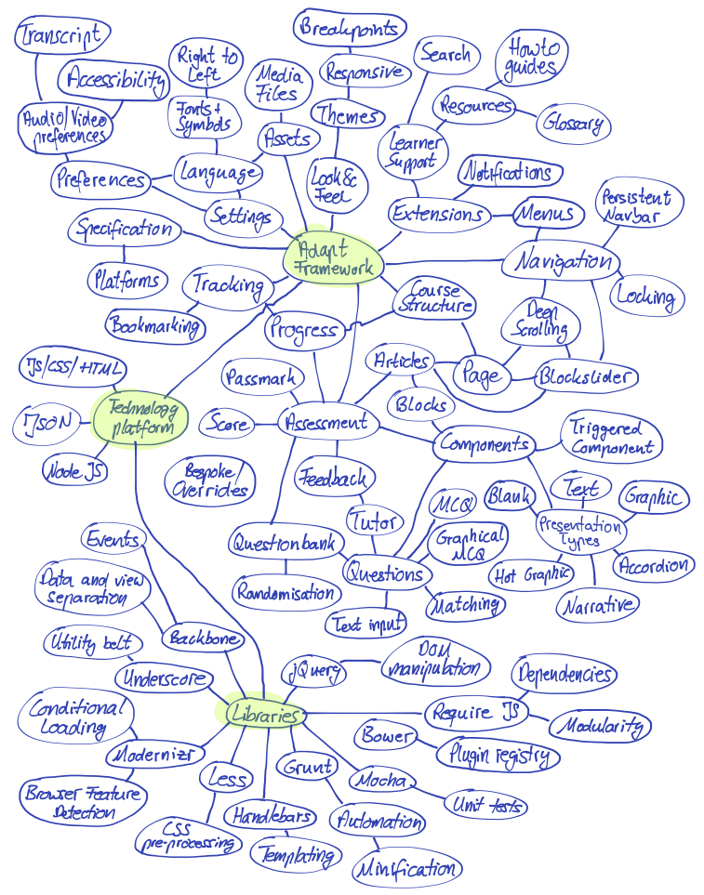

# Explanation

|  |  |  |
| --- | --- | --- |
| **ID** | **Node title** | **Description** |
|  |  |  |
|  |  |  |
|  |  |  |
|  |  |  |
|  |  |  |
|  |  |  |
|  |  |  |
|  |  |  |
|  |  |  |
|  |  |  |
|  |  |  |
|  |  |  |
|  |  |  |
|  |  |  |
|  |  |  |
|  |  |  |
|  |  |  |
|  |  |  |
|  |  |  |
|  |  |  |
|  |  |  |
|  |  |  |
|  |  |  |
|  |  |  |
|  |  |  |
|  |  |  |
|  |  |  |
|  |  |  |
|  |  |  |
|  |  |  |
|  |  |  |
|  |  |  |
|  |  |  |
|  |  |  |
|  |  |  |
|  |  |  |
|  |  |  |
|  |  |  |
|  |  |  |
|  |  |  |
|  |  |  |
|  |  |  |
|  |  |  |
|  |  |  |
|  |  |  |
|  |  |  |
|  |  |  |
|  |  |  |
|  |  |  |
|  |  |  |
|  |  |  |
|  |  |  |
|  |  |  |
|  |  |  |
|  |  |  |
|  |  |  |
|  |  |  |
|  |  |  |
|  |  |  |
|  |  |  |
|  |  |  |
|  |  |  |
|  |  |  |
|  |  |  |
|  |  |  |
|  |  |  |
|  |  |  |
|  |  |  |
|  |  |  |
|  |  |  |
|  |  |  |
|  |  |  |
|  |  |  |
|  |  |  |
|  |  |  |
|  |  |  |
|  |  |  |
|  |  |  |
|  |  |  |
|  |  |  |
|  |  |  |