FINTECH 545 Week04 Project Report

Yilun Wu(yw528)

Problem 1:

The calculation of the expected value and standard deviation of price at time t for each of the 3 types of price returns (Classical Brownian Motion, Arithmetic Return System, and Log Return) is in the Problem 1 Section of code file (code.ipynb).

In this problem, I set the **initial price $P_{0}=100$** (dollars), with the return rate follows the normal distribution with **mean $μ=0$** and **standard deviation $σ=0.5$** , and the expected values from theoretical computation and the actual values from simulation are shown below:

|  |  |  |  |  |
| --- | --- | --- | --- | --- |
| **Method** | **Mean** | | **Standard Deviation** | |
| Expected Value | Actual Value | Expected Value | Actual Value |
| Classical | $P_{0}$ (100) | 100.02 | $σ$ (0.5) | 0.4842 |
| Arithmetic | $P_{0}$ (100) | 102.39 | $σ$ (50) | 48.42 |
| Log | $P_{0}∙e^{\frac{σ^{2}}{2}}$ (113.31) | 115.05 | $P_{0}∙e^{\frac{σ^{2}}{2}}∙\sqrt{e^{σ^{2}}-1}$ (60.39) | 58.15 |

(Note: the expected value formulas are from Week1 Lecture Note)

According to the table above, we can figure out that the mean and standard deviation **match with the expectations**.

Problem 2:

The implementation of the “return_calculate()” function, the computation of arithmetic returns for all prices, and the calculation of VaR using all 5 methods are in the Problem 2 Section of code file (code.ipynb).

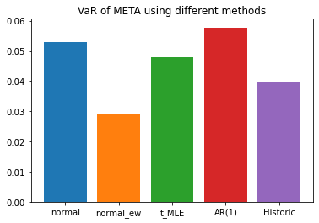

According to the graph that shows the comparison of the 5 VaR (Value at Risk) values, we can figure out that the VaR that computed using a normal distribution with an exponentially weighted variance is the lowest, and the VaR that computed using a fitted AR(1) model is the highest. All 5 values are close to 0.05 (5%), which means that these values will provide a similar estimation of risk conditions based on the time-sensitive price data provided.

Problem 3:

The computation of VaR of each portfolio using both discrete (arithmetic) return and log return are in the Problem 3 Section of code file (code.ipynb).

Firstly, I used the **Delta Normal VaR method** that assumed payoffs are linear and returns and distributed multivariate normal.

Using this method, we have the VaR for each portfolio is:

Portfolio A: $15428.34

Portfolio B: $8083.29

Portfolio C: $18164.90

And the total VaR for this portfolio is $38944.84.

The other method I have chosen is the **Historical VaR method**, and the primary reason I choose this method is that **the asset (stock) prices are not always linear and returns are not normal, and so in this case the Historical VaR method is more suitable**.

Using this method, we have the VaR for each portfolio is

Portfolio A: $15434.88

Portfolio B: $8090.33

Portfolio C: $18083.22

And the total VaR for this portfolio is $38908.30.

We can easily figure out that the **results are changed by using Historical VaR method from the original Delta Normal Method**, and from my perspective it is primarily because **Historical VaR method captures more non-linear features of the time-sensitive data, and it also include greater weights for least recent data points (prices many days ago for each stock).**