FINTECH 545 Week05 Project Report

Yilun Wu(yw528)

Problem 1:

The time to maturity is 14 calendar days. The computation of the time to maturity and the value of call/put are shown in the Problem 1 Section of the code file (code.ipynb).

The graph of the value of call and the put assuming At the Money (ATM) Option:

The graph of the value of call and the put assuming In the Money (ITM) for Call Option:

The graph of the value of call and the put assuming Out of the Money (OTM) for Call Option:

From these graphs above, we can figure out that **as the implied volatility increases, no matter which situation both call option and pull option has its option value increases as well**. Also, there exists a gap between the option value for call option and the option value for put option. It is obvious that when it is In the Money for Call Option case, the Call Option has higher value as the payoff for the option is positive here; similarly, for the Out of the Money for Call Option cases, the Call Option has lower value as now the payoff is for this option is 0, and the Put Option, on the other hand, has the higher payoff.

Also, the supply and demand factors can affect the implied volatility. Implied volatility is a market-based measure of the expected future volatility of the underlying assets. Therefore, **when the demand for certain options increases or the supply of these options decreases, the implied volatility tends to increase as well**, since traders are willing to pay higher prices for these options as they have the greater potential to provide more profitable payoffs or higher values afterwards, which results in higher volatility. On the other hand, **when the demand for certain options decreases or the supply of these options increases, the implied volatility may also decrease**, since the higher availability of these options results in lower value in the market for traders, and so the future volatility for them will also be likely to be lower.

Problem 2:

The calculation detail of implied volatility for each option is shown in the Problem 2 Section of the code file (code.ipynb), and the result is shown below:

The plot of the implied volatility vs the strike price for Puts and Calls are shown below:

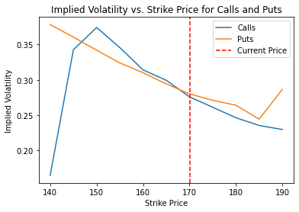

From the plot above, we can figure out that **when the strike price is close to the current price (underlying price), both Calls and Puts has its implied volatility constantly decreasing as strike price increases, yet when the strike price is far away from the underlying price, the implied volatility fluctuates rapidly**. The market dynamics that can contribute to the shapes and trends exhibited on this graph includes the market trends (supply & demand trends), geopolitical events, economic factors, social and cultural factors, etc. In this case, we have when the strike price is close to the current price, the curves become smoother or flatter, which indicates that the market is relatively more peaceful , and both traders and investors are not expecting abrupt changes in prices in the market; conversely, when the strike price is far away from the current price, the curves become sharper, which indicates that the market is more volatile and the prices may largely fluctuates.

Problem 3:

The calculation of the portfolio values and log returns are shown in the Problem 3 Section of the code file (code.ipynb).

The graph of portfolio value versus a range of underlying values for each portfolio are shown below:

From the plots above, we can first figure out that the portfolio value for the Stock and SynLong is the most straightforward, as its portfolio values proportionally increases with the underlying prices; The CoveredCall and the ProtectedPut are a mixture of Stock and Options, so they follows the trends of the original Call/Put yet they have the portfolio values limited within a certain range; the CallSpread and PutSpread have portfolio values limited to a certain range, which has its risk limited and, at the same time, profit/loss limited.

The Mean, VaR and ES of the prices changes between the current prices and the simulated prices 10 days later using AR(1) model for each portfolio are shown below:

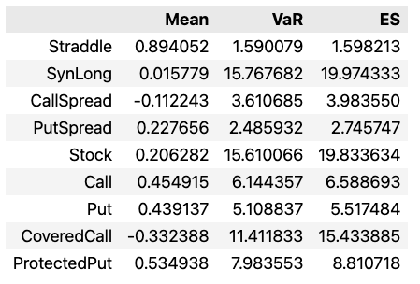

According to the data above, we can figure out that both SynLong and Stock has high risks due to their high Value at Risk and Expected Shortfall. The CoveredCall and ProtectedPut has higher risk than pure Call or pure Put but lower risk comparing to Stock and SynLong, as they are the mixture of Stocks and Options (also mentioned in the previous part above). Furthermore, the CallSpread and PutSpread are the ones with the lowest risks, since they have added a limit on the pure Call/Put, which also sacrifices some returns on the other hand. These values for each portfolio match our expectations when analyzing the shapes of these portfolios in the previous part.