FINTECH 545 Week07 Project Report

Yilun Wu(yw528)

Problem 1:

The implementation of the closed form Greeks for GBSM and a finite difference derivative calculation, and the binomial tree valuation for American options with and without discrete dividends are shown in the Problem 1 Section of the code file (code.ipynb).

The values between the two methods for both a call and a put are as follows:

Closed Form Greeks:

|  |  |  |
| --- | --- | --- |
|  | Call | Put |
| Delta | 0.083 | -0.917 |
| Gamma | 0.017 | 0.017 |
| Vega | 6.939 | 6.939 |
| Theta | -8.127 | -1.941 |
| Rho | -0.03 | -1.243 |
| Carry_rho | 1.133 | -12.515 |

Finite difference derivative:

|  |  |  |
| --- | --- | --- |
|  | Call | Put |
| Delta | 0.083 | -0.917 |
| Gamma | 0.017 | 0.017 |
| Vega | 6.939 | 6.939 |
| Theta | -8.127 | -1.941 |
| Rho | -0.03 | -1.243 |
| Carry_rho | 1.133 | -12.515 |

We can figure out that the values between the two methods are really close to each other. The detailed values are shown in the Problem 1 Section of the code file.

The value of the Call without dividend is **0.336**, and the value of the Put without dividend is **14.037**, and the Greeks without dividend are the same as the values in the tables above.

The value of the Call without dividend is **0.296**, and the value of the Put without dividend is **14.566**, and the Greeks without dividend are shown in the tables below:

|  |  |  |
| --- | --- | --- |
|  | Call | Put |
| Delta | 0.069 | -0.938 |
| Gamma | -4.441 | 1.066 |
| Vega | 5.913 | 5.491 |
| Theta | -6.954 | -0.303 |
| Rho | 0.881 | -12.277 |

The sensitivity of the Call option is **-0.025**, and the sensitivity of the Put option is **0.941**.

Problem 2:

The calculation detail of all VaR and ES is shown in the Problem 2 Section of the code file (code.ipynb), and the result is shown below:

Mean, VaR and ES using Simulated Prices from AAPL returns:

VaR and ES using Delta-Normal

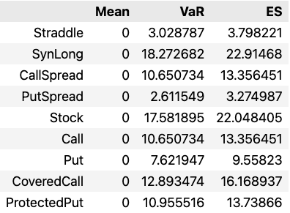

Based on the result presented above and the results from last week’s project, we can figure out that the VaR and ES of the simulated prices based on normal distribution is quite different and with higher variations. The reason behind this might be the fact that the AR(1) model is a more suitable model for stock/option prices and returns comparing to normal distribution model. Yet the basic patterns still holds--both SynLong and Stock has high risks due to their high Value at Risk and Expected Shortfall. The CoveredCall and ProtectedPut has higher risk than pure Call or pure Put but lower risk comparing to Stock and SynLong, as they are the mixture of Stocks and Options (also mentioned in the previous part above).

Problem 3:

The computation detail of the expected annual return and the super efficient portfolio are shown in the Problem 3 Section of the code file (code.ipynb).

The expected annual return of each stock is shown below:

|  |  |
| --- | --- |
| Stock | Expected Annual Return |
| AAPL | 0.157 |
| META | 0.018 |
| UNH | 0.254 |
| MA | 0.223 |
| MSFT | 0.156 |
| NVDA | 0.280 |
| HD | 0.121 |
| PFE | 0.077 |
| AMZN | -0.043 |
| BRK-B | 0.130 |
| PG | 0.082 |
| XOM | 0.522 |
| TSLA | -0.033 |
| JPM | 0.098 |
| V | 0.241 |
| DIS | -0.155 |
| GOOGL | -0.017 |
| JNJ | 0.124 |
| BAC | -0.112 |
| CSCO | 0.148 |

The super efficient portfolio is shown below:



And the portfolio’s Sharpe ratio is 1.468