**User Document:**

This section explains how to use this tool to validate a HNAP XML metadata file using Postman/cURL. **Postman** is an interactive and automatic tool for running REST APIs of your project. Postman is a Google Chrome app. It has a friendly GUI for constructing requests and reading responses. It works on the backend, and makes sure that each API is working as intended. How to download/install and use Postman tool, please visit the tutorial at: **https://www.guru99.com/postman-tutorial.html**

Once you have installed and gone through the tutorial then follow the steps below for validating an xml file;

1. Launch Postman by clicking on the logo.

1. Enter the API endpoint where it says ‘Enter request URL’ and select the method on the left of that field. The default method is GET but we will use POST as shown below.

|  |  |
| --- | --- |
| POST v | https://4nh2zjhata.execute-api.ca-central-1.amazonaws.com/Alpha2/validation |

1. Click ‘Headers’ tab and add a new key-value pair
   * 1. Key : Content-Type
     2. Value: multipart/form-data

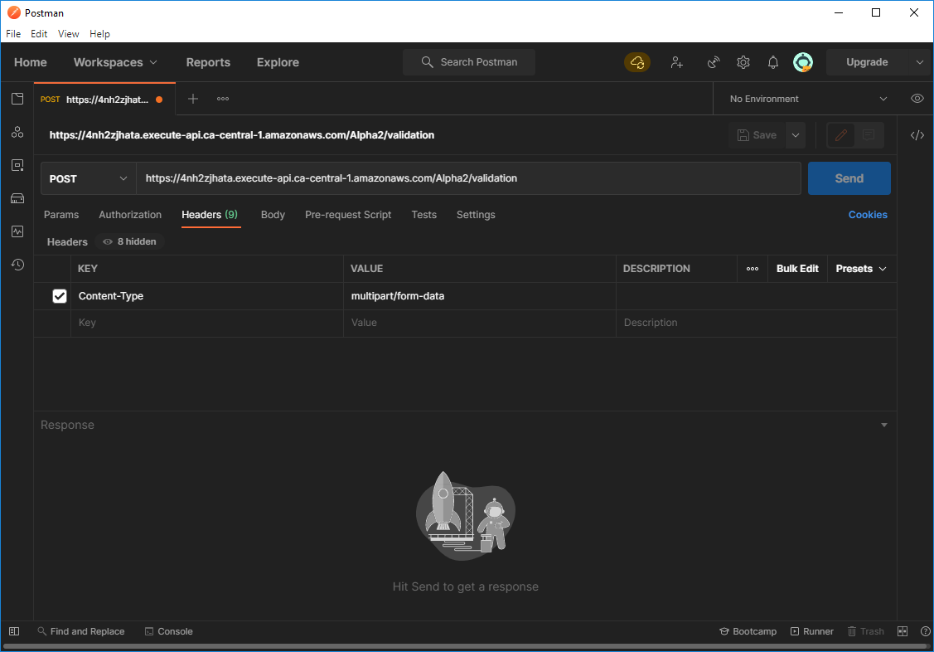

1. Next, click ‘Body’ tab
2. Select form-data radio button Add a key: ‘file’ and from the drop down box select ‘File’ as your option.

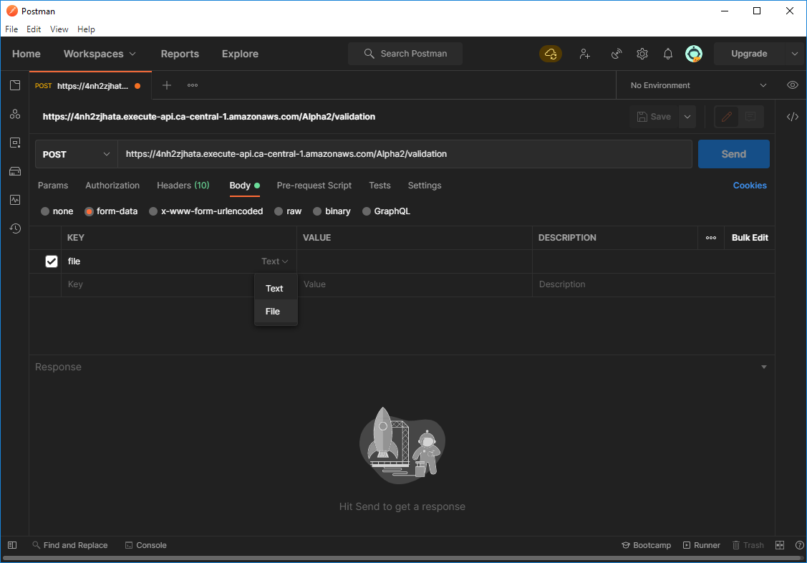

1. Click ‘Select Files’ button to select an xml file that you want to validate.
2. Press ‘Send’ button. This will send a POST request to the server which will call the necessary functions to validate the input xml file. The response from the server will have one of the following status code;

* 200: 'XML file has been validated successfully.'
* 401: "Bad Request: XML file to be validated is missing from the

input data. You must provide an input xml file"

* 402: "Bad Request: Input file does not seem to a XML file. It

should have *.xml or *.XML file extension"

* 404: "Bad Request: Error in the input data. The Content-Type should

be multipart/form-data."

* 500: "Server (EC2) Instance is not running. Start the server and

then run again."

If your xml file is validated then a Status Code of 200 will be returned with the response body containing all the messages. They can be used to diagnose the error in your xml file, if any. Below is one such response from schematron while validating ‘CellarBook.xml’

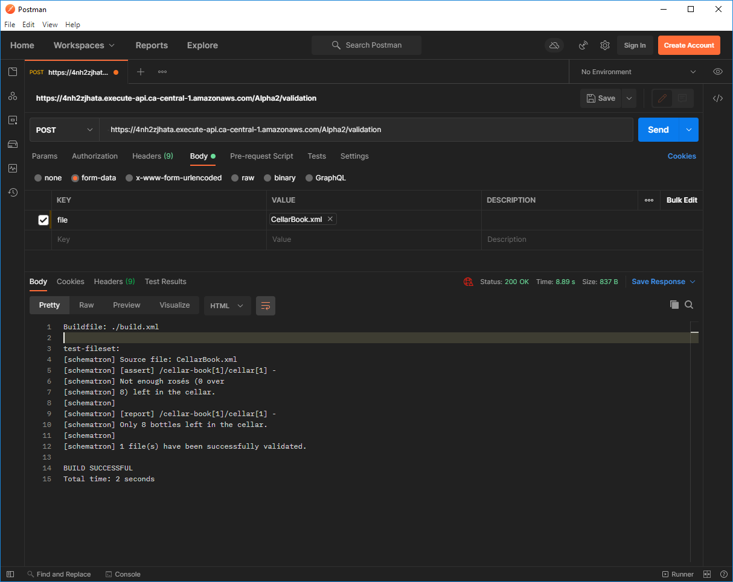

Do the same for the PUT Rest API with an additional header input required for authorization. The PUT API updates the schematron file at the server and so it is only allowed to be executed by the administrator. The following headers needs to be set;

Content-Type: multipart/form-data

x-api-key: xxxxxxxxxxx

Without an authorizing key the user will get status code 403 Forbidden message.

**Using cURL:**

**POST**

>>curl --location --request "POST" "https://4nh2zjhata.execute-api.ca-central-1.amazonaws.com/Alpha3/validation" -k --header "Content-Type: multipart/form-data" --form "file=@"C:/nrcan/Data/nrcan-a3dfbaf4-1b20-4061-aa0a-e7a79953f52d.xml""

**PUT:** [Note: you need api-key to run this API]

>>curl --location --request "PUT" <https://4nh2zjhata.execute-api.ca-central-1.amazonaws.com/Alpha3/validation> -k --header "Content-Type: multipart/form-data" --header "x-api-key: xxxxxxxxxxxx" --form "file=@"C:/nrcan/sample_metadata_and_schematron/Validation_Eng_Final_v12_UTF8.sch""