SECTION I
- Create the folder structures
You must have a root or administrator account in the AWS console
Go to your S3 section and create the following two buckets
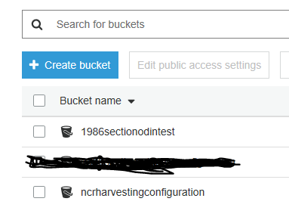
The bucket by the name ncrharvestingconfiguration is optional
The 1986sectionodintest is optional
In the ncrharvestingconfiguration create the following structure of folders
The subdirectories are hardcoded but, they can be made optional (next iteration)
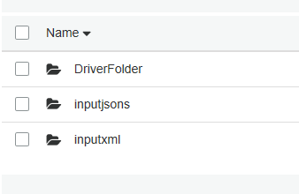
In the DriverFolder upload this two files
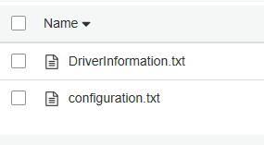
In the inputjsons copy some jsons input files (a set of input files will be provided)
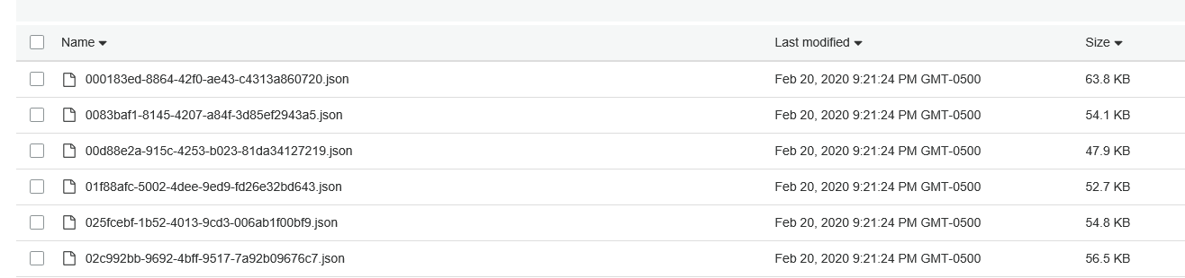
In the inputxml folder copy the file inputfile.xml (will be provide)
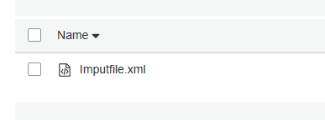
Go to the 1986sectionodintest and make it accessible to the users that you want to have access to

Create a directory
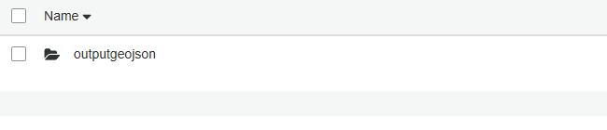
This is the directory where you will find the geojson files when running the Lambda Function.

This is the first stage of the deployment
SECTION II
- In this section we will create the Lambda Function, here we are following the standards of the AWS Practitioner guidelines
Open the console AWS as a root user or IAM user with admin privileges
Create a Lambda function from, choose the option of Author from scratch (look at the picture 2.1 below) make sure to select the exact Runtime that is indicated (this is our first option for now)

Picture 2.1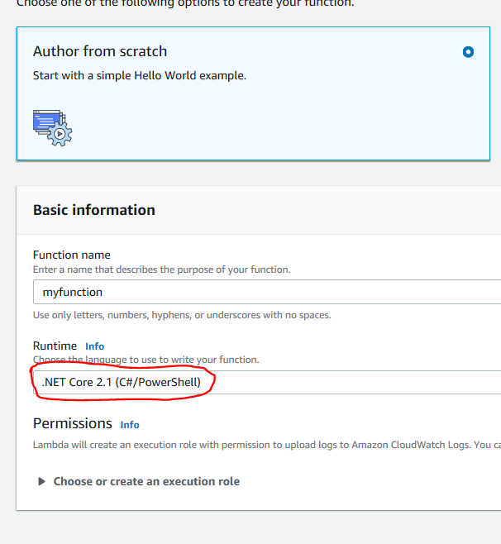
In the Function code select upload and choose the Function Package and Click on the Upload Button look at Picture 2.2
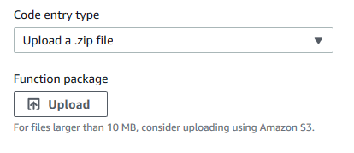
Picture 2.2
You will be prompt with a file dialog box, navigate to the location were you downloaded the HarvestingSection zipped file and choose it
The following section is to create the handler for the Lambda Function (very important step), look at the Picture 2.3
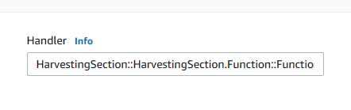
Picture 2.3
Enter the following string
HarvestingSection::HarvestingSection.Function::FunctionHandler

HarvestingSection::HarvestingSection.Function::FunctionHandler
This handler is describing the path to our function, from the assembly, class and function and can change based on the unit developed

Create this setting described in Picture 2.4 & Picture 2.5
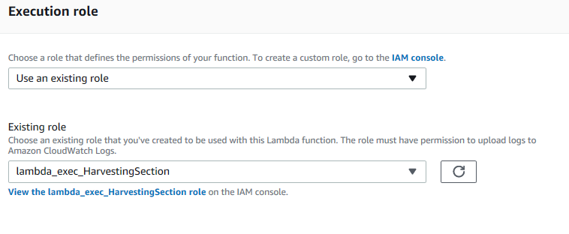
Picture 2.4
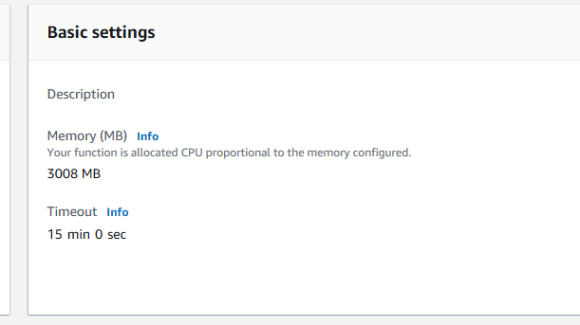
Picture 2.5
Configure a test event save it and run it, look at the Picture 2.6
// input and input 1 must contain the name of buckets used for input and output
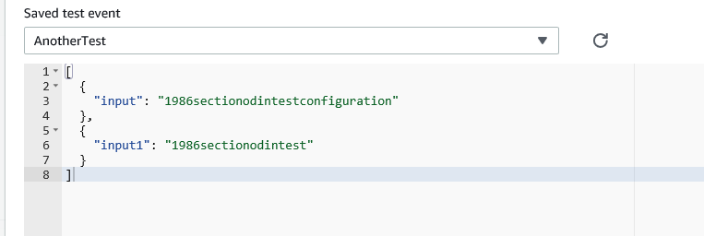
Picture 2.6
The strings in green color are the name of the buckets that you created in SECTION I on this document
You will have this execution log after if everything has been properly set Picture 2.7
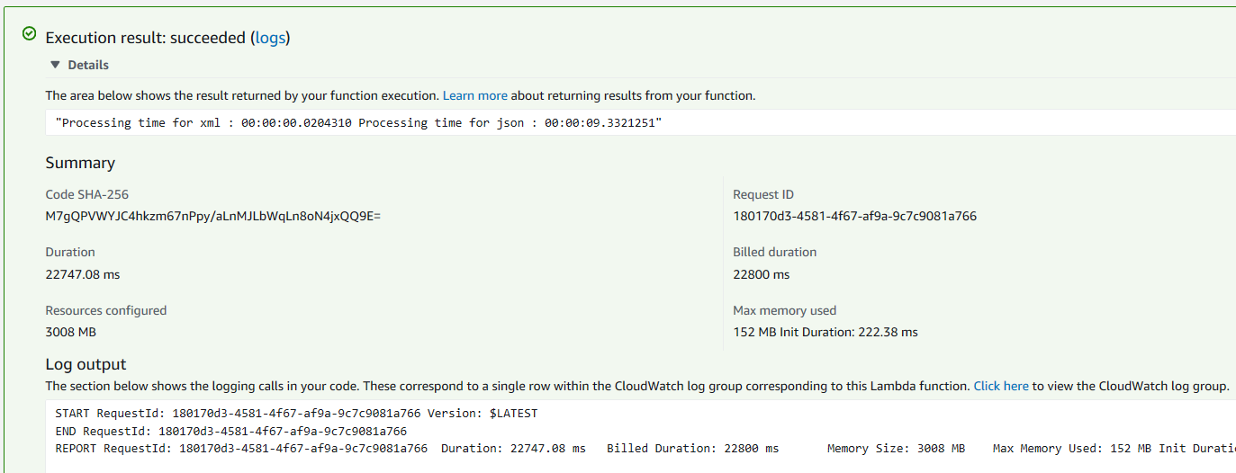

The next step is to go to CloudWatch Picture 2.8
Events=>Rules and Create a Rule (choose the name that you want) and configure as following Picture 2.9 & 2.10
// This sets a timer that calls the lambda function every minute
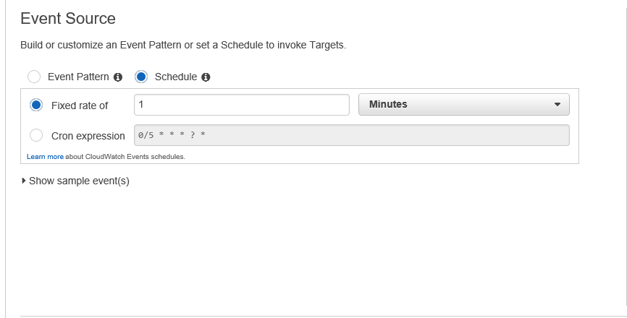
Picture 2.9

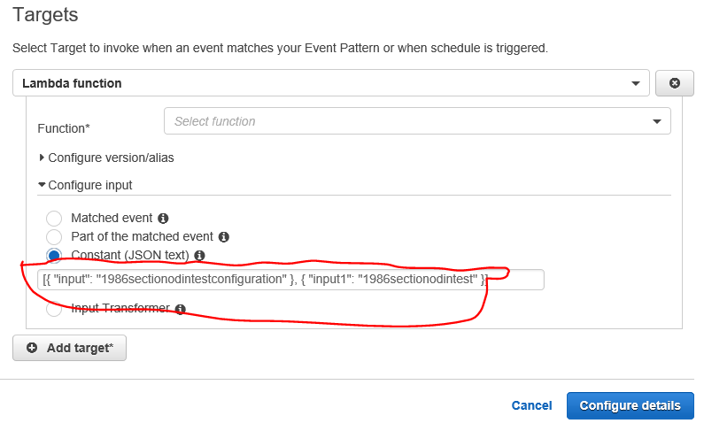
Picture 2.10
In the Picture 2.10 enter the string in the box circled in red that is the same that you enter in the Picture 2.6 and press Configure details button
The function will run every 1 minute (this is for test), you can change to hours, days, etc.
And you are done for the Installation of the program unit, I am writing as is now the same unit in Node JS, when is ready I will send it, because is Node JS, the only thing that you need to do after Upload is change to the Run Time code to a Node JS type, or if is Python the same.

Make sure that you have the needed permission Picture 2.11
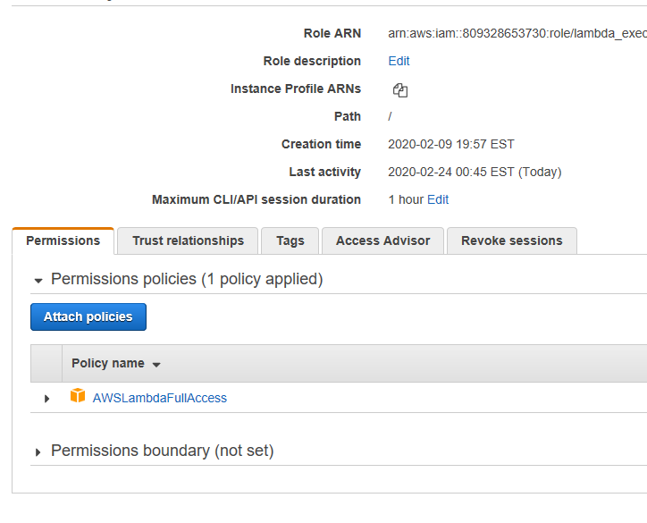
Picture 2.11

SECTION III

Here we will test the function if is running every 3 minutes or at the frequency that we expect
Go to the bucket 1986sectionodintest and clean it up, delete all the files Picture 2.12
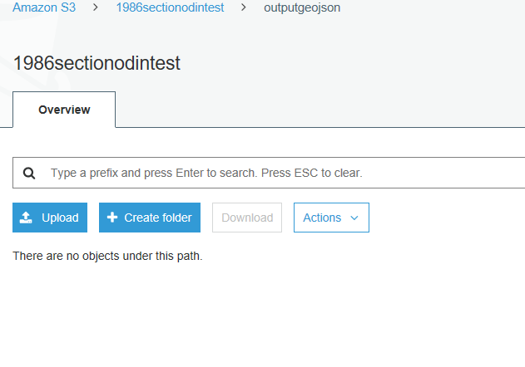
Picture 2.12
Go to the Cloud Watch and edit the rule (optional name), make sure that you Enable the rule with a fixed time of 3 minutes
Wait for 3 minutes and review the output bucket, refer to Picture 2.12
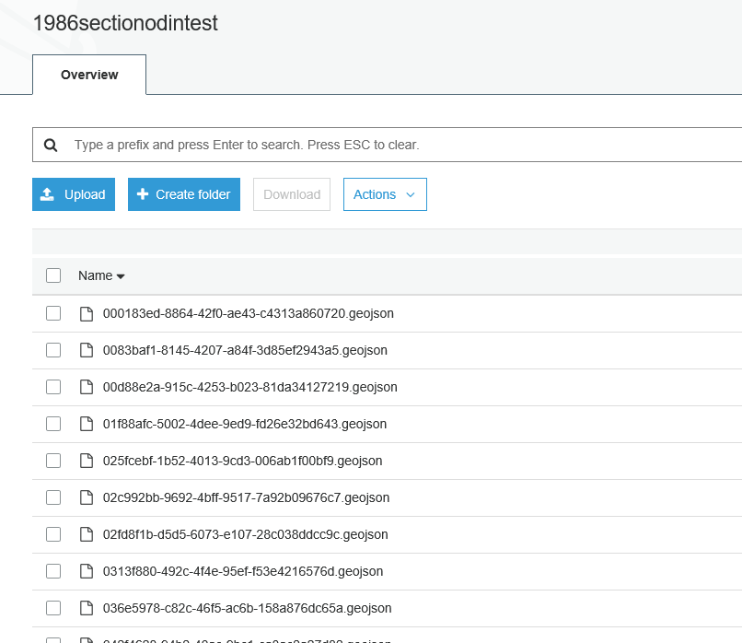

SECTION IV
In this section you will create one API Gateway for the lambda function

