Margaree River Connectivity Restoration Plan: 2024 - 2035
Table of contents

Project Overview

Purpose
The purpose of the Watershed Connectivity Restoration Plan (WCRP) is to systematically identify and assess potential barriers to Atlantic salmon migration in the Margaree Watershed. By conducting both desktop and field assessments, the project aims to evaluate the extent of migration barriers caused by manmade structures and identify opportunities for increasing connectivity for salmonid species. This assessment will guide the prioritization of barriers for remediation, ensuring that the most impactful sites are addressed first to enhance Atlantic salmon habitat and improve migration conditions.

Connectivity Status
In the Margaree Watershed, 270 structures potentially disconnect Atlantic Salmon habitat. Of these, 3 have been reconnected through debris jam removal, 1 has been identified as an actionable barrier and 266 require further field assessment.

Habitat Accumulation Curve
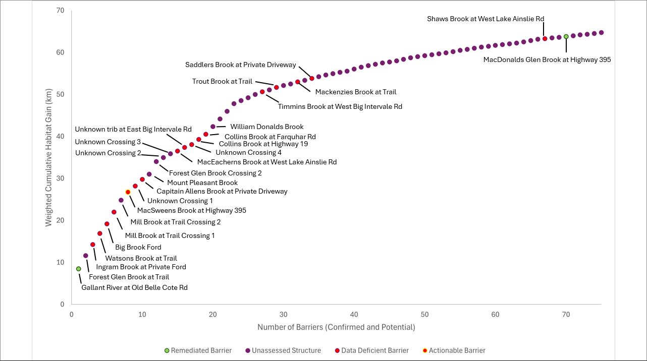
Figure 1: Habitat Accumulation Curve (HAC) showing structures in the Margaree watershed as of February 5th, 2026. Structures are ranked based on how much (km) habitat is upstream to the next structure or set of structures and that would be reconnected if the structure(s) became passable. Habitat upstream of data-deficient structures is considered disconnected until field assessments are completed. Structures that were excluded as passable are not shown; however, rehabilitated barriers are shown to demonstrate the connectivity gains achieved through implementation of this plan.

Map
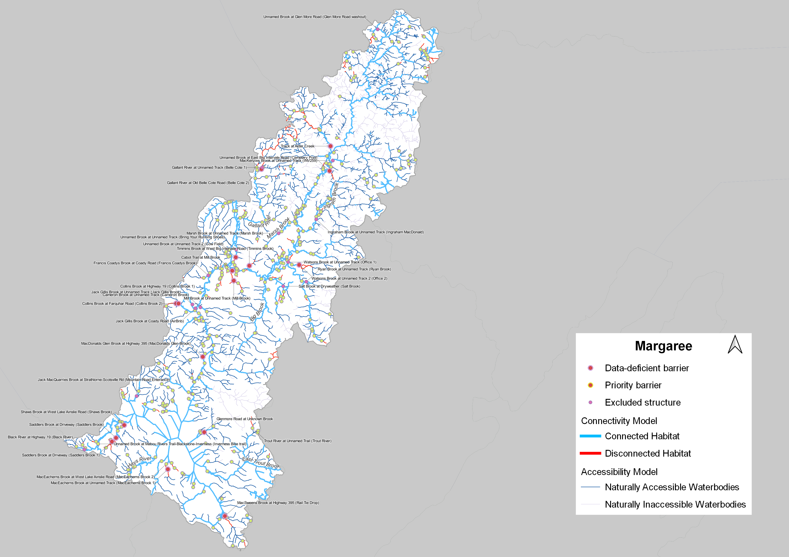
Figure 2: Map of focal species habitat and structures that are confirmed or potential barriers to fish passage in the Margaree watershed as of February 5th, 2026. Structure data were obtained from the Canadian Aquatic Barriers Database (aquaticbarriers.ca). The accessibility model represents areas of the watershed that focal species could access naturally in the absence of anthropogenic barriers. The habitat model represents the subset of accessible areas that may be used by focal species for key habitat function(s). Available local knowledge and data were incorporated and overrule habitat model results. Thick light-blue lines represent habitat that is currently connected, whereas thick red lines represent habitat considered to be disconnected because it is upstream of confirmed barriers or data-deficient structures. The y-axis represents the amount of habitat (km) blocked by each structure, discounted by 50% for first-order streams, and by passability (25%, 50%, or 75%) of partial barriers. Barriers that were rehabilitated through implementation of this plan are shown, but other excluded structures (e.g., those found to be passable) are not.

Progress Summary
The planning process for the Margaree River Connectivity Rehabilitation Plan began in 2024. Since that time, 39 structures have been assessed to determine their fish passage status, and habitat confirmations are planned for the 2026 field season. In total, 3 barriers have been rehabilitated through the removal of debris jams and one actionable barrier has been identified for the 2026 field season. The removal of debris jams at three sites has resulted in improved or restored access to approximately 30.25 km of habitat for focal species.

1. Vision and Scope

Purpose
The following Watershed Connectivity Restoration Plan (WCRP) represents the culmination of a collaborative planning effort, for the Margaree watershed, the overall aim of which is to build collaborative partnerships focusing on the health of the Margaree watershed to reduce the threat of aquatic barriers to migratory fish and the livelihoods that they support. This plan was developed to identify priority strategies that the Margaree River WCRP planning team (see Table 1) proposes to undertake between 2024-2035 to conserve and restore fish passage in the watershed, through crossing rehabilitation and barrier prevention strategies.
WCRPs are long-term, actionable plans that blend local stakeholder and rightsholder knowledge with innovative geographical information systems (GIS) analyses to gain a shared understanding of where restoration efforts will have the greatest benefit for migratory fish. The planning process is inspired by the Conservation Standards (v.4.0), which is a conservation planning framework that allows planning teams to systematically identify, implement, and monitor strategies to apply the most effective solutions to high priority conservation problems. There is a rich history of fish and fish habitat conservation and restoration work in the Margaree watershed that this WCRP builds upon and aims to complement over the length of the plan. This includes work undertaken by the Margaree Salmon Association and work supported by the Nova Scotia Salmon Association (NSSA) and the Atlantic Salmon Federation (ASF). The planning team will aim to work with the Nova Scotia Department of Transportation and other local stakeholders to promote coordination, decision-making, and implementation related to this plan.
The planning team compiled existing structure location and assessment data, habitat data, and previously identified priorities in the watershed, and combined this with local knowledge to create a strategic watershed-scale plan to improve freshwater connectivity. The Margaree River WCRP planning team applied the WCRP planning framework to define the “thematic” scope of freshwater connectivity and refine the “geographic” scope to identify the portions of the watershed where connectivity restoration efforts will take place. Additionally, the team selected focal species, assessed the current key habitat connectivity status of the watershed, defined concrete goals for gains in connectivity, undertook an iterative structure-ranking process to identify a list of priority barriers for rehabilitation to achieve those goals (?@tbl-priority). Although the current version of this plan is based on the best-available information at the time of publishing, WCRPs are intended to be “living plans” that are updated regularly as new information becomes available, or if local priorities and contexts change. As such, this document should be interpreted as a current “snapshot” in time, and future iterations of this WCRP will build upon the results presented in this plan to continuously improve the practice of aquatic barrier rehabilitation for migratory fishes in the Margaree watershed. For more information on how WCRPs are developed, see Mazany-Wright et al. (2021).

Vision
Healthy, well-connected stream networks within the Margaree watershed support thriving populations of migratory fish. Both residents and visitors to the watershed work together to mitigate the negative effects of aquatic barriers, improving the resiliency of the stream network for the benefit and appreciation of all.
The MSA has been working on fish passage barriers in smaller streams on the Margaree for many years, by removing beaver dams and clearing up blocked culverts. With this WCRP and in collaboration with ASF, CWF, and NSSA, MSA can start making data driven decisions on where to improve fish passage resulting in meaningful improvements for fish passage in the Margaree watershed.

Scope
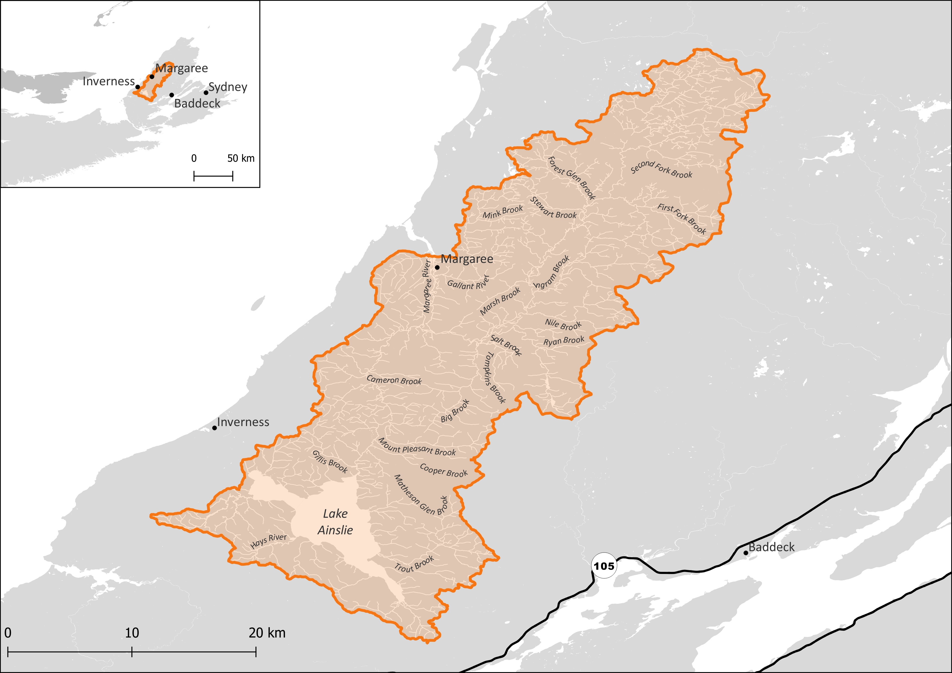 The geographic scope of this WCRP was further refined by identifying naturally accessible waterbodies, which are defined as streams, lakes, or reservoirs that focal species would access in the absence of anthropogenic barriers. Naturally accessible waterbodies were spatially delineated for each species using stream characteristics that define the upper limit of their movement based on their swimming abilities (?@tbl-species). The spatial extent of the naturally accessible waterbodies layer was then refined based on existing fish observation data and/or redd surveys (for Atlantic salmon). These maps were explored by the planning team to incorporate additional local knowledge, ensure accuracy, and finalize the criteria used to define naturally accessible waterbodies, which are shown for Atlantic salmon (?@fig-geoscope). The new geographic scope formed the foundation for all subsequent analyses and planning steps, including mapping and modelling key habitat, quantifying the current connectivity status, goal setting, and action planning, see Mazany-Wright et al. (2021).
Species | Accessibility Parameters | Key Habitat Parameters
Atlantic Salmon | Channel gradient <30%; waterfalls <5m | Channel gradient <3%
American Eel | All stream segments | Strahler order 2+
?(caption)

Focal Species
Focal species represent the ecologically and culturally important species for which habitat connectivity is being conserved or restored in the watershed. In the Margaree watershed, the planning team selected Atlantic salmon as a primary focus with interest in incorporating American eel in future work. The selection of these focal species was driven primarily by the focal species of the primary funds supporting this planning work, the rich angling history of the Margaree, and the current threats to Atlantic salmon in the region.

Atlantic Salmon
Atlantic salmon are anadromous fishes, meaning mature adults spawn in freshwater and juveniles rear in freshwater before undergoing a process called smoltification where they migrate out to the ocean for 1-3+ years before returning to the freshwater to repeat this process. Due to this migratory process, salmon require unimpeded access between the ocean and freshwater habitats to complete their life cycle.
Atlantic salmon spawn in the pool-riffle transition zones of the main stem and larger tributaries of a river De Gaudemar, Bonzom, and Beall (2000). Within these stretches, they seek out the tails of pools, where substrate size allows for females to excavate a space to deposit the eggs to incubate below gravel beds. Fast flowing, well oxygenated water with minimal fine sediments helps to maximize successful embryo development. Atlantic salmon juveniles (fry and parr) rear in habitat that is deeper and slower, to facilitate their weaker swimming and predation capabilities. Water depth, velocity, and substrate size tend to increase with parr as they increase in size and age. Shelter, in the form of large rocks, boulders, or overhead cover provide crucial refuge for overwintering habitat. Channel gradients most typically associated with these preferred spawning and rearing habitats range from 0.12 to 25%; with highest concentrations below 3% Amiro (1993).

American Eel
American eel are catadromous species, meaning they spawn in the Sargasso Sea and drift with the ocean currents towards the continental shelf as glass eels. Elvers then continue migrating towards freshwater tributaries to feed and mature, although some populations have been known to stay in the estuaries and bays or move between freshwater and estuary habitat over their life cycle. Their ability to tolerate a wide variety of salinities and temperature thresholds allows them to occupy a variety of habitat types. See Appendix B for maps of modelled eel habitat in the seven northeastern watersheds.

Structure Types
The following table highlights structure types threatening anadromous salmonids in the watershed. The results of this assessment were used to inform the subsequent planning steps; and identify knowledge gaps where there are limited spatial data to inform the assessment for a specific structure type.
Table 1.1: Structure types in the Margaree watershed and barrier rating assessment results. For each structure type listed ‘extent’ refers to the proportion of key habitat for Atlantic salmon that is being blocked by that structure type, ‘severity’ is the proportion of structures for each structure type that are known to block passage for Atlantic salmon based on field assessment, and ‘irreversibility’ is the degree to which the effects of a structure type can be reversed and connectivity restored. Key habitat for the purpose of this exercise is the total amount of spawning and rearing habitat represented within the Margaree watershed model.
Barrier Types | Extent | Severity | Irreversibility | Overall Threat Rating:
Small Dams (<5m Height) | Low | Low | Medium | Low
Natural Barriers | Medium | Low | Medium | Low
Road Stream Crossings | High | Very High | Low | High

2. Glossary

Freshwater connectivity:
The degree to which aquatic species can disperse and/or migrate freely through freshwater systems.

Longitudinal connectivity:
Connectivity of a stream along the upstream-downstream plane, including access to tributaries and spawning and rearing habitat. Longitudinal connectivity can be fragmented by physical barriers (e.g., anthropogenic, or natural structures) or by physiological limits of distribution for species (e.g., stream gradient, temperature, or flow requirements).

Lateral connectivity:
Connectivity of a stream bed to adjacent riparian wetlands, floodplains, side-channels, or off-channel features, including access to rearing and overwintering habitat. Lateral connectivity can be fragmented by physical barriers, channelization, armoring of the stream bed, or artificial flow regulation.

Vertical connectivity:
Connectivity of a stream bed to groundwater/hyporheic zone, including access to oxygen-rich water and temperature refugia. Vertical connectivity can be fragmented by water withdrawals and anthropogenically induced changes to the hydrological, thermal, and sediment regimes of the watershed.

Temporal connectivity:
Connectivity variability in any of the three spatial dimensions (longitudinal, lateral, vertical) based on changes in the natural flow regime over time. Variation in the temporal connectivity occurs naturally; however, fragmentation can be exacerbated through anthropogenically induced changes to the hydrological, thermal, and sediment regimes of the watershed.

Geographic Scope:
The spatial bounds within which connectivity models are applied and fish-passage improvement efforts are focused. This area is refined after the accessibility model is developed to cover only streams that are naturally accessible to each focal species or guild (see naturally accessible streams below).

Focal Species:
The ecologically and culturally important species (e.g., Chinook Salmon) for which habitat connectivity is being conserved and/or restored in the watershed.

Focal Guild:
Two or more focal species grouped together by shared characteristics (e.g., migratory behavior, swimming ability, and habitat use).

Key Ecological Attribute (KEA):
An aspect of a focal species or guild’s biology or ecology that, if missing or altered, would lead to the loss of that focal species over time (e.g., proportion of connected spawning habitat).

Structure:
A feature, either anthropogenic (e.g., culvert, dam) or a temporary natural feature (e.g., barrier beach, debris jam) that may fragment freshwater systems and limit the ability of species to disperse and/or migrate freely within their naturally accessible habitat. Differentiated from more permanent natural features, such as waterfalls, that delineate naturally accessible waterbodies.

Set of structures:
A set of two or more structures that must be addressed/considered together for restoration or rehabilitation when considering the total amount of connectivity to be gained during barrier prioritization.

Passability status:
A categorization of how passable a structure is (unknown, partially passable, passable, impassable) to the focal species or guild. Note: this status may differ from a passability status defined in another database that reflects passability to non-focal species or uses other terms such as “potentially passable”.

Barrier:
A structure that has been assessed as impassable to the focal species for all life stages.

Partial barrier:
A structure that differs in passability status (impassable and passable) across life stages or through time (e.g., seasonally).

Passable:
A structure that is fully passable to the focal species for all life stages.

Unknown:
A structure for which passability by the focal species is unknown. These are typically structures that have not been assessed or have been assessed but require further assessment. These structures are considered barriers in connectivity models.

Modeled barrier:
All structures assessed as barriers and partial barriers, or with unknown status (either unassessed or assessed but needs more information is still needed) are treated as barriers in connectivity models.

Confirmed barrier:
All barriers and partial barriers with confirmed key habitat upstream.

Deferred barrier:
Priority barrier for rehabilitation: The subset of confirmed barriers selected for proactive rehabilitation based on modelling outcomes. Remaining confirmed barriers may never be addressed or may be addressed at the end of their life cycle.

Natural barrier:
A permanent natural feature, such as a waterfall, stream reach with a steep gradient, or area of subsurface flow that focal species would not be able to pass. For diadromous species, all waterbodies upstream of such natural barriers are considered inaccessible. Resident species may have populations upstream and downstream of such barriers.

Stream network (also, hydrographic network):
The spatial representation of all waterbodies (streams, rivers, and lakes) in a watershed. The stream network is the foundation for all spatial modelling, and the accessibility and habitat models create subsets of the stream network.

Naturally accessible waterbodies:
The portions of the stream network that are considered likely accessible to focal species or guilds if no anthropogenic barriers existed on the landscape. These are typically defined as all waterbodies downstream of natural barriers for diadromous species. For resident species, populations may persist upstream of a natural barrier; therefore, naturally inaccessible waterbodies are those upstream of a natural barrier where no observations of the focal species have been recorded.

Current Connectivity Status:
The measure of important habitat (i.e., amount, proportion, or index) that is currently connected (i.e., unaffected by structures with a status of unknown, partially passable, or impassable) for each focal species and KEA. For non-diadromous species, indices such as the longest fragment or Dendridic Connectivity Index – potadromous (DCIp; Cote et al. 2009).

Connectivity Goal:
A SMART (Specific, Measurable, Achievable, Relevant, and Time-Bound) goal representing the desired future connectivity status of each focal species and KEA (e.g., a percent or total km of habitat) and the time by which it will be achieved (a target year).

Structure Prioritization:
An analysis that ranks structures (individually and/or in sets) by the amount of key habitat disconnected by each individual structure. Structures are ranked in descending order according connectivity gains (e.g., greatest amount of linear km of important habitat) if restored or rehabilitated. This analysis includes structures with a passability status of “unknown”, “partially passable”, or “impassable”.

Restoration:
Returning the ecological structure and function (e.g., natural channel-forming processes) of a site to pre-disturbance conditions.

Rehabilitation:
The partial recovery of ecosystem function. This is typical when improving passage by replacing one type of crossing with another that is passable but may still affect the streambed or channel-forming processes.

Rehabilitated barriers:
Structures for which connectivity for aquatic species was restored by altering or maintaining a structure that previously impeded movement.

Remediation:
A term for a form of restoration most often associated with mining, referring to the remediation of contaminated sediments. Often used as jargon in fish-passage discussions because it applies to both fish passage and barriers (i.e., both can be described as “remediated”). Most fish-passage projects involve ecological rehabilitation, but it is inaccurate to write that a barrier was rehabilitated. Instead, fish passage should be described as rehabilitated, improved, or restored (if appropriate), and barriers described as removed or addressed.

Excluded structures:
Structures that were investigated during a project but were removed from consideration or the model. Reasons for their exclusion could be that they do not exist, are passable, or no key habitat was found upstream.

Assessed structures that remain data deficient:
Structures that have had some form of assessment but need further investigation before a decision can be made to categorize them as either confirmed barriers, excluded structures (passable, non-existent, no suitable upstream habitat), or rehabilitated structures.

3. Methods

Connectivity Modelling
The current connectivity status was estimated using three models:
Accessibility model: Naturally accessible waterbodies are those that are considered likely accessible to focal species if no human-made barriers existed on the landscape. These were spatially delineated for each focal species using natural barriers (i.e., waterfalls, gradient barriers, or subsurface flows) that would limit upstream movement (?@tbl-species).
Habitat model: A subset of the naturally accessible waterbody layer was defined as key habitat based on the KEA. The habitat model identifies waterbodies that have a higher potential to support key habitat based on stream characteristics like channel gradient and discharge. The habitat model criteria can be found in (?@tbl-species).
Connectivity model: A layer of known or modelled structures was overlaid on the key habitat results. Structures with unknown passability were treated as a full barrier until confirmed passable (100% passable) or partially passable (25, 50, or 75%) by either local knowledge, desktop review, or field assessment. Watershed connectivity was estimated by calculating the amount of key habitat that is connected to the ocean (i.e., not fragmented by human-made barriers). The amount of key habitat considered connected was determined by the cumulative passability of all downstream barriers. Key habitat with only passable structures downstream was considered fully connected. All key habitat with any full barrier downstream was considered disconnected. Connected key habitat upstream of partial barriers was weighted based on the passability values of any downstream partial barriers. For example, a 10 km habitat patch with two downstream partial barriers (both with 50% passability) was considered to represent 2.5 km of connected key habitat. All connected habitats were summed and divided by the total amount of key habitat in the watershed to determine the proportion of connected habitat relative to the entire watershed.
A primary outcome of the WCRP is addressing barriers to restore connectivity within the Margaree River watershed. To achieve the goals set out in this plan it is necessary to identify a series of barriers that if made passable would reconnect a large contribution of Atlantic salmon and American eel habitat.
After all existing data and knowledge are collated for known and modelled crossings, an iterative ranking process is conducted to help confirm barriers to target for rehabilitation to meet the goals. The ranking process is primarily used to guide field assessments and maximize efficiency in ground truthing data/knowledge inputs and model outputs, while providing a secondary purpose to evaluate the relative key habitat gains of confirmed barriers in the watershed. Field assessments can include an assessment of either the passability status of a structure (whether fish can pass upstream, and to what degree), whether the upstream habitat is suitable for the focal species, and whether there are other undocumented anthropogenic or natural barriers upstream or downstream. First, structures are grouped into ‘sets’. Sets are identified by maximizing the key habitat gain for barriers in the same tributary system. If adding a structure to a set reduces the gain-per-barrier (i.e., the total habitat gain of the set divided by the number of barriers in the set), then it is excluded and will be considered part of another set. Each set is ranked by its potential to contribute to restoring the overall habitat connectivity. The higher a set is ranked, the more potential contribution it makes to restoring the overall habitat connectivity, therefore making the set a higher priority for field assessment. By assessing the passability status and upstream habitat of the top-ranked sets, we close knowledge gaps with the greatest influence on the overall connectivity model results.
Sets are ranked by a combination of two factors:
- The long-term potential impact that restoring connectivity at that structure could have on the overall connectivity status. This was measured by calculating and ranking sets by the amount of total upstream key habitat (i.e., ignoring any additional upstream sets). This ranking identifies sets that would have the greatest long-term potential gain in habitat connectivity once any subsequent upstream barriers are addressed.
- The immediate potential impact that restoring connectivity at that structure could have on the overall connectivity status. This was measured by calculating the amount of functional upstream habitat (i.e., key habitat between that set and the next upstream set of structures). Sets were then ranked by functional upstream habitat amount in tiers, where sets with no downstream sets were ranked first, then sets with one downstream set, and so on. This ranking identifies sets that have the greatest immediate potential gain in habitat by prioritizing sets that don’t rely on rehabilitation of downstream or upstream sets to realize these gains.
An overall ranking for each set was produced as a composite of the long-term and immediate potential gain ranks to prioritize sets that maximize long-term and immediate potential to improve key habitat connectivity in the watershed. All structures in the watershed (excluding those confirmed as passable) were ranked and a subset of those structures were selected for field assessment.
The majority of crossing structures in the Margaree River watershed were stream crossings for roads and trails making them the most abundant structure type in the watershed. The Margaree River watershed is also home to heavy beaver activity which can impact the flow and behaviour of streams within the watershed. Rapid assessment and ground truthing was completed for many of the structures within the watershed with formal assessments completed at three sites. Subsequent planning was done in partnership with the Nova Scotia Salmon Association to start the process of restoring structures by applying for applicable permits and beginning the restoration planning process.

Structure Ranking

4. Connectivity Status and Ranking

Current Connectivity Status
The current connectivity status assessment relies on GIS analyses to map known and modelled barriers to fish passage, identify stream reaches that have potential spawning and rearing habitat, estimate the proportion of habitat that is currently accessible to target species, and prioritize barriers for field assessment that would provide the greatest gains in connectivity. To support a flexible prioritization framework to identify priority barriers in the watershed, two assumptions are made: 1,any modelled (i.e., passability status is unknown) or partial barriers are treated as complete barriers to passage and 2, the habitat modelling is binary, it does not assign any habitat quality values. As such, the current connectivity status will be refined over time as more data on habitat and barriers are collected.
Table 4.1: Table showing current connectivity status for the Margaree watershed and the percentage of connected versus disconnected key habitat within the watershed as of February 27th, 2026.
Target Species | KEA | Indicator | Poor | Fair | Good | Very Good
Atlantic Salmon | % of Key Habitat | % of total habitat | <50% | 51-75% | 76-90% | >90%
 |  | Current Status: |  |  |  | 92
Comments: Indicator rating definitions are based on the consensus decisions of the planning team, including the decision not to define Fair. The current status is based on the connectivity model output, which is current as of February 5th, 2026.
Ranking of structures helps to identify which structures would open up the most habitat in key habitat areas of the watershed, this acts as a planning tool to indicate which barriers make sense to focus on in order to have the most impact on connectivity for focal species in the watershed.
Table 4.2: Goals to improve (1) spawning, and (2) rearing habitat connectivity for focal species in the Margaree watershed over the lifespan of the WCRP (2024-2035). The goals were established through discussions with the planning team and represent the resulting desired state of connectivity in the watershed. The goals are subject to change as more information and data are collected over the course of the plan timeline (e.g., the current connectivity status is updated based on barrier field assessments).
Goal # | Goal
1 | By 2035, increase the amount of connected habitat within the Margaree watershed.

Habitat Accumulation Curve

Figure 4.1: Habitat Accumulation Curve (HAC) showing structures in the Margaree watershed as of February 5th, 2026. Structures are ranked based on how much (km) habitat is upstream to the next structure or set of structures and that would be reconnected if the structure(s) became passable. Habitat upstream of data-deficient structures is considered disconnected until field assessments are completed. Structures that were excluded as passable are not shown; however, rehabilitated barriers are shown to demonstrate the connectivity gains achieved through implementation of this plan.

Map

5. Work Planning

Workplan Table

Operational Plan
The 2026 operational plan for the Margaree River Watershed will be created in the spring of 2026 to identify potential leads, potential participants, and estimated cost for the implementation of each action to take place in the Margaree watershed. Individuals and groups who are identified as potential participants will be contacted and engaged to plan who will lead and assist throughout the execution of this WCRP. Any organizations or individuals who express interest in participating will be listed in the “Lead” or “Potential Participants” column of the created operational plan to provide clarity on task roles and responsibilities. A roadmap for future coordination and engagement will be drafted in order to support activities described in the WCRP.
?(caption)
Table 5.1: SAMPLE Operational plan to support the implementation of strategies and actions to improve connectivity for target species in watershed.
Strategy / Actions | Lead(s) | Participants
1.1 – Conduct habitat assessment above and below confirmed actionable barriers | MSA | MSA, CWF to support
1.2 – Apply for permitting for actionable barriers with disconnected confirmed habitat | MSA | NSSA
1.3– Rehabilitate Stream-Road Crossings | MSA | MSA, NSSA, CWF to support
2 – Clear debris jams and identify opportunities to connect habitat without structure restoration | MSA
3 – Knowledge gap: Look into thermal refugia and lateral barriers within the Margaree. | MSA | CWF, ASF
?(caption)

6. Acknowledgements and References

Recommended Citation

Acknowledgements

References
Amiro, P. 1993. Habitat Measurement and Population Estimation of Juvenile Atlantic Salmon (Salmo Salar). Canadian Special Publication of Fisheries; Aquatic Sciences: Department of Fisheries; Oceans.
De Gaudemar, B, J M Bonzom, and E Beall. 2000. “Development and Stability of Barrier Beaches on the Atlantic Coast of Nova Scotia.” Journal of Fish Biology 57: 502–15.
Mazany-Wright, N, J Noseworthy, S Sra, S M Norris, and N W Lapointe. 2021. “Breaking down Barriers: A Practitioners’ Guide to Watershed Connectivity Remediation Planning.” Canadian Wildlife Federation.

Version History

Partners

Planning Team
Name | Organization
Micheal Fabiano | Margaree Salmon Association
Paul MacNeil | Margaree Salmon Association
Bill Haley | Margaree Salmon Association
Thomas Sweeny | Nova Scotia Salmon Association
Fielding Montgomery | Canadian Wildlife Federation
Nick Mazany-Wright | Canadian Wildlife Federation
Nicolas Lapointe | Canadian Wildlife Federation
Courtney Brake | Canadian Wildlife Federation
Kris Hunter | Atlantic Salmon Federation
?(caption)

Key Actors
Individual or Organization Name | Role and Primary Interest
Nova Scotia Department of Public Works | Local government department that would be tasked with culvert replacement.
Cheticamp River Salmon Association | Field support of MSA activities.
?(caption)

Detailed Methods

Connectivity Status Assessment Methods
The connectivity status assessment for anadromous salmonids in the Margaree watershed builds on existing connectivity modelling work undertaken by the Canadian Wildlife Federation in partnership with the Atlantic Salmon Federation. The Margaree model within the NovaScotiaFishPass spatially locates known and modelled barriers to fish passage, identifies potential spawning and rearing habitat for focal species, and estimates the amount of habitat that is currently accessible to focal species within the Margaree.

Priority Barriers
ID | Stream name | Road name | Owner | Proposed fix | Estimated cost | Upstream habitat Quality | Barrier type | Habitat gain | Cost Benefit ratio | Priority | Next steps | Reason | Notes
6cd84598-ee60-48a7-8215-9482dd9d2ed5 | MacSweens Brook |  | NS Department of Public Works |  | N/A | To be Assessed | Velocity and Vertical Barrier | 1.9km | N/A | High | Habitat Assessment and Engagement with NS Department of Public Works | Restore Passage | basically a water fall, 3 foot drop and large velocity barrier
?(caption)

Non-Actionable Barriers
ID | Stream name | Road name | Owner | Proposed fix | Estimated cost | Upstream habitat Quality | Barrier type | Habitat gain | Cost Benefit ratio | Priority | Next steps | Reason | Notes
6cd84598-ee60-48a7-8215-9482dd9d2ed5 | MacSweens Brook |  | NS Department of Public Works |  | N/A | To be Assessed | Velocity and Vertical Barrier | 1.9km | N/A | High | Habitat Assessment and Engagement with NS Department of Public Works | Restore Passage | basically a water fall, 3 foot drop and large velocity barrier
?(caption)

Excluded Structures
ID | Stream name | Road name | Owner | Proposed fix | Estimated cost | Upstream habitat Quality | Barrier type | Habitat gain | Cost Benefit ratio | Priority | Next steps | Reason | Notes
6cd84598-ee60-48a7-8215-9482dd9d2ed5 | MacSweens Brook |  | NS Department of Public Works |  | N/A | To be Assessed | Velocity and Vertical Barrier | 1.9km | N/A | High | Habitat Assessment and Engagement with NS Department of Public Works | Restore Passage | basically a water fall, 3 foot drop and large velocity barrier
?(caption)

Data Deficient Structures
ID | Stream name | Road name | Owner | Proposed fix | Estimated cost | Upstream habitat Quality | Barrier type | Habitat gain | Cost Benefit ratio | Priority | Next steps | Reason | Notes
6cd84598-ee60-48a7-8215-9482dd9d2ed5 | MacSweens Brook |  | NS Department of Public Works |  | N/A | To be Assessed | Velocity and Vertical Barrier | 1.9km | N/A | High | Habitat Assessment and Engagement with NS Department of Public Works | Restore Passage | basically a water fall, 3 foot drop and large velocity barrier
?(caption)

