Horsefly River Watershed Secwepemcúl’ecw Connectivity Restoration Plan: 2021 - 2040
Canadian Wildlife Federation
08-01-2025
Table of contents

Acknowledgements
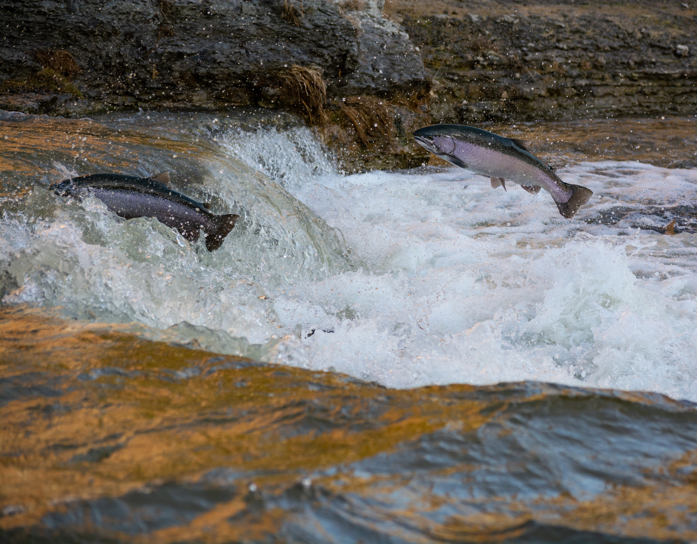
This plan is the culmination of a collaborative planning process undertaken in the Horsefly River watershed over many months with a team of individuals and groups that are passionate about the conservation and restoration of freshwater ecosystems and the species they support. Plan development was funded by the B.C. Salmon Restoration and Innovation Fund, Canada Nature Fund for Aquatic Species at Risk, and the RBC Bluewater Project.
We were fortunate to benefit from the feedback, guidance, and wisdom of many people who volunteered their time throughout this process — this publication would not have been possible without the engagement of our partners and the planning team (see ?@tbl-planteam). We recognize the incredible fish passage and connectivity work that has occurred in the Horsefly River watershed to-date, and we are excited to continue partnering with local groups and organizations to build upon existing initiatives and provide a road map to push connectivity restoration forward over the next 20 years and beyond.
The Canadian Wildlife Federation recognizes that the lands and waters that form the basis of this plan are the traditional unceded territory of the Northern Secwepemc people. We are grateful for the opportunity to learn from the stewards of this land and work together to benefit Pacific Salmon. A special thank you to Nishitha Singi for sharing the traditional Secwepemctsín names used in this plan.

1. Project Overview

Plan Purpose, Approach, and Scope
The following Watershed Connectivity Restoration Plan (WCRP) represents the culmination of a collaborative planning effort, the overall aim of which is to build collaborative partnerships within the Horsefly River watershed to improve connectivity for anadromous salmon and the livelihoods that they support, including the continued sustenance, cultural, and ceremonial needs of the Northern Secwépemc people. This 20-year plan was developed to identify priority actions that the Horsefly River WCRP planning team (see ?@tbl-planteam for a list of team members) will undertake between 2021-2040 to conserve and restore fish passage through barrier rehabilitation and prevention strategies.
WCRPs are long-term, actionable plans that blend local stakeholder and rightsholder knowledge with innovative geographic information systems (GIS) analyses to gain a shared understanding of where restoration efforts will have the greatest benefit for anadromous salmon. The planning process is inspired by the Conservation Standards (v.4.0), which is a conservation planning framework that allows planning teams to systematically identify, implement, and monitor strategies to apply the most effective solutions to high-priority conservation problems. There is a rich history of fish habitat planning and restoration work in the Horsefly River watershed that this WCRP builds upon, including work undertaken by the B.C. Fish Passage Technical Working Group, the Northern Secwepemc te Qelmucw (NStQ) and member communities, the Horsefly River Roundtable, and other local organizations (Masse Envrionmental Consultants Ltd. (2018); S. Hocquard, Steve Hocquard Consulting, pers. comm.).
The planning team compiled existing structure location and assessment data, habitat data, and previously identified priorities, and combined this with local and Indigenous knowledge to create a strategic watershed-scale plan to improve connectivity. The Horsefly River WCRP planning team applied the WCRP planning framework to define the “thematic” scope of freshwater connectivity and refine the “geographic” scope to identify only those portions of the watershed where structure prioritization will be conducted, and subsequent restoration efforts will take place. Additionally, the team selected focal fish species, assess the current key habitat connectivity status of the watershed, defined concrete goals for gains in connectivity, and undertook an iterative structure-ranking process to identify a list of priority barriers for rehabilitation to achieve those goals. Although the current version of this plan is based on the best-available information at the time of publishing, WCRPs are intended to be “living plans” that are updated regularly as new information becomes available, or if local priorities and contexts change. As such, this document should be interpreted as a current “snap-shot” in time, and future iterations of this WCRP will build upon the material presented in this plan to continuously improve connectivity planning in the Horsefly River watershed. For more information on how WCRPs are developed, see (Mazany-Wright et al. (2021c)).

Vision Statement
Healthy, well-connected streams and rivers within the Horsefly River watershed support thriving populations of migratory fish, improving the overall ecosystem health of the watershed. In turn, these fish provide the continued sustenance, cultural, and ceremonial needs of the Northern Secwépemc People, as they have since time immemorial. Both residents and visitors to the watershed work together to mitigate the negative effects of human-made aquatic barriers, improving the resiliency of streams and rivers for the benefit and appreciation of all.

Project Scope
Connectivity influences critical components of freshwater ecosystem structure and function, such as aquatic species dispersal and migration, the transport of energy and matter (e.g., nutrient cycling and sediment flows), and temperature regulation (Seliger and Zeiringer (2018)). Though each of these factors are important when considering the health of a watershed, for the purposes of this WCRP the term “connectivity” is defined as the degree to which focal species can disperse or migrate freely through freshwater systems. Within this context, connectivity is primarily constrained by physical barriers, including human-made infrastructure such as dams, weirs, and stream crossings, and natural features such as waterfalls and debris flows. This plan is intended to focus on the direct rehabilitation and prevention of localized, physical barriers instead of the broad land-use patterns that are causing chronic connectivity issues in the watershed. The planning team decided that the primary focus of this WCRP is addressing barriers to both longitudinal connectivity (i.e., along the upstream-downstream plane) and lateral connectivity (i.e., connectivity between the mainstem and adjacent riparian wetlands and floodplains) due to the importance of maintaining fish passage to spawning, rearing, and overwintering habitat in the watershed.
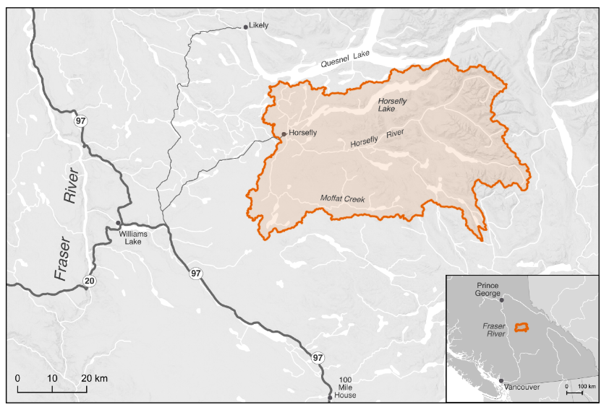
Figure 1.1: The primary geographic scope — the Horsefly River watershed — located in the Fraser River system.
The primary geographic scope of this WCRP is the Horsefly River watershed, located in the upper Fraser River drainage basin in central British Columbia (Figure 1.1). The scope constitutes the Horsefly River “watershed group” as defined by the British Columbia Freshwater Atlas (FWA). A consistent spatial framework was necessary to undertake a watershed selection process at the provincial scale to identify target watersheds to improve connectivity for salmon. The Horsefly River watershed was identified by the B.C. Fish Passage Restoration Initiative as one of four target watersheds for WCRP development (Mazany-Wright et al. (2021b)). The Horsefly River watershed has a drainage area of 276,603 ha, spanning from the Quesnel Highlands in the southeast to the confluence with Quesnel Lake in the northwest. Culturally and economically important populations of Chinook Salmon, Coho Salmon, and Sockeye Salmon are all found in the watershed, which historically supported Indigenous sustenance and trading economies (W. L. F. Nation. (2021), X. F. Nation. (2021)).
Secwepemctsín Name | Common Name | Scientific Name
Kekèsu | Chinook Salmon | Oncorhynchus tshawytscha
Sxeyqs | Coho Salmon | Oncorhynchus kisutch
Sqlelten7ùwi | Sockeye Salmon | Oncorhynchus nerka
?(caption)
The Horsefly River watershed comprises parts of Secwepemcúl’ecw, the traditional territory of the Northern Secwepemc te Qelmucw (NStQ), represented by the Northern Shuswap Tribal Council and four member communities or autonomous nations:
- Xatśūll Cmetem’ (Soda Creek First Nations)
- Stswēceḿc Xgāt’tem (Canoe Creek/Dog Creek First Nations)
- T’ēxelc (Williams Lake First Nation)
- Tsq’ēsceń (Canim Lake First Nation)
The geographic scope of this WCRP was further refined by identifying naturally accessible waterbodies, which are defined as waterbodies that focal species should be able to access in the absence of human-made barriers (Figure 1.2). Naturally accessible waterbodies were spatially delineated using fish species observation and distribution data, as well as data on “natural barriers”. These include waterfalls greater than 5 m in height, gradient barriers based on literatrure-derived species-specific swimming abilities, and areas of subsurface flow. These maps were explored by the planning team to incorporate additional local knowledge, ensure accuracy, and finalize the constraints on naturally accessible waterbodies. The planning team identified certain tributaries to the mainstem Horsefly River as “watershed exclusion areas”, which were excluded from further consideration under this plan due to intermittent or insufficient flows to support restoring connectivity for the focal species. The geographic scope was further refined based on several confirmed impassable waterfalls and modelled gradient barriers. Specifically, there are two impassable waterfalls that severely limit natural accessibility: one on the mainstem Horsefly River approximately 4 km upstream of the confluence with McKinley Creek, and the second on Moffat Creek approximately 5 km upstream from where it flows into the Horsefly River. All waterbodies not identified as naturally accessible were removed from the scope for further consideration. The naturally accessible waterbodies formed the foundation for all subsequent analyses and planning steps, including mapping and modelling useable habitat types, quantifying the current connectivity status, goal setting, and action planning (Mazany-Wright et al. (2021a)).
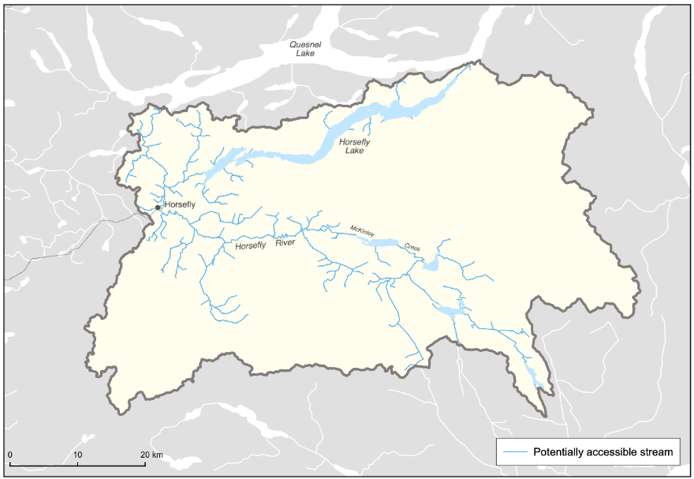
Figure 1.2: Naturally accessible waterbodies within the Horsefly River watershed. These do not represent useable habitat types, but rather identify the waterbodies within which habitat modelling and structure mapping and prioritization were undertaken.

Focal species
Focal species represent the ecologically and culturally important species for which habitat connectivity is being conserved or restored in the watershed. In the Horsefly River watershed, the planning team selected anadromous salmon as the focal guild, which comprises Chinook Salmon (Oncorhynchus tschawystcha), Coho Salmon (O. kisutch), and Sockeye Salmon (O. nerka). The selection of these focal species was driven primarily by the focal species of the primary fund supporting this planning work.

Anadromous Salmon
Anadromous salmon are cultural and ecological keystone species that contribute to productive ecosystems by contributing marine-derived nutrients to the watershed and forming an important food source for other species. Salmon species are sacred to the NStQ, having sustained life, trading economies, and culture since time immemorial (W. L. F. Nation. (2021), X. F. Nation. (2021), N. Singi pers. comm.). The stewardship of the resources and fisheries in their traditional territories are imbued in the spirit of the NStQ through a symbiotic relationship based on respect – the NStQ never take more salmon than is needed and there is no waste. The entirety of the salmon is used - smoked and dried to sustain the NStQ through the winter months, the roe harvested for consumption, salmon oil rendered to be stored and traded, and the skin used to store the oil (Wilson, Twohig, and Dahlstrom (1998), X. F. Nation. (2021), N. Singi pers. comm.). The salmon runs begin to return to the Horsefly River watershed in early August, and the NStQ traditionally celebrate and feast at this time. The harvest of the salmon strengthens the cultural connection to the land and the waters, providing an important food source for communities and the opportunity to pass knowledge and ceremony to future generations through fishing and fish processing (W. L. F. Nation. (2021), X. F. Nation. (2021)).
Anadromous salmon populations in the Horsefly River watershed have declined significantly in the past few decades, with the populations of all three focal species being listed as Threatened or Endangered by the Committee on the Status of Endangered Wildlife In Canada (COSEWIC). This has been exacerbated by the Big Bar landslide on the Fraser River in 2019, leading the four NStQ communities to voluntarily close the salmon fishery from 2019-2022. The stewardship of their waters continues through the work of the NStQ member communities and the Northern Shuswap Tribal Council.

Chinook Salmon | Kekèsu | Oncorhynchus tshawytscha
Conservation Unit | Biological Status | Run timing | Trend in spawner abundance (all available data) | Trend in spawner abundance (last 3 generations)
Middle Fraser River (Spring 5-2, 1.3) | Data Deficient/Poor | Data Deficient | Data Deficient | Data Deficient
?(caption)
COSEWIC Designated Unit | Status | Trend | Median percent change (last 3 generations) | Median percent change (historic) | Generation length
9- Middle Fraser, Stream, Spring (MFR+GStr) population | Threatened | Declining | -28% | -49% | 4.5 years
Chinook Salmon are the first to return each year, usually in early August (DFO (1991)), and have the most limited distribution within the watershed. Known spawning occurs in parts of the Horsefly River mainstem above the confluence with the Little Horsefly River and throughout McKinley Creek as far as Elbow Lake (DFO (1991), S. Hocquard, pers. comm.). Important rearing systems include Patenaude Creek, Kroener Creek, Black Creek, Woodjam Creek, Deerhorn Creek, and Wilmot Creek (S. Hocquard, pers. comm.).

Coho Salmon | Sxeyqs | Oncorhynchus kisutch
Conservation Unit | Biological Status | Run timing | Trend in spawner abundance (all available data) | Trend in spawner abundance (last 3 generations)
Interior Fraser | Data Deficient/Fair | Data Deficient | Data Deficient | Data Deficient
?(caption)
COSEWIC Designated Unit | Status | Trend | Median percent change (last 3 generations) | Median percent change (historic) | Generation length
Interior Fraser – Mid/Upper Fraser population | Threatened | Declining | Not estimated | +119% estimated based on last 10 years of escapement data-21% estimated based on entire escapement time series | 3 years
Coho Salmon are the most widely distributed of the three focal species in the watershed, with the ability to migrate into smaller, upper tributary systems (DFO (1991)). Spawning occurs in the Little Horsefly River between Gruhs Lake and Horsefly Lake, McKinley Creek below McKinley Lake, Woodjam Creek, Patenaude Creek, Tisdall Creek, and Black Creek. Rearing fry and juveniles have been observed in the Little Horsefly River, Patenaude Creek, and McKinley Creek up to Bosk Lake (DFO (1991), S. Hocquard pers. comm.).

Sockeye Salmon | Sqlelten7ùwi | Oncorhynchus nerka
Conservation Unit | Biological Status | Run timing | Trend in spawner abundance (all generations) | Trend in spawner abundance (last 3 generations)
Quesnel-Summer (cyclic) | Data Deficient/Fair-Poor | July-September | Data Deficient | Data Deficient
?(caption)
COSEWIC Designated Unit | Status | Trend | Median percent change (last 3 generations) | Median percent change (historic) | Generation length
16 -Quesnel-S population | Endangered | Declining | 260,974 | -97% | 272%
Sockeye Salmon have historically been the most abundant of the three focal species in the watershed, though the population has seen significant declines in recent years (DFO (1991), S. Hocquard pers. comm.). Sockeye Salmon spawning is known to occur throughout the Horsefly River (up to the impassable falls), in the Little Horsefly River between Gruhs Lake and Horsefly Lake, Moffat Creek (up to the impassible falls), and McKinley Creek up to Elbow Lake (Pacific-Salmon-Foundation (2024), DFO (1991), S. Hocquard pers. comm.). Additionally, a spawning channel aimed at enhancing the Sockeye Salmon population was constructed by Fisheries and Oceans Canada in 1989 (DFO (1991)). Currently, there are no Sockeye Salmon rearing in the Horsefly River watershed – all emergent fry migrate down to Quesnel Lake.

Structure Types
The following table highlights which structure types pose the greatest threat to anadromous salmon in the watershed. The results of this assessment were used to inform the subsequent planning steps, as well as to identify knowledge gaps where there is little spatial data to inform the assessment for a specific barrier type.
Table 1.1: Structure Types in the Horsefly River watershed and structure rating assessment results. For each structure type listed, Extent refers to the proportion of anadromous salmonid habitat that is being blocked by that structure type, Severity is the proportion of structures for each structure type that are known to block passage for focal species based on field assessments, and Irreversibility is the degree to which the effects of a structure type can be reversed and connectivity restored. The amount of habitat blocked used in this exercise is a representation of total amount of combined spawning and rearing habitat.
Structure Types | Extent | Severity | Irreversibility | Overall Threat Rating:
Road-Stream Crossings | Low | Very High | Medium | Very High
Lateral Barriers | High | Very High | High | High
Small Dams(<3m height) | Low | Low | High | Medium
Trail-stream Crossings | Low | Low | Medium | Low
Natural Barriers | Medium | High | Low | Low

Road-stream Crossings
Road-stream crossings are the most abundant structure type in the watershed, with 243 assessed and modelled crossings located on waterbodies with upstream modelled habitat. Demographic road crossings (highways, municipal, and paved roads) block 10.24 km of habitat (~3% of the total blocked habitat), with 69% of assessed crossings having been identified as barriers to fish passage. Resource roads block 17.31 km of habitat (~5%), with 60% of assessed crossings having been identified as barriers. The planning team felt that the data were underestimating the severity of road-stream crossing structures in the watershed, and therefore decided to update the rating from High to Very High. The planning team also felt that an irreversibility rating of Medium was appropriate due to the technical complexity and resources required to rehabilitate road-stream crossings.

Lateral Barriers
There are numerous types of lateral barriers that potentially occur in the watershed, including dykes, berms, and linear development (i.e., road and rail lines), all of which can restrict the ability of anadromous salmon to move into floodplains, riparian wetlands, and other off-channel habitats. No comprehensive lateral barrier data exists within the watershed, so threat ratings were based on qualitative local knowledge. Lateral barriers are not thought to be as prevalent as road- or rail-stream crossings but are likely very severe where they do exist. Significant lateral barriers are known to occur along the mainstem of the Horsefly River, which disconnect the mainstem river from historic floodplain and off-channel habitat. Overall, the planning team decided that a High threat rating adequately captured the effect that lateral barriers are having on connectivity in the watershed. Work to begin quantifying and mapping lateral habitat commenced in 2022, as described in the Operational Plan (Table 4.1) under Strategy 2: Lateral barrier rehabilitation.

Small Dams (<3 m height)
Initially, 6 mapped small dams were identified in the watershed that had upstream modelled spawning or rearing habitat for key species. Field assessments were conducted in 2021 and 2022, and 5 of the mapped dams were identified as presenting no barrier to fish passage because they did not exist, were off channel, or had no suitable key habitat upstream (see ?@tbl-excluded_structures). The remaining dam, at the outlet of McKinley Lake is equipped with a fishway that provides passage for salmon. The effectiveness of the fishway on the McKinley Lake dam is unknown, and further study to assess fish passage efficiency is recommended (see Table 4.4).

Trail-stream Crossings
There is very little spatial data available on trail-stream crossings in the watershed, so the planning team was unable to quantify the true Extent and Severity of this structure type. However, the planning team felt that trail-stream crossings are not prevalent within the watershed and that, where they do exist, they do not significantly restrict passage for anadromous salmon. As most crossings will be fords or similar structures, rehabilitation may not be required, or rehabilitation costs associated with these structures would be quite low. Overall, the planning team felt that the threat rating for trail-stream crossings was likely Low; however, the lack of ground-truthed evidence to support this rating was identified as a knowledge gap within this plan.

Natural Barriers
Natural barriers to fish passage can include debris flows, log jams, and sediment deposits, but natural features that have always restricted fish passage (e.g., waterfalls) are not considered under this barrier type. Natural barriers are difficult to include in a spatial prioritization framework due to their transient nature. The planning team identified known natural barriers that occur throughout the watershed, such as beaver dams and log jams. Generally, these natural barriers are only severe impediments to fish passage during low-flow years, but reduced baseflows have become more common in recent years. Based on this, the planning team felt that natural barriers will be severe most years where they exist, but are mostly reversible, resulting in an overall threat rating of Low.

2. Connectivity Status Assessment and Goals

Connectivity Status Assessment
The planning team identified two Key Ecological Attributes (KEAs) to assess the current connectivity status of the watershed for each focal species – Accessible Key Habitat and Accessible Overwintering Habitat (Table 2.1). KEAs are the key aspects of anadromous salmon habitat that are being targeted by this WCRP. For each KEA, an associated indicator was assigned to measure the status of that KEA. The connectivity status indicators were used to establish goals to improve key habitat connectivity over time and is the baseline against which progress is tracked over time.
The current connectivity status was estimated using three spatial models:
- Accessibility model: Naturally accessible waterbodies are those that are considered likely accessible to focal species if no human-made barriers existed on the landscape. These were spatially delineated for each focal species using natural barriers (i.e., waterfalls, gradient barriers, or subsurface flows) that would naturally limit upstream movement (?@tbl-param).
- Habitat model: A subset of the naturally accessible waterbody layer was defined as key habitat, i.e., habitat likely to support spawning or rearing, rather than simply movement corridors. The habitat model identifies areas within waterbodies that have a higher potential to support key habitat based on stream channel gradient and discharge. The habitat model criteria can be found in Appendix C.
- Connectivity model: A layer of known or modelled structures was overlaid on the key habitat results. Structures with unknown passability were treated as a full barrier until confirmed passable by either local knowledge, desktop review, or field assessment. Watershed connectivity was estimated by calculating the amount of key habitat that is connected to the ocean (i.e., not fragmented by human-made barriers). Key habitat with no structures or only passable structures downstream was considered connected. Key habitat upstream of full, partial, or potential barriers was considered disconnected. All connected habitat was summed and divided by the total amount of key habitat in the watershed to arrive at the KEA indicators. Detailed methods for the connectivity model can be found in Appendix C.
Table 2.1: Connectivity status assessment for spawning (a) and rearing (b) habitat in the Bulkley River watershed. The two KEAs - Accessible Spawning Habitat and Accessible Rearing Habitat - are evaluated by dividing the length of linear habitat (of each type) that is currently connected to focal species by the total length of all linear habitat (of each type) in the watershed.
Focal Species | KEA | Indicator | Poor | Fair | Good | Very Good
Andromous Salmon | Available Habitat | % of total linear habitat | <80% | - | 81-90% | >90%
 |  | Current Status: |  |  |  | 92
Comments: Indicator rating definitions are based on the consensus decisions of the planning team, including the decision not to define Fair. The current status is based on the connectivity model output, which is current as of December 2024.
Focal Species | KEA | Indicator | Poor | Fair | Good | Very Good
Andromous Salmon | Available Overwintering Habitat | Total Area (m2) of overwintering habitat connected | ? | ? | ? | ?
 |  | Current Status:
Comments: No baseline data exists on the extent of overwintering habitat in the watershed. A priority action is included in the Operational Plan (strategy 2.3) to develop a habitat layer, and this will be used to inform this connectivity status assessment in the future.

Goals
Table 2.2: Goals to improve (1) spawning and rearing and (2) overwintering habitat connectivity for focal species in the Horsefly River watershed over the lifespan of the WCRP (2021-2040). The goals were established through discussions with the planning team and represent the resulting desired state of connectivity in the watershed. The goals are subject to change as more information and data are collected over the course of the plan timeline (e.g., the current connectivity status is updated based on barrier field assessments).
Goal # | Goal
1 | By 2040, the percent (%) of total linear habitat connected for anadromous salmon will increase from 92% to 96% within the Horsefly River watershed (i.e., reconnect at least 14.77 km of habitat).
2 | By 2024, the total area of overwintering habitat connected for anadromous salmon will increase by 1,500 m² within the Horsefly River watershed.

3. Structure Prioritization

Field Assessment Ranking Process
A primary outcome of the WCRP will be the rehabilitation of barriers to connectivity in the Horsefly River watershed. To achieve Goal 1 in this plan, it is necessary to identify a suite of barriers that, if rehabilitated, will provide access to a minimum of 14.77 km of key habitat (Table 3.1).
Table 3.1: Spawning and rearing habitat connectivity gain requirements to meet WCRP goals in the Horsefly River watershed. The measures of currently connected and total habitat values are derived from the Intrinsic Potential habitat model described in Appendix B.
Habitat Type | Currently connected (km) | Total (km) | Current Connectivity Status | Goal | Gain required (km)
Spawning and Rearing | 326.28 | 355.26 | 92% | 96% | 14.77
After all existing data and knowledge are collated for known and modelled crossings, an iterative ranking process is conducted to identify barriers for rehabilitation to meet the goals. The ranking process is primarily used to guide field assessments and maximize efficiency in ground truthing data inputs and model outputs, while providing a secondary purpose to evaluate the relative key habitat gains of confirmed barriers in the watershed. This process, combined with input from local knowledge holders and experts, is used to develop field plans for assessing structures that have the potential to block the most key habitat in the watershed. Field assessments are based on the B.C. Fish Passage Strategic Approach Environment (2014) and can include a barrier assessment (i.e., evaluating passability of the structure), a habitat confirmation (i.e., evaluation of whether the upstream habitat is suitable for the focal species and whether there are other undocumented man-made or natural barriers upstream or downstream), or a detailed habitat investigation (e.g., a fish passage study or further in-depth analysis of habitat features in a waterbody).
The ranking process accounts for the long-term and immediate habitat gains potentially offered by each structure to improve key habitat connectivity in the watershed. All structures in the watershed (excluding those confirmed as passable) are ranked in each iteration of the ranking process. Details of the ranking process used to guide field assessments can be found in Appendix C.

Structure Prioritization Results
Following field assessments, structures are placed on one of five possible lists:
- Priority barriers list – the structure is confirmed as a full or partial barrier, has key habitat confirmed to exist upstream, and is considered actionable by the planning team (i.e., action items will be identified to advance rehabilitation of the structure). Depending on the barrier, owner, financial constraints, and quality of upstream habitat, the action may be to leave to end of life cycle before reviewing again, remove and decommission the structure, replace with a new passable structure, or modify to temporarily restore connectivity (e.g., fish ladder or baffles installed; (?@tbl-priority)).
- Assessed structures that remain data deficient list – some form of field assessment has been completed on the structure, but further investigation is required to confirm either the passability status or presence/suitability of upstream habitat (?@tbl-deficient).
- Rehabilitated barriers list – priority barriers that have been addressed either through removal, replacement, or temporary fish passage improvement projects; (?@tbl-rehab).
- Non-actionable barriers list – the structure is confirmed to be a barrier to fish passage and have some amount/quality of habitat upstream, but the planning team will not identify actions to advance rehabilitation of the structure because of logistic considerations (e.g., financial costs), short habitat gain, or the upstream habitat is of poor quality or unsuitable in its present condition to support key life stages of the focal species Appendix C.
- Excluded structures list – the structure is excluded from further consideration in subsequent ranking and work planning because the structure is confirmed passable, not present, or there is no key habitat upstream Appendix C.
Barrier Id | Modelled Crossing Id | Watercourse Name | Road Name | Structure Type | Partial Passability | Structure Owner | Num Barriers Set | Total Hab Gain Set | Upstream Habitat Quality | Estimated Cost $ | Next Steps | Reason | Notes | Supporting Links
57556 | 6800076 | Sucker Creek | Black Creek FSR | Stream crossing - CBS | Yes | MOTI | 1 | 5.07 | Medium | 20000 | Engage with barrier owner | Culvert passes fish but is not fully backwatered. Higher density of juveniles downstream | May just need to adjust backwater, consider replacement at end of life. Work with barrier owner to determine timeline for rehabilitation | http://a100.gov.bc.ca/pub/pscismap/imageViewer.do?habitatConfirmationId=1885
57507 | 6800089 | Wilmot Creek | MOTI | Stream crossing - CBS | No | MOTI | 1 | 2.93 | Medium | 400000 | Commission engineering designs | High potential for use by salmon, direct connection to Horsefly mainstem | Designs in progress | http://a100.gov.bc.ca/pub/pscismap/imageViewer.do?assessmentId=197825
124150 | 6800503 | Trib to Deerhorn | unnamed | Stream crossing - CBS | Unknown | Private | 1 | 1.89 | High | 150000 | Engage with barrier owner | Undersized culvert, fish present | Landowner says fish present | http://a100.gov.bc.ca/pub/pscismap/imageViewer.do?assessmentId=124330
197762 | 6800487 | Divan Creek | unnamed | Stream crossing - Ford | No | Forest tenure | 1 | 1.44 | Low | 2000 | Engage with barrier owner | Industry barrier | No permitted roads to site. Talk to Tolko about potential hand removal | http://a100.gov.bc.ca/pub/pscismap/imageViewer.do?assessmentId=198782
124272 |  | Trib to Woodjam Creek | Unnamed | Stream crossing - CBS | Yes | Private | 1 | 1.15 | High | 150000 | Engage with barrier owner | Undersized culvert, fish present | abundant fish downstream during 2017 assessment. May be passable to adults | http://a100.gov.bc.ca/pub/pscismap/imageViewer.do?assessmentId=197823
198300 | 6800483 | Molybdenite Creek | West Fraser/Tolko | Stream crossing - Ford | Unknown | Forest tenure | 1 | 0.88 | High | 10000 | Engage with barrier owner | Industry barrier | Remove debris from collapsed bridge from stream channel. Currently a barrier at low flows | http://a100.gov.bc.ca/pub/pscismap/imageViewer.do?assessmentId=199520
124268 | 6800048 | Vedder Creek | Horsefly-Quesnel Lake Road | Stream crossing - CBS | Yes | MOTI | 2 | 0.87 | High | 400000 | Commission engineering designs | Salmonid juveniles observed indicating high quality habitat | Designs in progress | http://a100.gov.bc.ca/pub/pscismap/imageViewer.do?assessmentId=124448
198876 |  | Vedder Creek | Private | Stream crossing - CBS | Yes | Private | 2 | 0.87 | High | 2000 | Engage with barrier owner | Easy fix, high quality habitat | Small flexi culvert, likely could be removed by hand | http://a100.gov.bc.ca/pub/pscismap/imageViewer.do?assessmentId=200136
124249 | 6800023 | Wawn Lake Creek | Millar Road | Stream crossing - CBS | Unknown | MOTI | 1 | 0.70 | Medium | 400000 | Engage with barrier owner | Deferred until Vedder and Wilmot complete | Currently backwatered by impassable beaver dam. Undersized | http://a100.gov.bc.ca/pub/pscismap/imageViewer.do?habitatConfirmationId=1882
124256 | 6800022 | Harpers Creek | Horsefly Road | Stream crossing - CBS | No | MOTI | 2 | 0.69 | Medium | 400000 | Commission engineering designs | Decent rearing habitat in Harpers Lake | Designs on hold while Vedder and Wilmot addressed | http://a100.gov.bc.ca/pub/pscismap/imageViewer.do?habitatConfirmationId=1883
57158 | 6800596 | Trib to McKinley Creek | R02156-887 | Stream crossing - CBS | No | Forest tenure | 2 | 0.36 | High | 150000 | Rehabilitation | Industry barrier | Short habitat gain (wetland upstream). Poorly defined channel beyond wetland. | http://a100.gov.bc.ca/pub/pscismap/imageViewer.do?assessmentId=197835
126471 |  | Trib to Woodjam Creek | unnamed | Stream crossing - CBS | Yes | FLNRO | 1 | 0.10 | Medium | 20000 | Engage with barrier owner | Potentially easy fix | Cattle trail, may be able to decommission or replace with small 3 m bridge. Discuss with barrier owner. Short habitat gain, parr able to pass at some flows, dewatering/ stranding potential. | http://a100.gov.bc.ca/pub/pscismap/imageViewer.do?habitatConfirmationId=685
57298 | 24708568 | Trib to Bosk Lake | Black Creek-Cruiser Lake | Stream crossing - CBS | Yes | Forest tenure | 1 | 0.08 | Medium | 250000 | Rehabilitation | Industry barrier | Tolko aiming to replace with clearspan bridge summer 2024 | http://a100.gov.bc.ca/pub/pscismap/imageViewer.do?assessmentId=197832
?(caption)
Barrier Id | Modelled Crossing Id | Watercourse Name | Road Name | Structure Type | Structure Owner | Barrier Status | Partial Passability | Assessment Type Completed | Total Hab Gain Set | Num Barriers Set | Next Steps | Notes | Supporting Links
1200000002 |  | Patenaude Creek | Private | Stream crossing - OBS | Private | BARRIER |  | Informal assessment | 3.62 | 1 | Barrier assessment (data deficient structures only) | Complete barrier assessment to verify status
126438 | 6800525 | Trib to Horsefly River | Private | Stream crossing - CBS | Private | POTENTIAL |  | Barrier assessment | 0.85 | 1 | Engage with barrier owner | Can't access site (landowner refusal). Brian checking with local consultant if he knows anything about the crossing. Bring to regulator if no resolution. | http://a100.gov.bc.ca/pub/pscismap/imageViewer.do?habitatConfirmationId=1882
1006800220 | 6800220 | Trib to Harpers Lake | unnamed | Other | Private | POTENTIAL |  | Other | 0.69 | 2 | Non-actionable
57430 | 6801719 | Gifford Creek | Hendrix-McKinley | Stream crossing - CBS | FLNRO | BARRIER |  | Habitat confirmation | 0.02 | 1 | In-depth habitat investigation (data deficient structures only) | Coho present downstream, some steep sections to falls, salmonids throughout to falls | http://a100.gov.bc.ca/pub/pscismap/imageViewer.do?habitatConfirmationId=703
124271 |  | MacLean Creek | Private | Stream crossing - CBS | Private | BARRIER |  | Habitat confirmation |  |  | Engage with barrier owner | Last assessed 2017. Can't access. Brian checking with local consultant on status of crossing. Bring in regulator if no resolution | http://a100.gov.bc.ca/pub/pscismap/imageViewer.do?habitatConfirmationId=681
?(caption)
Barrier Id | Modelled Crossing Id | Watercourse Name | Road Name | Type Of Rehabilitation | Rehabilitated By | Rehabilitated Date | Total Hab Gain Set | Actual Project Cost $ | Next Steps | Notes | Supporting Links
126511 | 6800263 | Trib to Horsefly River | unnamed | Replacement - OBS | Tolko | 2023-01-01 | 2.21 |  | N/A - project complete (rehabilitated structures only) | Culvert removed from under bridge
126594 | 6801993 | Niquidet Creek | R17330-730 | Replacement - OBS | Tolko | 2023-01-01 | 0.35 |  | N/A - project complete (rehabilitated structures only) | Crossing replaced with clearspan bridge
57168 | 24708567 | Boscar Lake Creek | Black Creek-Cruiser Lake | Removal/decommissioned | CWF | 2022-01-01 |  | 94613 | N/A - project complete (rehabilitated structures only) | Originally priced for a bridge, was decommissioned instead, hence major difference between estimated rehab and actual rehab costs. | https://cwf-fcf.org/en/resources/downloads/pdf/2021-2022-Projects-Technical-Briefing.pdf
?(caption)

4. Work Planning

Annual Work Plan
Action | Lead | Support | Estimated Cost | Timeline
Work with MOTI to advance Vedder 124268, Wilmot 57507, Harpers Lk 124256, Wawn Lk Ck 124249- complete designs | CWF | MOTI
Approach MOTI about improving backwater on Sucker Cr culvert 57556 | CWF | MOTI
Reach out to private landowners for Vedder, Trib to Deerhorn, Trib to Woodjam crossings | CWF | HRR
Determine next steps for Woodjam Ranch - FHPPP visit?
Work with FLNRO on removing cattle crossing 126471 Trib to Woodjam | CWF | FLNRO
Drone surveys for temperature refugia? | CWF | HRR
Complete barrier assessments on remaining modeled watershed crossings?
Check with Tolko on plans for modeled crossing 1024738332 - directly upstream from 57158 | CWF | Tolko
Update model with all current relvant information for Horsefly watershed | CWF
Review PSCIS assessments with good habitat upstream with group to determine if there is more work to be done there. | CWF | WG
re-run connectivity models | CWF
Develop 2025-2026 work plan | CWF | WG
Update WCRP based on 2024 field results and partner feedback, and edit mining section of report | CWF | WG
?(caption)

Annual Progress Updates
CWF continues to work with barrier owners to advance rehabilitation of priority barriers. Tolko Industries Ltd. has completed barrier rehabilitation on 126511 Tributary to Horsefly River and 126594 Niquidet Creek, with further plans to rehabilitate crossings on 57298 Boscar Creek and 57158 McKinley Creek in the near future. CWF continues to work with the B.C. Ministry of Transportation and Infrastructure to try to advance rehabilitation designs for Vedder and Wilmot creeks. CWF attended the 2023 Horsefly Salmon Festival, where they shared an interactive art display to communicate the fish passage efforts in the watershed. Other program partners were also in attendance to educate the public about various aspects of salmon and conservation taking place in the watershed. The Williams Lake First Nation worked with the B.C. Ministry of Forests to review and identify potential barriers for rehabilitation in the upper portions of the Horsefly River watershed, with some tentative sites for rehabilitation identified that are currently being explored.

Operational Plan
The operational plan represents a preliminary exercise undertaken by the planning team to identify the potential leads, potential participants, and estimated cost for the implementation of each action in the Horsefly River watershed. Table 4.1 summarizes individuals, groups, or organizations that the planning team felt could lead or participate in the implementation of the plan and should be interpreted as the first step in on-going planning and engagement to develop more detailed and sophisticated action plans for each entry in the table. The individuals, groups, and organizations listed under the “Lead(s)” or “Potential Participants” columns are those that provisionally expressed interest in participating in one of those roles or were suggested by the planning team for further engagement (denoted in bold), for those that are not members of the planning team. The leads, participants, and estimated costs in the operational plan are not binding nor an official commitment of resources, but rather provide a roadmap for future coordination and engagement during WCRP implementation.

Table 4.1: Operational plan to support the implementation of strategies and actions to improve connectivity for focal species in the Horsefly River watershed.
Strategy / Actions | Lead(s) | Participants | Total Budget
Strategy 1: Crossing Rehabilitation |  |  | $3,666,300.00
1.1 – Rehabilitate crossings that are acting as barriers | CWF | Horsefly River Roundtable, Fisheries and Oceans Canada (DFO) | $3,500,000.00
1.2 – Lobby the government to enforce their regulations | TBD | CWF, Horsefly River Roundtable, Williams Lake First Nation (WLFN) | $10,000.00
1.3 – Initiate a barrier owner outreach program for locations on the barrier rehabilitation shortlist | HRR, CWF, DFO |  | TBD
1.4 – Knowledge Gap: Continue updating the barrier prioritization model | CWF | TBD | $100,000.00
1.5 – Knowledge Gap: conduct field assessments on updated preliminary barrier list using the provincial fish passage framework and update connectivity goal if additional barriers are added to the barrier rehabilitation shortlist | CWF | Horsefly River Roundtable, DFO | $50,300.00
1.6 - Update longitudinal connectivity goal if additional barriers are added to the barrier rehabilitation shortlist
1.7 – Knowledge Gap: Identify and map crossing ownership for barriers on the barrier rehabilitation shortlist | TBD | CWF, DFO (Anthonie) | $1,500.00
1.8 – Knowledge Gap: Compile road maintenance schedules | DFO | CWF, WLFN, DFO, FLNRORD | $2,000.00
1.9 – Knowledge Gap: Survey trail-stream crossings to confirm low pressure rating | WLFN | CWF, DFO | $2,500.00
Strategy 2: Lateral Barrier Rehabilitation |  |  | $80,000.00
2.1 – Rehabilitate dikes / berms / other structures that are acting as barriers | CWF | DFO, Horsefly River Roundtable | TBD
2.2 – Initiate a barrier owner outreach program | TBD | CWF, DFO | TBD
2.3 – Knowledge Gap: Identify and map year-round lateral habitat, as well as overwintering habitat | Horsefly River Roundtable, DFO | CWF, Northern Shuswap Tribal Council (NSTC), WLFN | $65,000.00
2.4 – Knowledge Gap: Map lateral barriers and barrier ownership | CWF | DFO, Horsefly River Roundtable | $5,000.00
2.5 – Knowledge Gap: Develop a framework to assess and prioritize between different lateral barrier rehabilitation projects | CWF | DFO | $10,000.00
Strategy 3: Dam Rehabilitation |  |  | $1,305,000.00
3.1 - Rehabilitation Dams | TBD | TBD | $1,305,000.00
3.2 - Install Fish Passage | TBD | TBD | TBD
3.3 - Connect with B.C. Cattleman's Association to explore a partnership to rehabilitate dams | TBD | TBD | TBD
3.4 - Knowledge Gap: Continue updating the barrier prioritization model | CWF | TBD | $0.00
3.5 - Knowledge Gap: Assess dams to determine whether they exist and are truly blocking salmon habitat | HRR(?) DFO(?) CWF(?) | TBD | TBD
3.6 - Knowledge Gap: Identify and map dam ownership | TBD | TBD | TBD
Strategy 4: Barrier Prevention |  |  | $110,000.00
4.1 – Explore potential partnerships with industrial companies | TBD | CWF, DFO, Horsefly River Roundtable, WLFN | $10,000.00
4.2 – Stabilize sediment sources that are explicitly linked to sediment wedges or erosion that are acting as barriers | TBD | DFO | $100,000.00
Strategy 5: Progress Tracking Plan |  |  | TBD
5.1 - Implement the WCRP Progress Tracking Plan | CWF |  | TBD
5.2 - Develop a communication strategy to raise awareness and support for this WCRP | CWF, HRR | TBD | TBD
Total: |  |  | $5,161,300.00
Fundraising total: |  |  | $2,508,800
Proponent/government contribution total: |  |  | $2,652,500

References
Agrawal, A., R. S. Schick, E. P. Bjorkstedt, R. G. Szerlong, M. N. Goslin, B. C. Spence, T. H. Williams, and K. M. Burnett. 2005. Predicting the Potential for Historical Coho, Chinook, and Steelhead Habitat in Northern California. National Oceanic and Atmospheric Administration.
Bjornn, T. C., and D. W. Reiser. 1991. “Habitat Requirements of Salmonids in Streams.” Influences of Forest and Rangeland Management on Salmonid Fishes and Their Habitats 19: 83–138.
Burnett, Kelly M., Gordon H. Reeves, Daniel J. Miller, Sharon Clarke, Ken Vance-Borland, and Kelly Christiansen. 2007. “Distribution of Salmon-Habitat Potential Relative to Landscape Characteristics and Implications for Conservation.” Ecol. Appl. 17 (1): 66–80.
Busch, D. S., M Sheer, K. Burnett, P. Mcelhany, and T. Cooney. 2011. “Landscape-Level Model to Predict Spawning Habitat for Lower Columbia River Fall Chinook Salmon (Oncorhynchus Tshawytscha).” River Research Applications 29: 291–312.
Cooney, T., and D. Holzer. 2006. Appendix c: Interior Columbia Basin Stream Type Chinook Salmon and Steelhead Populations: Habitat Intrinsic Potential Analysis. National Oceanic and Atmospheric Administration. Northwest Fisheries Center: Northwest Fisheries Center.
DFO. 1991. Fish Habitat Inventory and Information Program - Stream Summary Information. DFO.
Hoopes, D. Y. 1972. Selection of Spawning Sites by Sockeye Salmon in Small Streams. Fishery Bulletin.
Lake, R. G. 1999. Activity and Spawning Behaviour in Spawning Sockeye Salmon. Thesis. UBC.
Ltd., Masse Environmental Consultants. 2018. Fish Habitat Confirmation Assessments Horsefly River Watershed. Prepared for Ministry of Environment & Climate Change Strategy. Masse Environmental Consultants Ltd.
Mazany-Wright, N., S. M. Norris, N. W. R. Lapointe, and B. Rebellato. 2021a. “A Freshwater Connectivity Modelling Framework to Support Barrier Prioritization and Remediation in British Columbia.” Canadian Wildlife Federation, 2021a.
———. 2021b. “Fish Passage Restoration Initiative Target Watershed Selection Process: Technical Documentation.” Canadian Wildlife Federation, 2021b.
Mazany-Wright, N., J. Noseworthy, S. Sra, S. M. Norris, and N. W. Lapointe. 2021c. “Breaking down Barriers: A Practitioners’ Guide to Watershed Connectivity Remediation Planning.” Canadian Wildlife Federation, 2021c.
McMahon, T. E. 1983. “Habitat Suitability Index Models: Coho Salmon.” U.S. Department of the Interior, Fish and Wildlife Service 29.
Nation., Williams Lake First. 2021. Secwepemc Land Use Patterns. https://www.wlfn.ca/about-wlfn/history/.
Nation., Xatśūll First. 2021. “Traditional History.” XFN.
Neuman, H. R., and C. P. Newcombe. 1977. Minimum Acceptable Stream Flows in British Columbia: A Review. Fisheries Management Report No. 70.
Pacific-Salmon-Foundation. 2024. Methods for Assessing Status and Trends in Pacific Salmon Conservation Units and Their Freshwater Habitats. The Pacific Salmon Foundation, Vancouver, British Columbia. https://salmonwatersheds.ca/document/lib_475/: PSF.
Porter, M., D. Pickard, K. Wieckowski, and K. Bryan. 2008. Developing Fish Habitat Models for Broad-Scale Forest Planning in the Southern Interior of B.C. ESSA Technologies Ltd.; B.C. Ministry of Environment.
Raleigh, R. F., and W. J. Miller. 1986. Habitat Suitability Index Models and Instream Flow Suitability Curves: Chinook Salmon. U.S. Fish and Wildlife Service Biological Reports 82. USFW.
Roberge, M., J. B. M. Hume, C. K. Minns, and T. Slaney. 2002. Life History Characteristics of Freshwater Fishes Occurring in British Columbia and the Yukon, with Major Emphasis on Stream Habitat Characteristics. Cultus Lake, British Columbia: Fisheries; Oceans Canada, Marine Environment; Habitat Science Division.
Rosenfeld, Jordan, Marc Porter, and Eric Parkinson. 2000. “Habitat Factors Affecting the Abundance and Distribution of Juvenile Cutthroat Trout (Oncorhynchus Clarki) and Coho Salmon (Oncorhynchus Kisutch).” Can. J. Fish. Aquat. Sci. 57 (4): 766–74.
Seliger, Carina, and Bernhard Zeiringer. 2018. “River Connectivity, Habitat Fragmentation and Related Restoration Measures,” 171–86.
Sheer, M. B., D. S. Busch, E. Gilbert, J. M. Bayer, S. Lanigan, J. L. Schei, K. M. Burnett, and D. Miller. 2009. Development and Management of Fish Intrinsic Potential Data and Methodologies: State of the IP 2008 Summary Report. Pacific Northwest Aquatic Monitoring Partnership Series 2009—4, 56 pp.
Sloat, Matthew R., Gordon H. Reeves, and Kelly R. Christiansen. 2017. “Stream Network Geomorphology Mediates Predicted Vulnerability of Anadromous Fish Habitat to Hydrologic Change in Southeast Alaska.” Glob. Chang. Biol. 23 (2): 604–20.
Wilson, I. R., K. Twohig, and B. Dahlstrom. 1998. Archaeological Overview Assessment Northern Secwepemc Traditional Territory. https://www2.gov.bc.ca/assets/gov/farming-natural-resources-and-industry/natural-resource-use/archaeology/forms-publications/aoa_-_williams_lake_-_northern_secwepemc_traditional_territory_-_1998_report.pdf.
Woll, C., D. Albert, and D. Whited. 2017. A Preliminary Classification and Mapping of Salmon Ecological Systems in the Nushagak and Kvichak Watersheds. Alaska: The Nature Conservancy.

Version History
v.1.0 – March 2024

Project Partners

Planning Team
Name | Organization
Greg Archie | Tsqescen First Nation
Nicholas Coutu | Williams Lake First Nation
Aaron Higginbottom | Williams Lake First Nation
Spencer Neufeld | Williams Lake First Nation
Nishitha Singi | Williams Lake First Nation
John Walker | Williams Lake First Nation
Teena Sellars | Xatsull First Nation
Robin Hawes | Department of Fisheries and Oceans Canada
Tyler Thibault | Department of Fisheries and Oceans Canada
Kirsten Jorgensen | Department of Fisheries and Oceans Canada
Steward Pearce | Department of Fisheries and Oceans Canada
Josh Noseworthy | Global Conservation Solutions
Simon Norris | Hillcrest Geographics
Brian Englund | Horsefly River Roundtable
Helen Englund | Horsefly River Roundtable
Judy Hillaby | Horsefly River Roundtable
Rick Walters | Horsefly River Roundtable
Betty Rebellato | Canadian Wildlife Federation
Nicolas Lapointe | Canadian Wildlife Federation
Nick Mazany-Wright | Canadian Wildlife Federation
Sarah Sra | Canadian Wildlife Federation
?(caption)

Key Actors
Individual or Organization Name | Role and Primary Interest
Borland Creek Mining | Borland Creek Logging Ltd. Is 100% owned and operated by Williams Lake First Nation. The company has provided fundraising support, and can assist with remediation efforts.
Cariboo Mining Association | A mining company that has been operating in central BC since the 1950’s and can help provide data and facilitate rehabilitation work.
Consus Management Ltd. | Local wildlife consultants in the watershed to consider for future work.
Dawson Road Maintenance Ltd | A road design and maintenance company at the roadway-watershed interface.
DWB Consulting Services Ltd. | Local wildlife consultants in the watershed to consider for future work.
Freshwater Fisheries Society of British Columbia | This group can provide project assistance with non-anadromous species.
Larry Davis | A biologist and local wildlife consultant in the watershed.
Local ranchers | These individuals can facilitate construction and consent to or facilitate complementary works on private property to improve fish habitat upstream and downstream.
Ministry of Forests, Lands and Natural Resource Operations (FLNRO) | FLNRO can assist with providing local knowledge, data, and expertise and can facilitate rehabilitation work.
Northern Shuswap Tribal Council | The Northern Secwepemc te Qelmucw (NStQ) a coalition of four communities of T’exelc(Williams Lake First Nation), Tsq’escen (Canim Lake Band), Xatsull First Nation, and Stswecem’c-Xget’tem First Nation that participated in the early stages of the planning and prioritization process.
Ministry of Transportation and Infrastructure (MOTI) | MOTI may own barriers and can play a role in improving and replacing their road-stream corssings that are barreirs.
Property owners along river and tributaries | These individuals can facilitate construction as well as consent/facilitate complimentary works on private property to improve fish habitat upstream and downstream.
Quesnel River Research Centre | This group can help with field assessments and project implementation.
Steve Hocquard | A local consultant (Steve Hocquard Consulting) that provided valuable review of barrier and habitat data to inform the spatial models used in this plan, Steve can help with field assessments and project implementation.
Tolko Industries Ltd. | A privately-owned Canadian forest products company that maintains forest service road-stream crossings in the Horsefly River watershed.
Upper Fraser Fisheries Conservation Alliance | This group can be contacted for advice and assistance.
West Fraser | An integrated forestry and diversified wood products company that maintains forest service road-stream crossings in the Horsefly River watershed.
?(caption)

Supplementary Information

Situation Analysis
The following situation model was developed by the WCRP planning team to “map” the project context and brainstorm potential actions for implementation. Green text is used to identify actions that were selected for implementation (see Strategies & Actions), and red text is used to identify actions that the project team has decided to exclude from the current iteration of the plan, as they were either outside of the project scope, or were deemed to be ineffective by the planning team.
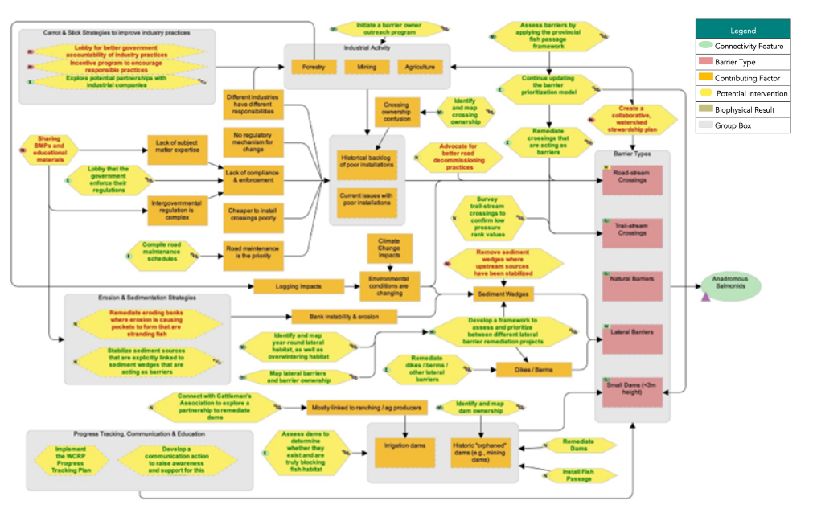
Figure 4.1: Situation analysis developed by the planning team to identify factors that contribute to fragmentation (orange boxes), biophysical results (brown boxes), and potential strategies/actions to improve connectivity (yellow hexagons) for focal species in the Horsefly River watershed.

Strategies & Actions
The planning team identified five broad strategies to implement through this WCRP, 1) crossing rehabilitation, 2) lateral barrier rehabilitation, 3) dam rehabilitation, 4) barrier prevention, and 5) communication and education. Individual actions were qualitatively evaluated based on the anticipated effect each action will have on realizing on-the-ground gains in connectivity. Effectiveness ratings are based on a combination of “Feasibility” and “Impact”. Feasibility is defined as the degree to which the project team can implement the action within realistic constraints (financial, time, ethical, etc.) and Impact is the degree to which the action is likely to contribute to achieving one or more of the goals established in this plan.

Strategy 1: Crossing Rehabilitation
Table 4.2: Strategy 1
ID | Actions | Details | Feasibility | Impact | Effectiveness
1.1 | Rehabilitate crossings that are acting as barriers | This intervention includes some projects that would be led by the planning team with conservation funds (e.g., orphaned barriers or those owned by individuals), while other rehabilitation projects would be the responsibility of the barrier owner. Industry will have to be engaged to successfully implement this intervention. HRR can help with finding local people to implement rehabilitation projects. | High | Very high | Effective
1.2 | Lobby the government to enforce their regulations | This can apply to both provincial and federal governments. For example, advocating for increased discretionary decisions to remove barriers to fish. One action could be to submit barrier assessment data to show proof that regulations are not being followed. | Very high | High | Effective
1.3 | Initiate a barrier owner outreach program for locations on the barrier rehabilitation shortlist | Work with landowners / users (e.g., ATV groups) to identify and rehabilitate their aquatic barriers. Education component can help prevent barriers from being installed in the first place. HRR to reach out to owners of confirmed barriers to discuss rehabilitation options; CWF to reach out to provincial representatives. | Very high | Very high | Very effective
1.4 | Knowledge Gap: Continue updating the barrier prioritization model | The model has been updated to reflect 2023 field assessments and review of field results. | Very high | High | Effective
1.5 | Knowledge Gap: conduct field assessments on updated preliminary barrier list using the provincial fish passage framework and update connectivity goal if additional barriers are added to the barrier rehabilitation shortlist |  | Very high | Very high | Very effective
1.6 | Update longitudinal connectivity goal if additional barriers are added to the barrier rehabilitation shortlist
1.7 | Knowledge Gap: Identify and map crossing ownership | For barriers on the barrier rehabilitation shortlist. | Very high | Very high | Very effective
1.8 | Knowledge Gap: Compile road maintenance schedules | Ground-truthing is important, as the schedules do not always reflect what happens in the field. | High | High | Effective
1.9 | Knowledge Gap: Survey trail-stream crossings to confirm low pressure rating values | Trail-stream crossings were surveyed by WLFN in 2022. No barriers were identified. | Very high | Medium | Need more information

Strategy 2: Lateral Barrier Rehabilitation
Table 4.3: Strategy 2
ID | Actions | Details | Feasibility | Impact | Effectiveness
2.1 | Rehabilitate dikes / berms / other lateral barriers |  | High | Very high | Effective
2.2 | Initiate a barrier owner outreach program |  | Very high | Very high | Very effective
2.3 | Knowledge Gap: Identify and map year-round lateral habitat, as well as overwintering habitat | Explore the use of a drone to identify lateral habitat. Volunteers from the HRR will conduct field habitat assessments following modules in the Pacific Streamkeepers Handbook to assess disconnected lateral and overwintering salmon habitats in the Horsefly watershed . The first phase of this project was initated in 2022. | Very high | Very high | Very effective
2.4 | Knowledge Gap: Map lateral barriers and barrier ownership | Focus on identifying ownership of priority lateral barriers that we want to rehabilitate in the short-term. | Very high | Very high | Very effective
2.5 | Knowledge Gap: Develop a framework to assess and prioritize among different lateral barrier rehabilitation projects | CWF is leading pilot project in the Lower Nicola River watershed to develop methods for identifying and prioritizing lateral barriers to anadromous salmonids. | Very high | Very high | Very effective

Strategy 3: Dam Rehabilitation
Table 4.4: Strategy 3
ID | Actions | Details | Feasibility | Impact | Effectiveness
3.1 | Rehabilitate Dams |  | Medium | Very high | Need more information
3.2 | Install Fish Passage |  | Medium | High | Need more information
3.3 | Connect with B.C. Cattleman's Association to explore a partnership to rehabilitate dams | This may involve exploring alternative water management actions that would allow for the rehabilitation of irrigation dams. | High | Medium | Need more information
3.4 | Knowledge Gap: Continue updating the barrier prioritization model |  | Very high | High | Effective
3.5 | Knowledge Gap: Assess dams to determine whether they exist and are truly blocking fish habitat | All known and mapped dams in areas with mapped key habitat have been assessed. No barriers to fish passage identified. Further assessment of McKinley Dam for passage efficiency is recommended. | Very high | High | Effective
3.6 | Knowledge Gap: Identify and map dam ownership | All known and mapped dams in areas with mapped key habitat have been assessed. No barriers to fish passage identified. | Very high | Very high | Very effective

Strategy 4: Barrier Prevention
Table 4.5: Strategy 4
ID | Actions | Details | Feasibility | Impact | Effectiveness
4.1 | Explore potential partnerships with industrial companies | Invite industrial players to a workshop on how to apply crossing / lateral barrier BMPs. BMPs could include those that minimize the need for road-stream crossings. | Very high | High | Effective
4.2 | Stabilize sediment sources that are explicitly linked to sediment wedges or erosion that are acting as barriers | This could include numerous bank stabilization techniques, including restoring riparian vegetation. This applies to some tributaries that have altered confluence areas - the link needs to be made between confluence alterations and timing of movement for juvenile fish. Local ranchers and B.C. Cattleman's Association could be engaged, as well as forestry licensees. | Very high | Medium | Need more information

Strategy 5: Communication and Education
Table 4.6: Strategy 5
ID | Actions | Details
5.1 | Develop a communication strategy to raise awareness and support for this WCRP | This intervention includes communicating both the WCRP and the collaborative process in developing it, as well as communicating outcomes (e.g., barrier rehabilitation). CNFASAR proposal: - HRR will work with CWF to develop outreach and communications materials, including press releases, social media content, a video, and content for their website - With HRR, CWF will present on fish passage issues and solutions at the annual Horsefly River Salmon Festival

Theories of Change & Objectives
Theories of Change are explicit assumptions about how the identified actions will achieve gains in connectivity and contribute towards reaching the goals of the plan. To develop Theories of Change, the planning team made explicit assumptions for each strategy to clarify the rationale used for undertaking actions and provided an opportunity for feedback on invalid assumptions or missing opportunities. The Theories of Change are results-oriented and clearly define the expected outcome. The following Theories of Change models were developed by the WCRP planning team to “map” the causal (“if-then”) progression of assumptions of how the actions within a strategy work together to achieve project goals.
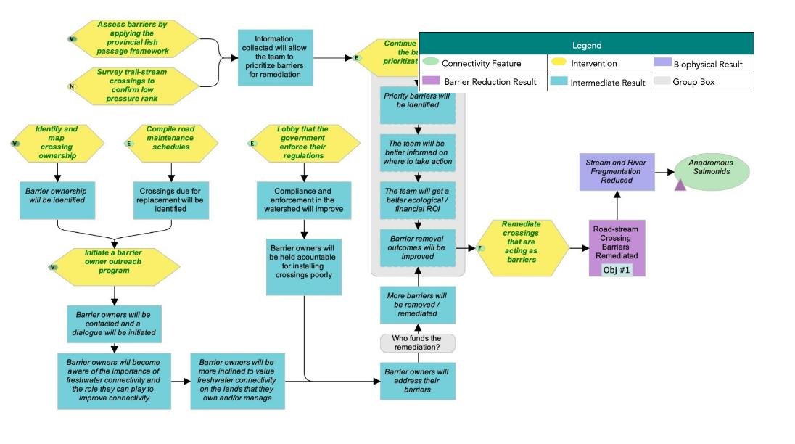
Figure 4.2: Theoies of Change model developed by the planning team for the actions identified under Strategy 1: Crossing Rehabilitation in the Horsefly River watershed.

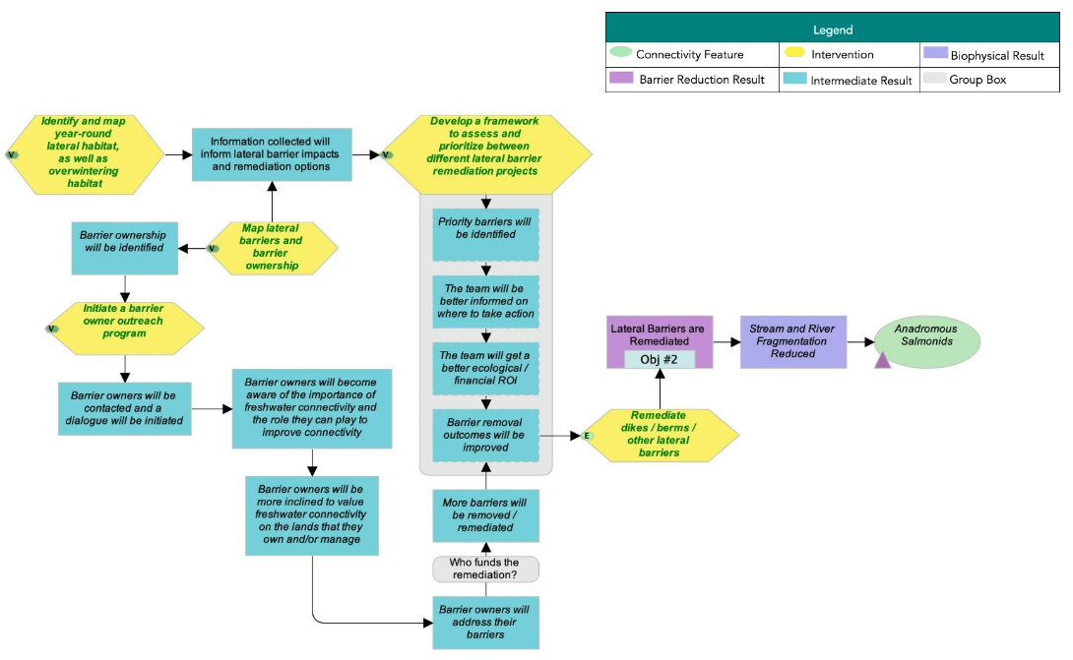
Figure 4.3: Theoies of Change model developed by the planning team for the actions identified under Strategy 2: Lateral Barrier Rehabilitation in the Horsefly River watershed.

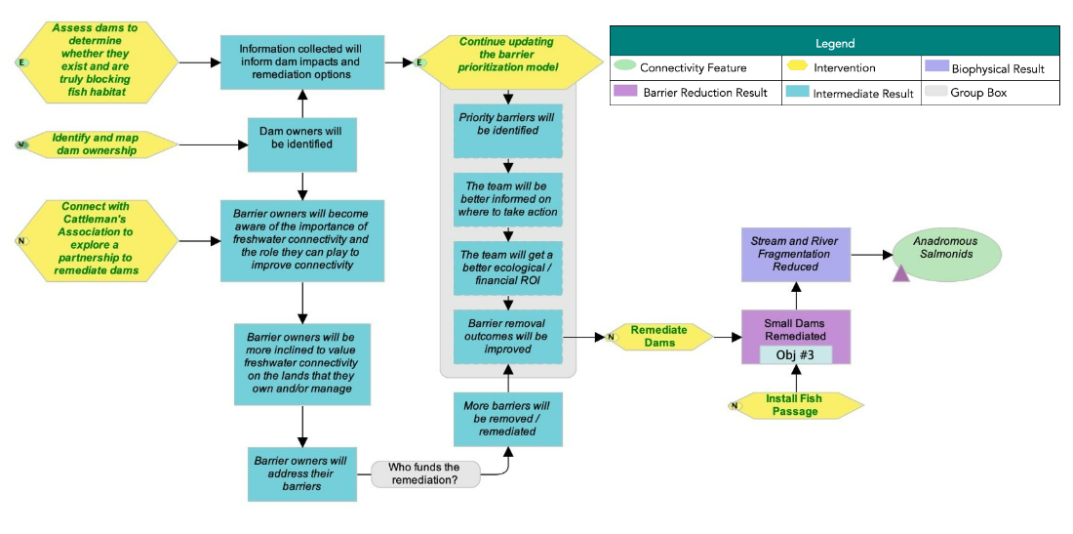
Figure 4.4: Theoies of Change model developed by the planning team for the actions identified under Strategy 3: Dam Rehabilitation in the Horsefly River watershed.

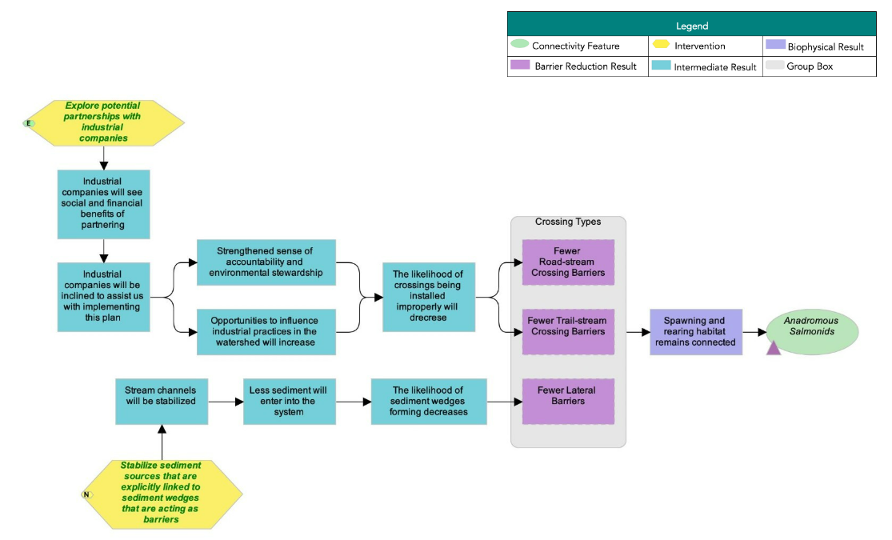
Figure 4.5: Theoies of Change model developed by the planning team for the actions identified under Strategy 4: Barrier Prevention in the Horsefly River watershed.

Data Download and Methods

Data Download
Coming soon

Connectivity Status Assessment Methods
The connectivity status assessment for anadromous salmonids in the Horsefly River watershed builds on existing connectivity modelling work undertaken by the B.C. Fish Passage Technical Working Group, resulting in a flexible, customizable open-source spatial model called “bcfishpass”. The model spatially locates known and modelled barriers to fish passage, identifies potential spawning and rearing habitat for focal species, and estimates the amount of habitat that is currently accessible to focal species. The model uses an adapted version of the Intrinsic Potential (IP) fish habitat modelling framework (see Sheer et al. (2009) for an overview of the IP framework). The habitat model uses two geomorphic characteristics of the stream network — channel gradient and mean annual discharge — to identify potential spawning habitat and rearing habitat for each focal species. The habitat model does not attempt to definitively map each habitat type nor estimate habitat quality, but rather identifies stream segments that have high potential to support spawning or rearing habitat for each species based on the geomorphic characteristics of the segment. For more details on the connectivity and habitat model structure and parameters, please see (Mazany-Wright et al. (2021a)). The variables and thresholds used to model potential spawning and rearing habitat for each focal species are summarized in Table 15. The quantity of modelled habitat for each species was aggregated for each habitat type and represents a linear measure of potential habitat. To recognize the rearing value provided by features represented by polygons for certain species (e.g., wetlands for Coho Salmon and lakes for Sockeye Salmon) a multiplier of 1.5x the length of the stream segments flowing through the polygons was applied.
Species | Channel Gradient (%)(Naturally Accessible Waterbodies) | Channel Gradient (%) | Mean annual discharge (m3/s) | Channel gradient (%) | Mean Annual discharge (m3/s) | Minimum Lake area (ha) | Multiplier (1.5x)
Chinook Salmon | 0-15 | 0-3 [1] [2] | 0.46-322.5 [3][4][5][6][7] | 0-5 [5][8] | 0.28-100 [9]
Coho Salmon | 0-15 | 0-5 [6][10] | 0.164-59.15 [3][4][5][10][11] | 0-5 [8][12] | 0.03-40 [8][13] |  | Wetland
Sockeye Salmon | 0-15 | 0-2 [14][15] | 0.175-65 [3][4][5][6] |  |  | 200 [5] | Lake
?(caption)
References: [1] Busch et al. (2011). [2] Cooney and Holzer (2006). [3] Bjornn and Reiser (1991). [4] Neuman and Newcombe (1977). [5] Woll, Albert, and Whited (2017). [6] Roberge et al. (2002). [7] Raleigh and Miller (1986). [8] Porter et al. (2008). [9] Agrawal et al. (2005). [10] Sloat, Reeves, and Christiansen (2017). [11] McMahon (1983). [12] Rosenfeld, Porter, and Parkinson (2000). [13] Burnett et al. (2007). [14] Lake (1999). [15] Hoopes (1972).

Other Tables
Barrier Id | Modelled Crossing Id | Watercourse Name | Road Name | Structure Type | Reason For Exclusion | Method Of Exclusion | Reason | Notes | Supporting Links
197761 | 6800240 | Trib to Horsefly River | unnamed | Stream crossing - Ford | Passable | Field assessment | Cattle trail/ford, location likely refers to historic crossing that has been decommissioned and abandoned at edge of channel
198871 | 6800319 | Niquidet Creek | unnamed | Stream crossing - OBS | Passable | Field assessment | Pedestrian bridge across creek, not a barrier to fish passage
57292 | 6802284 | Bassett Creek | 500 | Stream crossing - CBS | No key upstream habitat | Field assessment | Impassable natural barrier downstream
57317 | 6800584 | Trib to McKinley Creek | R01350-524 | Stream crossing - CBS | No key upstream habitat | Field assessment | No suitable habitat: small defined channel but no water = poor spawning, rearing, overwintering potential. No modeled key habitat upstream.
57596 | 6800587 | Bassett Creek | R14189-4C | None | No structure | Field assessment | No stream crossing identified but large woody debris jam present and passable to fish
773d7d7c-11b7-4c8c-b761-ff1d4d60818a |  | Rat/Peter Creek | n/a | None | No structure | Field assessment | Dam confirmed to not exist (formerly structure 1100000814)
1006800520 |  | Woodjam Creek | Private | None | No structure | Local knowledge | Access permission not granted. Landowners confirmed bridge/barrier no longer present
1006801356 |  | Trib to Horsefly Lake | R01350 | None | No structure | Field assessment | Crossing does not exist
a423c60a-dfb1-4414-bba3-bd57c89c6357 |  | Gibbons Creek | n/a | Dam | Passable | Field assessment | Dam appears to be off channel with water flowing around the dam, no fish passage issues (formerly structure 1100001822)
197763 |  | Niquidet Creek | unnamed | Stream crossing - Ford | Passable | Field assessment | Location is a cattle trail/ford, not a barrier to fish
40fc35b1-a834-4821-9c09-e8c64a646252 |  | Niquidet Creek | n/a | None | No structure | Field assessment | Dam confirmed to not exist (formerly structure 1100000763)
17e18f43-e699-4e2c-ae73-e3f3e48de11f |  | Gibbons Creek | n/a | None | No structure | Field assessment | Dam confirmed to not exist (formerly structure 1100000243)
198875 |  | Gibbons Creek | unnamed | Stream crossing - OBS | Passable | Field assessment | Road carried by a 2200 mm diameter OBS arch culvert that is 12 m long, does not represent a barrier to fish passage
1006801130 |  | Wilmot Creek | unnamed | None | No structure | Field assessment | Crossing does not exist
1006800484 |  | Molybdenite Creek | unnamed | None | No structure | Field assessment | Crossing does not exist
198161 |  | Trib to Elbow Lake | unnamed | Stream crossing - OBS | Passable | Field assessment | Open bottom arch culvert
1006800298 |  | Patenaude Creek | unnamed | None | No structure | Field assessment | Crossing does not exist
?(caption)
Barrier Id | Modelled Crossing Id | Watercourse Name | Road Name | Structure Type | Structure Owner | Barrier Status | Partial Passability | Assessment Type Completed | Total Hab Gain Set | Num Barriers Set | Next Steps | Notes | Supporting Links
1200000002 |  | Patenaude Creek | Private | Stream crossing - OBS | Private | BARRIER |  | Informal assessment | 3.62 | 1 | Barrier assessment (data deficient structures only) | Complete barrier assessment to verify status
126438 | 6800525 | Trib to Horsefly River | Private | Stream crossing - CBS | Private | POTENTIAL |  | Barrier assessment | 0.85 | 1 | Engage with barrier owner | Can't access site (landowner refusal). Brian checking with local consultant if he knows anything about the crossing. Bring to regulator if no resolution. | http://a100.gov.bc.ca/pub/pscismap/imageViewer.do?habitatConfirmationId=1882
1006800220 | 6800220 | Trib to Harpers Lake | unnamed | Other | Private | POTENTIAL |  | Other | 0.69 | 2 | Non-actionable
57430 | 6801719 | Gifford Creek | Hendrix-McKinley | Stream crossing - CBS | FLNRO | BARRIER |  | Habitat confirmation | 0.02 | 1 | In-depth habitat investigation (data deficient structures only) | Coho present downstream, some steep sections to falls, salmonids throughout to falls | http://a100.gov.bc.ca/pub/pscismap/imageViewer.do?habitatConfirmationId=703
124271 |  | MacLean Creek | Private | Stream crossing - CBS | Private | BARRIER |  | Habitat confirmation |  |  | Engage with barrier owner | Last assessed 2017. Can't access. Brian checking with local consultant on status of crossing. Bring in regulator if no resolution | http://a100.gov.bc.ca/pub/pscismap/imageViewer.do?habitatConfirmationId=681
?(caption)

