**CIS 485 – Abusive Workplace Interactive Ethics Scenario**

**Group 6**

**Date:** October 30, 2025

**Team Members:**

* **Megan Van Luyn (300144291)** – Project Manager
* **Komalpreet Kaur (300213116)** – Graphic Designer
* **Adakole Jumbo-Ochigbo (300204091)** – Documentation Lead
* **Mehak Gupta** **(300206222)** – Game Designer
* **Garv Singh Saini** **(300206119)** – Quality Assurance Lead

Link to game: [Abusive Workplace 2.1](https://canadianluyn.github.io/CIS485_Group-6/A2_G6_TheLateReport.html)

**Case Study Chosen**

The members of group 6 chose the Abusive Workplace Behavior case study, to create a Twine game around. This case study was selected for various reasons. We believed it was a great example of real world ethical issues that anyone can face at anytime. It provided us with room to be creative on how the interactions in the game could be designed, while not being too abstract.

The storyline of this game is closely based off of the Abusive Workplace Behavior case study [1], and as such has been a reference for this report.

**Prototype Workflow**

Mehak came up with two potential workflows for our game, and as a group we decided to go with option 2, which is shown below.

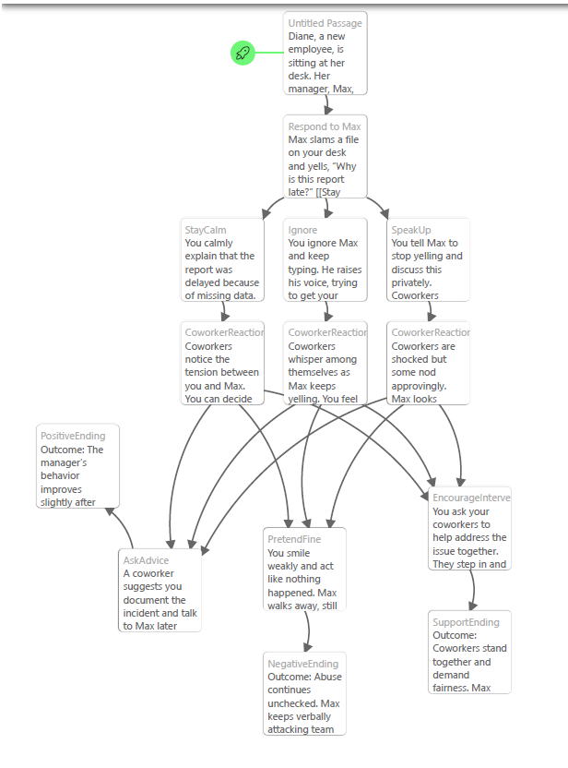

Figure 1: Workflow 2, chosen by group for game

**List of Ethical Dilemmas**

In summary, the list of ethical dilemmas the player will need to face are focused on how they respond to Max. Will they speak directly to him about his behavior, ignore it and let it continue, request assistance from a colleague, or go straight to someone with more power in the company.

The original case highlights common issues in toxic work environments, such as fear of speaking up, lack of support from management, and the normalization of bad behavior. The team used these ideas to create a story that shows how individual choices can either allow abuse to continue or lead to positive change.

**Respect and Integrity:**  
Players are encouraged to consider how they would react to being disrespected or verbally attacked at work. The story shows the importance of staying calm and professional while still standing up for oneself.

**Duty to Report:**  
The scenario raises the question of whether employees should speak up or report incidents they witness. It shows how staying silent can make the situation worse, while taking action can protect others and improve the workplace.

**Power and Accountability:**  
The project explores how authority and fear of consequences can affect ethical decisions. It reminds players that everyone shares some responsibility for maintaining fairness and respect, no matter their position.

**Workplace Culture:**  
The story emphasizes how silence can normalize abuse. It encourages open communication and teamwork as key steps in building a healthier and more supportive workplace.

**Alignment with the case study**

The *Abusive Workplace Behavior* case study from the **ACM Code of Ethics** emphasizes fairness, respect, and accountability in professional settings. Our interactive storyline builds on these same ideas by recreating similar challenges that test workplace ethics and professional conduct.

**Workplace Respect:**  
The player faces moments where communication and professionalism are tested, showing how disrespectful behavior can quickly create a hostile environment if left unaddressed.

**Fairness and Credit:**  
The scenario mirrors situations where individuals’ contributions are overlooked or dismissed, reinforcing the ethical duty to recognize others’ work and treat colleagues fairly.

**Leadership Accountability:**  
The story includes different leadership responses—some supportive, others dismissive—to show how managers and supervisors influence the organization’s ethical culture. This reflects the case study’s concern about the damage caused by managerial neglect.

# References

|  |  |
| --- | --- |
| [1] | Association for Computing Machinery (ACM), "Case Study: Abusive Workplace Behavior," [Online]. Available: https://www.acm.org/code-of-ethics/case-studies/abusive-workplace-behavior. [Accessed 28 October 2025]. |