Modelos VAR

Eduardo Canales

2023-12-01

## R Markdown

This is an R Markdown document. Markdown is a simple formatting syntax for authoring HTML, PDF, and MS Word documents. For more details on using R Markdown see <http://rmarkdown.rstudio.com>.

When you click the **Knit** button a document will be generated that includes both content as well as the output of any embedded R code chunks within the document. You can embed an R code chunk like this:

summary(cars)

## speed dist   
## Min. : 4.0 Min. : 2.00   
## 1st Qu.:12.0 1st Qu.: 26.00   
## Median :15.0 Median : 36.00   
## Mean :15.4 Mean : 42.98   
## 3rd Qu.:19.0 3rd Qu.: 56.00   
## Max. :25.0 Max. :120.00

## Including Plots

You can also embed plots, for example:

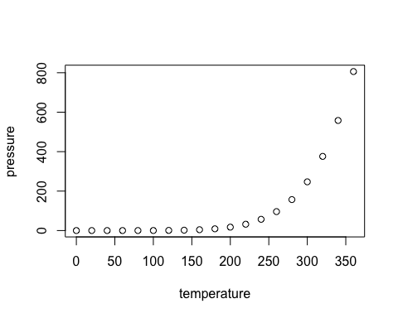

Note that the echo = FALSE parameter was added to the code chunk to prevent printing of the R code that generated the plot.

library(foreign)  
library(readxl)  
library(tseries)

## Registered S3 method overwritten by 'quantmod':  
## method from  
## as.zoo.data.frame zoo

library(dplyr)

##   
## Attaching package: 'dplyr'

## The following objects are masked from 'package:stats':  
##   
## filter, lag

## The following objects are masked from 'package:base':  
##   
## intersect, setdiff, setequal, union

library(ggplot2)  
##########################################################  
# Datos históricos del Indice de Precios Al Consumidor  
#########################################################  
IPC<- read_excel("Datos/Índice de Precios al Consumidor.xlsx")  
# Convertir la fecha a año  
IPC <- IPC %>%  
 mutate(Año = lubridate::year(Fecha))  
  
# Calcular el promedio por año para el indicador Variación Interanual que es   
## la inflación  
Inflacion<- IPC %>%  
 filter(Indicador == "Variación interanual") %>%  
 group_by(Año) %>%  
 summarise(Tasa_Inflación =round(mean(Valor),2))  
  
#########################################  
# Grafico para ver el comportamiento de la tasa de inflación   
##########################  
# Graficar el IPC a lo largo de los años  
ggplot(Inflacion, aes(x = Año, y = Tasa_Inflación)) +  
 geom_line(color = "#87CEFA") +  
 geom_point(color = "#EE9A00", size = 1) +  
 geom_text(aes(label = round(Tasa_Inflación,2)), vjust = -0.5, hjust = -0.5, color = "black", size = 2.5)+  
 labs(title = "Gráfico del comportamiento de la tasa de inflación en Honduras periodo 1992-2023",  
 x = "Año", y = "Tasa de Inflación") +  
 theme_minimal()+  
 theme(  
 plot.title = element_text(family = "Arial", hjust = 0.5),  
 plot.background = element_rect(color = "black", size = 1, fill = "white"),  
 panel.background = element_rect(fill = "white"),  
 panel.grid = element_blank()  
 )+  
 scale_x_continuous(breaks = seq(min(Inflacion$Año), max(Inflacion$Año), by = 5))

## Warning: The `size` argument of `element_rect()` is deprecated as of ggplot2 3.4.0.  
## ℹ Please use the `linewidth` argument instead.  
## This warning is displayed once every 8 hours.  
## Call `lifecycle::last_lifecycle_warnings()` to see where this warning was  
## generated.

