A BAT ASSESSMENT OF THE KINGSLAND

BASIN, KINGSLAND ROAD, LONDON N1 5BB

Commissioned by:

CHUG

Report Number: ASW/CHUG/029/16/2012

July 2012



ASW Ecology

Regent’s Place, 3rd Floor, 338 Euston Road, London NW1 3BT
Tel: 0870 7346004 Fax: 0870 7346005 Mobile: 07710 150590
E-mail: aswecology@yahoo.co.uk Website: www.asw-ecologysurveys.co.uk
CONTENTS

Page

Executive Summary 3

1. Introduction 4

2. Methodology 5

2.1 Bat assessment method 5
2.2 Constraints to bat assessment 5

3. Assessment results 6

3.1 Bat assessment results 6

4. Conclusions 8

4.1 Significance of bat assessment results 8
4.2 Impact assessment 8
4.3 Legal protection of bats in the UK 9

5. Recommendations 11

5.1 Bat monitoring at Kingsland Basin 11
5.2 Bat related enhancements at Kingsland Basin 11
5.3 Light readings and lighting related recommendations 12

6. References 13

Appendix 1
Sonogram based analysis raw data for the third bat night visit 14
and selected sonogram for this Bat Emergence Survey
at the Kingsland Basin – 16/7/2012

Appendix 2
Photographs A – F 15

Appendix 3
Map A: Location of bat sightings at Kingsland Basin, Kingsland Road, 21
LB Hackney, London – July 2012

EXECUTIVE SUMMARY

- A Bat Assessment of the Kingsland Basin, Kingsland Road, LB Hackney, London N1 5BB (now also referred to as the “Site” or “Basin” within this report), was undertaken for the client: CHUG (Canals in Hackney Users Group).

- This bat assessment was commissioned due to the concerns of the local boat owners at the Kingsland Basin, that there could be an adverse impact on local bats by the continuing redevelopment around the Site.

- Common pipistrelle was the only bat species detected at the Kingsland Basin during the survey visits, but very good foraging was noted.

- A likely common pipistrelle bat roost is probably present close to Quebec Wharf, as bats were clearly emerging from very closeby, then heading to the Basin to forage for insects.

- No Daubenton’s bats were found during the survey visits but this light adverse species is known to be present nearby, and may pass through the Basin as a transient visitor.

- It was found that dark conditions were present at the Basin during the bat survey visits, and that it is considered that the light overspill from the adjacent new apartment blocks, when all inhabited, will seriously encroach onto the Kingsland Basin.

- Such light overspill can adversely affect bat behaviour including that of pipistrelle bats, which can be sensitive to artificial lighting. Bat foraging may be adversely impacted upon and if any bat roosts are present closeby, these may be indirectly affected due to the decline in quality of the Basin as a bat feeding area.

- Therefore, it is also considered that the developers responsible for building the adjacent apartment blocks to the Basin, should take bats into account as should the local planners. Mitigation is needed to reduce the impact on bats from the adjacent developments.

- The main mitigation would be the requirement for a dark corridor through the Kingsland Basin for bats and that any intrusive lighting already present needs to be removed, so this can be achieved.

- This can be monitored by CHUG as well as with help/advice from a licensed bat consultant, and with habitat enhancements made such as suitable planting and installation of bat boxes.

1. INTRODUCTION

- A Bat Assessment of the Kingsland Basin, Kingsland Road, LB Hackney, London N1 5BB (now also referred to as the “Site” or “Basin” within this report), was undertaken for the client: CHUG (Canals in Hackney Users Group).

- This bat assessment was commissioned due to the concerns of the local boat owners at the Kingsland Basin, that there could be an adverse impact on local bats by the continuing redevelopment around the Site.

- This assessment would identify if bats are present; if such impacts would occur; to what extent; and what measures could be undertaken to mitigate this.

- The main method used for this bat assessment, as well as the full results and the final recommendations can be found within this report.

- Both this bat assessment and the report were undertaken and compiled by Mr Andrew S. Waller, Consultant Ecologist, ASW Ecology, with the kind help of an assistant, Alison Fure, also a licensed bat consultant.

- Mr Andrew S. Waller has been a Consultant Ecologist since 1997, and has very extensive experience/knowledge of protected wildlife species/issues including bats, for which he is fully licensed to survey throughout England by Natural England for consultancy purposes (Licence Number: 20120364). He is also a full member of the Institute of Ecology and Environmental Management (IEEM).

© Report copyright – ASW Ecology

METHODOLOGY

2.1 Bat assessment method

- During July 2012, three bat emergence survey visits were undertaken as part of this assessment of the Kingsland Basin. Between one to two licensed bat surveyors using bat detectors including the Bat Box Duet were present on each visit.

- All bat survey visits were undertaken in suitable weather conditions only, so there was the best chance of finding any possible emerging bats at the cottage.

- Indications of bats roosting at any site during bat detector surveying can include the sighting of early emerging bats; roost noises from a bat roost as bats get prepared for emergence; and bat “streams”- where bats may emerge one after the other in quick succession.

- All bat sightings would be plotted on a map for reference, and this can be found in Map A, at the end of this bat assessment report.

  - Constraints to assessment

- Due to the timing of this particular bat survey, it is not known what the exact level and type of bat activity could be present at the Kingsland Basin before or after July, when this assessment was done.

- The June to August period is critical to bats since this is when maternity roosts are present and young bats will be born. Large roosts are sometimes present within structures, and can be very visible during such bat emergence surveys. This survey was commissioned when such colonies will have gathered together.

- As always though, without taking into account any further active surveying or monitoring, this study can only provide a “snapshot” of the presence of bats at the Site during the time of the survey visits.

3. ASSESSMENT RESULTS

3.1 Bat assessment results

Bat emergence survey - visit 1 – 6/7/2012
Sunset time: 9.18pm
Weather: clear, light wind, dry and mild Temp (sunset): 18°C
Windspeed (max): 8mph
Surveyors present: 1 in total
Inverts present: flies, moths and mosquitoes

- 9.31pm – 1 common pipistrelle (Pipistrellus pipistrellus) – heard briefly over water and boats but not seen.
- 9.48pm – 1 then 2 common pipistrelles – seen over roof of building close to water and courtyard. Then intense foraging observed over water by these pipistrelle bats.
- 10.02pm – 2-3 common pipistrelles – foraging over water, boats and allotment plot.
- 10.10pm – 2-3+ common pipistrelles – continuous foraging over the Kingsland Basin.
- 10.12pm – 3+ common pipistrelles – over water and boats.
- 10.28pm – 4-5+ common pipistrelles – over water and boats.
- 10.34pm – 4-5+ common pipistrelles – over water and boats. Non-stop intense foraging activity by bats over Basin.

Bat emergence survey - visit 2 – 11/7/2012
Sunset time: 9.14pm
Weather: cloudy, dry, calm and mild Temp (sunset): 15°C
Windspeed (max): 0mph
Surveyors present: 1 in total
Inverts present: flies, mosquitoes and midges

- 9.35pm – 1 common pipistrelle – seen between buildings near the Travis Perkins timber yard at 317 – 319 Kingsland Road then over boats.
- 9.37pm - 1 common pipistrelle – seen over the water and then followed by a second pipistrelle that flies over the Travis Perkins timber yard to the water.
- 9.39pm – 1 common pipistrelle – this is a third pipistrelle that flies past building corner (Quebec Wharf) and over the Travis Perkins timber yard to water. Followed by a fourth bat and indicates there is a bat roost close to Quebec Wharf with a total of at least four bats emerging then heading to the Basin.
- 9.48pm – 1 common pipistrelle – over courtyard. Unclear if this is a bat returning or a new bat from wherever the roost is located. Intense foraging by bats over water and boats.
- 10.04pm – 3 common pipistrelles – still foraging over the Travis Perkins timber yard plus the boats and water.
- 10.23pm – 3+ common pipistrelles – still foraging intensely over water and boats. Non-stop activity noted again over Basin by these bats.

Bat emergence survey - visit 3 – 16/7/2012
Sunset time: 9.10pm
Weather: cloudy, dry, mild and light wind Temp (sunset): 17°C
Windspeed (max): 12mph
Surveyors present: 2 in total
Inverts present: flies, spiders, mosquitoes and moths

- 9.42pm to 9.46pm – 1 common pipistrelle – south of wall at Quebec Wharf. Foraging in sheltered environment.
- 9.44pm – 1 common pipistrelle – one pass from south to north and then east to the wood yard.
- 9.47pm – 1 common pipistrelle – over wall from north to south, over the courtyard.
- 9.47pm – common pipistrelles - foraging over the wood yard and Basin.
- 9.49pm – common pipistrelles – constant foraging activity over the Basin.
- 9.55pm – 2 common pipistrelles – over Kingsland Wharf and boats.
- 9.59pm – 3 common pipistrelles – over Basin.
- 10.01pm – common pipistrelles – intense foraging over northern part of Basin.
- 10.06pm – 1 common pipistrelle – heard feeding over nearby Regents Canal, from road bridge.
- 10.12pm – 1 common pipistrelle – over same canal and under bridge. Quite dark along this stretch of canal.
- 10.17pm – 2-3+ common pipistrelles – over Basin. Intense feeding noted again here by these bats.
- 10.17pm – common pipistrelle – occasional pass over Regents Canal.
- 10.42pm – 1 common pipistrelle – at Regents Canal, foraging at top of the Basin.

4. CONCLUSIONS

4.1 Significance of bat assessment results

- From the bat emergence survey results, it is clear that bats are indeed using the Kingsland Basin for foraging on a regular basis, and intense activity was noted during every visit. Common pipistrelle was the only bat species found at the Basin during this study, but the occasional additional bat species is possible at this Site. Although, Daubenton’s bat, an especially light adverse bat species, was not detected on this bat survey, it is known to be present on the Regents Canal, and hence may be present occasional over the Basin.

- One very interesting finding from the bat survey of the Basin was that it is very likely that there is a common pipistrelle bat roost close to Quebec Wharf, and that are emerging from the roost then heading direct to the Basin over the Travis Perkins timber yard west of Sarah Place. Such a roost would only be located close to the Basin due to the current foraging/commuting conditions present, and any changes may mean that the roost location will become defunct.

- A previous 2009 internal/external bat related building survey as part of a Biodiversity Assessment of Union Wharf was undertaken by the Ecology Consultancy. This was a daytime only survey and was always unlikely to discover any roosting bats, if present. As some buildings were classed a moderate roost potential for bats, they recommended two bat emergence survey night visits. It is unknown if anyone was allowed to undertake this recommendation.

- Given that there bats on the Basin, and this has been proved beyond doubt by this assessment, the local planning authority and the developers responsible for the adjacent new apartment blocks must take bats into account in terms of lighting impacts. This is clearly urgent and action must be taken now before the new blocks are inhabited and the full light intrusion onto the Basin significantly impacts on this European Protected Species (EPS).

- It should be noted that the local planning authority has a legal duty to ensure that the status of a EPS animal species e.g. bats, is resolved before planning consent can be given, and it is unknown if this is the case. If it is not, then the planners and developers need to take retrospective mitigation action to ensure that (a) no criminal offences are taking place such as light intrusion onto a bat roost and (b) that the bat usage at the Basin is not significantly reduced due to ignorance or lack of mitigation e.g. decline or loss of biodiversity.

4.2 Impact assessment

- In the absence of any mitigation measures or precautions, the following direct or indirect impacts from the adjacent developments to the Kingsland Basin on bats would be currently predicted as:

  - DIRECT: The loss of the dark corridor and foraging hotspot identified in this study at the Kingsland Basin will be a direct result of the significant light overspill currently expected when all of the adjacent apartment blocks are occupied. This will have a direct impact on bat usage and numbers at the Basin and it is possible that bats may not be able to forage at the Basin anymore. The loss of a foraging hotspot, let alone a commuting route would be expected. The impact would be more significant is further bat species such as Daubenton’s bat are present at other times of the year. Impact magnitude predicted: High

  - INDIRECT: There is a real chance of habitat fragmentation as a result of the future illumination of the Kingsland Basin when all of the adjacent apartment blocks have been completed and occupied. The lack of a dark corridor may mean that the current roosts around the Basin become isolated and local bat activity/usage in the area becomes fragmented. This may mean less viable bat populations in the area and the possible long-term loss of roosts. Impact magnitude predicted: Moderate to High

4.3 Legal protection of bats in the UK (Simplified current summary only of the legislation – please see other texts for full details)

4.3.1 THE LEGAL PROTECTION OF BATS IN ENGLAND AND WALES

Introduction

All species of bats in England and Wales are protected by law. Their legal protection derives from two sources:

the strict species protection provisions of the EU Habitats Directive as implemented in England and Wales by Part 3 of the Conservation of Habitats and Species Regulations 2010 (the "2010 Regulations"); and

Part 1 of the Wildlife and Countryside Act 1981 (as amended).

Conservation of Habitats and Species Regulations 2010 ("2010 Regulations")

The 2010 Regulations came into force on 1 April 2010. They replace the previously applicable regulations (Conservation (Natural Habitats, &c) Regulations 1994) in relation to England and Wales. The 2010 Regulations are the principal means by which the EU Habitats Directive is transposed in England and Wales.

The Regulations contain a number of Parts but Part 3 sets out the protection to be afforded to "European Protected Species" ("EPS"), which includes all species of British bats. The list also includes other species which are rare on a European scale, such as great crested newts, otters and dormice.

Under Part 3 of the 2010 Regulations both bats themselves and their "breeding sites and resting places" (most commonly their roosts) are protected.

Part 3 provides that it is a criminal offence to do the following (note that this is not an exhaustive list of all offences but rather a list of offences which will be of most relevance to developers):

to damage or destroy a breeding site or resting place of a bat (Reg 41(1)(d));

to deliberately capture, injure or kill any bat (Reg 41(1)(a));

to deliberately disturb bats [note, wherever they are occurring] (Reg 41(1)(b)), in particular:

any disturbance of bats which is likely to impair their ability to survive, to breed or reproduce, or to rear or nurture their young (Reg 41(2)(a)(i)); or

any disturbance of bats which is likely to impair their ability to hibernate or migrate (Reg 41(2)(a)(ii)); or

any disturbance of bats which is likely to affect significantly the local distribution or abundance of the species to which they belong (Reg 41(2)(b));

to have in one's possession or to control or to transport or to sell or exchange or offer to sell or exchange any live or dead bat or part of a bat which has been taken from the wild; or any part of, or anything derived from, a bat or any part of a bat (Reg 41(3) and (4)); and

to attempt any of the above (Reg 116(1)).

The maximum penalty that can be imposed for the above offences is (as at May 2010) a fine of up to £5,000, and/or up to six months imprisonment. The offences can be committed by individuals or by bodies corporate. Where a body corporate has committed the offence, the directors or officers of the company may also be prosecuted if the offence has been committed with their consent or connivance, or is attributable to their neglect (Reg 124).

Wildlife and Countryside Act 1981 ("WCA 1981")

The WCA 1981 protects a wide range of animals, plants and habitats in the UK. All British bat species are afforded protection under Part 1 of the WCA 1981, in addition to the protection they have under the 2010 Regulations.

As regards England and Wales the following offences apply to protect bats under the W&CA 1981:

a. to intentionally or recklessly disturb any bat while it is occupying a structure of place which it uses for shelter or protection (s9(4)(b) WCA 1981);

b. to intentionally or recklessly obstruct access to any structure or place which any bat uses for shelter or protection (s9(4)(c) WCA 1981);

c. attempting either of the above (s18(1) WCA 1981).

The maximum penalty that can be imposed for the above offences is (as at May 2010) a fine of up to £5,000, and/or up to six months imprisonment. The offences can be committed by individuals or by bodies corporate. Where a body corporate has committed the offence, the directors or officers of that company may also be prosecuted if the offence has been committed with their consent or connivance or is attributable to their neglect (s69(1) WCA 1981).

5. RECOMMENDATIONS

5.1 Bat monitoring at Kingsland Basin

- Bat monitoring should be undertaken at the Kingsland Basin after this assessment has been completed, especially after the new remaining blocks have been inhabited around the Site.

- This monitoring should be done by the developer responsible for the new apartment blocks around the Kingsland Basin, and this should have been put forward by the developers in their application to the local planning authority e.g. to show any impacts on bats post-development.

- However, whilst it is being seen what can be done about the above, CHUG members can of course do some monitoring themselves, and if needed under guidance/advice by a licensed bat consultant. The group intends to buy a bat detector, which is a very good idea, as they are ideally placed to observe bat activity at the Site, and the effects of the future light spill from all of the inhabited apartment blocks.

- The bat monitoring should be undertaken between April and September, and can be monthly or bi-monthly for example, and focus on bat activity and species diversity e.g. are Daubenton’s bats also present along with common pipistrelles at the Basin. Comparisons need to be made with previous visits so that any decline in bat usage of the basin can be assessed properly.

5.2 Bat related enhancements at Kingsland Basin

- Installation of bat boxes: it is certainly recommended that bat boxes could be installed at the island, if permission has been given for this and suitable locations found. Bat boxes can be installed on trees, buildings and bridges and a wide variety are now available for sale. The Schwegler 1FF Bat Box (http://www.nhbs.com/schwegler_1ff_bat_box_with_built_in_wooden_tefno_158636.html) is recommended and can be bought from Alana Ecology for example. This Woodcrete box can be installed either on suitable trees or on walls, and is maintenance free as droppings will fall down from the box. Boxes should be located as high as possible but at least three metres above the ground and away from vandals. The should be south-east to south-west facing where possible and free from clutter so that bats can enter and leave easily, but there should be vegetation nearby to provide shelter. Between three and six bat boxes could be purchased but placed in different locations so increase the chance of bats using these.

- Habitat management of island: the small island tree covered island at the eastern edge of the Basin, should be managed for bats and other wildlife, and hence great care must be taken when management is required. Key aspects are that no trees or shrubs to be pruned etc during breeding bird season of February to September, and that the vegetation should be diverse for different wildlife to benefit. Since the island provides some useful natural habitat in such a built up area, no non-native plants should be introduced and only native plant species used if stocking up is needed or replacement of specific plants. Also, this island needs to be kept dark at night with no direct illumination at all on it.
- Planting opportunities at the Basin’s allotment plot: it is also recommended that suitable native plants could be grown alongside the group’s innovative floating allotment plot, and these can be pot bound. Suitable night scented plants would attract night flying insects and hence could benefit local bats. Recommended plants include: evening primrose, mint, chives, marjoram, honeysuckle, white jasmine, dog rose, ivy, night-scented stock, sweet rocket, borage and lemon balm.

5.3 Light readings and lighting related recommendations

- A dark corridor must be maintained at the Kingsland Basin, so bats can commute and forage over at least part of the water without encountering light intrusion. This can be done by following SMART lighting design and getting rid of some of the obtrusive lighting already present. Such measures must be undertaken by the developers responsible for the new apartment blocks, so to ensure bats keep using the Basin. During this survey, a second bat specialist, Alison Fure, recorded light meter readings via a central transect route through the Basin, barely above moonlight e.g. 0.25 lux. This shows how currently dark the Basin is now, and such darkness needs to be retained.

- There also needs to be viable flight paths for bats between the buildings to the Basin, particularly through undeveloped plots. Plots need to be dark and not illuminated by artificial lighting so bats will use such important corridors still.

- The developers will need to undertake such measures, and they can also use low transmittance glass and lighting on PIR sensors.

- Narrow spectrum bulbs should be used to lower the range of species affected by the lighting, and light sources that emit ultrasonic light must be avoided.

- Reducing the height of lighting columns can be undertaken as lighting at a low level will reduce the ecological impact of the scheme.

- For pedestrian lighting, low level lighting that is as directional as possible should be used and below 3 lux at ground level according to BCT guidance.

- The effect of illumination on commuting bats has been measured at linear features. These linear features can be energy saving for bats, offering reduced exposure from weather conditions, such as wind and rain and also reduce predation exposure (Stone et al, 2009). The researchers installed high pressure sodium lights to mimic the intensity and light spectra of street lights along commuting routes of lesser horseshoe bats (Rhinolophus hipposideros). Bat activity was reduced dramatically and the onset of commuting behaviour was delayed in the presence of lighting (with no evidence of habituation). The results of the study demonstrated that illumination has a significant impact of the selection of flight routes of bats.

- Subsequent studies demonstrated little difference in both the magnitude and nature of the impact of LED’s on R. hipposideros and Myotis species, causing a significant reduction in activity along lit hedgerows (Stone et al, 2012). Researchers found that even the lowest light levels (3.6 lux) had an effect on bat behaviour.

6. REFERENCES

- Altringham, J.D. (2003) British Bats. HarperCollinsPublishers, London.

- Bat Conservation Trust (2012) Bat Surveys – Good Practice Guidelines (2nd Ed). Bat Conservation Trust, London.

- Bat Conservation Trust (2008) Bats and lighting in the UK – Bats and the Built Environment Series. Version 2. BCT, London.

- Entwistle, A.C. et al (2001) Habitat Management for Bats. JNCC, UK.

- Fure, A. (2006) Bats and lighting. The London Naturalist. Number 85. LNHS, London.

- Mitchell-Jones, A.J. (2004) Bat Mitigation Guidelines. English Nature.

- Mitchell-Jones, A.J. and McLeish, A.P. (2004) The Bat Workers’ Manual. 3rd Ed. JNCC, UK.
Appendix 1
Sonogram based analysis raw data for the third bat night visit
and selected sonogram for this Bat Emergence Survey
at the Kingsland Basin – 16/7/2012

Table 1: Selected bat activity (16.7.12)
Sunset 21.09p.m. Cloud cover 3/8 .Temperature 20 degrees centigrade at start. Windy
Time | Details: Duet detector + edirol recorder
21.44 sunset +35 mins | Common Pipistrelle pass from south to north and then east to wood yard Fig. 1
21.47 | common pipistrelles foraging around the wood yard and basin
21.49 | Common pipistrelles foraging now constant activity
21.59 | 3rd Common pipistrelle
22.01 | Foraging intensifies in the northern 1/3 of the basin, where it is more sheltered
22.17 | Light meter readings taken followed by search of main canal where occasional pip passes noted

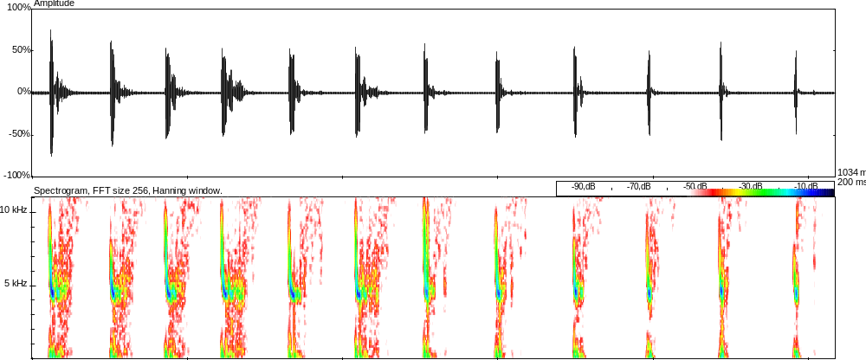
Fig. 1 Screenshot of the sonogram of a common pipistrelle flying around the basin 21.49

Appendix 2
Photographs A – F

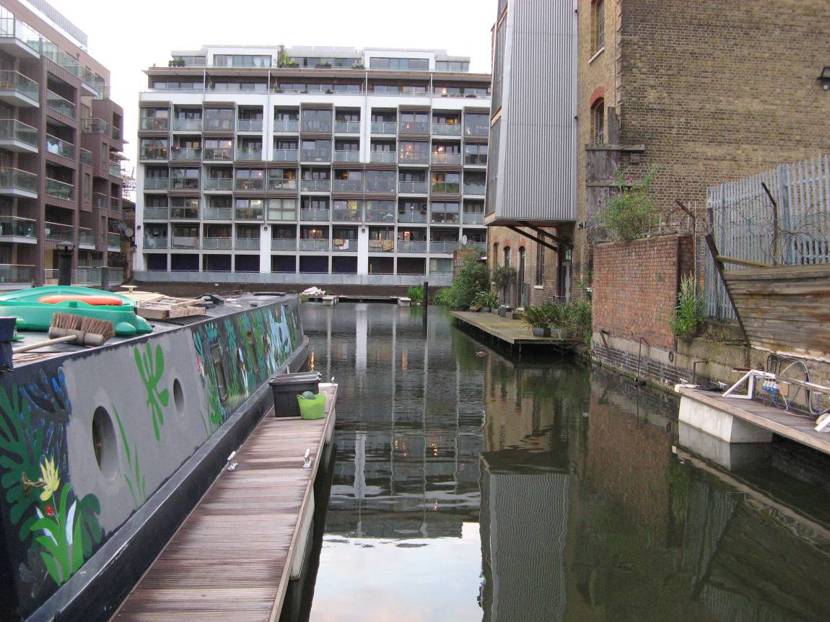

Photograph A
The north end of the Kingsland Basin, where much bat activity was noted during all three bat survey visits. Common pipistrelles were using most or all of the Basin for foraging and intense activity was present
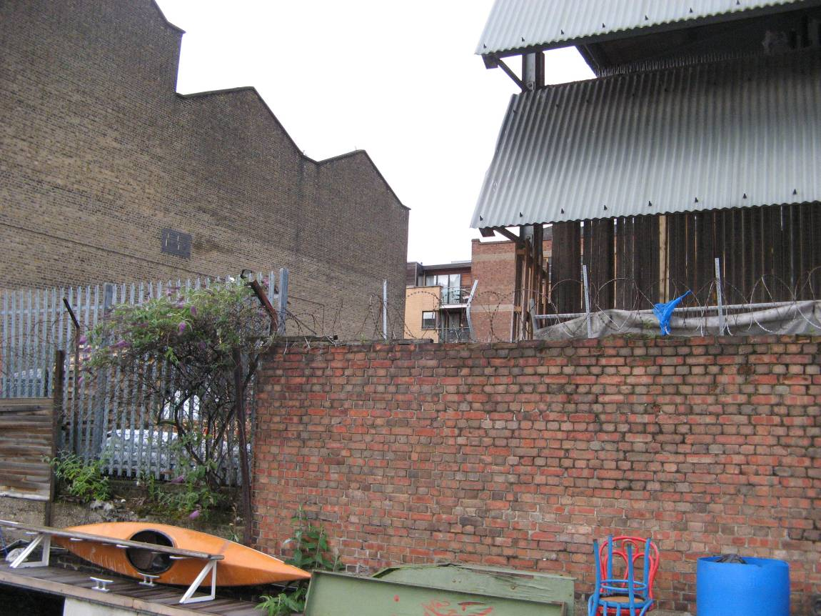

Photograph B
Common pipistrelles were noted to be emerging from a bat roost close to Quebec Wharf, and flying over the courtyard shown in the middle of this photograph then direct to the Basin to feed. Although this roost could not be pinpointed, the location of the Basin would clearly dictate the use of bat roosts nearby
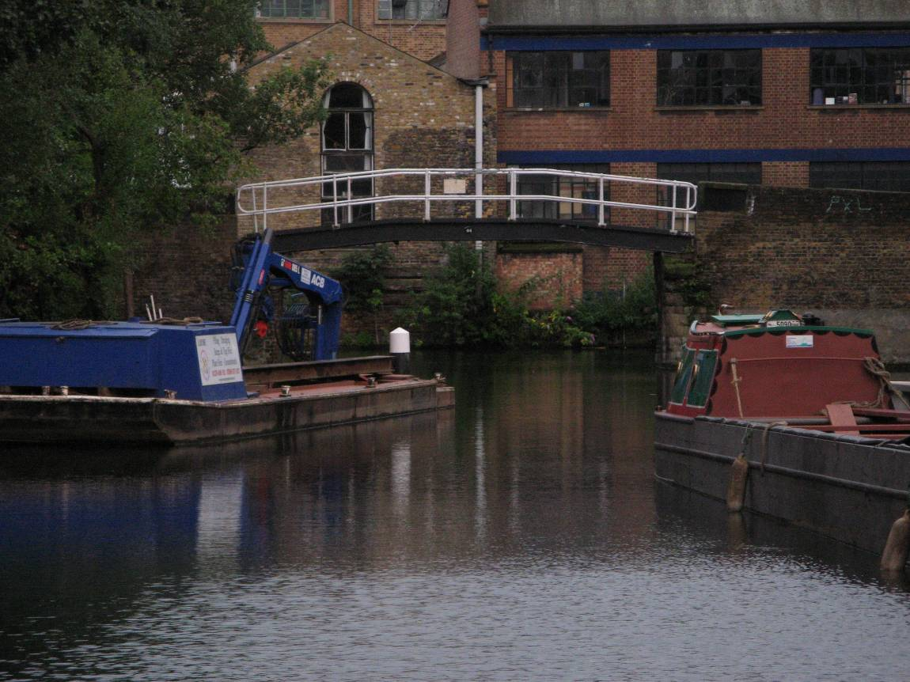

Photograph C
The adjacent canal at the south end of the Basin is also used by common pipistrelles and may be used by Daubenton’s bats, as this is a mostly dark corridor and a useful commuting route. It is not known if Daubenton’s bat enter the Basin or may fly across it at times
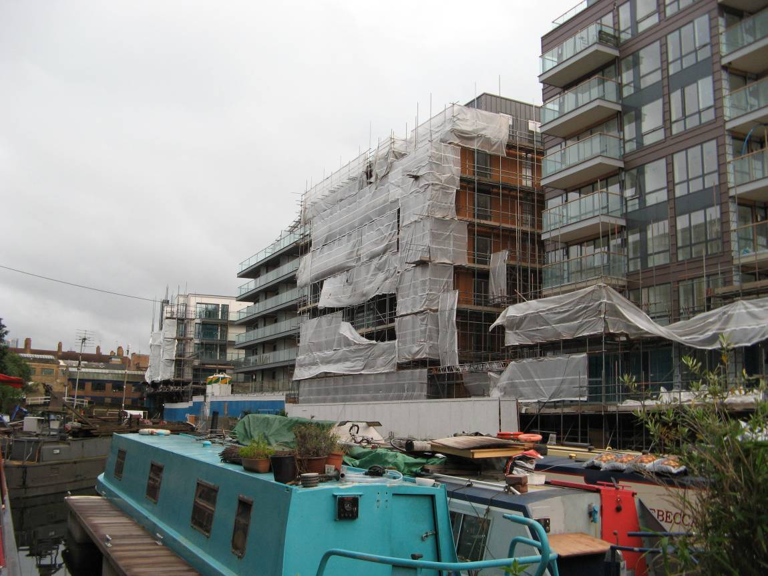

Photograph D
There are uninhabited apartment blocks on the east and west sides of the Basin, and there is a serious concern that when these are all taken up by new residents, the resulting light overspill onto the water will have a significant negative impact on local bats
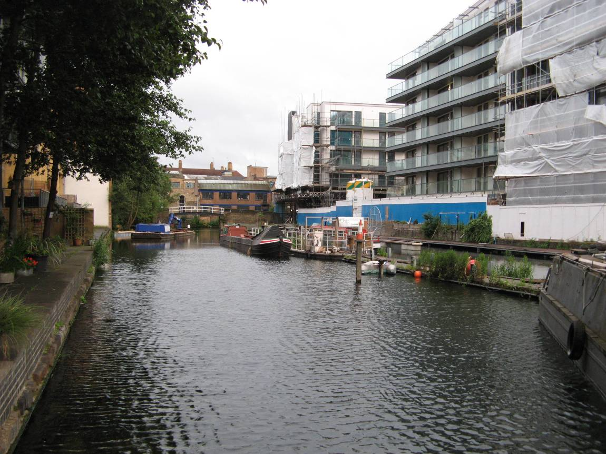

Photograph E
The Kingsland Basin was shown to be a dark corridor for bats, let alone a bat hotspot for foraging common pipistrelles, and this has to be maintained where possible by suitable mitigation by the developers responsible for the adjacent new blocks
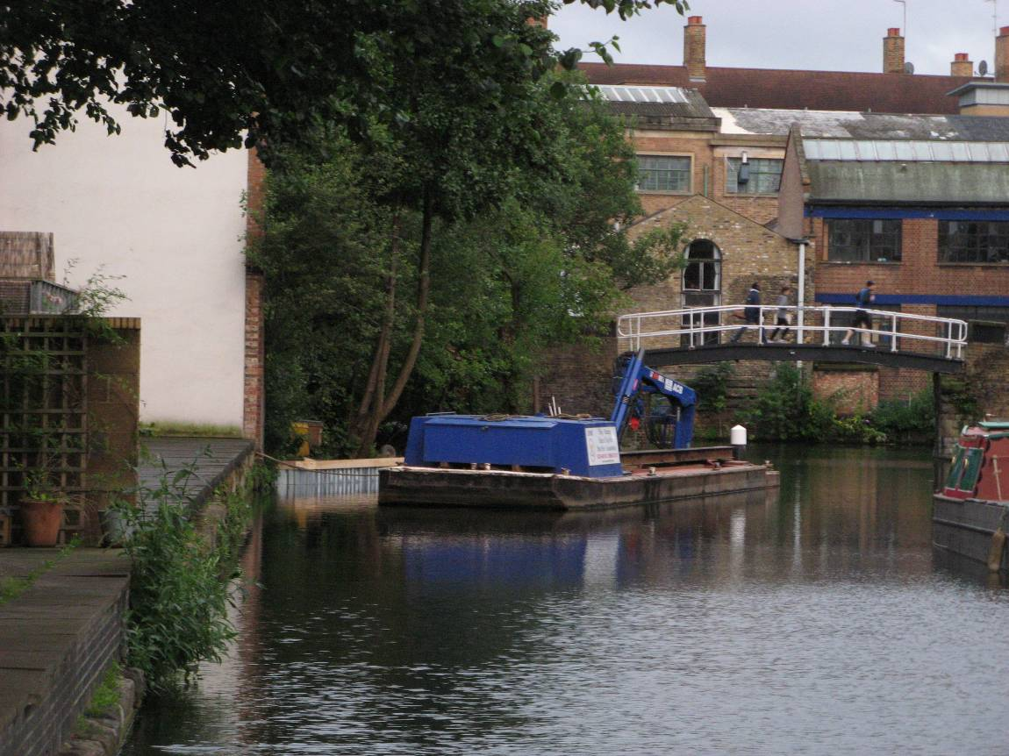

Photograph F
There are also ways that the Basin can be enhanced for local bats, and such measures can include suitable native planting, installation of bat boxes and long-term bat monitoring by CHUG
Appendix 3
Map A: Location of bat sightings at Kingsland Basin, Kingsland Road,
LB Hackney, London – July 2012

