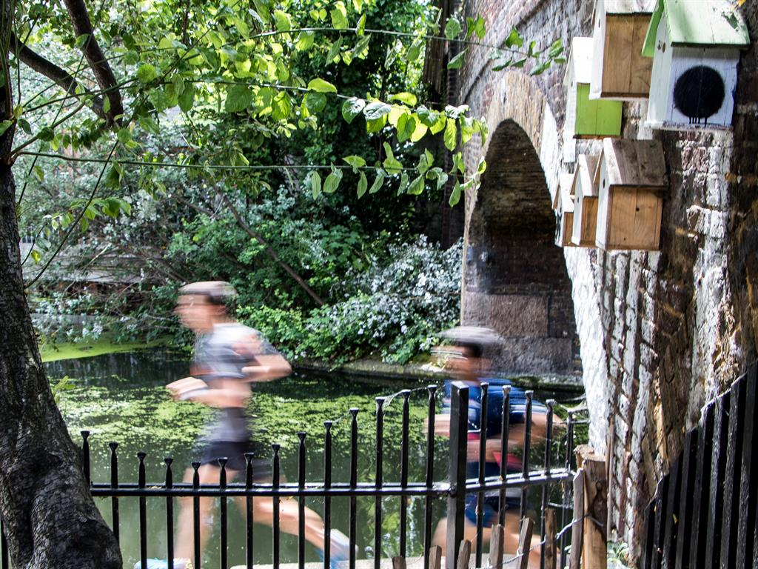
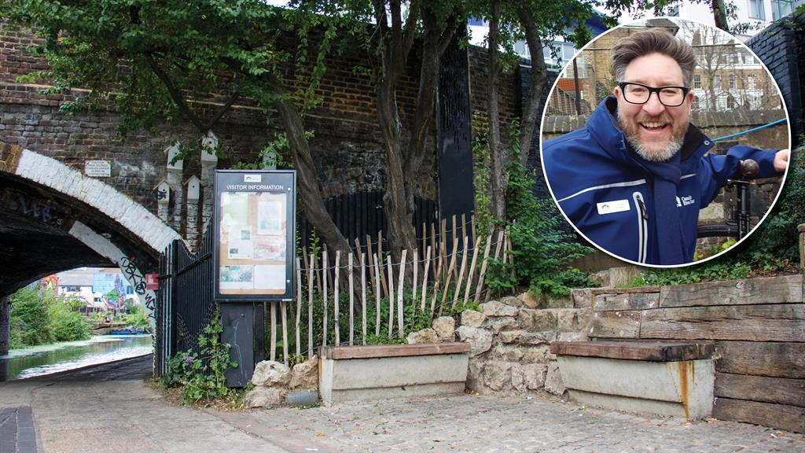
Garden bridges gap
Canal & River Trust ranger Dick Vincent on how the new SkyWay garden is uniting a community

What’s the big idea?
It’s a project created by the Canal & River Trust in partnership with the charity SkyWay. We wanted to do something with the arch under the bridge where Regent’s Canal meets Kingsland Road in Hackney, east London, to take away the problem of people sleeping rough there. We wanted to remove that rough-sleeping/bad behaviour/drinking sort of atmosphere.
When you’ve got somewhere like that, you’ve got two options: you can close it, which no one wants, or you can do what we’ve done here. Technically it’s called ‘placemaking’ but I like to call it ‘making it look nice’.

Where did the idea come from?
This is our overall vision for how we’d like to manage the canals — to get the community involved. Canals fell into decline when people stopped moving stuff on boats and went over to railways.
Around 30 to 40 years ago, the Kingsland Road bridge was the roughest place, where people sold drugs and boxers would train. When I talk to people who lived here then, they say no one would come here. All the canals in the country were like that, derelict and disused places.
But now it’s constantly busy. Cyclists, joggers, walkers, boaters, paddleboarders and dog walkers all come here. We haven’t sanitised this place, we’ve just given it back to the community.

How did you go about making it a reality?
While it was my idea, it was made real by a lot of people. SkyWay is a charity that works with vulnerable young people in Hackney. These youngsters are given the opportunity to contribute to this garden while learning new skills.
We also worked with the Thames Reach charity, which helps get homeless people out of these rough places. And, of course, we have Peter Beardsley, our gardener. He’s internationally renowned and amazingly talented, and he designed this whole thing for us.

What obstacles did you overcome?
From initial design to the spade hitting the ground, it took the best part of ten months. We had to go through planning, which we didn’t expect. But you can’t just go digging under a Transport for London red route without asking permission!
There were a lot of material costs as well. About seven tonnes of soil had to be brought in and, while soil is relatively cheap, transporting it isn’t. Then there were technical costs. The site is 200 years old and the National Grid and internet run underneath. We had to find out where the cables were so we didn’t damage them.
Transformation: Once home to rough sleepers, the canal at Kingsland Road is now a changed place. Inset, Dick Vincent

What’s your vision for the future?
Regent’s Canal is 8.6 miles long, out of 100 miles of canals in London alone. Half the bridges could have gardens like this but so far we’ve only got two. So there’s room for expansion and that’s what we want to do.
Through partnerships and along with the community, this is how we want to be managing the canals. We can’t do it everywhere but we’ll do it where we can. The SkyWay garden is a model for how it can work best. It has all the basic elements you need: a canal, a bit of land, and community involvement. Beyond that, the permutations are endless.

What’s the next big idea?
It’s all about expanding the original idea — for communities to take over these spaces. That happened quickly with the SkyWay garden. It’s now the community’s garden, tended by local people and the boaters who live in the Kingsland Basin. They’ve planted wildflowers all the way down to the next bridge and they look after it.
It’s about getting people to find these places and get stuck in. That alone will keep us busy for the next ten or 15 years. We call it ‘canal adoption’. These micro gardens can be anywhere and they’re here for everyone — and that’s a pretty special thing. INTERVIEW BY JULIA FOX
skyway.london

Garden bridges gap
Canal & River Trust ranger Dick Vincent on how the new SkyWay garden is uniting a community

What’s the big idea?
It’s a project created by the Canal & River Trust in partnership with the charity SkyWay. We wanted to do something with the arch under the bridge where Regent’s Canal meets Kingsland Road in Hackney, east London, to take away the problem of people sleeping rough there. We wanted to remove that rough-sleeping/bad behaviour/drinking sort of atmosphere.
When you’ve got somewhere like that, you’ve got two options: you can close it, which no one wants, or you can do what we’ve done here. Technically it’s called ‘placemaking’ but I like to call it ‘making it look nice’.

Where did the idea come from?
This is our overall vision for how we’d like to manage the canals — to get the community involved. Canals fell into decline when people stopped moving stuff on boats and went over to railways.
Around 30 to 40 years ago, the Kingsland Road bridge was the roughest place, where people sold drugs and boxers would train. When I talk to people who lived here then, they say no one would come here. All the canals in the country were like that, derelict and disused places.
But now it’s constantly busy. Cyclists, joggers, walkers, boaters, paddleboarders and dog walkers all come here. We haven’t sanitised this place, we’ve just given it back to the community.

How did you go about making it a reality?
While it was my idea, it was made real by a lot of people. SkyWay is a charity that works with vulnerable young people in Hackney. These youngsters are given the opportunity to contribute to this garden while learning new skills.
We also worked with the Thames Reach charity, which helps get homeless people out of these rough places. And, of course, we have Peter Beardsley, our gardener. He’s internationally renowned and amazingly talented, and he designed this whole thing for us.

What obstacles did you overcome?
From initial design to the spade hitting the ground, it took the best part of ten months. We had to go through planning, which we didn’t expect. But you can’t just go digging under a Transport for London red route without asking permission!
There were a lot of material costs as well. About seven tonnes of soil had to be brought in and, while soil is relatively cheap, transporting it isn’t. Then there were technical costs. The site is 200 years old and the National Grid and internet run underneath. We had to find out where the cables were so we didn’t damage them.
Transformation: Once home to rough sleepers, the canal at Kingsland Road is now a changed place. Inset, Dick Vincent

What’s your vision for the future?
Regent’s Canal is 8.6 miles long, out of 100 miles of canals in London alone. Half the bridges could have gardens like this but so far we’ve only got two. So there’s room for expansion and that’s what we want to do.
Through partnerships and along with the community, this is how we want to be managing the canals. We can’t do it everywhere but we’ll do it where we can. The SkyWay garden is a model for how it can work best. It has all the basic elements you need: a canal, a bit of land, and community involvement. Beyond that, the permutations are endless.

What’s the next big idea?
It’s all about expanding the original idea — for communities to take over these spaces. That happened quickly with the SkyWay garden. It’s now the community’s garden, tended by local people and the boaters who live in the Kingsland Basin. They’ve planted wildflowers all the way down to the next bridge and they look after it.
It’s about getting people to find these places and get stuck in. That alone will keep us busy for the next ten or 15 years. We call it ‘canal adoption’. These micro gardens can be anywhere and they’re here for everyone — and that’s a pretty special thing. INTERVIEW BY JULIA FOX
skyway.london

