# VISVESVARAYA TECHNOLOGICAL UNIVERSITY

**Belagavi-590018**



## VOIDSEEK

**MINI PROJECT REPORT**

**Submitted by**

|  |  |
| --- | --- |
| **ANUJNA K** | **4CB24CS014** |
| **CHATURTHI H V** | **4CB24CS028** |
| **CHINTAN C NAIK** | **4CB24CS029** |
| **DISHA G** | **4CB24CS041** |

**DEPARTMENT OF**

**BASIC SCIENCE AND HUMANITIES**

***Under the guidance of***

### Ms. PRATHIBHA M

**Assistant professor**

**Department of Computer Science and Engineering**



# CANARA ENGINEERING COLLEGE

(Affiliated to VTU Belagavi)

### SUDHINDRANAGARA, BENJANAPADAVU, BANTWAL- 574219, KARNATAKA

**2024-2025**

**APPROVAL**

This project entitled **“VOIDSEEK”** is here by approved a creditable study of an engineering subject **Introduction to Web Programming (BPLCK105A)** carried out and presented in a satisfactory manner to its acceptance as CIE Component for the subject.

|  |  |
| --- | --- |
| **Ms. PRATHIBHA M** | **Dr.N.SATHEESHA KUMARA** |
| **(Project Guide)** | **(Head of the Department)** |
|  |  |
|  |  |

**Examiner 1………………………………………...**

**Examiner 2…………………………………………...**



## DECLARATION

We, the students of second semester of Computer Science and Engineering from Canara Engineering College, Sudhindra Nagara, Bantwal- 574129, declare that the work entitled **“VOIDSEEK”** has been successfully completed under the guidance of

Ms. PRATHIBHA M, Assistant Professor, Department of Computer Science and Engineering. Further the matter embodied in the project report has not been submitted previously by anybody for the award of any degree or diploma to any university.

Place: SudhindraNagara, Bantwal

Date:31/05/2025

ProjectAssociates:

|  |  |
| --- | --- |
| **1.ANUJNA K** | **4CB24CS014** |
| **2. CHATURTHI H V** | **4CB24CS028** |
| **3.CHINTAN C NAIK** | **4CB24CS029** |
| **4.DISHA G** | **4CB24CS041** |

**CANARA ENGINEERING COLLEGE**

(Affiliated to VTU Belagavi) SudhindraNagara, Bantwal-574219, Karnataka

**DEPARTMENT OF**

**SCIENCE AND HUMANITIES**

## ACKNOWLEDGEMENT

We wish to express our heartfelt gratitude to our project guide **Ms. PRATHIBHA M, Assistant Professor, Department of Computer Science and Engineering,** Canara Engineering College for all the required approvals, guidance and timely advice.

We sincerely thank **Dr. N. SATHEESHA KUMARA,** HOD, Department of Basic Science and humanities, Canara Engineering College for the unwavering support.

We consider it a pleasure to extend our heartfelt gratitude to our beloved Principal **Dr. NAGESH H.R** and management of Canara Engineering College for providing us the facilities to carry out our project.

We acknowledge our sincere thanks to our project Coordinator **Mr. VINOD KUMAR M V** Assistant Professor, Department of Mechanical Engineering, Canara Engineering College for the unwavering support.

We thank all teaching and non-teaching staff/Technical staff of the Department of Computer Science and Engineering for their help and support.

Finally, this work will be incomplete if we forget to thank God for guiding us in the right path and our parents for their constant support and blessings. These are the driving force that kept us going all through the work.

## ABSTRACT

This project focuses on the development of an educational astronomical webpage that provides detailed information about a wide range of celestial objects, including planets, stars, moons, asteroids, galaxies, and nebulae. The goal is to make astronomy accessible and engaging through organized content, visually appealing layouts, and interactive features. The webpage serves as a reliable learning platform for students, educators, and space enthusiasts.

To enhance user engagement and understanding, the site includes 3D models of selected celestial bodies, allowing users to explore them in an interactive and immersive way. The webpage is developed using HTML, CSS, and JavaScript, ensuring responsiveness and ease of navigation across devices. This project showcases the effective integration of technology and education, promoting curiosity and deeper understanding of the universe.

## TABLE OF CONTENTS

**CONTENTS PAGENO**

|  |  |
| --- | --- |
| **ACKNOWLEDGEMENT** | **i** |
| **ABSTRACT** | **ii** |
| **TABLE OF CONTENT** | **iii** |
| 1. **INTRODUCTION** | **4** |
| 1. **LITERATURE REVIEW** | **6** |
| 1. **MATERIALS** | **8** |
| 1. **METHODOLOGY** | **10** |
| 1. **DESIGN AND DEVELOPMENT OF PAVER BLOCK** | **12** |
| 1. **RESULT AND DISCUSSIONS** | **14** |
| 1. **CONCLUSION** | **15** |
| 1. **REFERENCES** | **17** |

**CHAPTER 1**

# INTRODUCTION

The universe, with its vast and mysterious expanse, has intrigued humanity since the dawn of civilization. From the early days of stargazing and mythological interpretations of the night sky to the scientific revolution that led to telescopic observations and space exploration, our fascination with celestial bodies has remained constant. In recent decades, advances in both astronomy and digital technology have made it possible to explore the cosmos not only through physical observation but also through immersive virtual experiences. This project, titled **"Interactive Astronomical Webpage Featuring Celestial Bodies and 3D Models"**, is a step in that direction—merging scientific knowledge with modern web development tools to create a digital platform that brings the universe closer to users in an engaging and educational manner.

The core objective of this project is to design and develop an interactive webpage that serves as a rich repository of information about various celestial bodies. These include the planets of our solar system, their moons, distant stars, galaxies, comets, asteroids, black holes, and more. Each celestial body featured on the website is accompanied by detailed scientific data, such as composition, size, orbital characteristics, discovery history, and notable features. The content has been curated to ensure accuracy and relevance, making it valuable for students, educators, amateur astronomers, and general users interested in space science.

What distinguishes this webpage from a standard informational site is the incorporation of **interactive 3D models** that allow users to visualize celestial objects in a spatial, hands-on manner. Built using HTML, CSS, and JavaScript—along with libraries like **Three.js** and **WebGL**—these models can be rotated, zoomed, and explored in real time. This adds a dynamic, immersive element to the learning process, offering users a more intuitive understanding of astronomical concepts, such as planetary rotation, relative size, and orbital paths. The use of 3D visualization bridges the gap between textual learning and experiential understanding, especially for visual learners.

The design philosophy behind the webpage emphasizes simplicity, accessibility, and user engagement. The interface is clean and responsive, ensuring compatibility across multiple devices and screen sizes. Animations and effects are used to reflect the aesthetics of outer space—dark themes, glowing visuals, and smooth transitions contribute to an immersive experience. Content is categorized intuitively, allowing users to search, filter, and browse through celestial objects with easeinterface design, 3D model integration, coding strategies, and challenges encountered along the way. It will also highlight future scope for improvement and expansion, such as the integration of real-time astronomical data, virtual reality support, and multilingual options. Ultimately, this project stands as a testament to the power of combining science with technology to make learning a more immersive and enjoyable experience.

**CHAPTER 2**

# LITERATURE REVIEW

The integration of astronomy education with digital platforms has gained substantial attention in recent years, with numerous studies highlighting the effectiveness of interactive tools in enhancing learning outcomes. Researchers like Slater et al. (2001) and Zeilik et al. (2002) have emphasized the role of visual aids and simulations in helping learners grasp complex astronomical concepts such as planetary motion, star formation, and the scale of the universe. Traditional resources, while informative, often lack the dynamic and interactive features needed to engage modern learners. As a result, web-based astronomy tools like NASA’s “Eyes on the Solar System,” Stellarium, and Celestia have emerged, offering users the ability to explore the cosmos virtually. However, many of these tools require software installation and are not optimized for universal accessibility across devices, particularly mobile platforms. This limitation presents a significant gap that browser-based solutions can effectively address.

Simultaneously, the development of web technologies such as WebGL and JavaScript libraries like Three.js has made it possible to create interactive 3D models directly within the browser. These technologies allow for real-time rendering of complex graphics without the need for additional plugins, making them ideal for educational applications. According to Evans et al. (2014), WebGL has proven to be a powerful tool for scientific visualization, and its use in web-based learning environments continues to grow. Several astronomy-focused projects have already utilized these technologies to simulate planetary systems and visualize space phenomena in three dimensions. However, while platforms such as Solar System Scope and Space Engine Web are technologically advanced, they often prioritize high-fidelity simulation over simplicity, which can make them less approachable for beginners.

Equally important in the development of educational platforms is user experience. Studies by Nielsen (1994) and Kim and Reeves (2007) stress that usability and interactivity are critical for effective learning. Features such as smooth navigation, responsive design, drag-and-rotate interfaces, and interactive information cues help sustain user interest and promote deeper exploration. Despite this, many existing astronomy sites focus more on static content or visual realism, neglecting aspects of user interface and accessibility.

In conclusion, the current landscape of astronomical web platforms highlights both innovation and gaps. While several tools have made great strides in integrating 3D visualization and astronomical data, issues such as limited accessibility, lack of mobile responsiveness, and steep learning curves remain. This project seeks to address these gaps by offering an all-in-one, browser-based webpage that combines informative content, interactive 3D models, and user-friendly design to create a more inclusive and engaging astronomical learning experience.

## CHAPTER 3

**MATERIALS**

The development of the astronomical webpage required a combination of software tools, programming languages, libraries, and resources to effectively design and implement both the content and interactive features. The core technologies used in this project include HTML, CSS, and JavaScript, which form the foundation for structuring, styling, and enabling interactivity on the webpage. HTML was used to create the structural layout of the webpage, organizing content into sections such as celestial body descriptions, navigation menus, and interactive elements. CSS was employed to design a responsive and visually appealing user interface, using styles, themes, animations, and transitions that reflect the aesthetic of outer space. JavaScript served as the primary language for adding interactivity, enabling dynamic behaviors such as content switching, user-triggered animations, and the rendering of 3D models.

To create and render the 3D models of celestial bodies, the Three.js JavaScript library was utilized. Three.js is built on top of WebGL, allowing for hardware-accelerated 3D graphics directly in the browser without the need for plugins. This library provided tools for creating spheres to represent planets and stars, applying textures, adding lighting effects, and enabling user interactions like rotation, zoom, and camera movement.

For visual assets, including textures of planets and star fields, NASA’s public domain image database and other open-source space image repositories were used. These high-resolution textures added realism to the 3D models and enhanced the visual quality of the simulation. In some cases, additional image editing was done using tools like Adobe Photoshop or GIMP to optimize the textures for web use and ensure smooth loading performance.

The project was developed and tested using Visual Studio Code as the main code editor due to its extensive support for web development, integrated terminal, and useful extensions for HTML, CSS, and JavaScript. Browser-based debugging and live preview were conducted primarily in Google Chrome, which offers robust developer tools for testing responsiveness and performance.

To ensure that the webpage would function effectively across different screen sizes and devices, responsive design techniques were implemented using CSS Flexbox and Media Queries. The design was tested on various devices including laptops, tablets, and smartphones to validate accessibility and usability.

**CHAPTER 4**

**METHODOLOGY**

The development of the VOIDSEEK astronomy website followed a systematic methodology grounded in front-end web development practices. The goal was to build a static yet interactive and educational platform using only HTML, CSS, and JavaScript. This approach ensured lightweight implementation while still enabling a visually appealing and user-friendly experience for learners, students, and space enthusiasts. The methodology comprised multiple phases: planning, content collection, design, coding, testing, and final refinement.

The first step involved defining the website's content structure and thematic boundaries. The team decided to focus on nine major areas: Solar System (excluding dwarf planets), Celestial Concepts (including supermassive black holes, dark matter, and dark energy), Stellar Evolution, ISRO-based Space Missions, Space Technology (limited to satellites and telescopes), Space Phenomena (eclipses and auroras), Unsolved Mysteries, Space Travel with a focus on astronauts, and an interactive Quiz. This clear scope allowed the team to manage content complexity and development timelines effectively.

Once the structure was defined, the content collection phase began. Reliable and accurate information was sourced from trusted organizations such as NASA, ISRO, and scientific publications. The gathered data was filtered, summarized, and rewritten in simple language to ensure accessibility for a broader audience. The aim was to educate without overwhelming, which is especially important in topics like black holes or dark energy that involve complex physics.

Following the content preparation, the website's layout was sketched using wireframes. These wireframes helped visualize the arrangement of sections, placement of navigation bars, button positions, and how a user would transition from one category to another. This stage was crucial to maintaining a clean and consistent structure throughout the site. The focus was on a minimalistic and intuitive interface to encourage easy navigation and exploration.

With a layout in place, the front-end development phase was initiated. HTML was used to build the foundational structure, creating semantic sections for each topic. CSS was employed to design the interface, featuring dark backgrounds, glowing titles, and smooth transitions to match the theme of space. JavaScript was introduced to manage interactivity, particularly for handling the hamburger menu, dynamic section display, and quiz behavior. The site was built using Visual Studio Code, and development was supported by browser-based testing tools.

During the testing phase, the website was evaluated across different browsers such as Chrome and Firefox, and devices including mobile phones, tablets, and desktops. CSS media queries and responsive layouts ensured that the site maintained usability and visual appeal on all screen sizes. Bugs related to spacing, button alignment, and menu toggling were identified and corrected during this process.

The final refinement stage involved collecting feedback from peers and improving the content flow and UI consistency. Adjustments were made to text spacing, hover effects, and mobile navigation responsiveness. Additional enhancements included the use of smooth scrolling effects, better alignment of text blocks, and visual cues for interactivity.

**CHAPTER 5**

**DESIGN AND DEVELOPMENT**

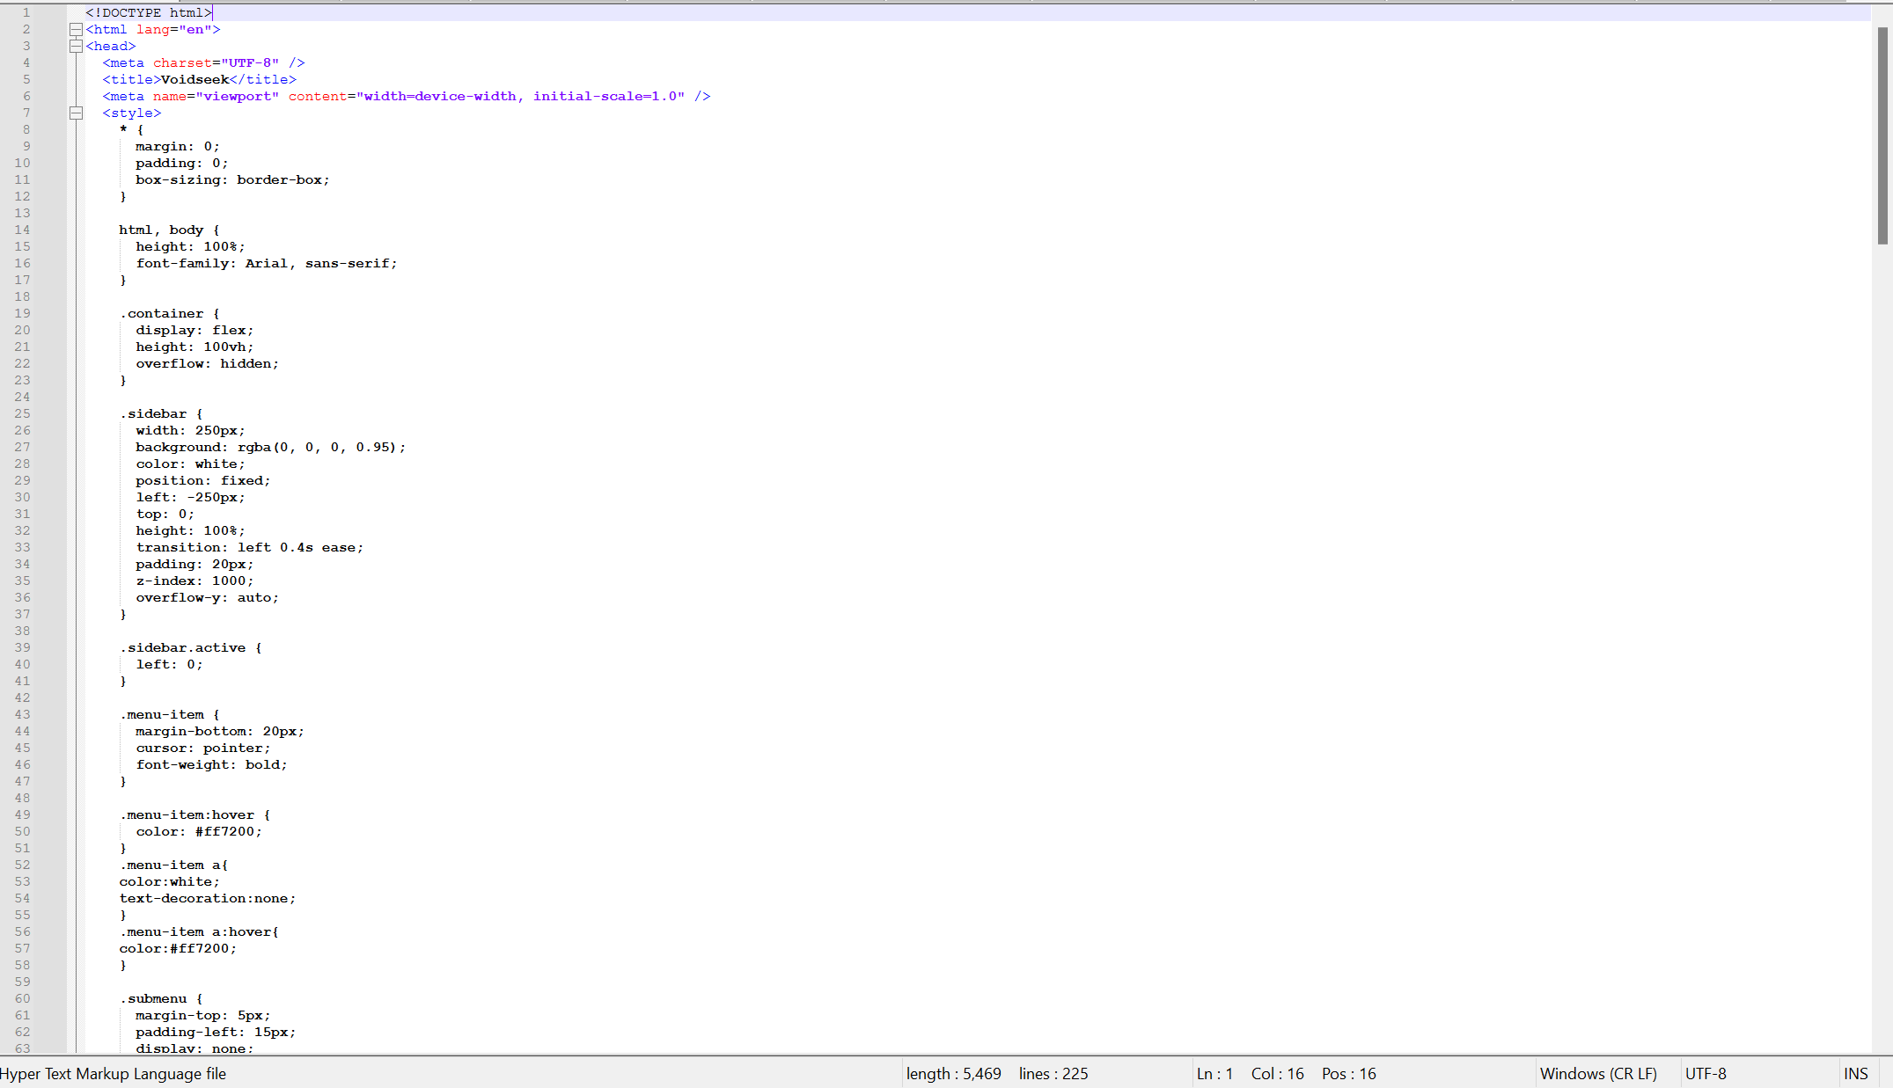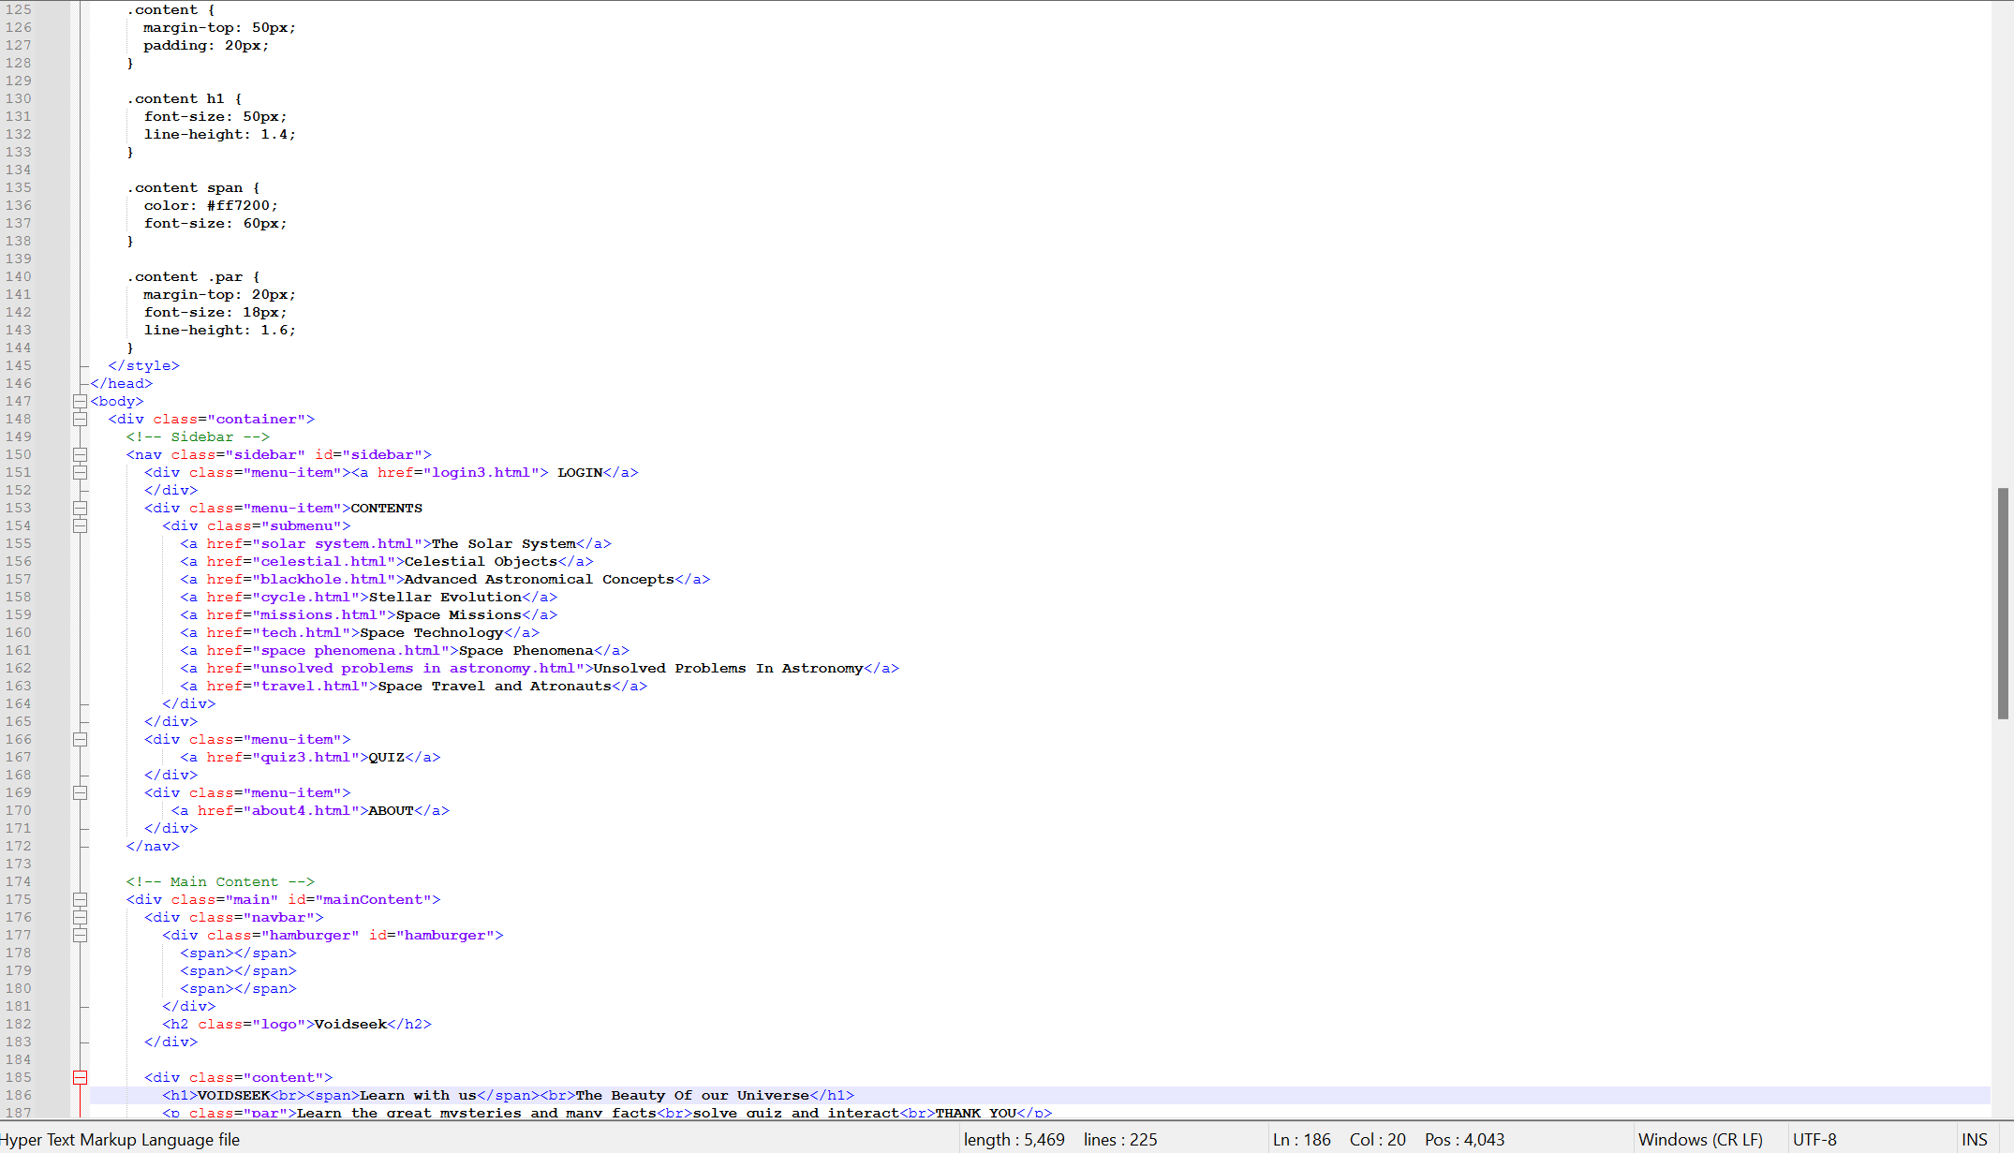

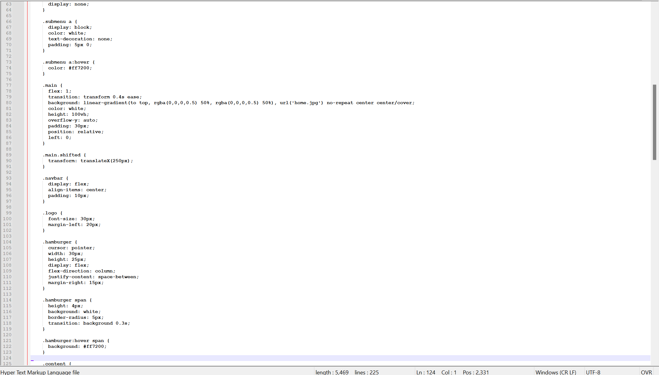

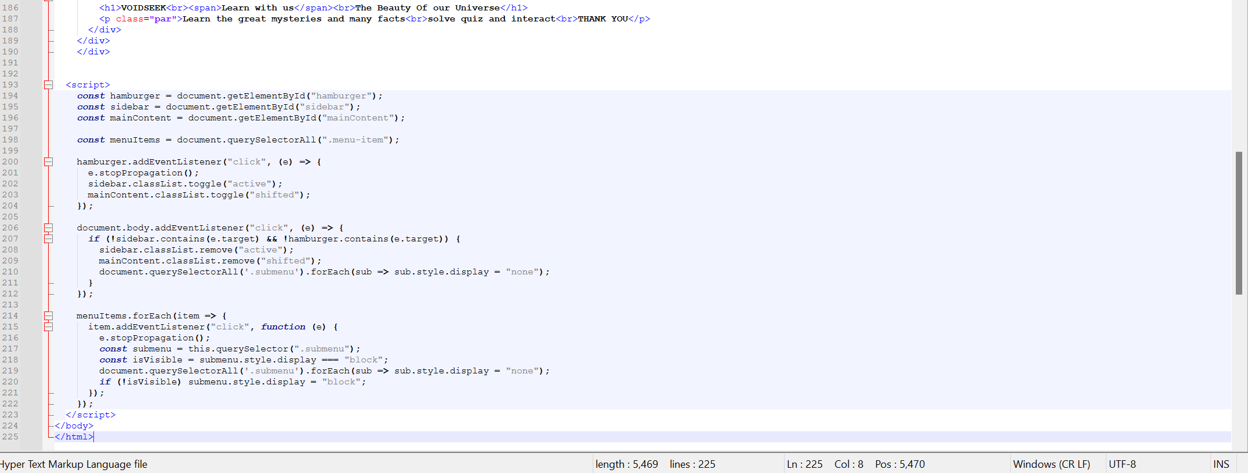

Figure 5.1 : Code for the home page

The design and development of VoidSeek focused on creating a clean, responsive layout using HTML for structure, CSS for styling, and JavaScript for interactivity. The site features organized sections on celestial topics, smooth navigation, and visually engaging elements like hover effects and animations.

**CHAPTER 6**

**RESULTS AND DISCUSSIONS**

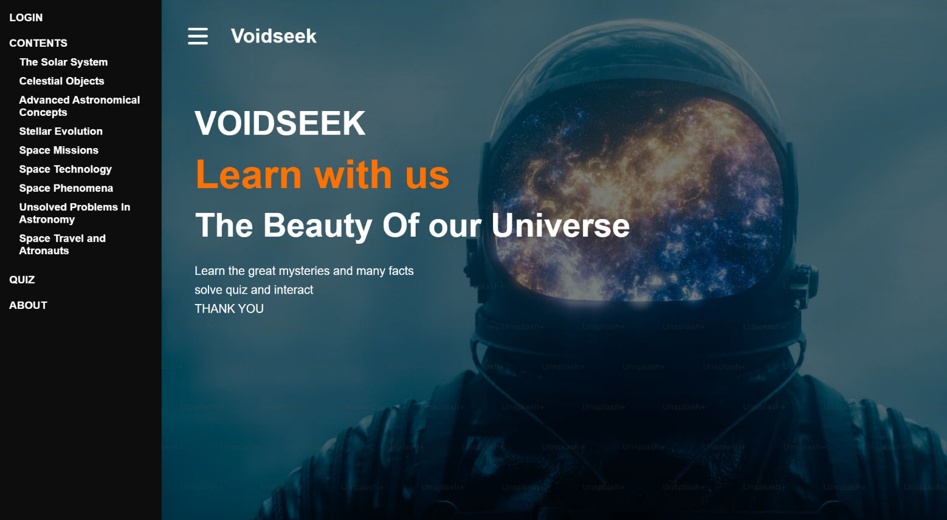

Figure 6.1 : Output of the home page

## The VoidSeek website was built using HTML, CSS, and JavaScript to provide accessible, interactive astronomy content. It features responsive design, basic animations, and easy navigation. Users found it visually appealing and informative. Future updates may add real-time data and multimedia.

## 

## 

## CONCLUSION

The VOIDSEEK project was conceptualized and developed with the intention of making astronomy more approachable, visually engaging, and educational for students, enthusiasts, and the general public. Through this mini-project, we successfully created an interactive, responsive, and content-rich website that showcases various fascinating aspects of space using fundamental front-end technologies—HTML, CSS, and JavaScript.

The website covers a wide array of carefully selected astronomical topics, including the Solar System (excluding dwarf planets), Celestial phenomena like supermassive black holes, dark matter, and dark energy, Stellar Evolution, ISRO-based space missions, space technologies such as satellites and telescopes, and natural space phenomena like eclipses and auroras. Additionally, the platform explores unsolved cosmic mysteries, the journey of astronauts in space travel, and includes a quiz section that enhances user engagement through interactive learning.

One of the major highlights of the project is its accessibility. The website is designed to function smoothly across a variety of devices and browsers, ensuring that users can access quality astronomy content regardless of the platform they use. The dark-themed layout, animations, and smooth transitions provide an immersive experience that mirrors the aesthetics of outer space while maintaining readability and usability.

The development process also offered valuable learning experiences. From conceptual planning and content curation to designing and coding, each phase of the project enhanced our understanding of both astronomy and web development. We faced and overcame several technical challenges, especially in achieving full responsiveness, building interactive features without external libraries, and maintaining visual consistency across diverse content sections.

In conclusion, VOIDSEEK stands as a testament to how simple technologies, when used thoughtfully, can create powerful educational tools. It combines scientific accuracy with creative design to bring the vastness of the universe closer to users in a structured and captivating format. We believe this project has laid the foundation for future enhancements, including real-time data, multimedia integration, multilingual support, and more advanced interactivity. With continued development, VOIDSEEK has the potential to grow into a full-fledged learning platform that inspires curiosity and exploration among its users.

## REFERENCES

**Websites:**

1. NASA - National Aeronautics and Space Administration

https://www.nasa.gov

2. ISRO - Indian Space Research Organisation

https://www.isro.gov.in

3. European Space Agency – Space Science Section

https://www.esa.int/Science_Exploration/Space_Science

**Books:**

1. Sagan, Carl. Cosmos. Ballantine Books, 1980.

2. Tyson, Neil deGrasse. Astrophysics for People in a Hurry. W. W. Norton & Company, 2017.

3. Hawking, Stephen. The Universe in a Nutshell. Bantam Books, 2001