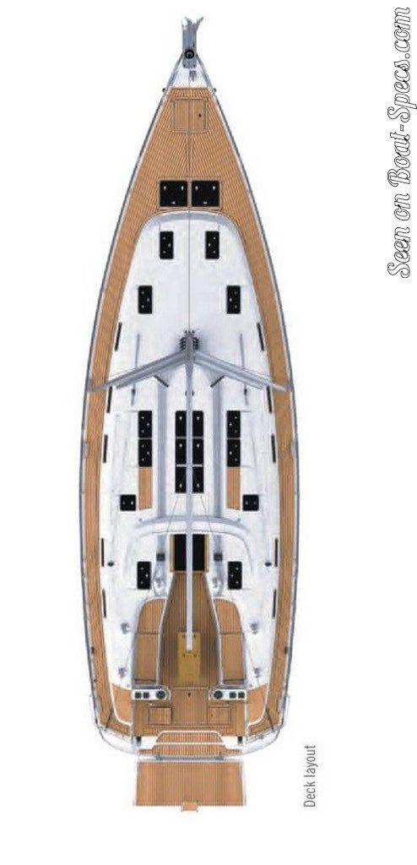

D2

Anchor control

T5

Gas bottles

T2

Danbouy tied to red life ring

T5

Outboard motor

T4

Red life ring, light & drogue

T3

Blue Life Sling

M1

C2

C1

C3

Heaving line - yellow

M1

Liferaft 8 person

EPIRB

Water

Knife

Flares

First aid

C1

Flares in yellow container

Sheets

Emergency tiller

10M anchor chain

CQR Anchor

Rectangular grey fender

Sail ties

Preventer

2x small drogues

Sheets, lines, mooring lines

Bag of snap shackles

Spare Blocks

D1

Rocna anchor

Snubber

Chain 50M

T1

Red life ring, light & drogue

C2

Water hose (roll flat)

Funnels

Seat for inflatable

Oars for inflatable

Anchor for inflatable

Outboard motor fuel

Fenders x 2

2 x 5L drinking water

Hull cleaning products

Electrical extension cord

Sponges

Bucket x 2

C3