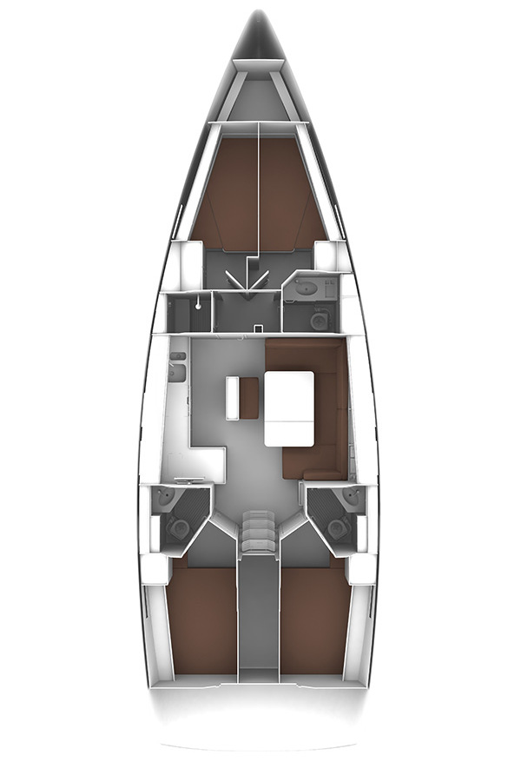
F1
Storm jib – colour bag?
Tri-sail – colour bag?
Head sails
Other sails

M1
Tool kit – big blue wrap
Wire cutters – white bag
Sail repair kit
Metal fittings, fasteners
Things that may be useful box
Spare light globes
Adhesives
Electrical spares – black box
Cordage & bungee
Screwdriver kit
Bosun’s chair
M9
406 EPIRB
M11
Grab bag
Defibrillator
First aid kits
Air Splints
M12
Mini-ITX computer
Hand held compass
M10
Bathroom supplies
Toilet paper
Soap
M13
Hand held VHF x2

A3

M16
Water tank 170L

A3

M4

M4

M15

M15
Sewage tank 130L

F1
F1
M1
F1
M6
F1
M5
F1
M7
F1
F2
Vacuum cleaner

A1

M6
Anchor remote control
3 x Floating torches
Winch handles
Spare batteries
Emergency nav lights
Small tool kit

M14
9 x Type 1 PFDs
Safety tethers Personal EPIRBs

F3
Bathroom supplies
Toilet paper
Soap

A1
Orange V sheet
Titley tracking device
Mask and Snorkel

M6
Cooking utensils
Pots and pans
Tupperware
M4
Water tanks 170L x2
A3
Emergency VHF antenna
Boat hook
Flag mast
Battens
A2
Batteries
M7
Diesel fuel tank 225L

A2
M5
Waste pump adaptor

A4
A4
Lubricants
Dinghy pump
Water maker spares
PFD spares
Flares
M8
Fire Extinguisher
Fire Blanket

M16

M2
Fire Extinguisher
M6

M3
High power spot light
Fluoro batten lights

A3

M11
F1

F1

