|  |
| --- |
| CanberraUAV |
| Deliverable 3 |
| Autonomous Flight Record |

|  |
| --- |
| www.canberraUAV.org.au  04/08/2014 |



# Table of Contents

1 Table of Contents 1

2 Flight Logs 2

2.1 Flight Log Book 2

2.2 GPS Telemetry 3

2.3 Video 3

2.4 Static Images 3

3 RF Transmitters 7

3.1 2.4 GHz RC Link 7

3.2 900 MHz Telemetry Link 7

3.3 433 MHz Telemetry Link 7

3.4 5.8 GHz Image and Telemetry Link 7

3.5 Voice Communications 8

4 Aircraft Specifications and Performance 9

# Flight Logs

## Flight Log Book

The following is an extract from our flight log book.

| Date | Aircraft | Start  Time | AUTO  time | Flight Comments | DroneShare link |
| --- | --- | --- | --- | --- | --- |
| 30/04/14 | Bushmaster | 10:09 | 0:04:57 | D2 video capture. First flight with enlarged tail – handled very well. | www.droneshare.com/mission/11495 |
| 11/05/14 | Bushmaster | 9:52 | 0:03:39 | Tuned the airspeed sensor and tested ground handling. | www.droneshare.com/mission/11488 |
| 18/05/14 | Bushmaster | 10:25 | 0:27:32 | Tested new (bigger) fuel tanks. | www.droneshare.com/mission/11503 |
| 18/05/14 | Bushmaster | 11:35 | 1:00:41 | First long-endurance flight. All went well. | www.droneshare.com/mission/11502 |
| 25/05/14 | Bushmaster | 10:47 | 0:01:51 | Second endurance flight. Aborted due to crash | www.droneshare.com/mission/11510 |
| 05/07/14 | Bushmaster | 10:18 | 0:11:02 | First AUTO flight of repaired airframe. | www.droneshare.com/mission/11509 |
| 06/07/14 | Bushmaster | 8:35 | 0:17:21 | Flight test before endurance flights | www.droneshare.com/mission/11508 |
| 06/07/14 | Bushmaster | 9:31 | 1:00:57 | First endurance flight | www.droneshare.com/mission/11512 |
| 06/07/14 | Bushmaster | 11:25 | 1:00:15 | Second endurance flight | www.droneshare.com/mission/11511 |
| 13/07/14 | Bushmaster | 9:38 | 1:00:37 | Endurance flight with camera and image processing on-board | www.droneshare.com/mission/11516 |
| 20/07/14 | Bushmaster | 14:04 | 0:06:32 | Flight with remote ground station > 5km away. | www.droneshare.com/mission/11518 |
| 20/07/14 | Bushmaster | 11:14 | 0:48:22 | Endurance flight with camera and image processing on-board | www.droneshare.com/mission/11515 |
| 02/08/14 | Bushmaster | 10:16 | 1:00:09 | Endurance flight with camera and image processing on-board | www.droneshare.com/mission/12016 |
| 02/08/14 | Bushmaster | 13:10 | 0:14:47 | Bottle drop test | www.droneshare.com/mission/12015 |
| 03/08/14 | Bushmaster | 10:59 | 0:11:07 | Bottle drop and ground station test | www.droneshare.com/mission/12107 |
| 03/08/14 | Bushmaster | 12:22 | 0:06:02 | Bottle drop and ground station test | www.droneshare.com/mission/12106 |
| 03/08/14 | Bushmaster | 13:12 | 0:07:03 | Bottle drop and ground station test | www.droneshare.com/mission/12108 |
|  | **Total** |  | **7:42:54** |  |  |

Our full flight logs are available at [www.droneshare.com/vehicle/1085](http://www.droneshare.com/vehicle/1085) and <http://uav.tridgell.net/Bushmaster/OBC-2014-auto/>. They contain the full GPS tracks (in kml and gpx format) and flight telemetry (in tlog format).

## GPS Telemetry

A KML log from a flight on the 20th June 2014 is shown below:

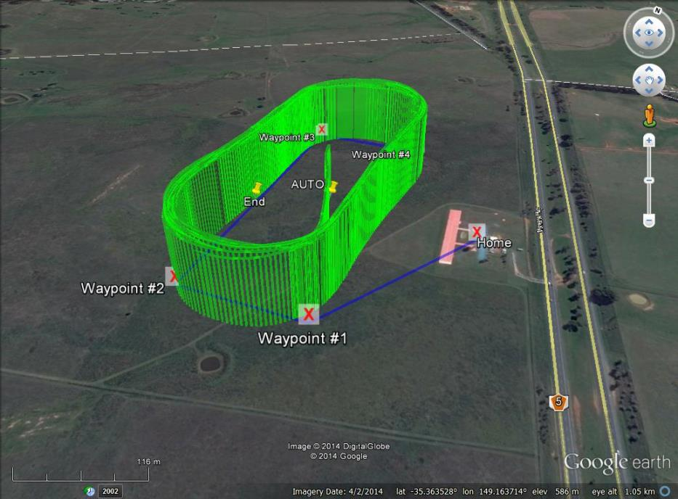

The full file is available from <https://api.droneshare.com/api/v1/mission/11515/messages.kmz>.

## Video

A video showing the aircraft during autonomous flight and the operational ground station is available at <http://youtu.be/fzzPpzbPJj0>.

## Static Images

The following are a set of static images showing the ground station, aircraft and team members during flight operations from a number of flights over the last 3 months.

|  |  |
| --- | --- |
| C:\Users\Stephen\Desktop\14389829337_fc1e2d9678_z.jpg | Pre-flight team briefing |
| C:\Users\Stephen\Desktop\14697079942_a27280bb71_z.jpg | Pre-flight checks |
| C:\Users\Stephen\Desktop\14510921417_e67b57b93a_z.jpg | Pre-flight checks |
| C:\Users\Stephen\Desktop\14640682175_b65f741aa1_z.jpg | Engine start |
| C:\Users\Stephen\Desktop\14583762592_1846219915_z.jpg | Monitoring the UAV during flight |
| C:\Users\Stephen\Desktop\14397885458_668ec51b3a_z.jpg | Flying the search pattern |
| C:\Users\Stephen\Desktop\10365931_259810527559813_1592013629026822069_n.jpg | Dropping a bottle to Joe |
| C:\Users\Stephen\Desktop\14719332203_8c3052287a_z.jpg | Approach to landing |
| C:\Users\Stephen\Desktop\IMG_20140802_131142.jpg | Ground station test |
| C:\Users\Stephen\Desktop\14637444171_8120964dab_z.jpg | Landing |
| C:\Users\Stephen\Desktop\14389592050_563c1bf7c6_z.jpg | Packing the UAV away after test flights |

# RF Transmitters

## 2.4 GHz RC Link

This link is used for manual RC control of the UAV’s throttle and flight control surfaces.

|  |  |
| --- | --- |
| Specification | Value |
| Model | FrSky Taranis 2.4 GHz (using a FrSky X9D transmitter module) |
| Transmission Frequency | 2400 – 2483.5 MHz |
| Transmitter Power | 60 mW (17 dBm) |
| Transmitter antenna gain | < 5 dBi |
| Calculated EIRP | < 23 dBm |
| Covering licence | Radiocommunications (Low Interference Potential Devices) Class Licence 2000. Part 45A, 53, 54 |

## 900 MHz Telemetry Link

This is a low bandwidth link for transmitting telemetry from the UAV to Ground Station. Commands can be sent from the Ground Station to UAV when necessary. They have been calibrated and tested for LIPD-2000 (Part 52) compliance by RFDesigns RF lab in Brisbane.

|  |  |
| --- | --- |
| Specification | Value |
| Model | RFD900 Telemetry Radio |
| Transmission Frequency | 915 – 928 MHz, 20 Channel Hopping |
| Transmitter Power | 27 dBm (UAV) 24 dBm (Ground) |
| Transmitter antenna gain | 3 dBi (UAV) 6 dBi (Ground) |
| Calculated EIRP | 30 dBm (UAV) 30 dBm (Ground) |
| Covering licence | Radiocommunications (Low Interference Potential Devices) Class Licence 2000. Part 52 |

## 433 MHz Telemetry Link

This is a low bandwidth link for transmitting telemetry to the Tracking Antenna from the Ground Station. This is in order to provide the position of the UAV so the Antenna knows which direction to point.

|  |  |
| --- | --- |
| Specification | Value |
| Model | 3D Robotics 433MHz Radio |
| Transmission Frequency | 433.05 – 434 MHz, channel hopping |
| Transmitter Power | 10 dBm (Antenna) 10 dBm (Ground) |
| Transmitter antenna gain | 2 dBi (Antenna) 2 dBi (Ground) |
| Calculated EIRP | 12 dBm (Antenna) 12 dBm (Ground) |
| Covering licence | Radiocommunications (Low Interference Potential Devices) Class Licence 2000. Part 17 |

## 5.8 GHz Image and Telemetry Link

This is a high bandwidth link for transmitting images from the UAV’s on-board cameras to the Ground Station. As a backup, the telemetry and command datastream also uses this link.

|  |  |
| --- | --- |
| Specification | Value |
| Model | Ubiquiti Rocket |
| Transmission Frequency | 5795 MHz |
| Transmitter Power | 26 dBm (UAV) 8 dBm (Ground) |
| Transmitter antenna gain | 10 dBi (UAV) 28 dBi (Ground) |
| Calculated EIRP | 36 dBm (UAV) 36 dBm (Ground) |
| Covering licence | Radiocommunications (Low Interference Potential Devices) Class Licence 2000. Part 45B, 55  “C-tick” No. N14691 |

## Voice Communications

This is a voice radio link using CB radios. It will be used to facilitate communications between the pilot and ground station during setup, takeoff, landing and pack-up.

|  |  |
| --- | --- |
| Specification | Value |
| Model | Uniden UH015SX and Uniden UH078SX handheld CB |
| Transmission Frequency | 476.425 -477.400 MHz |
| Transmitter Power | 6.9 dBm |
| Transmitter antenna gain | 3 dBi |
| Calculated EIRP | 9.9 dBm |
| Covering licence | Radiocommunications (Citizen Band Radio Stations) Class Licence 2002. “C-tick” No. N32Z068 |

# Aircraft Specifications and Performance

The Aircraft platform used by Canberra UAV is a custom built aircraft called the “Bushmaster”. It has the following specifications:

|  |  |
| --- | --- |
| Specification | Value |
| Maximum Airspeed | 64 kts (115 Km/h) |
| Cruise Airspeed | 56 kts (100 Km/h) |
| Endurance at maximum airspeed | Estimated 60 minutes |
| Endurance at cruise airspeed | 90 minutes |
| Maximum take off weight | 20 Kg |
| Competition take off weight | 15 Kg |
| Wingspan | 2.6 m |
| Airframe length | 2 m |
| Identifying marks | White with red trim |
| Aircraft planform and configuration | High wing V-tail tractor aircraft |