Reviewers’ comments

**Reviewer 1:**

**Please list your revision requests for the authors and provide your detailed comments, including highlighting limitations and strengths of the study and evaluating the validity of the methods, results, and data interpretation. If you have additional comments based on Q2 and Q3 you can add them as well.**

**Reviewer 1** | 20 Oct 2024 | 00:45

**#1**

This study examined differentially expressed genes (DEGs) between invasive breast cancer and adjacent normal tissue, using RNA-seq of 22 paired samples from African women. Authors highlighted genes from JAK-STAT pathway, and DEGs associated with blood pressure and heart rate.  
Major comment:  
1. What is the ER, PR, HER2, Ki-67, subtype, grade, TNM stage, and treatment status of the samples? Please include more detailed clinical and pathological information  
2. There is comprehensive data and analyses of RNA-seq data of primary breast cancer and matched normal tissue, eg, from TCGA. The current cohort is of small scale and only focused on one pathway. Authors shall discuss comparison with known data / results and think of the scientific significance / novelty of this study.  
3. Correlation with blood pressure and heart rate is a nice exploration for association of breast cancer with cardiovascular disease. However, the cohort size is small and these parameters are physiological fluctuating and are not good representations of cardiovascular status, which makes internal validity in question. History of hypertension, hyperlipidemia, heart disease and other metabolic syndrome is more of interest.  
4. The focus of JAK/STAT pathway looks subjective. The power of current data allows for a comprehensive pathway analysis of all DEGs. Is JAK/STAT pathway the most prominent or there are other enriched pathways? Many regular analyses remained undone.  
Minor:  
1. In methods, please add how the blood pressure, heart rate, BMI are measured.

**Q 2**

**Check List**

**Reviewer 1** | 20 Oct 2024 | 00:45

**#1**

a. Is the quality of the figures and tables satisfactory?  
- No  
  
b. Does the reference list cover the relevant literature adequately and in an unbiased manner?  
- Yes  
  
c. Are the statistical methods valid and correctly applied? (e.g. sample size, choice of test)  
- Yes  
  
d. Is a statistician required to evaluate this study?  
- No  
  
e. Are the methods sufficiently documented to allow replication studies?  
- No

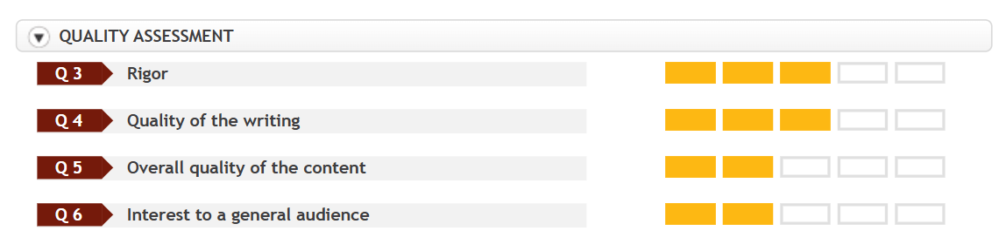

**Reviewer 2:**

**Reviewer 3**

**Independent review report submitted:**26 Oct 2024

**Interactive review activated:**28 Nov 2024

**Initial recommendation to the Editor:**Major revision is required

**EVALUATION**

**Q 1**

**Please list your revision requests for the authors and provide your detailed comments, including highlighting limitations and strengths of the study and evaluating the validity of the methods, results, and data interpretation. If you have additional comments based on Q2 and Q3 you can add them as well.**

**Reviewer 3** | 26 Oct 2024 | 14:23

**#1**

Strengths: The research focuses an innovative topic by investigating genetic mutations associated with hypertension in Kenyan women, contributing data to an underrepresented population.  
  
Weaknesses: The study has limitations, including a small sample size, an unclear definition of blood pressure measurement, the absence of long-term follow-up and uncorrected confounding factors. Additionally, the causal relationship between genetic mutations and hypertension remains difficult to establish.  
  
Major Points:  
1. The methods section should provide more detail on how clinical traits data were collected.  
2. It is necessary to describe how and when blood pressure measurements were taken. Was blood pressure measured before or after diagnosis, and if after, how long post-diagnosis? Additionally, was a standardized method used to ensure consistency across patients?  
3. The potential influence of cancer treatment on blood pressure needs to be addressed. Were patients undergoing treatment between or before sample collection and blood pressure measurement? If so, this could affect the results.  
4. The claim that genetic mutations are the "molecular mechanisms of hypertension among Kenyan women diagnosed with breast cancer" is too strong. The study does not adequately establish causality between the genetic mutations and hypertension.  
5. Several confounding factors, such as comorbidities, cancer stages, and patient age, were not accounted for, which may limit the validity of the conclusions.  
  
Minor Points:  
1. Data inconsistency is present between the abstract (stating 7,243 new cases of breast cancer in 2022) and the introduction (which mentions 2,296,840 new cases in 2022). This needs to be corrected.  
2. A table summarizing the clinical traits and basic characteristics of the patients would improve clarity and provide a better overview of the study population.  
3. The time frame of patient enrollment is unclear. Were all patients pathologically diagnosed with invasive breast carcinoma and who underwent surgery included in the study?  
4. Figures should be numbered in the order they are referenced in the manuscript. Additionally, Figures 1 and 4 are not mentioned in the text, which should be corrected.  
5. The manuscript should provide specific P-values and beta coefficients to support the statistical findings.  
6. There appears to be an inconsistency between the results and discussion sections. The results and figures show that STAT5 expression is positively associated with SBP and SOCS2 is positively associated with heart rate HR. However, the discussion suggests that downregulation of these genes may predispose patients to a hypertensive phenotype, which seems contradictory.

**Q 2**

**Check List**

**Reviewer 3** | 26 Oct 2024 | 14:23

**#1**

a. Is the quality of the figures and tables satisfactory?  
- Yes  
  
b. Does the reference list cover the relevant literature adequately and in an unbiased manner?  
- Yes  
  
c. Are the statistical methods valid and correctly applied? (e.g. sample size, choice of test)  
- Yes  
  
d. Is a statistician required to evaluate this study?  
- No  
  
e. Are the methods sufficiently documented to allow replication studies?  
- No

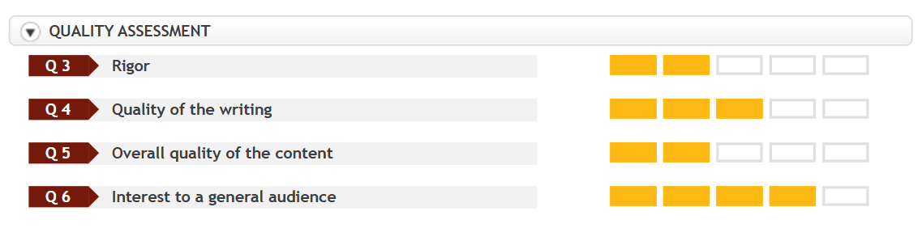

**Reviewer 3:**

**Reviewer 5**

**Independent review report submitted:**28 Nov 2024

**Interactive review activated:**28 Nov 2024

**Initial recommendation to the Editor:**Major revision is required

**EVALUATION**

**Q 1**

**Please list your revision requests for the authors and provide your detailed comments, including highlighting limitations and strengths of the study and evaluating the validity of the methods, results, and data interpretation. If you have additional comments based on Q2 and Q3 you can add them as well.**

**Reviewer 5** | 28 Nov 2024 | 00:07

**#1**

The authors presented an interesting study exploring the molecular mechanisms underlying the high prevalence of hypertension among breast cancer patients. However, several key issues needed to be addressed before the manuscript can be considered for publication in our journal:  
  
1. The methods used to measure blood pressure and heart rate require clarification, as these are very liable values based on the situation. 19 out of 22 patients in this study were reported to have hypertension, which seems disproportionally high compared to the general breast cancer population.  
2. Consider providing baseline characteristics of the study population. These should include, but are not limited to age, breast cancer stage, histological type, cancer-directed therapies, and cardiovascular comorbidities.  
3. In the results section, authors reported positive correlation between SOCS gene and heart rate, as well as the STAT5A gene and blood pressure. However, the Pearson correlation coefficient value (r-value) was not presented.  
4. The mechanisms between SOCS2 and STAT5A gene dysregulation in breast cancer cells with hypertension and elevated heart rate require further discussion, as these two issues are primarily cardiovascular system dysfunctions. If this association is valid, it is essential to explore whether breast cancer treatment (such as removing the tissue by surgery in this study) could positively affect blood pressure and/or heart rate. Writers mentioned prior studies associating STAT5A with endothelial dysfunction and SOC2 gene with diabetes but did not provide references (lines 183-184 and 199-203).  
5. Finally, as the authors mentioned in the discussion, the sample size is too small to reach a conclusion.

**Q 2**

**Check List**

**Reviewer 5** | 28 Nov 2024 | 00:07

**#1**

a. Is the quality of the figures and tables satisfactory?  
- Yes  
  
b. Does the reference list cover the relevant literature adequately and in an unbiased manner?  
- Yes  
  
c. Are the statistical methods valid and correctly applied? (e.g. sample size, choice of test)  
- No  
  
d. Is a statistician required to evaluate this study?  
- Yes  
  
e. Are the methods sufficiently documented to allow replication studies?  
- No

