# **Artificial Neural Network (AAN)**

# **Predictive-Classification Using TensorFlow**

**How it works**

The entire training dataset is stored. When a prediction is required, the neural network performs a linear regression from trained data.

**Input to a ANN Model**

Predicting Heat Disease  
The data set consists of around 900 observations on 17 features X. Some of the features are categorical. Age is the non-binary feature. The target Y variable Heart Disease is binary, which can take on two values, 1 or 0.

**Data cleaning and Preprocessing**

1. The dataset must provide features X, that directly impacts a binary target Y-variable.
2. The number of unique values are determined to evaluate features that may be dropped or combined
3. Non-numeric features are transposed by adding columns and providing a binary (0,1) value
4. The data is split into training and test buckets
5. The data is scaled to create a uniform distribution

**Summary of Model Parameters**

**Initial Model**

Model: "sequential"

_________________________________________________________________

Layer (type) Output Shape Param #

=================================================================

dense (Dense) (None, 5) 105

dense_1 (Dense) (None, 1) 6

=================================================================

Total params: 111 (444.00 Byte)

Trainable params: 111 (444.00 Byte)

Non-trainable params: 0 (0.00 Byte)

_________________________________________________________________

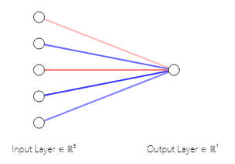

**Tuned Model**

Model: "sequential"

_________________________________________________________________

Layer (type) Output Shape Param #

=================================================================

dense (Dense) (None, 3) 63

dense_1 (Dense) (None, 9) 36

dense_2 (Dense) (None, 5) 50

dense_3 (Dense) (None, 1) 6

=================================================================

Total params: 155 (620.00 Byte)

Trainable params: 155 (620.00 Byte)

Non-trainable params: 0 (0.00 Byte)

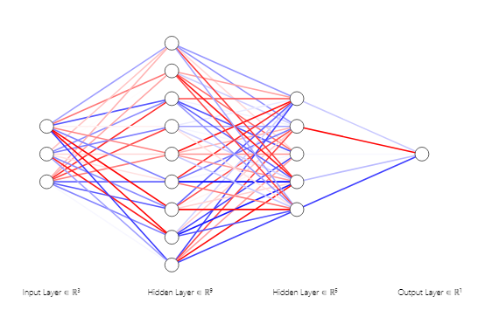

**Results**

|  |  |  |
| --- | --- | --- |
|  | Loss | Accuracy |
| Initial | 0.31449 | 0.8913 |
| Tuned | 0.30443 | 0.91739 |

**Conclusion**

The initial parameters used for the neural network had an accuracy of 0.89 while the tuned model came in just a little bit better with an accuracy of 0.92, which shows the tests used for the study are a good indicator in determining heart disease.

Tableau link - <https://public.tableau.com/app/profile/mark.meinhardt/viz/Project-4_16929198798350/NeuralNetworkII>