IMDB Movie Analytics Dashboard

System Design Specification (SDS)

0.1 Draft

2026-04-21

Zhou Can 2430036294
Liao Shuaiyu 2430026120
Zhu Junyu 2430026304
Chen Ziming 2430026024
Dai Ling 2430026032
Pan Meihao 2430026161

Computer Science and Technology Program
United International College
- Document Change Log
Change Date | Changed By | Version | Change Description
2026-04-21 | Zhou Can | 0.1 | Filled draft SDS with project overview, tools and standards, UI scenarios, database design, and diagrams for the IMDB Movie Analytics Dashboard project.
- Table of Contents
1. Document Change Log 2
2. Table of Contents 3
3. Design Overview 4
4. Tools and Standards 5
4.1. Tools 5
4.2. Standards 5
5. User Interface Design 6
5.1. Usage Scenario 1 6
5.2. Usage Scenario 2 6
6. Database Design 7
7. Diagrams 8

- Design Overview
This project aims to develop an interactive movie analytics dashboard based on the IMDB movie dataset. The system is designed as a single-page web dashboard that helps users explore how different movie attributes, such as budget, genre, release timing, and audience response, relate to commercial success and ratings.
The dashboard focuses on four analytical questions: (1) what factors influence box office success, (2) which genres are the most profitable, (3) what is the best time to release a movie, and (4) what factors influence movie ratings. To answer these questions, the system combines data filtering, visual analytics, and summary insights in one interface.
Technically, the system is implemented using Python for data processing and Streamlit for the web-based dashboard interface. The IMDB dataset is cleaned and transformed using Pandas and NumPy. Visualizations such as scatter plots, bar charts, line charts, and boxplots are generated using Plotly or similar visualization libraries. The user interface is designed in a dark-theme dashboard style and includes KPI cards, a filter panel, and multiple analytical cards. Users can adjust filters such as year range, genre, and minimum vote count to dynamically update the visualizations.
The final product is a standalone analytical tool intended for educational use in the Software Development Workshop II project. It does not rely on external partners or third-party services during runtime.

- Tools and Standards

Tools
The main tools and technologies used in this project are:
• Python – the main programming language used for implementation
• Streamlit – used to build the single-page web dashboard
• R – used for data cleaning
• Pandas – used for data cleaning, preprocessing, and tabular analysis
• NumPy – used for numerical operations and derived metrics
• Plotly – used for interactive charts and visual analytics
• Figma – used for dashboard interface design and prototyping
• CSV / IMDB dataset files – used as the project data source

Standards
The project follows the following standards and design principles:
• The system runs as a browser-based dashboard application
• Development and testing are performed primarily on Windows and Linux environments
• Python code follows general PEP 8 coding conventions where practical
• Visualizations follow standard data visualization practices, including clear labels, titles, legends, and readable scales
• The user interface follows a consistent dark-theme dashboard design with card-based layout and modern spacing
• The project emphasizes clarity, usability, and reproducibility of analysis rather than decorative complexity

- User Interface Design

Usage Scenario 1
Figure 1. Main dashboard interface mockup
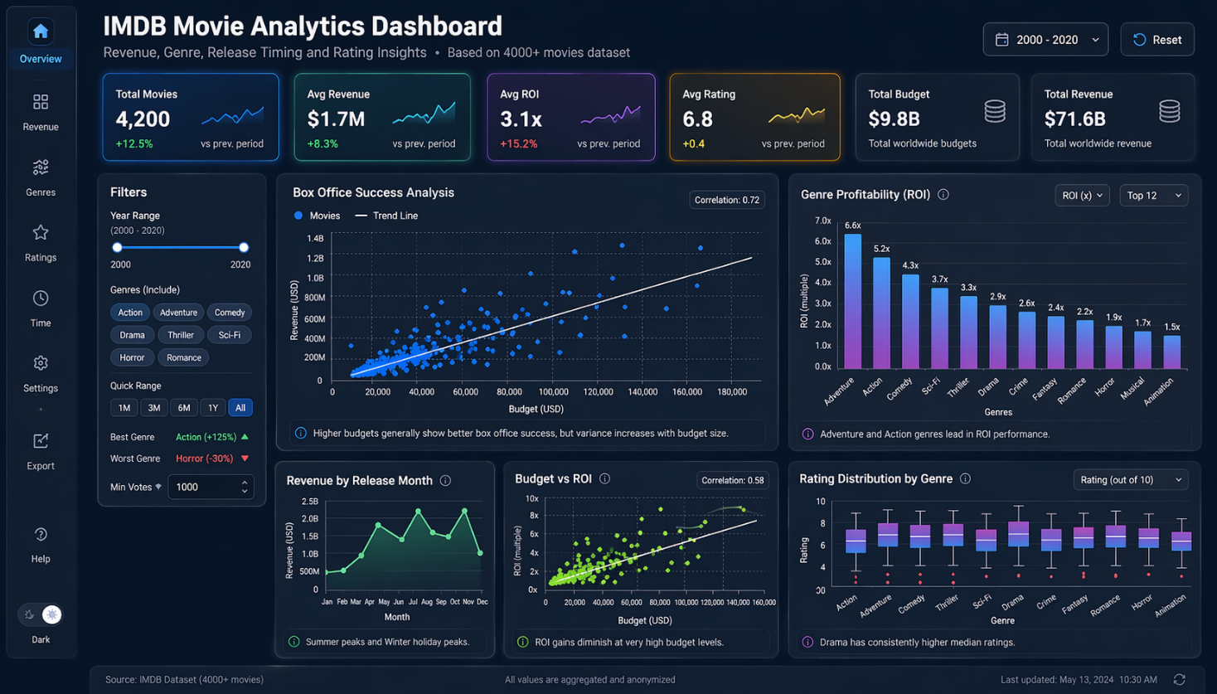

Figure 1 presents the main interface of the IMDB Movie Analytics Dashboard. The system is designed as a single-page interactive dashboard that allows users to explore movie data through dynamic filtering and visual analytics.

- Top Section – Header and Global Controls
At the top of the interface, the dashboard displays the title:
“IMDB Movie Analytics Dashboard”
Below the title, a subtitle describes the scope of analysis:
Revenue, Genre, Release Timing and Rating Insights
Additionally, a small note indicates the dataset size:
Based on 4000+ movies dataset
On the top-right corner, global controls are provided:
- Year Range Selector (Dropdown) – allows users to quickly switch between predefined time ranges
- Reset Button – resets all filters to default values

- KPI Section – Key Metrics Overview
Below the header, six KPI cards provide a quick summary of the dataset:
- Total Movies – total number of movies in the dataset
- Avg Revenue – average revenue per movie
- Avg ROI – return on investment across movies
- Avg Rating – average IMDB rating
- Total Budget – total combined budget
- Total Revenue – total combined revenue
Each KPI card includes:
- A large numeric value
- A small trend indicator (percentage change vs previous period)
- A mini trend chart (sparkline)
These indicators give users an immediate overview of the dataset before deeper analysis.

- Left Panel – Filter System
On the left side, a vertical filter panel allows users to refine the dataset interactively.
The panel includes the following controls:

1. Year Range (Range Slider)
- Users can select a time interval (e.g., 2000–2020)
- This filter affects all charts simultaneously

2. Genre Selection (Multi-select Tags)
- Users can include or exclude genres such as:
  - Action, Adventure, Comedy, Drama, Thriller, Sci-Fi, etc.
- Selected genres are highlighted

3. Quick Range Buttons
- Predefined time shortcuts:
  - 1M, 3M, 6M, 1Y, All

4. Min Votes Filter
- Numeric input to filter movies by minimum vote count
- Helps remove low-quality or low-confidence data

5. Summary Indicators
- Displays:
  - Best performing genre (e.g., Action +125%)
  - Worst performing genre (e.g., Horror -30%)
This panel transforms the dashboard into an interactive analytical tool rather than a static report.

- Main Analysis Section
The central area of the dashboard contains five analytical panels, each answering a specific research question.

- 1. Box Office Success Analysis (Top Left Panel)
This panel visualizes the relationship between budget and revenue using a scatter plot.
Features:
- Each point represents a movie
- X-axis: Budget
- Y-axis: Revenue
- A regression line shows overall trend
- Correlation value is displayed (e.g., 0.72)
Insight Provided:
Higher budgets generally correlate with higher revenue, but variability increases with budget size.

- 2. Genre Profitability (Top Right Panel)
This panel displays a bar chart showing ROI by genre.
Features:
- Genres sorted by ROI
- Color gradient enhances visual comparison
- Dropdown allows switching metric (e.g., ROI, revenue)
- Top-N filter (e.g., Top 12 genres)
Insight Provided:
Adventure and Action genres lead in ROI performance.

- 3. Revenue by Release Month (Bottom Left Panel)
This panel shows a line chart of revenue trends across months.
Features:
- X-axis: Month
- Y-axis: Revenue
- Highlights seasonal patterns
Insight Provided:
Summer and winter months show peak revenue periods.

- 4. Budget vs ROI (Bottom Middle Panel
This panel presents a scatter plot showing the relationship between budget and ROI.
Features:
- X-axis: Budget
- Y-axis: ROI
- Includes regression trend line
- Correlation value shown (e.g., 0.58)
Insight Provided:
ROI gains diminish at very high budget levels.

- 5. Rating Distribution by Genre (Bottom Right Panel)
This panel uses a boxplot to show rating distributions across genres.
Features:
- X-axis: Genre
- Y-axis: Rating
- Shows median, quartiles, and outliers
Insight Provided:
Drama has consistently higher median ratings.

- Footer Section
At the bottom of the dashboard:
- Data source is displayed:
Source: IMDB Dataset (4000+ movies)
- System note:
All values are aggregated and anonymized
- Last updated timestamp is shown

- Database Design (If Applicable)
The project uses a structured movie dataset derived from IMDB-related records. In implementation, the data is stored in tabular form (CSV and Pandas DataFrame) rather than in a live relational database. However, the logical database design can still be described using entity relationships.
The central entity is Movie. Important attributes include title, genre, budget, revenue, release date, vote average, vote count, and language. Related entities may include genre categories, keywords, production information, and collection metadata, depending on the final cleaned dataset used in the dashboard.
For dashboard implementation, the cleaned dataset will typically be flattened into analysis-ready tables so that filtering and chart generation are efficient. The ER diagram included below reflects the broader logical structure considered during project design.
Figure 2. Logical ER diagram for the movie data model
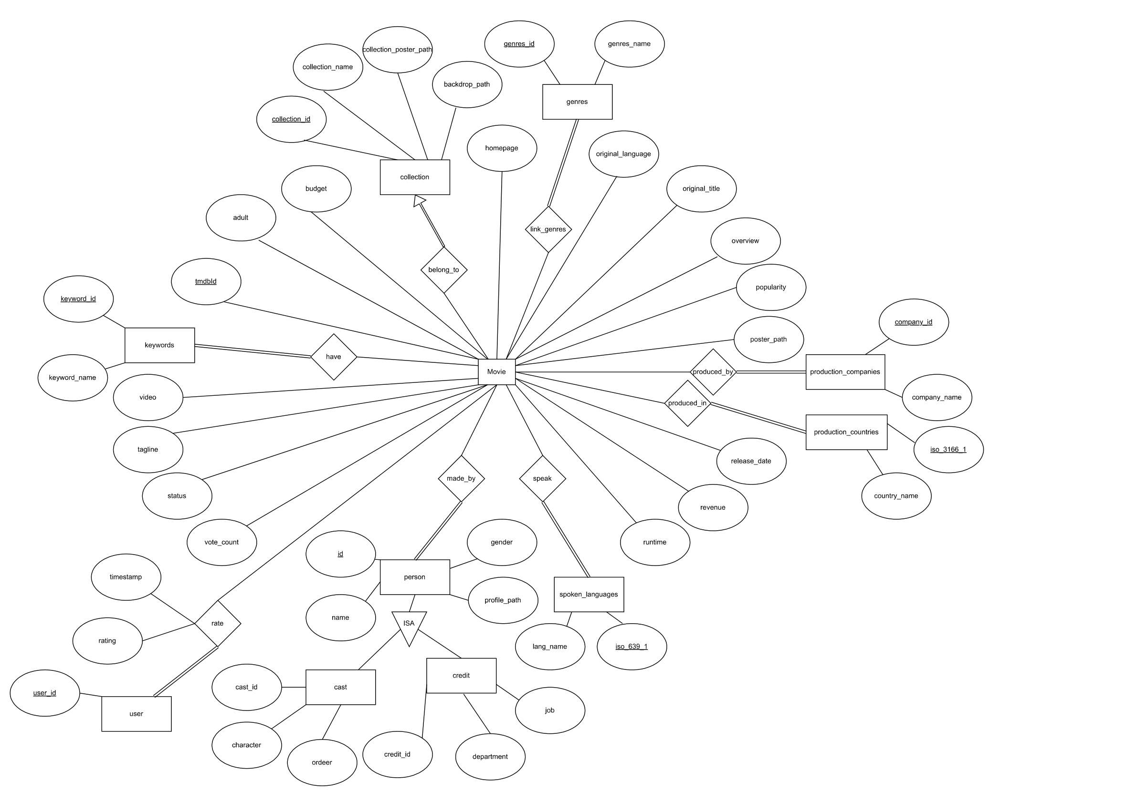
The database design of this project is based on the logical ER model and the cleaned movie-related dataset provided during development. To support structured storage and relationship validation, the data was implemented in a relational database using MySQL with XAMPP/phpMyAdmin.

Instead of keeping all information in a single denormalized movie table, the cleaned source files were further processed by Python scripts and transformed into table-specific import files. These scripts parsed nested attributes from the cleaned movie metadata, extracted related entities, removed duplicates, standardized formats, and generated normalized CSV files for database import. This preprocessing step made the database structure closer to the ER diagram and reduced redundancy in later analysis.
The main entity tables are:
- movie
- collection
- genres
- keywords
- production_companies
- production_countries
- spoken_languages
- person
- cast
- credit
- user
The relationship tables are:
- belong_to
- link_genres
- have
- produced_by
- produced_in
- speak
- made_by
- rate
- isa_cast
- isa_credit

The final schema contains 21 tables in total.
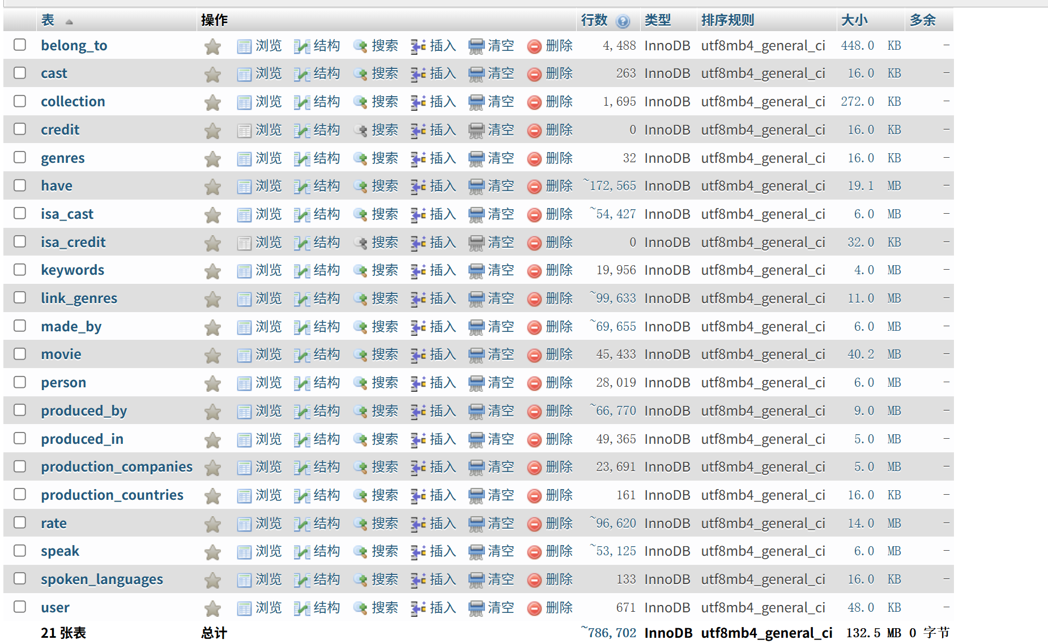
- Diagrams
The main system flow of the project can be summarized as follows:
Raw IMDB Dataset → Data Cleaning and Transformation → Analysis-Ready Dataset → Visualization Layer → Streamlit Dashboard Interface
The major software components are:
1. Data Input Layer – reads the movie dataset from file
2. Data Processing Layer – cleans missing values, standardizes fields, and computes derived metrics such as ROI
3. Visualization Layer – generates scatter plots, bar charts, line charts, and boxplots
4. Interface Layer – displays KPI cards, filters, charts, and written insights in the dashboard
In an object-oriented design perspective, the system can also be divided into modules such as DataLoader, DataProcessor, ChartBuilder, and DashboardUI.

6. Design Rationale
The design decisions focus on usability, clarity, and analytical efficiency. The dark theme reduces visual fatigue, while card-based layouts improve information grouping.
7. Logical Data Model
Movie(movie_id, title, genre, budget, revenue, release_date, vote_average, vote_count, language)
8. Layered Architecture
The system follows a layered architecture: Data Layer, Processing Layer, Visualization Layer, and Interface Layer.

