A E S T H E T I C P R I N C I P L E S
Aesthetic principles
Principles, не taste. Between vec3(0.10, 0.40, 0.80) and vec3(0.15, 0.42, 0.85) — choice by principle, not by preference.
Version: v0.4 • Date: 2026-10-31 • Status: cleaned (project-specific refs removed)
Reference images: 3 (warehouse surreal / mage combat / zombie horse graveyard)

1. Контекст
Principles, не taste. Между vec3(0.10, 0.40, 0.80) и vec3(0.15, 0.42, 0.85) выбор делается по принципам. Без явных principles default = «разумно, но не вдохновенно».
Этот документ — checklist для application, не рецепт креативности.

2. Эстетический профиль
70 / 25 / 5 ratio
│ │ └─ focal point (single light source, narrative anchor)
│ └───── vivid color accents (contrast against dominant)
└────────── dominant dark space (mood, breathing room)

Anti-pattern:
uniform saturation (всё ярко) — теряет depth, выглядит flat/amateur.

3. Color theory

3.1. 60-30-10 rule
Role | Доля пикселей | Luminance | Saturation
Dominant | 60% | 0.05-0.20 | 0.3-0.5
Secondary | 30% | 0.20-0.50 | 0.5-0.7
Accent | 10% | 0.50-0.90 | 0.7-1.0

3.2. Color harmony (выбрать ОДНУ, не смешивать)
Harmony | Colors | Когда
Complementary | 2 colors напротив (cyan↔magenta, blue↔orange, purple↔yellow) | dramatic contrast, tension
Analogous | 3 соседних цвета (blue→cyan→teal) | calm, serene, mood-driven
Triadic | 3 равноудалённых (red/yellow/blue) | vibrant, playful
Split-complementary | 1 base + 2 neighbors of opposite | balanced drama

3.3. Saturation/luminance balance
• Core (dark) regions: saturation 0.6-0.8, luminance 0.15-0.25
• Mid regions: saturation 0.4-0.5, luminance 0.30-0.50
• Rim/accent regions: saturation 0.3-0.4, luminance 0.60-0.80

Anti-pattern:
saturated core + saturated rim = muddy. Saturated core + desaturated rim = depth.

3.4. Sample palette (DRAMATIC_DARK)
deep_purple_core: rgb(0.08, 0.05, 0.20) HSL(255, 0.60, 0.13)
cyan_mid: rgb(0.10, 0.40, 0.80) HSL(215, 0.78, 0.45)
magenta_rim: rgb(0.80, 0.30, 0.50) HSL(340, 0.55, 0.55)
star_white_pure: rgb(1.00, 1.00, 0.95) HSL(50, 1.00, 0.97)
void_black: rgb(0.02, 0.02, 0.03)

Mood: cold/dramatic/deep. Use cases: core glow, atmospheric depth, rim light.

4. Composition

4.1. Focal point singularity
• 1 focal point per frame. Если >1 — competing attention, eye fatigue.
• Focal = brightest single element OR highest saturation OR center-most.
• Other elements supporting, НЕ competing.

4.2. Rule of thirds
• Camera target / focal element на пересечении thirds (не в центре кадра).
• Для static camera: shift focal to (0.33, 0.50) или (0.66, 0.50).
• Для moving camera: target trajectory проходит через thirds.

4.3. Background-foreground density contrast
• Background density < foreground density. НЕ заполняйте кадр равномерно.
• Background noise subtle (amplitude 0.3-0.5), foreground accents яркие (amplitude 0.6-1.0).

4.4. Vignette as attention director
• Gentle vignette: 0.7-0.85 at edges
• Strong vignette = amateur, eye senses manipulation
• No vignette = flat, lacks depth

5. Motion (Disney 12 simplified для real-time)

5.1. Easing
• smoothstep(t) для organic motion (НЕ linear)
• Linear только для mechanical rotation (gears, clock hands)
• mix(a, b, smoothstep(0.0, 1.0, t)) — standard pattern

5.2. Anticipation (10% перед main motion)
• Перед «впрыгиванием» camera — slight pull-back (10% amplitude, 100ms)
• В GLSL: pos += sin(t * 5.0) * 0.02 перед основным motion

5.3. Follow-through (15% после main motion)
• После резкой остановки — slight overshoot + dampened oscillation
• pos = target + sin((t - t_stop) * 8.0) * exp(-(t - t_stop) * 3.0) * 0.05

5.4. Camera motion: 1 primary axis
• 1 axis primary (largest amplitude)
• Other axes secondary (≤30% of primary amplitude)
• Anti-pattern: chaotic 3-axis motion = nausea, not aesthetic

5.5. Phase offsets для variety
• Multiple light sources: each phase offset by ~1.7 radians (golden angle 2.3998 / 2 ≈ 1.7)
• Avoid synchronized pulsing — looks mechanical

6. Density

6.1. FBM octaves
• 4-5 max. После 5 — mush, lost detail.
• amplitude half per octave (standard fbm)
• frequency double per octave

6.2. Light nodes count
• 3-5 max. Больше — competing, less impact.
• Если добавить ещё — удалить или объединить существующие.

6.3. Star field density
• 1 star per ~50×50 pixel area max
• Brighter stars rarer (logarithmic distribution)
• Anti-pattern: dense star field = noise, not depth

6.4. Detail vs scale
• Big shapes first, small details last
• 3-tier hierarchy: macro (composition) / meso (light nodes) / micro (noise detail)
• All three tiers needed; missing one = flat

7. Contrast & luminance balance

7.1. Dynamic range
• Min luminance in frame: 0.02-0.05 (deep shadow)
• Max luminance in frame: 0.85-1.00 (HDR accent)
• Ratio: 20:1 to 50:1 — cinematic
• < 10:1 = flat / TV-broadcast look
• > 100:1 = HDR display required, иначе crushed blacks

7.2. Tone mapping (ACES recommended)
• finalColor = ACESFilm(color) — preserves highlights, lifts shadows
• ACES: color = (color * (2.51 * color + 0.03)) / (color * (2.43 * color + 0.59) + 0.14)

7.3. Color contrast (S-channel in HSL)
• Average saturation in frame: 0.4-0.6
• Peak saturation (accents): 0.8-1.0
• Anti-pattern: average saturation > 0.7 = eye strain

8. Self-critique checklist
aesthetic_notes:
color:
- palette: <name>
- dominant/secondary/accent ratio: <60/30/10 | other>
- harmony: <complementary | analogous | triadic>
composition:
- focal_point: <which element>
- rule_of_thirds: <yes/no, where>
- bg/fg_density_contrast: <yes/no>
motion:
- easing: <smoothstep | linear | mixed>
- anticipation: <yes/no>
- follow_through: <yes/no>
- primary_axis: <x | y | z>
density:
- fbm_octaves: <N>
- light_nodes: <N>
- star_density: <low | med | high>
contrast:
- dynamic_range: <min/max luminance>
- tone_mapping: <ACES | raw | other>
reference_target:
- which reference image this aims for: <path or description>
- delta from reference: <what's different>
self_critique:
- 1-2 sentences: what works, what doesn't, what to try next

Если любой пункт empty — task не закрыт, вернуться к generation.

9. Comparative analysis — Image 1 vs Image 2 vs Image 3

9.1 Image 1: dark surreal warehouse
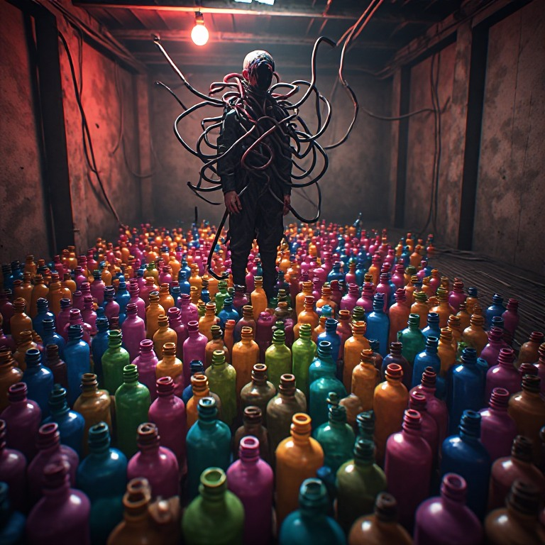
Image 1 — upload/8474358583453.jpg
Content:
dim warehouse, concrete walls, red bulb hanging, figure wrapped in cables, floor densely covered with colorful plastic bottles (pink/blue/green/orange/purple).
Aesthetic profile:
• Ratio: ~65/30/5 (dark dominant / bottle accents / red bulb focal)
• Color harmony: chaotic multicolor (6+ colors, no single harmony)
• Focal: red bulb (single, clear, directional lighting)
• Composition: figure center, bottles distributed — no rule of thirds
• Motion: static (gallery installation aesthetic)
• Dynamic range: ~30:1
• Narrative: figure eerie but passive

9.2 Image 2: fantasy mage with lightning whip
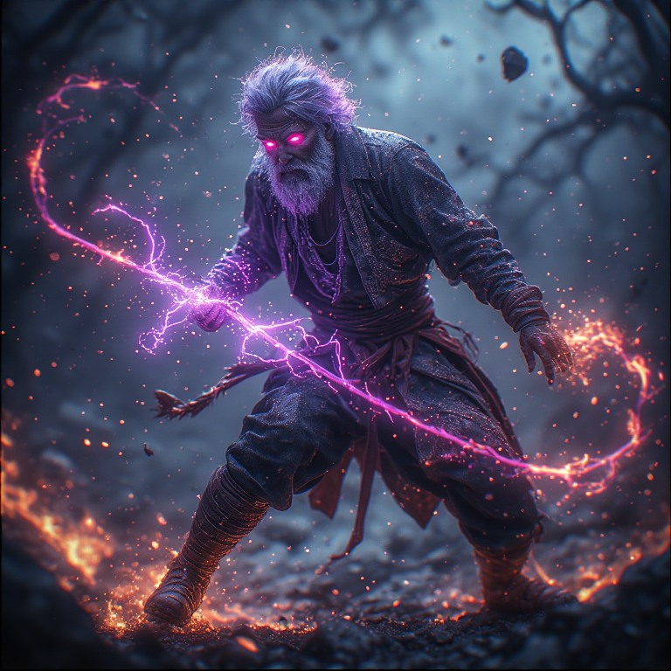
Image 2 — upload/Без названия - 2026-05-09T101224.022.jpg
Content:
old mage white hair/beard, red-purple glowing eyes, dark worn robes, combat pose. Right hand wields energy whip made of purple-pink lightning (S-shape around body). Dark scene, twisted dead trees background, floating debris, orange-red sparks and embers, ground fire glow.
Aesthetic profile:
• Ratio: ~60/30/10 (dark scene / whip+sparks accent / mage+eyes focal)
• Color harmony: complementary (purple-pink whip HSL ~320° ↔ orange-red sparks HSL ~25°)
• Focal: mage eyes + whip S-curve (dual, but whip leads eye)
• Composition: mage center — no rule of thirds, BUT whip S-curve creates dynamic flow
• Motion: strong implied (combat pose, whip S-curve, sparks trajectory)
• Dynamic range: ~50:1 (cinematic)
• Narrative: mage active combat — clear subject

9.3 Image 3: skeletal zombie horse in graveyard
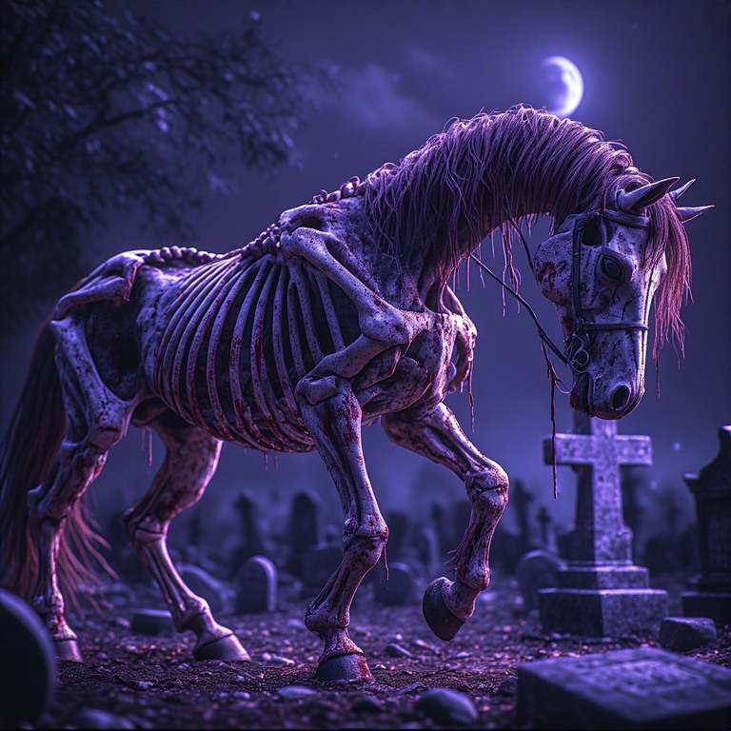
Image 3 — upload/Без названия - 2026-02-24T195643.383.jpg
Content:
skeletal zombie horse with exposed bones, visible ribs, decayed flesh and blood traces, purple-red mane hanging in strands, halter on head, walking with head down. Night graveyard scene, tombstones and stones scattered, stone cross on right side, distant blurred tombstones. Purple-blue tone overall, crescent moon in sky, dead branches from upper left, hazy moonlight, Halloween horror atmosphere.
Aesthetic profile:
• Ratio: ~75/20/5 (dark graveyard dominant / purple-blue tone / crescent moon focal) — closest to ideal 70/25/5 of all 3
• Color harmony: analogous (purple-blue-violet, single harmony, focused but less dramatic than complementary)
• Focal: dual (crescent moon + zombie horse) — horse is subject, moon is light source
• Composition: horse walking diagonally, off-center — rule of thirds ✓ (best of 3)
• Motion: implied walking (horse stride) — between Image 1 (static) and Image 2 (combat)
• Dynamic range: ~20:1 — lowest of 3 (atmospheric, not cinematic)
• Narrative: strong (zombie horse + graveyard + Halloween mood, clear subject + setting)
• Tone: muted, atmospheric, fog/moonlight — distinct от flat (Img 1) и HDR (Img 2)

9.4 Score (9 principles, 3-way)
Principle | Img 1 (warehouse) | Img 2 (mage) | Img 3 (horse) | Winner
70/25/5 ratio | 65/30/5 ✓ | 60/30/10 | 75/20/5 ✓✓ | Img 3
Color harmony | chaotic | complementary | analogous | Img 2
Focal singularity | single (bulb) | dual | dual | Img 1
Rule of thirds | no | no (S-curve flow) | yes (off-center) ✓ | Img 3
Density balance | bottles very dense | sparks distributed | sparse, controlled | Img 3
Dynamic range | ~30:1 | ~50:1 | ~20:1 | Img 2
Motion | static | strong implied | implied (walking) | Img 2
Narrative | passive | active combat | active walking + setting | Img 2
Tone mapping | flat | HDR/ACES feel | muted atmospheric | Img 2

9.6 Three aesthetic archetypes
Archetype | Image | Defining traits | Best for
Static surreal | Img 1 | chaotic color, static, single focal, gallery mood | ambient / menu / title screens
Dynamic dramatic | Img 2 | complementary harmony, motion, HDR, narrative action | action scenes, combat, climactic moments
Atmospheric horror | Img 3 | analogous harmony, muted tone, sparse density, mood-driven | exploration, mystery, somber scenes

9.7 Honest caveat
This is principled verdict, не taste. Principles in this doc favor:
• Complementary over multicolor OR analogous harmony (drama > calm)
• Motion over static
• Cinematic dynamic range over muted
• Narrative action over ambient mood

If your taste prefers Image 3's atmospheric horror (calm, muted, mood-driven) — that's valid. Different aesthetics serve different contexts (gallery vs action film vs horror film vs illustration).
The 3 archetypes are not ranked absolutely — they serve different goals. Image 2 wins by these principles, but Image 3 might be the right choice for a different mood.

