**Competitive analysis**

3D Modeling in a 2D interface:

Rotating Wireframe cube:

This program is essentially a rotating wireframe cube with a black background. The features of this program that I’ll be referencing will be the positioning of each vertex as the cube rotates, especially the 3d to 2d transformation of each point. In my program this will be the position of each object on the globe and everything that isn’t the background as the globe rotates. The features that are unneeded in my program are actually drawing the lines between the vertices and the automatic rotation of the shape. I’ll be referencing how the x, y and z positions change as the cube is rotated as well.

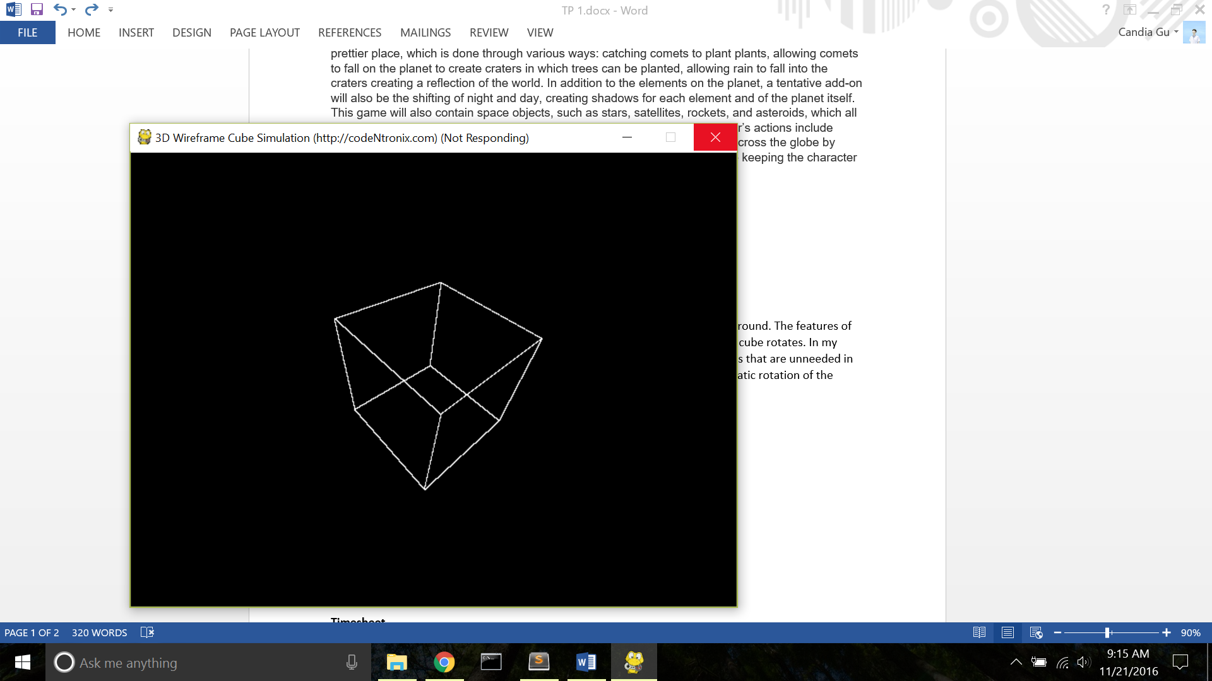

Rotating Cube:

This program is a basic rotating cube with actual faces. In addition to the positioning of the vertexes, I will be analyzing how this program uses Painter’s Algorithm to draw shapes over on another based on depth. This will be especially useful in my program for drawing objects in relations to each other, both on the globe and in space. The features I’ll be omitting include actually drawing the faces of the cube, since the globe is more spherical.

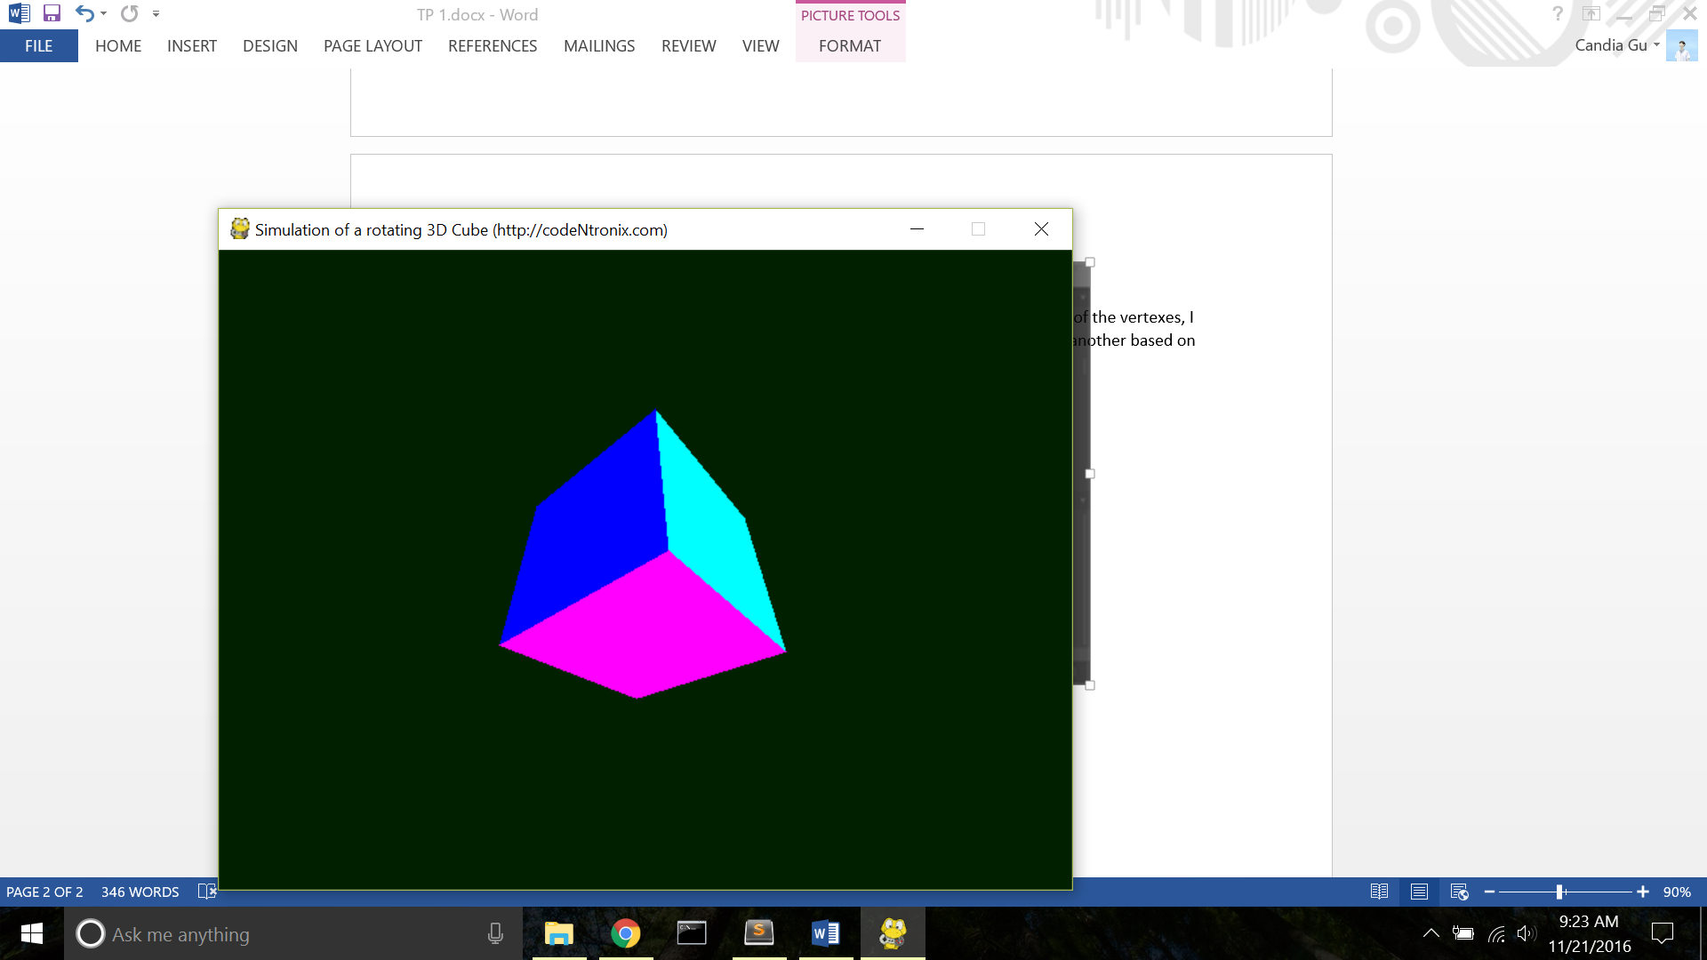

Animation:

Hermit

I will be referencing the animation it uses for its characters and the algorithm for its procedural environment generation. But instead of pre-generating the trees, I will be using an actual animation for the growth of the tree in my program, so like the loading screen. I might also reference the animation of each components in the main character.

Monument Valley:

This game is just aesthetic goals. Although this game has a very different premise than my game, I’ll be instead analyzing the character’s behavior as well as the color scheme of its scenes. Although this game is not written in python, I’ll be observing the aesthetic aspects of its animations and its scenes. I won’t be using the optical illusions that make up its scenes or the general missions of its game either.

