Selected Projects Portfolio
| Candice Ziqi Xia | CandiceXia.com |
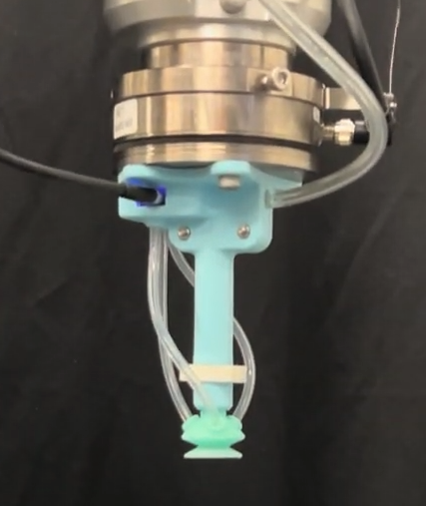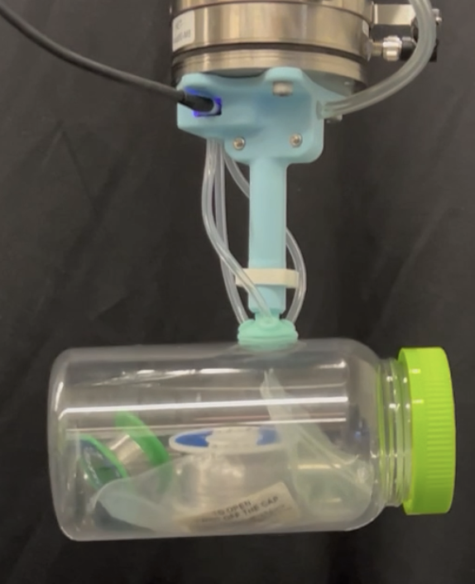  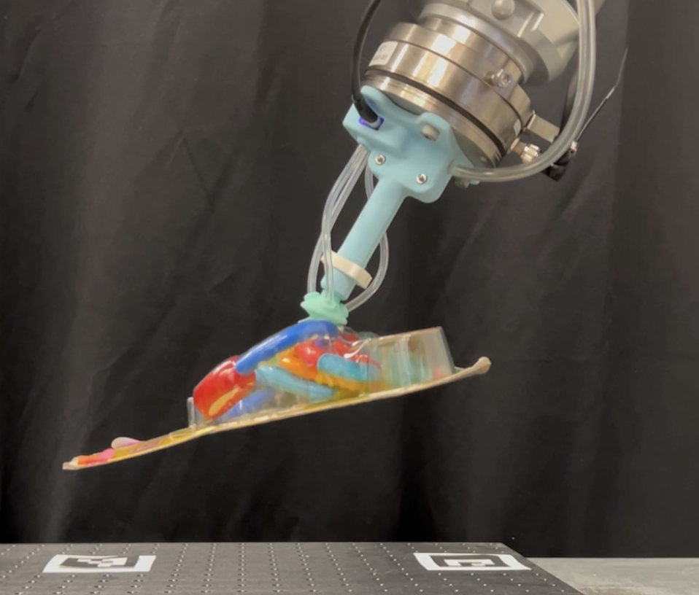  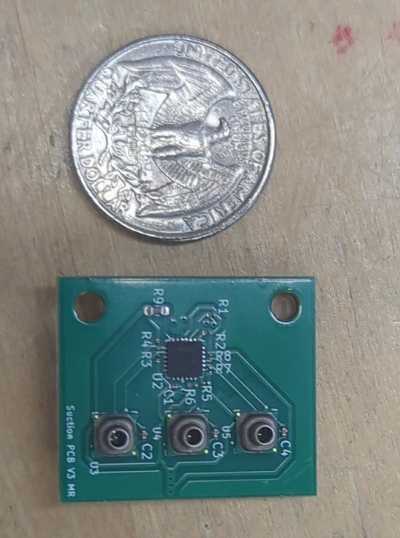 | Smart Suction Cup for Robotic Trash Sorting  Redesigned a research-grade smart suction cup into a lower-cost, compact, modular robotic gripper for trash sorting and industrial manipulation. The system uses multi-chamber pressure sensing to provide tactile feedback and help robotic arms detect and correct grasping errors.  My Role:  - Contributed to the mechanical and electronics redesign of the suction cup module, including casing integration, tubing cover design, pressure-sensor packaging, and the transition from a prototype to a compact custom PCB.  - Helped select components and microcontroller architecture, supported prototype assembly/testing, and communicated the design through technical presentations and reports.  Impact: This project supports more reliable robotic recycling and makes tactile robotic grippers more accessible for research labs and industrial automation.  Tools: KiCAD, JLCPCB manufacturing, microcontroller development (CircuitPython), OnShape, 3D Print/Slicing (Bambu), Silicone Molding

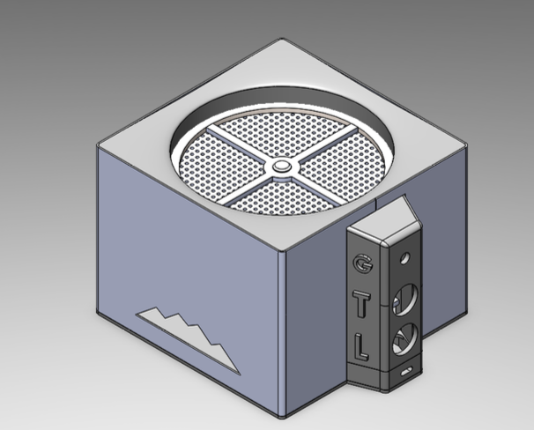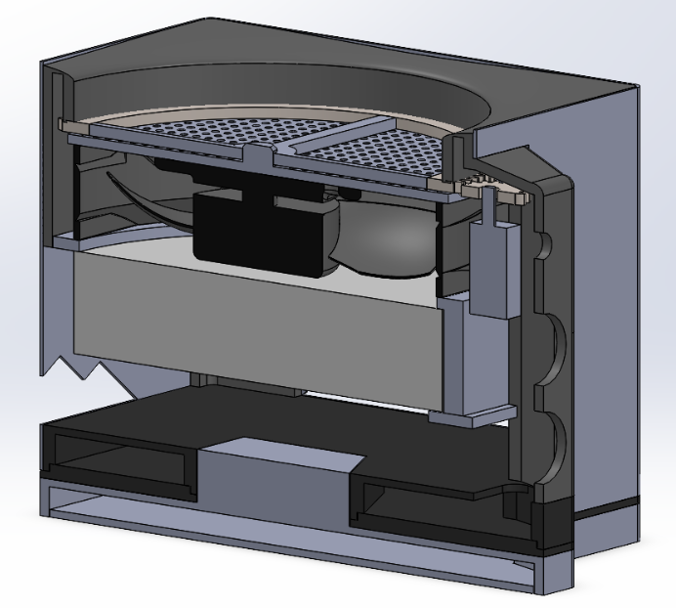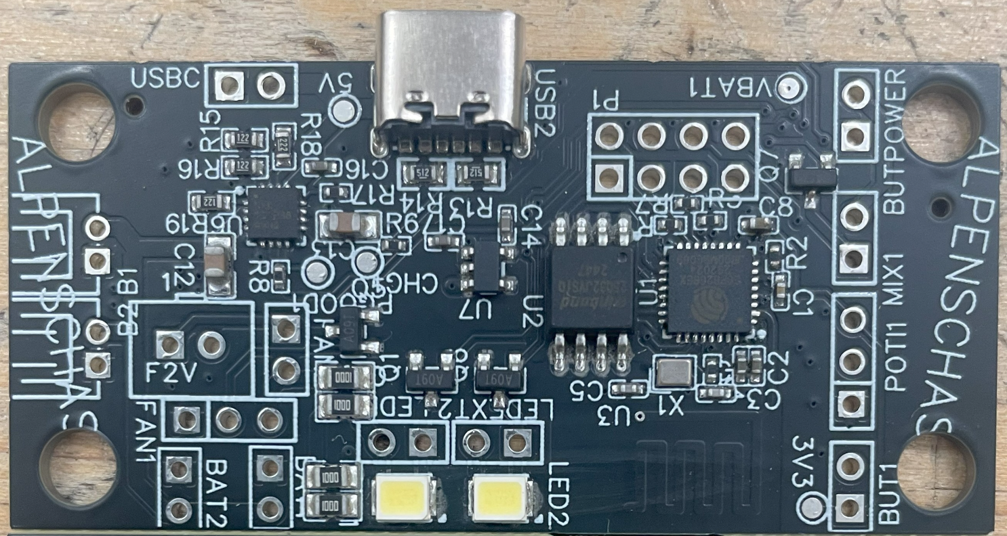  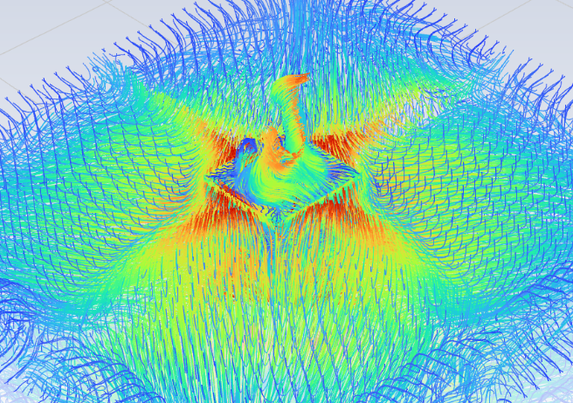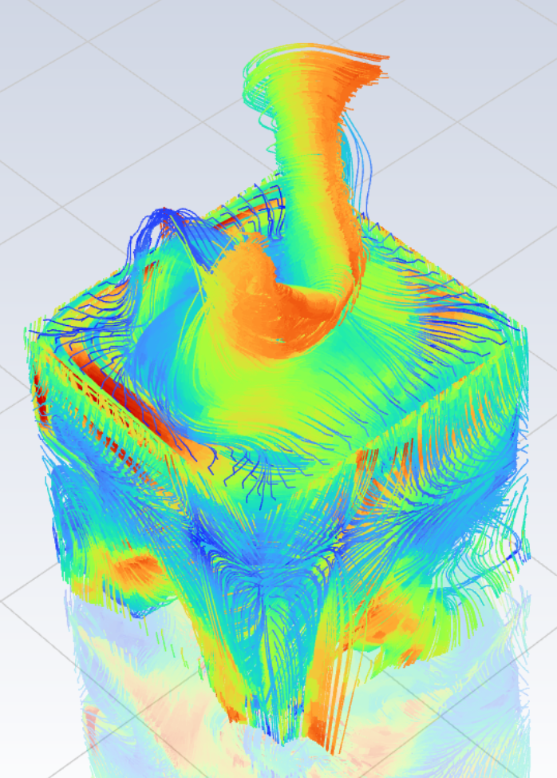 | Air Purification and Fragrance Delivery Unit (AlpenLuft)  Designed a compact air purifier and active fragrance dispenser that combines a HEPA filter, DC fan, and motorized zeolite-pearl mixing chamber in one portable unit. A slow-speed gearbox rotates the fragrance-loaded pearls, so scent is released evenly into the airflow, while the filter path cleans the air instead of acting as a passive air freshener.  My Role:  - Worked on the product development process from problem definition through final design review, including risk assessment with FMEA, design tradeoff/manufacturing feasibility evaluation, CAD, simulation, PCB design, and CFD simulations.  - Helped connect mechanical design decisions to user needs such as air quality, filter serviceability, fragrance distribution, and ease of assembly/disassembly.  Impact: The project explored a consumer-facing air-quality product that could improve indoor comfort while encouraging more structured, serviceable product design.  Tools: SOLIDWORKS, ANSYS Fluent, KiCAD

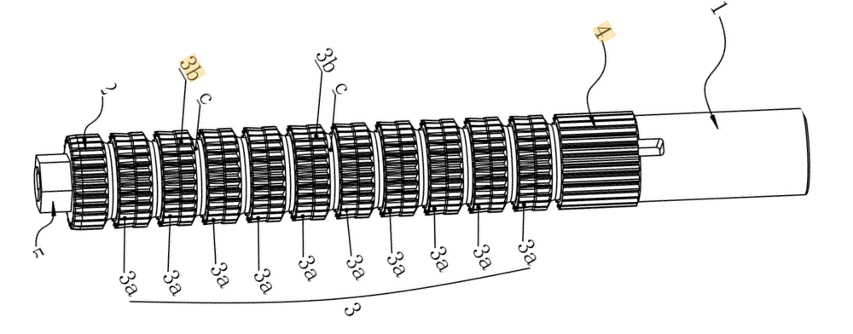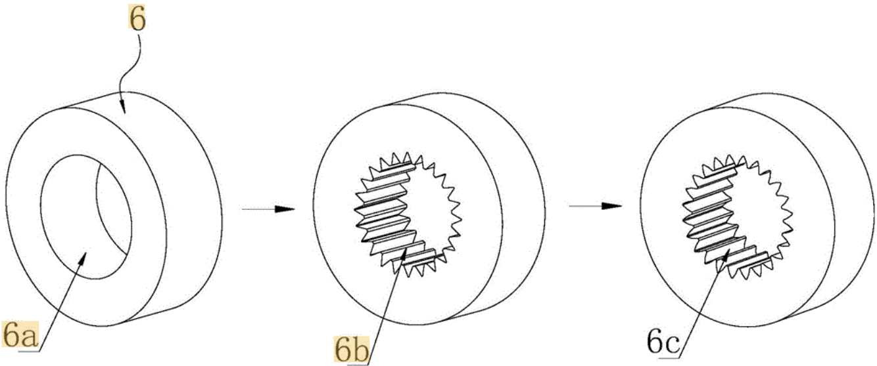  Gear broach to cut inner gears  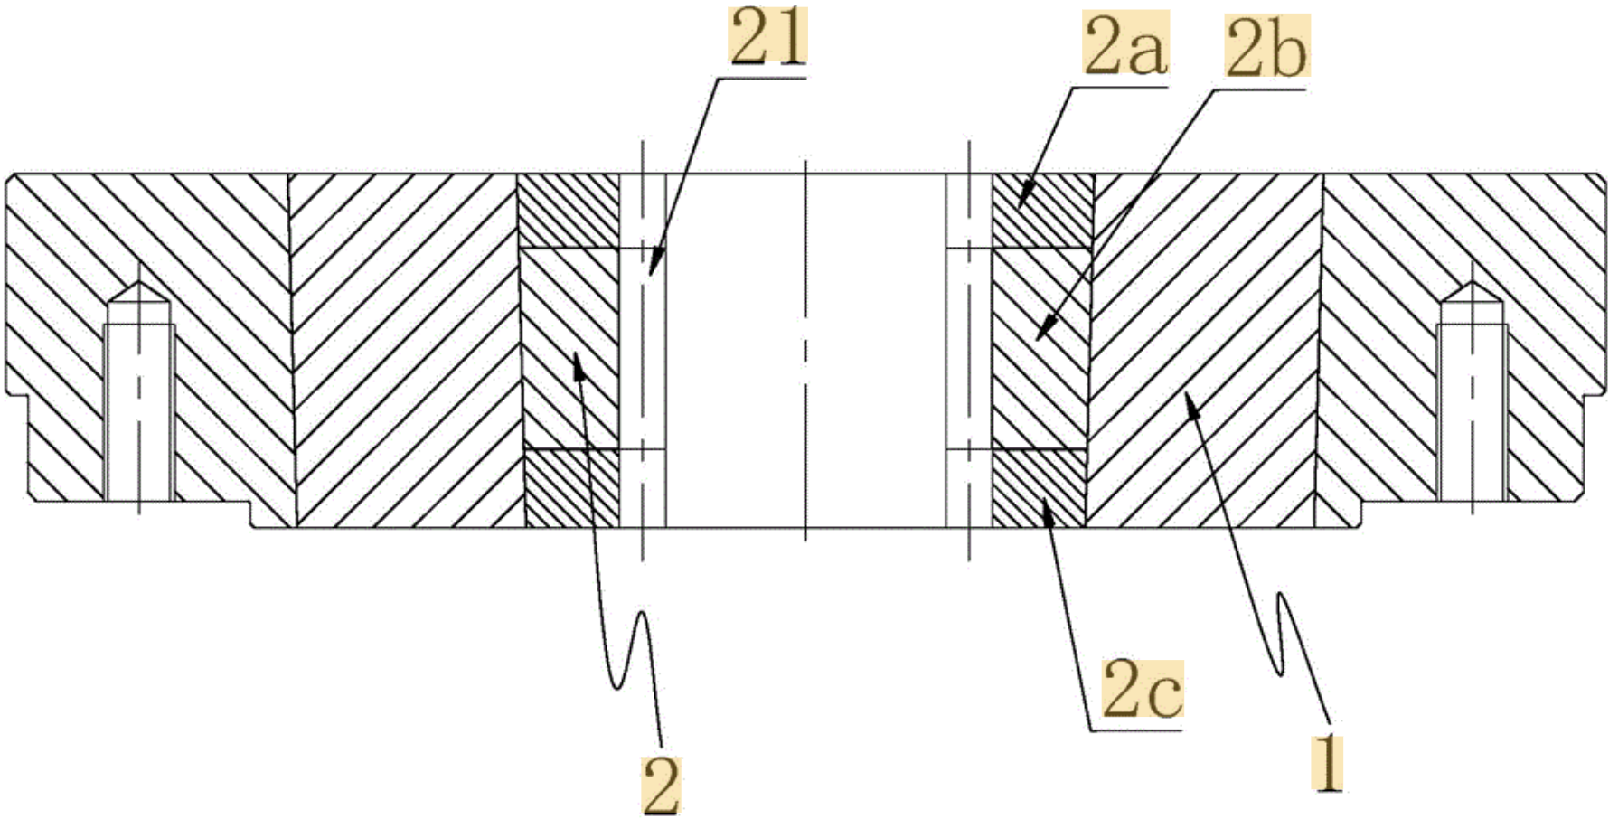  Die to form extruded crowned teeth in gears  Select projects/patents  (disclosed with permission) | Gear Manufacturing and Tooling Improvement  Supported manufacturing-focused mechanical design work for internal gear production, including tooling, fixtures, inspection aids, and production troubleshooting. Contributed to 4 utility patents related to gear manufacturing and tooling design (CN212350651U / CN212363066U / CN111195736B / CN111842522A).  My Role:  - Designed and refined internal-gear manufacturing tooling, cutting tools and inspection fixtures to improve setup repeatability, part stability, and machining accuracy for a gear manufacturing plant.  - Helped diagnose production issues, review CAD/tooling changes with senior engineers, and connect design decisions to shop-floor outcomes such as setup time, accuracy, and process consistency.  Impact: Improved practical manufacturing efficiency and reliability, helping engineering designs become more repeatable in production.  Tools: SOLIDWORKS, Siemens NX, machining process  Certain images and data unable to be shown due to proprietary IP and NDA

PRIMARY IMAGE  OPTIONAL OPTIONAL | Remote-Controlled Boilermaker Special Train Prototype  Designed and prototyped a remote-controlled train inspired by the Purdue Boilermaker Special to demonstrate mechanical systems for young audiences. The prototype included smartphone control, shifting actuation, mechanical assembly, and educational demonstration features.  My Role: Led the coding portion of the project and contributed to 3D printing and assembly. Helped integrate the control logic with the physical prototype so the train could demonstrate movement, shifting behavior, and user-controlled operation.  Impact: The project made mechanical design concepts more approachable by turning gears, controls, and prototyping into an interactive educational artifact.  Tools: CAD, 3D printing, Blynk smartphone app, embedded/control programming, mechanical assembly, prototyping.

