Images:

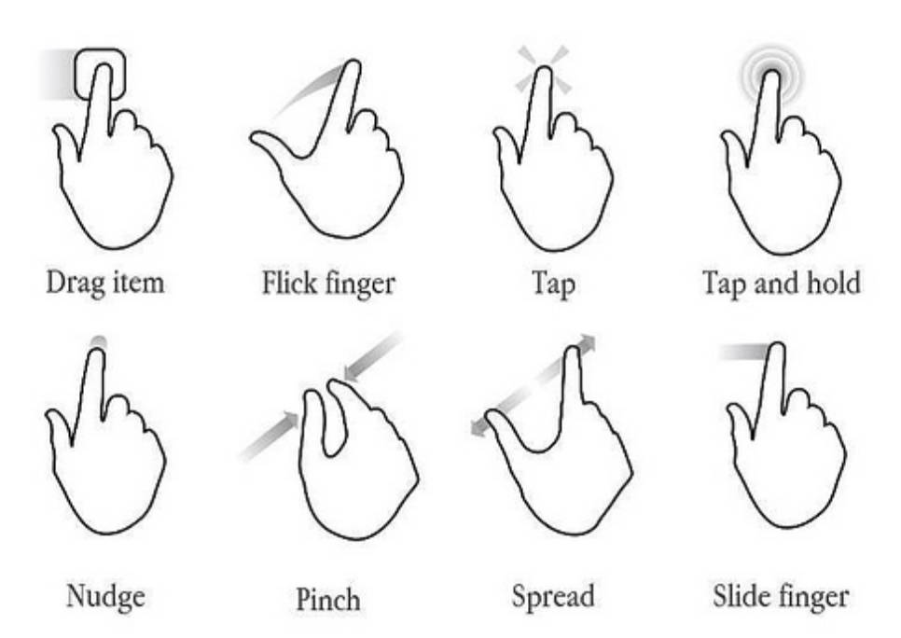
www.evolus.vn/Pencil/Downloads-Stencils.html

favbulous.com/post/695/6-multi-touch-gesture-icon-sets

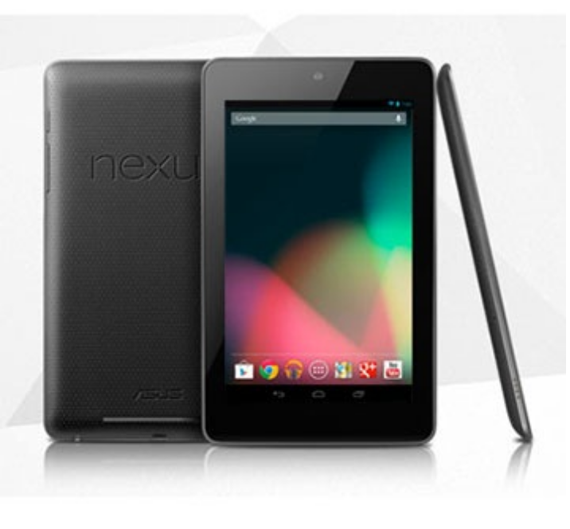
mashable.com/2012/06/27/nexus-7-google-table/

en.wikipedia.org/wiki/File:MVC-Process.png

www.freesfx.co.uk/sfx/

