Experiment Report
(Experiment 2: Random Variables and Probability Distributions)

Class:
Name:
Student ID:

Course Name: 概率和数理统计
Instructor:
Date: 2026.5.19

Experiment 2: Random Variables and Probability Distributions
- Experiment Objectives
- Understand the basic concept of a random variable and master the difference between discrete random variables and continuous random variables.
- Understand the meaning of the probability mass function and the probability density function.
- Become familiar with the commonly used functions in MATLAB related to probability distributions and master the method of drawing typical probability distribution figures.
- Through observing the figures of the binomial distribution, Poisson distribution, and normal distribution, understand the basic shapes of different probability distributions and the effect of parameters on the figures.
- Through MATLAB simulation experiments, understand the phenomenon that the binomial distribution approximates the Poisson distribution under certain conditions.
- Through simple application problems, master the basic methods of using MATLAB for random sample generation, frequency statistics, and theoretical probability verification.
- Experiment Preview
- Review the basic concept of random variables and make clear the definitions and differences between discrete random variables and continuous random variables.
- Review the definitions, parameter meanings, and typical application backgrounds of the following probability distributions:
  - Binomial distribution
  - Poisson distribution
  - Normal distribution
  - Uniform distribution
- Understand the difference between the probability mass function (PMF) and the probability density function (PDF).
- Preview the condition under which the binomial distribution approximates the Poisson distribution: when the number of trials $n$ is large and the success probability $p$ in each trial is small, if $np=λ$ remains constant, then the binomial distribution can be approximated by a Poisson distribution with parameter $λ$.
- Experiment Content
- MATLAB Tutorial: Learn the basic MATLAB functions and plotting commands related to probability distributions.
- Task 1 (Distribution Plotting): Draw the typical figures of the binomial distribution, Poisson distribution, and normal distribution, and compare the graphical features of discrete random variables and continuous random variables.
- Task 2 (Comparison of Binomial and Poisson Distributions): Compare the binomial distribution with parameters $n=1000$ and $p=0.005$ and the Poisson distribution with parameter $λ=5$, and observe the phenomenon that the binomial distribution approximates the Poisson distribution.
- Task 3 (Application Problems): Complete the following two application tasks:
(1) A bank call center receives 20 calls per hour on average. Assume that the number of calls received in each hour follows a Poisson distribution. Use MATLAB to simulate the call counts for 1000 hours, find the simulated probability that the number of calls in one hour is greater than 25. Then increase the number of simulated hours to 100000, compare the results for 1000 hours and 100000 hours, and explain the reason for the difference.
(2) A bank call center receives calls according to a Poisson distribution with average rate $λ=20$ per hour. Let $A_{1}$, $A_{2}$, $A_{3}$, $⋯$ be the numbers of calls received in consecutive hours, where the hourly call counts are independent. Define $S_{n}=A_{1}+A_{2}+⋯+A_{n}$ as the total number of calls received in the first n hours. Use MATLAB to simulate many working periods and estimate the probability that the total number of calls first reaches or exceeds 100 within 5 hours, that is, $S_{4}<100$ but $S_{5}≥100$.
(3) A measurement system records two independent values X and Y from the same machine, where $X\sim U[0,2]$ and $Y\sim U[0,2]$. A product is considered stable if the difference between the two measurements is less than 0.3, that is, $|X-Y|<0.3$. Use MATLAB to simulate many pairs of measurements, estimate the probability that a product is stable.
(4) A factory produces electronic parts, and each part is defective with probability 0.01 independently. In one inspection, 200 parts are checked. If the number of defective parts is greater than 3, the batch is rejected immediately. If the number of defective parts is not greater than 3, another 200 parts are checked independently. The batch is finally accepted only if the total number of defective parts in the two inspections is not greater than 5. Use MATLAB to simulate many batches, estimate the probability that a batch is finally accepted.
- Experiment Result
- Task 1 (Distribution Plotting)
- Source code:
clear; clc; close all;

% binomial distribution
p = 0.5;
n = 10;
k_binomial = 0:n;
P_binomial = binopdf(k_binomial, n, p);
subplot(3, 1, 1);
bar(k_binomial, P_binomial, 'FaceColor', [0.2 0.6 0.8], 'EdgeColor', 'k');
xlabel('k');
ylabel('P(X = k)');
title('Binomial Distribution: n = 10, p = 0.5');
grid on;

% Poisson distribution
lambda = 5;
k_Poisson = 0:15;
P_Poisson = poisspdf(k_Poisson, lambda);
subplot(3, 1, 2);
bar(k_Poisson, P_Poisson, 'FaceColor', [0.2 0.6 0.8], 'EdgeColor', 'k');
xlabel('k');
ylabel('P(X = k)');
title('Poisson Distribution: λ = 5');
grid on;

% normal distribution
mu = 0;
sigma = 1;
x = -4:0.1:4;
f = normpdf(x, mu, sigma);
subplot(3, 1, 3);
plot(x, f, 'r-');
xlabel('x');
ylabel('f(X)');
title('Normal Distribution: μ = 0, σ = 1');
grid on;
- Description of the code:
- Set basic parameters of the binomial distribution, and calculate using Statistics and Machine Learning Toolbox.
p = 0.5;
n = 10;
k_binomial = 0:n;
P_binomial = binopdf(k_binomial, n, p);
- Plot the figure of the binomial distribution.
subplot(3, 1, 1);
bar(k_binomial, P_binomial, 'FaceColor', [0.2 0.6 0.8], 'EdgeColor', 'k');
xlabel('k');
ylabel('P(X = k)');
title('Binomial Distribution: n = 10, p = 0.5');
grid on;

- Set basic parameters of the Poisson distribution, and calculate using Statistics and Machine Learning Toolbox.
lambda = 5;
k_Poisson = 0:15;
P_Poisson = poisspdf(k_Poisson, lambda);
- Plot the figure of the Poisson Distribution.
subplot(3, 1, 2);
bar(k_Poisson, P_Poisson, 'FaceColor', [0.2 0.6 0.8], 'EdgeColor', 'k');
xlabel('k');
ylabel('P(X = k)');
title('Poisson Distribution: λ = 5');
grid on;

- Set basic parameters of the normal distribution, and calculate using Statistics and Machine Learning Toolbox.
mu = 0;
sigma = 1;
x = -4:0.1:4;
f = normpdf(x, mu, sigma);
- Plot the figure of the normal distribution.
subplot(3, 1, 3);
plot(x, f, 'r-');
xlabel('x');
ylabel('f(X)');
title('Normal Distribution: μ = 0, σ = 1');
grid on;

- Screenshot of the terminal output:
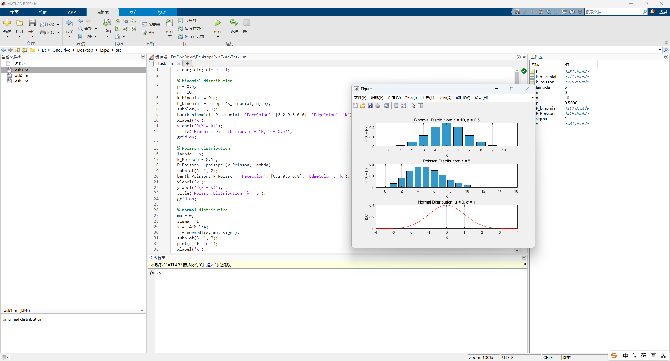
- Task 2 (Comparison of Binomial and Poisson Distributions)
- Source code:
clear; clc; close all;

% binomial parameters
n = 1000;
p = 0.005;
% Poisson paremeters
lambda = n * p;
k = 0:15;
P_binomial = binopdf(k, n, p);
P_Poisson = poisspdf(k, lambda);
bar(k, P_binomial, 'FaceColor', [0.2 0.6 0.8], 'EdgeColor', 'k');
hold on;
plot(k, P_Poisson, 'r-');
xlabel('k');
ylabel('Probability');
title('Comparison of Binomial and Poisson Distributions');
grid on;
legend('Binomial: n = 1000, p = 0.005', 'Poisson: λ = 5');
- Description of the code:
- Set the basic parameters of the binomial and Poisson distributions respectively, and calculate using Statistics and Machine Learning Toolbox.
% binomial parameters
n = 1000;
p = 0.005;
% Poisson paremeters
lambda = n * p;
k = 0:15;
P_binomial = binopdf(k, n, p);
P_Poisson = poisspdf(k, lambda);
- Plot the binomial and Poisson distributions on the same graph for comparison.
bar(k, P_binomial, 'FaceColor', [0.2 0.6 0.8], 'EdgeColor', 'k');
hold on;
plot(k, P_Poisson, 'r-');
xlabel('k');
ylabel('Probability');
title('Comparison of Binomial and Poisson Distributions');
grid on;
legend('Binomial: n = 1000, p = 0.005', 'Poisson: λ = 5');


- Screenshot of the terminal output:
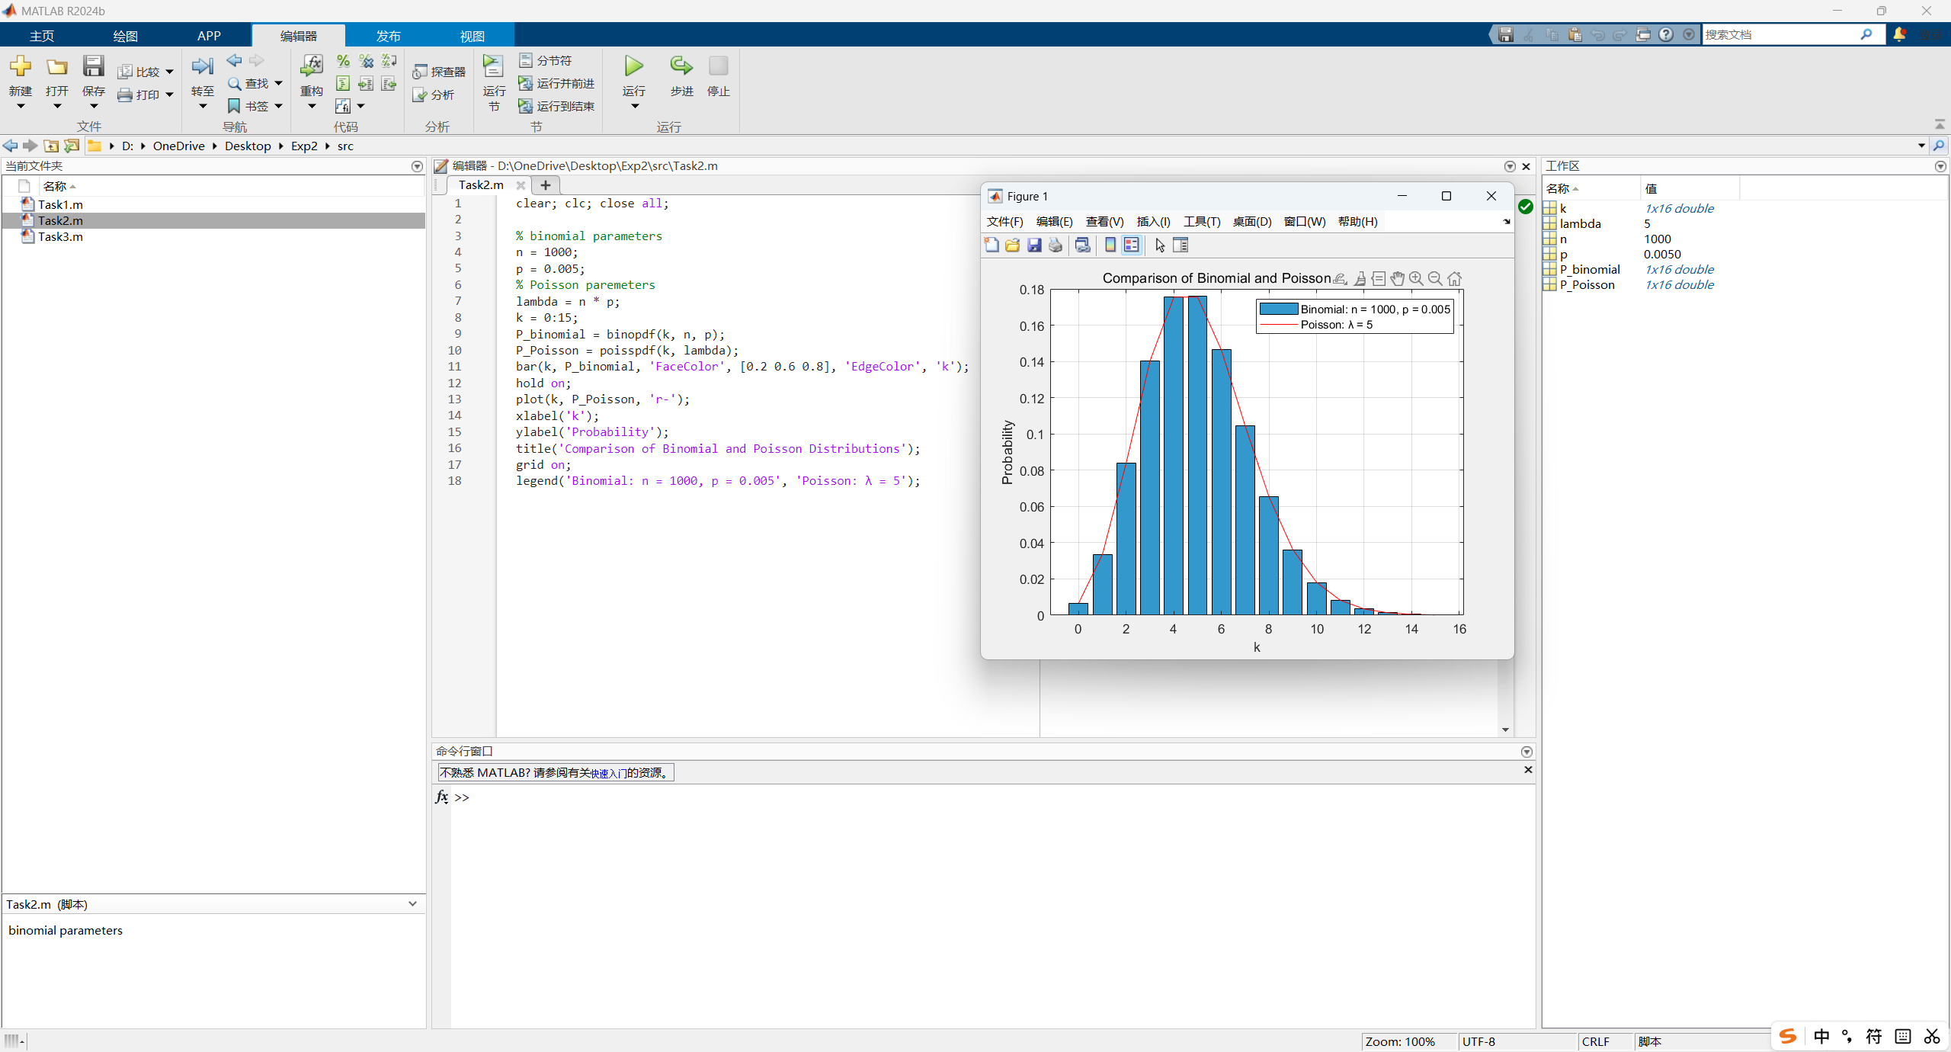
- Task 3 (Application Problems)
- Source code:
clear; clc; close all;

% a) Bank Call Center Problem
lambda_a = 20;
N_a = 1000;
A_a = poissrnd(lambda_a, [N_a, 1]);
event_a = (A_a > 25);
count_a = sum(event_a);
P_a = count_a / N_a;
disp('a) Bank Call Center Problem');
fprintf('1000 hours: Probability = %.4f\n', P_a);
% increase to 100000 hours
N_a_increased = 100000;
A_a_increased = poissrnd(lambda_a, [N_a_increased, 1]);
event_increased = (A_a_increased > 25);
count_a = sum(event_increased);
P_a_increased = count_a / N_a_increased;
disp('Comparison:');
fprintf('100000 hours: Probability = %.4f\n\n', P_a_increased);

% b) Cumulative Call Count Problem
lambda_b = 20;
nHours = 5;
N_b = 100000;
A_b = poissrnd(lambda_b, [N_b, nHours]);
S4 = sum(A_b(:,1:4), 2);
S5 = sum(A_b, 2);
event_b = (S4 < 100) & (S5 >= 100);
count_b = sum(event_b);
P_b = count_b / N_b;
disp('b) Cumulative Call Count Problem');
fprintf('Probability: %.4f\n\n', P_b);

% c) Measurement Stability Problem
a = 0;
b = 2;
N_c = 100000;
X = a + (b - a) * rand(N_c, 1);
Y = a + (b - a) * rand(N_c, 1);
D = abs(X - Y);
event_c = (D < 0.3);
count_c = sum(event_c);
P_c = count_c / N_c;
disp('c) Measurement Stability Problem');
fprintf('Probability = %.4f\n\n', P_c);

% d) Product Quality Inspection Problem
p_d = 0.01;
n_d = 200;
N_d = 100000;
X_d_1 = binornd(n_d, p_d, [N_d, 1]);
reject_d_1 = (X_d_1 > 3);
X_d_2 = binornd(n_d, p_d, [N_d, 1]);
total_defects = X_d_1 + X_d_2;
accept = (X_d_1 <= 3) & (total_defects <= 5);
count_d = sum(accept);
P_d = count_d / N_d;
disp('d) Product Quality Inspection Problem');
fprintf('Probability =%.4f\n', P_d);
- Description of the code:
- Bank Call Center Problem
- Set the basic parameters of the Poisson distribution.
lambda_a = 20;
N_a = 1000;
- Generate the call counts for 1000 hours.
A_a = poissrnd(lambda_a, [N_a, 1]);
- Check whether the event_a > 25 happens in each hour.
event_a = (A_a > 25);
- Count how many hours satisfy the event_a.
count_a = sum(event_a);
- Estimate the probability, and print the result.
P_a = count_a / N_a;
disp('a) Bank Call Center Problem');
fprintf('1000 hours: Probability = %.4f\n', P_a);
- Increase the number of simulated hours to 100000, and compare the results.
N_a_increased = 100000;
A_a_increased = poissrnd(lambda_a, [N_a_increased, 1]);
event_increased = (A_a_increased > 25);
count_a = sum(event_increased);
P_a_increased = count_a / N_a_increased;
disp('Comparison:');
fprintf('100000 hours: Probability = %.4f\n\n', P_a_increased);
- Cumulative Call Count Problem
- Set the basic parameters of the Poisson distribution, and generate the call counts for 5 consecutive hours independently.
lambda_b = 20;
nHours = 5;
N_b = 100000;
A_b = poissrnd(lambda_b, [N_b, nHours]);
- Calculate the total number of the calls in the first 4 hours and the first 5 hours.
S4 = sum(A_b(:,1:4), 2);
S5 = sum(A_b, 2);
- Check whether the event_b S4 < 100 but S5 >= 100 happens in this case.
event_b = (S4 < 100) & (S5 >= 100);
- Count how many cases satisfy the event_b.
count_b = sum(event_b);
- Estimate the probability, and print the result.
P_b = count_b / N_b;
disp('b) Cumulative Call Count Problem');
fprintf('Probability: %.4f\n\n', P_b);
- Measurement Stability Problem
- X and Y are both uniformly distributed on [0, 2], set the number of simulated measurement pairs, and generate many random values of X and Y on [0, 2].
a = 0;
b = 2;
N_c = 100000;
X = a + (b - a) * rand(N_c, 1);
Y = a + (b - a) * rand(N_c, 1);
- Calculate the absolute difference between X and Y.
D = abs(X - Y);
- Check whether the condition |X - Y| < 0.3 happens in each pair.
event_c = (D < 0.3);
- Count how many pairs satisfy the condition.
count_c = sum(event_c);
- Estimate the probability, and print the result.
P_c = count_c / N_c;
disp('c) Measurement Stability Problem');
fprintf('Probability = %.4f\n\n', P_c);
- Product Quality Inspection Problem
- Set the probability that one part is defective.
p_d = 0.01;
- Set the number of parts checked in each inspection.
n_d = 200;
- Generate the number of defective parts in the first inspection.
X_d_1 = binornd(n_d, p_d, [N_d, 1]);
- Check whether the batch is rejected immediately after the first inspection.
reject_d_1 = (X_d_1 > 3);
- Generate the number of defective parts in the second inspection.
X_d_2 = binornd(n_d, p_d, [N_d, 1]);
- Calculate the total number of defective parts in the two inspections.
total_defects = X_d_1 + X_d_2;
- Check whether the batch is finally accepted.
accept = (X_d_1 <= 3) & (total_defects <= 5);
- Count how many batches are accepted.
count_d = sum(accept);
- Estimate the probability, and print the result.
P_d = count_d / N_d;
disp('d) Product Quality Inspection Problem');
fprintf('Probability =%.4f\n', P_d);

- Screenshot of the terminal output:
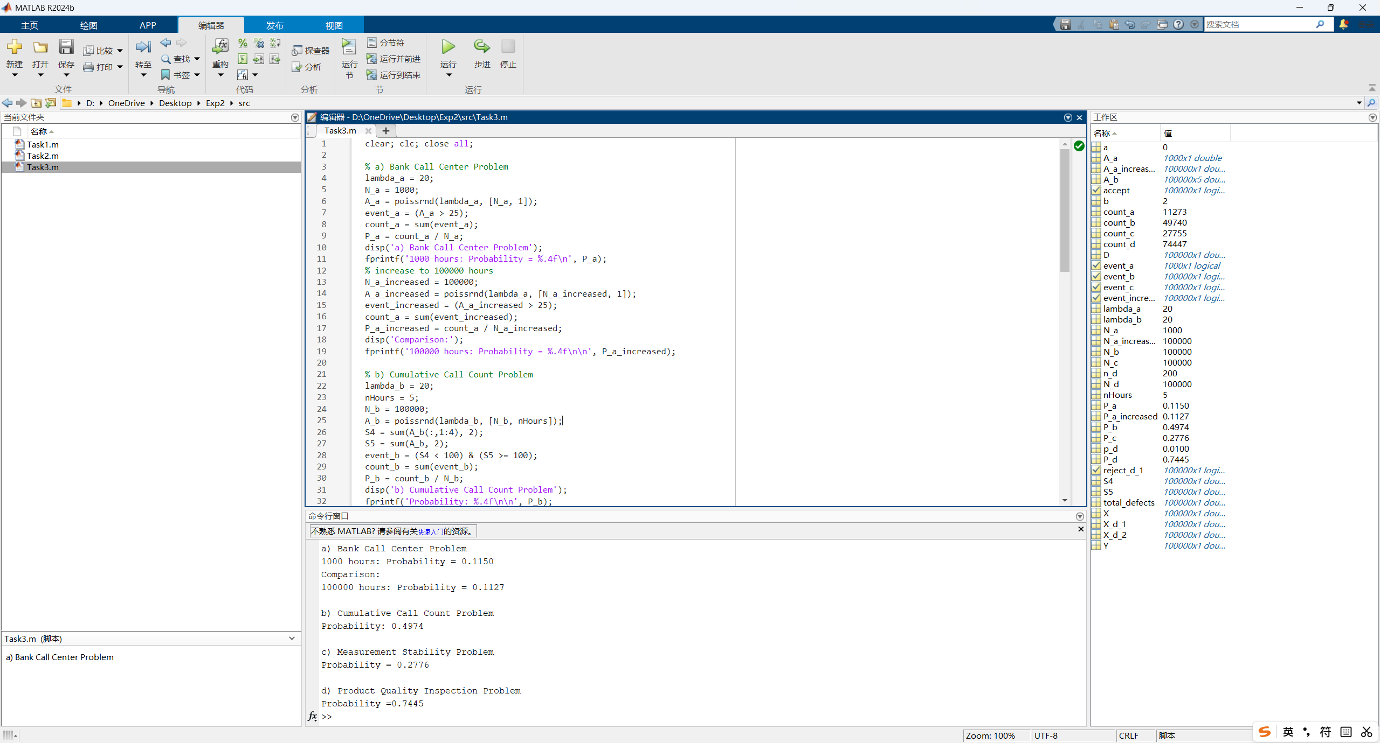
- Extended Questions
- Task 1 Results: Include the figures of the binomial distribution, Poisson distribution, and normal distribution. Briefly describe the graphical difference between the discrete distributions and the continuous distribution.

The binomial distribution and the Poisson distribution are discrete distributions, so their probabilities are displayed at separated integer values of k. Therefore, bar charts are suitable for showing their probability mass functions(PMF).
In the binomial distribution with n = 10 and p = 0.5, the graph is approximately symmetric around k = 5.
In the Poisson distribution with λ = 5, the probability is concentrated around k = 5 and the right tail gradually decreases.
In contrast, the normal distribution is a continuous distribution, so it is shown by a smooth probability density curve. Its value at a single point is not a probability; probability should be interpreted as the area under the curve over an interval.(PDF)
- Task 2 Results: Include the comparison figure of $B(1000,0.005)$ and $P(5)$. State whether the two distributions are close. Briefly explain whether the Poisson distribution can be used to approximate the binomial distribution in this case.

For the binomial distribution B(1000, 0.005), the parameter np is 5. Therefore, it is compared with the Poisson distribution P(λ = 5). From the comparison figure, the bars of the binomial distribution and the curve of the Poisson distribution almost overlap on the same horizontal axis. This means the two distributions are very close in this case. Since n is large, p is small, and np remains a moderate constant, the Poisson distribution can be used as a good approximation to the binomial distribution.
- Task 3 Results:
(1) Report the simulated probability and the theoretical probability that the number of calls in one hour is greater than 25. Briefly compare the two results.
Let X be the number of calls received in one hour. Then X follows a Poisson distribution with λ = 20.
In one simulation run, the estimated probability was about 0.1150 for 1000 hours and about 0.1127 for 100000 hours.
The theoretical probability is P(X > 25) = 1 - P(X <= 25) = 0.1122.
The result from 100000 simulated hours is closer to the theoretical value because a larger sample size reduces random fluctuation and makes the relative frequency more stable according to the law of large numbers.
(2) Report the simulated probability that the total number of calls is less than 100 in the first 4 hours but is at least 100 in the first 5 hours. If the theoretical probability is also calculated, report it and compare the two results.
Let A1, A2, A3, A4, and A5 be independent Poisson random variables with lambda = 20. Then S4 = A1 + A2 + A3 + A4 follows P(80), and A5 follows P(20). The event is S4 < 100 and S5 >= 100.
In one simulation with 100000 working periods, the estimated probability was about 0.4974.
The theoretical probability can be calculated by summing P(S4 = s)P(A5 >= 100 - s) for s = 0, 1, ..., 99, and the result is about 0.4962.
The simulated and theoretical probabilities are very close, showing that the simulation correctly reflects the theoretical Poisson model.
(3) Report the simulated probability that a product is stable, that is, $|X-Y|<0.3$. If the theoretical probability is also calculated, report it and compare the two results.
X and Y are independent uniform random variables on [0, 2]. A product is stable if |X - Y| < 0.3.
In one simulation with 100000 pairs of measurements, the estimated probability was about 0.2776.
The theoretical probability can be obtained geometrically from the square region 0 <= X <= 2 and 0 <= Y <= 2. The unstable region consists of two right triangles outside the band |X - Y| < 0.3, so the theoretical probability is $1 - \left(\frac{{1.7}^{2}}{4}\right) = 0.2775$.
The simulated result is close to the theoretical value.
(4) Report the simulated probability that a batch is finally accepted. If the theoretical probability is also calculated, report it and compare the two results.
Let X_d_1 and X_d_2 be the numbers of defective parts in the first and second inspections. Both follow B(200, 0.01), independently. The batch is finally accepted when X_d_1 <= 3 and X_d_1 + X_d_2 <= 5.
In one simulation with 100000 batches, the estimated acceptance probability was about 0.7445.
The theoretical probability is sum from x = 0 to 3 of P(X_d_1 = x)P(X_d_2 <= 5 - x), which is about 0.7446.
The two values are close, so the simulation result is reasonable. The small difference is caused by random sampling error.
- Summary and Experiment Reflections
In this experiment, I mainly learned how to use MATLAB to study random variables and several common probability distributions.
Through Task 1, I learned how to use Statistics and Machine Learning Toolbox to avoid the complicated formulas of different distributions. Through the charts I plotted, I had better understanding of the difference between discrete and continuous random variables, and the difference between PMF and PDF.
Through Task 2, I understood more clearly why the Poisson distribution can be used to approximate the binomial distribution when the number of trials is large, the success probability is small, and λ = np remains fixed. In the experiment, the binomial distribution B(1000, 0.005) and the Poisson distribution with λ = 5 were very close in shape and probability values. This helped me connect the theoretical condition with an actual graph, instead of only memorizing the formula from the textbook.
Through Task 3, I learned the basic method of using simulation to estimate probabilities. The main idea is to generate a large number of random samples, count the number of times that the required event happens, and then use relative frequency to approximate the probability. I also found that when the number of simulations increased from 1000 to 100000, the simulated result became closer to the theoretical probability. This made me understand the law of large numbers more intuitively. The simulation results are not exactly the same as the theoretical values because random sampling always contains some fluctuation, but the error becomes smaller when the sample size is large enough.
The main challenge I met was that the MATLAB syntax was not so clear in the Guide. For example, it only mentioned the use of Statistics and Machine Learning Toolbox but did not show how to use it to generate random numbers with poissrnd and binornd clearly. So I have to ask AI to learn how to use it in class, which took a lot of time.

