PropChk B2C Automation
Detailed Proposal
Prepared by BoltBlazers | PDQI (Pre-Delivery Quality Inspection) — B2C Segment

1. Purpose
This proposal covers building one unified, fully connected system for PropChk's B2C inspection business — covering everything from the moment a lead is won, through booking, engineer allotment, inspection, validation, and report delivery. The goal is to remove manual double-entry and manual notifications wherever they exist today.

2. Current Process — Where Things Stand Today
The diagram below shows how a booking currently flows through four disconnected systems, with a manual hand-off at every arrow.
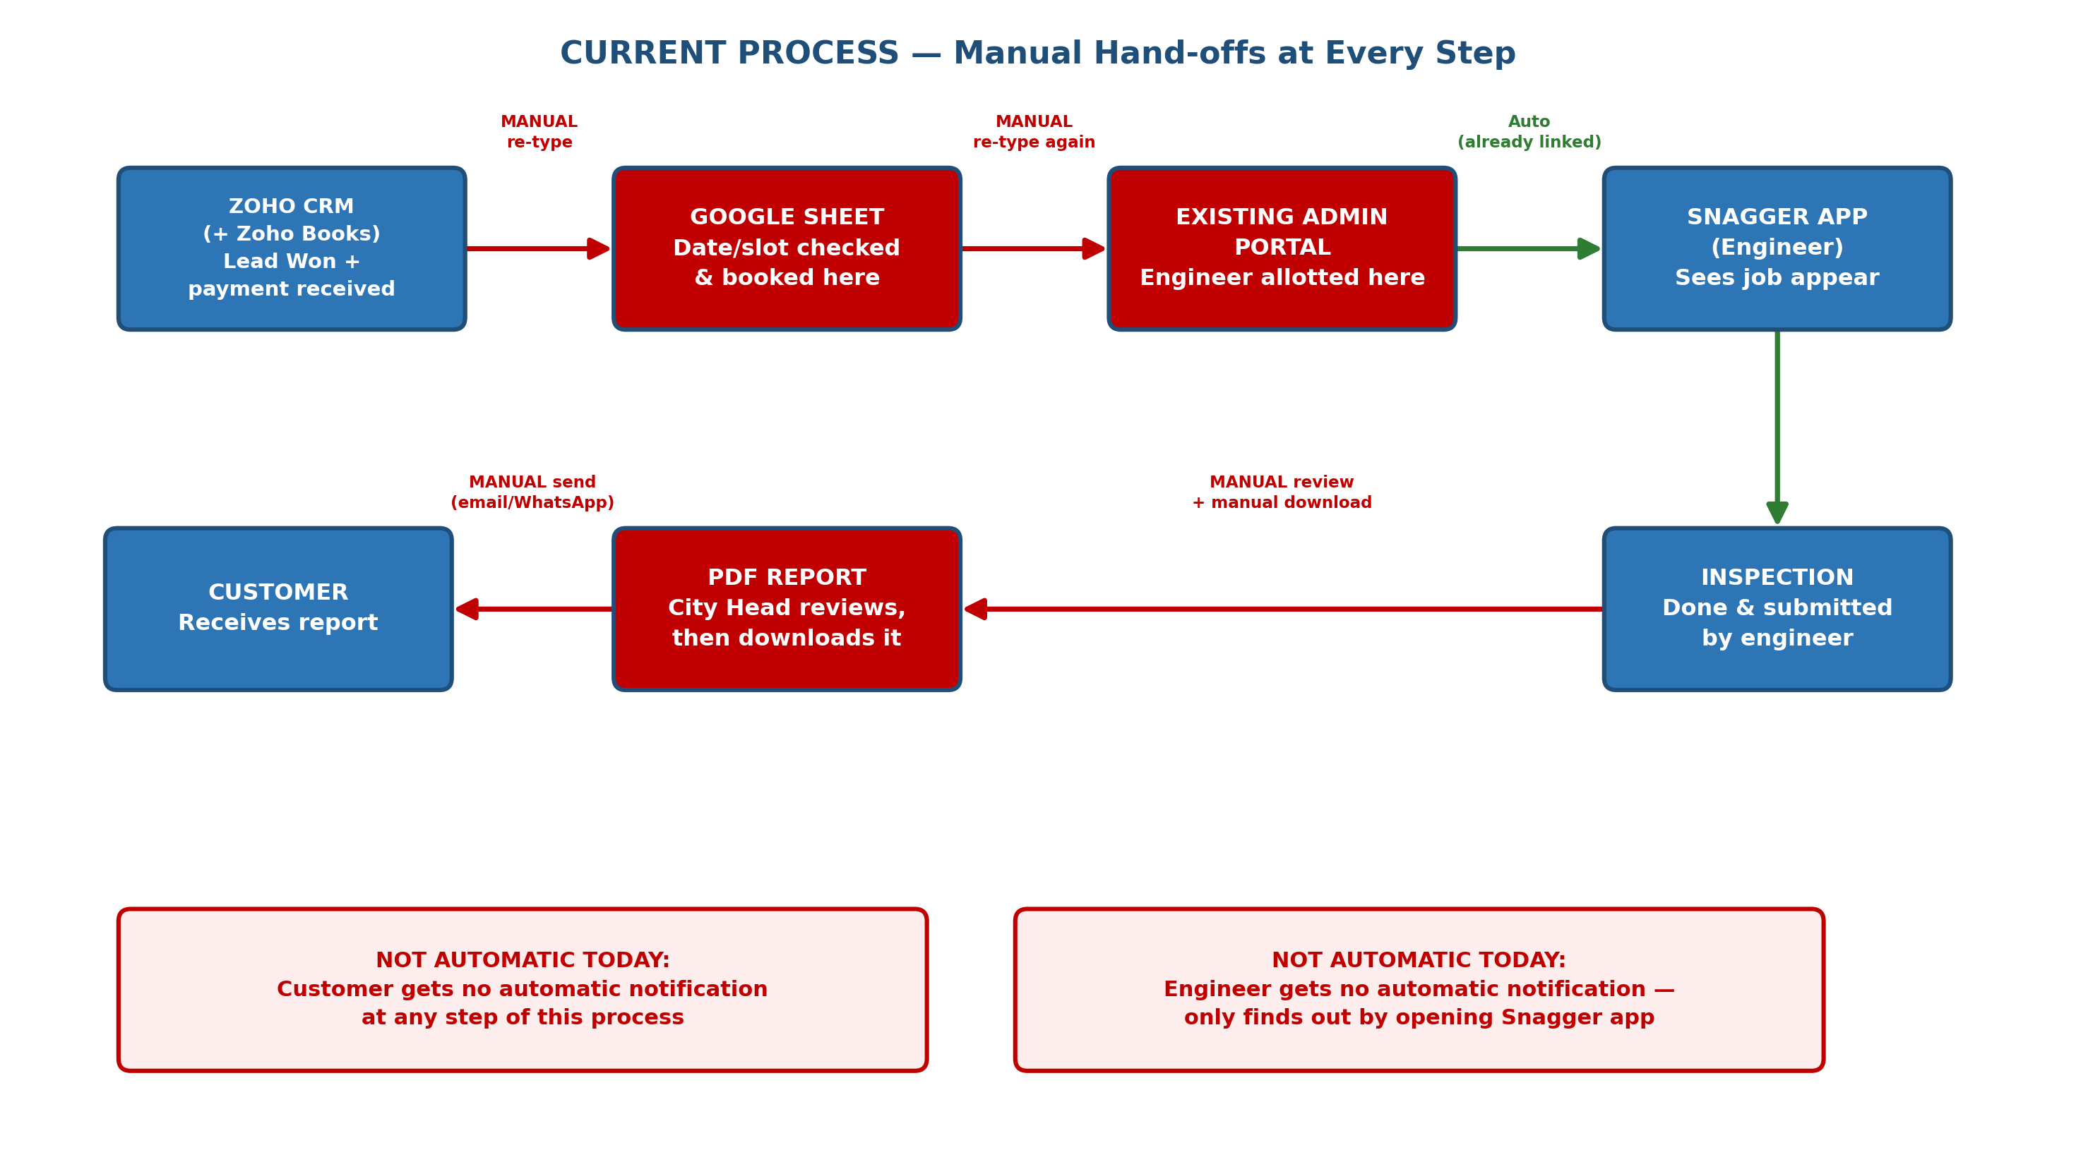

2.1 Pain Points
# | Pain Point | Impact
1 | Same customer/engineer data typed into Google Sheet, then again into the Admin Portal | Wasted time, risk of typos, data drifting out of sync
2 | No automatic notification to the customer at any step | Customer has to be manually called or messaged for every update
3 | No automatic notification to the engineer | Engineer only finds out about a job by opening the Snagger app themselves
4 | PDF report is manually downloaded and sent by the City Head | Delay in report delivery; depends on someone remembering to do it
5 | No customer self-service | Every booking/reschedule needs a sales person on the phone

3. Proposed Solution — One Connected System
Google Sheet is fully retired. In its place, one new portal connects Zoho, the existing Admin Portal, and the Snagger app — keeping all four in sync automatically.
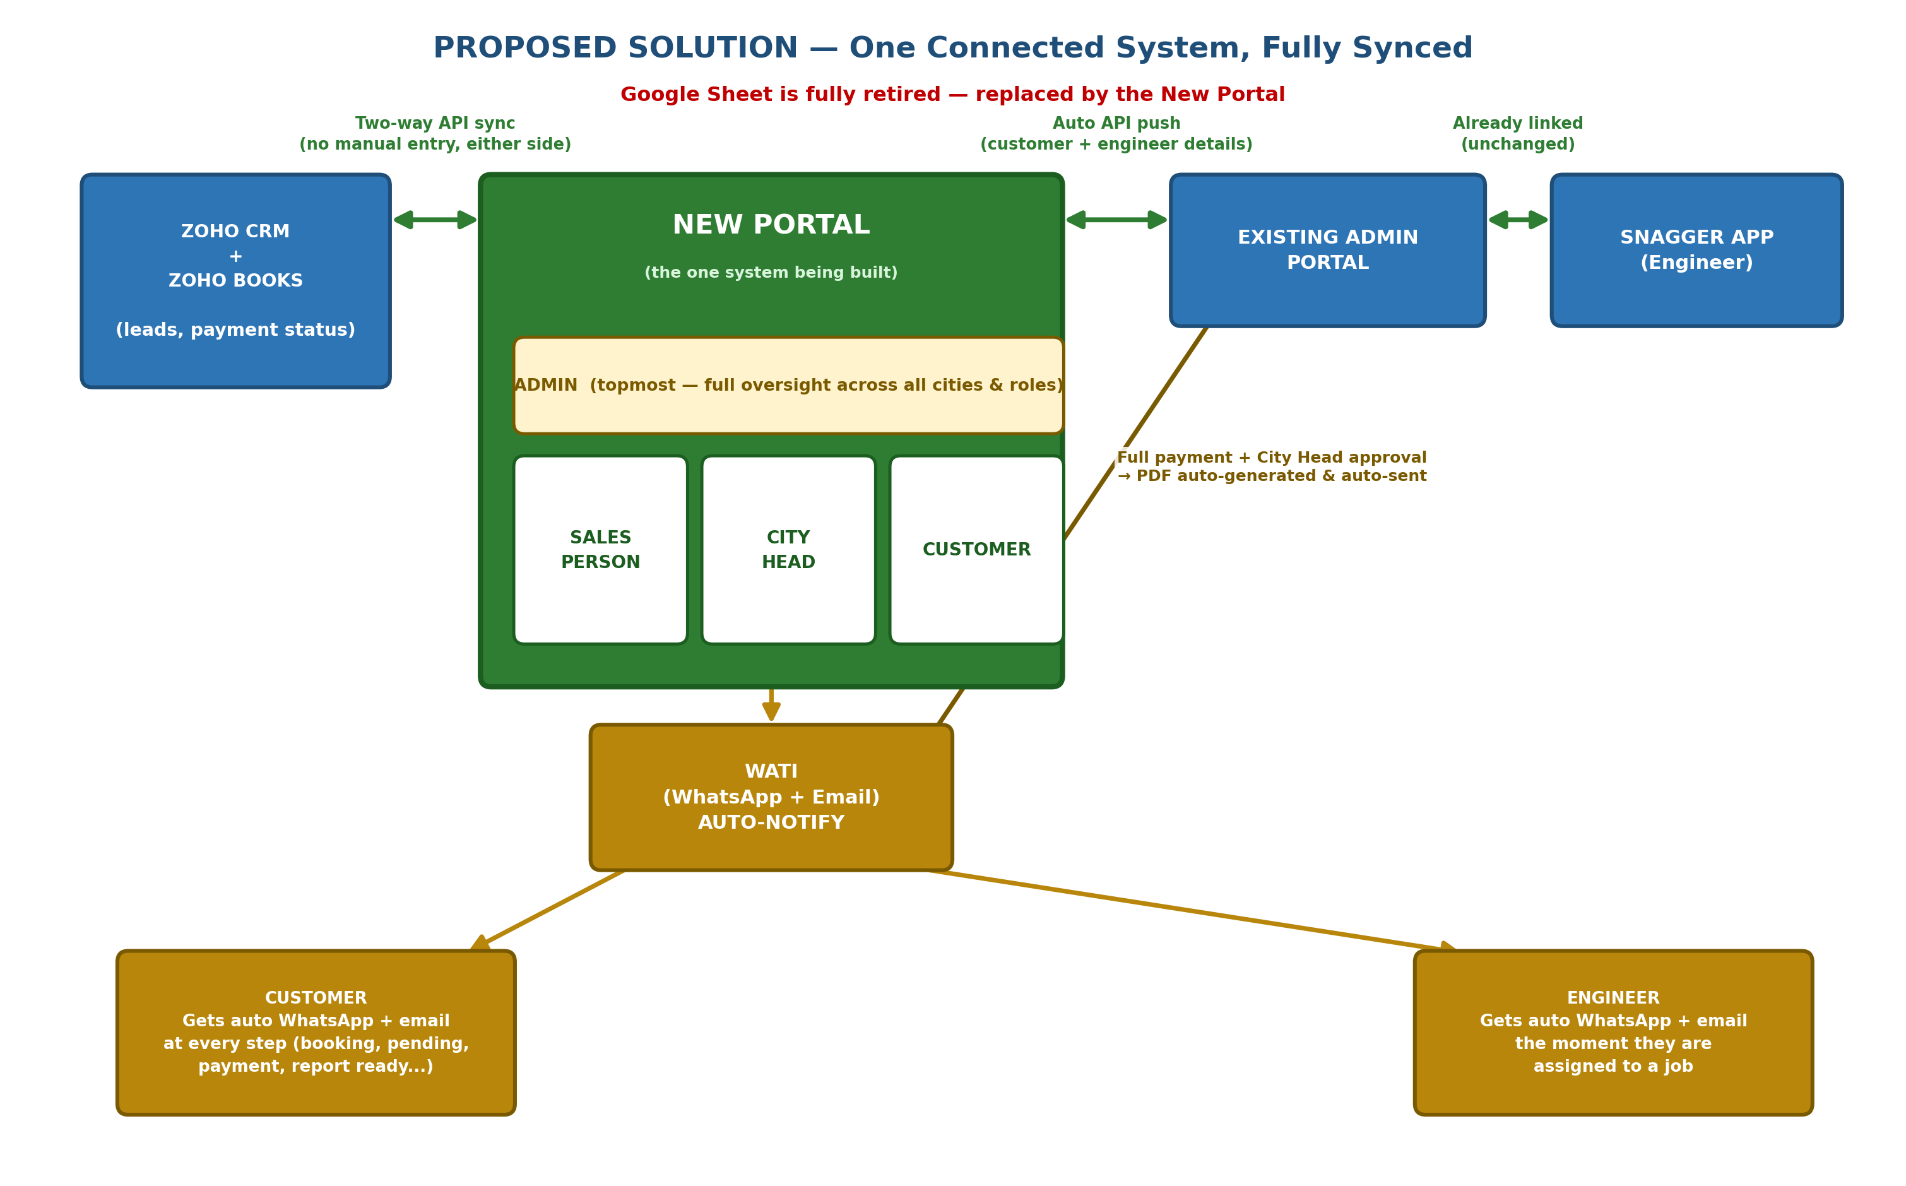

3.1 Roles in the New Portal
Role | What they can do
Admin (topmost) | Full oversight across all cities and all other roles — sees every booking, every report, every user; manages accounts and settings company-wide.
Sales Person | Views leads (auto-synced from Zoho), books a date/slot for a customer (live, on a call, or in advance), sees live payment status.
City Head | Sees bookings needing an engineer, allots engineers (with nearest-match suggestion), reviews and validates submitted inspections, gives final approval that releases the report.
Customer | Views payment/invoice status, books or reschedules their own inspection (subject to the approval rules in Section 4), views current and past reports.
Note: Engineers do not get a login on this new portal — they continue using the existing Snagger app, unchanged. The new portal pushes their job details to the Admin Portal automatically, which is already linked to the Snagger app.

4. Booking Logic
Note: The sales call itself — following up a lead, discussing the service, negotiating and converting the customer — remains a manual, human-driven conversation. This proposal does not automate the sales conversation. What's automated is everything that happens once a slot needs to be booked — whether the sales person does it live, on that same call, or the customer books it themselves later through the portal.

4.1 Two Ways a Slot Gets Booked
- Sales person books it live, on a call with the customer.
- Customer says “I'm paying now, I'll book the actual date later” — payment and date-booking are independent steps; either can happen first.

4.2 Payment-Based Confirmation Rules
Scenario | Result
Full payment received | Booking confirmed immediately — slot locked.
Partial payment, booked by the Sales Person on the customer's behalf | Goes through directly — confirmed.
Partial payment, booked by the customer via self-serve portal | Goes into “Pending” — needs Sales Person approval.
A booking still in “Pending” | Does NOT lock the slot — stays open to other customers/sales bookings.

4.3 Shift Structure
- Two shifts per engineer per day — Morning (10 AM–1 PM) and Evening (2 PM–5 PM).

4.4 When a Slot Fills Up
“Slot filled” means all engineers for that particular date and shift are engaged by confirmed (fully-paid) bookings. If this happens while a customer is still sitting in “Pending” on that same slot:
- The customer is automatically notified (WhatsApp + email) to pick another slot.
- The Sales Person can also personally step in to help that customer rebook.

5. Engineer Allotment
- City Head allots the engineer from the portal; the system suggests the nearest engineer by comparing the property's location to each engineer's home address.
- For the evening shift, the suggested engineer is kept near that same engineer's morning-shift location — minimizing travel between the two.
- The moment the City Head confirms an engineer against a customer's slot, all details (customer + engineer + date/time) are automatically pushed to the existing Admin Portal via its API — no manual re-typing.
- The assigned engineer automatically receives a WhatsApp + email notification the moment they are assigned — closing today's gap where they only find out by opening the Snagger app.
Requires: API access to the existing Admin Portal from PropChk — see Section 9.

6. Inspection → Validation → Report
- Engineer completes the inspection and submits it via the existing Snagger app (unchanged).
- City Head reviews the submission in the new portal — sends it back to the engineer if an issue is found, or approves it if everything is correct.
- Final approval is only possible once full payment has been received — even if the inspection itself is already complete.
- On approval: the PDF report is auto-generated and auto-sent via WhatsApp + email — no manual download/send by the City Head.

7. Payment Visibility
Throughout the portal — for Admin, Sales Person, City Head, and Customer views alike — payment status (partial or full) is shown live, pulled directly via the Zoho Books API. No one has to ask or check separately.

8. Automatic Notifications (WhatsApp + Email, via WATI)
Every event below triggers an automatic WhatsApp + email message, in addition to being visible on the portal.
Event | Customer | Engineer
Booking confirmed | ✓
Booking pending | ✓
Portal credentials issued | ✓
Payment received (partial/full) | ✓
Engineer assigned |  | ✓
Slot bumped — please rebook | ✓
Inspection completed | ✓
Report ready (PDF auto-sent) | ✓

9. Technology Stack
Layer | Choice
Frontend | React
Backend | Spring Boot
Database | PostgreSQL
Hosting | GCP, or whatever PropChk prefers — hosted on PropChk's own cloud account

9.1 Access & Dependencies Required from PropChk
- Zoho CRM API access
- Zoho Books API access
- Existing Admin Portal API access (for the auto-push of customer/engineer data)
- WATI API access
- Cloud hosting account details (GCP or preferred provider) for deployment
Timeline in Section 10 assumes this access is provided early — any delay here pushes the timeline out correspondingly.

10. Timeline
4 – 5 Weeks

11. Explicitly Out of Scope
- Lead-to-sales-rep assignment — already automated by PropChk via round robin.
- AI-based inspection / defect detection — separate, future initiative.
- Engineer login/portal access — engineers continue using the existing Snagger app only.

