性能测试

gamma接受压测的fcgi在64机器上，测试环境fcgi请求的域名test-jtapi.jd.com，线上不是这个

这个域名的请求，会经过IDC机器上的nginx转发到测试环境64机器上，

为了不劳烦IDC的nginx，我们在gamma验证的时候，直接配置test-jtapi.jd.com指向10.191.171.64机器就好

配置本机的host，因为jmeter不走fiddler等任何代理，走的本机hosts然后就是实际的互联网DNS解析

在C:\Windows\System32\drivers\etc\hosts 文件写入 10.191.171.64 test-jtapi.jd.com

下面的Fcgi处理请求

/operad/ad/recommend?userid=duxinyi1314&usertype=1&skucnt=10

<http://test-jtapi.jd.com/operad/ad/recommend?userid=duxinyi1314&usertype=1&skucnt=10>

jmeter

10.190.171.64 nginx

单机：  76  
sh jmeter -n -t AdRecommd_5000.jmx -l  AdRecommd_5000.jtl   
sh jmeter -n -t AdRecommd_5000.jmx -l  AdRecommd_5000.jtl  -r

sh jmeter -n -t AdRecommd_600_5.jmx -l  AdRecommd_600_5.jtl   
sh jmeter -n -t AdRecommd_600_5.jmx -l  AdRecommd_600_5.jtl -r

sh jmeter -n -t AdRecommd_600_5.jmx -l  AdRecommd_600_5.jtl   
sh jmeter -n -t AdRecommd_400_5.jmx -l  AdRecommd_400_5.jtl -r

性能测试过程

控制机Controller(10.190.20.76)，增加四台Agent（10.191.152.101,10.191.43.231,10.191.86.210,10.191.86.211），以五台机来运行JMeter.

Fcgi部署机器10.191.171.64

1）

sh jmeter -n -t AdRecommd_100_5.jmx -l  AdRecommd_100_5.jtl –r

100*5 1000次 153s 150ms

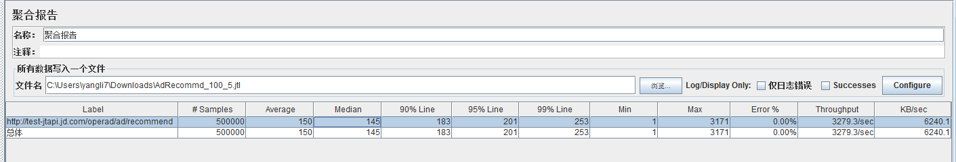

2）

sh jmeter -n -t AdRecommd_150_5.jmx -l  AdRecommd_150_5.jtl -r  
150*5个并发请求，循环1000次

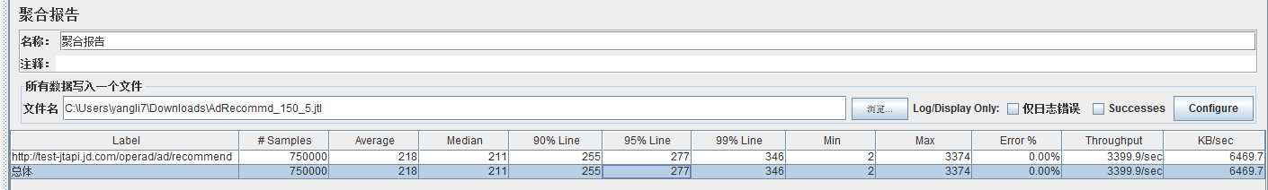

Starting the test @ Fri Jul 22 16:17:13 CST 2016 (1469175433206)

Remote engines have been started

Waiting for possible shutdown message on port 4445

summary + 55506 in 16.4s = 3383.7/s Avg: 210 Min: 2 Max: 1261 Err: 0 (0.00%) Active: 750 Started: 733 Finished: 0

summary + 105600 in 30.1s = 3513.0/s Avg: 213 Min: 141 Max: 1332 Err: 0 (0.00%) Active: 750 Started: 733 Finished: 0

summary = 161106 in 46.5s = 3467.3/s Avg: 212 Min: 2 Max: 1332 Err: 0 (0.00%)

summary + 100500 in 30s = 3354.0/s Avg: 223 Min: 151 Max: 3204 Err: 0 (0.00%) Active: 750 Started: 733 Finished: 0

summary = 261606 in 76.4s = 3422.9/s Avg: 216 Min: 2 Max: 3204 Err: 0 (0.00%)

summary + 101800 in 30s = 3392.9/s Avg: 220 Min: 138 Max: 1275 Err: 0 (0.00%) Active: 750 Started: 733 Finished: 0

summary = 363406 in 106s = 3414.4/s Avg: 217 Min: 2 Max: 3204 Err: 0 (0.00%)

summary + 99900 in 30s = 3330.3/s Avg: 225 Min: 152 Max: 3215 Err: 0 (0.00%) Active: 750 Started: 733 Finished: 0

summary = 463306 in 136s = 3395.9/s Avg: 219 Min: 2 Max: 3215 Err: 0 (0.00%)

summary + 104200 in 30s = 3473.4/s Avg: 215 Min: 134 Max: 1278 Err: 0 (0.00%) Active: 750 Started: 733 Finished: 0

summary = 567506 in 166s = 3409.9/s Avg: 218 Min: 2 Max: 3215 Err: 0 (0.00%)

summary + 97600 in 30s = 3255.8/s Avg: 230 Min: 149 Max: 3374 Err: 0 (0.00%) Active: 750 Started: 733 Finished: 0

summary = 665106 in 196s = 3386.3/s Avg: 220 Min: 2 Max: 3374 Err: 0 (0.00%)

summary + 84894 in 24.2s = 3508.5/s Avg: 207 Min: 5 Max: 1409 Err: 0 (0.00%) Active: 0 Started: 733 Finished: 750

summary = 750000 in 221s = 3399.7/s Avg: 218 Min: 2 Max: 3374 Err: 0 (0.00%)

Tidying up remote @ Fri Jul 22 16:20:54 CST 2016 (1469175654207)

... end of run

3）

sh jmeter -n -t AdRecommd_200_5.jmx -l  AdRecommd_200_5.jtl -r

Starting the test @ Fri Jul 22 16:29:02 CST 2016 (1469176142439)

summary + 1 in 0.1s = 11.4/s Avg: 2 Min: 2 Max: 2 Err: 0 (0.00%) Active: 6 Started: 0 Finished: 0

Remote engines have been started

Waiting for possible shutdown message on port 4445

summary + 94205 in 27.2s = 3468.8/s Avg: 279 Min: 1 Max: 1346 Err: 0 (0.00%) Active: 1000 Started: 980 Finished: 0

summary = 94206 in 27.2s = 3457.7/s Avg: 279 Min: 1 Max: 1346 Err: 0 (0.00%)

summary + 101000 in 30s = 3368.9/s Avg: 296 Min: 219 Max: 1647 Err: 0 (0.00%) Active: 1000 Started: 980 Finished: 0

summary = 195206 in 57.2s = 3411.2/s Avg: 288 Min: 1 Max: 1647 Err: 0 (0.00%)

summary + 101800 in 30s = 3396.1/s Avg: 294 Min: 195 Max: 1442 Err: 0 (0.00%) Active: 1000 Started: 980 Finished: 0

summary = 297006 in 87.2s = 3406.0/s Avg: 290 Min: 1 Max: 1647 Err: 0 (0.00%)

summary + 104200 in 30s = 3468.1/s Avg: 288 Min: 201 Max: 1574 Err: 0 (0.00%) Active: 1000 Started: 980 Finished: 0

summary = 401206 in 117s = 3421.9/s Avg: 289 Min: 1 Max: 1647 Err: 0 (0.00%)

summary + 103000 in 30s = 3437.8/s Avg: 290 Min: 210 Max: 1395 Err: 0 (0.00%) Active: 1000 Started: 980 Finished: 0

summary = 504206 in 147s = 3425.1/s Avg: 290 Min: 1 Max: 1647 Err: 0 (0.00%)

summary + 104400 in 30s = 3481.6/s Avg: 287 Min: 209 Max: 1443 Err: 0 (0.00%) Active: 1000 Started: 980 Finished: 0

summary = 608606 in 177s = 3434.7/s Avg: 289 Min: 1 Max: 1647 Err: 0 (0.00%)

summary + 103500 in 30s = 3446.8/s Avg: 290 Min: 192 Max: 1424 Err: 0 (0.00%) Active: 1000 Started: 980 Finished: 0

summary = 712106 in 207s = 3436.5/s Avg: 289 Min: 1 Max: 1647 Err: 0 (0.00%)

summary + 104000 in 30s = 3469.2/s Avg: 288 Min: 201 Max: 1357 Err: 0 (0.00%) Active: 1000 Started: 980 Finished: 0

summary = 816106 in 237s = 3440.6/s Avg: 289 Min: 1 Max: 1647 Err: 0 (0.00%)

summary + 100700 in 30s = 3357.0/s Avg: 297 Min: 205 Max: 3312 Err: 0 (0.00%) Active: 1000 Started: 980 Finished: 0

summary = 916806 in 267s = 3431.2/s Avg: 290 Min: 1 Max: 3312 Err: 0 (0.00%)

summary + 83194 in 24s = 3498.0/s Avg: 277 Min: 5 Max: 1545 Err: 0 (0.00%) Active: 0 Started: 980 Finished: 1000

summary = 1000000 in 291s = 3436.7/s Avg: 289 Min: 1 Max: 3312 Err: 0 (0.00%)

Tidying up remote @ Fri Jul 22 16:33:53 CST 2016 (1469176433790)

... end of run

4）

sh jmeter -n -t AdRecommd_250_5.jmx -l  AdRecommd_250_5.jtl -r

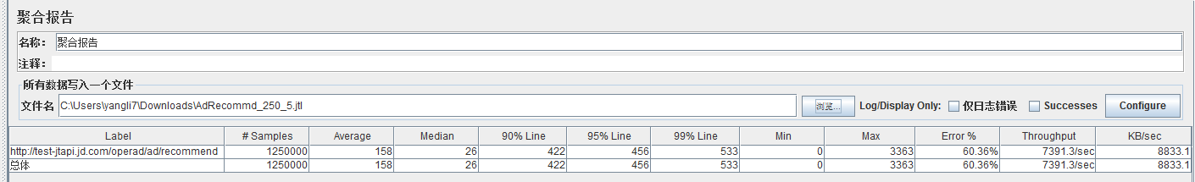

Starting the test @ Fri Jul 22 16:45:25 CST 2016 (1469177125723)

Remote engines have been started

Waiting for possible shutdown message on port 4445

summary + 18606 in 4s = 4730.7/s Avg: 171 Min: 0 Max: 1137 Err: 6573 (35.33%) Active: 1250 Started: 1247 Finished: 0

summary + 242300 in 30s = 8081.5/s Avg: 154 Min: 0 Max: 3363 Err: 156806 (64.72%) Active: 1250 Started: 1247 Finished: 0

summary = 260906 in 34s = 7692.9/s Avg: 155 Min: 0 Max: 3363 Err: 163379 (62.62%)

summary + 246600 in 30s = 8215.1/s Avg: 151 Min: 0 Max: 1616 Err: 162093 (65.73%) Active: 1250 Started: 1247 Finished: 0

summary = 507506 in 64s = 7938.1/s Avg: 153 Min: 0 Max: 3363 Err: 325472 (64.13%)

summary + 249700 in 30s = 8327.5/s Avg: 149 Min: 0 Max: 1613 Err: 165025 (66.09%) Active: 1250 Started: 1247 Finished: 0

summary = 757206 in 94s = 8062.4/s Avg: 152 Min: 0 Max: 3363 Err: 490497 (64.78%)

summary + 239006 in 30s = 7967.7/s Avg: 156 Min: 0 Max: 1431 Err: 152282 (63.71%) Active: 1250 Started: 1247 Finished: 0

summary = 996212 in 124s = 8039.5/s Avg: 153 Min: 0 Max: 3363 Err: 642779 (64.52%)

summary + 202994 in 30s = 6765.1/s Avg: 175 Min: 0 Max: 1592 Err: 111676 (55.01%) Active: 971 Started: 1247 Finished: 279

summary = 1199206 in 154s = 7791.0/s Avg: 157 Min: 0 Max: 3363 Err: 754455 (62.91%)

summary + 50794 in 15.2s = 3336.9/s Avg: 193 Min: 5 Max: 1373 Err: 0 (0.00%) Active: 0 Started: 1247 Finished: 1250

summary = 1250000 in 169s = 7390.2/s Avg: 158 Min: 0 Max: 3363 Err: 754455 (60.36%)

Tidying up remote @ Fri Jul 22 16:48:15 CST 2016 (1469177295228)

5）

sh jmeter -n -t AdRecommd_220_5.jmx -l  AdRecommd_220_5.jtl -r

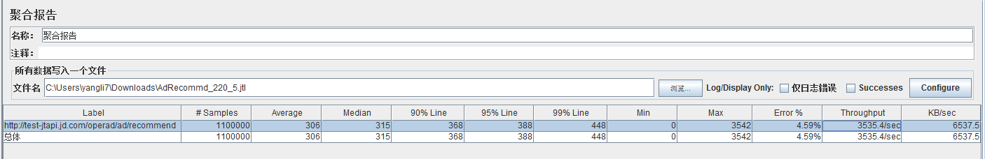

Starting the test @ Fri Jul 22 17:08:24 CST 2016 (1469178504798)

Remote engines have been started

Waiting for possible shutdown message on port 4445

summary + 15206 in 5s = 3148.9/s Avg: 246 Min: 0 Max: 1339 Err: 52 (0.34%) Active: 1100 Started: 1087 Finished: 0

summary + 109600 in 30s = 3653.7/s Avg: 301 Min: 0 Max: 1430 Err: 6016 (5.49%) Active: 1100 Started: 1087 Finished: 0

summary = 124806 in 35s = 3583.7/s Avg: 294 Min: 0 Max: 1430 Err: 6068 (4.86%)

summary + 109700 in 30s = 3652.2/s Avg: 300 Min: 0 Max: 1522 Err: 7718 (7.04%) Active: 1100 Started: 1087 Finished: 0

summary = 234506 in 65s = 3615.4/s Avg: 297 Min: 0 Max: 1522 Err: 13786 (5.88%)

summary + 109800 in 30s = 3664.6/s Avg: 299 Min: 0 Max: 1561 Err: 6485 (5.91%) Active: 1100 Started: 1087 Finished: 0

summary = 344306 in 95s = 3631.0/s Avg: 298 Min: 0 Max: 1561 Err: 20271 (5.89%)

summary + 114300 in 30s = 3809.0/s Avg: 289 Min: 0 Max: 3542 Err: 13823 (12.09%) Active: 1100 Started: 1087 Finished: 0

summary = 458606 in 125s = 3673.8/s Avg: 295 Min: 0 Max: 3542 Err: 34094 (7.43%)

summary + 106200 in 30s = 3541.3/s Avg: 310 Min: 0 Max: 1374 Err: 1413 (1.33%) Active: 1100 Started: 1087 Finished: 0

summary = 564806 in 155s = 3648.1/s Avg: 298 Min: 0 Max: 3542 Err: 35507 (6.29%)

summary + 112500 in 30s = 3748.0/s Avg: 293 Min: 0 Max: 1495 Err: 9929 (8.83%) Active: 1100 Started: 1087 Finished: 0

summary = 677306 in 185s = 3664.3/s Avg: 297 Min: 0 Max: 3542 Err: 45436 (6.71%)

summary + 102300 in 30s = 3408.5/s Avg: 321 Min: 0 Max: 1386 Err: 854 (0.83%) Active: 1100 Started: 1087 Finished: 0

summary = 779606 in 215s = 3628.6/s Avg: 301 Min: 0 Max: 3542 Err: 46290 (5.94%)

summary + 100800 in 30s = 3363.0/s Avg: 327 Min: 0 Max: 1420 Err: 2642 (2.62%) Active: 1100 Started: 1087 Finished: 0

summary = 880406 in 245s = 3596.1/s Avg: 303 Min: 0 Max: 3542 Err: 48932 (5.56%)

summary + 101900 in 30s = 3395.9/s Avg: 324 Min: 0 Max: 1394 Err: 925 (0.91%) Active: 1100 Started: 1087 Finished: 0

summary = 982306 in 275s = 3574.2/s Avg: 306 Min: 0 Max: 3542 Err: 49857 (5.08%)

summary + 97300 in 30s = 3238.0/s Avg: 335 Min: 0 Max: 1399 Err: 609 (0.63%) Active: 945 Started: 1087 Finished: 155

summary = 1079606 in 305s = 3541.1/s Avg: 308 Min: 0 Max: 3542 Err: 50466 (4.67%)

summary + 20394 in 6.3s = 3238.2/s Avg: 214 Min: 5 Max: 1305 Err: 0 (0.00%) Active: 0 Started: 1087 Finished: 1100

summary = 1100000 in 311s = 3534.9/s Avg: 306 Min: 0 Max: 3542 Err: 50466 (4.59%)

Tidying up remote @ Fri Jul 22 17:13:36 CST 2016 (1469178816360)

... end of run

6）sh jmeter -n -t AdRecommd_40_5.jmx -l  AdRecommd_40_5.jtl -r

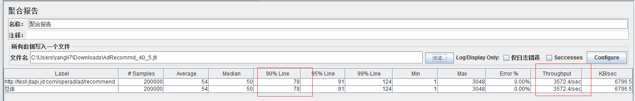

Creating summariser <summary>

Created the tree successfully using AdRecommd_40_5.jmx

Configuring remote engine: 127.0.0.1

Configuring remote engine: 10.191.152.101:1099

Configuring remote engine: 10.191.43.231:1099

Configuring remote engine: 10.191.86.210:1099

Configuring remote engine: 10.191.86.211:1099

Starting remote engines

Starting the test @ Fri Jul 22 17:20:06 CST 2016 (1469179206125)

Remote engines have been started

Waiting for possible shutdown message on port 4445

summary + 82206 in 24s = 3497.5/s Avg: 55 Min: 1 Max: 3048 Err: 0 (0.00%) Active: 200 Started: 195 Finished: 0

summary + 109600 in 30s = 3652.8/s Avg: 54 Min: 13 Max: 1153 Err: 0 (0.00%) Active: 194 Started: 195 Finished: 6

summary = 191806 in 54s = 3584.6/s Avg: 54 Min: 1 Max: 3048 Err: 0 (0.00%)

summary + 8194 in 3s = 3259.3/s Avg: 42 Min: 5 Max: 1065 Err: 0 (0.00%) Active: 0 Started: 195 Finished: 200

summary = 200000 in 56s = 3570.0/s Avg: 54 Min: 1 Max: 3048 Err: 0 (0.00%)

Tidying up remote @ Fri Jul 22 17:21:02 CST 2016 (1469179262525)

... end of run

sh jmeter -n -t AdRecommd_5_5.jmx -l  AdRecommd_5_5.jtl -r

接口测试相关信息&性能测试的脚本准备

各类用户标识

test-jtapi.jd.com/operad/ad/recommend?

规格ID（crtsize） :  21  220X120  
规格ID：27  160X210  
规格ID：2    160x210

domain    要咨询下郭勇  你用RTX还是微信方便？我拉个测试群  
budlename  目前是留空的

 /**  
     * sign = md5(sid + userid + usertype + tagid + specid + width + height + skucnt + clientip + domain + bundlename + 请求时间 + key)  
     */

openid_BE38EA9DD803ADCB6E79086CE3D4234B  
openid_982C0C2A446EFFF15586D1BD740A0B2D  
openid_C618EEB7546DC6A6E2EA9864ECC1864D  
openid_06F6AA4F45747519A686BE17011F1454  
openid_A7D9E3091512FE609F6A6FDBBE7C8918  
openid_36DCBC362DB30409927B555E7763C9F9  
openid_F0620B9C1BBF64C9175C6A7A5B400698  
openid_3E9FC7881D4DC3F140116656053202A2  
openid_26E08C6CCB41FF61843FC1EC9C308AF5  
openid_86ADC1E0CBAE6BD132D0493873E8D9DA  
openid_F454D488C8D59826652AC0D12A0474B5  
openid_0E3536CE64B6D4FF9FBAF4074E821518  
openid_1FAB99679F8F51DA78794D020D512CE9  
openid_24E60B91FA3123128977D3043EBD4DC4

下面的Fcgi处理请求

/operad/ad/recommend?userid=duxinyi1314&usertype=1&skucnt=10

IDC nginx转发请求

http://test-jtapi.jd.com/operad/ad/recommend?userid=duxinyi1314&usertype=1&skucnt=10

10.190.171.64 nginx