1.Running environment: JDK8

Download and setup:

<https://www.oracle.com/java/technologies/javase-jdk8-downloads.html>

2.Startup project on the command line:

Path: \findwords\target\findwords-1.0-SNAPSHOT.jar

Command:java -jar findwords-1.0-SNAPSHOT.jar

3.Open the link in browser：<http://127.0.0.1:8081/homepage>

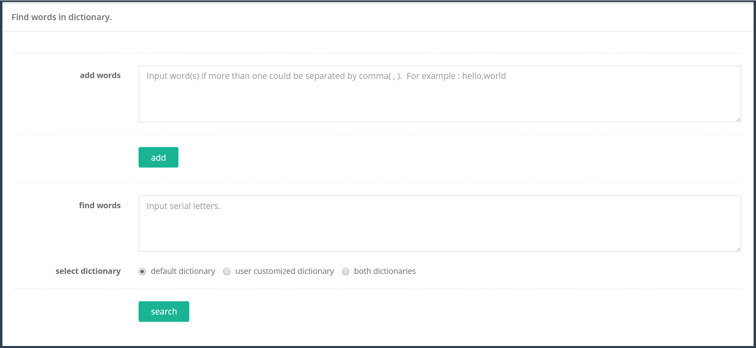

4.The function of adding and finding words can be used in the page.

(1)Add some new words.

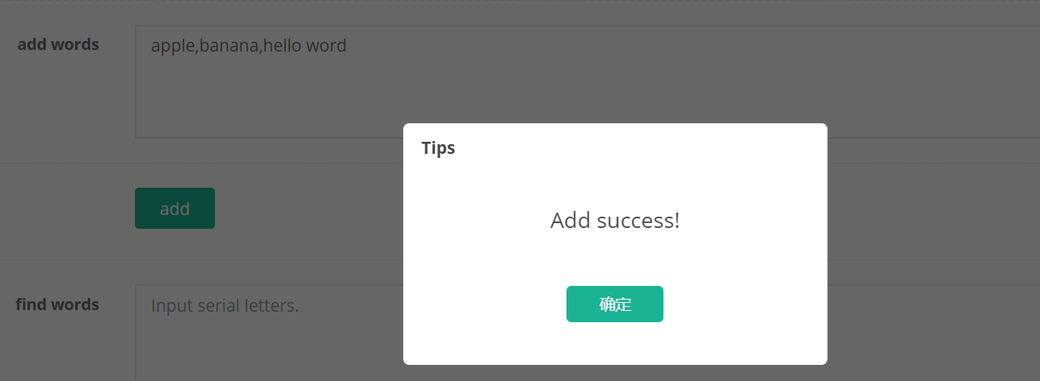

(2)Find words in the default dictionary.

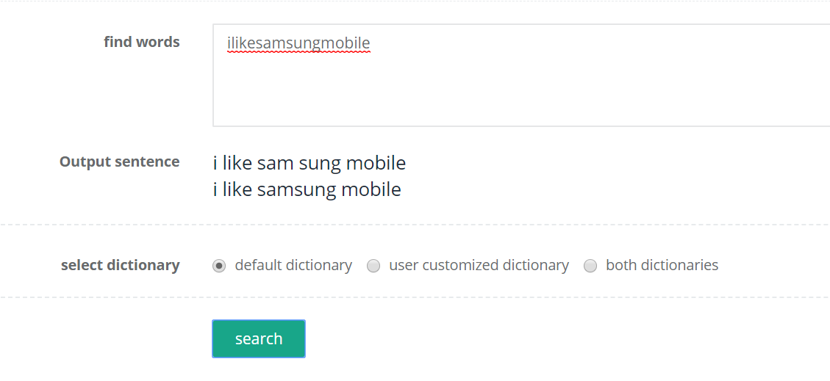

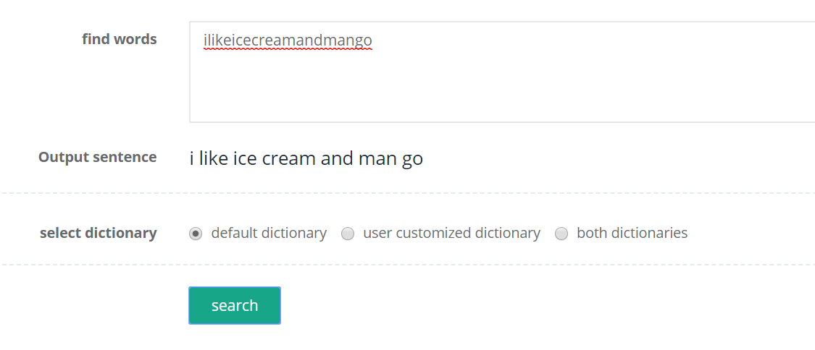

(3)Find words in the user customized dictionary.

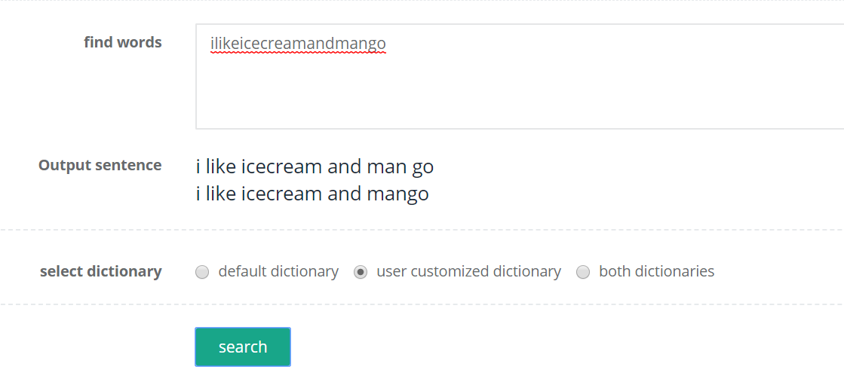

(4)Find words in the both dictionaries.

