

OPERATING SYSTEM

# LAB-ASSIGNMENT

BY-NISARG SIR AACHARY

007

**KENILVASOYA2000@GMAIL.COM**

* **Q1. A. Create a basic calculator with using case.**

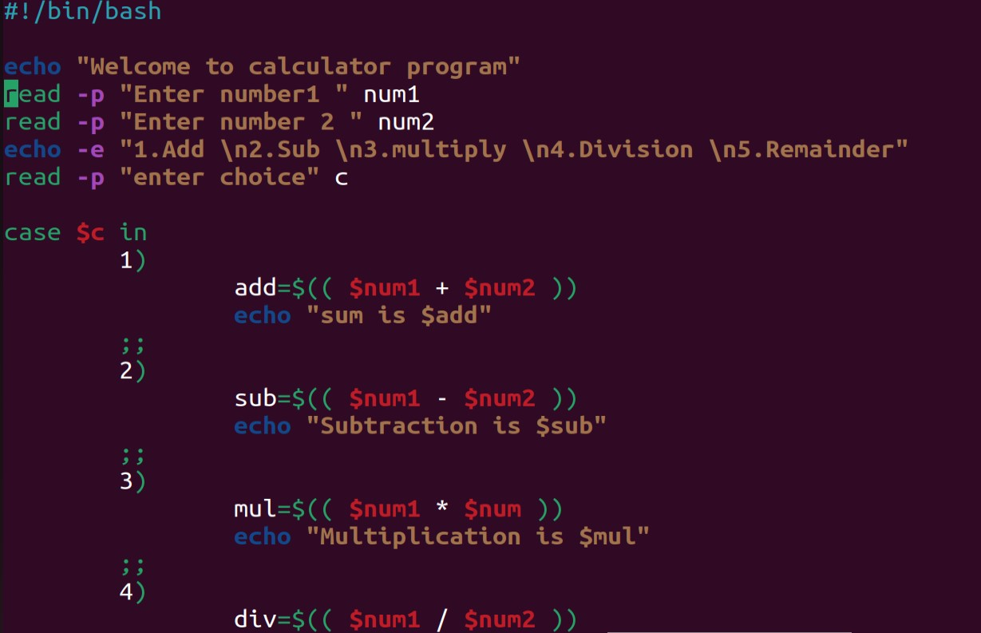

➢

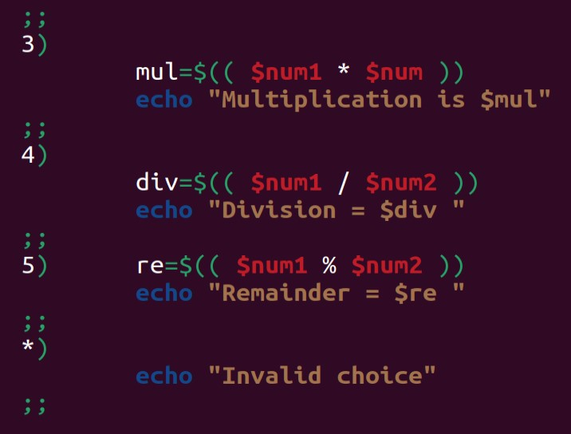

* **Q2.B. B. Find out the greatest number among three numbers entered by users using if condition**
* 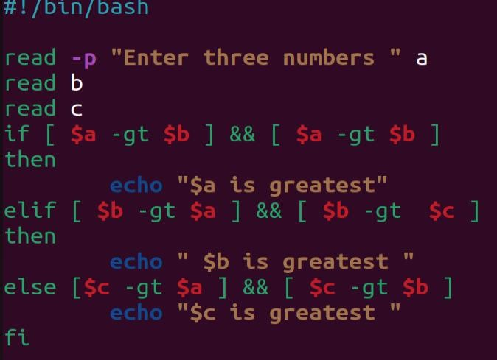

* C. Write a program to take input of number from user and generate that number of .txt files.

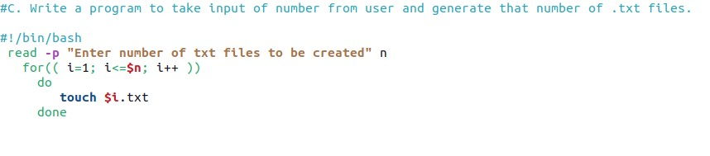

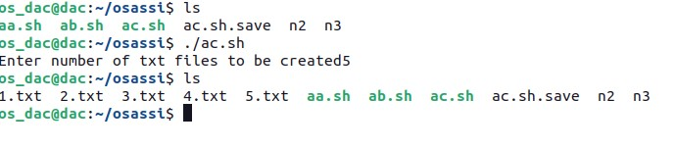

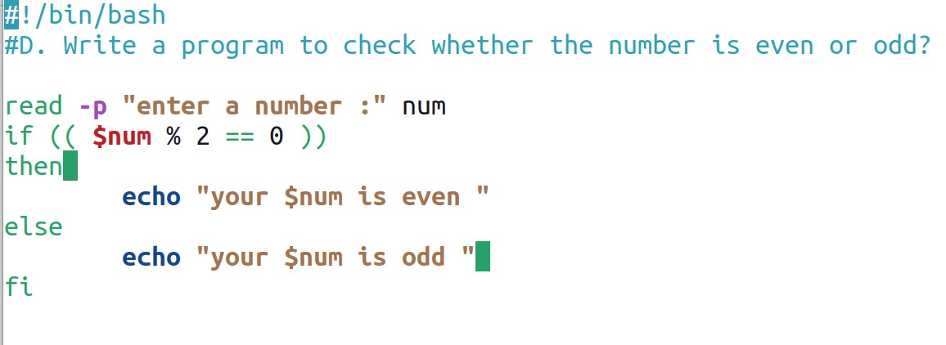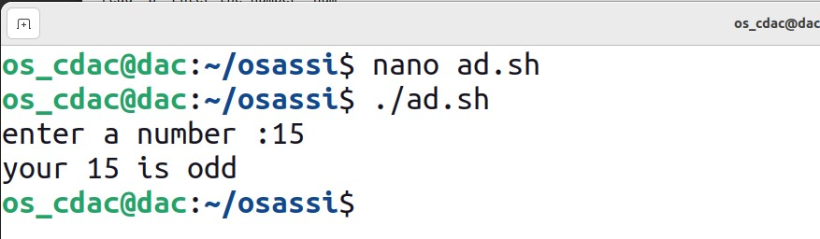

Loop Excercise (Use For/While/Until)

1. Write a Shell Script to display the first 10 natural numbers.

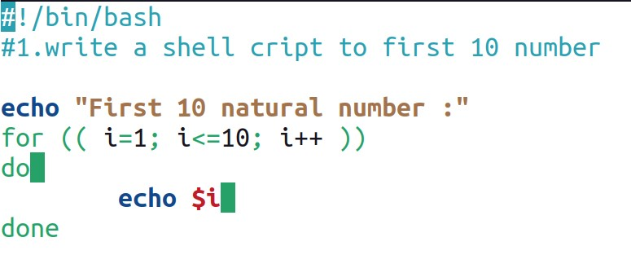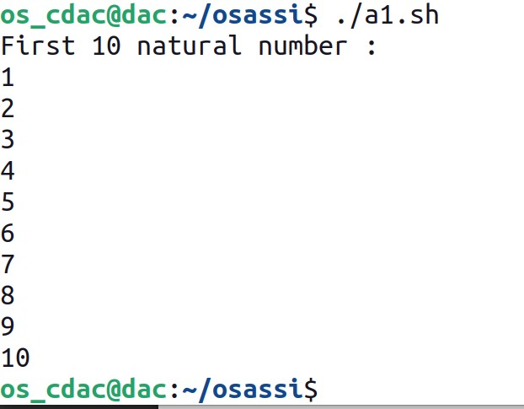

1. Write a Shell Script to compute the sum of the first 10 natural numbers.

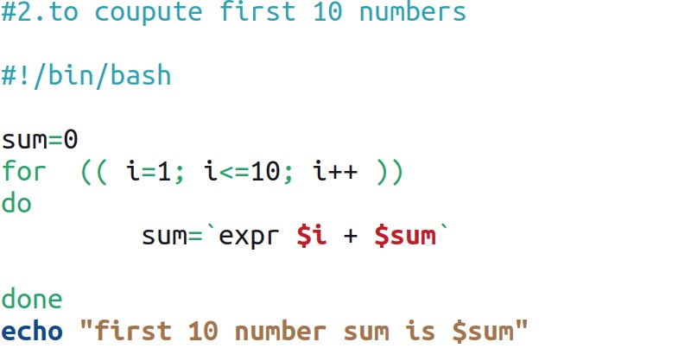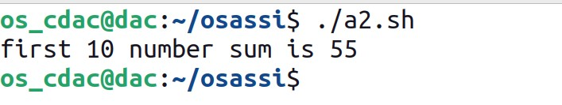

1. Write a Shell Script to display n terms of natural numbers and their sum.

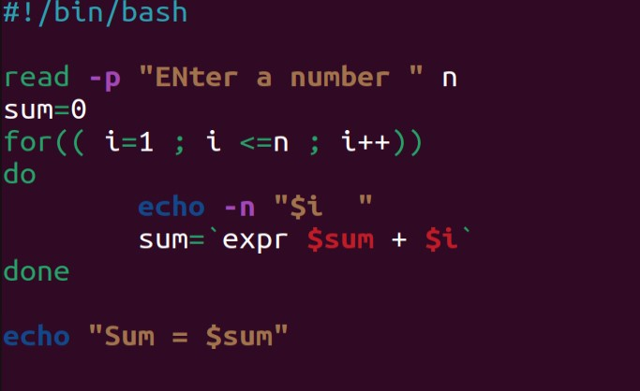

>>>>>>>>>>>>>>>>>>>>>>>>>>>>>>>>>>>>>>>>>O/P;-<<<<<<<<<<<<<<<<<<<<<<<<<<<<<<<<<<

The first 7 natural number is :

1 2 3 4 5 6 7

The Sum of Natural Number upto 7 terms : 28

1. Write a Shell Script to read 10 numbers from the keyboard and find their sum and average.

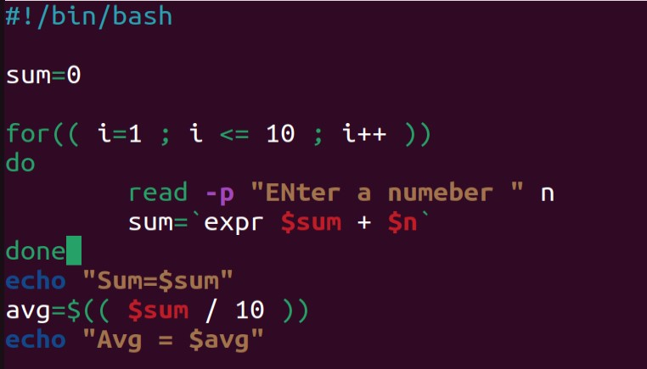

**>>>>>>>>>>>>>>>>>>>>>>>>>>>>>>>>>O/P<<<<<<<<<<<<<<<<<<<<<<<<<<<<<<<<<<**

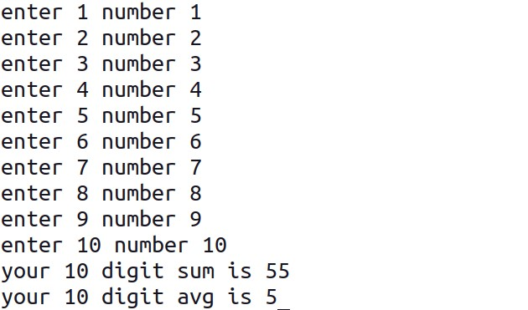

1. **Write a Shell Script to display the cube of the number up to an integer.**

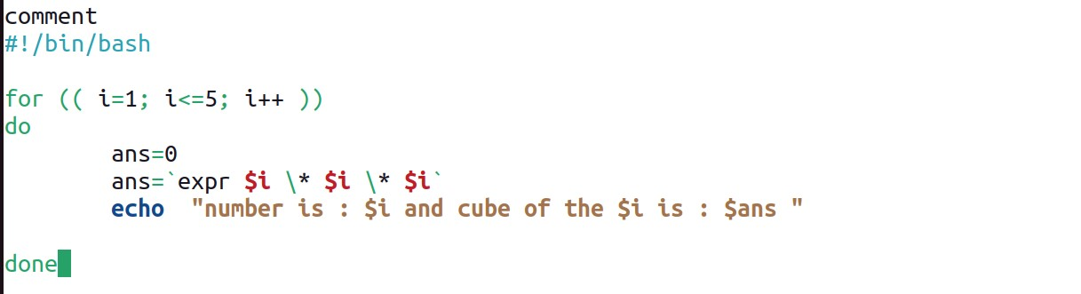

## >>>>>>>>>>>>>>>>>>>>>>>>>>>>>>>>>O/P:-<<<<<<<<<<<<<<<<<<<<<<<<<<<<<

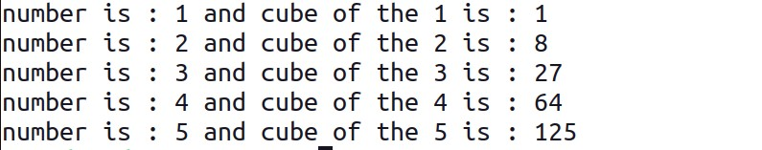

1. **Write a Shell Script to display the multiplication table for a given integer.**

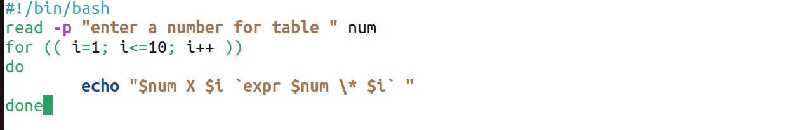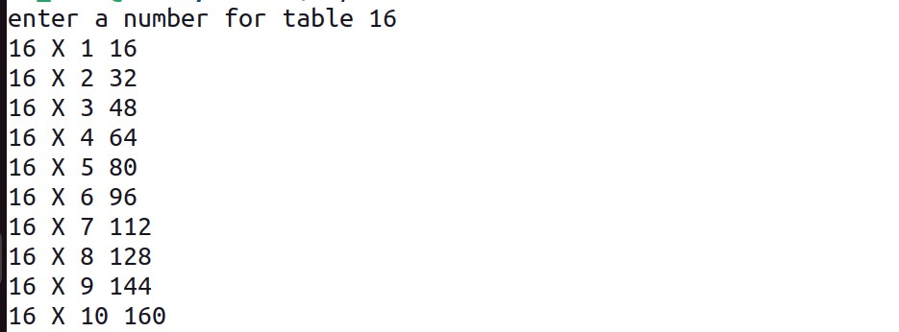

1. **Write a Shell Script to display the multiplier table vertically from 1 to n.**

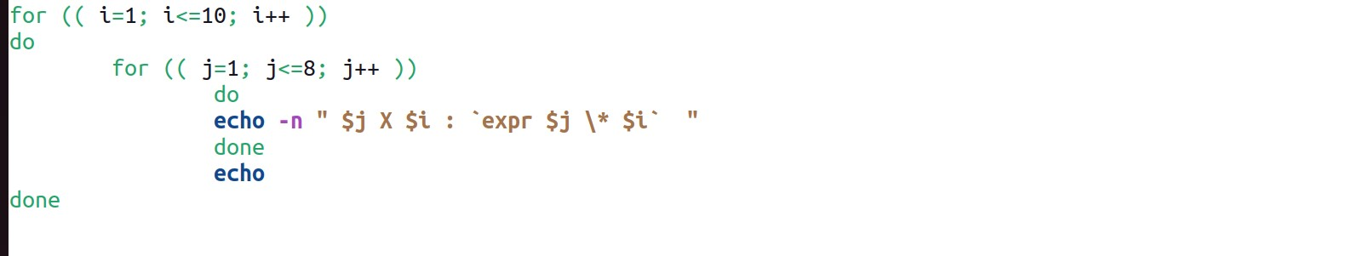

**>>>>>>>>>>>>>>>>>>>>>>>>>>>>>>>>>>>>>>o/p<<<<<<<<<<<<<<<<<<<<<<<<<<<<<<<<<**

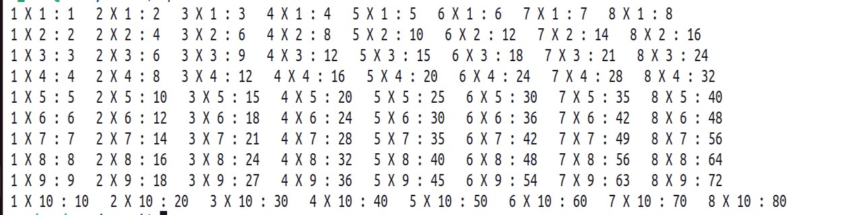

1. **Write a Shell Script to display the n terms of odd natural numbers and their sum.**

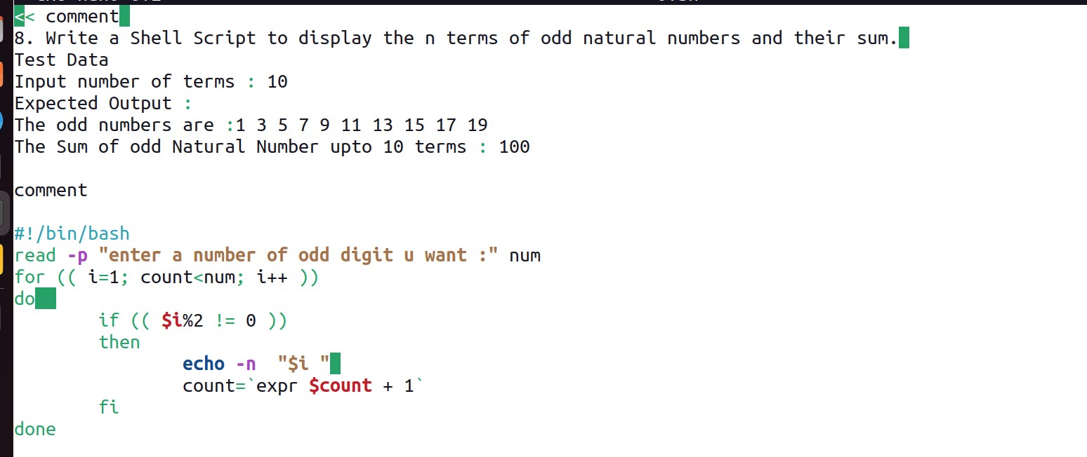

**>>>>>>>>>>>>>>>>>>>>>>>>>>>>>>>>>>>>>>o/p<<<<<<<<<<<<<<<<<<<<<<<<<<<<<<<<<**



1. Write a Shell Script to display a pattern like a right angle triangle using an asterisk.

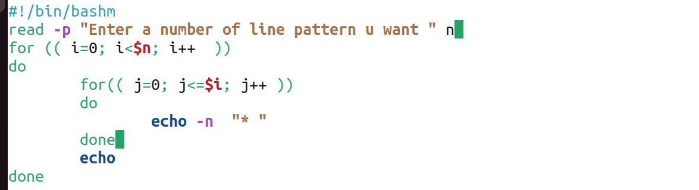

**>>>>>>>>>>>>>>>>>>>>>>>>>>>>>>>>>>>>>>o/p<<<<<<<<<<<<<<<<<<<<<<<<<<<<<<<<<**

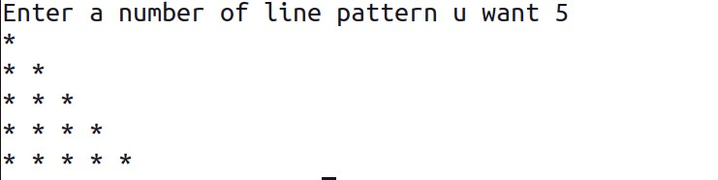

1. **Write a Shell Script to display a pattern like a right angle triangle with a number.**

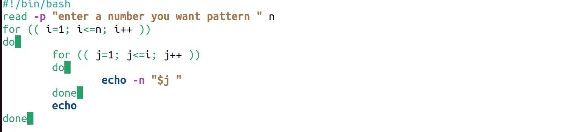

**>>>>>>>>>>>>>>>>>>>>>>>>>>>>>>>>>>>>>>o/p<<<<<<<<<<<<<<<<<<<<<<<<<<<<<<<<<**

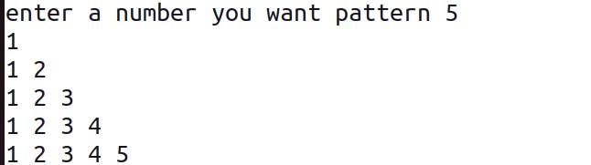

1. Write a Shell Script to make such a pattern like a right angle triangle with a number which will repeat a number in a row.

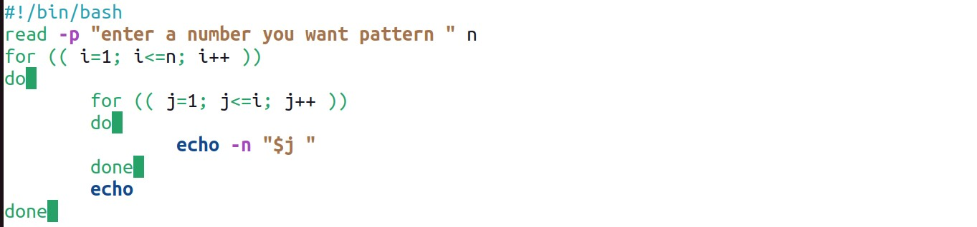

**>>>>>>>>>>>>>>>>>>>>>>>>>>>>>>>>>>>>>>o/p<<<<<<<<<<<<<<<<<<<<<<<<<<<<<<<<<**

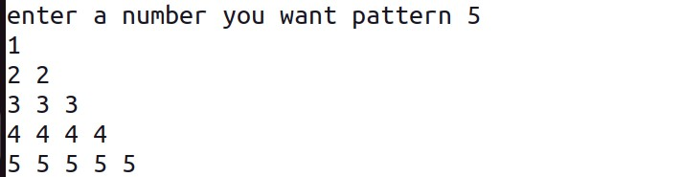

1. **Write a Shell Script to make such a pattern like a right angle triangle with the number increased by 1.**

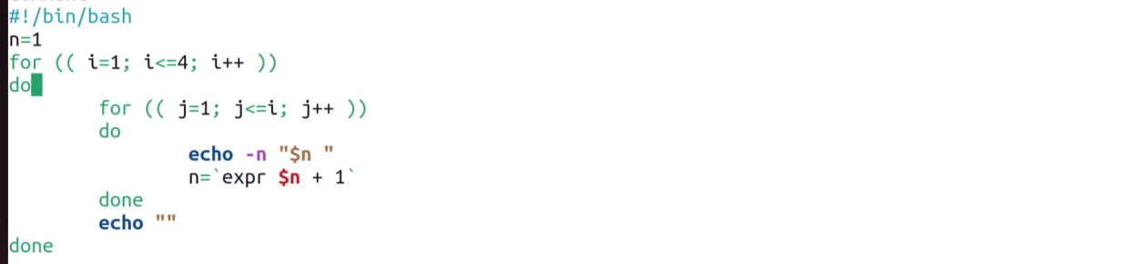

**>>>>>>>>>>>>>>>>>>>>>>>>>>>>>>>>>>>>>>o/p<<<<<<<<<<<<<<<<<<<<<<<<<<<<<<<<<**

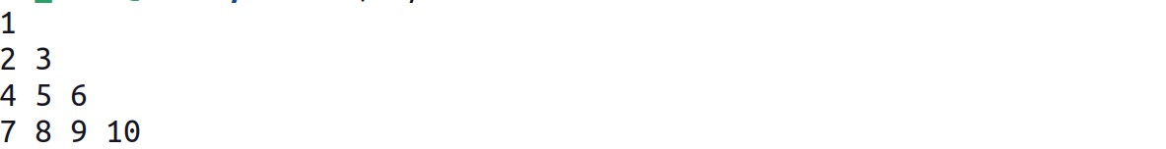

1. **Write a Shell Script to make a pyramid pattern with numbers increased by 1.**

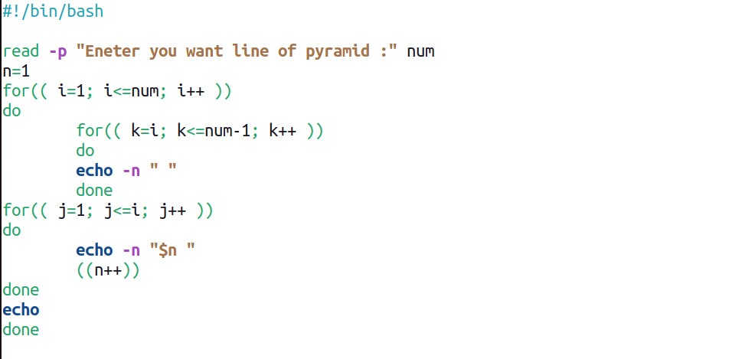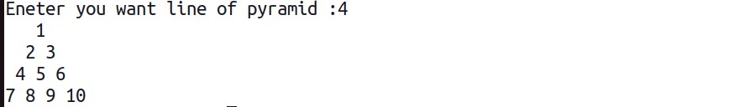

1. **Write a Shell Script to make such a pattern as a pyramid with an asterisk.**

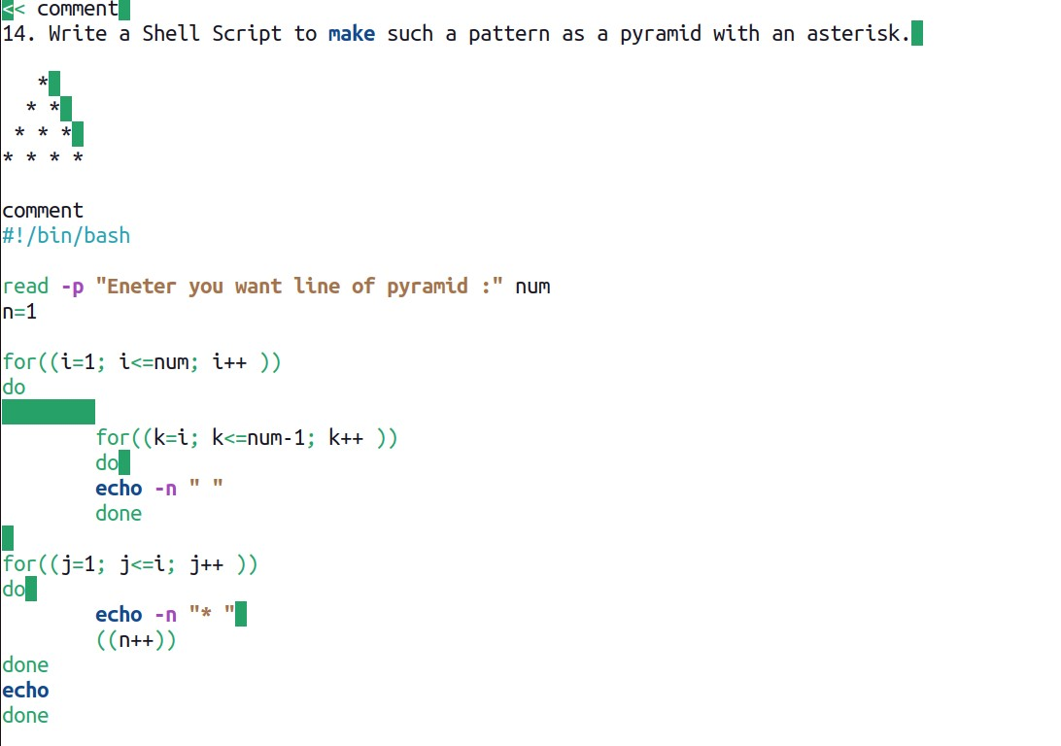

1. **Write a Shell Script to calculate the factorial of a given number.**

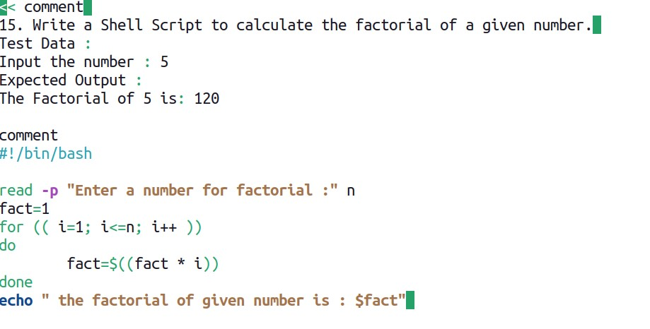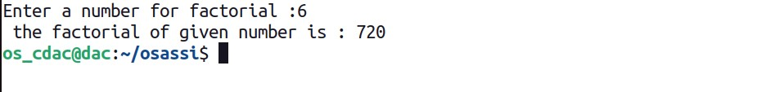

1. **Write a Shell Script to display the sum of n terms of even natural numbers.**

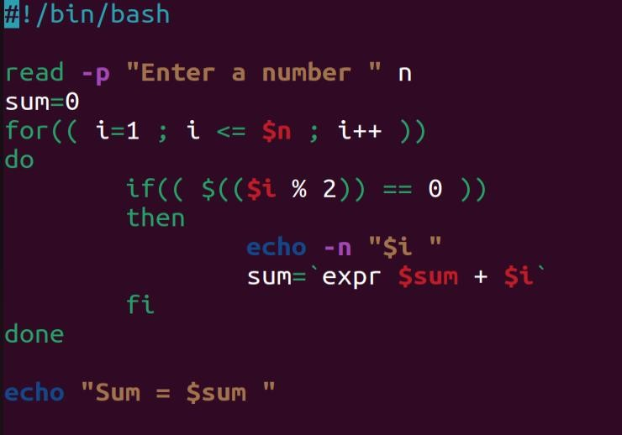

**Input number of terms : 5**

**Output :**

**The even numbers are :2 4 6 8 10**

**The Sum of even Natural Number upto 5 terms : 30**

1. **Write a Shell Script to make such a pattern like a pyramid with a number which will repeat the number in the same row.**

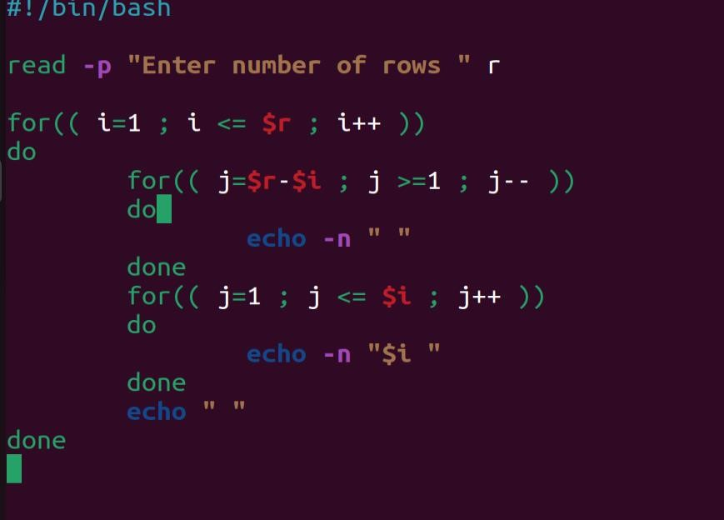

**20. Write a Shell Script to display the pattern as a pyramid using asterisks, with each row containing an odd number of asterisks.**

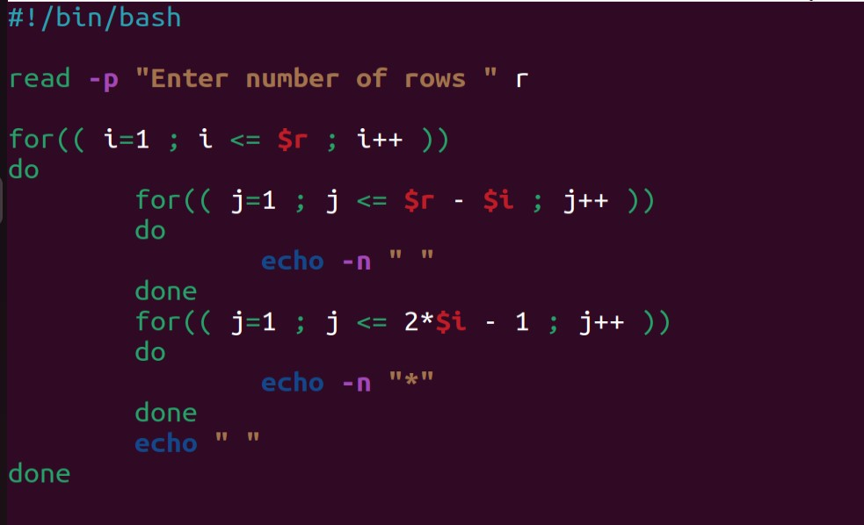

## o/p:-

**\***

**\*\*\***

**\*\*\*\*\***

**21. Write a Shell Script to display the sum of the series [ 9 + 99 + 999 + 9999 ...].**

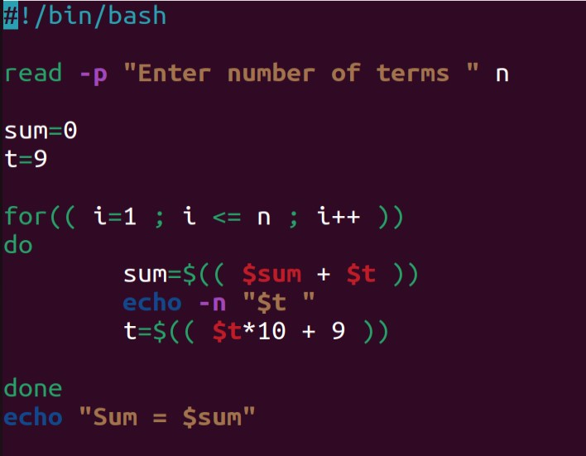

**Input the number or terms :5**

**Output :**

**9 99 999 9999 99999**

**The sum of the saries = 111105**

1. **Write a Shell Script to print Floyd's Triangle.**

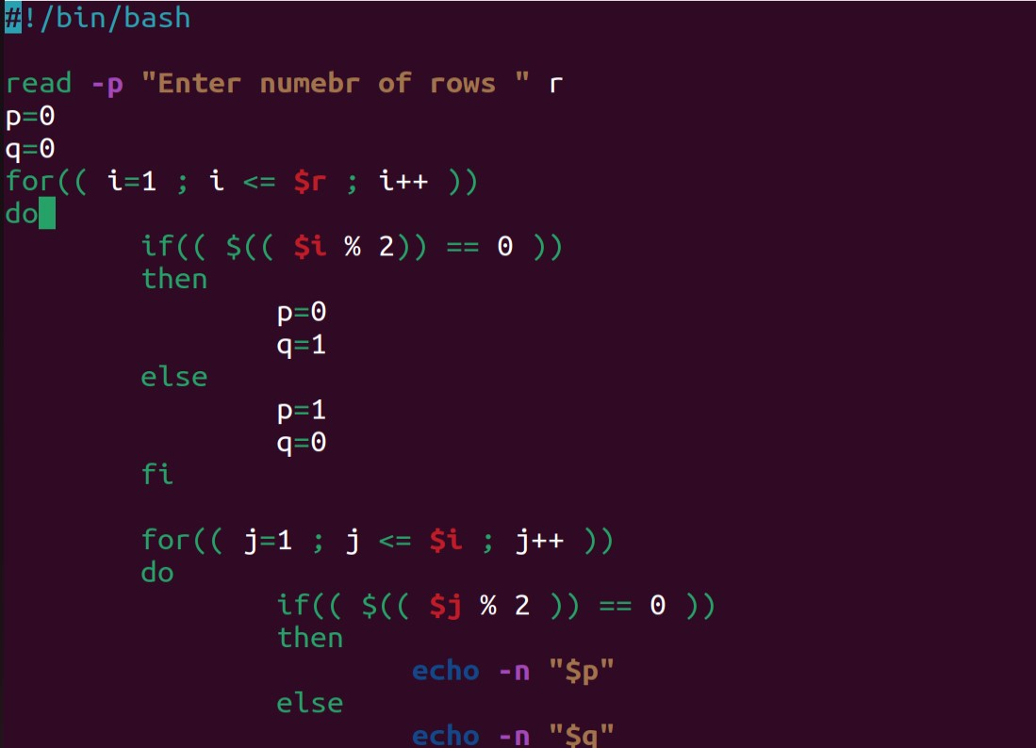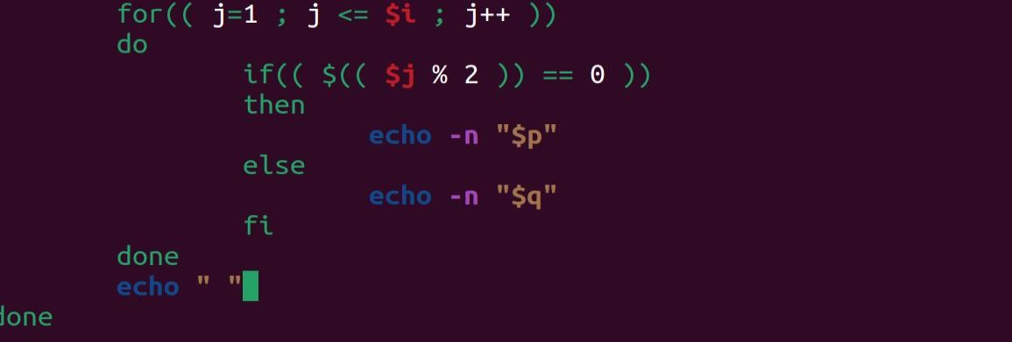

**o/p:**

**1**

**01**

**101**

**0101**

**10101**

1. **Write a Shell Script to find the sum of the series [x - x^3 + x^5 + ......].**

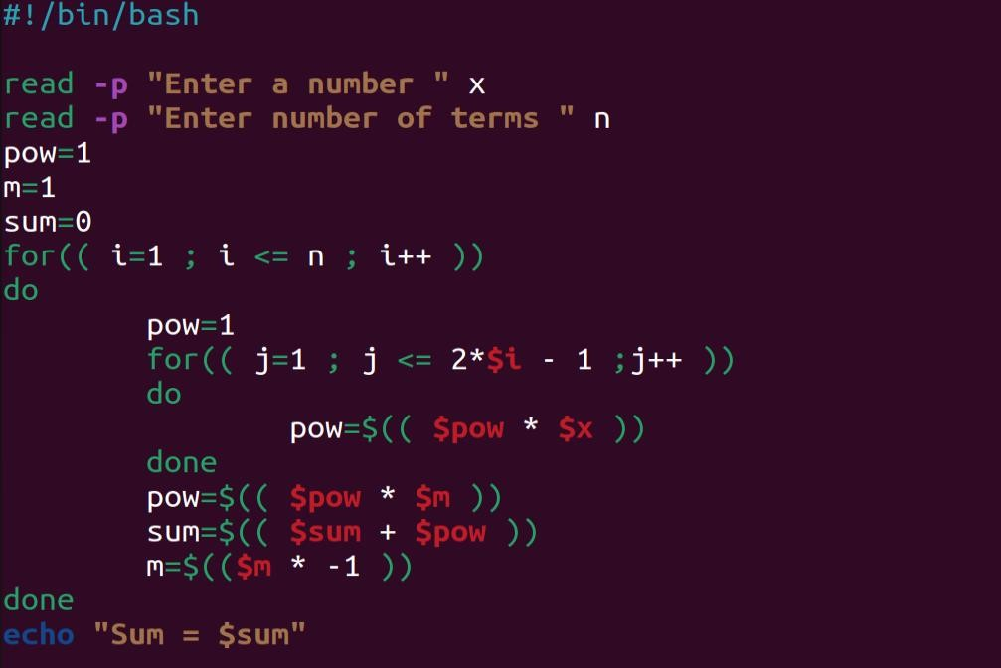

**Test Data :**

**Input the value of x :3 Input number of terms : 5 Output :**

**The sum is : 16.375000**

1. **Write a Shell Script to find the sum of the series [ x - x^3 + x^5 + ......].**

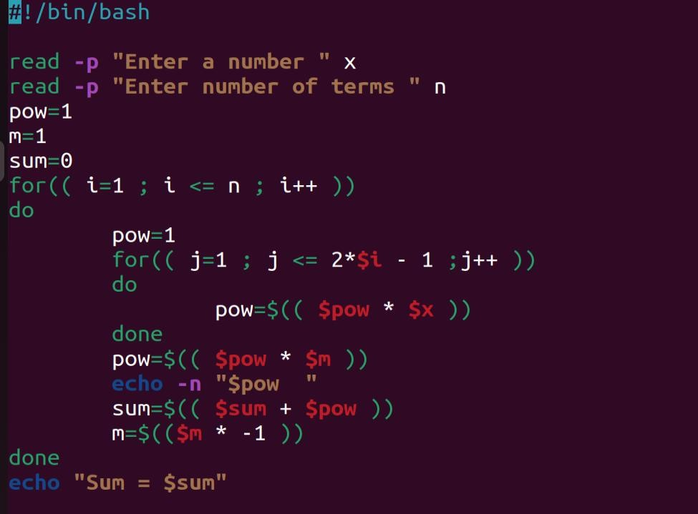

**Input the value of x :2 Input number of terms : 5 Output :**

**The values of the series:**

**2**

**-8**

**32**

**-128**

**512**

**The sum = 410**

1. **Write a Shell Script that displays the n terms of square natural numbers and their sum.**

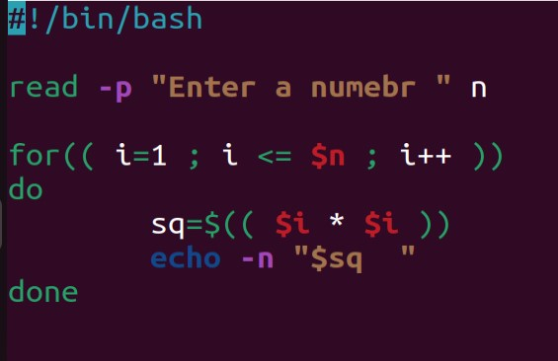

**1 4 9 16 ... n Terms**

**Test Data :**

**Input the number of terms : 5**

**Output :**

**The square natural upto 5 terms are :1 4 9 16 25**

**The Sum of Square Natural Number upto 5 terms = 55**

**26. Write a Shell Script to find the sum of the series 1 +11 + 111 + 1111 + .. n terms.**

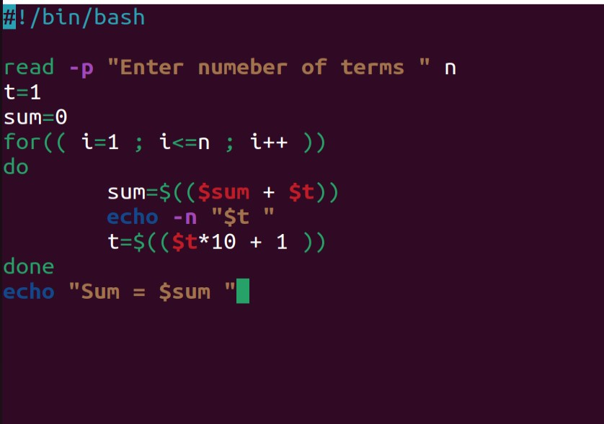

**Test Data :**

**Input the number of terms : 5 Output :**

**1 + 11 + 111 + 1111 + 11111**

**The Sum is : 12345**

1. **Write a Shell Script to check whether a given number is a 'Perfect' number or not.**

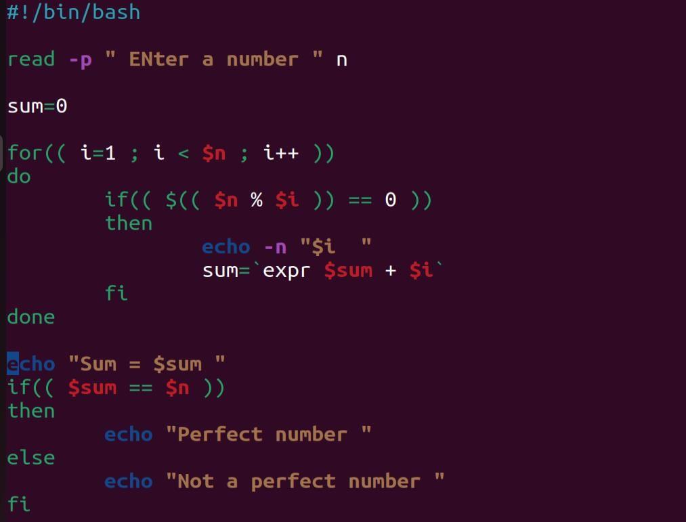

Test Data :

Input the number : 56

Expected Output :

The positive divisor : 1 2 4 7 8 14 28

The sum of the divisor is : 64

So, the number is not perfect.

1. **Write a Shell Script to find the 'Perfect' numbers within a given number of ranges.**

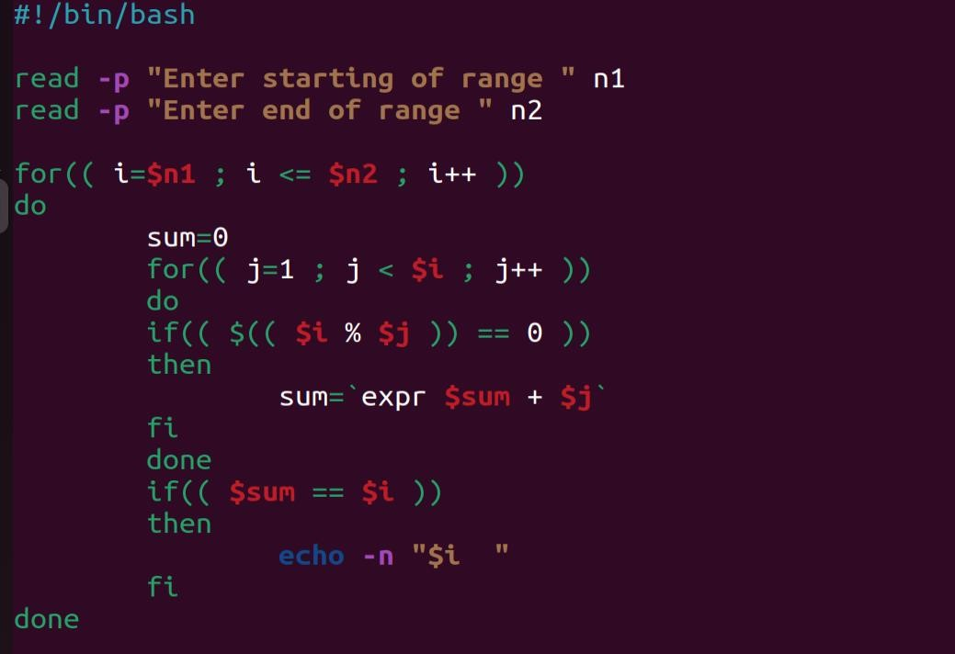

**Test Data :**

**Input the starting range or number : 1 Input the ending range of number : 50**

**Output :**

**The Perfect numbers within the given range : 6 28**

1. **Write a Shell Script to check whether a given number is an Armstrong number or not.**

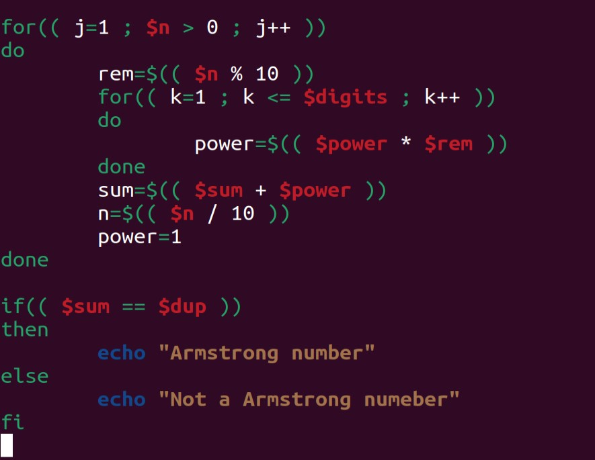



**Test Data : Input a number: 153**

**Output :**

**153 is an Armstrong number.**

1. **Write a Shell Script to find the Armstrong number for a given range of number.**

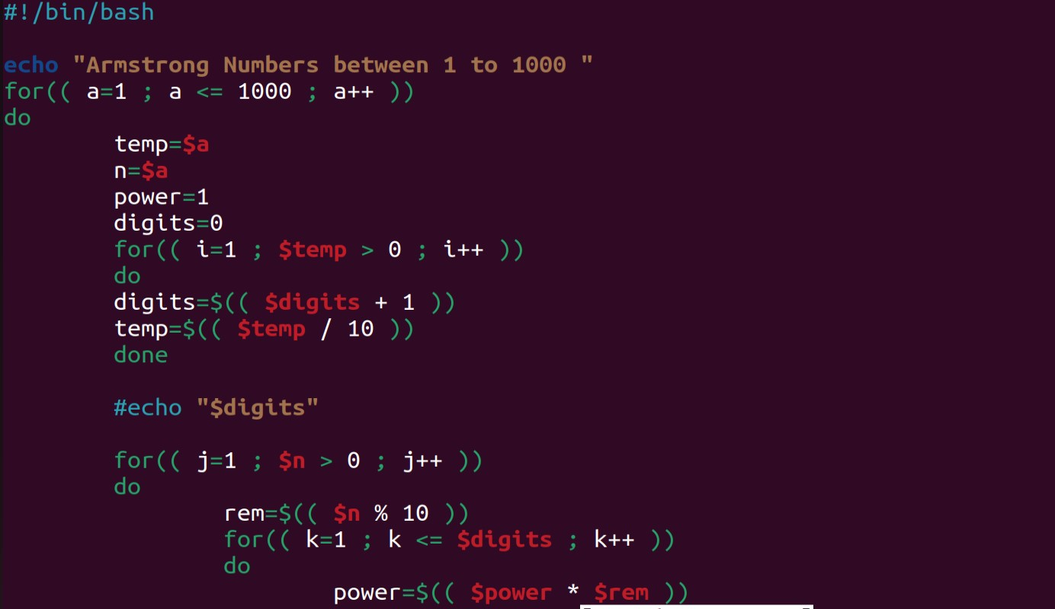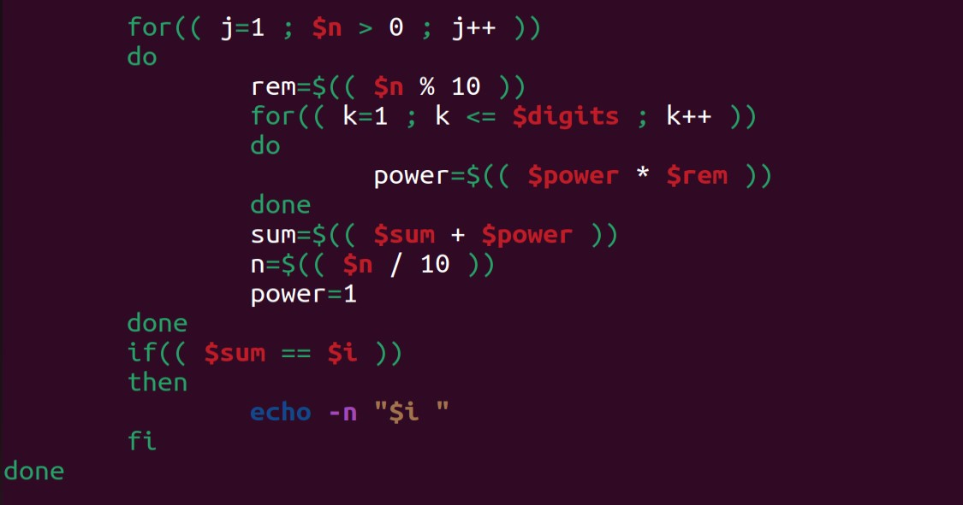

**Input starting number of range: 1**

**Input ending number of range : 1000**

**>>>>>>>>>>>>>>>>>>>>>>>>>>>>>>>>>>>>>>>>>>>Output :<<<<<<<<<<<<<<<<<<<<<<<<<<<<<<<**

**Armstrong numbers in given range are: 1 153 370 371 407**

1. **Write a Shell Script to display a pattern like a diamond.**

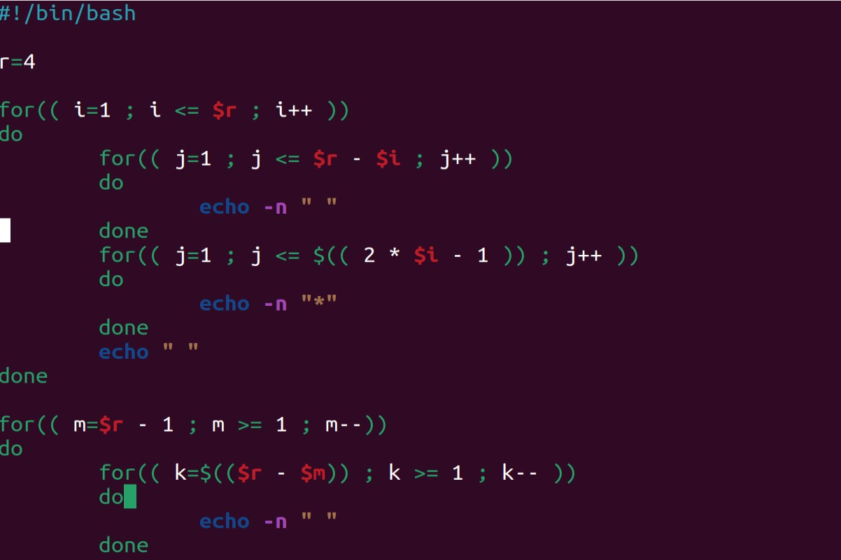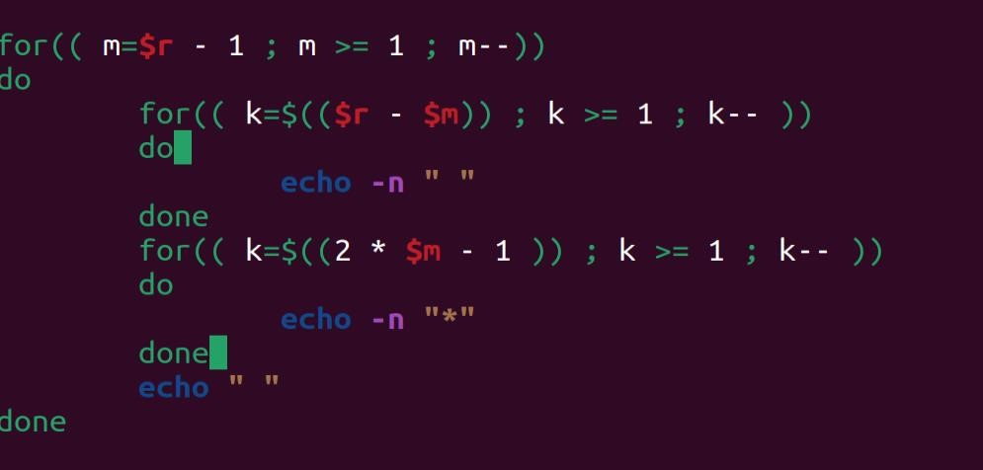

**>>>>>>>>>>>>>>>>>>>>>>>>>>>>o/p<<<<<<<<<<<<<<<<<<<<<<<<<<<<<<<<<<<<<<<<<<<<**

**\***

**\*\*\***

**\*\*\*\*\***

**\*\*\*\*\*\*\***

**\*\*\*\*\*\*\*\*\***

**\*\*\*\*\*\*\***

**\*\*\*\*\***

**\*\*\***

**\***

1. **Write a Shell Script to determine whether a given number is prime or not.**

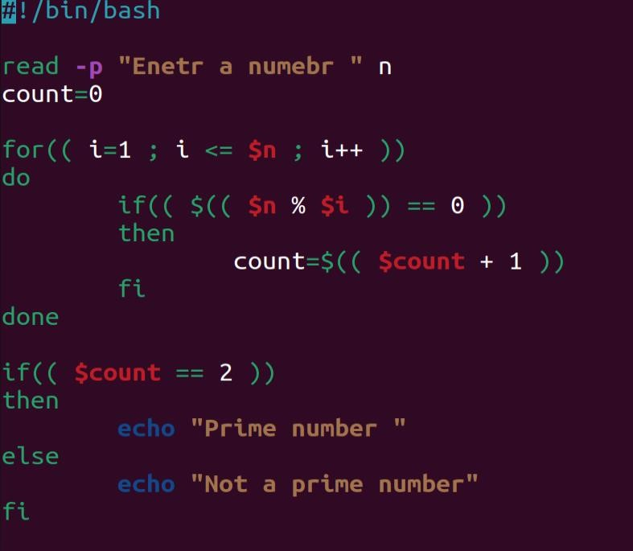

**Test Data : Input a number: 13 Output :**

**13 is a prime number.**

**34. Write a Shell Script to find the prime numbers within a range of numbers.**

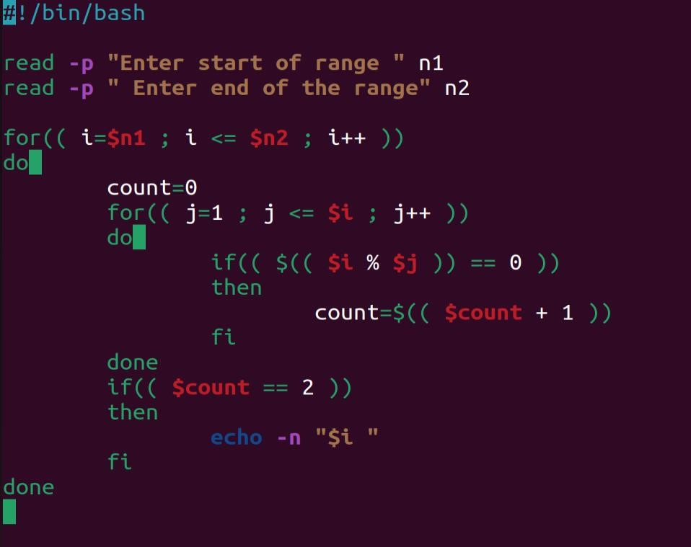

**Output :**

**The prime number between 1 and 50 are :**

**2 3 5 7 11 13 17 19 23 29 31 37 41 43 47**

**35. Write a Shell Script to display the first n terms of the Fibonacci series.**

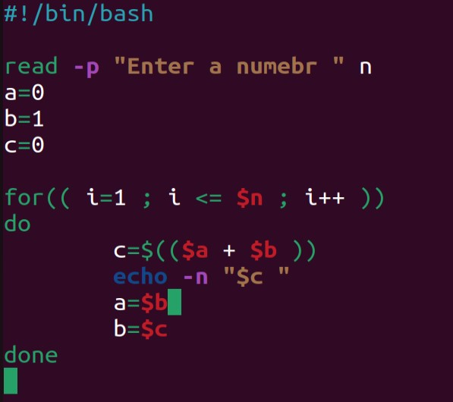

**>>>>>>>>>>>>>>>>>>>>>>>>>>>>>>>>>>>>>>Output :<<<<<<<<<<<<<<<<<<<<<<<<<<<<<<<<<<<**

**Fibonacci series 0 1 2 3 5 8 13 .....**

**Test Data :**

**Input number of terms to display : 10**

**Here is the Fibonacci series upto to 10 terms :**

**0 1 1 2 3 5 8 13 21 34**

1. **Write a Shell Script to display a such a pattern for n rows using a number that starts with 1 and each row will have a 1 as the first and last number.**

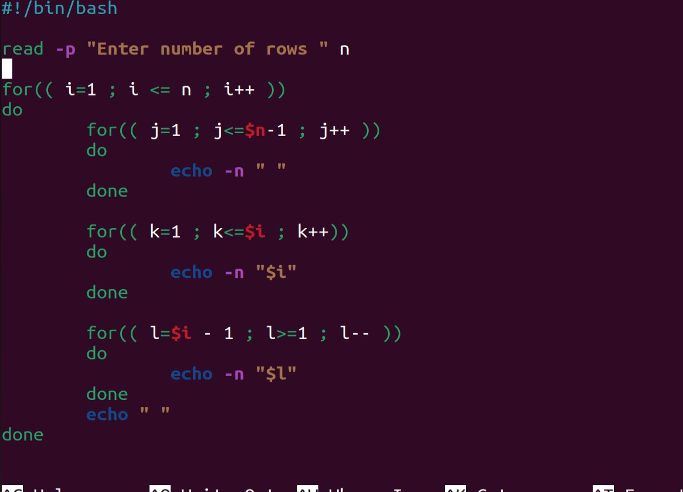

**>>>>>>>>>>>>>>>>>>>>>>>>>>>>>>>>>>o/p<<<<<<<<<<<<<<<<<<<<<<<<<<<<<<<<<<<<<<<<<**

**1**

**121**

**12321**

1. **Write a Shell Script to display the number in reverse order.**

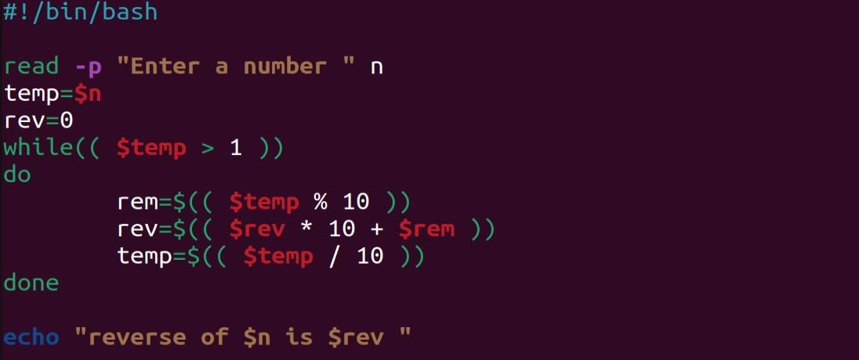

**>>>>>>>>>>>>>>>>>>>>>>>>>>>>>>>>>>>>>>Output :<<<<<<<<<<<<<<<<<<<<<<<<<<<<<<<<<<<**

**Test Data :**

**Input a number: 12345**

**The number in reverse order is : 54321**

1. **Write a Shell Script to check whether a number is a palindrome or not.**

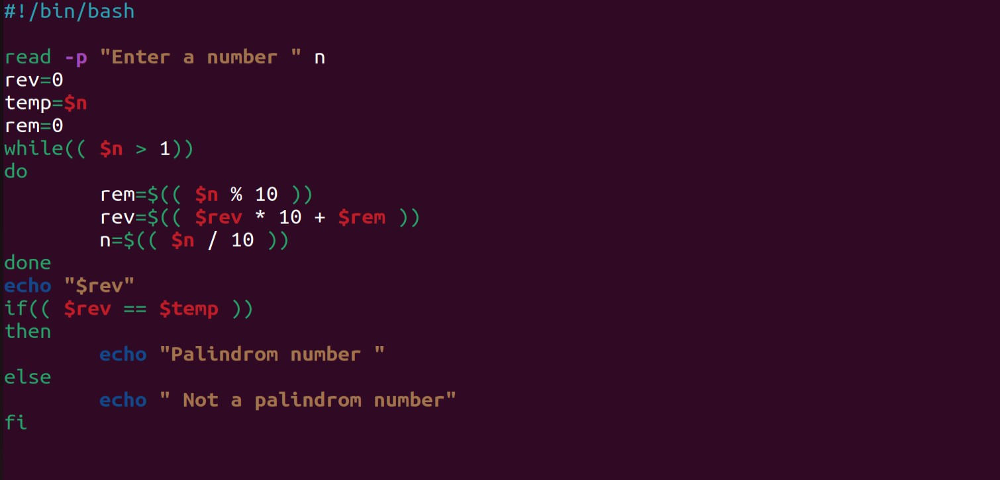

**>>>>>>>>>>>>>>>>>>>>>>>>>>>>>>>>>>>>>>Output :<<<<<<<<<<<<<<<<<<<<<<<<<<<<<<<<**

**Test Data :**

**Input a number: 121 >>> 121 is a palindrome number**

.

1. **Write a Shell Script to find the number and sum of all integers between 100 and 200 which are divisible by 9.**

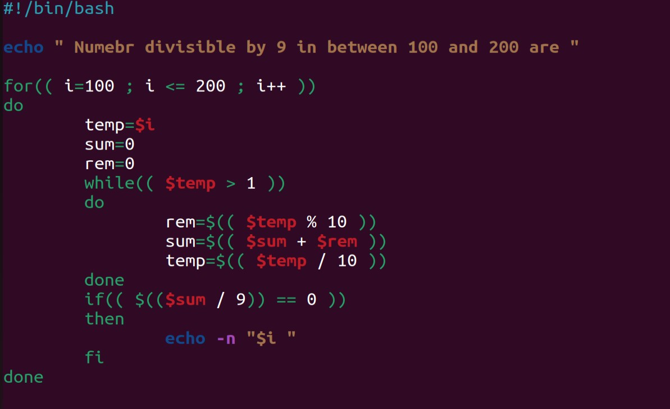

**Output :<<<<<<<<<<<<<<<<<<<<<<<<<<<<<<<<<<<<<<< Numbe>>>>>>>>>>>>>>>>>>>>>>>>>>>>>>>>>>>>rs between 100 and 200, divisible by 9 :**

**108 117 126 135 144 153 162 171 180 189 198**

**The sum : 1683**

**40. Write a Shell Script to display the pyramid pattern using the alphabet.**

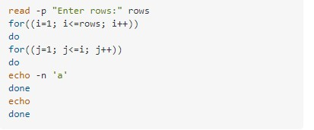

## >>>>>>>>>>>>>>>>>>>>>>>>>>>>>>>>>>>>o/p<<<<<<<<<<<<<<<<<<<<<<<<<<<<<<<<<

