Marketing Report

# 1. KPIs

• Total Sales: $63,325.80

• Total Customers: 20

• Average Order Value: $2,110.86

• Customer Retention Rate: 100.00%

# 2. Product Performance

• Best-Selling Product: EMO Robot (Lite)

• Low Stock Alert:

# 3. Product Table

|  |  |  |
| --- | --- | --- |
| Product Name | Units Sold | Total Revenue |
| EMO Robot (Lite) | 20 | $6,239.60 |
| EMO Robot (Classic) | 15 | $5,849.70 |
| EMO Robot (Dream) | 9 | $3,931.02 |
| EMO Robot (Ultimate) | 5 | $2,573.90 |
| Moxie Robot | 7 | $8,725.08 |
| ROYBI Robot | 15 | $4,656.60 |
| Aibo Robot | 7 | $31,657.08 |
| The Wild Robot - Roz | 5 | $3,567.00 |

# 4. Order and Customer Insights

|  |  |  |
| --- | --- | --- |
| Order ID | Date | Total |
| PO0030 | 22-10-2024 | $1,646.16 |
| PO0029 | 20-10-2024 | $1,646.16 |
| PO0028 | 18-10-2024 | $826.76 |
| PO0027 | 16-10-2024 | $2,335.94 |
| PO0026 | 14-10-2024 | $2,368.62 |

# 5. Customer Demographics

|  |  |
| --- | --- |
| City | Number of Customers |
| Melbourne | 16 |
| Sydney | 1 |
| Brisbane | 1 |
| Perth | 1 |
| Adelaide | 1 |

# 6. Charts

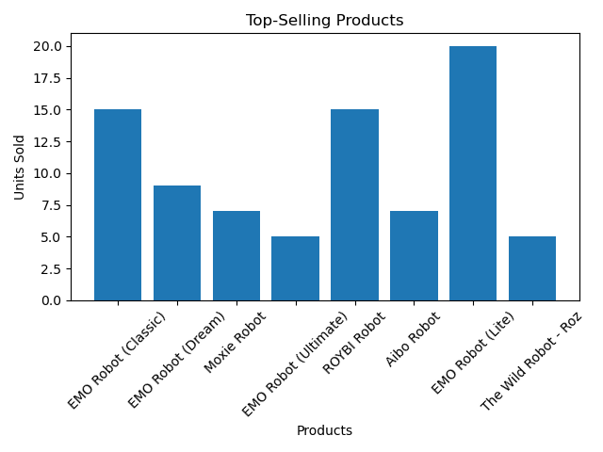

Top-Selling Products

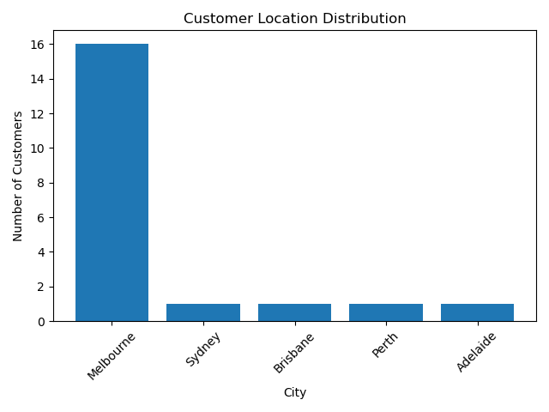

Customer Location Distribution

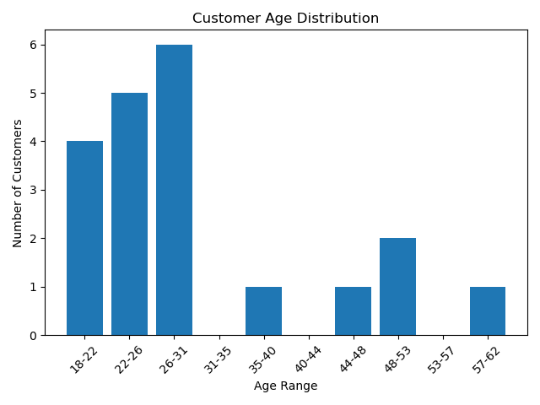

Customer Age Distribution