Performance Test Report

Name | A | B
Date | Feb 19, 2023, 2:53:09 PM | Jul 31, 2022, 9:30:40 PM
Project | MarvelApi | MarvelApi
Scenario | Estrés | Smoke
Comment
Notes

Summary
Results summary
 | A | B
Project | MarvelApi | MarvelApi
Scenario | Estrés | Smoke
Name | 14:52 - 19 Feb 2023 | 21:30 - 31 Jul 2022
Description
NeoLoad Web | https://neoload.saas.neotys.com/#!result/45d50e18-0ec8-4e37-8131-9e2024de9658/overview | https://neoload.saas.neotys.com/#!result/e01cd21a-85db-466a-a60f-bbd48e815c28/overview
Status | Passed | Passed
Start date | Feb 19, 2023, 2:53:09 PM | Jul 31, 2022, 9:30:40 PM
End date | Feb 19, 2023, 2:55:11 PM | Jul 31, 2022, 9:35:40 PM
Duration | 00:02:01 | 00:05:00
Termination reason | Execution policy | Execution policy
Load Policy | • The population Edge is constant with 10 users.  • The population Firefox is loaded by peaks with 5 users for 2.0 minutes and 10 users for 2.0 minutes. | • The population Population1 is constant with 2 users.
LG Hosts | l​o​c​a​l​h​o​s​t​:​7​1​0​0​ | l​o​c​a​l​h​o​s​t​:​7​1​0​0​
Filters | None | None
Debug | Disabled | Disabled
Statistics Summary
 | A | B | %
Average pages/s | 0.0 | 0.0 | +0%
Average requests/s | 10.6 | 2.5 | -76.4%
Total pages | 0 | 0 | +0%
Total requests | 1294 | 764 | -41%
Average Request response time | 1.09 s | 0.782 s | -28.3%
Total request errors | 0 | 0 | +0%
Error rate | 0 | 0 | +0%
Average Page response time | 0 s | 0 s | +0%
Total throughput | 94.2 MB | 56.8 MB | -39.7%
Average throughput | 6.18 Mb/s | 1.51 Mb/s | -75.6%
Total users launched | 15 | 2 | -86.7%
Total iterations completed | 639 | 381 | -40.4%
Total action errors | 0 | 0 | +0%
Alerts total duration | 94.7% | 0% | -100%

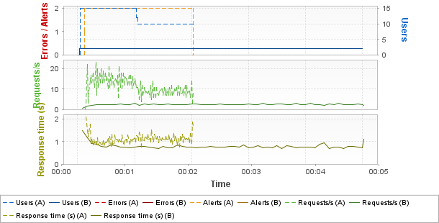
Hot spots
Top 3 errors
Greatest increases
Page Results | Count A | Count B | %
No errors on pages
Greatest decreases
Page Results | Count A | Count B | %
No errors on pages
Top 3 alerts
Greatest increases
Sev. | Alert Results | Duration % A | Duration % B | %
Empty list
Greatest decreases
Sev. | Alert Results | Duration % A | Duration % B | %
Empty list
Top 3 average response times (Pages)
Greatest increases
Page Results | Duration A | Duration B | %
Empty list
Greatest decreases
Page Results | Duration A | Duration B | %
Empty list
Top 3 average response times (Push messages)
Greatest increases
Push messages results | Duration A | Duration B | %
Empty list
Greatest decreases
Push messages results | Duration A | Duration B | %
Empty list
Top 3 maximum response times (Pages)
Greatest increases
Page Results | Duration A | Duration B | %
Empty list
Greatest decreases
Page Results | Duration A | Duration B | %
Empty list
Top 3 maximum response times (Push messages)
Greatest increases
Push messages results | Duration A | Duration B | %
Empty list
Greatest decreases
Push messages results | Duration A | Duration B | %
Empty list
Errors
Request errors
Error Type | Count A | Count B | % | Description
No errors
Action errors
Error Type | Count A | Count B | % | Description
No errors
Alerts
Element | Critical A | Critical B | % | Warning A | Warning B | %
Controller | 0 |  |  | 1
LG localhost:7100 | 0 |  |  | 1
General statistics
Avg A | Avg B | Avg % | Max A | Max B | Max % | Err A | Err B | Err %
Empty list
Transaction statistics
Avg A | Avg B | Avg % | Max A | Max B | Max % | Err A | Err B | Err %
Empty list

Scenario A
Summary
Name | 14:52 - 19 Feb 2023 | Project | MarvelApi
Description |  | Scenario | Estrés
Status | Passed | Load Policy | • The population Edge is constant with 10 users.  • The population Firefox is loaded by peaks with 5 users for 2.0 minutes and 10 users for 2.0 minutes.
Start date | Feb 19, 2023, 2:53:09 PM | Load Policy
End date | Feb 19, 2023, 2:55:11 PM | Stop Policy | • Population Edge: immediate.  • Population Firefox: immediate.
Duration | 00:02:01 | Stop Policy
Termination reason | Execution policy | Filters | None
LG Hosts | l​o​c​a​l​h​o​s​t​:​7​1​0​0​ | Debug | Disabled
Populations
Edge
User Path | Percentage | WAN Emulation | Signal strength | Bandwidth ↑ | Latency ↑ | Packet loss % ↑ | Bandwidth ↓ | Latency ↓ | Packet loss % ↓ | Browser | Handle cookies | Connections | Handle cache
MarvelApi | 50.0% | Unlimited |  | Unlimited | 0ms | 0% | Unlimited | 0ms | 0% | Microsoft Edge 41 | Yes | 10 | As recorded
Firefox
User Path | Percentage | WAN Emulation | Signal strength | Bandwidth ↑ | Latency ↑ | Packet loss % ↑ | Bandwidth ↓ | Latency ↓ | Packet loss % ↓ | Browser | Handle cookies | Connections | Handle cache
MarvelApi | 50.0% | Unlimited |  | Unlimited | 0ms | 0% | Unlimited | 0ms | 0% | Firefox 13.0 | Yes | 6 | As recorded
User Paths
Name | Description | On failed assertion | On error | Think time | Thinktime range
MarvelApi |  | Do nothing | Do nothing | From pages | 0%
Rendezvous
Enabled | Name | Policy | Value | Timeout
Empty list

Scenario B
Summary
Name | 21:30 - 31 Jul 2022 | Project | MarvelApi
Description |  | Scenario | Smoke
Status | Passed | Load Policy | • The population Population1 is constant with 2 users.
Start date | Jul 31, 2022, 9:30:40 PM | Load Policy | • The population Population1 is constant with 2 users.
End date | Jul 31, 2022, 9:35:40 PM | Stop Policy | • Population Population1: immediate.
Duration | 00:05:00 | Stop Policy | • Population Population1: immediate.
Termination reason | Execution policy | Filters | None
LG Hosts | l​o​c​a​l​h​o​s​t​:​7​1​0​0​ | Debug | Disabled
Populations
Population1
User Path | Percentage | WAN Emulation | Signal strength | Bandwidth ↑ | Latency ↑ | Packet loss % ↑ | Bandwidth ↓ | Latency ↓ | Packet loss % ↓ | Browser | Handle cookies | Connections | Handle cache
MarvelApi | 100.0% | Unlimited |  | Unlimited | 0ms | 0% | Unlimited | 0ms | 0% | Recorded one | Yes | 6 | As recorded
User Paths
Name | Description | On failed assertion | On error | Think time | Thinktime range
MarvelApi |  | Do nothing | Do nothing | From pages | 0%
Rendezvous
Enabled | Name | Policy | Value | Timeout
Empty list

User Paths
User Paths
Avg A | Avg B | Avg % | Max A | Max B | Max % | Err A | Err B | Err %
MarvelApi
94.2 | 298.7 | +217% | 114.5 | 298.9 | +161% | 0 | 0 | +0%

Transactions
Shared Containers
Avg A | Avg B | Avg % | Max A | Max B | Max % | Err A | Err B | Err %
Empty list
MarvelApi
Avg A | Avg B | Avg % | Max A | Max B | Max % | Err A | Err B | Err %
MarvelApi
94.2 | 298.7 | +217% | 114.5 | 298.9 | +161% | 0 | 0 | +0%
Init
0 | 0 | +0% | 0 | 0 | +0% | 0 | 0 | +0%
Actions
2.17 | 1.56 | -27.9% | 4.63 | 3.69 | -20.3% | 0 | 0 | +0%
GetPokemon
1.67 |  |  | 3.25 |  |  | 0
GetComics
0.497 | 0.379 | -23.7% | 2.26 | 2.47 | +9.2% | 0 | 0 | +0%
GetCharacter
 | 1.18 |  |  | 2.6 |  |  | 0
End
0 | 0 | +0% | 0 | 0 | +0% | 0 | 0 | +0%

Push messages
Shared Containers
Avg A | Avg B | Avg % | Max A | Max B | Max % | Err A | Err B | Err %
Empty list
MarvelApi
Avg A | Avg B | Avg % | Max A | Max B | Max % | Err A | Err B | Err %
Empty list

Pages
Shared Containers
Avg A | Avg B | Avg % | Max A | Max B | Max % | Err A | Err B | Err %
Empty list
MarvelApi
Avg A | Avg B | Avg % | Max A | Max B | Max % | Err A | Err B | Err %
Empty list

Requests
Shared Containers
Avg A | Avg B | Avg % | Max A | Max B | Max % | Err A | Err B | Err %
Empty list
MarvelApi
Avg A | Avg B | Avg % | Max A | Max B | Max % | Err A | Err B | Err %
MarvelApi
94.2 | 298.7 | +217% | 114.5 | 298.9 | +161% | 0 | 0 | +0%
Actions
2.17 | 1.56 | -27.9% | 4.63 | 3.69 | -20.3% | 0 | 0 | +0%
GetPokemon
1.67 |  |  | 3.25 |  |  | 0
/v1/public/characters
1.67 |  |  | 3.25 |  |  | 0
GetComics
0.497 | 0.379 | -23.7% | 2.26 | 2.47 | +9.2% | 0 | 0 | +0%
/v1/public/characters/${ id} /comics
0.498 |  |  | 2.26 |  |  | 0
/v1/public/characters/${ id} /comics
 | 0.379 |  |  | 2.47 |  |  | 0
GetCharacter
 | 1.18 |  |  | 2.6 |  |  | 0
/v1/public/characters
 | 1.18 |  |  | 2.6 |  |  | 0

Media Contents
MarvelApi
Err A | Err B | Err % | Lag A | Lag B | Lag % | Buffer A | Buffer B | Buffer %
Empty list

Monitors
Controller
Performance Counters
Min A | Min B | Min % | Avg A | Avg B | Avg % | Max A | Max B | Max %
Controller/User Load
0 | 0 | +0% | 12.3 | 1.99 | -83.8% | 15 | 2 | -86.7%
Controller/Throughput
0 | 0 | +0% | 6.14 | 1.51 | -75.4% | 12.6 | 2.93 | -76.7%
Controller/Alerts
0 | 0 | +0% | 0 | 0 | +0% | 0 | 0 | +0%
Controller/Critical Alerts
0 | 0 | +0% | 0 | 0 | +0% | 0 | 0 | +0%
Controller/Warning Alerts
0 | 0 | +0% | 0 | 0 | +0% | 0 | 0 | +0%
Controller/CPU Load
0 | 0 | +0% | 16 | 12 | -25.2% | 100 | 53 | -47%
Controller/JVM Memory Used
0 | 0 | +0% | 9.05 | 6.59 | -27.2% | 12 | 8 | -33.3%
Controller/OS Memory Used
- |  |  | 80.5 |  |  | 83
Controller/Thread Count
0 | 0 | +0% | 496.6 | 567.2 | +14.2% | 507 | 572 | +12.8%
Controller/Connected
0 | 0 | +0% | 0.992 | 0.997 | +0.5% | 1 | 1 | +0%
Controller/Total Disconnections
0 | 0 | +0% | 0 | 0 | +0% | 0 | 0 | +0%
Controller/Total Reconnections
0 | 0 | +0% | 0 | 0 | +0% | 0 | 0 | +0%
Controller/Network/Segments sent/sec.
0 | 0 | +0% | 2,725 | 443.5 | -83.7% | 8,520 | 5,169 | -39.3%
Controller/Network/Segments retransmitted/sec.
0 | 0 | +0% | 0 | 0 | +0% | 0 | 0 | +0%
Controller/Network/eth7 (Bluetooth Device (Personal Area Network))/Megabits received/sec.
0 |  |  | 0 |  |  | 0
Controller/Network/eth7 (Bluetooth Device (Personal Area Network))/Megabits sent/sec.
0 |  |  | 0 |  |  | 0
Controller/Network/eth2 (Fortinet Virtual Ethernet Adapter (NDIS 6.30))/Megabits received/sec.
0 |  |  | 0 |  |  | 0
Controller/Network/eth2 (Fortinet Virtual Ethernet Adapter (NDIS 6.30))/Megabits sent/sec.
0 |  |  | 0 |  |  | 0
Controller/Network/wlan2 (Realtek 8821CE Wireless LAN 802.11ac PCI-E NIC)/Megabits received/sec.
0 | 0 | +0% | 6.81 | 0 | -100% | 15.6 | 0 | -100%
Controller/Network/wlan2 (Realtek 8821CE Wireless LAN 802.11ac PCI-E NIC)/Megabits sent/sec.
0 | 0 | +0% | 0.206 | 0 | -100% | 0.862 | 0 | -100%
Controller/NeoLoad Web/Megabits received/sec.
0 | 0 | +0% | 0 | 0 | +0% | 0 | 0 | +0%
Controller/NeoLoad Web/Megabits sent/sec.
0 | 0.003 | +INF | 0.012 | 0.011 | -7.3% | 0.03 | 0.017 | -43%
Controller/Default zone/User Load
0 | 0 | +0% | 12.3 | 1.99 | -83.8% | 15 | 2 | -86.7%
Controller/Default zone/Edge/User Load
0 |  |  | 9.92 |  |  | 10
Controller/Default zone/Edge/MarvelApi/User Load
0 |  |  | 9.92 |  |  | 10
Controller/Default zone/Firefox/User Load
0 |  |  | 2.48 |  |  | 5
Controller/Default zone/Firefox/MarvelApi/User Load
0 |  |  | 2.48 |  |  | 5
Controller/Network/eth5 (Fortinet SSL VPN Virtual Ethernet Adapter)/Megabits received/sec.
 | 0 |  |  | 0 |  |  | 0
Controller/Network/eth5 (Fortinet SSL VPN Virtual Ethernet Adapter)/Megabits sent/sec.
 | 0 |  |  | 0 |  |  | 0
Controller/Network/eth4 (ASIX AX88179A USB 3.2 Gen1 to Gigabit Ethernet Adapter)/Megabits received/sec.
 | 0.077 |  |  | 2.59 |  |  | 8.89
Controller/Network/eth4 (ASIX AX88179A USB 3.2 Gen1 to Gigabit Ethernet Adapter)/Megabits sent/sec.
 | 0.022 |  |  | 0.095 |  |  | 0.226
Controller/Network/eth1 (Fortinet Virtual Ethernet Adapter (NDIS 6.30))/Megabits received/sec.
 | 0 |  |  | 0 |  |  | 0
Controller/Network/eth1 (Fortinet Virtual Ethernet Adapter (NDIS 6.30))/Megabits sent/sec.
 | 0 |  |  | 0 |  |  | 0
Controller/Default zone/Population1/User Load
 | 2 |  |  | 2 |  |  | 2
Controller/Default zone/Population1/MarvelApi/User Load
 | 2 |  |  | 2 |  |  | 2
LG localhost:7100
Performance Counters
Min A | Min B | Min % | Avg A | Avg B | Avg % | Max A | Max B | Max %
LG localhost:7100/CPU Load
0 | 0 | +0% | 15.4 | 12 | -22.1% | 100 | 54 | -46%
LG localhost:7100/JVM Memory Used
0 | 0 | +0% | 3.48 | 5.21 | +49.6% | 7 | 9 | +28.6%
LG localhost:7100/OS Memory Used
79 |  |  | 81.2 |  |  | 83
LG localhost:7100/Throughput
0 | 0 | +0% | 6.13 | 1.51 | -75.4% | 12.6 | 2.93 | -76.7%
LG localhost:7100/User Load
0 | 0 | +0% | 12.3 | 1.99 | -83.8% | 15 | 2 | -86.7%
LG localhost:7100/Thread Count
0 | 0 | +0% | 80.5 | 61.9 | -23.1% | 92 | 64 | -30.4%
LG localhost:7100/Http client/Thread Pool used
0 | 0 | +0% | 0.145 | 0.101 | -30.6% | 0.175 | 0.11 | -37.1%
LG localhost:7100/Http client/Task Pool used
0 | 0 | +0% | 0 | 0 | +0% | 0.017 | 0 | -100%
LG localhost:7100/Controller Connection/Disconnections
0 | 0 | +0% | 0 | 0 | +0% | 0 | 0 | +0%
LG localhost:7100/Controller Connection/Reconnections
0 | 0 | +0% | 0 | 0 | +0% | 0 | 0 | +0%
LG localhost:7100/Controller Connection/Ping Duration (ms)
2 | 2 | +0% | 2.72 | 3.33 | +22.5% | 3 | 5 | +66.7%
LG localhost:7100/Network/Segments sent/sec.
0 | 0 | +0% | 375.7 | 191.3 | -49.1% | 5,138 | 4,598 | -10.5%
LG localhost:7100/Network/Segments retransmitted/sec.
0 | 0 | +0% | 0 | 0 | +0% | 0 | 0 | +0%
LG localhost:7100/Network/eth7 (Bluetooth Device (Personal Area Network))/Megabits received/sec.
0 |  |  | 0 |  |  | 0
LG localhost:7100/Network/eth7 (Bluetooth Device (Personal Area Network))/Megabits sent/sec.
0 |  |  | 0 |  |  | 0
LG localhost:7100/Network/eth2 (Fortinet Virtual Ethernet Adapter (NDIS 6.30))/Megabits received/sec.
0 |  |  | 0 |  |  | 0
LG localhost:7100/Network/eth2 (Fortinet Virtual Ethernet Adapter (NDIS 6.30))/Megabits sent/sec.
0 |  |  | 0 |  |  | 0
LG localhost:7100/Network/wlan2 (Realtek 8821CE Wireless LAN 802.11ac PCI-E NIC)/Megabits received/sec.
0.001 | 0 | +0% | 6.8 | 0 | -100% | 15.6 | 0 | -100%
LG localhost:7100/Network/wlan2 (Realtek 8821CE Wireless LAN 802.11ac PCI-E NIC)/Megabits sent/sec.
0.002 | 0 | -100% | 0.207 | 0 | -100% | 0.862 | 0 | -100%
LG localhost:7100/Network/eth5 (Fortinet SSL VPN Virtual Ethernet Adapter)/Megabits received/sec.
 | 0 |  |  | 0 |  |  | 0
LG localhost:7100/Network/eth5 (Fortinet SSL VPN Virtual Ethernet Adapter)/Megabits sent/sec.
 | 0 |  |  | 0 |  |  | 0
LG localhost:7100/Network/eth4 (ASIX AX88179A USB 3.2 Gen1 to Gigabit Ethernet Adapter)/Megabits received/sec.
 | 0.078 |  |  | 2.61 |  |  | 8.76
LG localhost:7100/Network/eth4 (ASIX AX88179A USB 3.2 Gen1 to Gigabit Ethernet Adapter)/Megabits sent/sec.
 | 0.022 |  |  | 0.096 |  |  | 0.229
LG localhost:7100/Network/eth1 (Fortinet Virtual Ethernet Adapter (NDIS 6.30))/Megabits received/sec.
 | 0 |  |  | 0 |  |  | 0
LG localhost:7100/Network/eth1 (Fortinet Virtual Ethernet Adapter (NDIS 6.30))/Megabits sent/sec.
 | 0 |  |  | 0 |  |  | 0

Alerts
Controller
Alerts
Sev. | Alert | First Occurrence A | First Occurrence B | Duration % A | Duration % B | %
 | Controller/OS Memory Used >= 80.0% | 00:00:06.512 |  | 94.6
Too high amount of OS memory used
LG localhost:7100
Alerts
Sev. | Alert | First Occurrence A | First Occurrence B | Duration % A | Duration % B | %
 | LG localhost:7100/OS Memory Used >= 80.0% | 00:00:06.439 |  | 94.7
Too high amount of OS memory used

Main graphs
Average page response time

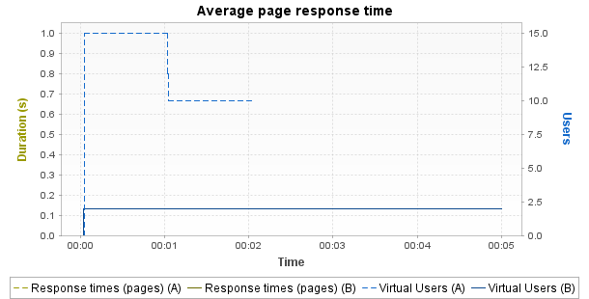

 | Min | Average | Max
A | 0 | 0 | 0
B | 0 | 0 | 0
% | +0% | +0% | +0%
Notes: Displays the average response time, in seconds, of all pages during the test.
Average request response time

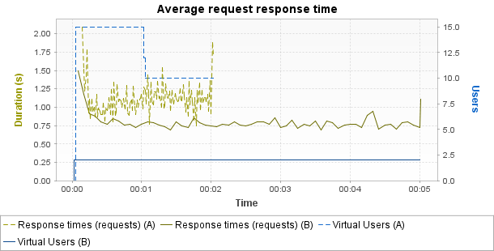

 | Min | Average | Max
A | 0.744 | 1.092 | 2.094
B | 0.687 | 0.782 | 1.5
% | -7.7% | -28.4% | -28.4%
Notes: Displays the average response time, in seconds, of all requests during the test.
Average response time (Transactions)

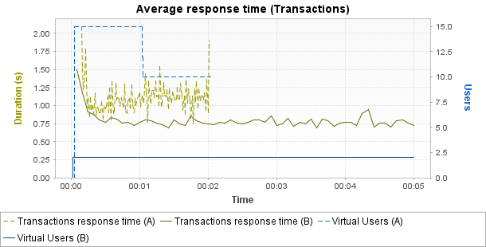

 | Min | Average | Max | Median | Avg-90% | Std. Dev.
A | 0.744 | 1.085 | 2.096 | 1.077 | 1.072 | 0.179
B | 0.687 | 0.781 | 1.5 | 0.763 | 0.772 | 0.085
% | -7.7% | -28% | -28.4% | -29.1% | -28% | -52.7%
Notes: Displays the average response time, in seconds, of all Transactions during the test.
Requests per second

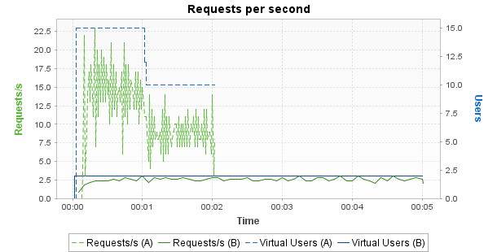

 | Min | Average | Max
A | 0 | 10.6 | 23
B | 0.8 | 2.5 | 3
% | +INF | -76.1% | -87%
Notes: Displays the number of requests per second.
Errors

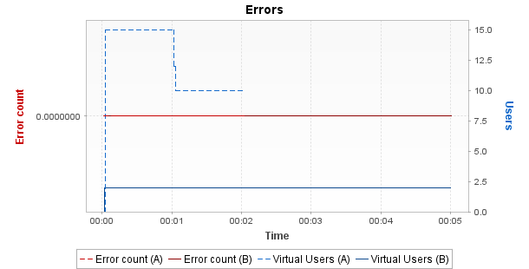

 | Min | Average | Max
A | 0 | 0 | 0
B | 0 | 0 | 0
% | +0% | +0% | +0%
Notes: Displays the number of errors per sampling interval.
Throughput

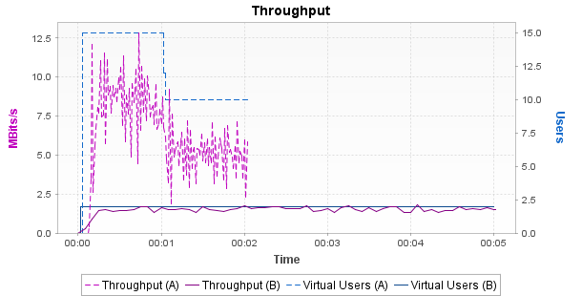

 | Min | Average | Max
A | 0 | 6.13 | 12.85
B | 0 | 1.49 | 1.83
% | +0% | -75.8% | -85.8%
Notes: Displays the number of megabits of data per second returned by the server.
Response time against load

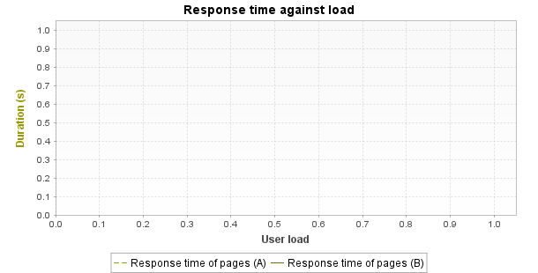

 | Min | Average | Max
A | 340,282,346,638,528,860,000,000,000,000,000,000,000 | 0 | 0
B | 340,282,346,638,528,860,000,000,000,000,000,000,000 | 0 | 0
% | +0% | +0% | +0%
Notes: Displays the average response time, in seconds, of all pages according to the number of simultaneous Virtual Users.
Distribution of Transaction Durations

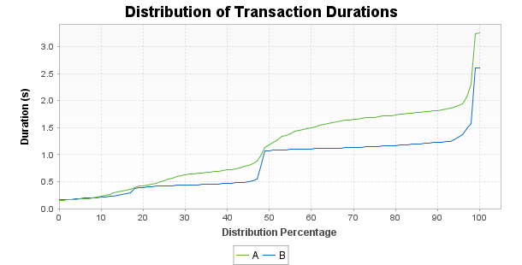
Notes: Displays the percentage of Transactions that were performed within a given time range. This graph helps determine the percentage of Transactions that meet a performance objective. For example, it may show that 90% of the Transactions have a duration under n seconds.
Top 10 First Alerts

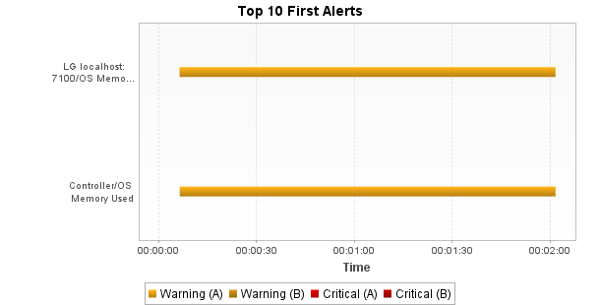
Notes: Displays the list of alerts on the monitored counters during the test.

