Performance Test Report

Name | A | B
Date | Feb 19, 2023, 3:43:04 PM | Feb 19, 2023, 2:53:09 PM
Project | MarvelApi | MarvelApi
Scenario | Estrés | Estrés
Comment
Notes

Summary
Results summary
 | A | B
Project | MarvelApi | MarvelApi
Scenario | Estrés | Estrés
Name | 15:42 - 19 Feb 2023 | 14:52 - 19 Feb 2023
Description
NeoLoad Web | https://neoload.saas.neotys.com/#!result/ba58ccd8-1cba-4043-b6dc-f4dd6e965b93/overview | https://neoload.saas.neotys.com/#!result/45d50e18-0ec8-4e37-8131-9e2024de9658/overview
Status | Passed | Passed
Start date | Feb 19, 2023, 3:43:04 PM | Feb 19, 2023, 2:53:09 PM
End date | Feb 19, 2023, 3:45:06 PM | Feb 19, 2023, 2:55:11 PM
Duration | 00:02:02 | 00:02:01
Termination reason | Execution policy | Execution policy
Load Policy | • The population Firefox is constant with 10 users.  • The population Edge is customized | • The population Edge is constant with 10 users.  • The population Firefox is loaded by peaks with 5 users for 2.0 minutes and 10 users for 2.0 minutes.
LG Hosts | l​o​c​a​l​h​o​s​t​:​7​1​0​0​ | l​o​c​a​l​h​o​s​t​:​7​1​0​0​
Filters | None | None
Debug | Disabled | Disabled
Statistics Summary
 | A | B | %
Average pages/s | 0.0 | 0.0 | +0%
Average requests/s | 7.0 | 10.6 | +51.4%
Total pages | 0 | 0 | +0%
Total requests | 865 | 1294 | +49.6%
Average Request response time | 1.38 s | 1.09 s | -21%
Total request errors | 0 | 0 | +0%
Error rate | 0 | 0 | +0%
Average Page response time | 0 s | 0 s | +0%
Total throughput | 65.1 MB | 94.2 MB | +44.7%
Average throughput | 4.23 Mb/s | 6.18 Mb/s | +46.1%
Total users launched | 10 | 15 | +50%
Total iterations completed | 426 | 639 | +50%
Total action errors | 0 | 0 | +0%
Alerts total duration | 0% | 94.7% | +INF

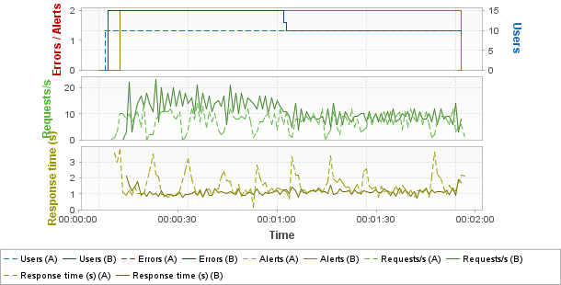
Hot spots
Top 3 errors
Greatest increases
Page Results | Count A | Count B | %
No errors on pages
Greatest decreases
Page Results | Count A | Count B | %
No errors on pages
Top 3 alerts
Greatest increases
Sev. | Alert Results | Duration % A | Duration % B | %
Empty list
Greatest decreases
Sev. | Alert Results | Duration % A | Duration % B | %
Empty list
Top 3 average response times (Pages)
Greatest increases
Page Results | Duration A | Duration B | %
Empty list
Greatest decreases
Page Results | Duration A | Duration B | %
Empty list
Top 3 average response times (Push messages)
Greatest increases
Push messages results | Duration A | Duration B | %
Empty list
Greatest decreases
Push messages results | Duration A | Duration B | %
Empty list
Top 3 maximum response times (Pages)
Greatest increases
Page Results | Duration A | Duration B | %
Empty list
Greatest decreases
Page Results | Duration A | Duration B | %
Empty list
Top 3 maximum response times (Push messages)
Greatest increases
Push messages results | Duration A | Duration B | %
Empty list
Greatest decreases
Push messages results | Duration A | Duration B | %
Empty list
Errors
Request errors
Error Type | Count A | Count B | % | Description
No errors
Action errors
Error Type | Count A | Count B | % | Description
No errors
Alerts
Element | Critical A | Critical B | % | Warning A | Warning B | %
Controller |  | 0 |  |  | 1
LG localhost:7100 |  | 0 |  |  | 1
General statistics
Avg A | Avg B | Avg % | Max A | Max B | Max % | Err A | Err B | Err %
Empty list
Transaction statistics
Avg A | Avg B | Avg % | Max A | Max B | Max % | Err A | Err B | Err %
Empty list

Scenario A
Summary
Name | 15:42 - 19 Feb 2023 | Project | MarvelApi
Description |  | Scenario | Estrés
Status | Passed | Load Policy | • The population Firefox is constant with 10 users.  • The population Edge is customized
Start date | Feb 19, 2023, 3:43:04 PM | Load Policy
End date | Feb 19, 2023, 3:45:06 PM | Stop Policy | • Population Firefox: immediate.  • Population Edge: immediate.
Duration | 00:02:02 | Stop Policy
Termination reason | Execution policy | Filters | None
LG Hosts | l​o​c​a​l​h​o​s​t​:​7​1​0​0​ | Debug | Disabled
Populations
Firefox
User Path | Percentage | WAN Emulation | Signal strength | Bandwidth ↑ | Latency ↑ | Packet loss % ↑ | Bandwidth ↓ | Latency ↓ | Packet loss % ↓ | Browser | Handle cookies | Connections | Handle cache
PokemonGo | 50.0% | Unlimited |  | Unlimited | 0ms | 0% | Unlimited | 0ms | 0% | Firefox 13.0 | Yes | 6 | As recorded
Edge
User Path | Percentage | WAN Emulation | Signal strength | Bandwidth ↑ | Latency ↑ | Packet loss % ↑ | Bandwidth ↓ | Latency ↓ | Packet loss % ↓ | Browser | Handle cookies | Connections | Handle cache
PokemonGo | 50.0% | Unlimited |  | Unlimited | 0ms | 0% | Unlimited | 0ms | 0% | Microsoft Edge 44 | Yes | 10 | As recorded
User Paths
Name | Description | On failed assertion | On error | Think time | Thinktime range
PokemonGo |  | Do nothing | Do nothing | From pages | 0%
Rendezvous
Enabled | Name | Policy | Value | Timeout
Empty list

Scenario B
Summary
Name | 14:52 - 19 Feb 2023 | Project | MarvelApi
Description |  | Scenario | Estrés
Status | Passed | Load Policy | • The population Edge is constant with 10 users.  • The population Firefox is loaded by peaks with 5 users for 2.0 minutes and 10 users for 2.0 minutes.
Start date | Feb 19, 2023, 2:53:09 PM | Load Policy
End date | Feb 19, 2023, 2:55:11 PM | Stop Policy | • Population Edge: immediate.  • Population Firefox: immediate.
Duration | 00:02:01 | Stop Policy
Termination reason | Execution policy | Filters | None
LG Hosts | l​o​c​a​l​h​o​s​t​:​7​1​0​0​ | Debug | Disabled
Populations
Edge
User Path | Percentage | WAN Emulation | Signal strength | Bandwidth ↑ | Latency ↑ | Packet loss % ↑ | Bandwidth ↓ | Latency ↓ | Packet loss % ↓ | Browser | Handle cookies | Connections | Handle cache
MarvelApi | 50.0% | Unlimited |  | Unlimited | 0ms | 0% | Unlimited | 0ms | 0% | Microsoft Edge 41 | Yes | 10 | As recorded
Firefox
User Path | Percentage | WAN Emulation | Signal strength | Bandwidth ↑ | Latency ↑ | Packet loss % ↑ | Bandwidth ↓ | Latency ↓ | Packet loss % ↓ | Browser | Handle cookies | Connections | Handle cache
MarvelApi | 50.0% | Unlimited |  | Unlimited | 0ms | 0% | Unlimited | 0ms | 0% | Firefox 13.0 | Yes | 6 | As recorded
User Paths
Name | Description | On failed assertion | On error | Think time | Thinktime range
MarvelApi |  | Do nothing | Do nothing | From pages | 0%
Rendezvous
Enabled | Name | Policy | Value | Timeout
Empty list

User Paths
User Paths
Avg A | Avg B | Avg % | Max A | Max B | Max % | Err A | Err B | Err %
PokemonGo
119.7 |  |  | 120.5 |  |  | 0
MarvelApi
 | 94.2 |  |  | 114.5 |  |  | 0

Transactions
Shared Containers
Avg A | Avg B | Avg % | Max A | Max B | Max % | Err A | Err B | Err %
Empty list
PokemonGo
Avg A | Avg B | Avg % | Max A | Max B | Max % | Err A | Err B | Err %
PokemonGo
119.7 |  |  | 120.5 |  |  | 0
Init
0 |  |  | 0 |  |  | 0
Actions
2.75 |  |  | 6.49 |  |  | 0
GetPokemon
2.13 |  |  | 5.53 |  |  | 0
GetComics
0.616 |  |  | 2.72 |  |  | 0
End
0 |  |  | 0 |  |  | 0
MarvelApi
Avg A | Avg B | Avg % | Max A | Max B | Max % | Err A | Err B | Err %
MarvelApi
 | 94.2 |  |  | 114.5 |  |  | 0
Init
 | 0 |  |  | 0 |  |  | 0
Actions
 | 2.17 |  |  | 4.63 |  |  | 0
GetPokemon
 | 1.67 |  |  | 3.25 |  |  | 0
GetComics
 | 0.497 |  |  | 2.26 |  |  | 0
End
 | 0 |  |  | 0 |  |  | 0

Push messages
Shared Containers
Avg A | Avg B | Avg % | Max A | Max B | Max % | Err A | Err B | Err %
Empty list
PokemonGo
Avg A | Avg B | Avg % | Max A | Max B | Max % | Err A | Err B | Err %
Empty list
MarvelApi
Avg A | Avg B | Avg % | Max A | Max B | Max % | Err A | Err B | Err %
Empty list

Pages
Shared Containers
Avg A | Avg B | Avg % | Max A | Max B | Max % | Err A | Err B | Err %
Empty list
PokemonGo
Avg A | Avg B | Avg % | Max A | Max B | Max % | Err A | Err B | Err %
Empty list
MarvelApi
Avg A | Avg B | Avg % | Max A | Max B | Max % | Err A | Err B | Err %
Empty list

Requests
Shared Containers
Avg A | Avg B | Avg % | Max A | Max B | Max % | Err A | Err B | Err %
Empty list
PokemonGo
Avg A | Avg B | Avg % | Max A | Max B | Max % | Err A | Err B | Err %
PokemonGo
119.7 |  |  | 120.5 |  |  | 0
Actions
2.75 |  |  | 6.49 |  |  | 0
GetPokemon
2.13 |  |  | 5.53 |  |  | 0
/v1/public/characters
2.13 |  |  | 5.53 |  |  | 0
GetComics
0.616 |  |  | 2.72 |  |  | 0
/v1/public/characters/${ id} /comics
0.62 |  |  | 2.72 |  |  | 0
MarvelApi
Avg A | Avg B | Avg % | Max A | Max B | Max % | Err A | Err B | Err %
MarvelApi
 | 94.2 |  |  | 114.5 |  |  | 0
Actions
 | 2.17 |  |  | 4.63 |  |  | 0
GetPokemon
 | 1.67 |  |  | 3.25 |  |  | 0
/v1/public/characters
 | 1.67 |  |  | 3.25 |  |  | 0
GetComics
 | 0.497 |  |  | 2.26 |  |  | 0
/v1/public/characters/${ id} /comics
 | 0.498 |  |  | 2.26 |  |  | 0

Media Contents
PokemonGo
Err A | Err B | Err % | Lag A | Lag B | Lag % | Buffer A | Buffer B | Buffer %
Empty list
Shared Containers
Err A | Err B | Err % | Lag A | Lag B | Lag % | Buffer A | Buffer B | Buffer %
Empty list

Monitors
Controller
Performance Counters
Min A | Min B | Min % | Avg A | Avg B | Avg % | Max A | Max B | Max %
Controller/User Load
0 | 0 | +0% | 9.91 | 12.3 | +24% | 10 | 15 | +50%
Controller/Throughput
0 | 0 | +0% | 4.24 | 6.14 | +44.7% | 9.16 | 12.6 | +37.4%
Controller/Alerts
0 | 0 | +0% | 0 | 0 | +0% | 0 | 0 | +0%
Controller/Critical Alerts
0 | 0 | +0% | 0 | 0 | +0% | 0 | 0 | +0%
Controller/Warning Alerts
0 | 0 | +0% | 0 | 0 | +0% | 0 | 0 | +0%
Controller/CPU Load
0 | 0 | +0% | 3.69 | 16 | +334% | 19 | 100 | +426%
Controller/JVM Memory Used
0 | 0 | +0% | 6.94 | 9.05 | +30.3% | 9 | 12 | +33.3%
Controller/OS Memory Used
- | - | -0% | 45.7 | 80.5 | +76.4% | 47 | 83 | +76.6%
Controller/Thread Count
0 | 0 | +0% | 425.7 | 496.6 | +16.7% | 444 | 507 | +14.2%
Controller/Connected
0 | 0 | +0% | 0.992 | 0.992 | -0% | 1 | 1 | +0%
Controller/Total Disconnections
0 | 0 | +0% | 0 | 0 | +0% | 0 | 0 | +0%
Controller/Total Reconnections
0 | 0 | +0% | 0 | 0 | +0% | 0 | 0 | +0%
Controller/Network/Segments sent/sec.
0 | 0 | +0% | 4,137 | 2,725 | -34.1% | 12,048 | 8,520 | -29.3%
Controller/Network/Segments retransmitted/sec.
0 | 0 | +0% | 0 | 0 | +0% | 0 | 0 | +0%
Controller/Network/eth7 (Bluetooth Device (Personal Area Network))/Megabits received/sec.
0 | 0 | +0% | 0 | 0 | +0% | 0 | 0 | +0%
Controller/Network/eth7 (Bluetooth Device (Personal Area Network))/Megabits sent/sec.
0 | 0 | +0% | 0 | 0 | +0% | 0 | 0 | +0%
Controller/Network/eth2 (Fortinet Virtual Ethernet Adapter (NDIS 6.30))/Megabits received/sec.
0 | 0 | +0% | 0 | 0 | +0% | 0 | 0 | +0%
Controller/Network/eth2 (Fortinet Virtual Ethernet Adapter (NDIS 6.30))/Megabits sent/sec.
0 | 0 | +0% | 0 | 0 | +0% | 0 | 0 | +0%
Controller/Network/wlan2 (Realtek 8821CE Wireless LAN 802.11ac PCI-E NIC)/Megabits received/sec.
0.018 | 0 | -100% | 4.54 | 6.81 | +49.9% | 9.39 | 15.6 | +66%
Controller/Network/wlan2 (Realtek 8821CE Wireless LAN 802.11ac PCI-E NIC)/Megabits sent/sec.
0.001 | 0 | -100% | 0.162 | 0.206 | +27.1% | 0.256 | 0.862 | +236%
Controller/NeoLoad Web/Megabits received/sec.
0 | 0 | +0% | 0 | 0 | +0% | 0 | 0 | +0%
Controller/NeoLoad Web/Megabits sent/sec.
0 | 0 | +0% | 0.011 | 0.012 | +10% | 0.023 | 0.03 | +29.5%
Controller/Default zone/User Load
0 | 0 | +0% | 9.91 | 12.3 | +24% | 10 | 15 | +50%
Controller/Default zone/Firefox/User Load
9 | 0 | -100% | 9.99 | 2.48 | -75.2% | 10 | 5 | -50%
Controller/Default zone/Firefox/PokemonGo/User Load
9 |  |  | 9.99 |  |  | 10
Controller/Default zone/Edge/User Load
0 | 0 | +0% | 0 | 9.92 | +INF | 0 | 10 | +INF
Controller/Default zone/Edge/PokemonGo/User Load
0 |  |  | 0 |  |  | 0
Controller/Default zone/Edge/MarvelApi/User Load
 | 0 |  |  | 9.92 |  |  | 10
Controller/Default zone/Firefox/MarvelApi/User Load
 | 0 |  |  | 2.48 |  |  | 5
LG localhost:7100
Performance Counters
Min A | Min B | Min % | Avg A | Avg B | Avg % | Max A | Max B | Max %
LG localhost:7100/CPU Load
0 | 0 | +0% | 3.73 | 15.4 | +312% | 20 | 100 | +400%
LG localhost:7100/JVM Memory Used
0 | 0 | +0% | 2.45 | 3.48 | +42% | 4 | 7 | +75%
LG localhost:7100/OS Memory Used
45 | 79 | +75.6% | 46 | 81.2 | +76.3% | 47 | 83 | +76.6%
LG localhost:7100/Throughput
0 | 0 | +0% | 4.24 | 6.13 | +44.5% | 9.16 | 12.6 | +37.4%
LG localhost:7100/User Load
0 | 0 | +0% | 9.91 | 12.3 | +24% | 10 | 15 | +50%
LG localhost:7100/Thread Count
0 | 0 | +0% | 73.4 | 80.5 | +9.6% | 80 | 92 | +15%
LG localhost:7100/Http client/Thread Pool used
0 | 0 | +0% | 0.119 | 0.145 | +21.3% | 0.145 | 0.175 | +20.7%
LG localhost:7100/Http client/Task Pool used
0 | 0 | +0% | 0 | 0 | +0% | 0.017 | 0.017 | +0%
LG localhost:7100/Controller Connection/Disconnections
0 | 0 | +0% | 0 | 0 | +0% | 0 | 0 | +0%
LG localhost:7100/Controller Connection/Reconnections
0 | 0 | +0% | 0 | 0 | +0% | 0 | 0 | +0%
LG localhost:7100/Controller Connection/Ping Duration (ms)
2 | 2 | +0% | 2 | 2.72 | +36.1% | 2 | 3 | +50%
LG localhost:7100/Network/Segments sent/sec.
0 | 0 | +0% | 689.9 | 375.7 | -45.5% | 6,524 | 5,138 | -21.2%
LG localhost:7100/Network/Segments retransmitted/sec.
0 | 0 | +0% | 0 | 0 | +0% | 0 | 0 | +0%
LG localhost:7100/Network/eth7 (Bluetooth Device (Personal Area Network))/Megabits received/sec.
0 | 0 | +0% | 0 | 0 | +0% | 0 | 0 | +0%
LG localhost:7100/Network/eth7 (Bluetooth Device (Personal Area Network))/Megabits sent/sec.
0 | 0 | +0% | 0 | 0 | +0% | 0 | 0 | +0%
LG localhost:7100/Network/eth2 (Fortinet Virtual Ethernet Adapter (NDIS 6.30))/Megabits received/sec.
0 | 0 | +0% | 0 | 0 | +0% | 0 | 0 | +0%
LG localhost:7100/Network/eth2 (Fortinet Virtual Ethernet Adapter (NDIS 6.30))/Megabits sent/sec.
0 | 0 | +0% | 0 | 0 | +0% | 0 | 0 | +0%
LG localhost:7100/Network/wlan2 (Realtek 8821CE Wireless LAN 802.11ac PCI-E NIC)/Megabits received/sec.
0 | 0.001 | +0% | 4.54 | 6.8 | +49.8% | 9.36 | 15.6 | +66.7%
LG localhost:7100/Network/wlan2 (Realtek 8821CE Wireless LAN 802.11ac PCI-E NIC)/Megabits sent/sec.
0.002 | 0.002 | +10.1% | 0.162 | 0.207 | +27.9% | 0.255 | 0.862 | +238%

Alerts
Controller
Alerts
Sev. | Alert | First Occurrence A | First Occurrence B | Duration % A | Duration % B | %
 | Controller/OS Memory Used >= 80.0% |  | 00:00:06.512 |  | 94.6
Too high amount of OS memory used
LG localhost:7100
Alerts
Sev. | Alert | First Occurrence A | First Occurrence B | Duration % A | Duration % B | %
 | LG localhost:7100/OS Memory Used >= 80.0% |  | 00:00:06.439 |  | 94.7
Too high amount of OS memory used

Main graphs
Average page response time

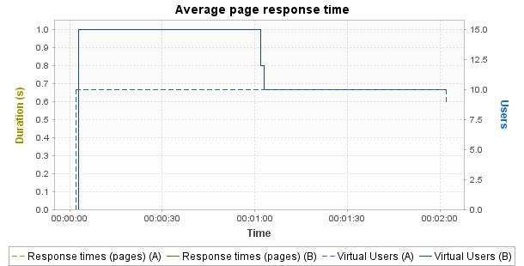

 | Min | Average | Max
A | 0 | 0 | 0
B | 0 | 0 | 0
% | +0% | +0% | +0%
Notes: Displays the average response time, in seconds, of all pages during the test.
Average request response time

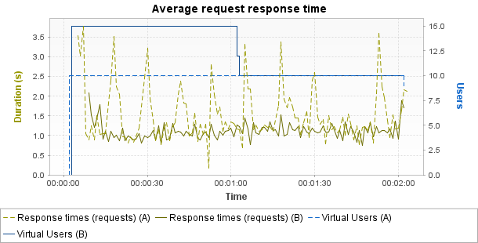

 | Min | Average | Max
A | 0.18 | 1.384 | 3.786
B | 0.744 | 1.092 | 2.094
% | +313% | -21.1% | -44.7%
Notes: Displays the average response time, in seconds, of all requests during the test.
Average response time (Transactions)

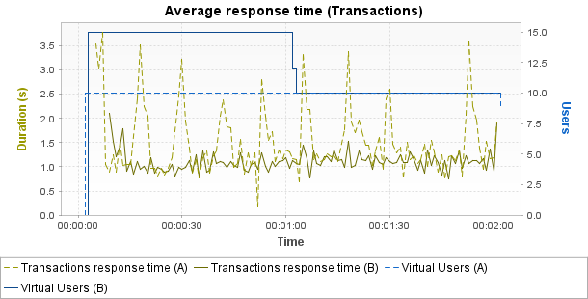

 | Min | Average | Max | Median | Avg-90% | Std. Dev.
A | 0.18 | 1.377 | 3.786 | 1.222 | 1.312 | 0.553
B | 0.744 | 1.085 | 2.096 | 1.077 | 1.072 | 0.179
% | +313% | -21.2% | -44.7% | -11.9% | -18.3% | -67.7%
Notes: Displays the average response time, in seconds, of all Transactions during the test.
Requests per second

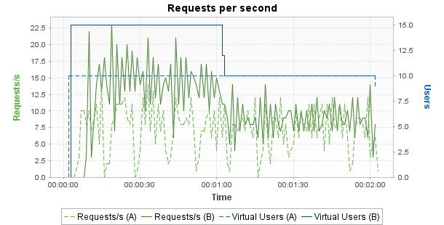

 | Min | Average | Max
A | 0 | 7 | 14
B | 0 | 10.6 | 23
% | +0% | +50.8% | +64.3%
Notes: Displays the number of requests per second.
Errors

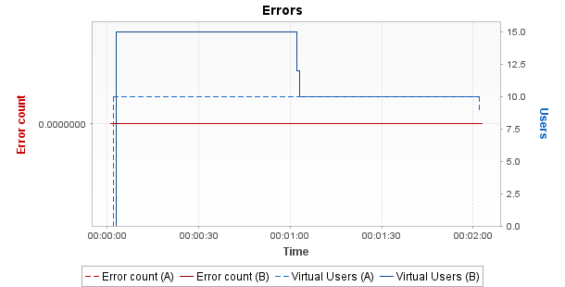

 | Min | Average | Max
A | 0 | 0 | 0
B | 0 | 0 | 0
% | +0% | +0% | +0%
Notes: Displays the number of errors per sampling interval.
Throughput

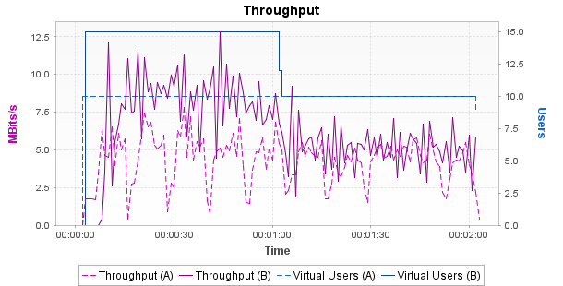

 | Min | Average | Max
A | 0 | 4.2 | 7.79
B | 0 | 6.13 | 12.85
% | +0% | +46% | +65%
Notes: Displays the number of megabits of data per second returned by the server.
Response time against load

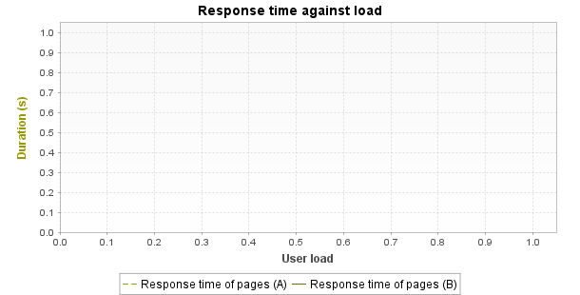

 | Min | Average | Max
A | 340,282,346,638,528,860,000,000,000,000,000,000,000 | 0 | 0
B | 340,282,346,638,528,860,000,000,000,000,000,000,000 | 0 | 0
% | +0% | +0% | +0%
Notes: Displays the average response time, in seconds, of all pages according to the number of simultaneous Virtual Users.
Distribution of Transaction Durations

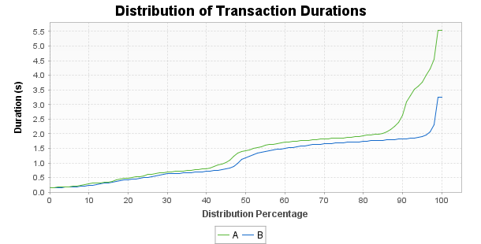
Notes: Displays the percentage of Transactions that were performed within a given time range. This graph helps determine the percentage of Transactions that meet a performance objective. For example, it may show that 90% of the Transactions have a duration under n seconds.
Top 10 First Alerts

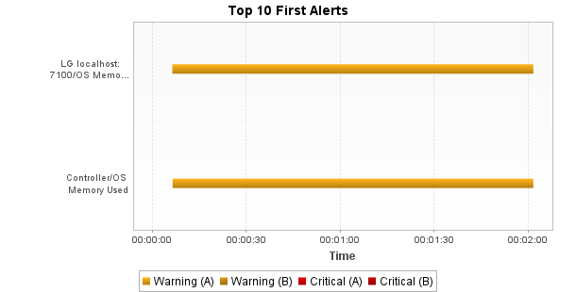
Notes: Displays the list of alerts on the monitored counters during the test.

