NS-CSC 229
INTEGRATED DESIGN PROJECT II
GROUP PROJECT REPORT
FARM INPUT INVENTORY TRACKER
A web-based system for tracking seeds, fertilizers and tools in a small farm store
Group 30
B.Sc. Computer Science, 200 Level
S/N | Matriculation number | Name
291 | FT24CMP0514 | ANZAKU Paul Alu
292 | FT24CMP0626 | ABUBAKAR Fahad
293 | FT24CMP0193 | JOHN Johnson Tuta
294 | 2200470522 | GHALI Abdulmumin
295 | FT24CMP0558 | KADON David Gideon
296 | FT24CMP0209 | AUDU Nohdi Jika
297 | FT24CMP0321 | MUHAMMAD Aliyu Muhammad
298 | FT24CMP0565 | UMAR Adam Muhammad
299 | FT24CMP0413 | MOSES Emmanuel Olotu
300 | FT24CMP0159 | ADAMU Hauwa'u

Source of member details: official NS-CSC 229 group allocation sheet (Group 30).
Date of submission: [Enter date]
Course lecturer / supervisor: [Enter name]

TABLE OF CONTENTS
PART A – System Identification and Background
A.1 Introduction to the Project
A.2 Background and Current Process
PART B – Problem Analysis
B.1 Existing Process
B.2 Statement of the Problem
B.3 Proposed Solution
PART C – Aim, Objectives and Scope
C.1 Aim
C.2 Specific Objectives
C.3 Scope
PART D – Users and Stakeholders
PART E – System Requirements
E.1 Functional Requirements
E.2 Non-Functional Requirements
E.3 Requirements-to-Feature Mapping
PART F – System Design and Modelling
F.1 System Architecture
F.2 Use Case Diagram
F.3 Activity Diagram: Recording a Stock Out
F.4 Database Design
F.5 Interface Screens
F.6 Data Flow Diagrams
PART G – Feasibility and Technology Choices
PART H – Implementation
H.1 Project Structure
H.2 Stock Movement Logic
H.3 Alert Logic
H.4 Security Measures Implemented
H.5 Sample Data
H.6 Running the System
PART I – Testing and Evaluation
I.1 Test Approach
I.2 Test Plan and Results
I.3 Failed Tests and Corrections
I.4 Performance Measurement
I.5 Evaluation
PART J – Project Management and Team Contributions
PART K – Required Deliverables
Limitations, Conclusion and Recommendations
References
Appendix A – Setup and Run Summary
Appendix B – Core Stock Movement Function
Appendix C – Implemented Features
Appendix D – AI Assistance and Academic Integrity Disclosure

PART A – SYSTEM IDENTIFICATION AND BACKGROUND

A.1 Introduction to the Project
The Farm Input Inventory Tracker is a web-based application that helps a small farm store keep an accurate, up-to-date record of the agricultural inputs it holds: seeds, fertilizers, pesticides, herbicides, farming tools, irrigation equipment and other supplies. It lets the store register each item, record every receipt (stock in) and every issue (stock out), warns the storekeeper when an item reaches its minimum level, and produces inventory, usage and valuation reports.
The problem it addresses. A small farm store usually keeps its stock records in a paper ledger or exercise book. Balances have to be worked out by hand, shortages are discovered only when a customer or farm worker asks for an item that is no longer on the shelf, and summarising how much of each input was used in a season means reading back through pages of entries. Errors, missing entries and delayed reordering during planting season can directly affect farm production.
Intended users and setting. The system is intended for the storekeeper who handles day-to-day receipts and issues, and for the store owner or manager (administrator) who configures the store and reviews reports. It is used from an ordinary web browser on a computer or phone connected to the store’s local network; for this course it runs on a single laptop.
Why it is useful. Replacing manual records with a system that updates balances automatically, refuses impossible issues, and raises alerts early helps the store avoid stock-outs of critical inputs, reduce losses that cannot be traced, and base purchasing decisions on recorded usage rather than memory.

A.2 Background and Current Process
Basis of this background. The group did not have access to a real farm store for this project, and no interviews, surveys or field visits were carried out. The background below is therefore a realistic scenario of a small farm store, not a record of findings from a real organisation. The store used in the demonstration is fictional (“Green Valley Farm Store”) and all sample data in the system is synthetic.
In the assumed scenario the store is run by a storekeeper who reports to the owner. Goods arrive from several suppliers (seed companies, fertilizer distributors, agrochemical and hardware suppliers). The storekeeper records deliveries in a stock ledger, hands out inputs to farm teams or walk-in customers on verbal or slip requests, notes the issue in the ledger, and counts the shelves periodically. When the owner wants to know how much of an input was used or what the stock is worth, the storekeeper compiles the figures by hand. Known difficulties of this way of working are set out in Part B.

PART B – PROBLEM ANALYSIS

B.1 Existing Process
The assumed current workflow is as follows:
- A supplier delivers goods. The storekeeper checks quantities against the delivery note.
- The storekeeper writes the delivery into the paper stock ledger and calculates the new balance by hand.
- A farm team or customer asks for an input, usually verbally or by a slip.
- The storekeeper hands over the goods and writes the issue in the ledger, again recalculating the balance manually.
- At intervals the storekeeper counts the shelves and compares the count with the ledger.
- When asked, the storekeeper compiles a usage or stock summary from the ledger pages for the owner.
Table 1: Elements of the existing process
Element | Description
Inputs | Delivery notes, verbal or slip requests for goods, physical stock counts
Activities | Receiving goods, storing, issuing goods, recalculating balances, counting, reporting
Records | Paper stock ledger or exercise book, delivery notes, issue slips
Outputs | Hand-compiled stock lists and usage summaries
Users | Storekeeper (records and issues), store owner/manager (reviews), farm teams and customers (request goods)

B.2 Statement of the Problem
The following problems and limitations are identified for the assumed manual process. They are based on the scenario in A.2 and on general characteristics of paper-based record keeping, not on measured data.
Table 2: Problems of the existing process and their effects
No. | Problem | Effect
P1 | Balances are calculated by hand after every receipt and issue. | Arithmetic slips and forgotten entries make the recorded balance differ from the real stock, so decisions are made on wrong figures.
P2 | Nothing warns the storekeeper that an item is running low. | Shortages are noticed only when someone asks for the item, causing delays in replenishment and possibly missed planting or spraying dates.
P3 | Issues larger than the recorded stock are not prevented. | The ledger can show impossible (negative) balances or hide missing goods, and the discrepancy is found late.
P4 | The history of one item is scattered across ledger pages. | Finding every movement of an item for a dispute or audit is slow and error-prone.
P5 | Usage and stock-value summaries are compiled manually. | Reports are late, inconsistent and rarely produced, so purchasing is based on memory rather than recorded consumption.
P6 | A paper ledger has no access control or audit trail. | Entries can be altered or removed without trace, and responsibility for losses cannot be established.
P7 | Items, categories and suppliers are not recorded in a consistent structure. | The same item may be written in different ways, making searches and totals unreliable.

B.3 Proposed Solution
The proposed solution is a web application with a database, whose main features were chosen to address the problems above. Table 3 connects each major feature to the problem or user need it answers.
Table 3: Proposed features mapped to problems
Proposed feature | Problems addressed | How it helps
Item records with category, unit, minimum threshold, price and supplier | P7, P4 | One consistent record per item with a unique Item ID and structured fields.
Stock in / stock out with automatic quantity update | P1, P4 | The system calculates every balance; each movement is stored with date, person and reference.
Rejection of issues above available stock | P3 | The server refuses a stock-out larger than the quantity in stock; the database also forbids negative quantity.
Low-stock and out-of-stock alerts | P2 | Alerts are recalculated at every stock change and shown on the alerts page, navigation counter and dashboard.
Transaction history with search and filters | P4 | Every movement can be found by item, type, date or text.
Reports (inventory, item, stock in, stock out, usage, low stock, valuation) | P5 | Reports are generated on demand for a date range and can be printed or exported to PDF and CSV.
Login, roles and audit log | P6 | Only authenticated users can act; administrator functions are restricted; important actions are logged.

PART C – AIM, OBJECTIVES AND SCOPE

C.1 Aim
To design, implement and test a web-based Farm Input Inventory Tracker that enables a small farm store to record inventory items and stock movements accurately, receive timely low-stock alerts and generate usage reports.

C.2 Specific Objectives
- Develop item records that store the name, category, description, quantity, unit, minimum threshold, unit price and supplier of each input, with add, edit, view, search, filter, sort and delete functions.
- Record stock-in and stock-out transactions that automatically and atomically update the available quantity, and validate that no issue can reduce stock below zero.
- Automate the detection of low-stock and out-of-stock items and provide notifications that update whenever stock changes.
- Generate inventory, individual item, stock-in, stock-out, usage, low-stock, valuation, reorder and tool-loan reports with date-range filtering where relevant and print, PDF and CSV output.
- Provide secure access through authentication, role-based restrictions and an audit log.
- Evaluate the prototype with documented test cases covering valid input, invalid input and edge cases, and report the results honestly.

C.3 Scope
In scope (implemented and demonstrated): login and logout with two roles; item records with categories and suppliers; stock-in, stock-out, tool lend and tool return with transaction history; low-stock and out-of-stock alerts; dashboard with totals and charts; nine report types with print, PDF and CSV; lending and return of returnable tools with a record of who holds what; a run-out forecast and reorder planner built from recent use; settings (store information, profile, password, alert rule, currency, rows per page, categories); audit log; clearly marked sample data that an administrator can remove; local operation with SQLite.
Out of scope (not implemented in this course project):
- Purchase orders, supplier invoices, payment processing or accounting integration.
- Multiple stores or warehouses, barcode scanning, or a native mobile application.
- A user-management screen (the two demonstration accounts are created by the setup script).
- E-mail or SMS delivery of alerts; alerts are displayed inside the application only.
- Costing methods such as FIFO or weighted average; valuation uses the latest recorded unit price.
- Production hosting concerns such as HTTPS configuration, automated backups and load handling.

PART D – USERS AND STAKEHOLDERS
Table 4: Users and stakeholders
Stakeholder / user | Role in the proposed system
Storekeeper (operator, system role “storekeeper”) | Registers and edits items, records stock in, stock out, tool loans and returns, watches alerts and the reorder planner, generates reports, maintains own profile and password.
Store owner / manager (administrator, system role “admin”) | Has all storekeeper functions and in addition maintains store information, alert rules, forecast settings, system configuration and categories, deletes items that have history, reads the activity log and reviews summary reports.
Farm workers and customers (recipients) | Receive inputs or borrow tools. They do not log in; their team or name is recorded as the recipient of a stock-out or as the borrower of a tool.
Suppliers | Deliver inputs. They do not log in; the supplier name is recorded on items and on stock-in transactions.
Project lecturer / supervisor | Evaluates the prototype, documentation and demonstration.

PART E – SYSTEM REQUIREMENTS

E.1 Functional Requirements
Table 5: Functional requirements
ID | Requirement
FR1 | The system shall require a valid username and password before any page other than the login page can be used, and shall allow the user to log out.
FR2 | The system shall redirect unauthenticated requests for protected pages to the login page.
FR3 | The system shall allow an authorised user to add an inventory item with name, category, unit, minimum threshold, unit price, supplier and description, rejecting missing or invalid values and duplicate Item IDs.
FR4 | The system shall allow an authorised user to edit an item’s details without directly changing its quantity.
FR5 | The system shall ask for confirmation before deleting an item, and shall require explicit confirmation (administrator only) to delete an item that has transaction history.
FR6 | The system shall allow items to be searched, filtered by category and stock status, sorted and paginated.
FR7 | The system shall record a stock-in transaction and increase the item’s quantity by the quantity received.
FR8 | The system shall record a stock-out transaction and decrease the item’s quantity, and shall reject any stock-out larger than the quantity available.
FR9 | The system shall keep a permanent history of every stock movement with reference, item, type, quantity, balance after, date, responsible person, supplier or recipient and notes.
FR10 | The system shall classify each item as in stock, low stock or out of stock from its quantity and minimum threshold, and shall update this classification and the related notifications whenever stock or the threshold changes.
FR11 | The system shall provide an alerts page listing affected items that can be filtered by status and category.
FR12 | The system shall display a dashboard with total items, total units, low-stock and out-of-stock counts, total received and issued, recent activity, category distribution and a stock-movement chart.
FR13 | The system shall generate general inventory, individual item, stock-in, stock-out, usage, low-stock, valuation, reorder (purchase list) and tool-loan reports, with date-range filtering where relevant, and shall allow printing and export to PDF and CSV.
FR14 | The system shall allow users to change their profile and password, and shall allow an administrator to change store information, alert preferences and system configuration.
FR15 | The system shall record important actions (log-in, item changes, stock movements, settings changes) in an audit log.
FR16 | The system shall allow an item to be marked as a returnable tool, shall record lending a returnable tool to a named borrower (reducing the quantity in the store) and returning it (increasing the quantity), shall reject lending more than is in the store, and shall reject a return larger than the quantity that borrower currently has on loan.
FR17 | The system shall show which borrower holds which tools, for how long, and shall not count lending as consumption.
FR18 | The system shall estimate, from the stock issued in a configurable recent period, how many days of cover each item has, shall list items that are low, out or forecast to run out within a configurable number of days, and shall suggest an order quantity and estimated cost for each, grouped by supplier in a purchase-list report.

E.2 Non-Functional Requirements
Table 6: Non-functional requirements
ID | Category | Requirement
NFR1 | Usability | Pages shall be usable from a 390-pixel-wide phone screen to a desktop screen without horizontal page scrolling; destructive actions shall ask for confirmation; error messages shall state what is wrong.
NFR2 | Security | Passwords shall be stored only as salted hashes; every state-changing form shall carry a CSRF token; all database queries shall be parameterised; output shall be HTML-escaped; sessions shall expire after 2 hours; repeated failed log-ins shall be temporarily blocked.
NFR3 | Reliability / integrity | A stock movement and its quantity update shall succeed or fail together; the database shall reject negative quantities even if the application is bypassed.
NFR4 | Performance | On the demonstration data set, common pages shall be generated by the server in well under one second.
NFR5 | Maintainability | The schema shall be kept in a SQL file, business rules in clearly named functions, and an automated test suite shall be provided and runnable with one command.
NFR6 | Portability / compatibility | The system shall run locally on Windows, Linux or macOS with Python 3.10 or newer, with no external service and with all front-end libraries bundled so it works without internet access.
NFR7 | Accessibility | Form fields shall have labels, and stock status shall be shown with text as well as colour.

E.3 Requirements-to-Feature Mapping
Test identifiers refer to the test plan in Part I.
Table 7: Requirements, implementing features and tests
Requirement | Implementing feature | Test(s)
FR1, FR2 | Login page, session handling, login-required routes | T01–T04
FR3, FR4 | Item form, server-side validation, edit page | T07–T10
FR5 | Delete button with confirmation dialog and history checkbox | T11
FR6 | Inventory list with search, filters, sort, pagination | T12
FR7, FR8 | Stock in / stock out forms and atomic transaction function | T14–T18
FR9 | Transaction history page, item history, balance-after column | T20
FR10, FR11 | Alert service, notifications table, alerts page | T22, T23
FR12 | Dashboard | B02 (browser check)
FR13 | Reports module, CSV and PDF generators | T24, T25
FR14, FR15 | Settings page, audit_logs table | T27, T34
FR16, FR17 | Lend and return forms, Tool loans page, outstanding-loan calculation | T29–T33, T35
FR18 | Forecast function, Alerts & reorder page, reorder report | T34, T36, B07
NFR1 | Responsive CSS, client-side validation, dialog | B01–B06
NFR2 | Password hashing, CSRF, parameterised SQL, escaping, lockout | T05, T06, T13, T26
NFR3 | BEGIN IMMEDIATE transactions, CHECK constraints | T19, T21
NFR4 | Indexed queries | Timing measurement, Part I
NFR5 | schema.sql, init_db.py, tests folder | Full test run

PART F – SYSTEM DESIGN AND MODELLING

F.1 System Architecture
The system follows a classic three-part web architecture (Figure 1). The browser displays HTML pages styled with CSS and enhanced by JavaScript for convenience checks, the confirmation dialog and charts. The Flask application receives each request, checks the session and role, validates the input on the server, performs the business operation, and renders a Jinja2 template. The stock service (which handles stock in, stock out, lending and returns) is the only component that changes item quantities; it works inside a database transaction and calls the alert service before committing. The report builder reads the database and produces the same data as an HTML page, a CSV file or a PDF file. All data is stored in a single SQLite file.
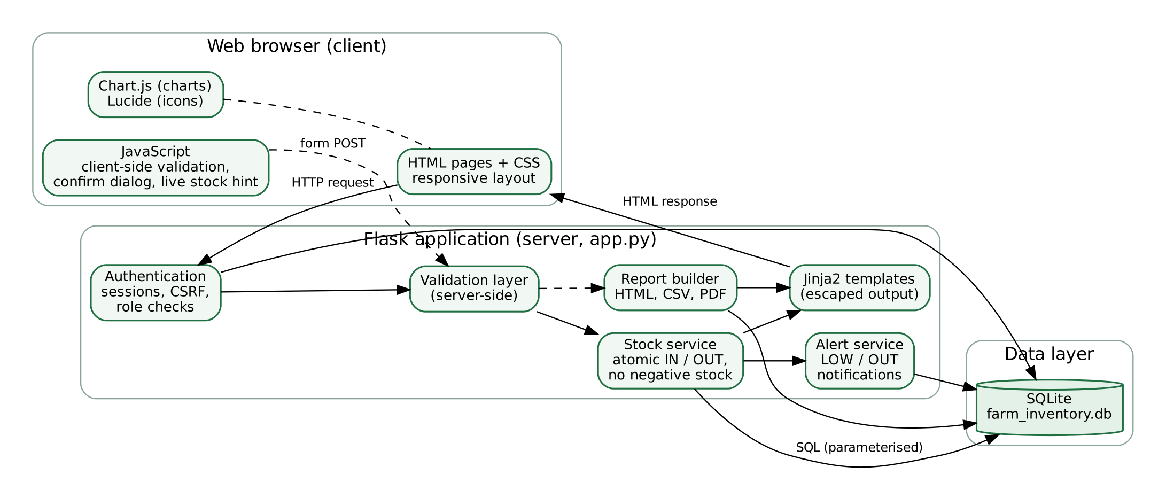
Figure 1: System architecture

F.2 Use Case Diagram
Two actors use the system (Figure 2). The storekeeper performs day-to-day operations. The administrator inherits every storekeeper use case and additionally maintains settings, categories and sensitive operations such as deleting an item that has history. Suppliers and recipients appear only as recorded data and are therefore not actors.
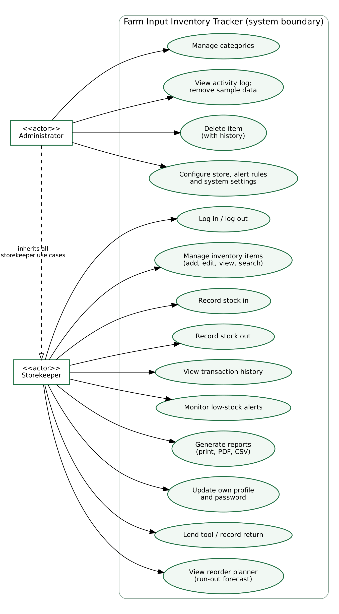
Figure 2: Use case diagram

F.3 Activity Diagram: Recording a Stock Out
Recording a stock out is the most important workflow because it must protect stock integrity. Figure 3 shows that the browser check is only a convenience: the server validates the session, the token and every field, then inside one database transaction compares the requested quantity with the quantity available. A request that fails any check changes nothing.
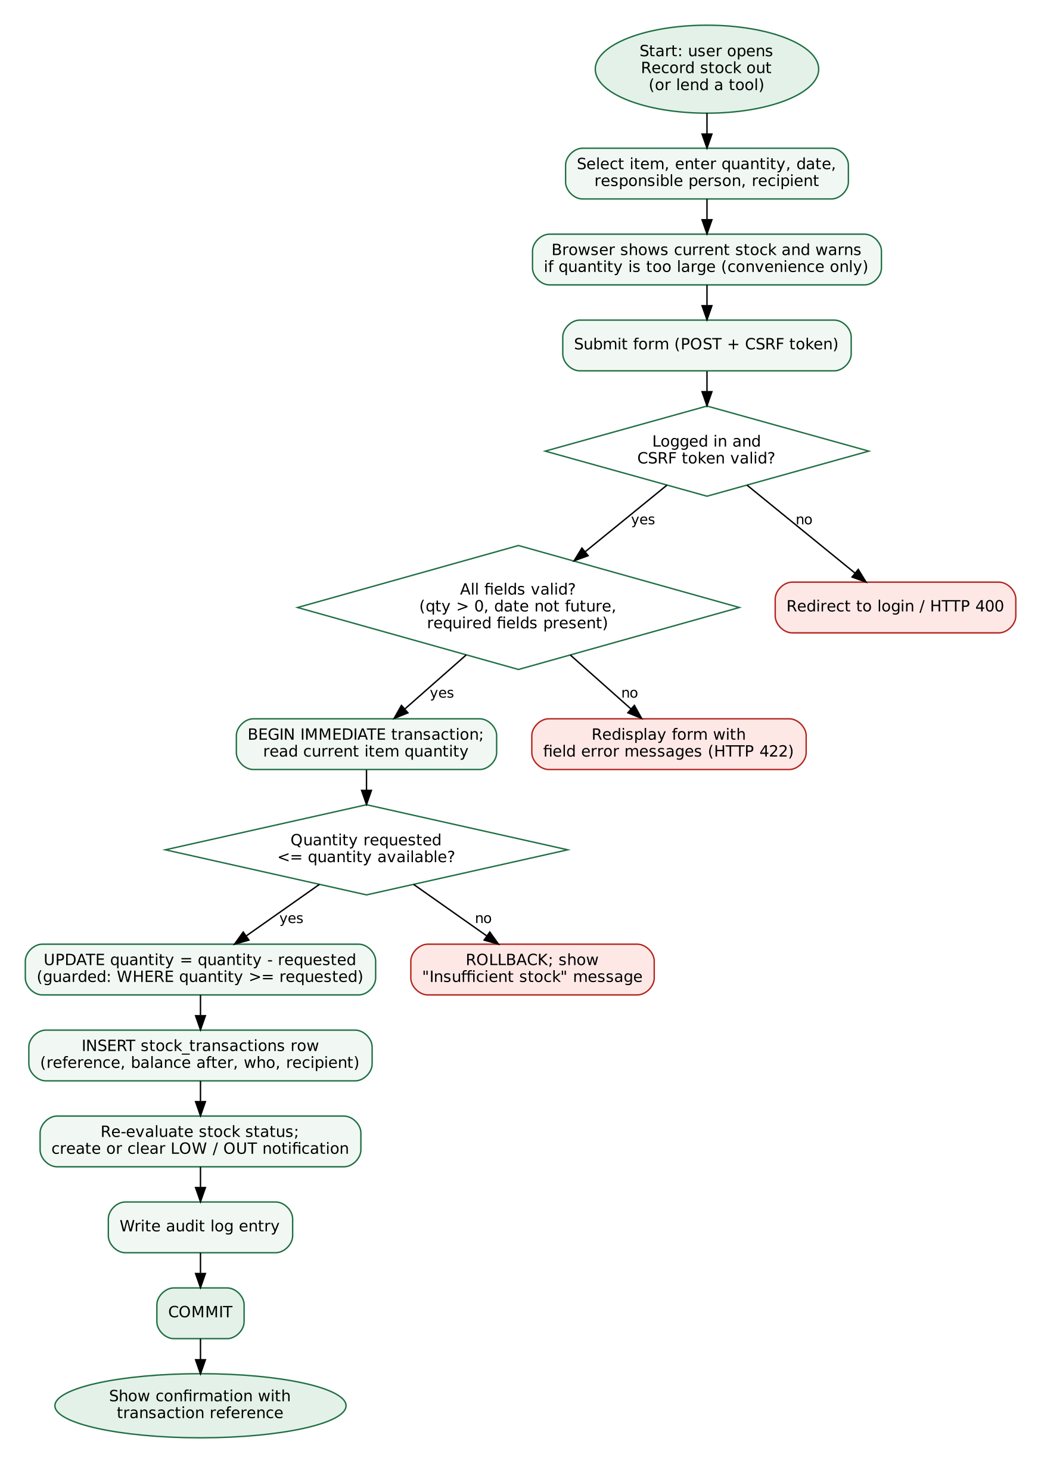
Figure 3: Activity diagram for recording a stock out

F.4 Database Design
The database has eight tables (Figure 4). Items carry an is_returnable flag, and a stock transaction has one of four types: IN, OUT, LOAN (a tool lent out) and RETURN (a tool brought back); who holds a tool is calculated from lent minus returned per item and borrower. Categories and suppliers describe items; each inventory item belongs to one category and optionally one supplier; every stock transaction belongs to one item and records the user who created it; notifications belong to an item; audit logs belong to a user; settings hold key-value configuration. Foreign keys are enforced (PRAGMA foreign_keys = ON). Deleting a category that has items, or an item that has transactions, is blocked by the database unless the application deletes the history deliberately.
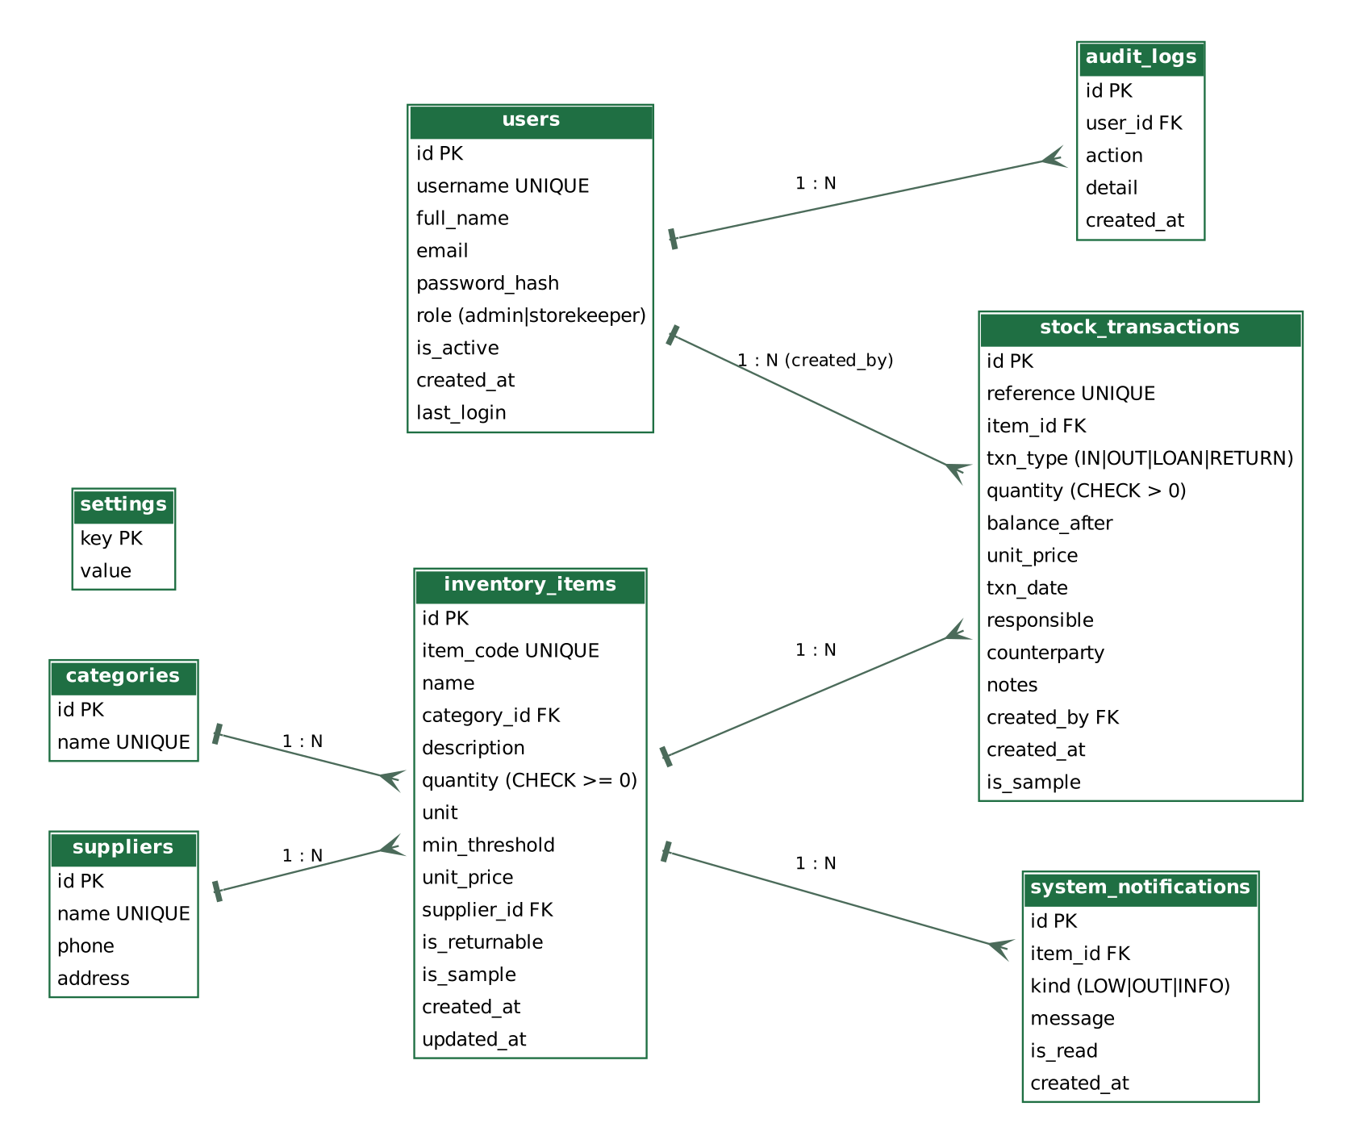
Figure 4: Entity-relationship diagram
Table 8: Key tables and constraints
Table | Purpose | Key constraints
users | Accounts and roles | username UNIQUE; role in (admin, storekeeper); password stored as hash
categories | Item categories | name UNIQUE
suppliers | Supplier names | name UNIQUE
inventory_items | One row per item with current quantity | item_code UNIQUE; quantity >= 0; min_threshold >= 0; unit_price >= 0; is_returnable in (0, 1); FK category (RESTRICT), FK supplier (SET NULL)
stock_transactions | Permanent movement history | reference UNIQUE; txn_type in (IN, OUT, LOAN, RETURN); quantity > 0; balance_after >= 0; FK item (RESTRICT)
system_notifications | Low / out-of-stock alerts | kind in (LOW, OUT, INFO); FK item (CASCADE)
audit_logs | Record of important actions | FK user (SET NULL)
settings | Store and system configuration | key PRIMARY KEY

F.5 Interface Screens
Figures 5 to 16 show the main screens captured from the running prototype with the demonstration data. Rows marked “Sample” are synthetic demonstration records; records added by users are not marked. The interface is styled as a “field ledger”: a warm paper-coloured background, dark soil-brown navigation bar, leaf green for primary actions, ochre and clay red for warnings, a serif display face for headings and figures, a monospaced face for item IDs and references, ruled tables, and stock gauges that show the quantity against its minimum level. Fonts and the Lucide icon set are bundled so the look is the same offline.
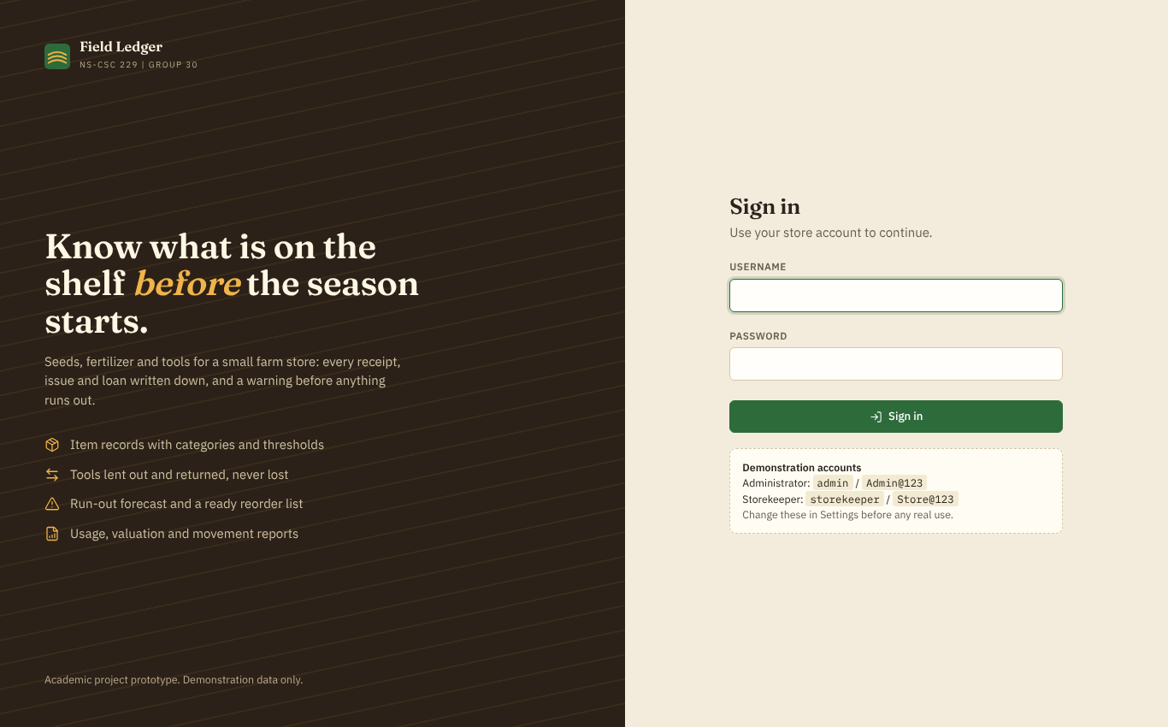
Figure 5: Login page with demonstration accounts
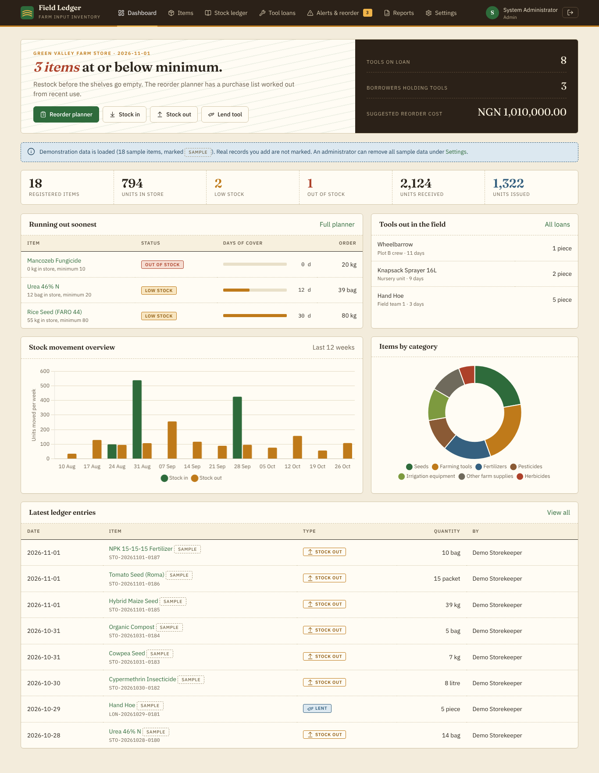
Figure 6: Dashboard: totals, movement chart, category distribution, recent activity and items needing attention
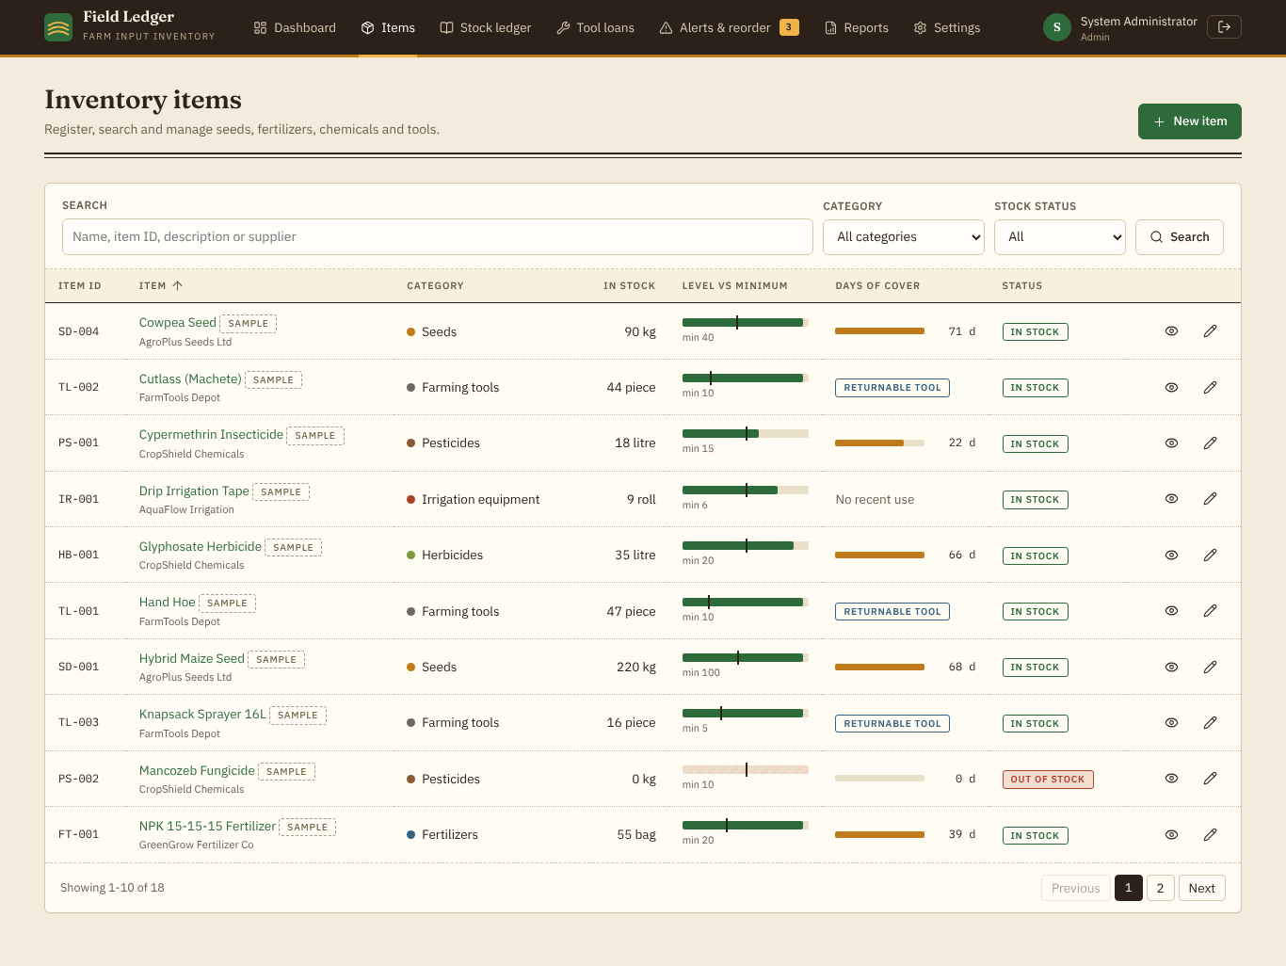
Figure 7: Inventory list with search, category and status filters, sortable columns and pagination
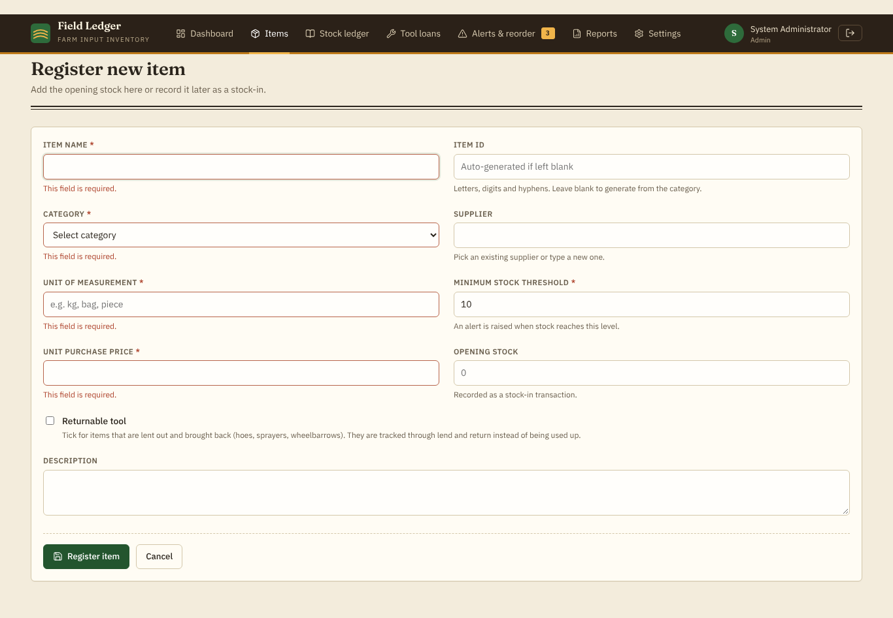
Figure 8: Item form showing client-side validation messages
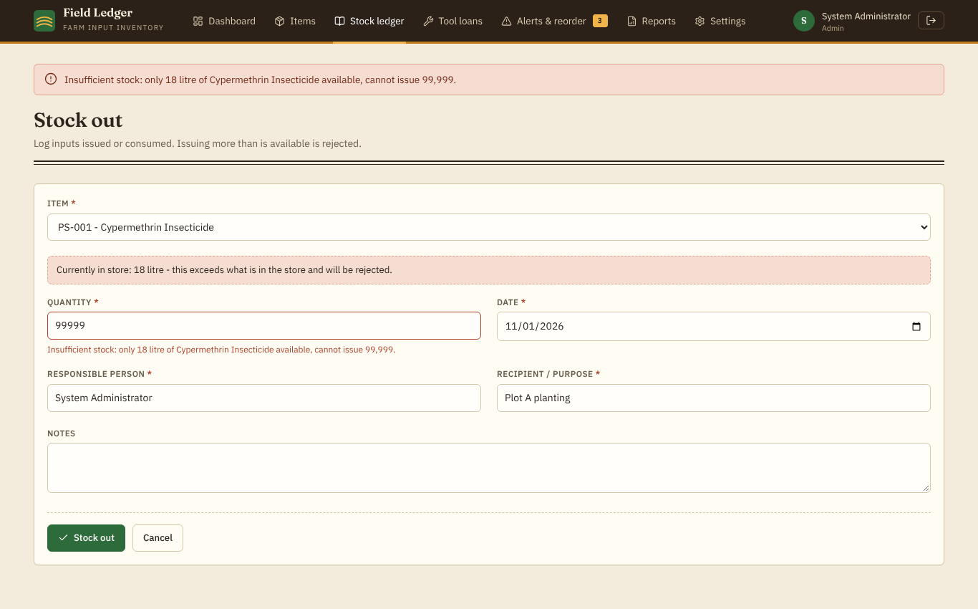
Figure 9: A stock-out larger than the available quantity is rejected by the server
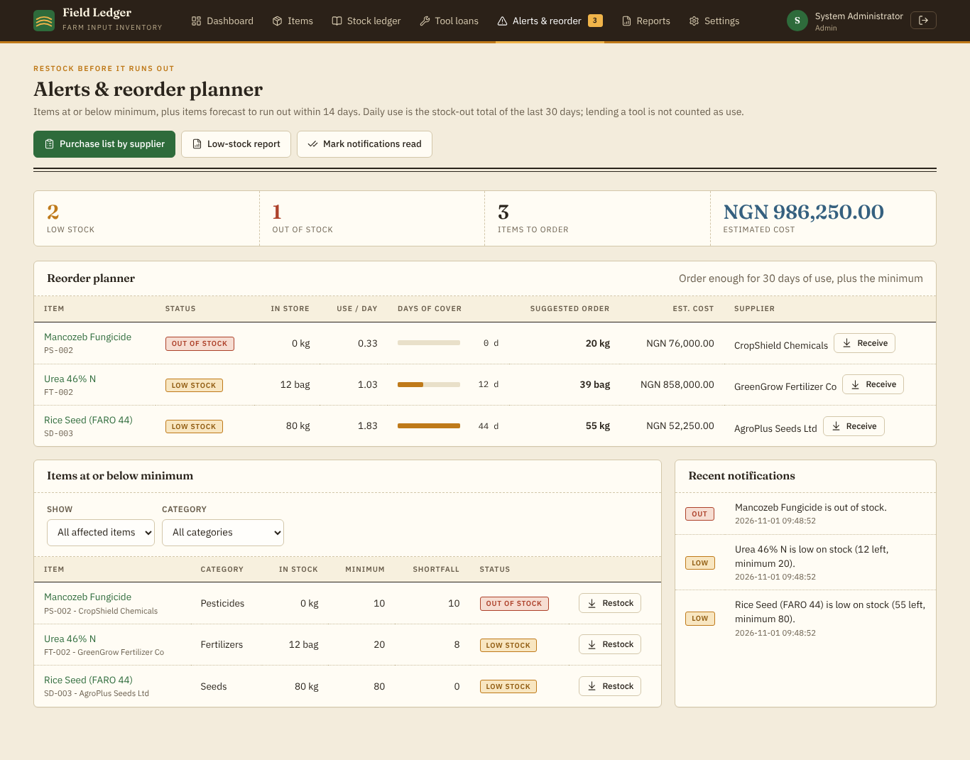
Figure 10: Alerts and reorder planner: items to order, days of cover, suggested quantity and cost, supplier
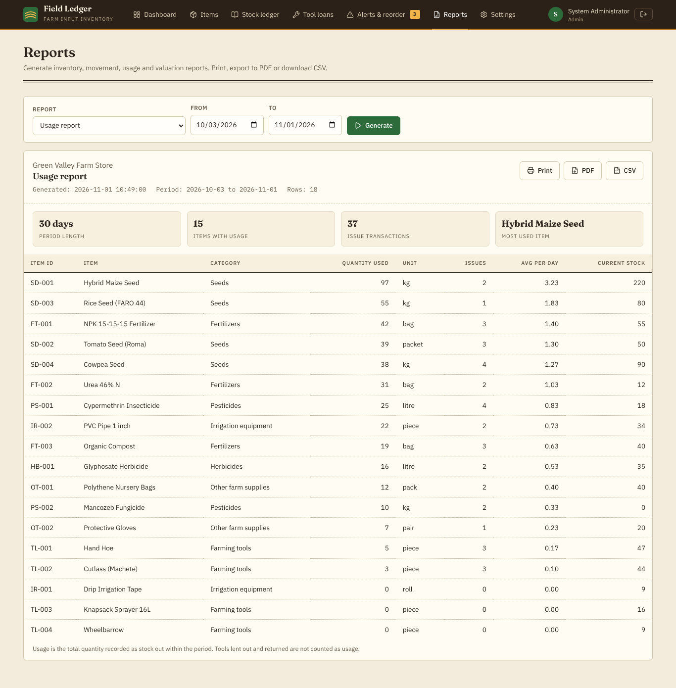
Figure 11: Usage report with summary statistics, date range, print, PDF and CSV
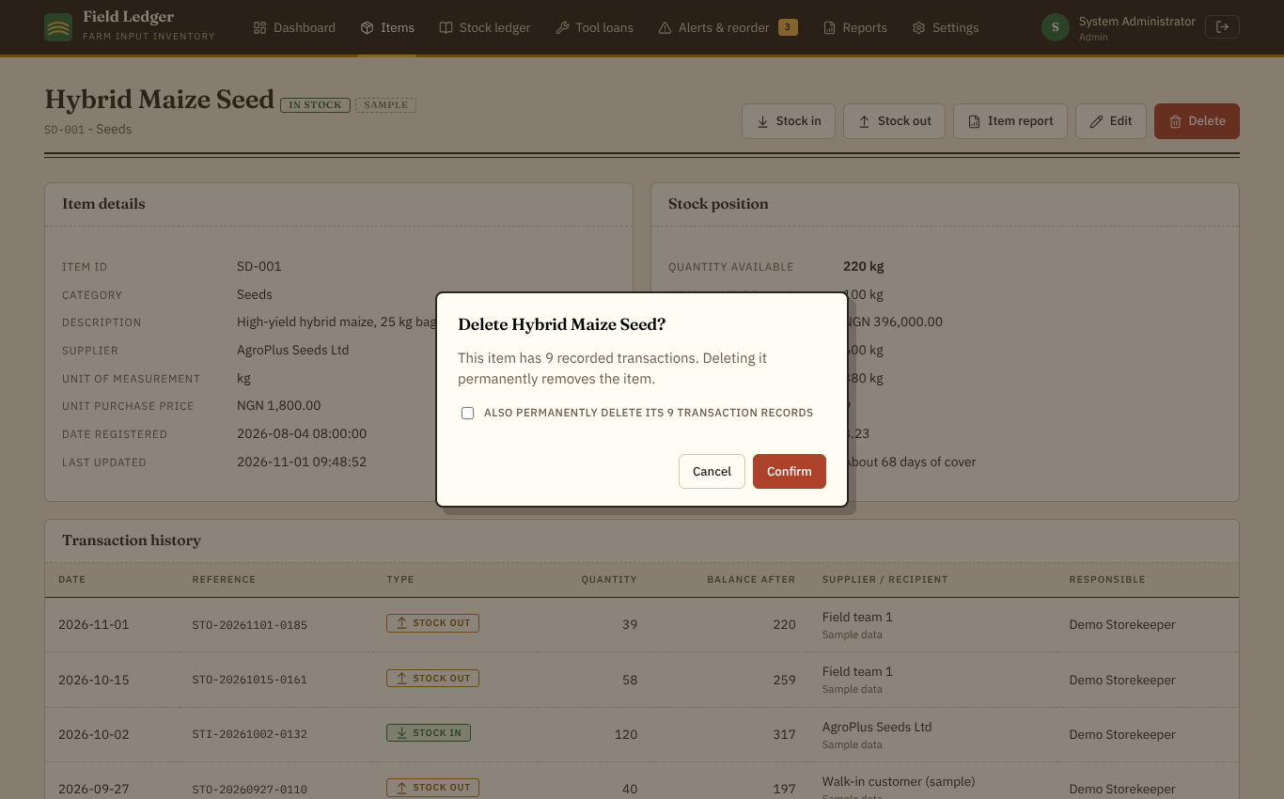
Figure 12: Confirmation dialog before deleting an item that has transaction history
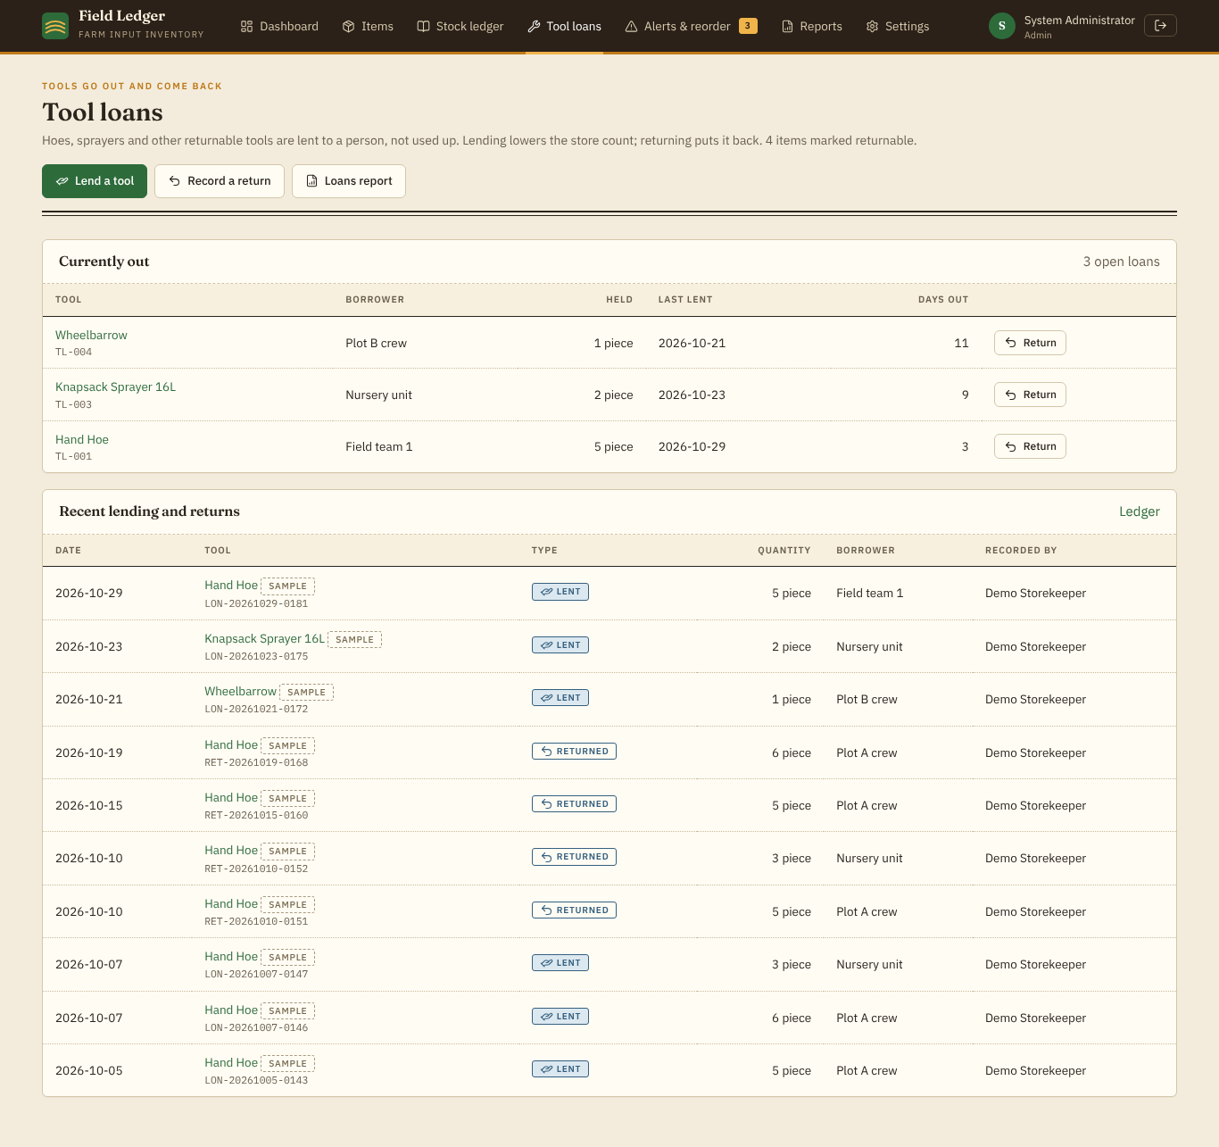
Figure 13: Tool loans: tools currently out, who holds them and for how long
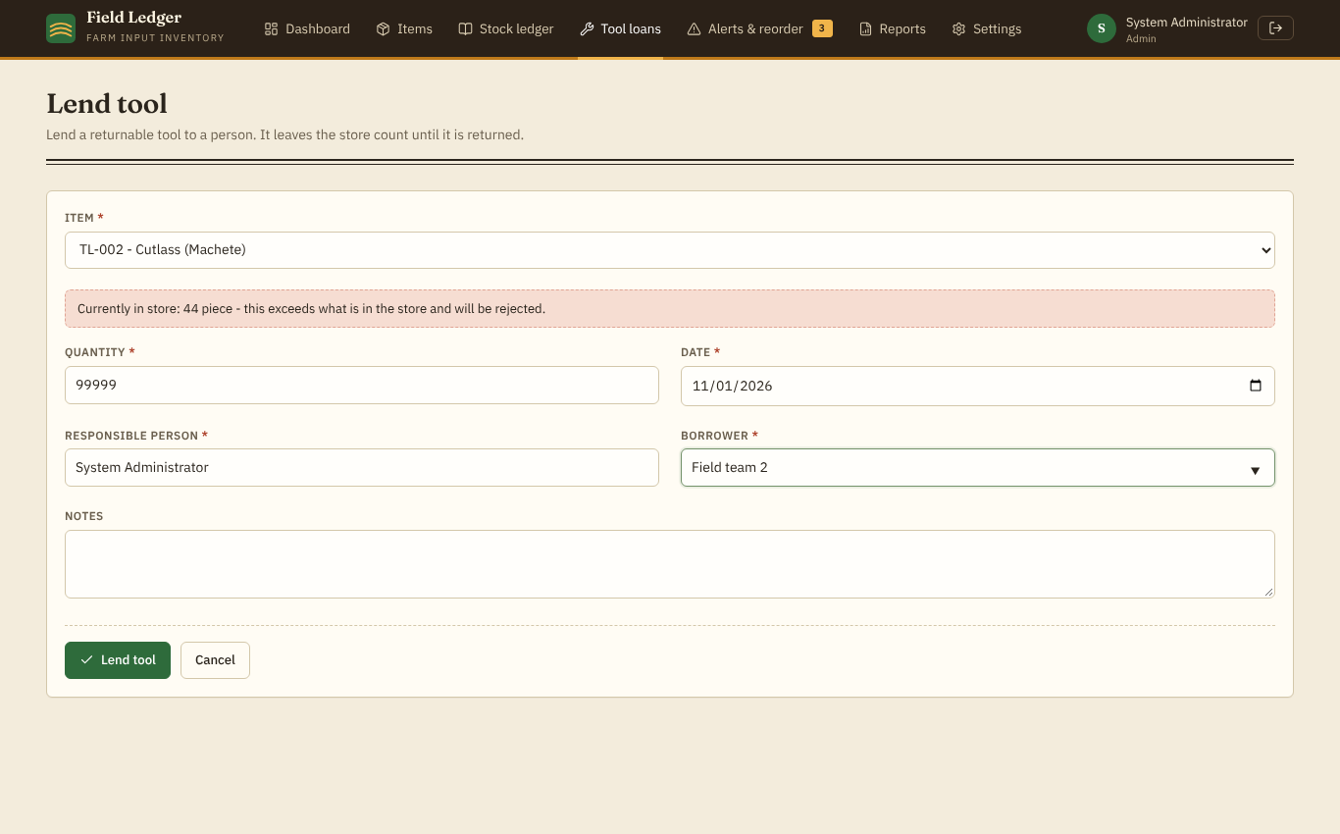
Figure 14: Lending a tool: the form warns when the quantity exceeds what is in the store
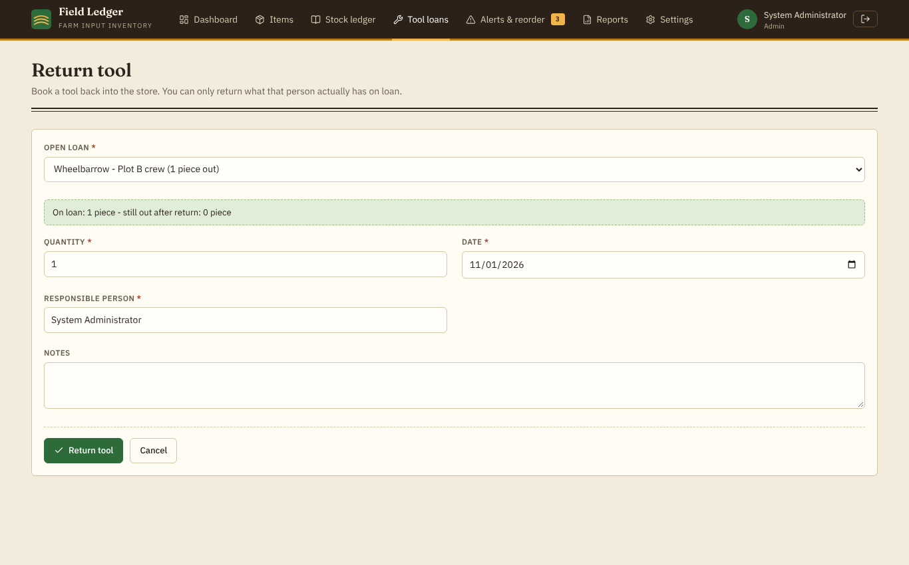
Figure 15: Returning a tool: only open loans can be selected; quantity defaults to what is out
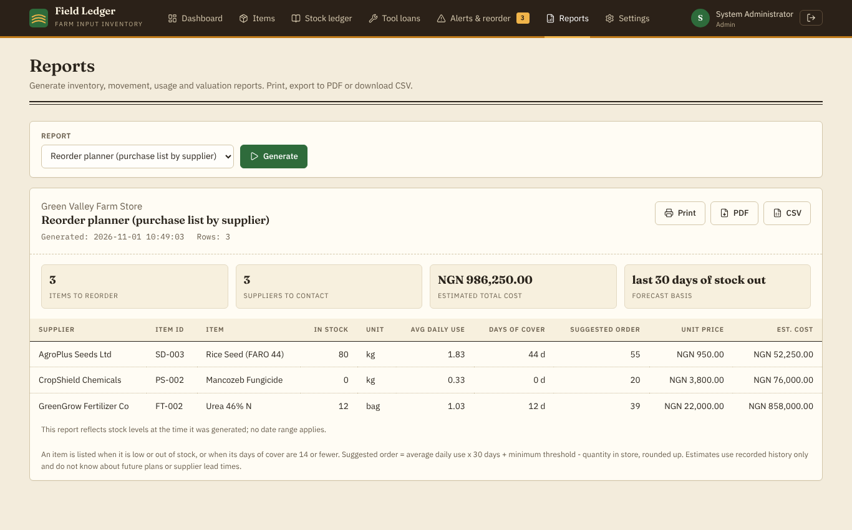
Figure 16: Reorder report: purchase list grouped by supplier with estimated cost
Figure 17 shows the dashboard on a 390-pixel-wide phone screen, where the top navigation collapses into a menu button and cards stack vertically.
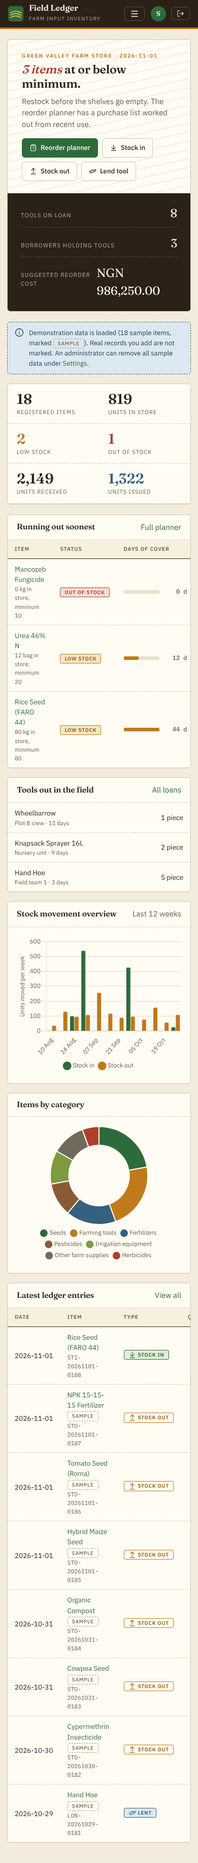
Figure 17: Dashboard on a phone-width screen

F.6 Data Flow Diagrams
Figure 18 is the context diagram: the whole system is one process exchanging data with its users. Figure 19 is the Level 0 diagram, which divides the system into six processes and five data stores. The flows are consistent with the functional requirements in Part E.
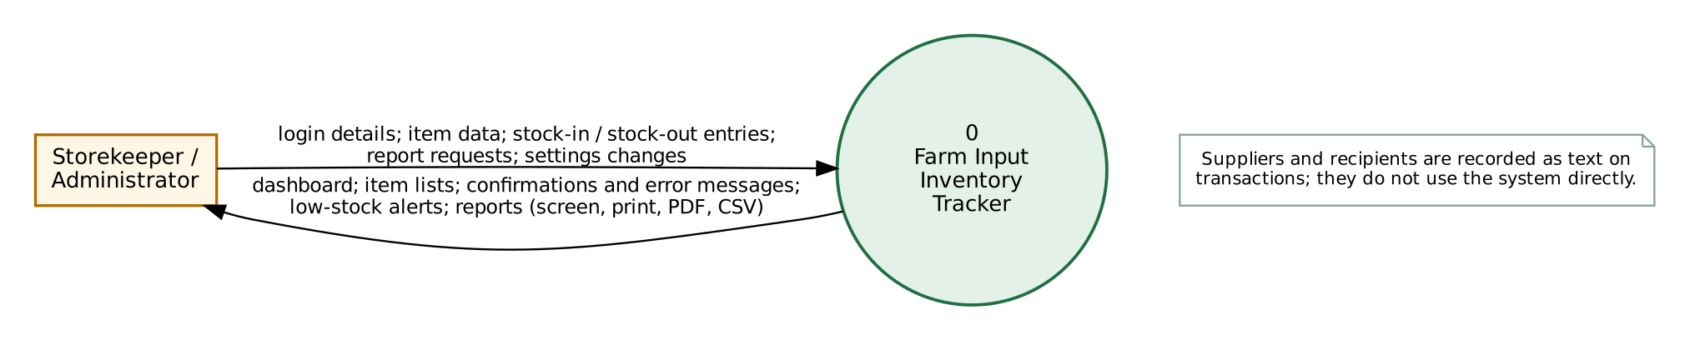
Figure 18: Context diagram (Level 0 context)
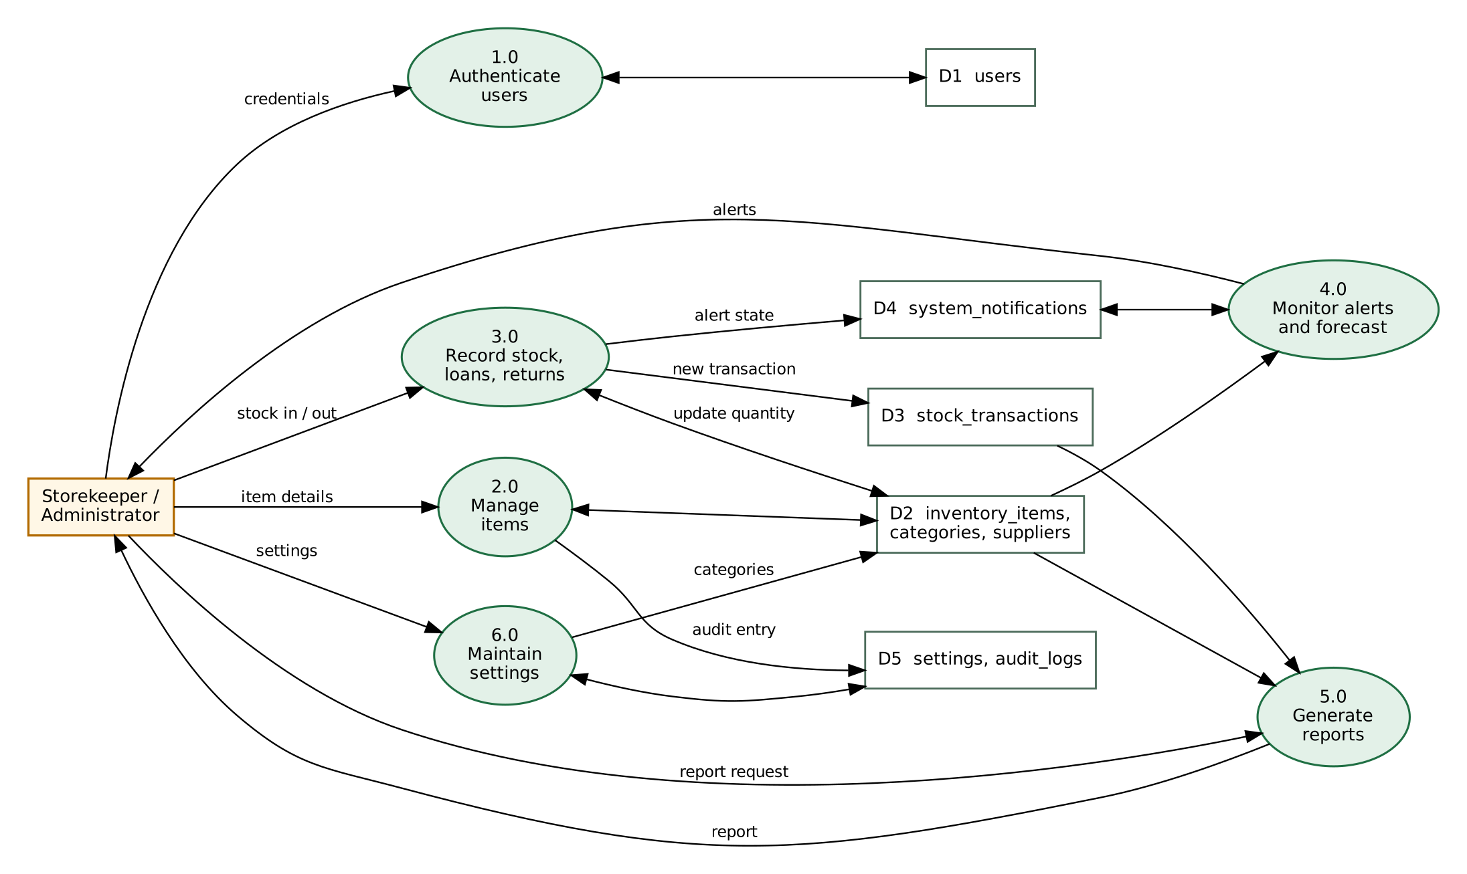
Figure 19: Level 0 data flow diagram

PART G – FEASIBILITY AND TECHNOLOGY CHOICES
Technical feasibility. The system needs only a computer with Python 3.10 or newer and a web browser. Flask, SQLite (included with Python), ReportLab, Chart.js and Lucide are freely available and well documented, and the front-end libraries are bundled in the project, so no internet connection is required to run it. The group members are computer science students with Python and web-development coursework, and the prototype was demonstrated to run on a standard Linux environment with Python 3.13.
Economic feasibility. Every component is free and open source, so there is no licensing cost. Running the system locally costs nothing beyond an existing computer. A real store that wanted to share the system across several computers would need a small server or hosting plan, which is outside the scope of this project and was not costed.
Operational feasibility. The interface uses plain labels, confirmation messages and visible alerts, and a short user guide (docs/USER_GUIDE.md) explains each page. A storekeeper who can use a web browser should need only brief guidance. This has not been tested with real storekeepers; no user trial was conducted.
Technology selection. Flask was chosen over PHP because it is compact, the group is familiar with Python, and its test client makes automated testing straightforward. SQLite provides a real relational database with foreign keys, CHECK constraints and transactions in a single file that is easy to back up and demonstrate. Jinja2 (included with Flask) escapes output by default, which helps prevent cross-site scripting. HTML, CSS and JavaScript are used for the interface; Chart.js draws the dashboard charts; Lucide provides a consistent icon set; ReportLab generates PDF reports; pytest and a headless browser were used for testing.

PART H – IMPLEMENTATION
The group implemented a minimum viable product that demonstrates the complete core workflow: register an item, receive stock, issue stock, see the alert, and produce a report. The application is about 1,300 lines of Python, 820 lines of templates, 200 lines of JavaScript and 270 lines of CSS, plus a 70-test automated test suite.

H.1 Project Structure
Table 9: Project folders and files
File / folder | Content
app.py | Flask application: routes, validation, atomic stock operation, alert logic, report builders (HTML, CSV, PDF)
schema.sql | SQLite schema with constraints, foreign keys and indexes
init_db.py | Creates the database, default categories, settings and demonstration accounts; optionally loads flagged sample data
templates/ | Jinja2 pages: login, dashboard, inventory, item form/detail, stock forms (in, out, lend, return), ledger, tool loans, alerts and reorder planner, reports, settings, error
static/ | style.css, app.js and bundled Chart.js and Lucide
tests/test_app.py | 70 automated tests
docs/ | Screenshots, diagrams, recorded test output, user guide
README.md, requirements.txt | Setup and run instructions; dependencies

H.2 Stock Movement Logic
Item quantity is never edited directly. Every change is made by one function, record_transaction (Appendix B), which handles all four movement types (IN, OUT, LOAN, RETURN) and opens a database transaction with BEGIN IMMEDIATE so that no other writer can change the data in the middle of the operation. It reads the current quantity, rejects a stock-out or loan larger than the quantity available (and a return larger than what that borrower holds), updates the item with a guarded UPDATE (WHERE quantity >= requested), inserts the transaction row with the balance after the movement, re-evaluates the alert state, writes the audit entry and commits. If any step raises an error, the whole transaction is rolled back. The database also has CHECK (quantity >= 0), so a negative quantity is impossible even if the application code were bypassed. When an item is created with an opening quantity, that quantity is entered as a stock-in transaction so the history is complete.

H.3 Alert Logic
An item is OUT when its quantity is zero, LOW when its quantity is at or below its minimum threshold (an administrator may change the rule to “strictly below”), and otherwise in stock. The function sync_alert runs inside the same transaction as every stock change, every item edit and every change of the alert rule. It creates a notification when the status changes to LOW or OUT (without duplicating one that is already open) and marks open notifications as resolved when the item returns to normal. The alerts page, navigation counter and dashboard are computed from current quantities, so they cannot become stale.

H.3a Tool Loans and Reorder Forecast
Items marked as returnable tools (hoes, sprayers, wheelbarrows and similar) are lent and returned rather than used up. A loan lowers the store quantity and a return raises it, using the same atomic function as stock in and out. The tools on loan are not stored separately: for each item and borrower (names compared without regard to case) the system adds up quantities lent and subtracts quantities returned, so a return can never exceed what that person actually holds. Lending is not counted as consumption in the forecast. For consumable items the forecast takes the stock issued in the last N days (default 30) and divides by N to get daily use; days of cover is the quantity in store divided by daily use. An item needs ordering when it is low or out, or when its cover is at or below the warning horizon (default 14 days). The suggested order is daily use × target cover days (default 30) + minimum threshold − quantity in store, rounded up; the estimated cost uses the item’s recorded unit price. This is a simple average of recent use, not a statistical demand forecast; it ignores seasons and sudden changes, and an item with no recent use shows “no recent use” rather than a guess. The three day values can be changed by an administrator in Settings.

H.4 Security Measures Implemented
- Passwords hashed with Werkzeug (scrypt) – no plain-text passwords are stored.
- Server-side session with HttpOnly and SameSite cookies, 2-hour lifetime, and the account re-checked on each request.
- CSRF token required on every POST request; requests without it receive HTTP 400.
- All SQL uses bound parameters; sort columns are chosen from a fixed whitelist.
- Output escaped by Jinja2; CSV export neutralises cells that start with =, +, - or @; a content-security policy and other security headers are sent.
- Five failed log-ins for the same user and address lock further attempts for five minutes (kept in memory, so it resets when the server restarts).
- Role checks: store information, alert rules, system configuration, categories and sample-data removal are administrator-only.

H.5 Sample Data
The setup script can load 18 items (seeds, fertilizers, pesticides, a herbicide, tools, irrigation equipment and supplies; four of the tools are returnable and three loans are open), five suppliers and about 190 stock transactions over 90 days. All of these rows carry an is_sample flag; the interface marks them “Sample”, and an administrator can delete them from Settings. The quantities are produced only by recording transactions, and an automated test checks that every item’s quantity equals the sum of its movements. The data is synthetic; no real supplier, person or business is represented. The sample usage figures are random and must not be read as research results.

H.6 Running the System
Installation and run instructions are in README.md and summarised in Appendix A. In short: install the requirements, run python init_db.py --reset, run python app.py and open http://127.0.0.1:5000. Demonstration accounts: admin / Admin@123 and storekeeper / Store@123 (for demonstration only).

PART I – TESTING AND EVALUATION

I.1 Test Approach
Testing was carried out in two ways. First, an automated suite of 70 test cases (pytest) exercises the application through Flask’s test client; each test uses its own temporary database, so the demonstration database is never changed. Second, an automated headless Chrome script (Playwright) opened the running application to check JavaScript behaviour, charts, the confirmation dialog, client-side validation and the phone layout, and to capture the screenshots in this report. The tests were run by the tool that built the system; the group should repeat them (python -m pytest tests -v) before the demonstration. No testing was done with real users, on other browsers, or on a physical phone.

I.2 Test Plan and Results
Table 10 lists the test cases with the actual results from the final run, in which all 70 automated tests passed (70 passed in about 29 s; full output in docs/test-results.txt). Several rows group related automated tests.
Table 10: Test cases and actual results
ID | Feature / requirement | Test input / action | Expected result | Actual result
T01 | Login (FR1) | Log in as admin with the correct password | Redirect to dashboard; protected page opens | Passed
T02 | Login (FR1) | Log in with a wrong password | Message “Incorrect username or password”; no access | Passed
T03 | Protected routes (FR2) | Request 8 protected pages while logged out | Each redirects to login | Passed
T04 | Logout (FR1) | Sign out, then request a protected page | Session ended; redirected to login | Passed
T05 | CSRF (NFR2) | POST a form without the token | Request rejected with HTTP 400 | Passed
T06 | Lockout (NFR2) | Five wrong passwords, then the right one | “Too many failed attempts” message | Passed
T07 | Add item (FR3) | Add a valid item; add another with opening stock 50 | Item saved with auto Item ID; opening stock creates a stock-in record | Passed
T08 | Input validation (FR3) | Empty name, empty unit, negative threshold, text threshold, negative price, invalid category, empty price | Each rejected (HTTP 422); nothing saved | Passed
T09 | Duplicate ID (FR3) | Add a second item with an existing Item ID | Rejected: “already in use” | Passed
T10 | Edit item (FR4) | Change name, category, unit, threshold, price | Details updated; quantity unchanged | Passed
T11 | Delete (FR5) | Delete item without history; with history unconfirmed, confirmed; as storekeeper | Deleted only when allowed and confirmed; storekeeper blocked for items with history | Passed
T12 | Search, filter, sort, pagination (FR6) | Search by name; filter by category; sort by price; 14 items at 10 per page | Correct subsets and order; “Showing 1-10 of 14” and “11-14 of 14” | Passed
T13 | SQL injection (NFR2) | Search for x' OR '1'='1; sort value containing DROP TABLE | Treated as text; tables intact | Passed
T14 | Stock in (FR7) | Receive 40 into an empty item | Quantity 40; transaction STI-… with balance 40 | Passed
T15 | Stock out (FR8) | Issue 15 from 40 | Quantity 25; transaction STO-… | Passed
T16 | Over-issue (FR8) | Issue 10.5 from 10; issue exactly 10; then issue 1 from 0 | First and last rejected “Insufficient stock”; exact issue allowed; quantity never below 0 | Passed
T17 | Invalid quantity (FR8) | Quantity 0, -5, abc, empty, 1e999, nan for stock in and out | All rejected; quantity and history unchanged | Passed
T18 | Dates and required fields (FR7, FR8) | Future date; wrong date format; empty responsible person; empty recipient; unknown item | All rejected; nothing saved | Passed
T19 | Atomicity (NFR3) | Force an error after the quantity update during a stock out | HTTP 500; quantity restored; no transaction row left | Passed
T20 | Ledger consistency (FR9) | Sequence of in/out movements including a rejected one | Quantity equals total in minus total out (78.5); last balance-after matches | Passed
T21 | Database constraint (NFR3) | Set quantity to -1 directly in SQL | IntegrityError raised by CHECK constraint | Passed
T22 | Alert lifecycle (FR10) | Item with minimum 10: 30 → 10 → 0 → restock; also repeated low issues; raise threshold; change rule | LOW at 10, OUT at 0, cleared on restock; one notification per state; threshold and rule changes re-evaluate | Passed
T23 | Alert filters (FR11) | Filter alerts page by low only and out only | Only matching items listed | Passed
T24 | Reports (FR13) | Usage totals, valuation (60 kg × 10 = 600), date-range filter, invalid range, item report without item, item history, low-stock list | Correct figures; clear messages for invalid input | Passed
T25 | Exports (FR13) | PDF for all 9 report types; CSV with cell beginning = | Valid PDF files; formula cell neutralised | Passed
T26 | Output escaping (NFR2) | Item named <script>alert(1)</script> | Shown as text, not executed | Passed
T27 | Settings and roles (FR14, FR15) | Change password (wrong, weak, valid); storekeeper edits store settings; admin edits store and system settings | Validation messages; storekeeper gets HTTP 403; admin changes saved | Passed
T28 | Sample data | Check flags, quantity = sum of movements (lent and returned included); remove sample data | All rows flagged; consistent; removal clears them | Passed
T29 | Lend and return (FR16) | Add a returnable tool with 10; lend 3; return 2 | Store 7 after loan, 9 after return; LOAN transaction balance 7 | Passed
T30 | Over-lend (FR16) | Lend 5 when 2 are in the store | Rejected (HTTP 422); quantity unchanged; no loan row | Passed
T31 | Over-return (FR16) | Borrower holds 2, return 3; someone who borrowed nothing returns 1 | Both rejected; quantity unchanged | Passed
T32 | Borrower names (FR16) | Lend to “Musa”, return as “musa” | Treated as the same borrower; loan closed | Passed
T33 | Non-returnable item (FR16) | Try to lend an ordinary consumable item | Rejected; quantity unchanged | Passed
T34 | Forecast settings (FR14, FR18) | Save alert settings with a usage window of 0 days | Rejected (HTTP 422) | Passed
T35 | Loan visibility (FR17) | Open the item page and Tool loans page after lending; try to clear the returnable flag while tools are out | Borrower and quantity shown; flag cannot be removed while loans are open | Passed
T36 | Reorder planner and reports (FR13, FR18) | Item with 90 in store, 85 issued in 30 days, minimum 10; reorder and loans reports as CSV and PDF | Suggested order 90 (ceil of 85/30 × 30 + 10 − 5); reports contain the expected rows; PDF valid | Passed
T37 | Lending is not use (FR17, FR18) | Lend 6 of 10 tools | No stock-out recorded; forecast shows loans, not a run-out estimate | Passed

Table 11: Browser checks (automated headless Chrome)
ID | Check | Actual result
B01 | Login with empty fields shows client-side message | “This field is required.” shown – Passed
B02 | Dashboard charts and icons render | 2 charts created; 22 icons rendered – Passed
B03 | Item form submitted empty | 4 fields highlighted with messages – Passed
B04 | Stock-out form hint with quantity 99,999 for an item with 18 in stock | Hint warns that stock is exceeded; server then rejected the request with “Insufficient stock: only 18 litre …” – Passed
B05 | Delete confirmation dialog opens and cancels | Opened and closed; item not deleted – Passed
B06 | Phone width (390 px) has no horizontal page scroll | Passed after correction D3 below (failed on first run of the earlier layout; re-checked on the redesigned layout – Passed)
B07 | Lend form with quantity 99,999 for a tool with 44 in store | Hint warns the quantity exceeds the store – Passed
B08 | Return form: choose an open loan | Hint “On loan: 1 piece”; quantity pre-filled with 1 – Passed (first run showed “1.0”; corrected)

I.3 Failed Tests and Corrections
The first runs were not clean. Table 12 records every failure honestly.
Table 12: Failures found and corrections
Ref | What failed | Cause | Correction and re-test
D1 | T13 (first run): assertion failed | A defect in the test, not the application: the “item registered” message still on screen contained the item name. | Test changed to check the “No items match your search” message; passed.
D2 | T24 usage-report test (first full run) | A defect in the test: it read the summary row instead of the data row of the CSV. | Test changed to parse the CSV properly; passed.
D3 | B06: horizontal scroll at 390 px | Application defect: dashboard grid cells could not shrink below the width of their tables. | Added min-width: 0 to grid children in the stylesheet; re-test passed.
D4 | Browser console reported a 404 | Application defect: the browser requested a missing favicon. | Added an inline icon link; error no longer appears.
D6 | Three existing tests failed after the forecast feature and interface redesign were added (alert filters, alert-rule settings, sample-data consistency) | Tests out of date, not application defects: the alerts page now also lists the reorder planner; the alert settings form now requires the three forecast day values; the consistency formula ignored lent and returned tools. | Tests updated to match the new page structure, form fields and the formula (in + returned − out − lent); all passed.
D7 | B08: return form pre-filled the quantity as “1.0” | Application defect: the number was copied from the page as text. | Value now converted to a plain number; re-checked in the browser (“1”).
D5 | Alerts page: “Restock” button clipped at the table edge (seen in a screenshot) | Application defect: table column too narrow. | Widened the table column; checked in a new screenshot.

I.4 Performance Measurement
Server processing time for common pages was measured in-process with Flask’s test client on the demonstration database (10 requests per page, sandbox environment). Median times (measured again after the forecast and loan features were added): dashboard 4.3 ms, inventory list 3.1 ms, item detail 2.6 ms, stock ledger 2.4 ms, alerts and reorder planner 2.2 ms, tool loans 1.8 ms, inventory and reorder reports 2–3 ms, and a PDF report 10.9 ms (worst single request 97 ms). These figures exclude network transfer and browser rendering and were taken on a small data set; they show that NFR4 is met for the demonstration data but say nothing about large stores.

I.5 Evaluation
Against the objectives: Objective 1 (item records) is met (T07–T12); Objective 2 (atomic stock movements, no negative stock, tool loans and returns) is met in tests T14–T21 and T29–T33; Objective 3 (alerts) is met in T22–T23, with the reorder forecast checked in T34 and T36–T37; Objective 4 (reports) is met in T24–T25 and T36, with PDF output limited to a plain table layout; Objective 5 (security) is met for the measures listed in H.4, but has not been reviewed by a security specialist; Objective 6 (evaluation) is met by this part, within the limits stated in I.1. Concurrent use by several users at the same moment was reasoned about (BEGIN IMMEDIATE and the guarded update) but not load-tested.

PART J – PROJECT MANAGEMENT AND TEAM CONTRIBUTIONS
The course requires a group of about ten students to assign roles, agree deadlines and keep a record of tasks, and requires an individual contribution statement for every member. This information was not supplied when this report was prepared, so it has not been invented. The highlighted fields must be completed by the group before submission.
Table 13: Group members, roles and contributions (to be completed by the group)
S/N | Name | Matric number | Role | Contribution (specific)
291 | ANZAKU Paul Alu | FT24CMP0514 | [Enter role] | [Describe modules / tasks]
292 | ABUBAKAR Fahad | FT24CMP0626 | [Enter role] | [Describe modules / tasks]
293 | JOHN Johnson Tuta | FT24CMP0193 | [Enter role] | [Describe modules / tasks]
294 | GHALI Abdulmumin | 2200470522 | [Enter role] | [Describe modules / tasks]
295 | KADON David Gideon | FT24CMP0558 | [Enter role] | [Describe modules / tasks]
296 | AUDU Nohdi Jika | FT24CMP0209 | [Enter role] | [Describe modules / tasks]
297 | MUHAMMAD Aliyu Muhammad | FT24CMP0321 | [Enter role] | [Describe modules / tasks]
298 | UMAR Adam Muhammad | FT24CMP0565 | [Enter role] | [Describe modules / tasks]
299 | MOSES Emmanuel Olotu | FT24CMP0413 | [Enter role] | [Describe modules / tasks]
300 | ADAMU Hauwa'u | FT24CMP0159 | [Enter role] | [Describe modules / tasks]

Suggested roles from the course instructions that the group may allocate: group coordinator; requirements and documentation lead; system design and interface lead; implementation team members for modules (authentication, items, stock movements, alerts, reports, settings); database lead; testing and quality-assurance lead; integration and version-control coordinator; demonstration and presentation coordinator.
Table 14: Task and progress record (to be completed by the group)
Task | Owner | Deadline | Status
Requirements and problem analysis | [name] | [date] | [status]
Database design | [name] | [date] | [status]
Interface design | [name] | [date] | [status]
Backend modules | [name] | [date] | [status]
Testing | [name] | [date] | [status]
Report and slides | [name] | [date] | [status]

Use of AI assistance. The prototype source code, the automated tests and the first drafts of this report and of the user guide were produced with substantial assistance from an AI assistant (Claude, Anthropic). Course rules require that such assistance is disclosed and that every member verifies the work and can explain it. See Appendix D. Each member must be able to explain the parts they are asked about during the defence.

PART K – REQUIRED DELIVERABLES
Table 15: Deliverables checklist and status
Deliverable | Where it is / status
Project charter (title, group number, members, roles, problem, aim, objectives, scope) | Title and members on the cover; problem in B.2; aim, objectives and scope in Part C; roles in Part J [to be completed]
Requirements and design document with diagrams | Parts E and F of this report
Working prototype and source code | Folder farm-tracker (app.py, schema.sql, init_db.py, templates, static)
README / setup guide | README.md; summarised in Appendix A
Test plan and completed test results | Part I; docs/test-results.txt; tests/test_app.py
Final technical report | This document
User guide | docs/USER_GUIDE.md
Presentation slides and live demonstration | [Not yet prepared – the group must prepare slides and rehearse the demonstration]
Individual contribution statements | One report per member in the course template [each member to complete]
References for third-party code and libraries | References section and Appendix D

LIMITATIONS, CONCLUSION AND RECOMMENDATIONS

Limitations
- The problem analysis is based on an assumed scenario, not on a real store; no interviews or user trials were conducted.
- The forecast is a simple average of recent stock-outs, not a statistical model, and cannot anticipate seasons. Loans are tracked by borrower name typed by the storekeeper, not by registered borrower accounts. Quantities in different units cannot be meaningfully added; the dashboard figure “units in stock” is a simple sum for orientation.
- Back-dated movements are allowed (future dates are not); “balance after” is the balance when the entry was made.
- There is no user-management screen; the demonstration accounts come from the setup script.
- Valuation uses the latest recorded unit price, not FIFO or average cost.
- Alerts are shown only inside the application (no e-mail or SMS), and the login lockout resets when the server restarts.
- Tested only with an automated headless Chrome browser and an in-process test client; not tested on other browsers, on physical phones, with many simultaneous users, or with large data volumes.
- The PDF export is a plain table; Print > Save as PDF gives a styled copy.

Conclusion
The group’s project produced a working Farm Input Inventory Tracker that covers the four required features of the Group 30 topic: item records, stock movements, low-stock alerts and usage reports, and extends them to the three kinds of input named in the topic: consumables are forecast and reordered, and tools are lent and returned. Stock quantities change only through recorded movements that are applied atomically, impossible issues are rejected by both the application and the database, alerts follow every change, and reports can be printed or exported. In the final run all 70 automated tests passed, after the defects listed in I.3 had been corrected. The system is suitable for a local demonstration with the sample data; it should be regarded as a prototype, not as production software.

Recommendations
- Test the prototype with a real storekeeper and refine the screens from their feedback.
- Add user management, e-mail or SMS alerts, purchase-order tracking, and a forecast that allows for seasons.
- Add batch/expiry tracking for seeds and chemicals, and an average-cost valuation method.
- Before any real deployment, serve the application over HTTPS, store the lockout state in the database, schedule database backups and have the security measures reviewed.

REFERENCES
Chart.js Contributors. (n.d.). Chart.js documentation. https://www.chartjs.org/docs/
Elmasri, R., & Navathe, S. B. (2016). Fundamentals of database systems (7th ed.). Pearson.
Grinberg, M. (2018). Flask web development: Developing web applications with Python (2nd ed.). O’Reilly Media.
Lucide Contributors. (n.d.). Lucide icons. https://lucide.dev
OWASP Foundation. (2021). OWASP Top 10:2021. https://owasp.org/Top10/
Pallets. (n.d.). Flask documentation. https://flask.palletsprojects.com/
Pressman, R. S., & Maxim, B. R. (2020). Software engineering: A practitioner’s approach (9th ed.). McGraw-Hill Education.
ReportLab. (n.d.). ReportLab documentation. https://docs.reportlab.com/
Silver, E. A., Pyke, D. F., & Thomas, D. J. (2017). Inventory and production management in supply chains (4th ed.). CRC Press.
SQLite Consortium. (n.d.). SQLite documentation. https://www.sqlite.org/docs.html
Sommerville, I. (2016). Software engineering (10th ed.). Pearson.
Waters, D. (2003). Inventory control and management (2nd ed.). Wiley.
Anthropic. (2026). Claude Sonnet 5.5 [Large language model]. https://claude.ai
Note for the group: confirm each reference against the source before submission and add any other source actually used. Minimum stock levels and reorder points are standard topics in inventory-control texts such as Waters (2003) and Silver et al. (2017); this report does not claim any specific research finding from them.

APPENDICES

Appendix A – Setup and Run Summary
cd farm-tracker
python -m venv venv
source venv/bin/activate (Windows: venv\Scripts\activate)
pip install -r requirements.txt
python init_db.py --reset (add --empty for no sample data)
python app.py (then open http://127.0.0.1:5000)
python -m pytest tests -v (run the automated tests)

Demonstration accounts (demonstration use only): administrator admin / Admin@123; storekeeper storekeeper / Store@123. Passwords can be changed in Settings.

Appendix B – Core Stock Movement Function (from app.py)
def record_transaction(item_id, txn_type, quantity, txn_date, responsible, counterparty, notes, unit_price=None):
"""Atomically record a stock movement and update the item's quantity.

txn_type: IN (received), OUT (issued/consumed/sold), LOAN (tool lent out), RETURN (tool returned).
Returns the new transaction reference. Raises ValidationError for business-rule violations
(e.g. issuing more than is available). Nothing is written unless every step succeeds.
"""
conn = get_db()
with tx(conn):
item = conn.execute("SELECT * FROM inventory_items WHERE id=?", (item_id,)).fetchone()
if not item:
raise ValidationError({"item_id": "Selected item does not exist."})
if txn_type in ("LOAN", "RETURN") and not item["is_returnable"]:
raise ValidationError({"item_id": f"{item['name']} is not marked as a returnable tool, so it cannot be lent or returned."})
price = item["unit_price"]
if txn_type in ("OUT", "LOAN"):
if quantity > item["quantity"]:
raise ValidationError({"quantity": (
f"Insufficient stock: only {fmt_qty(item['quantity'])} {item['unit']} of "
f"{item['name']} available, cannot {'lend' if txn_type == 'LOAN' else 'issue'} {fmt_qty(quantity)}.")})
new_qty = round(item["quantity"] - quantity, 3)
cur = conn.execute(
"UPDATE inventory_items SET quantity=?, updated_at=datetime('now') WHERE id=? AND quantity>=?",
(new_qty, item_id, quantity))
if cur.rowcount != 1: # guard against a concurrent change
raise ValidationError({"quantity": "Stock changed while saving; please retry."})
elif txn_type == "RETURN":
held = loan_outstanding(conn, item_id, counterparty)
if quantity > held + 1e-9:
raise ValidationError({"quantity": (
f"{counterparty} has {fmt_qty(held)} {item['unit']} of {item['name']} on loan, "
f"so {fmt_qty(quantity)} cannot be returned.")})
new_qty = round(item["quantity"] + quantity, 3)
conn.execute("UPDATE inventory_items SET quantity=?, updated_at=datetime('now') WHERE id=?", (new_qty, item_id))
else: # IN
new_qty = round(item["quantity"] + quantity, 3)
price = unit_price if unit_price is not None else item["unit_price"]
conn.execute(
"UPDATE inventory_items SET quantity=?, unit_price=?, updated_at=datetime('now') WHERE id=?",
(new_qty, price, item_id))
next_id = conn.execute("SELECT COALESCE(MAX(id),0)+1 FROM stock_transactions").fetchone()[0]
ref = f"{TXN_PREFIX[txn_type]}-{txn_date.replace('-', '')}-{next_id:04d}"
conn.execute(
"""INSERT INTO stock_transactions(reference,item_id,txn_type,quantity,balance_after,unit_price,
txn_date,responsible,counterparty,notes,created_by) VALUES (?,?,?,?,?,?,?,?,?,?,?)""",
(ref, item_id, txn_type, quantity, new_qty, price, txn_date, responsible,
counterparty or None, notes or None, session.get("user_id")))
sync_alert(conn, item_id)
audit(conn, f"STOCK_{txn_type}", f"{ref}: {item['item_code']} {fmt_qty(quantity)} {item['unit']}")
return ref

Appendix C – Implemented Features
- Authentication: login, logout, session expiry, lockout, two roles, CSRF protection.
- Items: add (with optional opening stock), edit, view, delete with confirmation, search, category and status filters, sorting, pagination, automatic Item ID.
- Stock: stock in, stock out, tool lend and return, over-issue and over-return rejection, transaction history with filters, atomic updates, references and balance after.
- Tool loans: returnable-tool flag, who holds what and for how many days, return shortcut, loans report.
- Forecast and reorder: days of cover from recent use, reorder planner with suggested quantity and cost, purchase list by supplier, configurable usage window, warning horizon and target cover.
- Alerts: low and out-of-stock detection, notifications, alerts page with filters, navigation counter, restock shortcut, configurable rule.
- Dashboard: store-status headline, tools-on-loan and reorder-cost panel, six summary figures, items running out soonest, tools out in the field, 12-week movement chart, category chart, latest ledger entries, sample-data notice.
- Reports: nine reports, date ranges, summary statistics, generation timestamp, print, PDF, CSV.
- Settings: store information, profile, password, alert preferences, currency, rows per page, categories, activity log, remove sample data.

Appendix D – AI Assistance and Academic Integrity Disclosure
An AI assistant (Claude, Anthropic) generated the application source code, automated tests, diagrams and the first drafts of this report and the user guide from the project brief and the course templates. It also ran the automated tests and the headless-browser checks reported in Part I and recorded their results. Third-party software used: Flask, Werkzeug, Jinja2, ReportLab, pytest, Playwright, Graphviz, Chart.js and Lucide, under their open-source licences. The group is responsible for reading, running and understanding the system, for correcting any statement that does not match what the group actually did, and for completing the highlighted fields. [Group to confirm that this disclosure is accurate and complete.]

