NS-CSC 229
INTEGRATED DESIGN PROJECT II
INDIVIDUAL STUDENT PROJECT CONTRIBUTION REPORT
Student’s Full Name | [Enter full name]
Matriculation Number | [Enter matric number]
Programme/Department | B.Sc. Computer Science / [Enter department]
Level | 200 Level
Group Number | 30
Assigned Project Topic | Group 30: Farm Input Inventory Tracker
Date of Submission | [Enter date]

Highlighted text in square brackets marks information that was not supplied and must be completed or confirmed by the student before submission. Delete this note when finished.

1. Project Overview
Group 30 was assigned the Farm Input Inventory Tracker: a web application that lets a small farm store keep track of seeds, fertilizers, agrochemicals and tools. The problem is that stock records in such stores are usually kept by hand, so balances are wrong, shortages are noticed late, and usage reports are slow to produce. The intended users are the storekeeper, who records every receipt and issue, and the store owner (administrator), who configures the system and reviews reports. The group’s solution is a Flask and SQLite application with item records, stock-in and stock-out transactions that update quantities automatically, low-stock alerts, usage and valuation reports, and secure login. The full details are in the group report.

2. My Assigned Responsibilities
Official role in the group: [Enter the role the group coordinator assigned to you, e.g. implementation / database / testing lead].
The part of the project I worked on and am reporting here is the working prototype: the database design, the Flask back end (authentication, items, stock movements, alerts, reports, settings), the responsive user interface, the automated tests, and the setup and user documentation. [Confirm this matches your real contribution; if other members shared any of these parts, say exactly which parts were yours.] The expected outputs were a prototype that runs locally, a database with initialisation script, a test suite with recorded results, and a README. My role did not change during the project. [Edit if it did.]

3. Description of My Individual Contributions
Database design. I designed an eight-table SQLite schema (users, categories, suppliers, inventory_items, stock_transactions, system_notifications, audit_logs, settings) with foreign keys and constraints: quantity cannot be negative, a transaction quantity must be greater than zero, and types such as IN/OUT/LOAN/RETURN, the returnable-tool flag and the user roles are restricted to allowed values. I decided that an item’s quantity is changed only by recording a transaction, and that each transaction stores the balance after it, so the history can always be checked against the current quantity. I wrote init_db.py to create the schema and load clearly flagged sample data.
Stock movement logic. I implemented one function, record_transaction, that performs every stock-in, stock-out, tool loan and tool return. It opens a transaction with BEGIN IMMEDIATE, reads the item, rejects an issue or loan larger than the available quantity (and a return larger than the borrower holds), updates the quantity with a guarded UPDATE, inserts the transaction row, re-evaluates alerts and writes the audit log, and commits; any error rolls everything back (Appendix A). I chose to enforce the rule both in Python and with a CHECK constraint so a bug in one layer cannot create a negative stock.
Alerts. I wrote sync_alert, which runs in the same transaction as every stock change, item edit and rule change. It opens a LOW or OUT notification when an item crosses its threshold, avoids duplicates, and clears the notification when the item is restocked. The alerts page, navigation counter and dashboard are computed from current quantities.
Tool loans and reorder forecast. To cover the tools named in the project topic, I added returnable tools: lending lowers the store count, returning raises it, and who holds what is calculated from lent minus returned per borrower, so over-returns are rejected. I also added a run-out forecast that divides recent stock-out by the number of days to get daily use, shows days of cover, and suggests an order quantity and cost for each item that is low or about to run out. It is a simple average and I describe it as such; it does not model seasons.
Authentication and security. I implemented login with hashed passwords, session expiry, CSRF tokens on all forms, role checks, a login lockout after five failures, parameterised SQL, escaped output and security headers.
Reports and interface. I built the nine reports (including the reorder purchase list and the tool-loans report) with date ranges, CSV and PDF export (ReportLab), and the pages for dashboard, inventory, stock movements, alerts and reorder planner, tool loans, reports and settings, using a “field ledger” look (paper background, soil-brown navigation, leaf green and ochre accents, a serif display face, ruled tables and stock gauges), Lucide icons, Chart.js charts and a layout that works on phone screens. Client-side validation and the confirmation dialog were added for convenience; the server validates everything again.
Testing and documentation. I wrote 70 automated tests, ran a headless-browser check of the interface, recorded the results, fixed the defects found, and wrote the README and user guide. Collaboration: [State which parts, if any, were done together with other members, and who they were.]
AI assistance disclosure. I used an AI assistant (Claude, Anthropic) to help generate and revise the code, tests, diagrams and drafts of the documents. [Confirm: I have read the code, run the system and tests myself, and can explain every part listed above.]

4. Tools, Technologies and Technical Skills Used
Tool / technology | How I used it
Python 3 and Flask | Back end: routes, validation, sessions, business rules
SQLite (sqlite3 module) | Relational database, constraints, transactions (BEGIN IMMEDIATE / COMMIT / ROLLBACK)
Jinja2, HTML, CSS, JavaScript | Pages and templates, responsive styling, client-side validation, confirmation dialog
Chart.js and Lucide | Dashboard charts and the icon set (bundled so the app works offline)
ReportLab | PDF export of reports
pytest | 70 automated tests, each on a temporary database
Playwright with headless Chrome | Browser checks of JavaScript, layout, and capture of screenshots
Graphviz | Architecture, use case, flowchart, ER and data flow diagrams
Claude (AI assistant) | Drafting and revising code, tests and documents (see Section 3)

5. Evidence of My Work
Each item below is genuine output from the project. The evidence record table at the end of the report lists the matching test results.
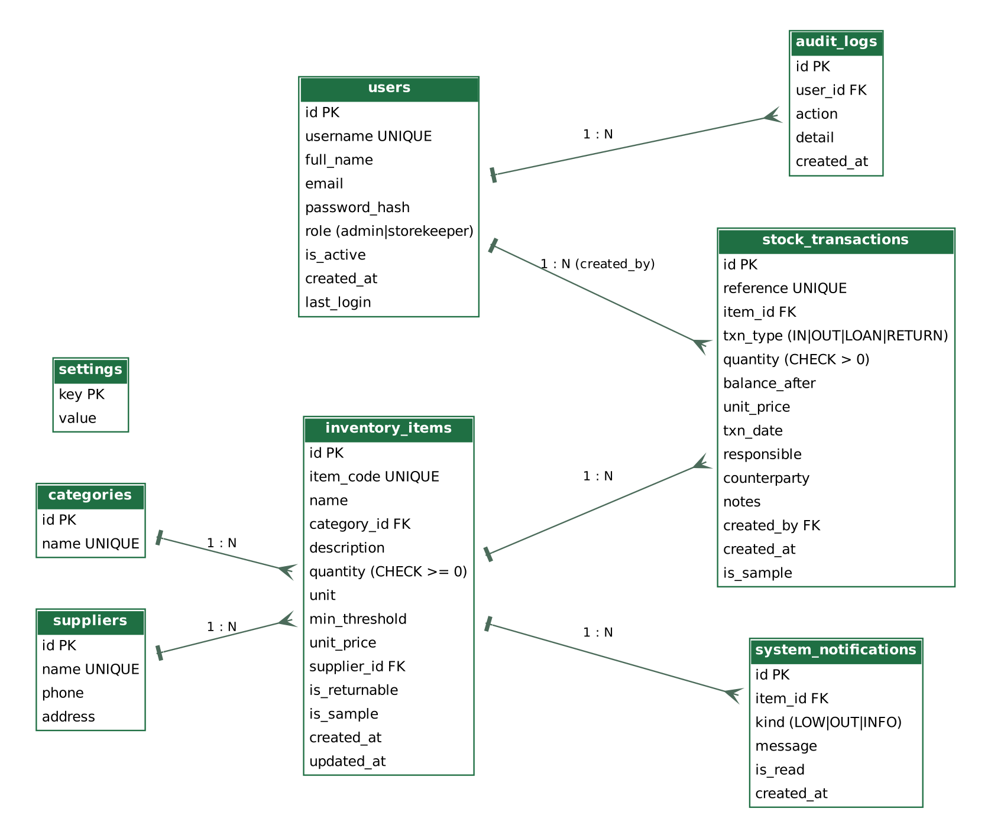
Figure 1: E01 – Entity-relationship diagram of the database I designed. It shows the eight tables and the one-to-many relationships between them.
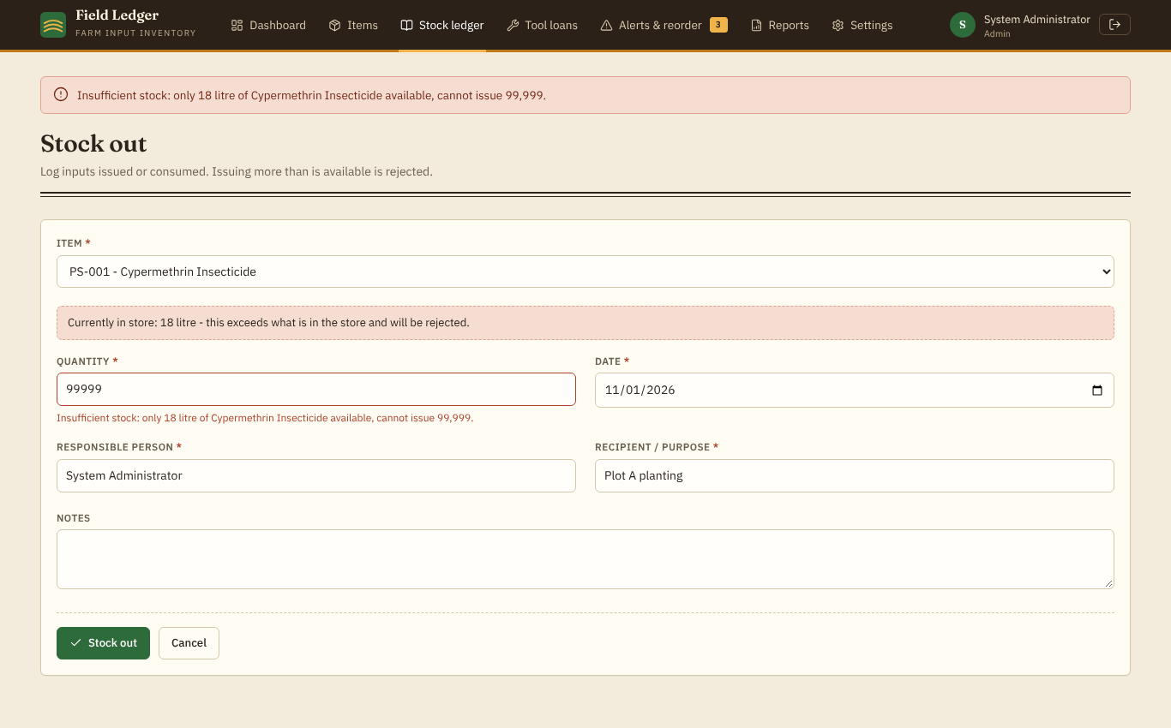
Figure 2: E02 – Result of my stock-out validation: asking to issue 99,999 litres when only 18 are in stock is rejected with a clear message and nothing is saved.
E03 – Core function record_transaction (Appendix A) and E04 – the passing test run (Appendix B) are included as appendices because of their length.

6. Challenges Encountered and How it was Addressed if any
Challenge 1: stock must never become wrong or negative. Cause: a stock movement needs two changes (the quantity and the history row); if one succeeded and the other failed, the records would disagree, and two users issuing at once could both pass the check. Actions: I put both changes in one BEGIN IMMEDIATE transaction, used a guarded UPDATE (WHERE quantity >= requested) and added a CHECK constraint. Outcome: a test forces an error after the quantity update and confirms the quantity is restored and no transaction row remains; another test confirms the database itself rejects a negative quantity. Lesson: business rules that protect data should be enforced at more than one level and tested by deliberately causing failures.
Challenge 2: alerts becoming stale or duplicated. Cause: a notification created when stock falls would stay open after restocking, and repeated small issues could create many identical ones. Actions: I made alert evaluation a single function called inside every transaction that can change stock status (including threshold and rule changes), which creates a notification only on a change of state and clears it on recovery. Outcome: tests for the full cycle 30 → 10 → 0 → restocked pass. Lesson: derived state is easier to keep correct when it is recomputed in one place.
Challenge 3: layout broke on a phone-width screen. Cause: grid cells containing wide tables could not shrink, so the page scrolled sideways at 390 pixels. I found this only when the browser check reported horizontal scrolling. Action: I set min-width: 0 on the grid children so the tables scroll inside their cards. Outcome: the re-run check passed. Lesson: responsive behaviour must be tested in a browser, not assumed.

7. Testing and Results of My Contribution
I checked my work with 70 automated tests and a scripted browser check. The final run passed all 70 (70 passed in about 29 s). Key checks:
Test / action | Expected result | Actual result | Correction
Issue 10.5 from a stock of 10 | Rejected, quantity unchanged | Passed | None
Quantity 0, -5, abc, empty, 1e999, nan | All rejected | Passed | None
Error forced mid-transaction | Rollback, no history row | Passed | None
Stock 30 → issue 20 → issue 10 → restock | LOW at 10, OUT at 0, cleared after restock | Passed | None
Usage and valuation totals | 40 kg used; value 600 | Passed | First run failed because my test read the wrong CSV row; test fixed
Search with SQL-injection text | Treated as plain text | Passed | First run failed because the test looked at a leftover message; test fixed
Lend 3 of 10 tools, return 2; lend more than is in store; return more than held | Store 7 then 9; both over-limit requests rejected | Passed | None
Reorder suggestion: 90 in store, 85 issued in 30 days, minimum 10 | Suggested order 90 | Passed | None
Three older tests after the redesign and forecast feature | Still pass | Failed first, then passed | Tests updated for the new page layout, settings fields and ledger formula
Browser: phone width 390 px | No sideways scrolling | Failed first, then passed | min-width: 0 added to grid children
Browser: console errors | None except expected rejection | 404 for favicon, then none | Icon link added

Limits of my testing: no real users, no other browsers or physical phones, and no load testing.

8. Knowledge and Skills Acquired
Technical: designing a relational schema with constraints; using database transactions to keep data consistent; protecting a web application (hashing, CSRF, parameterised queries, escaping); generating PDF and CSV output; writing automated tests. Analytical: turning a business rule (never issue more than is in stock) into code, database constraints and tests. Communication and project management: documenting a system accurately and reporting failures honestly. Teamwork: [Describe what you learned from working with the group, e.g. coordination, version control, meetings.]

9. Personal Reflection and Recommendations
What went well: the core workflow of registering an item, receiving stock, issuing stock, seeing the alert and printing a report works end to end, and the test suite gives confidence when changing the code. What I could improve: I did not test with a real storekeeper, there is no user-management page, and alerts are not sent by e-mail or SMS. Next time I would involve a real user early, keep a task record from the first week, and use version control with regular commits as evidence of progress. Working with the team: [Describe how you worked with the group and any difficulties.]

10. References
Anthropic. (2026). Claude Sonnet 5.5 [Large language model]. https://claude.ai
Chart.js Contributors. (n.d.). Chart.js documentation. https://www.chartjs.org/docs/
Lucide Contributors. (n.d.). Lucide icons. https://lucide.dev
OWASP Foundation. (2021). OWASP Top 10:2021. https://owasp.org/Top10/
Pallets. (n.d.). Flask documentation. https://flask.palletsprojects.com/
ReportLab. (n.d.). ReportLab documentation. https://docs.reportlab.com/
SQLite Consortium. (n.d.). SQLite documentation. https://www.sqlite.org/docs.html

11. Appendices (if applicable)

Appendix A – E03: Core stock movement function (from app.py)
def record_transaction(item_id, txn_type, quantity, txn_date, responsible, counterparty, notes, unit_price=None):
"""Atomically record a stock movement and update the item's quantity.

txn_type: IN (received), OUT (issued/consumed/sold), LOAN (tool lent out), RETURN (tool returned).
Returns the new transaction reference. Raises ValidationError for business-rule violations
(e.g. issuing more than is available). Nothing is written unless every step succeeds.
"""
conn = get_db()
with tx(conn):
item = conn.execute("SELECT * FROM inventory_items WHERE id=?", (item_id,)).fetchone()
if not item:
raise ValidationError({"item_id": "Selected item does not exist."})
if txn_type in ("LOAN", "RETURN") and not item["is_returnable"]:
raise ValidationError({"item_id": f"{item['name']} is not marked as a returnable tool, so it cannot be lent or returned."})
price = item["unit_price"]
if txn_type in ("OUT", "LOAN"):
if quantity > item["quantity"]:
raise ValidationError({"quantity": (
f"Insufficient stock: only {fmt_qty(item['quantity'])} {item['unit']} of "
f"{item['name']} available, cannot {'lend' if txn_type == 'LOAN' else 'issue'} {fmt_qty(quantity)}.")})
new_qty = round(item["quantity"] - quantity, 3)
cur = conn.execute(
"UPDATE inventory_items SET quantity=?, updated_at=datetime('now') WHERE id=? AND quantity>=?",
(new_qty, item_id, quantity))
if cur.rowcount != 1: # guard against a concurrent change
raise ValidationError({"quantity": "Stock changed while saving; please retry."})
elif txn_type == "RETURN":
held = loan_outstanding(conn, item_id, counterparty)
if quantity > held + 1e-9:
raise ValidationError({"quantity": (
f"{counterparty} has {fmt_qty(held)} {item['unit']} of {item['name']} on loan, "
f"so {fmt_qty(quantity)} cannot be returned.")})
new_qty = round(item["quantity"] + quantity, 3)
conn.execute("UPDATE inventory_items SET quantity=?, updated_at=datetime('now') WHERE id=?", (new_qty, item_id))
else: # IN
new_qty = round(item["quantity"] + quantity, 3)
price = unit_price if unit_price is not None else item["unit_price"]
conn.execute(
"UPDATE inventory_items SET quantity=?, unit_price=?, updated_at=datetime('now') WHERE id=?",
(new_qty, price, item_id))
next_id = conn.execute("SELECT COALESCE(MAX(id),0)+1 FROM stock_transactions").fetchone()[0]
ref = f"{TXN_PREFIX[txn_type]}-{txn_date.replace('-', '')}-{next_id:04d}"
conn.execute(
"""INSERT INTO stock_transactions(reference,item_id,txn_type,quantity,balance_after,unit_price,
txn_date,responsible,counterparty,notes,created_by) VALUES (?,?,?,?,?,?,?,?,?,?,?)""",
(ref, item_id, txn_type, quantity, new_qty, price, txn_date, responsible,
counterparty or None, notes or None, session.get("user_id")))
sync_alert(conn, item_id)
audit(conn, f"STOCK_{txn_type}", f"{ref}: {item['item_code']} {fmt_qty(quantity)} {item['unit']}")
return ref

Appendix B – E04: Automated test run (final run)
platform linux -- Python 3.13, pytest 9.1.1
collected 70 items

tests/test_app.py ... (70 tests)

============================= 70 passed in about 29 s =============================

Appendix C – Alert evaluation function (from app.py)
def sync_alert(conn, item_id):
"""Create/clear notifications so they always reflect the item's current stock status.
Called inside the same DB transaction that changed the stock."""
it = conn.execute("SELECT id,name,quantity,min_threshold,unit FROM inventory_items WHERE id=?", (item_id,)).fetchone()
if not it:
return
st = stock_status(it["quantity"], it["min_threshold"])
last = conn.execute(
"SELECT kind FROM system_notifications WHERE item_id=? AND kind IN ('LOW','OUT') AND is_read=0 "
"ORDER BY id DESC LIMIT 1", (item_id,)).fetchone()
if st == "OK":
conn.execute("UPDATE system_notifications SET is_read=1 WHERE item_id=? AND kind IN ('LOW','OUT')", (item_id,))
return
if last and last["kind"] == st:
return
conn.execute("UPDATE system_notifications SET is_read=1 WHERE item_id=? AND kind IN ('LOW','OUT')", (item_id,))
if st == "OUT":
msg = f"{it['name']} is out of stock."
else:
msg = f"{it['name']} is low on stock ({fmt_qty(it['quantity'])} {it['unit']} left, minimum {fmt_qty(it['min_threshold'])})."
conn.execute("INSERT INTO system_notifications(item_id,kind,message) VALUES (?,?,?)", (item_id, st, msg))

Suggested Responsibility Record
Assigned task / responsibility | Expected output | Deadline | Status
Database design and set-up script | schema.sql, init_db.py | [date] | Completed
Back end: login, items, stock movements, alerts, reports, settings | app.py | [date] | Completed
User interface and responsive layout | templates, style.css, app.js | [date] | Completed
Testing and defect correction | tests/test_app.py, test results | [date] | Completed
README and user guide | README.md, USER_GUIDE.md | [date] | Completed

Suggested Evidence and Testing Records
Evidence / test ID | What it demonstrates or checks | Expected result | Actual result / status
E01 | Database design (Figure 1) | Eight related tables | Included
E02 / T01 | Over-issue rejected (Figure 2) | Rejected with message; stock unchanged | Passed
E03 | record_transaction function (Appendix A) | Atomic update | Included
T02 | Rollback after forced error | Quantity restored; no history row | Passed
T03 | Alert lifecycle | Opens at threshold, clears on restock | Passed
E04 / T04 | Full automated suite (Appendix B) | All tests pass | 70 of 70 passed
T05 | Phone-width layout | No sideways scroll | Failed first run; passed after fix

Student Declaration
I declare that this report accurately describes my individual contributions to the NS-CSC 229 group project. The work and evidence presented as my own were produced by me, except where collaboration or external sources have been acknowledged. I understand that I may be asked to explain and demonstrate the work reported here.
Declaration field | Student entry
Student’s full name | [Enter full name]
Signature
Date | [Enter date]

