PROJECT RECORD / PROBLEM SOLVING IN ENGINEERING
RecoverTrack
Systems thinking for recovery at home
Complete record • Modules 1–5 • 10 embedded figures
Name: ____________________ Roll no.: ____________________
Team / section: ____________________ Guide: ____________________

Project summary
RecoverTrack is a project-stage recovery workspace for patients, caregivers and clinicians. It turns reviewed prescription details into a medication schedule, records dose reports and daily check-ins, and shares authorized recovery information. This record applies systems thinking to the household coordination process: define the system, investigate its structure, model feedback, compare interventions and test a critical assumption. The software prototype is demonstrated; local field effects and the accuracy of human review still require measurement.
Project focus | Working definition
System studied | Household coordination of an already prescribed post-surgery plan.
Proposed local boundary | Consenting adult patient–caregiver households in Hyderabad; first 14 days after discharge.
Main intervention | A reviewed shared record, traceable updates and clearer responsibility handovers.
Prototype | React, Express on Vercel, Neon PostgreSQL, Tesseract.js and explicit attention rules.

The five-module path
Module | Question | Book pages
1 · PID | What system are we studying, and what is the baseline? | 2–3
2 · Root cause | What patterns, structures and beliefs may explain it? | 4–5
3 · Feedback | Which loops sustain it, and where can we intervene? | 6–7
4 · Selection | Which alternatives offer a feasible system change? | 8–9
5 · Prototype | What did we test, learn and leave unverified? | 10–11

Evidence key: “Recorded” means supported by project records. “Hypothesis” means a relationship or perspective to investigate. “Proposed” means a plan or target that has not yet been achieved. The diagrams are models, not proof of clinical benefit.
Adapted to RecoverTrack from the supplied PSE workbook. References and the completion checklist are on page 12. No patient interviews, local statistics or clinical improvements have been invented.

MODULE 1 · A

Project Informatics Document
Workbook pp. 4–8 [1] | Describe the as-is system before choosing technology.
Purpose: a PID establishes the local context, system boundary, stakeholders and measurable baseline. It prevents a preferred technology from deciding what the problem must be.

Scope and preliminary problem statement
Super-system: post-discharge healthcare. Sub-system: medication coordination at home. Proposed pilot: adult patient–caregiver households in Hyderabad during the first 14 days after discharge. This is a proposed study boundary, not a completed field study or the application’s maximum course duration.
Problem statement — under 100 words: The proposed study investigates how adults recovering from surgery and their caregivers interpret medication instructions, organize doses and communicate dose status at home. When records or responsibilities are unclear, families may struggle to establish what has been taken and what needs follow-up. The frequency, timing and causes of these difficulties must be measured locally before claiming their prevalence or selecting a final intervention.

Existing-system inquiry: workbook 5W2H
Question | What to investigate
What? | Candidate symptoms: unclear instructions, incomplete status records and repeated clarification.
Who is affected? | Recovering patients, family caregivers and clinicians reviewing recovery.
Who influences it? | People handing over instructions, preparing medicines and reporting status; study handoffs without assigning blame.
When? | Compare morning/evening routines, handovers and weekdays/weekends; do not assume which period is worse.
Where? | Participating Hyderabad households, including situations with and without a maintained plan.
How? | Trace instructions through interpretation, the dose event, reporting and follow-up.
How much? | Collect setup time, unresolved status counts and caregiver effort before estimating impact or cost.

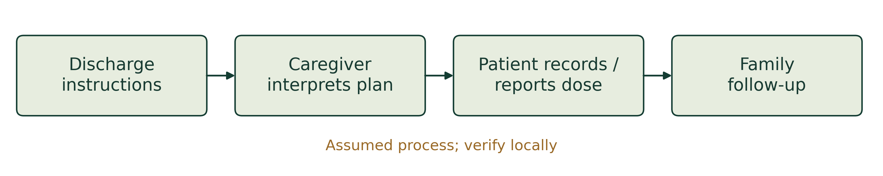
Figure 1. Candidate as-is journey. Validate the sequence through observation; it is not a field finding.

MODULE 1 · B

Boundary, stakeholders and baseline
Workbook pp. 5–8 [1] | Establish what is inside, outside and still unknown.
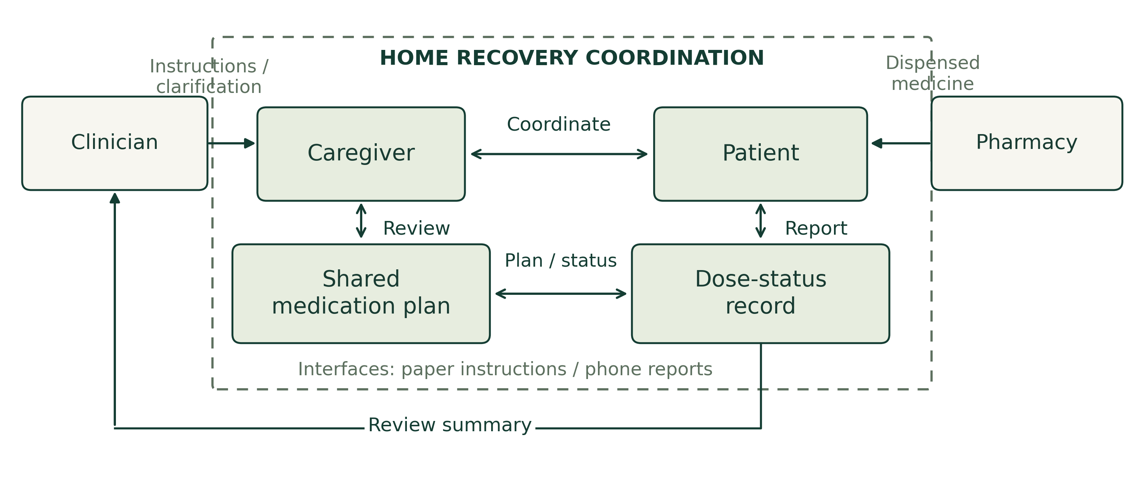
Figure 2. Functional system boundary. Instructions and medicines enter; status reports and clarification requests leave.
Inside: understanding and coordinating an already prescribed plan. Outside: diagnosis, prescribing, surgery, dispensing decisions and emergency treatment. Interfaces to examine include paper instructions, medicine packaging, notes, messages, calls and a phone screen.
Stakeholder | Anticipated need to validate
Patient | Understand the next prescribed action and report it with little effort.
Caregiver | Know the reviewed plan, responsibility and latest recorded status.
Clinician | Review authorized context at agreed follow-up, without an assumption of continuous monitoring.
Pharmacist · external | Clarify dispensing information within professional responsibility.

Two local baseline measures
Metric | Definition / proposed source | Status
A · Setup time | Median minutes from receiving instructions to completing a checked daily plan; observed or realistic simulated task. | Not measured
B · Unresolved status | Due doses without a definitive Taken/Skipped log at an agreed cutoff ÷ all doses due by then × 100%; consented diary. | Not measured

B measures recording completeness, not medicine ingestion. Exclude future doses; report B as N/A if no doses are due. Record sample size, conditions, dates and sources. Collect local measurements before claiming field impact.

Three “How might we” statements
1. How might we turn difficult instructions into a daily plan the household can check accurately?
2. How might we make dose responsibilities and reports clear when several people help?
3. How might we present unresolved records for appropriate follow-up while keeping reporting manageable?

MODULE 2 · A

Systems mapping and root cause
Workbook pp. 9–15 [1] | Look below visible events.
Purpose: the Iceberg Model connects visible events to patterns, system structures and mental models. An event tells us what happened; a structure explains how the parts are arranged. Beliefs can sustain that arrangement.
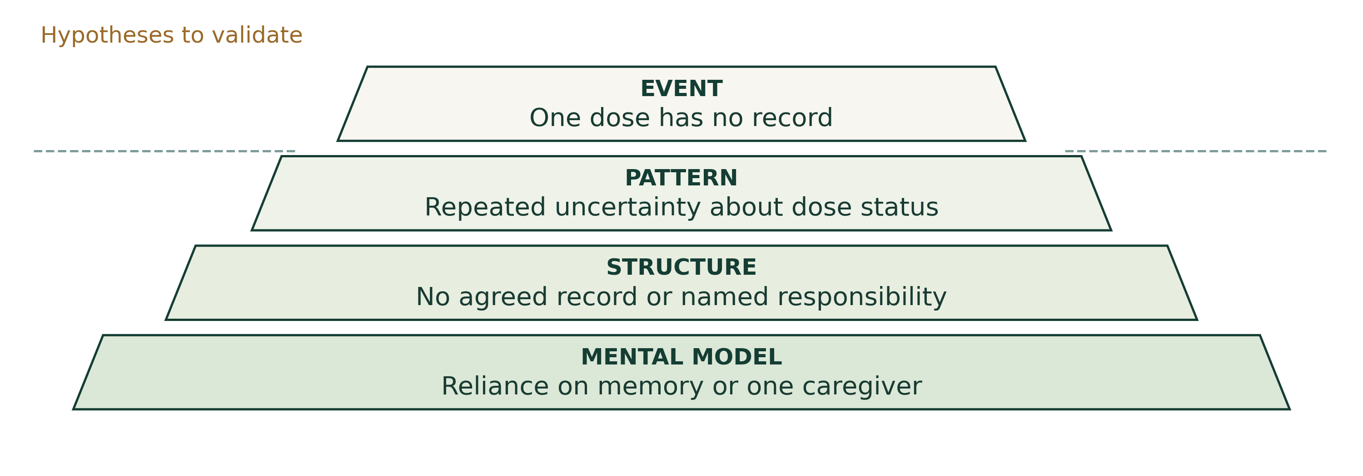
Figure 3. Four levels of inquiry. Every RecoverTrack example shown is a hypothesis to validate.

Write-up for the four levels
Events: a dose-status entry is missing or a caregiver asks for clarification. List observable facts before proposing causes.
Patterns: uncertainty may recur around busy routines or responsibility changes. Compare days, times and households before calling it a pattern.
Structures: instructions, updates and responsibilities may be spread across separate people or records. Examine who can see and change each record.
Mental models: a person may expect memory, repeated calls or one family member to maintain coordination. Interviews must establish whether such beliefs are present.
Root-cause hypothesis: unclear information ownership and weak handoffs may contribute to unresolved dose status. This is not a proven cause. Incomplete reporting, deliberate skipping, unclear instructions and connectivity loss need different responses.

Questions that can challenge the hypothesis
- Who updates the record, and what happens when that person is unavailable?
- What information is usually missing when someone asks about a dose?
- When is the current process clear and successful, and what is different then?
Record contrary examples and revise the map. Do not turn anticipated stakeholder views into invented interview quotations.

MODULE 2 · B

Stakeholder journeys and bottlenecks
Workbook pp. 12–15 [1] | Revisit the system map using different perspectives.
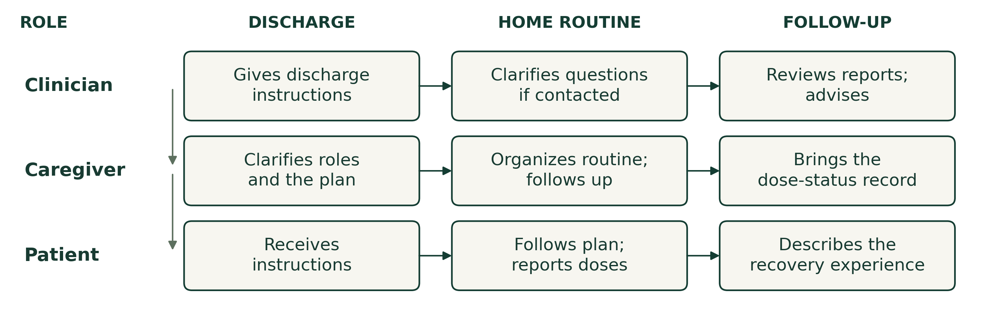
Figure 4. Candidate stakeholder journeys from discharge to follow-up; the field sequence is not yet observed.
Stakeholder | Priority / belief to explore | Lifecycle
Patient | Low effort, understandable instructions and control over sharing; may expect someone else to maintain the record. | Daily during recovery
Caregiver | Clear responsibility and current status; may rely on memory or calls when records are unavailable. | Dose times and handovers
Clinician | Accurate context and manageable review workload; may expect families to raise concerns. | Discharge and agreed follow-up

Non-negotiable: correct prescribed details, consent and protection from unauthorized changes. Negotiable: presentation, reminder timing and division of household tasks. Potential tensions are effort versus detailed reporting and privacy versus convenient sharing.

Three bottlenecks to test
Bottleneck | Working explanation | What would test it?
Data | No identifiable latest status. | Trace the latest update and compare accounts of the same event.
Process | Handover without named responsibility. | Observe a change of caregiver and ask who should update next.
Human | Discomfort, misunderstanding or reporting burden. | Observe task effort and ask about skipped or incomplete entries.

Refined HMW and revised map
How might we give a consenting household one understandable, reviewed plan with explicit dose responsibility and traceable reports, so unresolved records can receive appropriate attention?
Revise Figure 2 with the links “instructions explained,” “responsibility handed over” and “status reported.” Use dashed connectors for uncertain relationships. Keep hypotheses open until local observations support or contradict them.

MODULE 3 · A

Causal loops and leverage
Workbook pp. 16–17 [1] | Explain feedback rather than listing isolated causes.
Purpose: a causal loop diagram (CLD) models how variables affect one another over time. A closed loop returns to its starting variable. These links are hypotheses, not established effects in patients.
Symbol | Meaning
+ | Variables change in the same direction, with other conditions unchanged.
− | Variables change in opposite directions; this does not mean “bad”.
R / B | Even number of negative links → reinforcing; odd number → balancing.
|| | The response is delayed; the effect is not immediate.

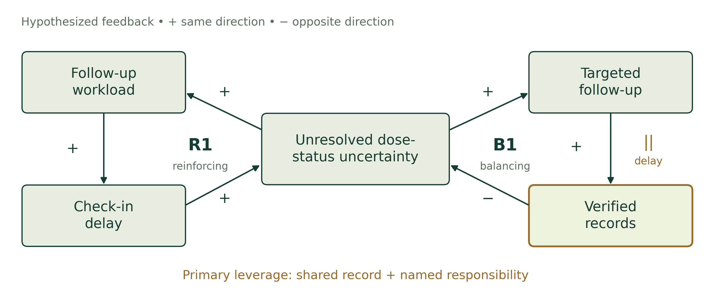
Figure 5. R1 has no negative links; B1 has one. The loop polarities are checked, but the proposed causal links need evidence.

Interpret the two loops
R1 — Coordination pressure: follow-up workload → check-in delay → unresolved dose-status uncertainty → follow-up workload. All three links are positive: extra uncertainty may trigger more work and further delay.
B1 — Closing the information gap: uncertainty → targeted follow-up → verified status records → lower uncertainty. The negative final link makes it balancing. A person being unavailable introduces delay.
Primary leverage: one reviewed shared plan, clear responsibility for reporting and dated updates. The prototype supports shared records and actor history; formal named dose ownership and teach-back remain proposed workflow additions.
Candidate measures are follow-up minutes/day, reporting-delay minutes and unresolved due entries/day. “Verified record” here means a confirmed self-report, not proof of ingestion.

MODULE 3 · B

System archetypes and intervention depth
Workbook pp. 18–20 [1] | Choose a provisional pattern and test its fit.
Working archetype: Shifting the Burden. Repeated calls may answer a dose-status question quickly, while a shared record and responsibility handover remain weak. Dependence on the quick fix may delay adoption of the longer-term process. Interviews must establish whether this pattern occurs.
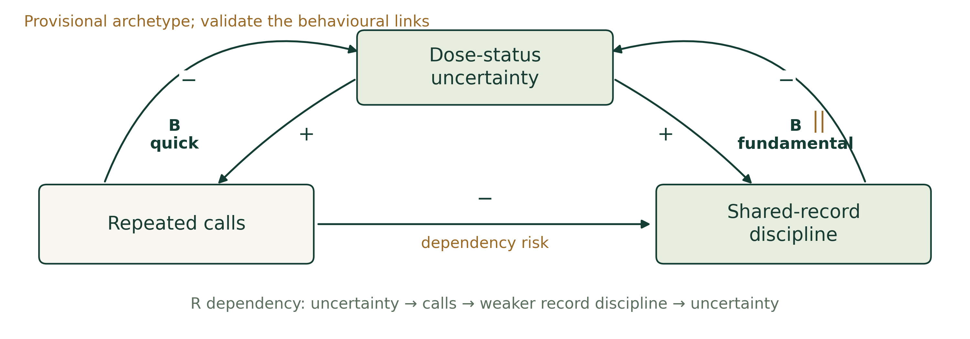
Figure 6. Proposed Shifting the Burden pattern. The long-term process includes a delay; the dependency link is a hypothesis.
Archetype | Possible project relevance
Shifting the Burden | Repeated clarification substitutes for a maintained record; primary working interpretation.
Fixes that Fail | Excessive reminders could create alert fatigue.
Limits to Growth | Review demand could exceed available clinician time.
Success to the Successful | Already-engaged households might receive more support.
Tragedy of the Commons | Several households could compete for limited follow-up capacity.

Where to intervene
Level | Example | Role in RecoverTrack
Event | Send one more reminder. | May resolve an immediate gap; does not establish a shared process.
Structure | Maintain a reviewed record and permission rules. | Implemented software contribution.
Rules / mental model | Agree who reports, how handover works and when concerns are reviewed. | Proposed field-process contribution; validate with users.

The chosen direction strengthens an information flow and a reporting practice. Revise the archetype if observations show a different loop; a familiar diagram is not evidence that the pattern exists.

MODULE 4 · A

Divergent thinking and convergence
Workbook pp. 21–22 [1] | Generate alternatives before choosing the prototype.
Purpose: divergent thinking opens several interdisciplinary options; convergence selects a feasible intervention after considering reach, depth and remaining limitations. The ratings and placements below are design judgements, not measured impacts.
ID / idea | Domains | What it helps / what remains | Type / level
I1 · Printable dose chart | CSE + industrial engineering | Visible plan; remote updates and handovers can remain unclear. | Product/process; local information aid
I2 · Editable OCR draft | CSE + ECE image processing | Less repeated typing; recognition errors and status uncertainty remain. | Product; transfer step
I3 · Alarm pillbox | ECE + mechanical | Physical dose cue; opening a box does not prove correct ingestion or shared reporting. | Proposed hardware; local structure
I4 · Shared reviewed record | CSE + industrial engineering | Common history and roles; connectivity and reporting effort remain. | Product/process/behaviour; structure
I5 · Teach-back and named owner | Industrial engineering + CSE | Clearer handover; requires staff participation and continued practice. | Proposed process/behaviour; rules

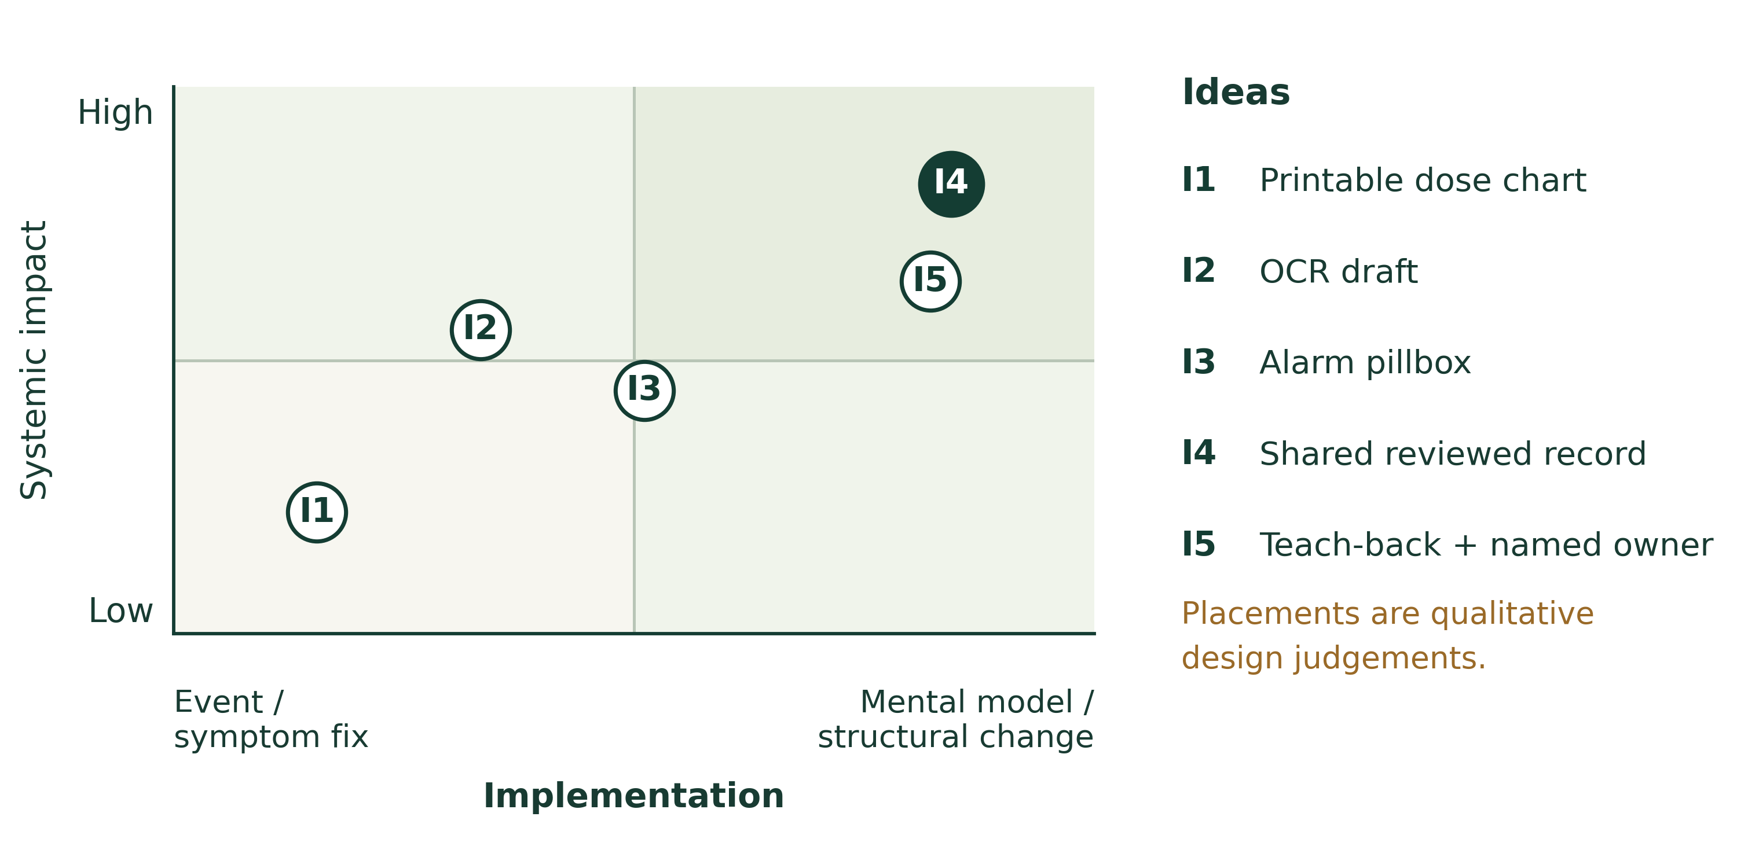
Figure 7. Workbook-aligned selection map: systemic impact versus depth of implementation. Placement is qualitative; feasibility is assessed separately.
The workbook’s horizontal axis runs from event/symptom fixes toward mental-model or physical/structural change. It is not an implementation-ease axis. No numerical improvement is implied by a point’s position.

MODULE 4 · B

Selected solution and architecture
Workbook p. 23 [1] | Connect the intervention to a feasible prototype.
Idea | Expected reach | System-change depth | Implementation ease
I1 | Low | Low | High
I2 | Medium | Low–medium | Medium
I3 | Medium | Medium | Low
I4 | High | High | Medium
I5 | Medium | High | Medium

Selection: I4 is the main intervention; I2 supports entry of prescription details. I5 is a proposed field-workflow extension. The software currently implements reviewed prescriptions, shared schedules, self-reported doses and role-based views. It does not establish a validated clinical benefit.
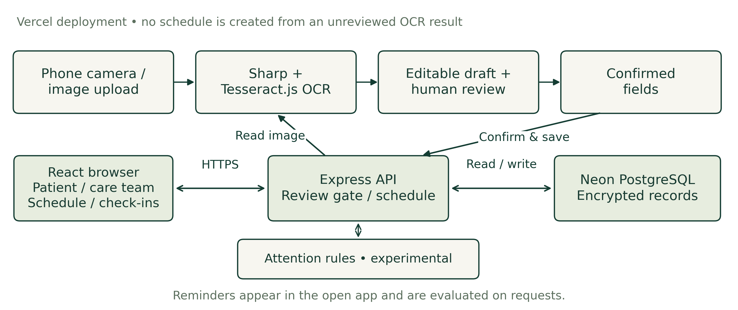
Figure 8. Current prototype architecture. OCR reaches scheduling only through editable fields and human review. [2, 4]

Engineering-domain integration
Domain | Applied contribution
CSE / software engineering | React UI, Express API, review gates, household permissions, scheduling and AES-256-GCM record payloads in Neon PostgreSQL.
ECE / image processing | Existing phone camera and image quality; Sharp preparation and OCR input. The project studies capture quality, without claiming a custom camera circuit or sensor.

Human-factors design and care-team input support both domains. Operational boundary: reminders depend on open-app requests; closed-app push/email/WhatsApp/calls are not connected. Attention flags use transparent experimental rules and do not diagnose or change treatment. [2, 4]

MODULE 5 · A

Rapid prototyping and the critical assumption
Workbook pp. 24–25 [1] | Test the most consequential uncertainty.
Critical assumption: a caregiver can correct and verify all five extracted medication fields, with every field correct and each review completed in under 30 seconds. This is a proposed test of review accuracy and effort, not a claim of safe clinical use. [3]
Assumption | Severity / uncertainty | Current response
C1 · Accurate, quick human review | High / high | Editable drafts; required confirmation; volunteer study pending.
C2 · Self-reports accurately reflect dose-taking | High / high | Treat entries as self-reports; do not infer actual ingestion.
C3 · Free hosting meets required availability | Medium / medium | Durable storage and failure states; quotas and cold starts remain.
C4 · Access stays within authorized roles | High / medium | Household, role and consent checks tested; production privacy duties remain.

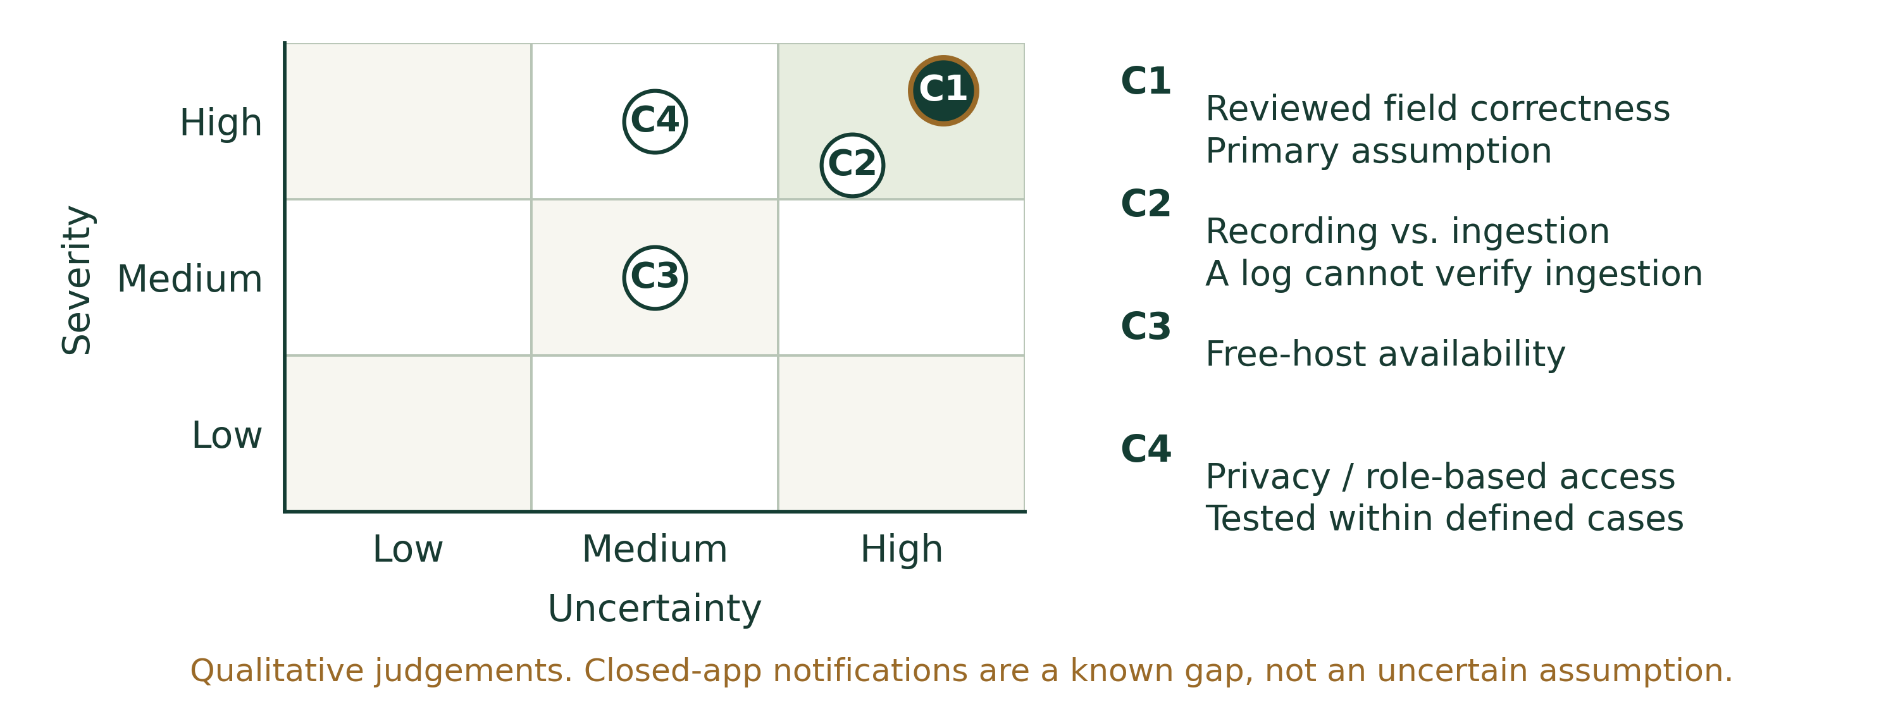
Figure 9. Qualitative risk selection. Positions are design judgements, not probabilities; C1 is the selected experiment.

Proposed experiment — not yet conducted
1. Recruit five consenting volunteers; assign four fictional cards each: 20 review tasks, balanced across clear and difficult images.
2. Independently verify reference name, strength, amount, frequency and duration. Save raw output before correction.
3. Time draft display to submission. Retain errors, retakes, rejected reads and manual fallbacks; report median and P90.
4. Check final fields against the references. Separately verify explicit times, dates and timezone. Run a balanced manual-entry round before claiming time savings.
Pass: every field correct in every task and every task <30 s. Fail: any field error or task ≥30 s. The target applies to review, not complete account or household setup. [3]

MODULE 5 · B

Measured results and validation conclusion
Project records [2–4] | Separate engineering evidence from field outcomes.
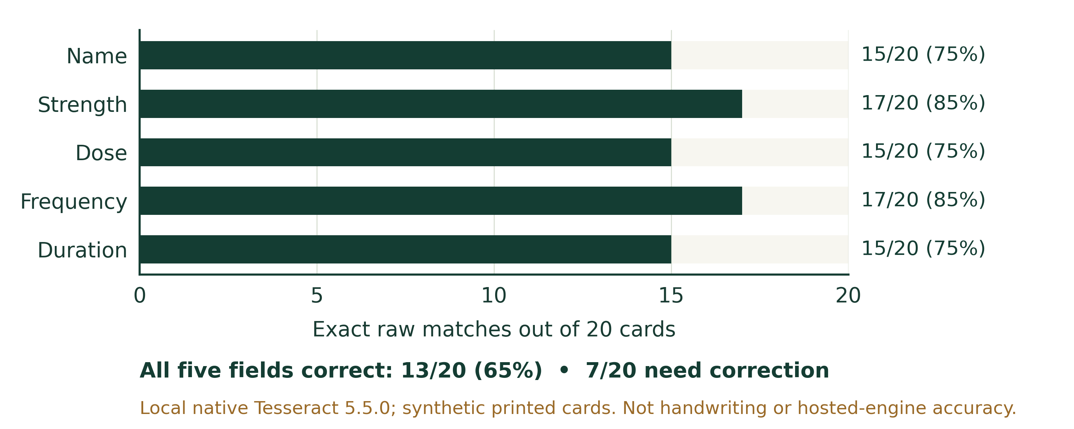
Figure 10. Exact raw OCR matches on 20 generated printed cards, using the local Python/native-Tesseract pipeline. [3]
All five fields matched on 13/20 cards (65%); 7/20 (35%) had at least one mismatch. Skew, faint print and clutter exposed failures. These figures describe synthetic printed inputs, not handwriting, real prescriptions or accuracy of the hosted Tesseract.js engine.
Recorded software evidence: 114 passing cases across completed runs: 57 Node, 10 MongoDB, 9 PostgreSQL, 21 Python and 17 browser cases. They test behavior, permissions, review gates and persistence; they are separate from the pending volunteer study. [4]

Required before/after comparison
Module 1 measure | Before intervention | After intervention
A · Median checked-plan setup time, minutes | Not measured locally | Not measured locally
B · Unresolved due-dose status at cutoff, % | Not measured locally | Not measured locally

Use comparable observation periods and the same review cutoff. Exclude future doses. The OCR benchmark and software tests cannot replace these local field baselines.

Conclusion and next iteration
The software workflow is demonstrated, but the critical human-review assumption is not yet validated. Required review and manual entry provide recovery paths; no measured post-review accuracy or improvement in medication adherence has been established.
- Run the controlled review study; improve capture guidance where errors persist.
- Collect consented local baseline A/B data, then compare the proposed intervention.
- Validate handover and workload effects before extending notifications or clinical use.

SYNTHESIS AND SOURCES

What makes the project distinctive
A clear contribution, bounded claims and a traceable next experiment.

Project contribution
RecoverTrack addresses recovery coordination through a reviewed shared record, visible reporting history and role-based access. Its systems contribution is the connection between understandable instructions, household information flow and appropriate human follow-up. The prototype combines image capture, human correction, scheduling and daily reports in one workflow while keeping treatment decisions with people.
Strength | Evidence or boundary
System-level reasoning | PID → stakeholder structure → feedback → leverage → prototype.
Controlled prescription transfer | Extracted fields remain drafts until review; manual entry stays available.
Transparent attention flags | Rules summarize recorded patterns; no diagnosis or clinical prediction claim.
Accountable sharing | Individual roles, household permissions, consent and actor history.
Honest evaluation | Raw OCR limitations are reported; field and volunteer targets stay unclaimed.

Before submitting the final record
1. Replace the proposed local scope with your actual approved site and participant details.
2. Add cited local A/B measurements and genuine stakeholder notes; do not invent quotations or results.
3. Run the review study, record failures and update the CLD and conclusion when evidence changes.

Sources and traceability
[1] Supplied PSE workbook: “PSE All Modules 1 2 3 4 5.pdf,” 25 pages. Module 1: pp. 4–8; Module 2: pp. 9–15; Module 3: pp. 16–20; Module 4: pp. 21–23; Module 5: pp. 24–25. Frameworks and selection-axis definitions come from this document.
[2] RecoverTrack project source: README.md, docs/IMPLEMENTATION.md and server/intelligence-node.mjs. Current architecture and implemented limits take precedence over the older proposal PDFs’ planned TrOCR, logistic-regression, MongoDB and external-notification stack.
[3] OCR evaluation: docs/OCR_EVALUATION.md and docs/ocr-evaluation.json, recorded 23 October 2026; 20 generated printed cards with field-level references. The human-review study is still pending.
[4] Software verification: docs/VALIDATION.md, completed project test runs; the 114-case count spans separate suites/runs. It is not a patient sample or a clinical outcome study.
Repository and supporting project records
Live prototype
All ten diagrams and charts are embedded in this Word document. Print or copy them into your record book with their captions and evidence labels. No separate diagram files are needed.

