Go through the formula

When running a two-sample equal-variance t-test, the basic assumptions are that the distributions of the two populations are normal, and that the variances of the two distributions are the same.

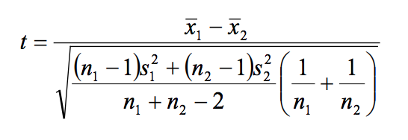

difference in means / sqrt (variance / sample size)

|  |  |  |  |  |
| --- | --- | --- | --- | --- |
| Nurse Type | Direct Care | Non-Nursing | Indirect Care | Nurse’s Admin |
| t-values | | | | |
| RN | -1.58 | -1.38 | 2.02 | 1.39 |
| NA | -1.62 | 0.06 | 1.77 | 3.09 |
| p-values | | | | |
| RN | 0.12 | 0.17 | 0.05 | 0.17 |
| NA | 0.12 | 0.95 | 0.09 | 0.005 |

Table: t & p-values for each category of two samples

