**Carat Vs Price**

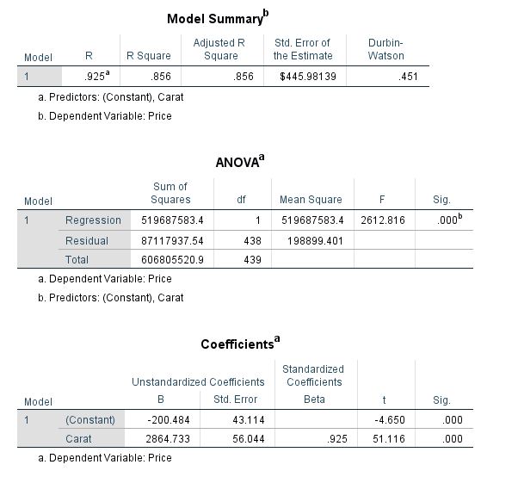

**ColorN vs Price**

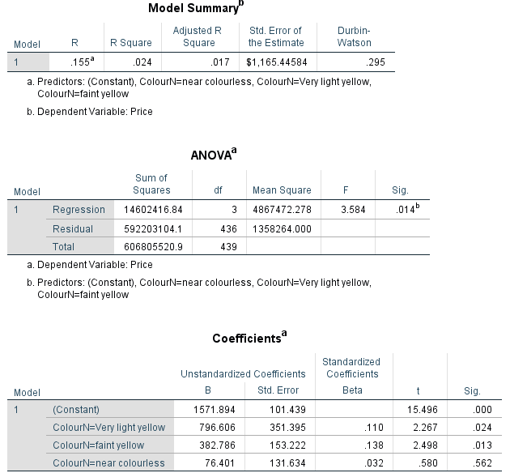

**Color Vs Price (Color and ColorLess)**

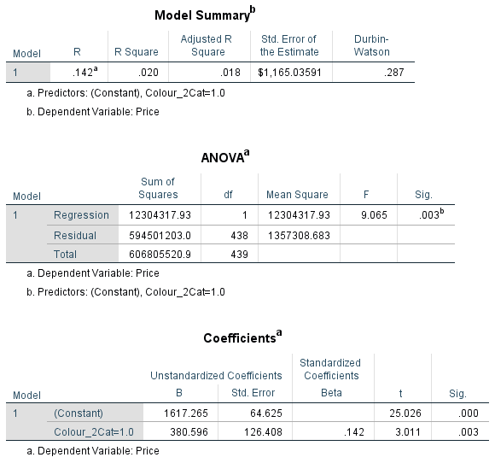

**Clarity Vs Price (Scale)**

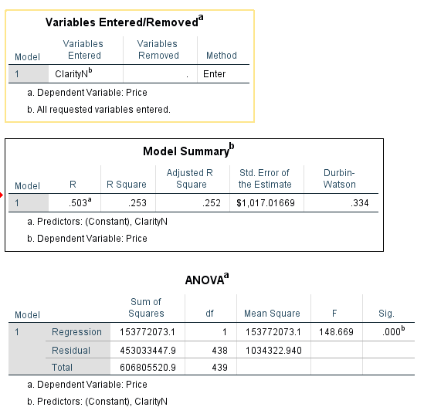

**Clarity Vs Price (Categorical)**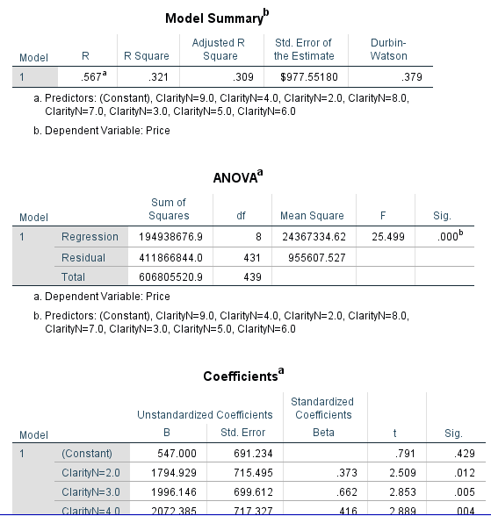

**Clarity Vs Price (Three Categories)**

**10X Flaws, 30x Flaws, Visible Flaws**

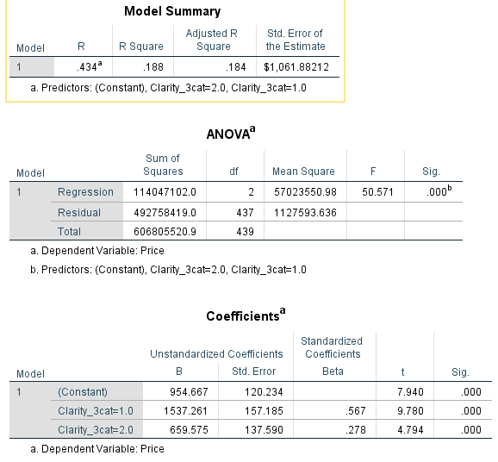

**Clarity Vs Price (Five Categories)**

**1-I1,I2,**

**2- SI*1***

***3- SI2***

***4-SI3***

***5-VS1,VS2,WS1,WS2***

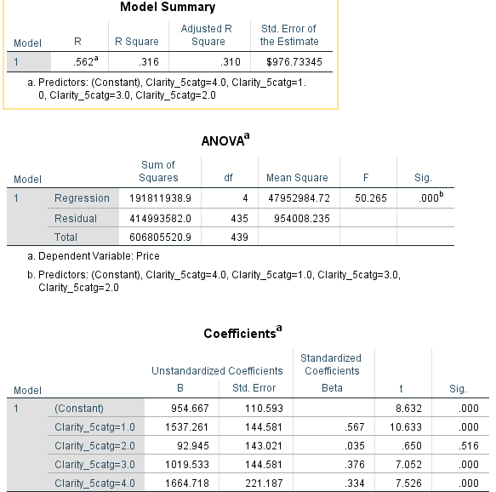

**CutN vs price**

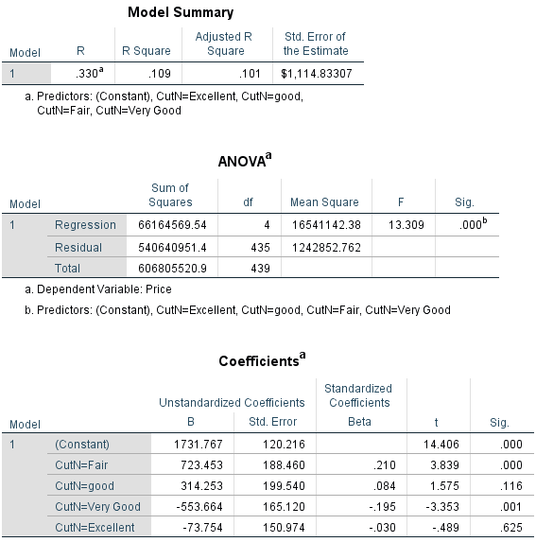

**polishN vs price**

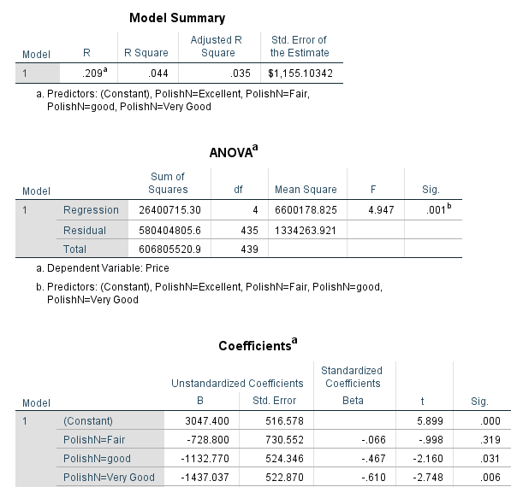

**SymmetryN vs Price**

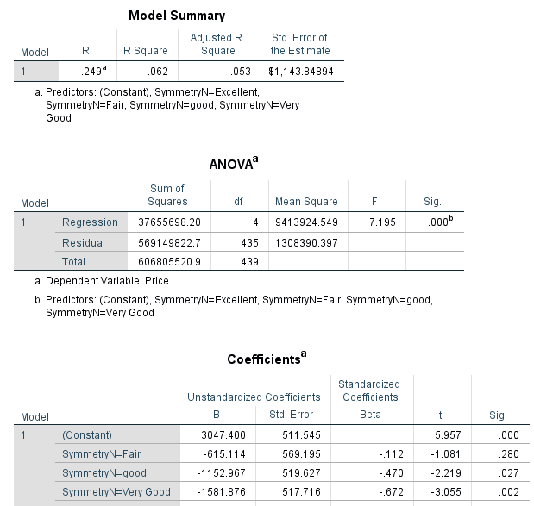

**Cut, Polish, Symmetry vs price**

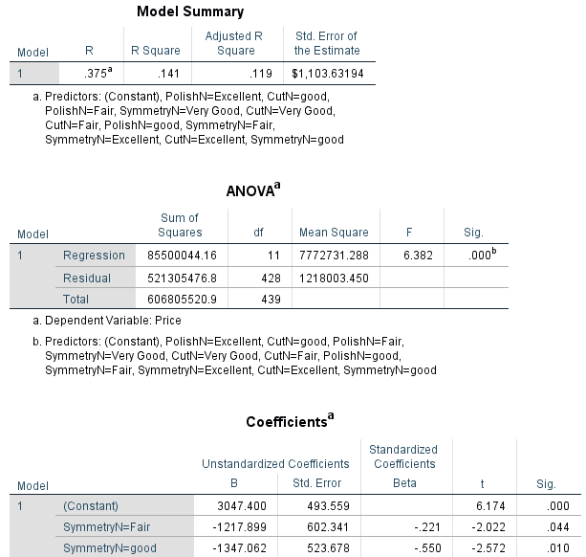

**CertificationN vs Price**

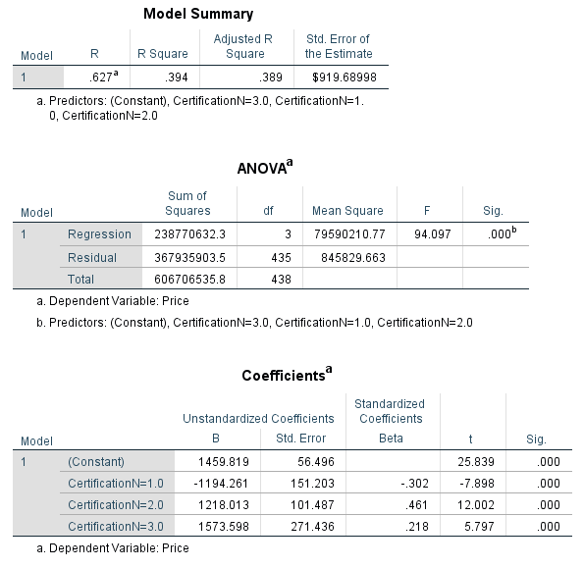

Wholesaler vs price

