

**Managing & Programming Database MCDA5540**

**Master of Science in Computing and Data Analytics**

**Assignment-4**

**Submitted by**:

Caner Adil Irfanoglu (A00425840)

Sunil Padikar (A00429)

Vinay Govindan (A00429120)

Gaganpreet Singh (A00429660)

**Submitted to**:

TRISHLA SHAH

**EXECUTION**

1. **Command -** *./import_texts.sh ../data_files/ newsitems v_govindan v_govindan*

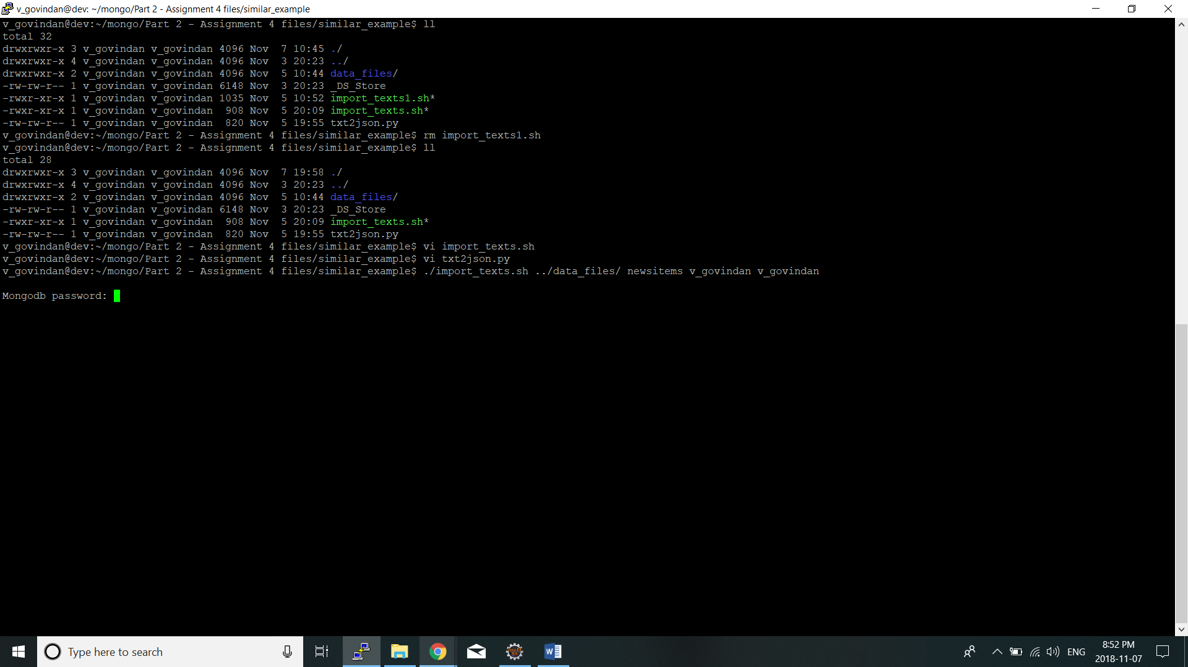

2. After entering the mongo db password

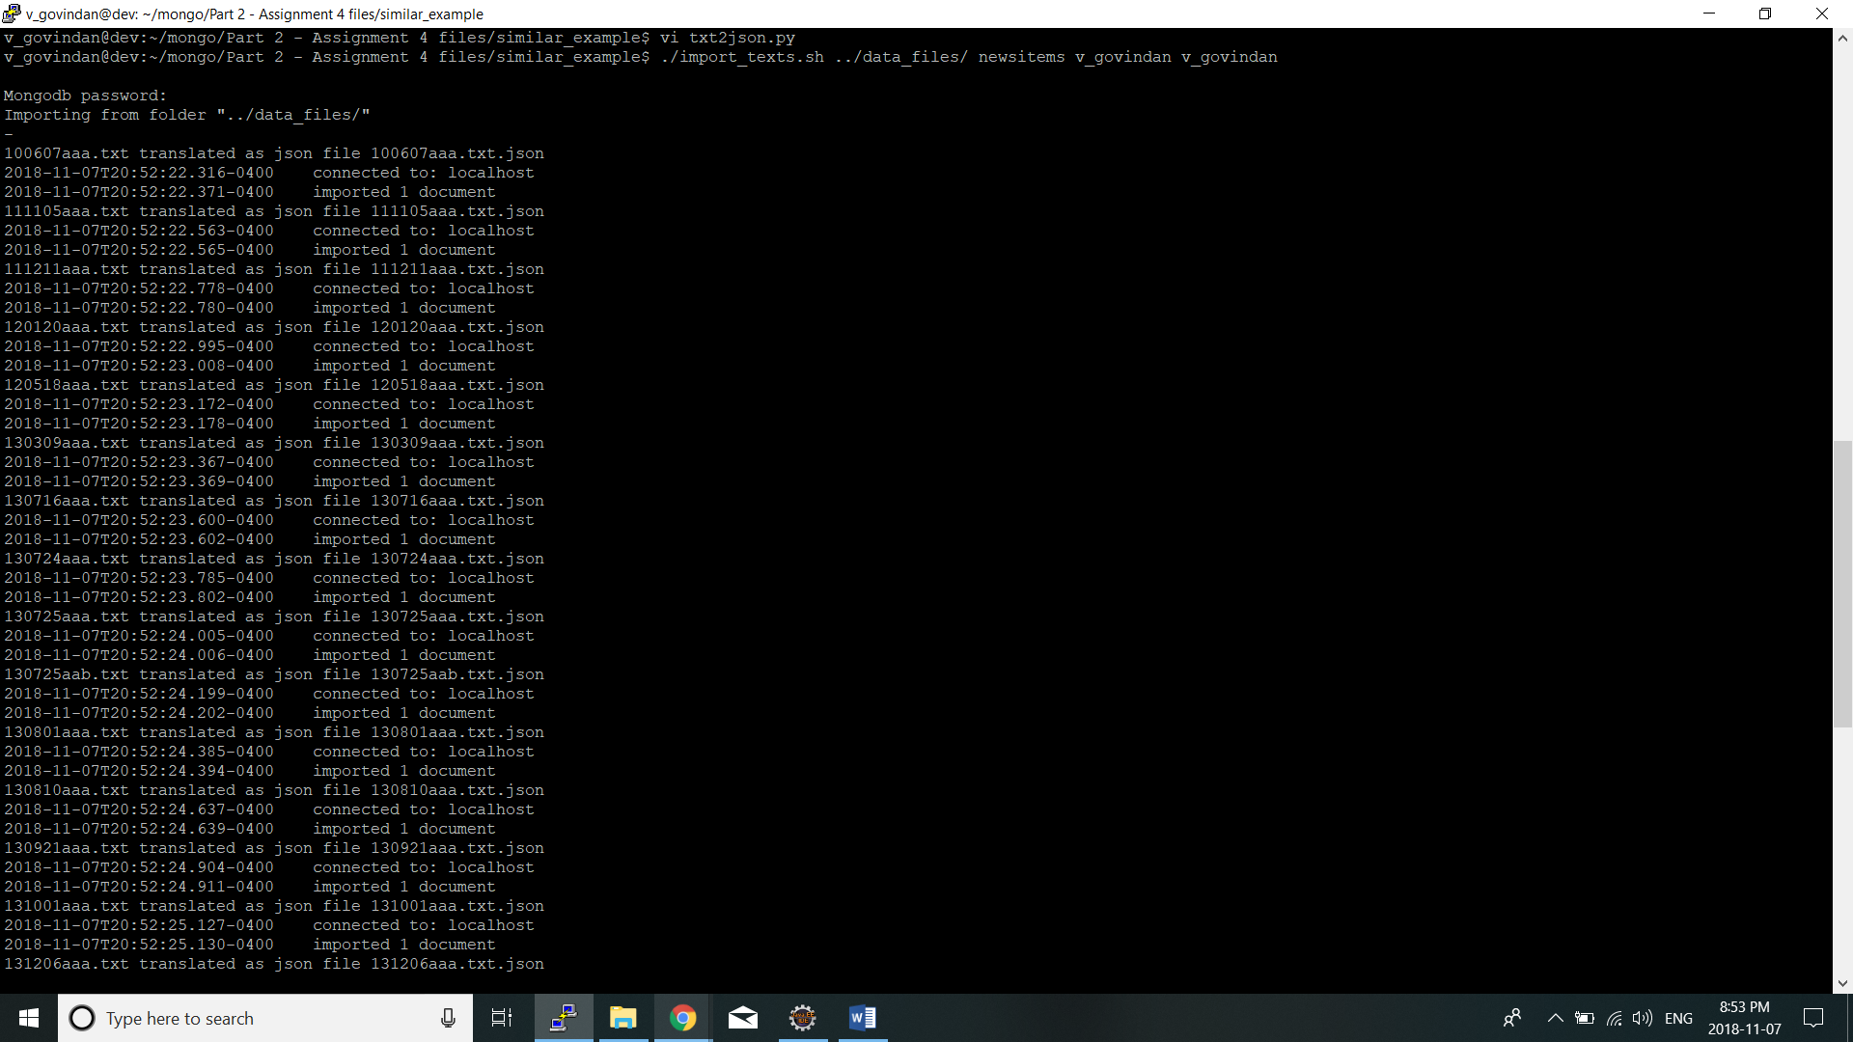

1. The script has processed and imported all the files in the directory “data_files” and created an index based on “title” and “content” fields

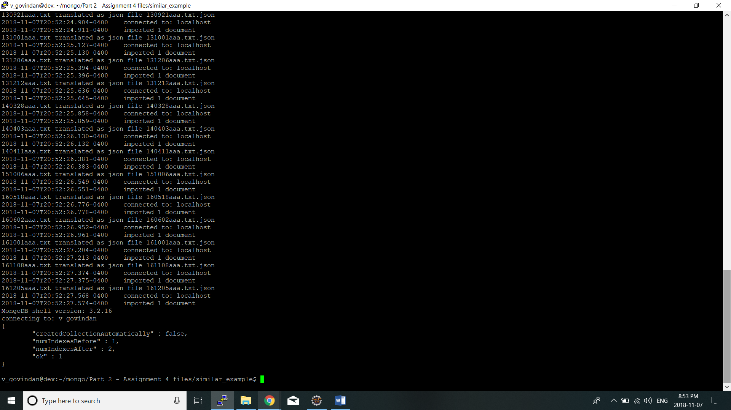

1. We check the indexing based on the following query :

***db.newsitems.find({$text: {$search: "Trump"}}, {_id:0, title:1, score: {$meta: "textScore"}}).sort({score: {$meta: "textScore"}}).limit(2)***

