DMBS Project Design

Caner Adil Irfanoglu (A00429)

Sunil Padikar (A00429)

Gaganpreeth Singh (A00429)

Vinay Govindan (A00429120)

**Disclaimer:**

**We haven’t copied anything from anywhere.**

**We have just modified the existing program to fetch results**

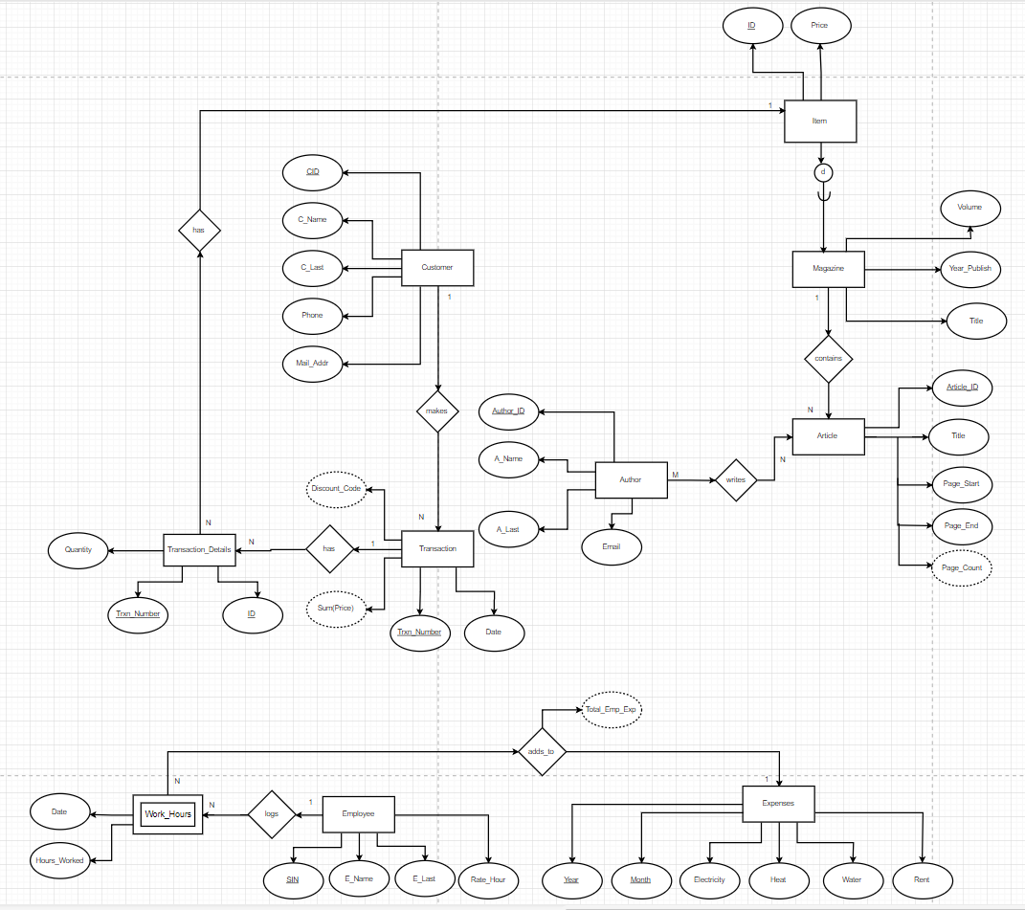

EER Diagram :

Schema :

All the tables below are in 1NF as each filed has only one datatype, has only a single value per row and each row can be uniquely identified.

***ITEM(ID, Price)***

ITEM tables has no partial or transitive dependency as price is uniquely identified by the primary key ID and price cannot determined ID uniquely hence the relation is in BCNF.

Note: ID is unique for each vol. magazine and it is foreign key in MAGAZINE table

as Magazine_ID

***MAGAZINE(Maganize_ID unique NOT NULL , Title, Year_Publish, Volume)***

***Foreign Key MAGAZINE (Maganize_ID) references ITEM (ID)***

Magazine is in 2NF and has no partial dependency as all the fields depends on both Title and Volume which put together forms the Candidate Key .It is in 3NF, BCNF as Maganize_ID and Year_Publish depends only on Title+ Volume & not the other way around hence there is no transitive dependency.

***ARTICLE(Article_ID, Title, Page_Start, Page_End, Magazine_ID NOT NULL)***

***Foreign Key ARTICLE (Magazine_ID) references MAGAZINE (Magazine_ID)***

The table Article is already in 3NF, BCNF as there is No partial and transitive dependencies since all the fields depend on Article_ID & not the other way around.

***AUTHOR(Author_ID, A_Name, A_Last, Email)***

The Author table is in 3NF, no partial and transitive dependencies as all the fields depend on Article_ID.

***WRITES(Author_ID, Article_ID)***

***Foreign Key WRITES (Article_ID) references ARTICLE (Article_ID)***

***Foreign Key WRITES (Author_ID) references AUTHOR (Author_ID)***

Writes table satisfies BCNF because both Author_ID and Article_ID form the candidate key and there is no partial or transitive dependency.

***CUSTOMER(CID, C_Name, C_Last, Phone, Mail_Addr)***

The Customer table is already in 3NF, BCNF as there is no partial and transitive dependencies since all the fields depend on CID and not the other way around.

***TRANSACTION (Trxn_Number, Date, CID, Discount_Code)***

***Foreign Key TRANSACTION(CID) references CUSTOMER(CID)***

The Transaction table is in 3NF, BCNF since there is no partial or transitive dependency and when a customer levels up their discount code will change even though CID remains the same. So, Discount Code is only determined by Trxn_Number and so are the other fields.

***TRANSACTION_DETAILS (Trxn_Number, ID, Quantity)***

***Foreign Key TRANSACTION_DETAILS(Trxn_Number) references TRANSACTION(Trxn_Number)***

***Foreign Key TRANSACTION_DETAILS(ID) references ITEM(ID)***

The Transaction_Details table is in 3NF, BCNF since there is no partial or transitive dependency and since a customer can purchase same items on different transactions Trxn_Number is required alongside with ID. Also, Trxn_Number is not sufficient to determine quantity, since the transaction can include same quantities of different items.

So, Quantity is only determined by using Trxn_Number and ID and not the other way around.

***EMPLOYEE (SIN, E_Name, E_Last, Rate_Hour)***

The Employee table is already is in 3NF, BCNF where there is no partial and transitive dependencies as all the fields depend on SIN and not the other way around.

***WORK_HOURS (Date, SIN, Hours_Worked)***

***Foreign Key WORK_HOURS (SIN) references EMPLOYEE (SIN)***

The WORK_HOURS table is already is in 3NF, BCNF where there is no partial and transitive dependencies as all the fields depend on Date and SIN and not the other way around.

***EXPENSES (Year, Month, Electricity, Heat, Water, Rent, Total_Emp_Exp)***

The Expenses table is already is in3NF, BCNF as there is no partial and transitive dependencies since all the fields depend on Year and Month and not the other way around.

Current Status of tables :

Here we are just considering a sample of two tables “author” and “item” table to show its current state of query execution plan.

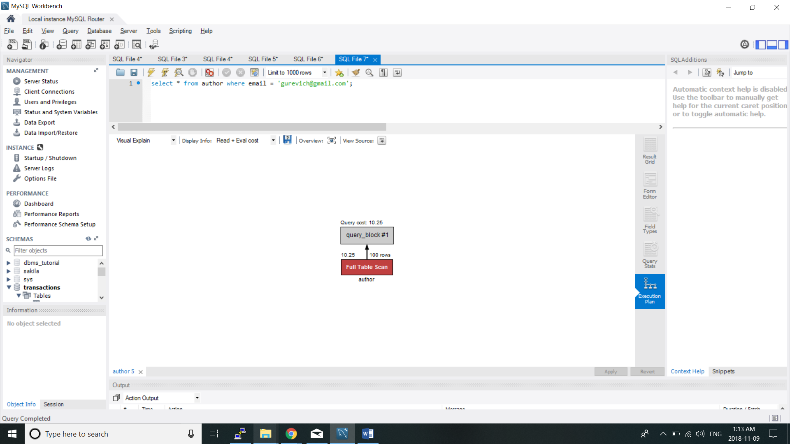

The author table now upon querying for a author based on the email even thought it is logically unique to every author scans the entire table. Indexing the author table based on the email would reduce the number of scans.

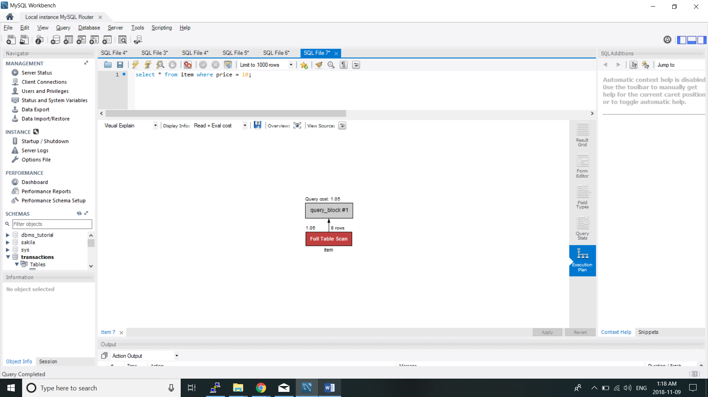

Similarly the item table can also be indexed based on the price which would reduce the number of rows being scanned.