PERFORMANCE COMPARISONS

Query 1-a: Running a full scan on MySQL local server

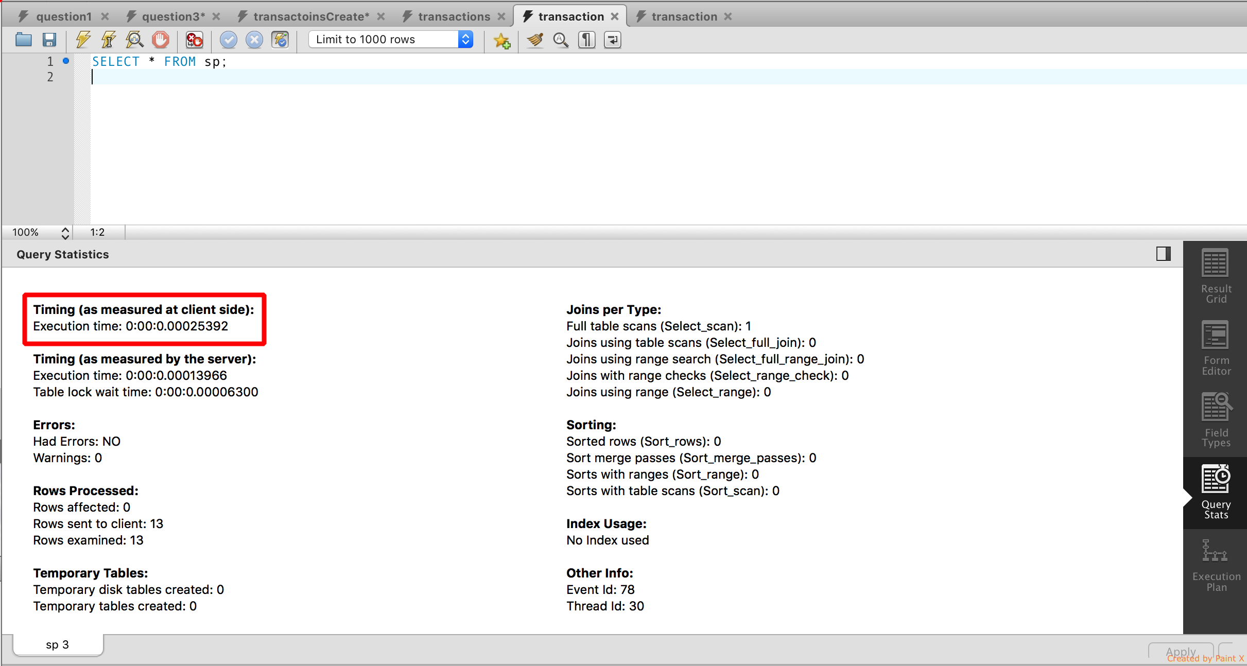



Query 1-b: Running a full scan on IBM Db2 on Cloud

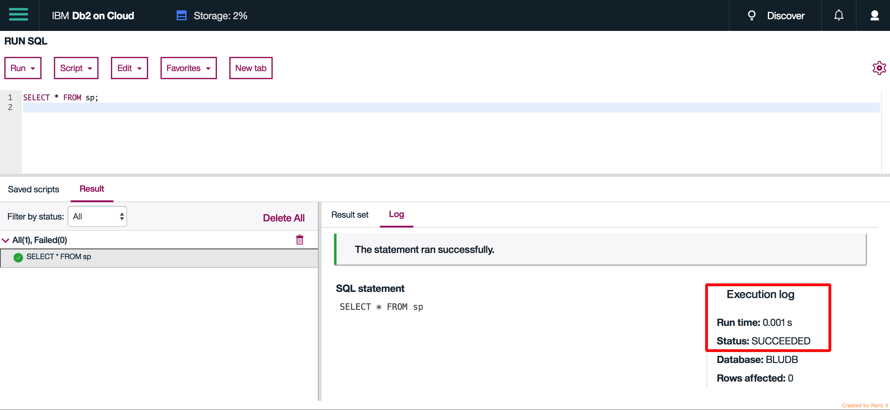

Query 2-a: Running a full scan + unique key look up on MySQL local server





Query 2-b: Running a full scan + unique key look up on IBM Db2 on Cloud

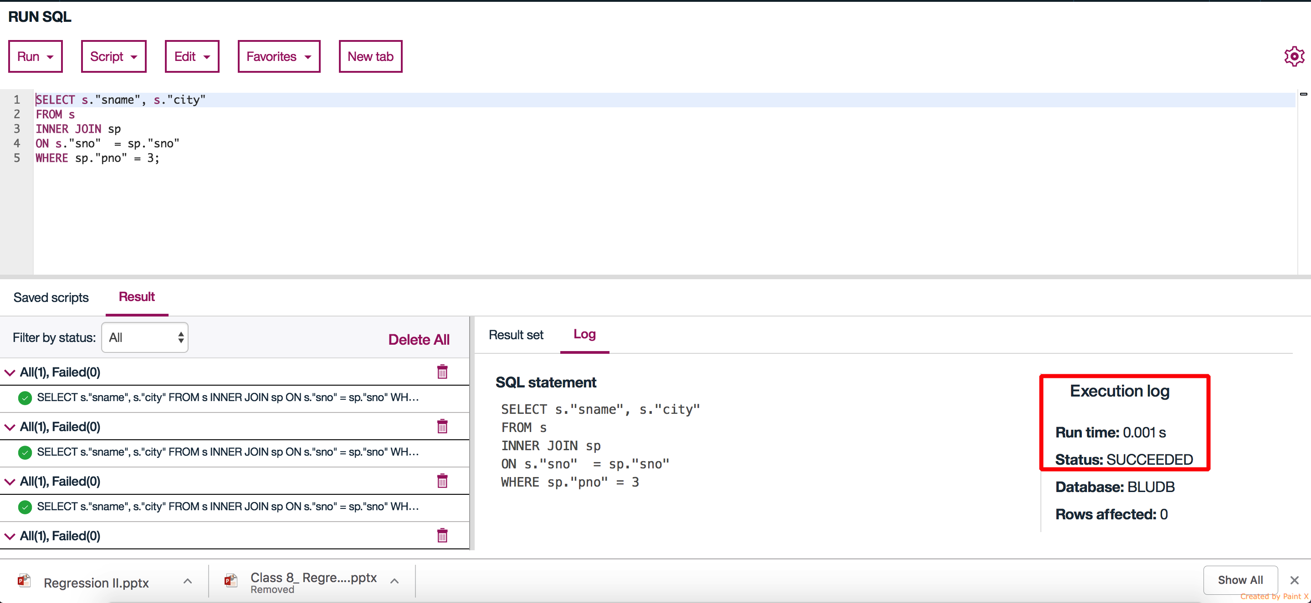

Query 3-a: Running full scan + unique key look up + non-unique key look up on MySQL local server

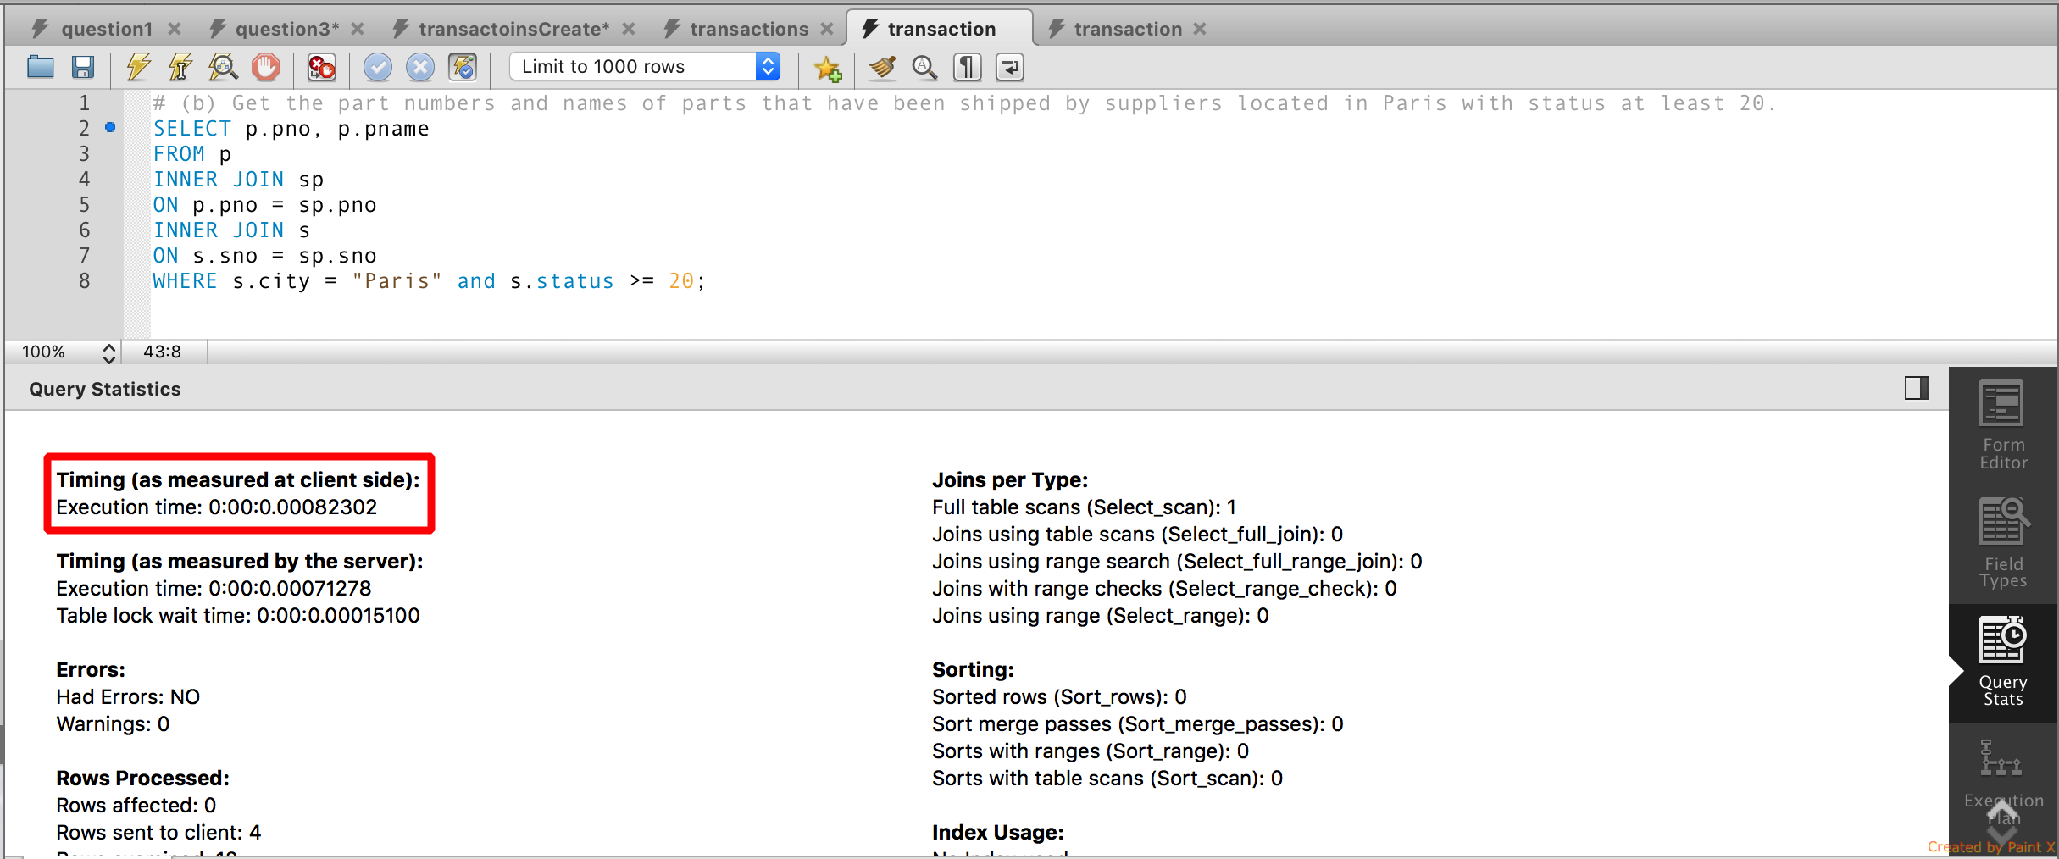

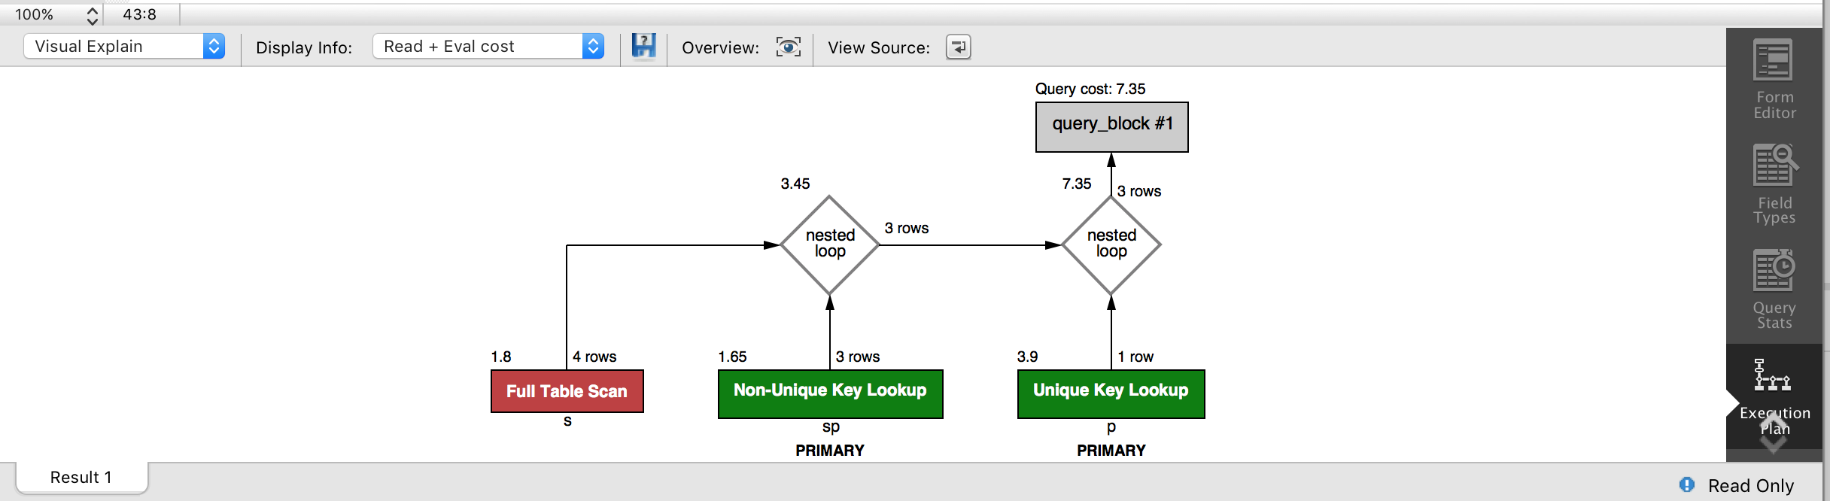

Query 3-b: Running full scan + unique key look up + non-unique key look up on IBM Db2 on Cloud

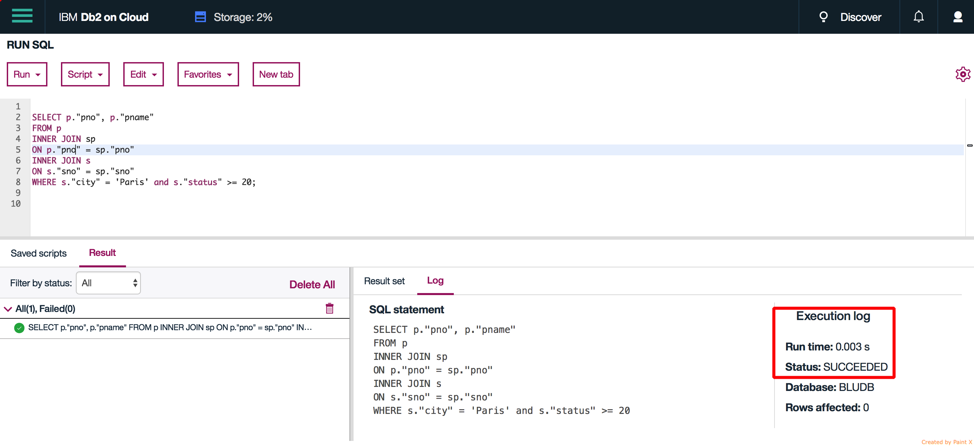

Conclusion:

For full table scan results are ambiguous since Db2 only using 3 digits after decimal. The difference can be a rounding error.

For full table scan + unique key look up Db2 seems to perform better

For full table scan + unique key look + non-unique key look up MySQL seems to perform better.

Db2 might be performing better with unique key lookups whereas MySQL is superior for non-unique key look ups.